Ryan Hopkins (2221956)
[Email address]
Abstract
[Draw your reader in with an engaging abstract. It is typically a short summary of the document.
When you’re ready to add your content, just click here and start typing.]
nETWORKING Operating Systems and Services
ACCA5023 By Ryan Hopkins

Contents
Routing for windows 2
Forest creation 3
A records forward lookup zones 3
Reverse lookup zones 4
User accounts 4
ADDS 4
Drive mapping 5
Accessibility of the drive 5
Dhcp on linux 6

- Configure IIS Server
  - Create https://webs. yourname.acca website and enable windows internal authentication.
  - All the users can be authenticated.

All authenticated users should be presented a text “Welcome to Swansea Website

Routing for windows
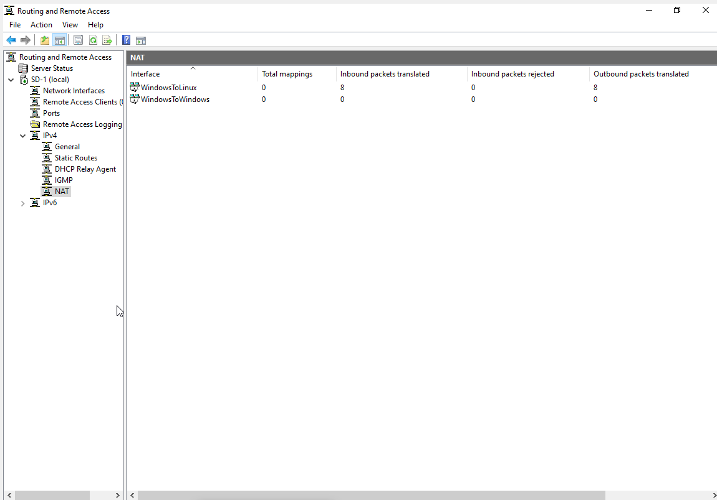
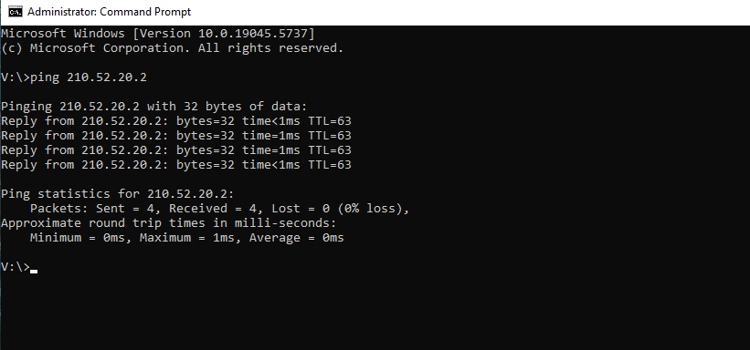

Forest creation
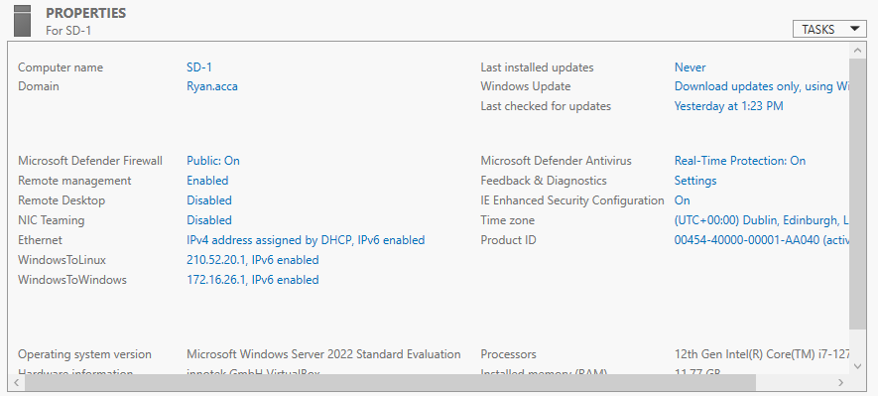

A records forward lookup zones
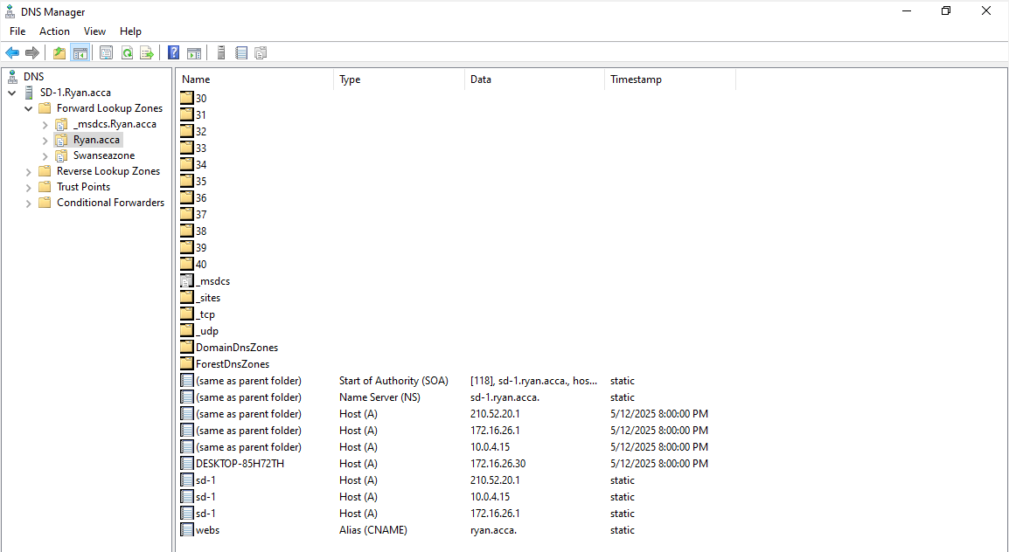

Reverse lookup zones
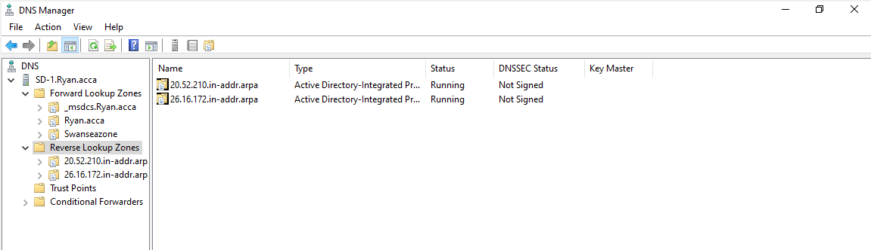

User accounts
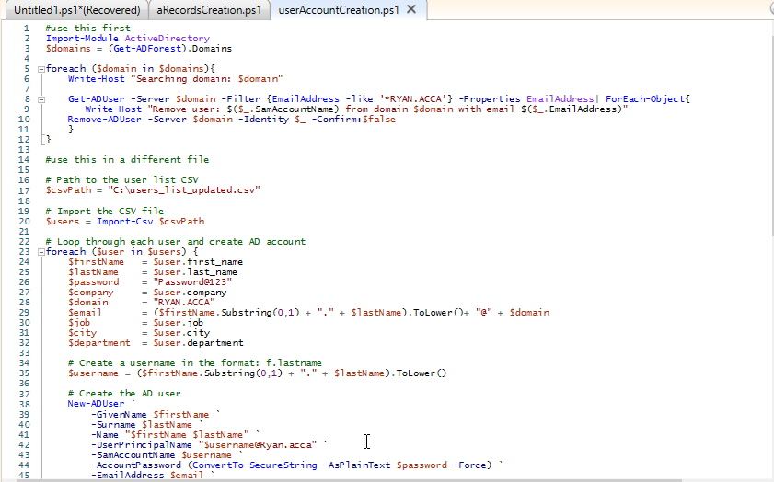

ADDS
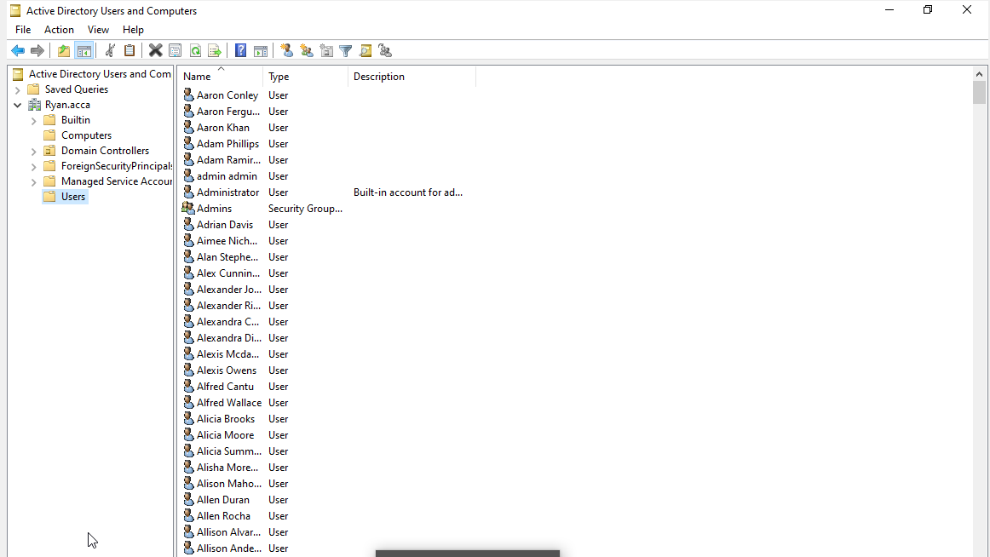

Drive mapping
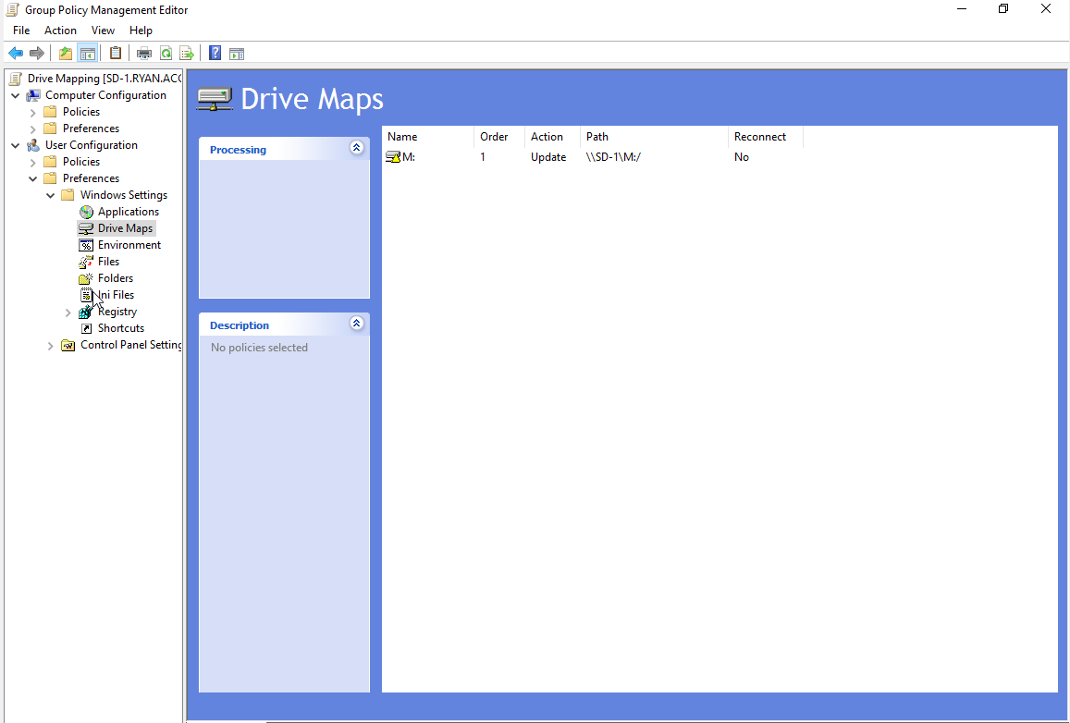

Accessibility of the drive
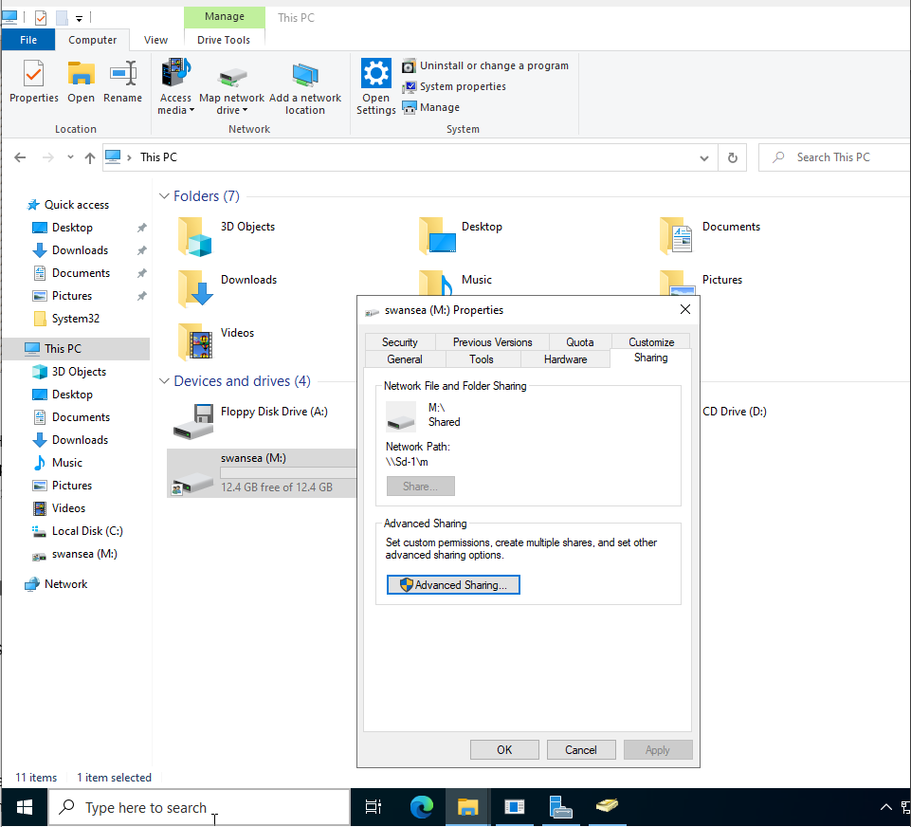

Domain setup on the windows client
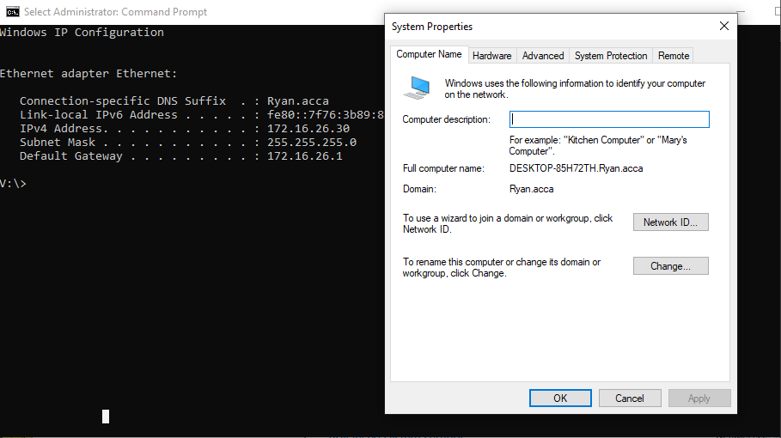

DHCP pool for windows
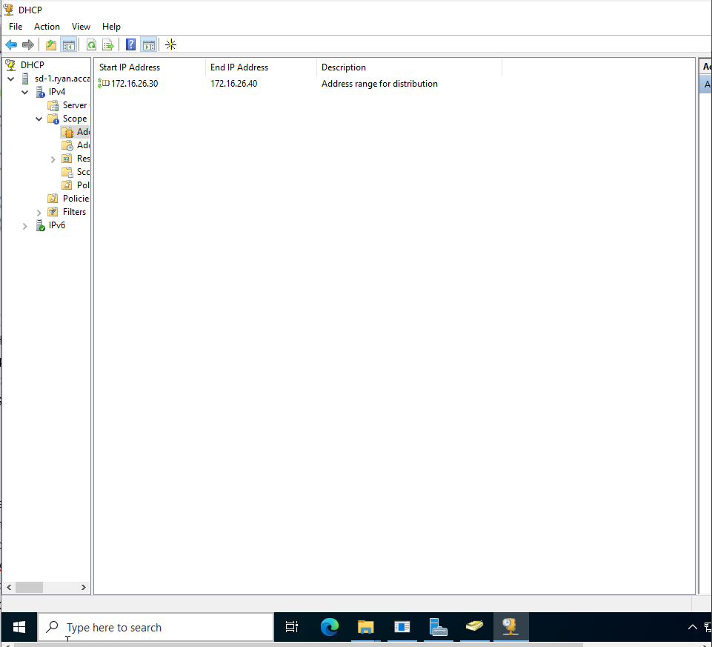

DHCP on the windows client
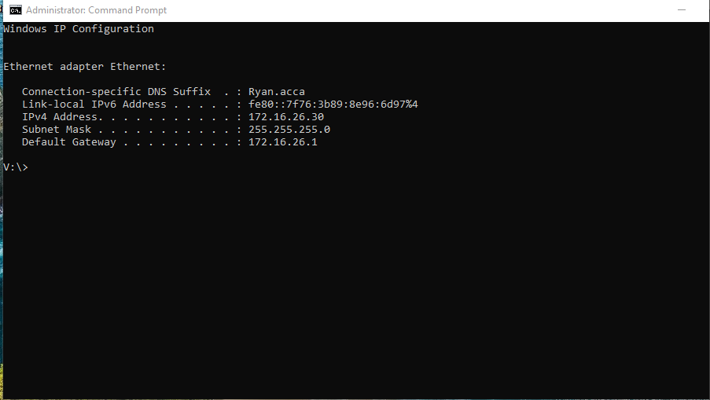

Child domains
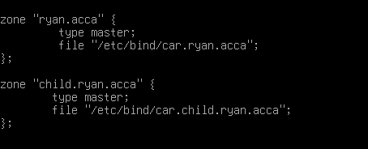

Dhcp on linux


