Adam Evans (0450685)
06/06/22
Business review of another business utilising their published financial statements.
Financial Management and Planning ACPA7002
Lecturer: Howard Davis

Contents
Executive Summary 2
Introduction 3
The Use of Financial Statements 4
Use and Limitation of Ratios 4
Ratio Analysis 8
Summary of Findings 10
Conclusion and Recommendation 11
Appendix 12
References 24

Executive Summary
This report will consist of reviewing the McLaren Group via their published financial statements to assess if they are suitable for a partnership. A brief outline of the group will follow to understand it’s role and divisions. Then a look at the ratios that will be used against the financial statements provided by McLaren looking at their uses and any limitations. A ratio Analysis will then be undertaken to apply the ratios and margins to critically assess McLarens standing as a potential partner. In addition, the ratios, the global pandemic, and other noteworthy developments within the McLaren group, will be discussed before reaching an objective decision. The primary recommendation would be to compare what has been found here about McLaren and then to apply ratios to similar competitors with similar business models and global standing before any partnership is created.
Introduction
This business review will focus on McLaren group, formed in 1963, it is a British manufacturing company, based in Woking, specialising in sports and luxury automobiles. (McLaren, 2014)
Its three business divisions are:
McLaren Racing, primarily focused on the McLaren formula 1 team that has taken part in over 180 races and won 20 world Championships. McLaren also has taken part in the Le Mans 24 Hours, the Indianapolis 500, IndyCar series and the Extreme E Championship (McLaren, 2014)
McLaren automotive was launched in 2010, with the main product groups being the sports series, the super series, and the ultimate series, from 2018 to 2025, there is an aim to deliver 18 new cars after an investment of 1.2billion. (McLaren, 2014)
McLaren Applied, this division is focused on advanced engineering and technology solutions (McLaren Applied, 2022). Applied was sold to Greybull capital in 2021, retaining the McLaren management team but stating Greybull’s investment will allow to expand its business strategy. (McLaren, 2021)
The focus of this report will be covering the periods 2019 to the end of the calendar year 2021. Though a private company it still allows for its financial statements to be viewed publicly, primarily for the interest of potential investors.

The Use of Financial Statements
The three main financial statements are The Income Statement, Balance Sheet and Cashflow Statement. Using the Statements, it is possible to view a thorough picture of an organisations past and present financial health and profitability. They are used by stakeholders such as shareholders, senior managers, and potential future investors.
The Income statement will show the reader an organisations financial performance over a specific period. It displays insight into operations, areas performing well or poorly and results from past strategies. (Fridson and Alvarez, 2011)
The balance sheet shows assets, liabilities, and equity for its relevant organisation, it is the summary of all its finances.
The Cashflow Statement shows the ins and outs of cash and cash equivalents for the organisation, where they are coming from and where they are being spent out.
With the use of Financial Ratios applied to information obtained from these statements a deeper understanding and a clearer resolution can be formed and analysed. They are historical tools that can be used to model potential and forecast for the future. They need to be used in tandem with other information such as national economy, competitors, and the relevant industry. (Fields, 2016)

Use and Limitation of Ratios
In this review I will be looking at sixteen financial ratios grouped as follows, Profitability Ratios, Activity Ratios, Leverage Ratios, Liquidity Ratios, and Investor Ratios. Ratio analysis is a technique to analyse the financials of an organisation. Before looking at the individual ratios, it is worth nothing some limitations found within them.
Limitations to consider when using these ratios:
Financial statements are created by companies themselves and though audited can be directed to show more how the company wants to be seen rather than a completely accurate representation of what the company is. Any ratios used against information that has a bias is most likely going to reflect that when analysed. This is a reason why ratios can’t be used independently from other information about an organisation, the more information, as with most things, the more accurate a picture will form.
Changes to a company should be considered, from management or operational structure, supply chain issues or as seen in recent years, global pandemics. These factors can have a drastic effect on financial statements and ratios and as such need to be considered. Organisational change to a company’s accounting and reporting for instant could have a great impact on the ratios, so there needs to be a clear understanding of what makes up the figures in a statement so that they can be compared. Financial statements use of notes can be helpful for this as they will usually explain any of these changes to the reader.
As the information is all historical its use for analysis can’t predict the future however the analysis can be used to formulate strategies for the future running of the organisation. Also worth noting, as this is historical information it is worth considering inflation overtime to more accurately compare the different time periods for different statements. (CFI, 2021)

Profitability Ratios
These ratios are used to consider an organisations capability to create profits from its assets, equity and operations. Used for comparison with similar business models or own history. Split into two distinct groups, three Margin ratios and two return rations. The Margin ratios show how well the business can turn sales into profit. The return ratios are used to judge the organisations’ ability to return profits to shareholders.
The Gross profit margin is used to see how financially sound an organisation is, it is shown as the percentage of net sales. Large changes over periods can reflect poorly on an organisation. Gross Profit Margin = (Gross Profit ÷ Sales) x 100
Operating Profit Margins can describe the profit a company makes per pound, the higher the ratio the more efficient an organisation will generally tend to be. It is useful to measure previous years against most recent to get an overall view of how the business has improved, or not. Operating Profit Margin = (Operating profit ÷ Sales) x 100 (Hayes, 2021b)
Net Profit Margin determines the profit that is generated, described as a percentage against the organisation’s revenue. It is a key indicator of a how financially sound an organisation is and allows investors the ability to see if there is enough profit to cover overheads and operational running costs. It is possible for NPM to be disproportionally affected by temporary boosts to profit so is best used in tandem with other tools to give a more accurate image of the organisation. Net Profit Margin = (Net Income ÷ Sales) x 100 (Murphy, 2022)
Return on assets is used by stakeholders and investors to see how effectively a profit can be generated from the organisation’s assets. Best used against similar organisations or historical information, there needs to be similar asset bases to have meaningful comparison. This ratio will include any debts the organisation owes. Return on Assets = (Net income ÷ Assets) x 100
Return on equity is used to see how effective an organisation can create profits. Different business models will have varying ROEs and as such is not effective to use outside of specific industries. High ROE does not necessarily represent a positive for an organisation, it could mean large debts or fluctuating profits. ROE does not take into account any liabilities an organisation would have. Return on Equity = (Net income ÷ Shareholder equity) x 100 (Hargrave, 2020)

Activity Ratios
Activity Ratios are primarily used to see how an organisation is using its assets to generate its revenue. They are useful when comparing similar industries, or different periods of time.
Days Sales Outstanding is a metric that shows the average number of days before complete payment is made. The lower the DSO the quicker payments are being completed and the money can be used within the company. Depending on the industry, positive DSO figures vary. Days Sales Outstanding = Debtors ÷ Average Revenue Per Day (Kenton, 2019)
Inventory turnover shows how much inventory is sold and replaced over a specific period. The higher the rate the less likely an organisation is overstocked with products possibly not needed, or that better promotion or communication with the consumers is needed. Inventory Turns = Costs of Goods Sold ÷ Average Inventory (Fernando, 2022b).
Days Payable Outstanding can be used to tell the average time an organisation will take to pay debtors and invoice creditors. The larger the number, the longer it is taking to make payment, this can be used to advantage, as the money can be used for other means before paying debtors. However, for potential investors reviewing the organisation, a high DPO could indicate an inability to pay bills. Context would be required for this ratio. Days Payable Outstanding = Current Liabilities ÷ Average COGS per day.

Leverage Ratios
Leverage ratios are used as an assessment of an organisations ability to meet the requirements of its financial obligations. Debt is useful to help a company grow however it needs to be controlled and monitored so it doesn’t become a hindrance.
The Debt-to-equity ratio is used to appraise on what level an organisation is using debt to manage its financing. This is observed by measuring debt against stockholders’ equity. Debt to Equity Ratio = (Long Term Debt ÷ Stockholders Equity) x 100 (Fernando, 2022).
Interest coverage is used to test an organisation’s ability to pay it interest owed on its outstanding debts. This is achieved by looking at the earnings before interest, taxes, depreciation, and amortization and comparing and the interest owed. It works best when comparing to similar organisations, with similar business models. Interest Coverage = (EBITDA ÷ Interest) x 100 (Hayes, 2021b).

Liquidity Ratios
Liquidity ratios are a group used to see if a company is able to cover any current debt obligations without the need for outside assistance (Hayes, 2021).
The current Ratio compares an organisations current asset against its current liabilities, It can be used by investors to determine the companies capability to pay off short term debts. There is a tendency for this tool to oversimplify specific details regarding assets and liabilities. Current Ratio = Current Assets ÷ Current Liabilities (Fernando, 2021).
The quick ratio is able to look at an organisations potential to use near-cash assets for instant payment of current liabilities. Stock is removed from calculations as even though it is an asset it cannot be guaranteed and may not be immediately sold so can’t be considered an option to be used instantly. Quick Ratio = (Current Assets – Stock) ÷ Current Liabilities (Seth, 2021).

Investor Ratios
This set of tools are used by investors to assess an organisations current and likely future profitability.
Earnings per ordinary share will demonstrate the value of a business by describing the amount of money that it has made for its shares. The higher the figure the more value that is created for the shares. There are ways an organisation can boost its perceived value so earnings per share should be analysed in context against possible factors for this, such as accounting procedures changing or a reduction in shares. Earnings Per Ordinary Share = Net Income ÷ No of Shares (Fernando, 2020)
The Dividend Cover ratio is used to see how many times an organisation can pay its dividends to the required shareholders. Notably even with a high ratio figure this ratio does not describe whether the organisation would be able to immediately pay this as it may be cash poor. (Corporate Finance Institute, 2018) Dividend Cover = (EPS ÷ Dividend per Share) x 100
The Price per Earnings Ratio allows potential investors to view how much a organisations relative worth is compared to similar organisations during a specific period. High or low price per earnings could be shown due to under or over valuing the organisation. As it is primarily used to measure against similar organisations a limitation of this ratio is that different ways of reporting and cycle rates of the included organisations need to be standardised to provide a meaningful comparison. Price per Earnings Ratio = Market Value per Share ÷ EPS
The Dividend Yield Ratio is used by investors to see how much of overall profit will be paid out to the shareholders. This is useful to see what the tangible worth of the stock will be, the higher the ratio the more likely a shareholder will receive payment essentially showing if there would be a good return on this investment. It is worth noting that a high ratio could be the result of declining stock price, so like all the ratios and metrics viewed, context is key. Dividend Yield Ratio = (Dividend per Share ÷ EPS) x 100 (Fernando, 2021)

Ratio Analysis
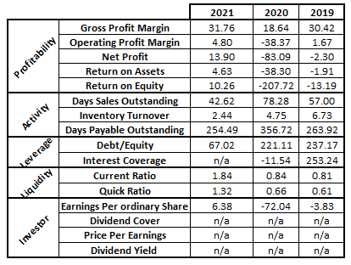
This period can be seen as pre vs post covid, in general the ratios seem to be showing a positive improvement, not just from 2020 but through to the post covid figures.
The profitability ratios have all achieved higher value post covid, Gross profit Margin is at a high at 31.76%, the operating profit is exceeding the pre-covid levels and net profit is now in the positive at 13.90. Similarly, the returns ratios are now in positive positions. Due to the last few years uncertainty found in Brexit and the Global pandemic, it does appear that the group is no longer investing out so as to maintain a level of profitability until the financial climate could reward risks.
Days sales outstanding is at a low of 42, compared to 57 pre pandemic so the ability to reuse the cash is at an all time high, for this period. The inventory turnover has slowed down over the course of the three years, most likely due to the demand stalling from the global pandemic and the follow on from that through cultural change, working from home and less travel for example. Days payable outstanding has removed 8 days from it’s pre pandemic amount, showing the group still have the best part of the year to use the cash for other means, so there is still a certain amount of flexibility there, but could be evidence it needs this cash to function.
The debt-to-equity ratio has lowered dramatically, previously it reflected an organisation looking for growth however with the restructure it looks as though it is now reflective of an organisation looking to sustain itself. Not enough information has been released to determine 2021s Interest coverage, though in a good position in 2019 there was a large and not surprising downturn in 2020, the current inability to understand current rates could mean McLaren has not yet recovered to an acceptable level.
The liquidity ratios are both showing a great positive that the group was previously lacking suggesting in years 2019 and 2020 that the group would not have the amount to pay short term.
Earning Per Ordinary Share shows a dramatic improvement from 2020 and an increase to 2019, most favourably the figure is no longer in the negative. This is most likely, at least in part, due to the selling of applied, thus boosting the share prices. It will be of interest to see 2022s results. It Could also be due to Brexit lowering the perceived value of a British manufacturing company.

Summary of Findings
Covid obviously had a major impact to the figures of 2020, Worldwide lockdowns and closure of industries effected every aspect of global life, it is understood then why the 2020 figures have such a negative colour.
The profitability ratios on surface are all positive however due to the selling of applied there is an argument that this is just a short-term fluctuation and will be needed to be monitored. Also, the lack perceived demand as noted from the inventory turnover could mean the shares values have lessened resulting in an even further distorted result. Though usually fluctuations like this can be viewed negatively it is hard not to address the impact of Covid 19.
The activity ratios have gone back to pre-covid levels, however the Inventory turnover has not, this could be something to watch out for as McLaren seem to be operating with the same business model for received payment and paying debts however there seems to less demand for their brand.
Investor Ratios, as McLaren is a private company it is not required to publish any of these details, it does so under its investor’s portal on its webpage, Interestingly, though geared for investment, McLaren doesn’t give the figures for the Classic Investor ratios which could be seen as a red flag due to the group clearly wanting investors but then obscuring specific details to aid a thorough review.
Removing applied from the Group has made a noticeable difference in the ratios, whether this is sustainable will be of great interest to potential partners.

Conclusion and Recommendation
The recommendation of this report would be to not partner with McLaren Group at this time.
McLaren Group is a global recognised brand, as with most companies it was not impervious to the effect the Covid 19 Pandemic had across the world. 2021 is currently looking good for the group however a lot of the positive increase in the ratios could be from the sales of Applied, details of this partnership would need to be investigated further to see what positives could be rewarded to partners with the group.
It may be worth a further look into the historical data of the group, adjusted for inflation to see if there is more consistency as the time-period selected for this review was extremely turbulent due to the fluctuations and challenges of the last few years however further assessment could be completed on similarly placed automotive brands to get a clearer idea of where McLaren is placed.
Appendix
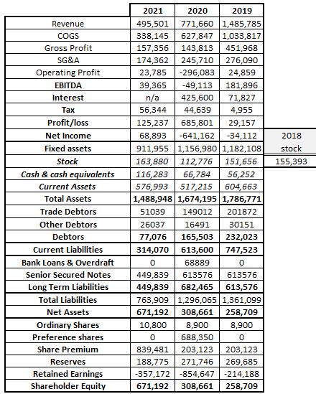
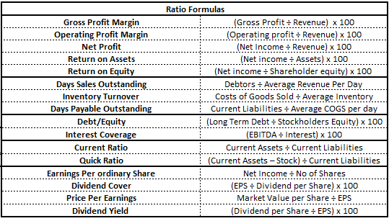
2019
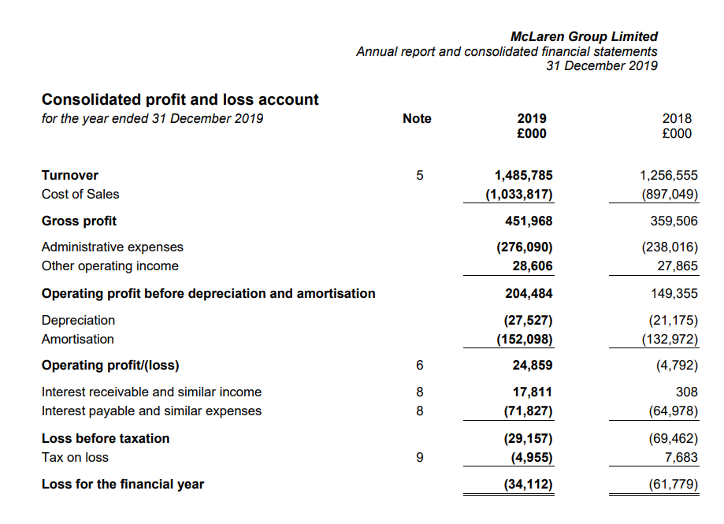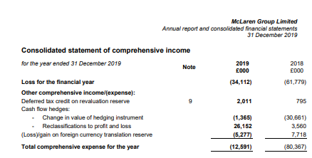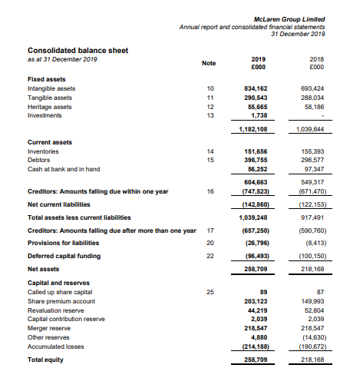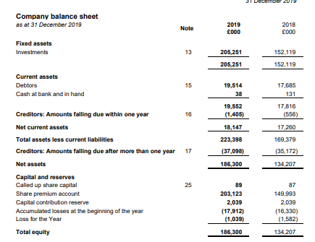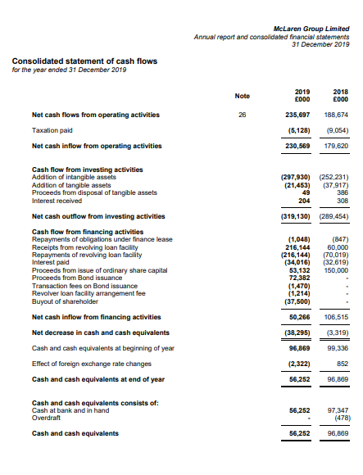

2020
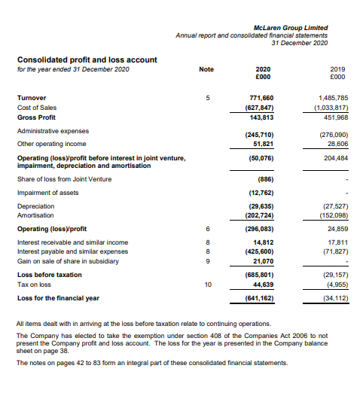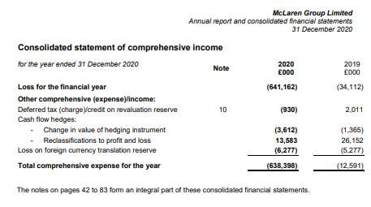
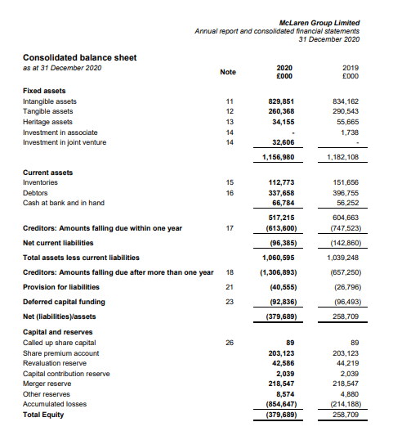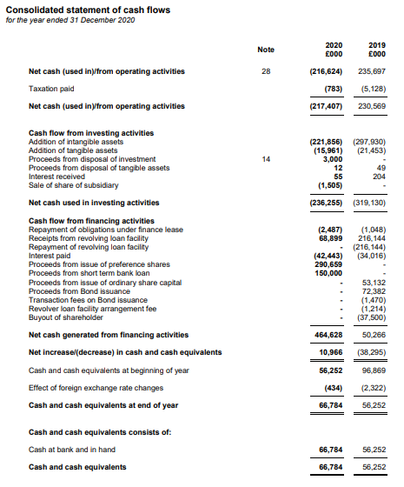

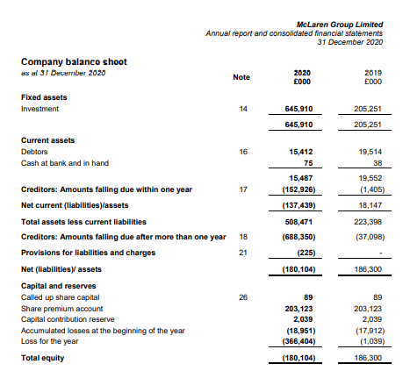

2021
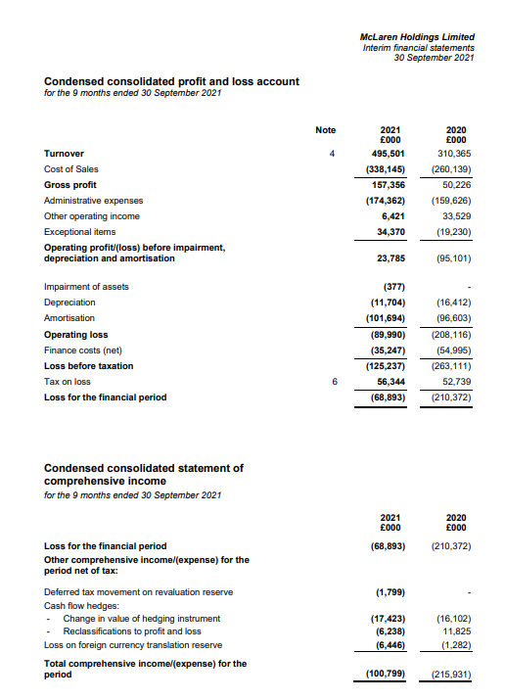
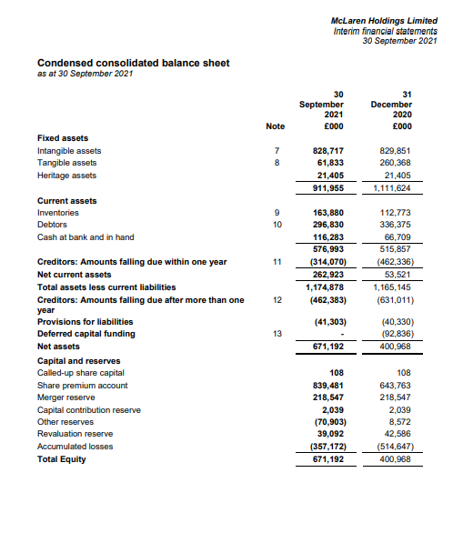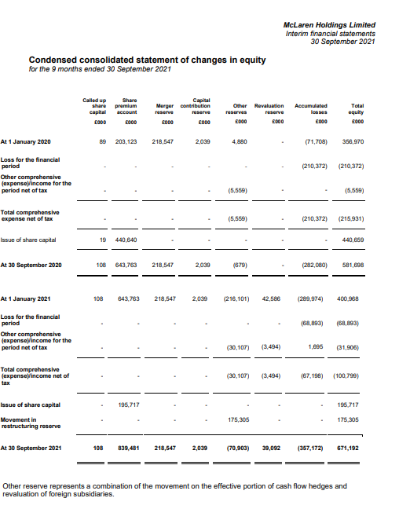
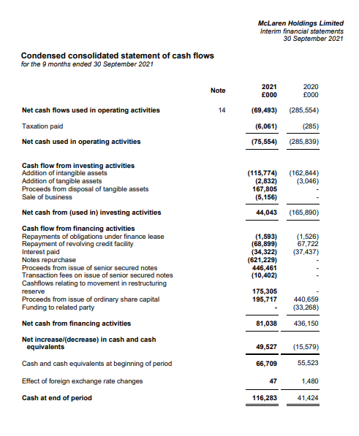

Reference list
Atrill, P. and Mclaney, E.J. (2017). Accounting and Finance for non-specialists. 10th ed. Harlow, England ; New York: Pearson.
CFI (2021). Limitations of Ratio Analysis - Ratios are Popular, Learn About the Problems. [online] Corporate Finance Institute. Available at: https://corporatefinanceinstitute.com/resources/knowledge/finance/limitations-ratio-analysis/.
Corporate Finance Institute (2018). Dividend Coverage Ratio - Formula, Examples, and Guide to DCR. [online] Corporate Finance Institute. Available at: https://corporatefinanceinstitute.com/resources/knowledge/finance/dividend-coverage-ratio-formula/.
Fernando, J. (2020). Understanding Earnings Per Share – EPS. [online] Investopedia. Available at: https://www.investopedia.com/terms/e/eps.asp.
Fernando, J. (2021a). Current Ratio. [online] Investopedia. Available at: https://www.investopedia.com/terms/c/currentratio.asp.
Fernando, J. (2021b). What the price-to-earnings ratio tells us. [online] Investopedia. Available at: https://www.investopedia.com/terms/p/price-earningsratio.asp.
Fernando, J. (2022a). Debt/Equity Ratio. [online] Investopedia. Available at: https://www.investopedia.com/terms/d/debtequityratio.asp.
Fernando, J. (2022b). Inventory turnover definition. [online] Investopedia. Available at: https://www.investopedia.com/terms/i/inventoryturnover.asp.
Fields, E. (2016). The essentials of finance and accounting for nonfinancial managers. New York: American Management Association.
Fridson, M.S. and Alvarez, F. (2011). Financial statement analysis : a practitioner’s guide. Hoboken, N.J.: Wiley.
Hargrave, M. (2020). How Return on Equity Works. [online] Investopedia. Available at: https://www.investopedia.com/terms/r/returnonequity.asp#:~:text=Return%20on%20equity%20(ROE)%20is.
Hargrave, M. (2022). How to Use Return on Assets When Analyzing a Company. [online] Investopedia. Available at: https://www.investopedia.com/terms/r/returnonassets.asp.
Hayes, A. (2021a). Liquidity Ratio. [online] Investopedia. Available at: https://www.investopedia.com/terms/l/liquidityratios.asp.
Hayes, A. (2021b). The Importance of Profitability Ratios. [online] Investopedia. Available at: https://www.investopedia.com/terms/p/profitabilityratios.asp#:~:text=Profitability%20ratios%20are%20a%20class.
Hayes, A. (2021c). Why the Interest Coverage Ratio Matters. [online] Investopedia. Available at: https://www.investopedia.com/terms/i/interestcoverageratio.asp.
Kenton, W. (2019). Understanding Days Sales Outstanding. [online] Investopedia. Available at: https://www.investopedia.com/terms/d/dso.asp.
McLaren (2014). McLaren Automotive. [online] www.mclaren.com. Available at: https://www.mclaren.com/group/companies/mclaren-automotive/.
McLaren (2021). McLaren Group agrees sale of McLaren Applied. [online] www.mclaren.com. Available at: https://www.mclaren.com/group/news/articles/mclaren-group-agrees-sale-mclaren-applied/.
McLaren (2021). McLaren Group agrees sale of McLaren Applied. [online] Available at:
https://www.mclaren.com/group/news/articles/mclaren-group-agrees-sale-mclaren-applied/
[Accessed 9 May 2022].
McLaren Investors. (2021). Results centre. [online] Available at:
https://investors.mclaren.com/investors/result-centre/year/2021.McLaren (2021) McLaren Investors. Interim Results 2021 Results centre. [online] Available at:
https://investors.mclaren.com/sites/mclaren-ir/files/2021-11/interim-report-sep-2021.pdf
McLaren (2020) McLaren Investors. McLaren Q1 2020 Results. [online] Available at:
https://investors.mclaren.com/sites/mclaren-ir/files/2020-
05/mcLaren_q1_2020_results_presentation.pdf
McLaren (2020) McLaren Investors. Annual Report 2020 Results centre. [online] Available at:
https://investors.mclaren.com/sites/mclaren-ir/files/report-document/mclaren-group-limited-2020-
annual-report.pdf
McLaren (2019) McLaren Investors. Annual Report 2019 Results centre. [online] Available at:
https://investors.mclaren.com/sites/mclaren-ir/files/2020-05/mclaren-group-limited-financial-
statements-2019.pdf
McLaren (2021) Q3-2021-presentaion [online] Available at:
https://investors.mclaren.com/sites/mclaren-ir/files/2021-11/q3-2021-results-presentation.pdf
Mclaren (2014). About. [online] Mclaren.com. Available at: https://www.mclaren.com/group/about/.
McLaren Applied (2022). mclaren-applied. [online] mclarenapplied.com. Available at: https://mclarenapplied.com/about [Accessed 3 Jun. 2022].
Murphy, C. (2022). How to Calculate Net Profit Margin Using Apple’s Revenue and Profit. [online] Investopedia. Available at: https://www.investopedia.com/terms/n/net_margin.asp.
Seth, S. (2021). How the Quick Ratio Works. [online] Investopedia. Available at: https://www.investopedia.com/terms/q/quickratio.asp.
Tidd, J. and Bessant, J.R. (2018). Managing innovation : integrating technological, market and organizational change. 6th ed. Hoboken, Nj: Wiley.
Zhang, S. (2022). The Strategy for McLaren to Change its Current Market Situation. [online] www.atlantis-press.com. doi:10.2991/aebmr.k.220405.142.

