ANALYSIS AND SIMULATION OF CENTRIFUGAL CLUTCH

BY AUBRIEL NDLOVU (2224770)

Context

Introduction
What are centrifugal clutches?
History of centrifugal clutches?
Materials
Application
The Advantages and Disadvantages
Electromagnetic clutches
Conclusion
Reference

Introduction
It is the intent of this technical report to provide an in-depth analysis of centrifugal clutches as they apply to small motor equipment as well as how the centrifugal friction clutch has evolved over time.
As a result, we will discuss the choice of materials, typical applications, and operating conditions. Throughout this report, I will discuss the advantages and disadvantages of centrifugal clutches. In a later section, I will discuss how electromagnetic clutches can be used to automate manufacturing processes today.

What are centrifugal clutches?
As a result of my research using the (Electricalworkbook,2021) source, I learned that centrifugal clutches use friction between two surfaces, such as single plate clutches or multi-plate clutches. Even so, centrifugal clutches do not require circumferential or radial clutch springs to function.
Floating clutch plates cause centrifugal force to cause the clutch plates to rotate when the engine speed increases. According to (blm-cm,2022), centrifugal clutches engage when the engine speed increases. An engine's speed decreases, resulting in clutch disengagement.
According to the Eletricalworkbook 2021 source, centrifugal clutches work based on centrifugal force, which states that the magnitude of centrifugal force increases with speed, and vice versa. As a result of centrifugal force, which depends on speed, centrifugal clutches engage and disengage the flywheel.
After reaching a certain speed, the driven member engages with the driving member automatically. Therefore, a clutch pedal is not required to engage or disengage the drive. As a result, these clutches are used with automatic transmissions.
According to UBB2020, a clutch should produce friction torque and actuate at an acceptable force. It should be able to dissipate the heat generated by friction without damaging the clutch components, according to (ecoursesonline).
In addition, it should have a good coefficient of friction and wear resistance for the clutch material. Furthermore, it should be able to transmit more power than the engine's maximum power.
In addition, the(lancereal,2019) source states that the hub, flyweights, springs, linings and housing should be designed properly to transfer centrifugal force.

History of centrifugal clutches?
The first centrifugal clutch was used on railway locomotives in 1858, according to (academic-accelerator 2021). They were first mentioned (in connection with electric motors) in an 1899 patent. The United States issued his patent for an automotive centrifugal clutch in 1898.
As a result, the source continues to state that the "Automatic Clutch" design was published in the June 1934 issue of Mechano Magazine. As early as 1936, Armstrong Siddeley cars had automatic (centrifugal) clutches. Invention of the centrifugal clutch for balloon catheters is credited to Thomas Fogerty, also known as the inventor of the balloon catheter. In the 1940s, small motors were used for a variety of purposes.

Materials
A (what-when-how-2018) source suggests that clutch friction linings generate heat over relatively short periods of time due to severe rubbing. To withstand the operating conditions, the lining material should have a combination of the following properties. Having a relatively high coefficient of friction under all operating conditions.
In addition, friction properties must be maintained throughout the entire working life. A relative high level of energy absorption for a short period of time. The plate must be able to withstand high compression loads. Grips and friction characteristics can be maintained despite interface contamination.
The most common types are sintered iron and bronze based on copper. Metallized semi-metallic linings are composed of metallic and organic materials. A metallic lining material becomes sufficiently adherent and densified during the process of compressing and heating it.
This process results in the material sintering. Riveted together and ground flat, the metallic rings are riveted to the driven plate. When compared to organic asbestos-based linings, metallic or semi-metallic linings have a higher coefficient of friction, can operate at higher temperatures, and are more torque-tolerant.

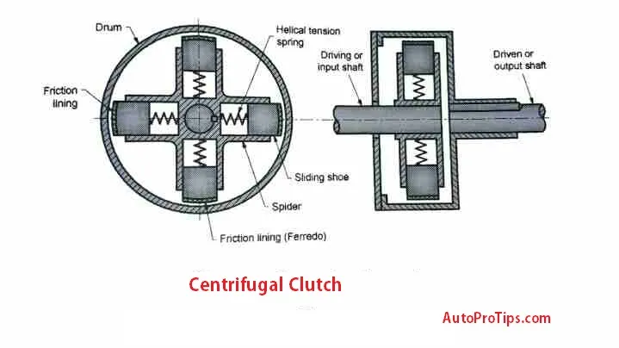

Figure 1- image sourced from Autoprotips 2021 showing Centrifugal clutch.
- SPIDER
Spiders are special hubs that are rigidly attached to driving shafts. There are four equal-spaced radial guides on the spider that are keyed to the driving shaft. Spring connections connect friction shoes to spiders.
- CLUTCH PLATE
Generally, clutch plates have an internal radial friction surface and are cylindrical in shape. No splines are present on the shaft of the clutch plate which is rigidly attached to the driven shaft.
- FRICTION SHOES (SLIDDING SHOES)
On their outer sides, friction shoes are covered with a frictional material. It is necessary to allow enough clearance for the friction shoes to slide within the spider to perform their function. The clearance between friction shoes and spider guides allows them to slide radially. As a result, friction shoes are also known as sliding shoes.
An assembly of spider and shoe is contained within a coaxial drum mounted on the driven shaft. Drums may also be referred to as cover plates. In the event of accidental damage to the drum, the housing acts as a safety cover.
- DRUM (COVER PLATE)
The drum is designed to rotate with the shaft and provide extra protection for the assembly. The housing also provides support to the drum, allowing it to rotate smoothly and freely. This helps to minimize the risk of damage due to vibrations or impacts.

An illustration of the centrifugal clutch in stationary or disengaged position can be found in Figure 1. The helical tension springs keep the friction shoes in place. This disengaged position prevents friction shoes from contacting clutch plates.
Application
According to (theengineerspost2023), centrifugal clutches are commonly used in the following applications. Centrifugal clutches are often used in go-karts because they are easy to operate and provide smooth acceleration. Minibikes often use centrifugal clutches due to their simplicity and dependability. Lawnmowers commonly use centrifugal clutches due to their simple operation and minimal maintenance requirements.
Some agricultural machines use centrifugal clutches for smooth and reliable power transmission, such as tillers and cultivators. Small power equipment, such as generators and pressure washers, use centrifugal clutches because they are low maintenance.
Conveyors and material handling systems use these clutches to provide smooth power transmission. Portable power tools such as chainsaws and hedge trimmers are equipped with centrifugal clutches to facilitate stable and low-maintenance operation. For smooth and consistent power transmission, centrifugal clutches are used in some motorized bicycles.

The Advantages and Disadvantages
A list of advantages and disadvantages is then provided by the source.
The following benefits can be gained when utilizing a centrifugal clutch:
- A centrifugal clutch is simple to design, and it requires little maintenance over time.
- The simple design of centrifugal clutches makes them extremely reliable.
- Automatic clutch engagement ensures smooth acceleration as the engine speed rises.
- Compared to other types of clutches, centrifugal clutches are relatively affordable.
- Centrifugal clutches are easy to install since they don't require adjustments or require installation processes.
Despite this, centrifugal clutches have the following drawbacks:
- As centrifugal clutches only engage at a certain engine RPM, they are not suitable for low-speed applications.
- Heavy-duty applications may not be suitable for centrifugal clutches due to their limited torque capacity.
- The lack of adjustability makes centrifugal clutches unsuitable for tasks that require precise clutch engagement.
- As the engine must keep running even if the transmission isn't engaged, centrifugal clutches lack slippage, which is important in some situations.
- When the engine speed changes frequently, centrifugal clutches have difficulty engaging due to their dependence on engine RPM.

Electromagnetic clutches
According to (Autoprotips 2021), electromagnetic clutches transmit torque mechanically but operate by electric actuation. Once the clutch armature and rotor are engaged, the clutch coil becomes an electromagnet and produces magnetic lines of flux, which results in 100% lock up.
Magnetic clutches are clutches that are operated by electromagnetic actuators. Electrical clutches transmit torque mechanically, but they work electrically. Therefore, it is called an electromagnetic clutch. In addition, electromagnetic clutches have been modified and adapted for use in various clutches. Electromagnetic clutches have windings on their flywheels. A battery or dynamo supplies current to the winding.
Additionally, the source states that when the engine is off, the clutch is disengaged, and the rotor is separated from the hub by an air gap.
A rotor that is connected to an engine shaft rotates when the engine starts. Battery power is used to supply DC current to clutch windings. This winding is transformed into an electromagnet by DC current to attract an armature towards it. Hub rotates as friction plate is forced towards rotor by armature. As a result, the hub rotates, and the rotor transmits 100% torque when engaged. When the clutch is pressed, the battery shuts off the power supply, thereby disengaging the clutch.
If the battery or dynamo output is low at low speeds, the clutch is not firmly engaged. A pressure plate with three springs also helps to engage the clutch firmly at low speeds.
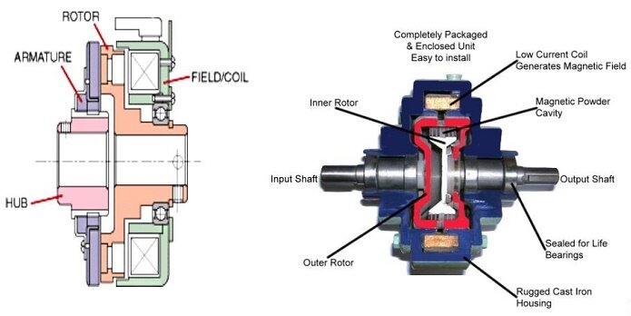
Figure 2 – An image sourced from (Emworks 2023) showing an Electrical clutch.
The application for the electrical clutch is as follows lawnmowers and conveyor drives use electromagnetic clutches. Additionally, packaging machines, food processing machines, printing machines, and factory automation machines use these technologies. Due to the lack of linkage required to actuate the clutch, they can now be used for remote applications. Copier machines, printing machines, conveyor drives, and manufacturing facility automation use electromagnetic clutches.

Conclusion
I thoroughly analysed centrifugal clutches as they relate to small motor equipment throughout my report, in addition to providing a brief history of the centrifugal friction clutch.
As a result, you can see how my goal was to discuss materials, typical applications, and operating conditions. I also discussed centrifugal clutches' advantages and disadvantages throughout this report. I also discussed how electromagnetic clutches are used today to automate manufacturing processes in a later section.

Reference
what-when-how.com. (n.d.). Clutch Frictional Material (Automobile). [online] Available at: http://what-when-how.com/automobile/clutch-frictional-material-automobile/#:~:text=The%20metallic%20linings%20are%20normally.
Gómez, M. (2023). Electromagnetic clutches. [online] Eide. Available at: https://eide.net/en/electromagnetic-clutches/ [Accessed 5 Nov. 2023].
Kalyani, U. (2021). Electromagnetic Clutch Applications - Pros and Cons. [online] AutoProTips.com. Available at: https://www.autoprotips.com/electromagnetic-clutch-applications/ [Accessed 5 Nov. 2023].
ecoursesonline.iasri.res.in. (n.d.). TS&C: Lesson 10. Working principles of Clutch and its Construction and clutch materials. [online] Available at: http://ecoursesonline.iasri.res.in/mod/page/view.php?id=1368.
Lancereal. (2019). Centrifugal Clutch Explained – An Engineer’s Guide to a Centrifugal Clutch. [online] Available at: https://www.lancereal.com/centrifugal-clutch-explained/.
Clutches. (n.d.). Available at: https://www.uobabylon.edu.iq/eprints/publication_7_455_752.pdf [Accessed 5 Nov. 2023].
Workbook, A.E. (2021). What is Centrifugal Clutch? Working, Diagram, Construction & Applications. [online] ElectricalWorkbook. Available at: https://electricalworkbook.com/centrifugal-clutch/.
sachin (2022). Centrifugal Clutches: A Selection Guide. [online] BLM Automatic Clutch. Available at: https://www.blm-cm.com/blog/centrifugal-clutches-a-selection-guide/#:~:text=A%20centrifugal%20clutch%20is%20a [Accessed 5 Nov. 2023].
on, B.T. (2018). How does a Centrifugal Clutch work? What are the pros and cons? [online] EngineeringClicks. Available at: https://www.engineeringclicks.com/centrifugal-clutch/.
Ram (2019). Centrifugal Clutch - Working, Pros & Cons, Diagram | Auto Pro Tips. [online] AutoProTips.com. Available at: https://www.autoprotips.com/centrifugal-clutch/ [Accessed 5 Nov. 2023]
Anon, (2017). Centrifugal Clutch: Construction, Working, Applications, Advantages, And Disadvantages - Mechanical Education. [online] Available at: https://www.mechanicaleducation.com/what-is-centrifugal-clutche/.
Yousef (2023). Centrifugal Clutch: Diagram, Parts, Working & Uses [PDF]. [online] The Engineers Post. Available at: https://www.theengineerspost.com/centrifugal-clutch/#:~:text=The%20following%20are%20the%20centrifugal%20clutch%E2%80%99s%20primary%20components%3A [Accessed 5 Nov. 2023].
EMWorks. (n.d.). All applications. [online] Available at: https://www.emworks.com/application/ [Accessed 5 Nov. 2023]

TASK B

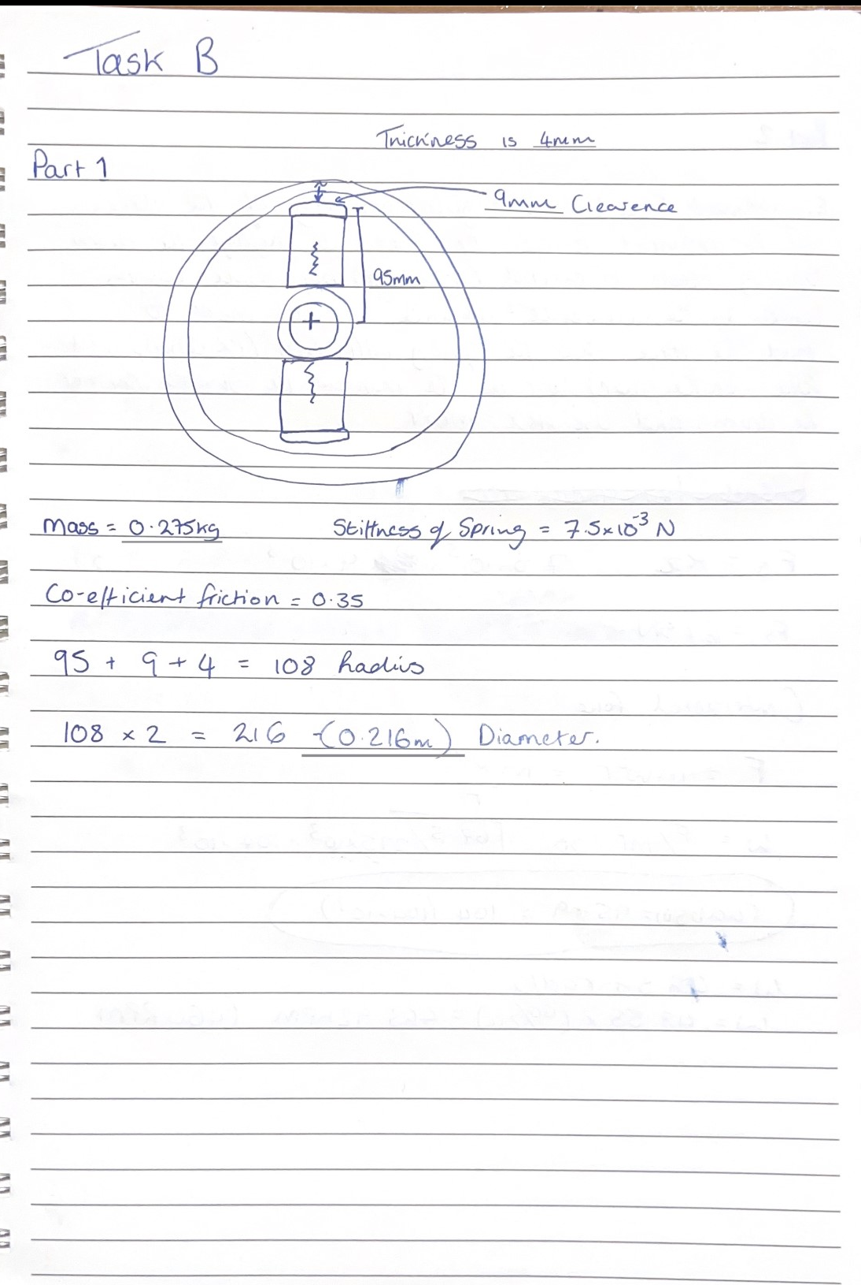
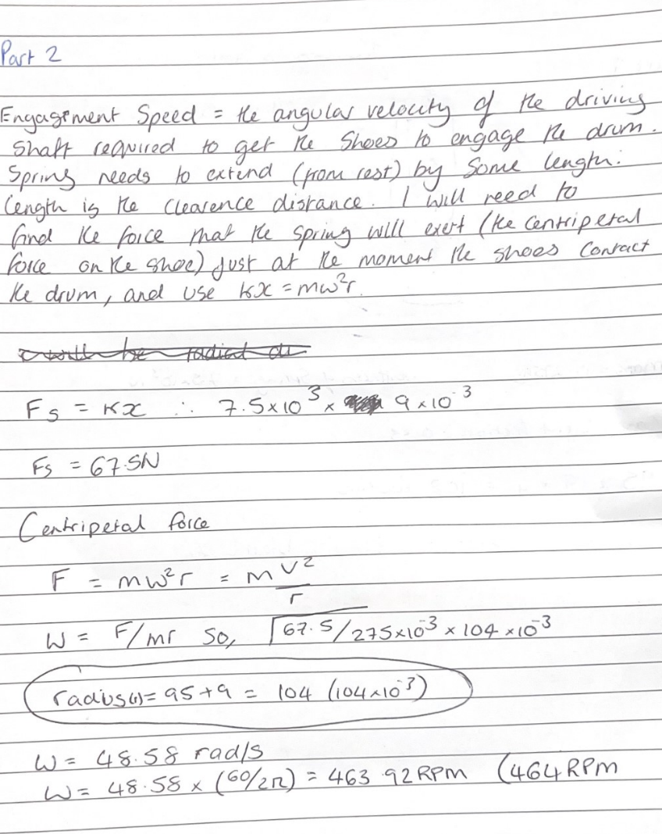

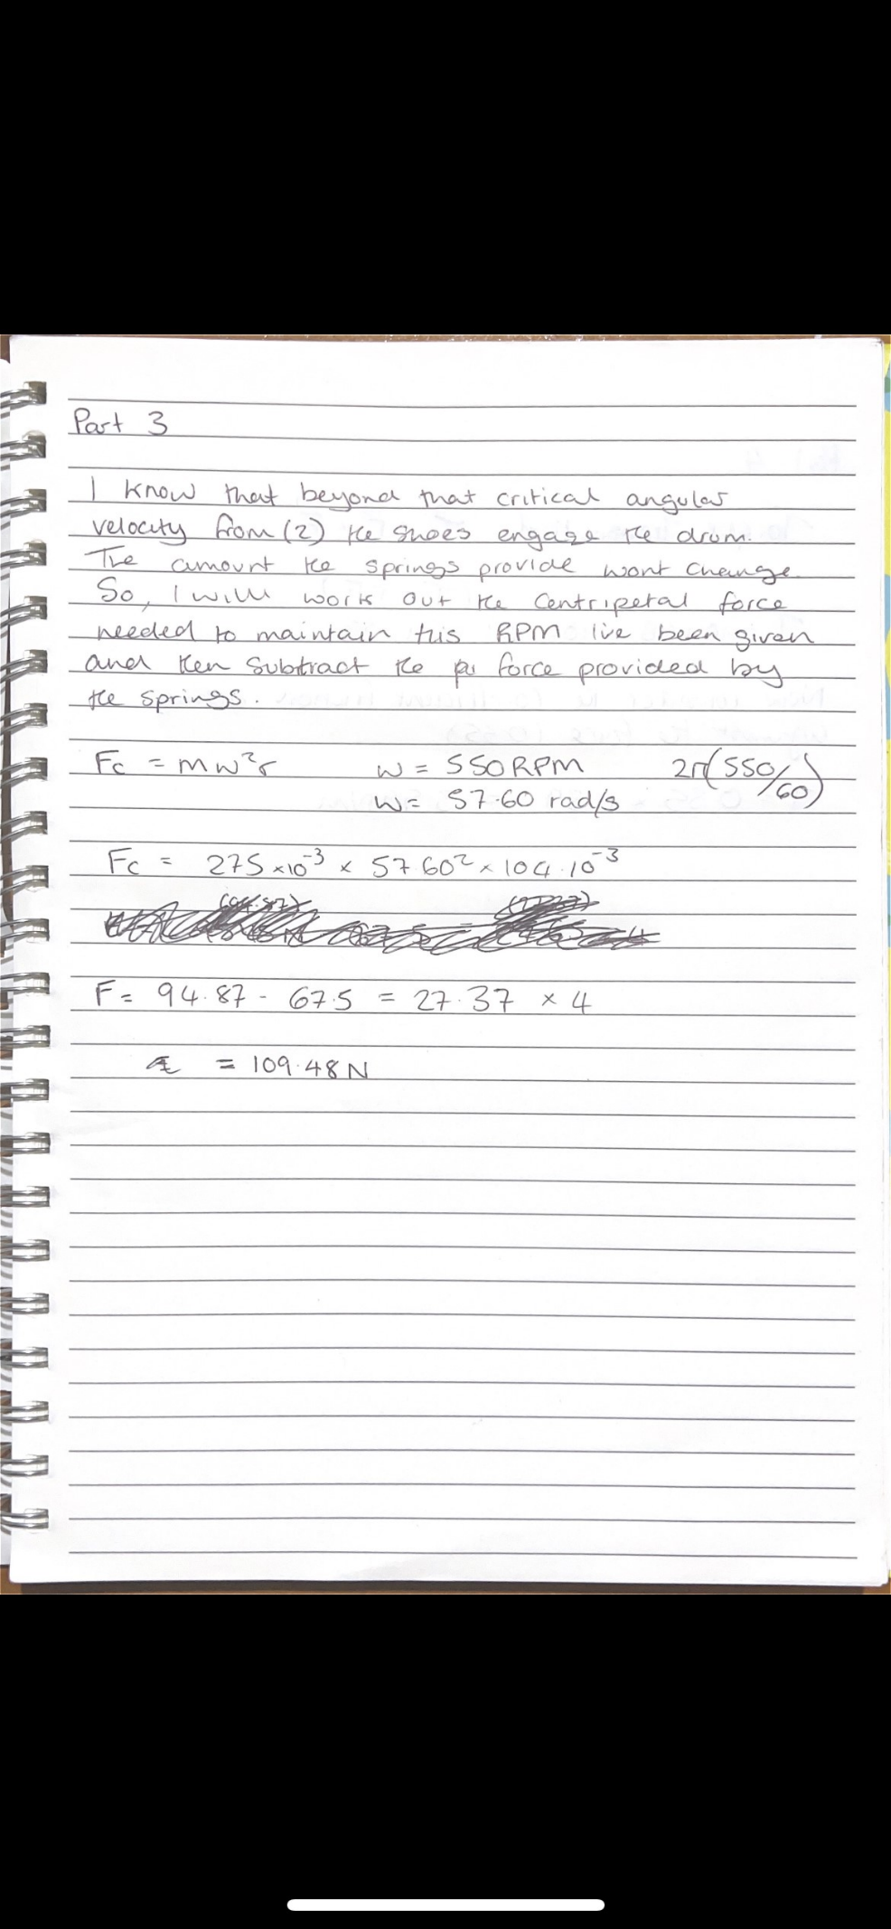

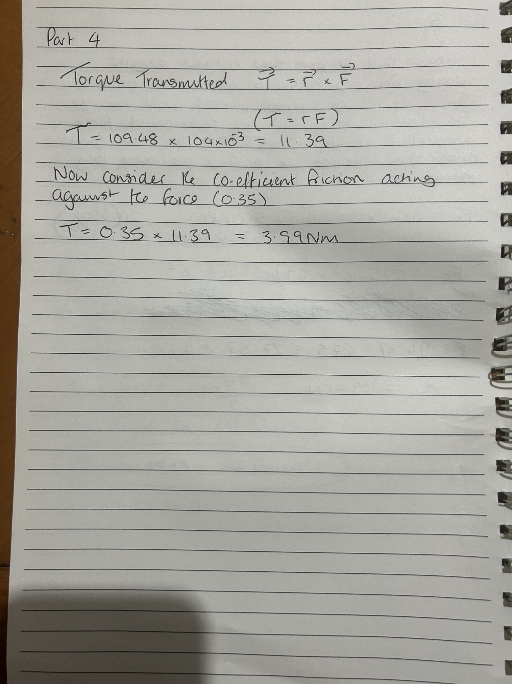

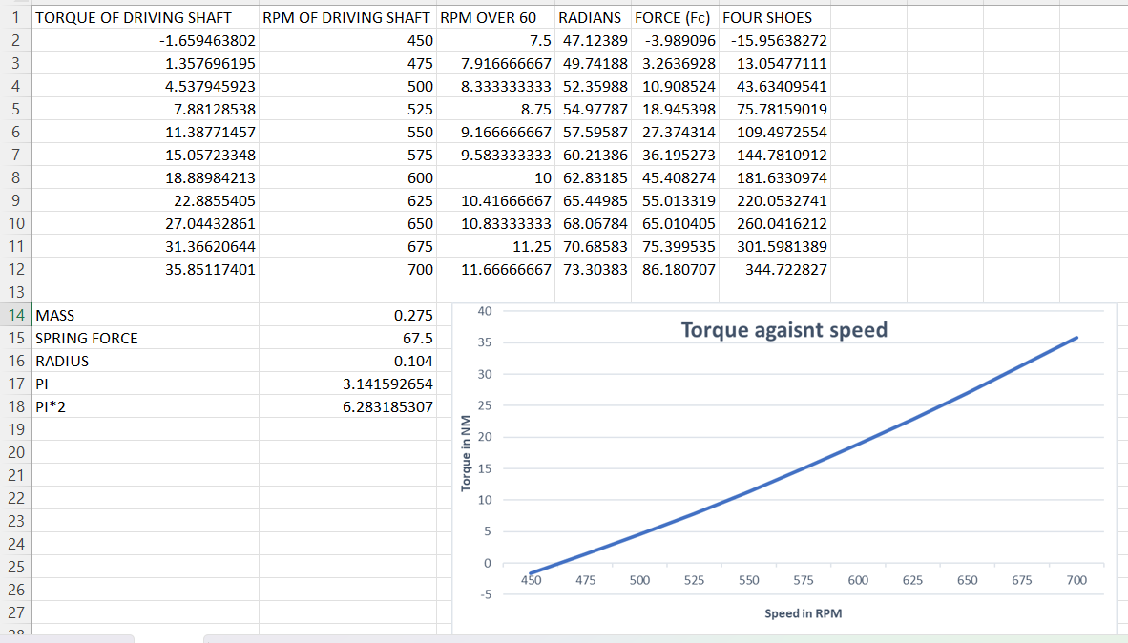
PART 5

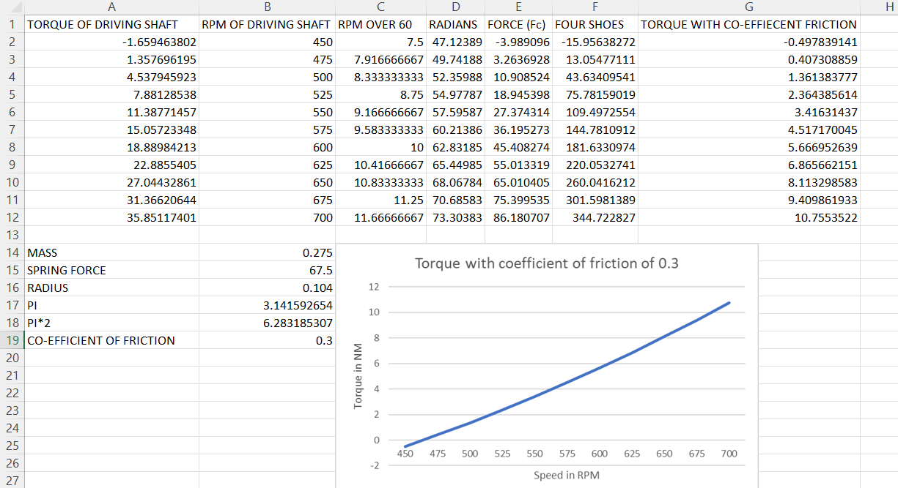
PART 6(A)

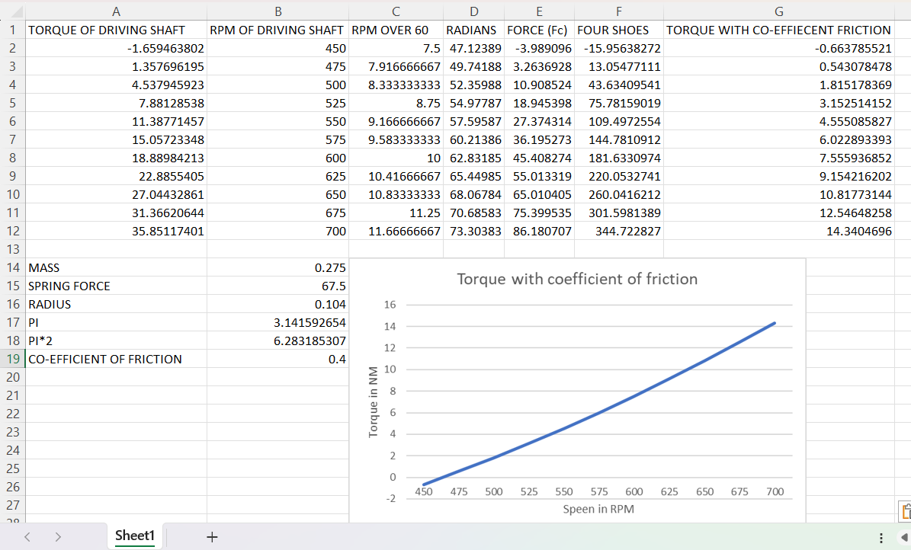
PART 6 (B)

