Appendix A
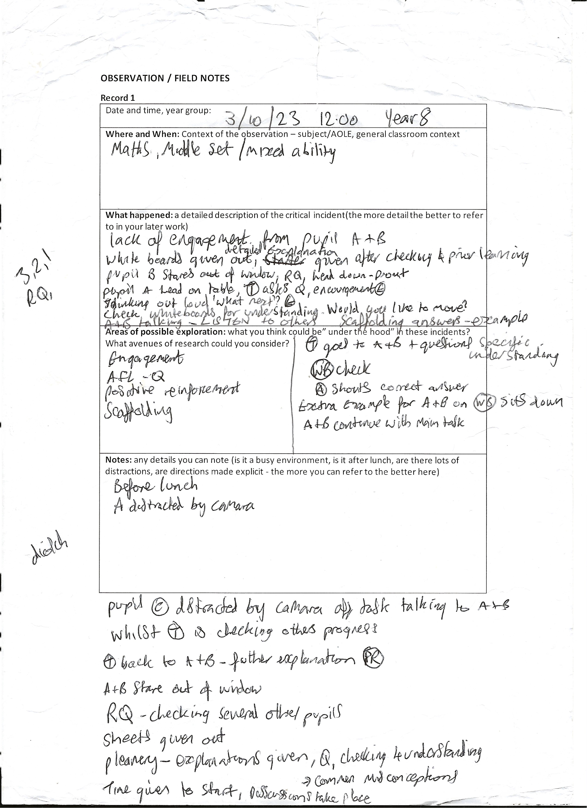

Appendix B

Date, Time, and Year Group: Tuesday 3rd October from approximately 12-1pm with Year 8.
Where and When: The lesson was with a mainstream mixed ability Maths group, in the Maths and Numeracy AOLE, and it was the lesson before their lunchbreak.
What Happened:
The class entered the room and were asked to sit in the usual seating plan. Pupil’s A and B sat on the front row next to the window. The Teacher then explained what would be happening during the lesson and began with checking for prior knowledge from the previous lesson. Pupil’s A and B were talking, and the teacher prompted them with a question to check for understanding. Assessment for Learning (AFL) strategies in the form of random questioning were used by the teacher to check all pupils conceptual understanding of the topic of the nth term. The teacher went onto explain a more advanced example of the topic and at this point pupil B was staring out of the window. The teacher prompted them to concentrate on the example as they would need it to complete the tasks set, which they did. Following this, pupil A put his head on the desk. The teacher then asked pupil A, a question which made them sit up. Pupil A said that they did not know the answer and the teacher reassuringly told them that they could do it. The teacher then explained the answer on the board whilst describing what she was doing out loud, thus giving pupils a scaffolding of how to work out the answer. The teacher then asked the pupils what she should do next and paused, giving them time to think. The teacher then accepted volunteer answers as to the next step in the process.
Following this an example question was given and the pupils were asked to complete their answers on the mini whiteboards. Whilst the teacher was circling the room and checking that pupils understood the task, pupils A and B began chatting and were off topic. The teacher then gave pupil A the choice of either moving seat or getting on with their work. The pupil chose the latter. The teacher then asked the class to show her their mini whiteboards to check for conceptual understanding and strategic competence and selected a pupil C at random to explain their answer. During this explanation pupils A and B began talking. The teacher stopped pupil C’s explanation and told pupil A and B to listen as they were being rude, and they needed the information to carry out the task. Pupil C then continued with the explanation.
All pupils were then asked to complete another question from the board. Whilst the class were doing this, she gave another example on a mini whiteboard to pupils A and B to assist their understanding as they appeared not to understand the basic concepts of the task. Following this they then attempted to answer a question by themselves whilst the teacher circulated the room assisting others. The teacher then went back to the front of the class and asked for pupils to hold up their whiteboards and asked for a volunteer to answer the first question. Pupil A then enthusiastically shouted out the correct answer. The teacher then selected other pupils at random to answer questions, asking approximately half of the class at least one question.
The teacher then asked the class to continue with questions that were on the board whilst sitting with pupil’s A and B ensuring that they were on task and following the correct examples that they had and applying the knowledge to new questions. After a few minutes the teacher circulated the class again. Pupil D then began talking across the class to pupils A and B. When the teacher had finished explaining an example to a different group of pupils she asked pupils A, B and D to get back on task. She then sat with pupils A and B and talked them through another question, giving them some positive feedback and encouragement. The teacher was asked for assistance by pupil E, so they went to them. Pupils A and B then began staring out of the window and discussing something that was outside. They did this for a minute or two and then got back on task on their own accord.
The teacher then went back to the front of the class and went through the questions one at a time, asking other pupils who had not previously answered for their explanations as to how to answer and giving positive reinforcement to all pupils for their explanations. The teacher then gave out a work sheet activity based on the topic that the class had been going over and gave them three minutes to pick a question that they wanted to do. The teacher then summed up the lesson by going through a different example on the board and asking pupils at random what the next step was. She also explained some common misconceptions along the way. She then informed the pupils that the work sheet was to be completed for homework but said that they could complete some questions in the time remaining in the lesson. The pupils at this point discussed the answers and how to complete the questions.

Areas of possible exploration:
. Engagement of the pupils in class
. Assessment for Learning (AFL) Questions
. Learning theories
. Scaffolding
. Moral reasoning
Notes: Most of the class were engaged in learning throughout the lesson. The atmosphere in the class was relaxed and the pupils seemed to be happy. The pupils all seemed comfortable to answer questions in front of their peers and for help from the teacher if they needed it. Pupils A and B needed to be kept on task at regular intervals but responded well to the teacher when she either explained something to them or when she politely asked them to stay on task.

