Nathan J Morris

This research paper will aim to investigate the potential Use of Plastics in Civil Engineering.
Essay
The following research paper will look in depth at potential uses of plastics in civil engineering and evaluate recent research, analyse applications of waste plastic in concrete, road construction, and assess the materials practicality, functionality and future use.

Contents

1. Introduction 2
Overview 2
2. Evaluate recent research findings in relationship to waste plastic forms as a partial replacement for aggregates in concrete and as a reinforcing material for mortars 2
3. Analyse the application of waste plastic materials in road construction techniques 4
Dry Process 5
Wet Process 5
4. Critically assess the material’s practicality, functionality, and future potential in these applications (1+2), with reference to opinions from the media and professionals, both positive and negative aspects 9
5. Conclusion 10
6. References 11

Word count - 2404

Introduction

Overview

Plastic consumption has quadrupled over the last 30 years, in 2019 the estimated production worldwide was roughly 460 million tonnes. Of this only approximately 9% is recycled (oecd.org). Plastic production alone accounts for 3.4% of global greenhouse gas production and there are now approximately 30 million tonnes of waste plastic in our oceans and a further 109 million tonnes of plastic waste in our rivers. (oecd.org).
Most of the plastic waste ends up in landfill and can take on average more than 400 years to degrade (nationalgeographic.com). If current trends continue by 2050 there will be 12.5 billion tonnes of plastic waste in landfill alone.
There have been many studies looking into ways we can reduce, re use and rethink ways in which we use plastic and manage its waste, most notably by Geyer Jambreck and Law 2017(Geyer et al, 2017). They identified that the biggest problem we face with plastics is with the waste that we cannot recycle. Braungart and Mcdonough also found that dumping this waste in landfill is a failure in the design process of plastic itself and more needs to be done in using this waste product as a resource (Mcdonough,et al,2002). This then poses the question as to what else we can do with that plastic waste.
Concrete is one of the worlds most used substances and is currently the most widely used building material, but with this widespread use it is also using up a finite supply of sand and aggregate (Science museum.org). It therefore makes sense to look at potential alternative mixes to the usual sand, stone, water and cement mix. With plastic waste being a large environmental problem there have already been many studies looking into the possibility of using plastic waste as a potential aggregate in concrete. Below I will aim to examine this research further and focus on research that has been undertaken looking at aggregate substitution with plastic.

Evaluate recent research findings in relationship to waste plastic forms as a partial replacement for aggregates in concrete and as a reinforcing material for mortars

There have been many studies over the last few years looking at the use of various plastics (High density polyethelyne, Polypropylene and Polyethelyne terephthalate) most notably Alqahtani et al, 2016 looking at recycled aggregates in concrete and Mustafa et el, 2019 looking at the replacement of sand by using plastic waste in concrete. Both studies identified the benefits regarding a lighter overall weight of the concrete by replacing the aggregate with a plastic alternative but noticed an impact on workability of the mix with increasing levels of plastic replacement.
An example of a standard concrete reference block versus a polypropelyne (EPP) based aggregate can be seen in figure 1 below.

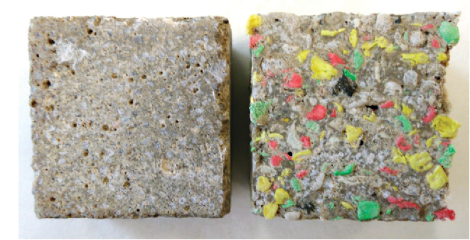

Figure 1 – Standard concrete block (left) and EPP block (right) (Jankovysky et al 2018).

Further studies into compressive strength by Batanyneh et al, 2017 noticed a reduction in tensile, compressive, and bending strength. This reduction was also supported in research undertaken by Liu et al 2013 and Akinyele et al, 2018. The main conclusion to be drawn from these studies is that compressive strength of concrete is reduced significantly with plastic aggregate replacement as plastic doesn’t bond to the cement mix like sand does. Workability was also negatively impacted. It was found that as the proportion of plastic in concrete increases the compressive strength also decreases. There appears to be certain uses where high strength concrete is not required such as sports court flooring and places where good drainage may be required but there needs to be more research in looking at various sizes, types and shapes of the plastics used in aggregate replacement to determine how best to incorporate this technology, but overall from the literature currently out there the outcome of replacement of aggregate for reinforcing of mortars is poor.
Research from Bath university partnered with India’s Goa engineering college undertook a study where due to shortages in sand production prompted a trial where it was discovered that a better option would be to replace 10% of the sand used in concrete with a finely ground plastic bottle particle mix instead. This mix ratio found that it was possible to achieve a very similar 54MPa compressive strength value for the test specimen which is very similar to that of structural concrete. This mix achieved a beneficial solution to re using plastic waste while also not impacting on concrete strength (Theengineer, 2022).

Analyse the application of waste plastic materials in road construction techniques

One of the most common types of road construction worldwide are bitumen roads, these utilise aggregates such as crushed rock and gravel which are combined with sand and most commonly mixed with bitumen which acts as the glue to hold the mix together. This mix is then laid on top of a well compacted sub base and an un bound road base layer to form the final road surface (eapa.org, 2022).
There have been many studies most notably in India regarding the use of disposable plastic bags being re used in the construction of new roads. The national rural roads development agency in India conducted a study on the use of re using plastic bags that were blended with bitumen to enhance the durability of new roads. It was found that a road of approximate length 1km and roughly 3.4m in width utilized 10,000 plastic bags and increased the strength of the road by 100%, it was claimed that the bituminous plastic mix remained pot hole free and lasted approximately 10 years compared to the normal road type construction which lasted 4-5 years (Raut et al 2016).
The Mix in this case study found that the waste plastic allowed for an increased binding of the aggregate with improved stability, density and improved water resistance. Flynn 1993 found that the addition of these recycled polyethelyne products reduced rutting of surfaces and assisted in reducing low temperature cracking. Similar studies by Shridhar et al, 2004 also found a 30% increase in tensile strength and doubled the fatigue resistance by adding recycled plastic bags to a bituminous mix compared to normal road construction.
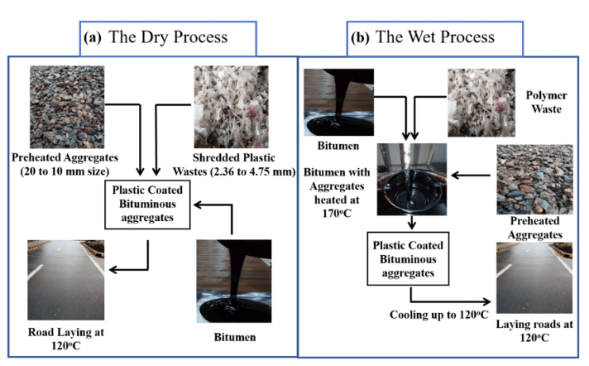
There are 2 main ways in which plastics can be mixed with bituminous products for road construction, these are dry, or wet processes and can be outlined in figure 2 below.
Figure 2 – Wet and dry process (Bhatari B,2017).

The dry process is commonly considered the more environmentally friendly, simple and cheapest, whilst the wet process involves a greater cost, more machinery and is therefore used less frequently (Mishra and Gupta, 2018).
Before the two processes are described all plastics need to be cleaned, sorted dried and shredded.

Dry Process

The dry process involves shredding waste plastic and adding to a hot aggregate, particle sizes of 2-3mm are preferred. This mix is then heated to 170c and the plastic melts and coats the aggregate. This is then mixed with a heated bitumen slurry and the mix is then used for road construction (Mishra and Gupta, 2018).

Wet Process

The wet process involves a powdered or polymer plastic form to be added to a hot bitumen slurry before adding the aggregate mix, it has to be ensured that a mix of 6-8% plastic powder is added and a thorough mixing occurs with bitumen is achieved, the temperature range should remain around 170c (Asare et al, 2019).
There have been many studies undertaken in India that have compared roads constructed using plastic waste, one of these studies undertaken by the journal of pavement research and technology, 2010 outlined the below comparison of data.

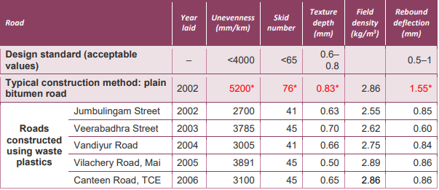
Table 1 - Journal of pavement research and technology , 2010.

As you can see the table above outlines the many benefits seen with this type of road construction ranging from improved skid factors to unevenness. It is also estimated that a cost saving per Km using the recycled plastic method with a 11% plastic mix compared to the traditional method achieves a cost saving of approximately $670 per km (Vasudevan et al, 2010).

A company in Ghana called Nelplast Ghana ltd has also developed a pavement block purely from waste plastic which gained approval from Ghanas environment ministry of science and allowed a whole new road in Accra to be constructed of this brick, with positive signs of durability as well as low costs (Nelplastgh.com, 2022).

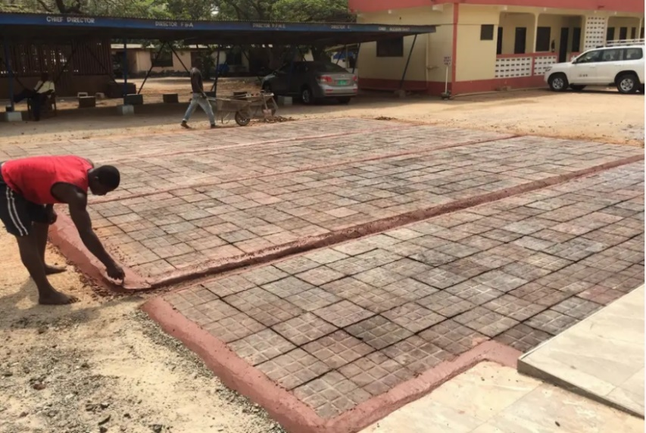

Figure 3 – (Nelplastgh.com, 2022)
Whilst most of the research is from oversees and primarily India, within the United Kingdom a company called MacRebur has developed a product that utilises plastic waste and adds this directly to asphalt. The fibrous plastic (PET and HDPE) is added to the bituminous binder during the production process which according to MacRebur improves the deformation, fracture resistance and crack propagation of the finished product.
This technology through MacRebur has now been globally accepted and is currently being used for construction products in the united states, Australia and also within the United Kingdom. (White and Reid, 2019).
MacRebur undertook a trial for a plastic constructed road within Cumbria, UK with very positive results, which the department for transport in the UK have also approved £1.6 million worth of funding to extend this road further using the same technology, and promising an additional £26 million worth of funding to improve the research and testing of this technology across the united kingdom (Department of transport, 2019).
There have also been many trials most notably from the Netherlands with modular road construction. The first plastic road was launched in a Dutch city called Zwolle in 2018, it was a 30m bicycle path made from recycled plastic cups and bottle caps (Figure 4 below).

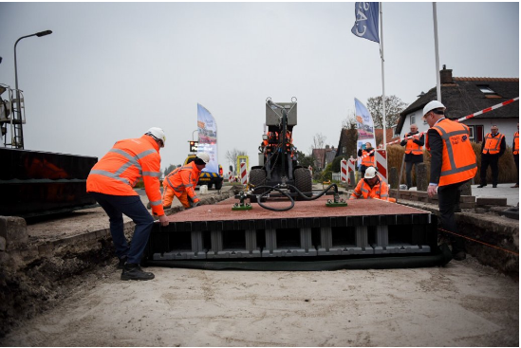

Figure 4 – Plastic road modules – Netherlands (Geoexplorer.org, 2022)
These plastic roads can be laid relatively quickly (approximately 70% faster than asphalt roads) with an estimated lifespan of three times that of the traditional road type. The creators also state that they are easily transported and can withstand much greater temperature variances also. The developers state the hollow design will also allow services to run beneath the surface as well as drainage etc. This design isn’t without its negatives however, maintenance and repairs of services underneath these road sections would require whole sections to be removed and possibly damaging water mains and cables underneath, shipping / transportation costs for larger roads would also be significant as well.

Critically assess the material’s practicality, functionality, and future potential in these applications (1+2), with reference to opinions from the media and professionals, both positive and negative aspects

Plastic road construction allows considerable amounts of waste plastics to be re used where otherwise they would be sent to landfill. India has one of the worlds largest road networks and this network is growing at an astonishing rate of approximately 10,000km per year (bbc.com, 2022). This technology would allow considerable amounts of plastic waste to be put to use not only for the environmental benefits but also for the improved longevity and resilience of new roads.
Below are some positives and negatives associated with plastic road construction, these have been adapted from the paper by Avinash Singh, 2020 titled “driving future plastic roads”.

Positives
Replacing 10% of the sand used in concrete with a finely ground plastic bottle particle mix would appear to be the best option for concrete design, offering near identical strength values to normal aggregates whilst minimising workability and compressive strength losses.
Plastic waste re used at an approximate rate of 8% ratios with asphalt would solve the issue of plastic landfill waste and help increase the value of this material in 3rd world countries. Plastics can be engineered to meet specific requirements, this may include weather resistance / improved durability. Using less asphalt in the construction process would reduce carbon emissions by approximately 2%. Modular plastic pieces are easier to work with than asphalt. This method is also much more cost effective compared to traditional road construction.
Research into the appropriateness for use for this road type also highlights the resistance to water stagnation and therefore the formation of pot holes is reduced, a higher tensile strength compared to asphalt will give a much better impact rating as well as durability, an improved resistance to cracking, lower tyre noise due to an increased binder thickness and texture and also improved night time visibilities have also been reported as well as lower maintenance and repairs have been reported (trimbakwala et al, 2017). Abrasion and chemical resistance are also improved over traditional road types

Negatives

Complete aggregate replacement in concrete as mentioned above, especially in high strength concrete according to Batanyneh et al, 2017 noticed a significant reduction in tensile, compressive, and bending strength.
Some negatives relating to plastic road construction have been found to include that differing plastic materials used in the manufacturing process may separate once melted, impacting on structural integrity of the road. One of the main concerns from plastic road construction however is that leaching of microplastics on the surface of plastic roads may lead to harmful particulates being released due to rainfall causing microplastic pollution into waterways and the environment. This leaching is caused by the separation of the bonding materials when it gets wet. Another potential downside is releasing HCL gases when chlorine is present which could potentially cause issues when water main bursts occur in proximity to these road surfaces (trimbakwala et al, 2017).

Conclusion

It is widely agreed that as population increases there will be an increase in additional waste products, one of which being plastic waste. The use of these additional waste materials in the construction industry and preventing them going to landfill is a positive one. The improved waste management in utilising plastic waste in the construction industry combined with increased benefits over traditional road construction methods can only be a good thing. From the literature examined a full aggregate replacement in concrete with recycled plastic material does not seem to provide many benefits for strength, however in the form of lightweight screeds there may be some uses, but more research is needed in this field. For concrete and especially structural concrete there would appear to be benefits looking into a small replacement of the aggregate i.e 10% sand replacement with fine plastic bottles but more research is needed in this field also, however initial testing seems positive.
Regarding the uses of recycled plastic in road construction, there seems to be significant benefits ranging from cost, durability, longevity, and waste management. The literature explored shows that this type of technology is now moving from small research projects to an adopted globally recognised solution to the issue of plastic waste and new road surface technologies, it will only get more prevalent as time goes on. Countries such as India, Ghana and the Netherlands are really progressing with this technology and the United Kingdom has only relatively recently begun to invest into this product, but following the Macrebur trial the UK government are now looking to heavily invest in this technology in the near future.

References

A whopping 91% of plastic isn't recycled - science (2020) National geographic. Available at: https://www.nationalgeographic.com/science/article/plastic-produced-recycling-waste-ocean-trash-debris-environment (Accessed: December 1, 2022).

Akinyele, J.O. and Ajede, A. (2018) “The use of granulated plastic waste in structural concrete,” African Journal of Science, Technology, Innovation and Development, 10(2), pp. 169–175. Available at: https://doi.org/10.1080/20421338.2017.1414111.

Alqahtani, F.K. et al. (2017) “Production of recycled plastic aggregates and its utilization in concrete,” Journal of Materials in Civil Engineering, 29(4), pp. 162–248. Available at: https://doi.org/10.1061/(asce)mt.1943-5533.0001765.

Asare, P.N., Kuranchie, F.A. and Ofosu, E.A. (2019) “Evaluation of incorporating plastic wastes into asphalt materials for road construction in Ghana,” Cogent Environmenta lScience,5(1),p.1576373. Available at: https://doi.org/10.1080/23311843.2019.1576373.

Asare, P.N., Kuranchie, F.A. and Ofosu, E.A. (2019) “Evaluation of incorporating plastic wastes into asphalt materials for road construction in Ghana,” Cogent Environmental Science, 5(1), p. 1576373. Available at: https://doi.org/10.1080/23311843.2019.1576373.
Batayneh, M., Marie, I. and Asi, I. (2007) “Use of selected waste materials in concrete mixes,” Waste Management, 27(12), pp. 1870–1876. Available at: https://doi.org/10.1016/j.wasman.2006.07.026.

Bharati, B. (2017) “Utilization of plastic waste in construction of roads,” ICSESD-2017 Available at: https://doi.org/10.24001/icsesd2017.5.

Building the modern world Concrete and our environment (2020) science museum. Available at: https://www.sciencemuseum.org.uk/objects-and-stories/everyday wonders/building-modern-world-concrete-and-our-environment (Accessed: December 1, 2022).

Could plastic roads make for a smoother ride? - BBC future (2021). Available at: https://www.bbc.com/future/article/20210302-could-plastic-roads-make-for-a-smoother-ride (Accessed: December 8, 2022).

Driving into the future on Plastic Roads ~ by Avinash S Singh: Accessed on 08th December 2022. Available at: https://www.linkedin.com/pulse/10-driving-future-plastic-roads-avinash-singh-30th-june-avinash-singh.

Feasibility Study of plastic waste use in road construction: Positive ... (2018). Available at: https://www.researchgate.net/publication/333486048_FEASIBILITY_STUDY_OF_PLASTIC_WASTE_USE_IN_ROAD_CONSTRUCTION_POSITIVE_AND_NEGATIVE_ASPECTS (Accessed: December 8, 2022).

Geyer, R., Jambeck, J.R. and Law, K.L. (2017) “Production, use, and fate of all plastics ever made,” Science Advances, 3(7), pp. 782–1700. Available at: https://doi.org/10.1126/sciadv.1700782.

Jankovsky, O. (no date) [PDF] lightweight concrete made with waste expanded polypropylene-based ... Available at: https://www.semanticscholar.org/paper/LIGHTWEIGHT-CONCRETE-MADE-WITH-WASTE-EXPANDED-AND-Z%C3%A1lesk%C3%A1/adbf51ef24c66d45deefed9cf962a459099cc8c3 (Accessed: December 4, 2022).

Liu, F. et al. (2015) “Performance of recycled plastic-based concrete,” Journal of Materials in Civil Engineering, 27(2), pp. 401–404. Available at: https://doi.org/10.1061/(asce)mt.1943-5533.0000989.

Mishra, B. and Gupta, M.K. (2020) “Use of plastic waste in bituminous mixes by wet and dry methods,” Proceedings of the Institution of Civil Engineers - Municipal Engineer, 173(2), pp. 87–97. Available at: https://doi.org/10.1680/jmuen.18.00014.

Mustafa, M.A. (2019) “Effect of partial replacement of sand by plastic waste on impact”. Available at: https://www.sciencedirect.com/science/article/abs/pii/S2352012419301018 (Accessed: December 12, 2022).

News and In-Depth (no date) UK study shows waste plastic can replace sand in concrete, The Engineer. Available at: https://www.theengineer.co.uk/content/news/uk-study-shows-waste-plastic-can-replace-sand-in-concrete (Accessed: December 4, 2022).

Plastic pollution is growing relentlessly as waste management ... - OECD (no date) OECD. Available at: https://www.oecd.org/environment/plastic-pollution-is-growing-relentlessly-as-waste-management-and-recycling-fall-short.htm (Accessed: December 1, 2022).

Recylced plastic finds home in asphalt binder (no date). Available at: https://trid.trb.org/view/372099 (Accessed: December 8, 2022).

Tougher roads with recycled plastic - global opportunity explorer (no date). Available at: https://goexplorer.org/tougher-roads-with-recycled-plastic/ (Accessed: December 15, 2022).

Trimbakwala (2017) “International Journal of Scientific and Research Publications,” International Journal of Scientific and Research Publications, 7(4), pp. 2250–3153. Available at: https://doi.org/10.29322/ijsrp.

Using waste plastics in road construction - semantic scholar (no date). Available at: https://www.semanticscholar.org/paper/Using-Waste-Plastics-in-Road-Construction-Sasidharan-Torbaghan/164bcbb32fe0bd00a9efe5de65a348fa6d79c24b (Accessed: December 8, 2022).

“Utilization of waste plastic materials in road construction” (no date). Available at: https://www.researchgate.net/publication/343627799_Utilization_of_Waste_Plastic_Materials_in_Road_Construction (Accessed: December 12, 2022).

Vasudevan, R. et al. (2012) “A technique to dispose waste plastics in an ecofriendly way – application in construction of Flexible Pavements,” Construction and Building Materials, 28(1),pp.311–320. Available at: https://doi.org/10.1016/j.conbuildmat.2011.08.031.

What is asphalt - EAPA (no date). Available at: https://www.eapa.org/what-is-asphalt (Accessed: December 1, 2022).

White, G. and Reid, G. (2019) “Recycled waste plastic modification of bituminous binder,” Bituminous Mixtures and Pavements VII, pp. 3–12. Available at: https://doi.org/10.1201/9781351063265-1.

