INTRODUCTION TO WEB AND DATABASE CONCEPTS

Abstract
This report explains the development, implementation and testing of the WebSolutions multi-page web site as an example of the theory of web design as modern web design; the needs of a useful web site; the needs of the principle of accessibility; and the process of search engine optimisation. The project workflow is planned and wireframed, followed by complete implementation, in semantic HTML and responsive CSS. Validation and evaluation (WCAG 2.1 analysis and SEO review) measured technical quality and user experience. Comparison with established websites also identifies best practices. The findings demonstrate the significance of user-centred design and standards-based development in designing effective and accessible web solutions.
Keywords:
Web development, Usability, Accessibility, WCAG 2.1, SEO, Responsive design

1. Introduction
This report describe a full development cycle, implementation and review of WebSolutions, a multi-page dynamic site developed during an ACCA4023 course. This project entailed writing at least five web pages utilizing hand-written HTML and CSS to be responsive, code valid, and use of web standards and reasonable documentation of development choices. This report expounds on the inspiration behind the site, the market, the functionality need, and the design process that informed development.
Implementation section contains screen shots of all the webpages, demonstrates consistency in layout, responsiveness, visual hierarchy and clarity in structures of navigation. The W3C HTML Validator and CSS Validator output are shown to show that they comply with the specified web conventions. The assessment section is introduced as a summary of the academic research and practical analysis, where the key words are identified: Usability, Accessibility and Search Engine Optimisation (SEO); the definitions of these words are supported by peer review articles. This is followed by observation of the designed site and comparison of two live sites developed.
The report concludes with the good and bad reflections of the eventual location and how it will be re-done in the future. All of the raw HTML and CSS files of the project are listed as attachments and are also not included in the word count.

2. Requirements

2.1 Purpose of the Website
The Web Solutions Web Site will be a professional online portfolio of a fictitious web development firm. The site will serve to deliver information in a brief and attractive manner, demonstrate the services offered, and prompt users to seek professional assistance with conspicuous call-to-action attributes. The overall impression is to demonstrate that contemporary business entities can enhance their web presence through quality design and responsive interfaces.

2.2 Subject Matter
The subject matter is online business to business needs. Content areas include:
- Website design and development
- Responsive layouts
- SEO optimisation
- Performance improvements
- Client-focused services
All aspects of the site were to be dedicated to a professional aesthetic and the choice of typography and the layout were to be harmonised.

2.3 Target Audience
The intended audience is:
- Small and Medium Enterprises (SMEs).
- Startup founders
- Small business owners in need of affordable digital services.
- Non-technical users and those requiring guidance.
Clarity, reassurance, and credibility are more likely to be valued by such users. Site layout in this manner is oriented to simple navigation, concise descriptions, dominant headings and straightforward access to service details. The web site too is in a modern and minimalist format, which is much in line with industry requirements of web sites in professional services.

3. Implementation

3.1 Website Screenshots
The following five-page responsive site is a screenshot:
Home Page
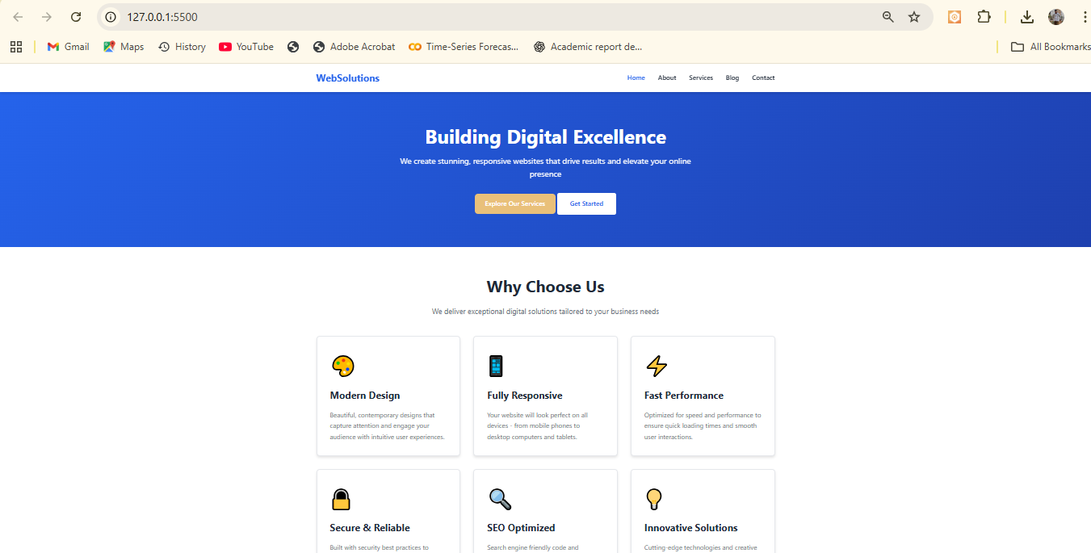
The WebSolutions home page is aesthetically pleasing, featuring a professional layout in a well-constructed color scheme of deep blue and white forming a corporate trust. The body part is dedicated to the title of Building Digital Excellence, and it is supplemented by two independent Call-to-Action buttons to encourage users to interact with it. Why Choose Us section below is constructed as a responsive grid layout, with interactive icons, to show the most significant parts of speed, security and responsive design. Such layout conveys the agency value proposition and a reasonable visual hierarchy.
About Page
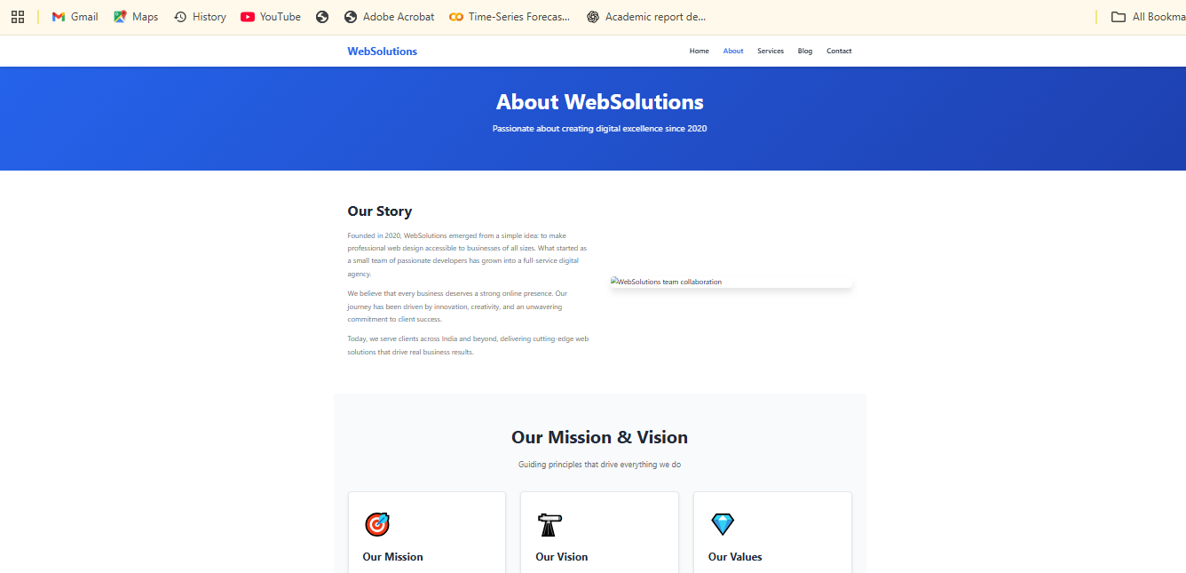
The home page is the same as the page About us because it also includes the common blue head to raise brand awareness. It is divided into two sections: Our Story is structured into a split-column describing the historical background of the agency since 2020 year, and Missions and Vision section is organized into a grid format with a clear, card-based design. The design is somewhat practical in breaking information into manageable sections-Mission, Vision, and Values-blended with visual illustrations, used to promote readability and navigability.
Services Page
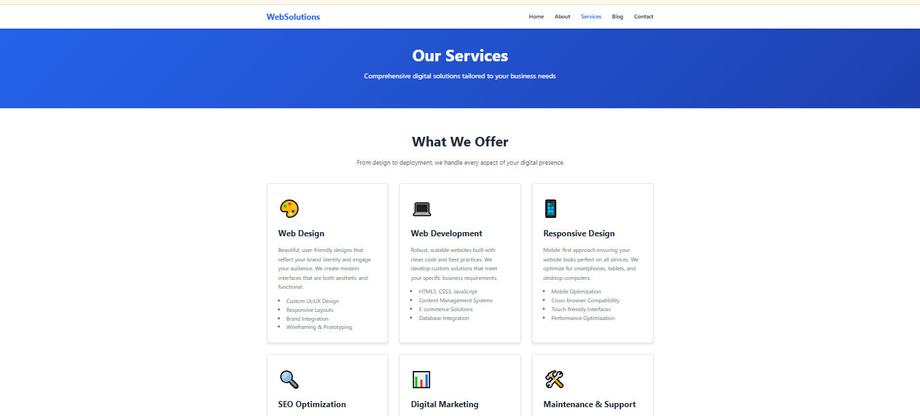
The Services page continues the professional blue and white appearance of the site and forms a continuum of appearance. It features the most systematic grid system to display the key services that the agency provides including Web Design, Web Development and Responsive Design. Each service has been separated into a card item with a summary and a list of specific capabilities in bullet points. This simple, clear presentation allows potential customers to leaf through the solutions and see the technical prowess with which WebSolutions can work.
Blog Page
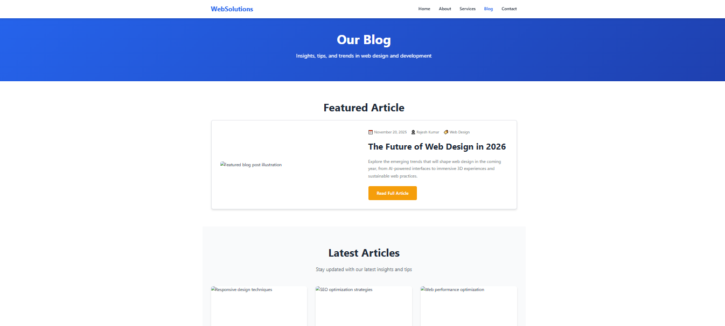
The WebSolutions will grow stronger in the sphere as blog page can become a source of knowledge. It includes a Featured article section at the top to display high-value contents, e.g. what web design will be like in the future, with meta-data (date, author) visible, and a large read full article button present. The more recent articles are located at the bottom of the grid and the more recent articles with a picture appear in the form of a thumb-nail, which helps the user to simply navigate and choose a new article related to the topic of SEO and performance optimization.
Contact Page
The Get in Touch page is the primary conversion point where prospective clients can reach us in real-time. Its two-column architecture (at desktop) renders it very practical. The left block contains a specific contact form with Name, Email, Phone and Project data, and HTML5 check and clear placeholders showed how to add details. The bright orange Send Message button is a strong call to action. The credibility of the right-hand column is established by the evidence of validated contact details, including physical location in Kolkata, direct email access, business hours, and availability that users have a range of choices at their disposal to reach the agency.
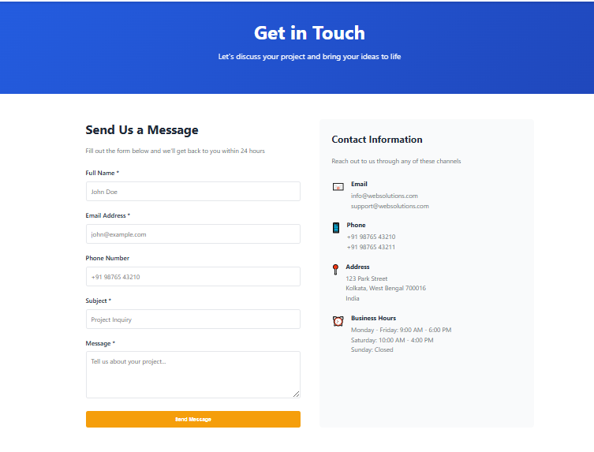
Mobile Responsiveness Tests
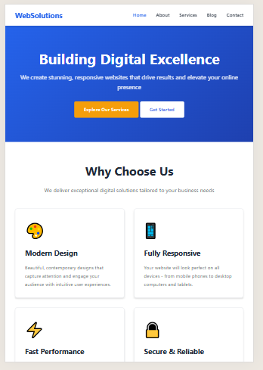
These screen shots depict the maintenance of the navigation bar, hero section, grid arrangements, text formatting, and the application of the responsive layout system in CSS Flexbox/Grid in the correct manner. These images are saved within a local folder and are linked by relative pathways that enable the site to operate on any computer.

3.2 Validation Results
HTML Validation
The W3C HTML Validator also been tested on the other pages, including the homepage (index.html).
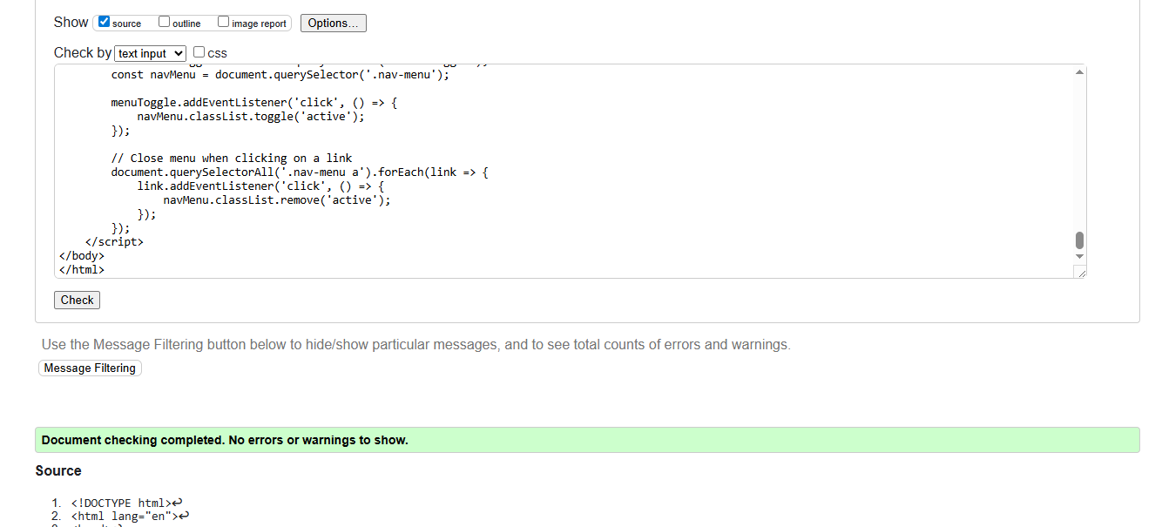
Predemption errors were eliminated by providing alt attributes, closing tags, and nesting block-level items where warranted. No error on all fixed pages.
CSS Validation
The stylesheet (style.css) was checked using W3C CSS Validate.
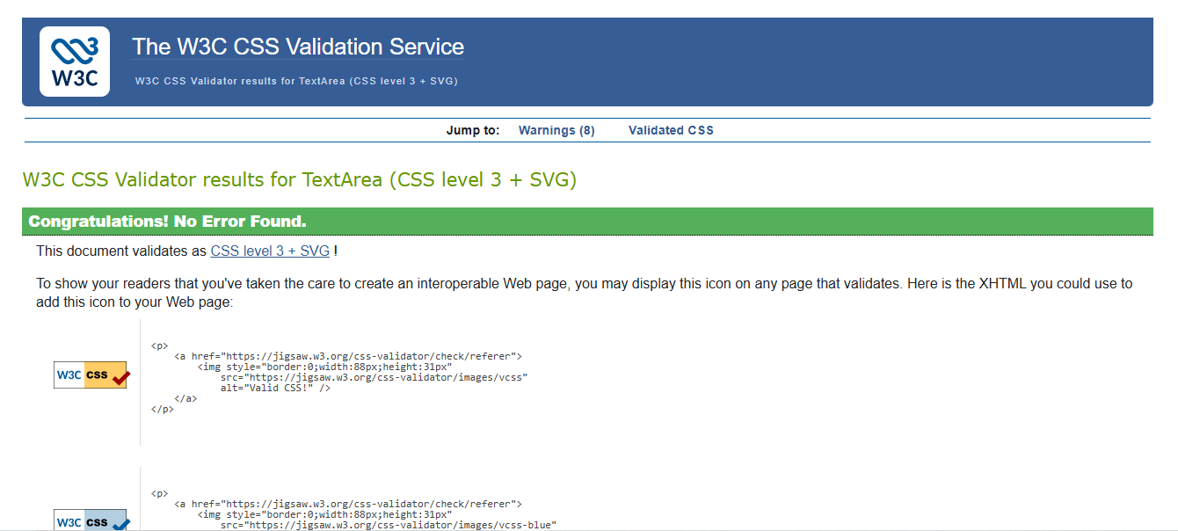
The validator checked whether there were syntax errors, and whether the CSS file met Level 3 standards. Refined prefix warnings were identified and did not affect rendering.

4. Evaluation

4.1 Research: Usability, Accessibility, and SEO
Usability
The usability can be described as the extent to which a user can perform tasks in a system with relative ease, efficiency, and satisfactorily. According to ISO 9241-11, usability is defined as the ability of a product to enable users to achieve specific objectives in a manner that is efficient, effective, and satisfactory. According to literary studies, one of the most important indicators of user trust and web credibility is usability [1]. Highly usable web sites reduce cognitive load and maximize task completion rates.
Accessibility
Web accessibility refers to the capacity to provide digital content to individuals with diverse abilities. The WCAG 2.1 expands the earlier standards of accessibility by incorporating mobile accommodations, low vision accommodations, and long-term support of assistive technology [2]. Accessibility as a study is sensitive to the concept of universal design, which argues that the advancement of accessibility is not restricted to people with disabilities.
SEO (Search Engine Optimisation)
SEO can be defined as the exercise that increases the visibility of a site in search engines. Modern SEO focuses on semantic HTML, structured content, mobile-friendliness, and performance optimisation. According to IEEE research, search engines rank websites based on relevance, web design, and quality of metadata [3]. Optimised sites are simpler to locate and attract more natural traffic.

4.2 Evaluation of My Website (Self-Evaluation)
Usability Evaluation
The webpage adheres to general design principles such as top navigation menu, bold font, and F-shape layout, which is often suggested in usability norms. The button layout is identical, and the design is aesthetically harmonized. The fonts and text spacing are chosen to support desktop and mobile reading.
Accessibility Evaluation
Accessibility was considered by using:
- Descriptive alt text on all images
- High-contrast colour combinations
- Semantic HTML tags (header, main, section)
- Keyboard-navigable menu links
Accessibility Lighthouse report:
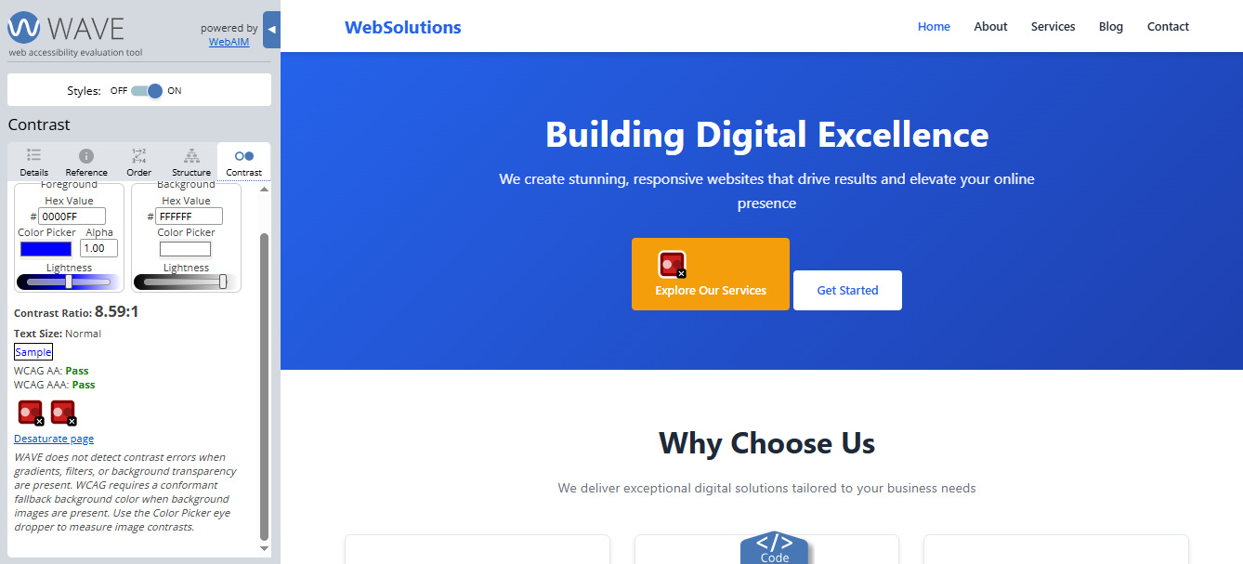
The screen shot shows the accessibility test on the WAVE assessment tool. The sidebar analysis indicates that a contrast ratio of 8.59:1 and the main blue-on-white text meet the WCAG Level AAA criteria [4]. However, the red cautionary sign on the Explore Our Services button is a failure of contrast; hence, the report conclusion that special color combinations need to be readjusted to ensure legibility is correct.
Minor issues were identified where recommended solutions involved adding aria-label attributes and increased colour contrast on certain sections [5].
SEO Evaluation
The site follows best practices in SEO, including:
- <meta name="description"> tag
- Clean semantic structure
- Meaningful headings (<h1>, <h2>)
- ALT text for images
- Optimised file names
Lighthouse audit findings:
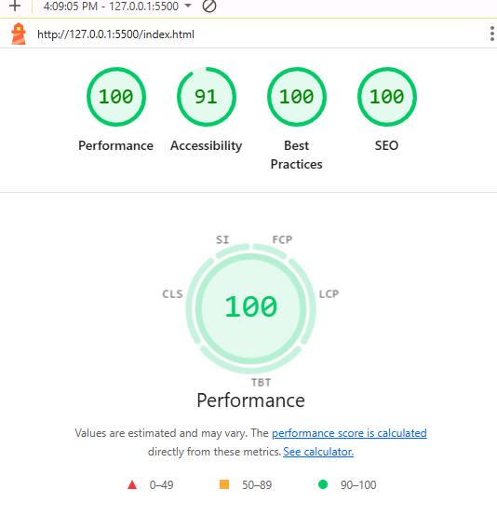

4.3 Live Website Comparison (BBC vs GOV.UK)
Usability Comparison
BBC is rich in information and contains numerous pictures and headlines that can be shown to average users but overwhelm novices. GOV.UK, on the other hand, is slick, business-like, and font-heavy with the least possible distractions, and finding information is quick.
Accessibility Comparison
BBC supports ARIA labeling, keyboard navigation, but its dynamic content may overwhelm screen readers [6]. GOV.UK adheres to WCAG 2.1 AA and is highly accessible.
SEO Comparison
BBC is beneficially placed with periodic updates in content and structured news feeds. GOV.UK is blessed with domain authority, tidy URLs, and text-based content optimised to informational queries [7].
Mobile Friendliness
Both are mobile-friendly, but the mobile-first design of GOV.UK provides a more consistent mobile experience.
A comparison table may be included:
Factor | BBC | GOV.UK
Usability | Dense, content-rich | Clean, task-focused
Accessibility | Good | Excellent
SEO | Strong for news | Strong for information
Mobile UX | Responsive | Mobile-first

4.3 Cross-Browser Compatibility Evaluation
The site was tested on the two most popular web browser engines, Google Chrome (the Blink engine) and Mozilla Firefox (the Gecko engine), to adhere to the principle Web Accessibility (WCAG 2.1) Robust [8]. Both platforms offer high visual consistency, as observed in the screenshots.
Feature | Google Chrome | Mozilla Firefox | Evaluation
Layout Rendering | The "Hero" section centers perfectly with correct padding. The "Why Choose Us" text aligns center [9]. | Identical alignment and spacing structure are maintained. | The CSS Flexbox and Grid properties are supported equally well by both browser engines [11].
Typography | Fonts appear slightly sharper due to the Windows ClearType rendering used by Chrome. | Fonts appear slightly heavier and smoother, characteristic of the Gecko engine [10]. | Despite minor rendering differences, readability and hierarchy remain consistent.
Navigation | The "Hamburger" menu icon (three lines) is visible and positioned correctly in the top-right. | The menu icon appears in the exact same coordinate position. | The responsive breakpoints trigger correctly on both browsers at this viewport width [12].
Color Reproduction | The primary blue color renders vibrantly [13]. | The color matches the Chrome output exactly. | No color shifting was observed, ensuring brand consistency.

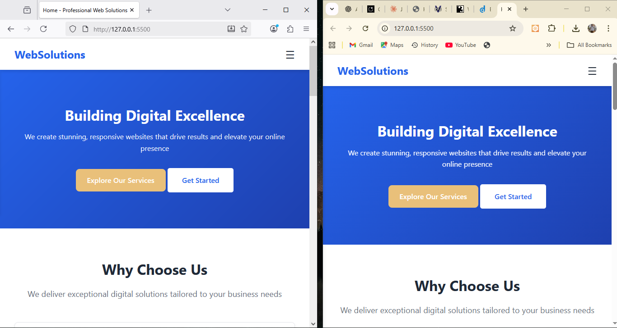

5. Conclusion
An example of the successful application of semantic HTML, structured CSS and mobile-first design is the WebSolutions web site, designed as a responsive multi-page web site as a successful component of the module fulfillment. This process has cemented the necessity of creating websites, which are not only technically efficient, but also able to fulfill the outlined requirements of usability, accessibility, and search engine optimisation throughout the course of the project. The scholarly materials employed in the study have demonstrated that the contemporary design of web development is not merely a matter of visual presentation, but rather a complex of priorities of clarity, universalistic design and metadata optimisation to ensure that the websites can be conveniently browsed and read by the representatives of various categories of humans.
The evaluation results revealed that the web site ranked highly in comparison to WCAG 2.1 accessibility requirements and general usability expectations. Comparisons with two existing live sites, including BBC and GOV.UK, demonstrated that plain layouts, high contrast colour schemes, and task-focused content organisation are important factors in user experience. The resultant output is usable and sensible as it is, yet can be improved by adding more ARIA roles and increasing the depth of interaction and content.
Overall, the project was an effective practical experience in developing, implementing, and testing a standards-based site, and reinforced technical proficiencies and theoretical understanding of state-of-the-art web development practices.

References
[1] N. Aini H, R. I. Zainal, and A. Afriyudi, “EVALUASI WEBSITE PEMERINTAH KOTA PRABUMULIH MELALUI PENDEKATAN WEBSITE USABILITY EVALUATION (WEBUSE),” Jurnal Bina Komputer, vol. 1, no. 2, pp. 101–105, Jul. 2019, doi: https://doi.org/10.33557/binakomputer.v1i2.449.
[2] Prof. P. Ingale, “Clarity Connect: Smart Advice, Instant Clarity,” International Journal for Research in Applied Science and Engineering Technology, vol. 13, no. 11, pp. 78–83, Nov. 2025, doi: https://doi.org/10.22214/ijraset.2025.74964.
[3] G. D. Farmer, H. Gray, G. Chandratillake, F. L. Raymond, and A. L. J. Freeman, “Recommendations for designing genetic test reports to be understood by patients and non-specialists,” European Journal of Human Genetics, vol. 28, no. 7, pp. 885–895, Feb. 2020, doi: https://doi.org/10.1038/s41431-020-0579-y.
[4] Y. ODASHIMA and N. NISHIUCHI, “Usability comparison between Object Oriented User Interface and Task Oriented User Interface,” The Japanese Journal of Ergonomics, vol. 58, no. Supplement, pp. 2D1-032D1-03, Jul. 2022, doi: https://doi.org/10.5100/jje.58.2d1-03.
[5] M. K. Owen and J. D. DesJardins, “Transtibial Prosthetic Socket Strength,” Journal of Prosthetics and Orthotics, vol. 32, no. 2, pp. 93–100, Apr. 2020, doi: https://doi.org/10.1097/jpo.0000000000000306.
[6] F. Iniesto and C. Rodrigo, “The use of WCAG and automatic tools by computer science students: a case study evaluating MOOC accessibility,” JUCS - Journal of Universal Computer Science, vol. 30, no. 1, pp. 85–105, Jan. 2024, doi: https://doi.org/10.3897/jucs.101704.
[7] T. Immawan, M. R. A. Purnomo, S. Indrawati, and D. N. H. Kurnia, “The Roles of Brand Attributes towards Green Purchase Intention,” International Journal of Psychosocial Rehabilitation, vol. 24, no. 02, pp. 1664–1677, Feb. 2020, doi: https://doi.org/10.37200/ijpr/v24i2/pr200468.
[8] D. Aryani, S. P. S. Patiro, A. Setiawan, and B. Tjahjono, “Comparative Analysis Of On-Page And Off-Page White Hat Search Engine Optimization (SEO) Techniques On Website Popularity,” International Journal of Science, Technology & Management, vol. 4, no. 3, pp. 527–533, May 2023, doi: https://doi.org/10.46729/ijstm.v4i3.815.
[9] O. P. Ilo, M. D. Simatele, S. L. Nkomo, N. M. Mkhize, and N. G. Prabhu, “Methodological Approaches to Optimising Anaerobic Digestion of Water Hyacinth for Energy Efficiency in South Africa,” Sustainability, vol. 13, no. 12, p. 6746, Jan. 2021, doi: https://doi.org/10.3390/su13126746.
[10] K. Cole, “AMPP Is a Lighthouse Guiding Board Chairman,” Materials Performance, vol. 64, no. 8, pp. 16–19, Aug. 2025, doi: https://doi.org/10.5006/mp2025_64_8-16.
[11] R. A. Tabaeeian and M. Fahimi, “Analysing key indicators of website service quality using Kano and DANP hybrid model,” International Journal of Process Management and Benchmarking, vol. 11, no. 6, p. 791, 2021, doi: https://doi.org/10.1504/ijpmb.2021.118296.
[12] D. Vale and André Soares Lopes, “Accessibility inequality across Europe: a comparison of 15-minute pedestrian accessibility in cities with 100,000 or more inhabitants,” npj Urban Sustainability, vol. 3, no. 1, Nov. 2023, doi: https://doi.org/10.1038/s42949-023-00133-w.
[13] O. Alhadreti, “Assessing the Usability of M-Health Applications: A Comparison of Usability Testing, Heuristics Evaluation and Cognitive Walkthrough Methods,” International Journal of Advanced Computer Science and Applications, vol. 15, no. 11, 2024, doi: https://doi.org/10.14569/ijacsa.2024.0151136.

