Community development



Natalie Ford
2007772

Contents
Title | Page number
Introduction | 3
Focus community | 4
How the community works | 5
Challenges faced by community | 6
Continuation of growth | 7
Recommendations | 8
Conclusion | 9
Appendices | 10-12
References | 13-14

Introduction
Within this report a specific community will be investigated to discover how it is maintained, and how it can grow and develop. What methods are used to foster growth and any challenges that may be faced. The community that will be looked at is domestic abuse organisations in Llanelli.
Domestic abuse is defined as occurrence or a continuation of the same occurrences including dominating, forceful, intimidating, humiliating and aggressive behaviour, including sexual abuse, in a large number of incidents these behaviours are demonstrated by partner or ex-partner, or a loved one or carer (Womens aid, 2022).
Organisation meaning a group of individuals who work in unison in a structured way for a collective reason (Cambridge university, 2023). In this instance to assist adults, children, and young people who experience domestic abuse.
It is important to discover the communities that are available to help in every aspect of recovery from abuse and how these communities link in to one another to provide a strong support system for individuals who need it.

Focus community.

The focus community within this report is a part of domestic abuse support within Llanelli. An organisation called Threshold (2023a) provide support for individuals that have experienced abuse and require support in areas such as their mental health, housing or somewhere safe to stay, financial and legal help. Threshold mission statement is they are an organisation devoted to the removal of aggression and mistreatment of “women, men, children and young people”, including offenders through accomplishing “political, cultural and social” readjustments. Threshold DAS was previously known as Llanelli Womens aid Ltd and was established in 1984. Due to the high volume of women that needed help the charity appealed to Gwalia housing, the focus was to provide further support providing somewhere safe for individuals to stay, therefore a six bedroom refuge was built with disabled access was open in 1993. In 2002 an “outreach office” these enabled individuals living in the local community to acquire assistance from the service. To continue to grow the services available the Welsh assembly government provided funding, with the “community facilities programme” that provides financial assistance in a variety of quantities to better community provisions (Gov.Wales, 2017). This funding then gave the opportunity to provide floating support workers who were then able to provide assistance to a further 15 families. In 2007 the organisation then became an “incorporated charity limited by guarantee” and in 2009 with further financial assistance from the Welsh government a community base was bought to provide a full array of services in one place, that became available to the public in 2011. In 2013 Threshold grew to become a recognised “Agored Cymru Centre” and received European Social Funding (ESF) which is an organisational fund from the European union increasing expertise of personnel (Gov.UK, 2014). Enabling them to provide academic schemes for people focusing on reducing economic negligence in “Carmarthenshire and convergence areas”. In 2014 Threshold had an application agreed from Big Lottery for three years providing an “Early family intervention project”, enabling them to expand services integrating the entire family as well as perpetrators.

How the community works.
Threshold (2023b) also offer different services under “helping hands” options. These include: food banks, charity shops, repair café, period poverty, and teracycle. A repair café is a place that the local community are able to visit to have household items, clothing, furniture and many other items fixed (if possible) to avoid having to buy new. Anybody is welcome to visit these set up café meetings even if they do not have anything that needs to be fixed, they can call in to meet others and have a cup of tea (repair café, 2023). Period poverty is a worldwide problem, that means women are not able to have appropriate menstrual products, or the knowledge of what to do or what to use. 29% of British people surveyed stated they did not know what period poverty is (Appendix 1), in another survey conducted by YouGov (2023) a total of 362 individuals involved in the survey stated they have struggled financially to afford to buy appropriate menstrual products in the past five years. Teracycle is a company that works towards eradicating “the idea of waste” to decrease the waste that ends up in a landfill (Terracycle, 2023). By providing further services as these, Threshold enable individuals to move forward in life in a healthier and more positive way.
Threshold also offer counselling, support workers, safety workers, early family intervention programmes as well as the refuge. Threshold also offer support for males that are subject to abuse, offering “a safe place to tell their story” as well as help with housing and how they can access their children (Threshold, 2023c).

Challenges faced by community.
One of the challenges for individuals in abusive relationships is the cost of living crisis (2023) at present that is the decrease of financial availability, meaning bills are just about covered or income may even fall short. The increase in prices of household items has also increased pressures on individuals, which in turn has also increased stress levels that potentially lead to abuse within the home. Womens aid conducted a survey that found 96% stated the cost-of-living crisis has had a detrimental affect on their monetary situation. This means some women are forced to choose either to stay with their abuser or face greater financial difficulties, this in turn increases the possibility of continuing to be abused withing an unsafe environment (Miles and partners, 2023).
A challenge for Threshold could be the potential lack of funding, with a lot of money that has been put in to this community/organisation has been from Welsh government grants and funding, as well as the big lottery funding…….
In 2020 covid 19 brought the world to a standstill and saw all non essential travel and face to face interactions prohibited. Covid 19 is a respiratory disease that can lead to sever illness or even death (World health organisation, 2023). The restrictions put in place meant that individuals could not freely gain support in person as most business were closed, non essential travel was banned, no meeting anyone outside of those you live with (BBC news, 2020). These restrictions were described to have brought about a “shadow pandemic” with information gathered by UN Women (2023) stating that all versions of abuse had increased during the pandemic.

Continuation of growth.

In 2015 the Welsh government brought in to affect the Violence against women, domestic abuse, and sexual violence (Wales) act 2015 (Legislation.gov, 2015) which states under section 12 that the Welsh minister must provide a report that describes the progression made in respect of attaining the targets of the “national strategy on violence against women, domestic abuse and sexual violence (2016 to 2021)”. As well as the progression in regard to establishing the initiative of the “violence against women, domestic abuse and sexual violence (Wales) act 2015 in Wales”. There is a new initiative from the government (2021-2026) that is dedicated to developing the “Ask and Act” training and principles (Appendix 2)- this is a procedure of focused investigation that is performed throughout appropriate authorities (identified in “the Violence against women, Domestic abuse and Sexual violence act) to recognise “violence against women, domestic abuse and sexual violence (Welsh government, 2017b). There is also the ‘Don’t be a bystander’ campaign, encouraging individuals to ask others simply if they are ok if they suspect something is wrong. It states how asking this simple question could be the first lifeline someone has had to gaining help from abuse (Welsh government, 2023).
Within the local area of Llanelli the awareness of help available for those experiencing violence against women, domestic abuse and sexual violence is not highly advertised. Contact numbers are available on the Carmarthenshire County council website for Threshold in Llanelli (Carmarthenshire county council, 2023). There has over the last few years been an event called “White ribbon day” which in 2021 Dyfed Powys police supported to end abuse against females (Dyfed Powys police, 2021). Llanelli online news (2022) also showed support for the white ribbon campaign in 2022, with their webpage showing the contact details for Threshold also. Threshold themselves also advertised that they would be within the local area at a white ribbon event in November 2021 (Appendix 3) which does highlight what they do in the local area, however, if anyone attending the even would need to speak to them they may not be able to as they could be with the persecutor or have fear someone they know may see them, but they could make a note of all the contact details needed.

Recommendations.
With the increase in violence against women, domestic abuse, and sexual violence due to the pandemic, it is important to ensure the advertising of what help is available is increased to highlight to those who need assistance what avenues they have access to locally to leave an abusive situation and gain the support they need. The support can vary from financial, housing, emotional and physical. Without the advertising and awareness there may be many women and children within violent situations unaware they have ways to leave.
A possible new way to allow individuals to highlight to others they are in a difficult situation may be having a safe word introduced in to work places or within local shops and businesses. Meaning an individual could go in to a local shop at say the safe word to a shop keeper and they could help them, or children could use it within school to tell a teacher of any issues. There is already a scheme called “ask for Angela” that has been rolled out throughout UK bars, pubs and clubs. This means if someone asks for Angela the member of staff is aware that the individual is being harassed or is in an uncomfortable situation. There is guidance available to show what to do if someone asks you (Appendix 4) and also posters to make people aware what to do if they are in this type of situation (Appendix 5). It is a nationwide campaign that originated in Lincolnshire and was embraced by the nation with authorization from “the Safer Communities Sexual Violence and abuse partnership” (Areyouok, 2023).

Conclusion.
The work that Threshold do within the local community providing protection for those affected by violence against women, domestic abuse and sexual violence is invaluable, however, the extend of advertising that they have within the local area is not noticeable. This could mean there are many people going without the help they need. With the white ribbon day in November 2021 being such a good way to highlight what they do as an organisation, there is nothing to show that this was done again in 2022 or that it will be arranged again in 2023.
There are also laws in place that should be taught within schools, colleges, universities, GP surgeries and work places such as “Clares law” this allows individuals to ask for information about an individuals past to protect them from possibly becoming a sufferer of domestic violence and potentially leaving before the relationship goes too far (Threshold, 2023d).
The current help available from Threshold is wide ranging from the refuge, counselling, support workers, early family intervention programmes, to DASH programme for 0-16 year olds. This project is to provide assistance to infants and young people who have been exposed to or encountered domestic abuse (Threshold, 2023e).
Working collaboratively with schools, GP’s, local police and hospitals, victims will be able to be provided with a wider range of support and increased safety when they exit volatile relationships or situations. Increasing the likelihood that victims will not return to these situations/relationships and will be able to progress in their personal lives.
With all the services available from Threshold going forward it is vital to ensure all of them are advertised and made known in appropriate venues with increased knowledge means increased help provided, this will in turn ensure that such a vital organisation to the local community continues to thrive and has the ability to help as many individuals as possible to start a new journey to a future without violence or abuse.

Appendices.
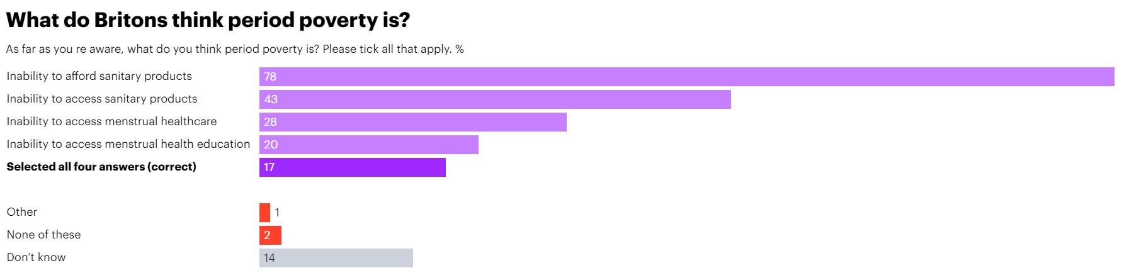
Appendix 1

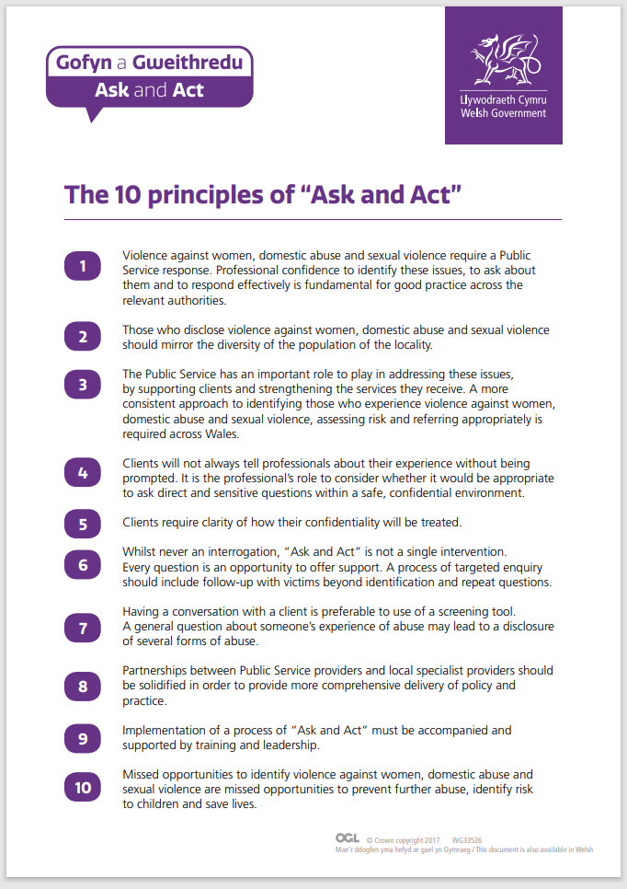
Appendix 2 (Welsh government, 2017a).

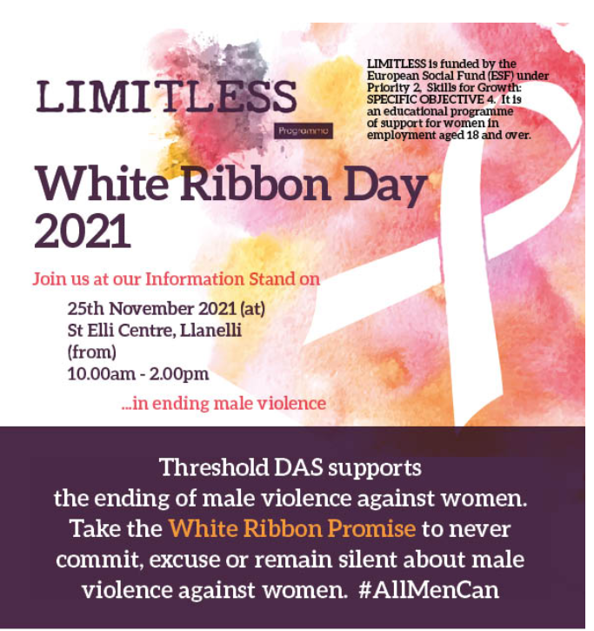
Appendix 3
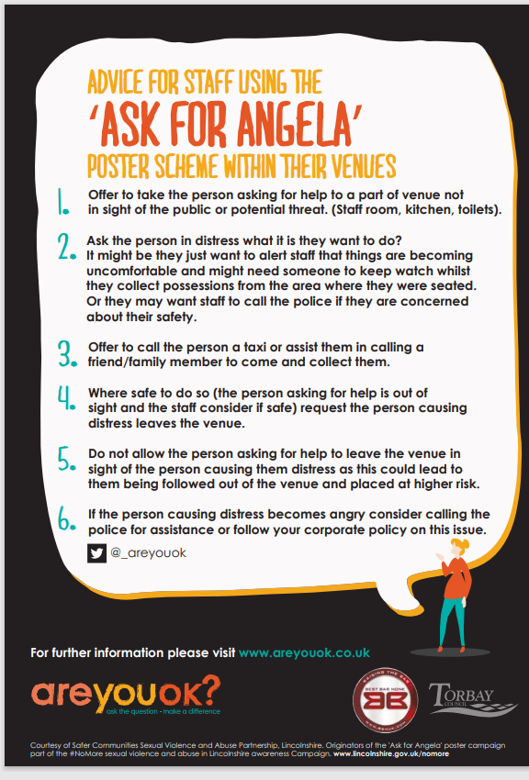
Appendix 4

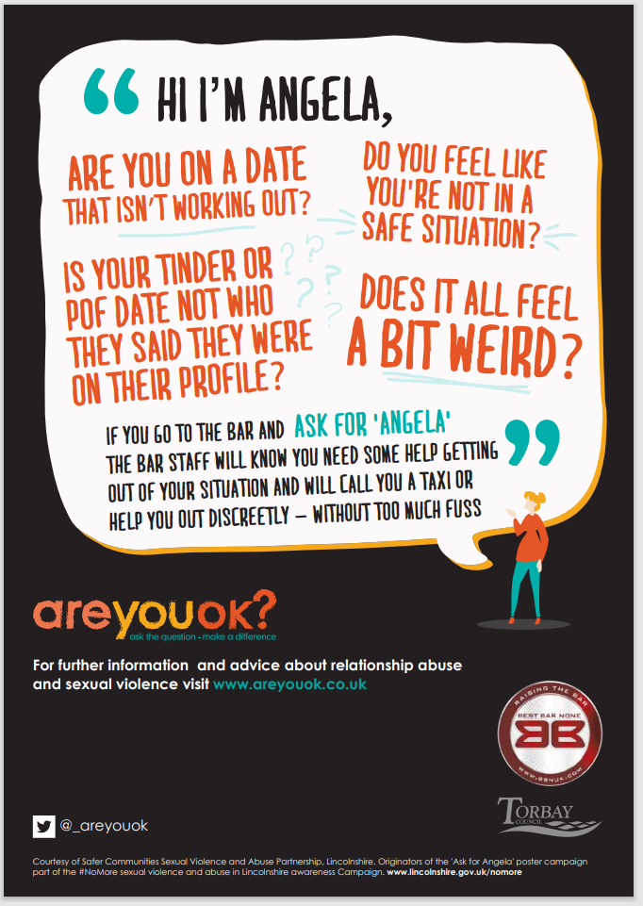
Appendix 5

References.
Are you ok? (2023) Ask for Angela. Available at: https://www.areyouok.co.uk/im-a-professional/campaign-materials/ask-for-angela/ (Accessed on 5th April 2023).
BBC news (2020) Coronavirus: what are the current restrictions and why are they needed?. Available at: https://www.bbc.co.uk/news/explainers-52010555 (Accessed on 31st March 2023).
Cambridge dictionary (2023) Definition of organisation. Available at: https://dictionary.cambridge.org/dictionary/english/organization (Accessed on 28th March 2023).
Carmarthenshire county council (2023) Domestic abuse. Available at: https://www.carmarthenshire.gov.wales/home/council-services/emergencies-and-community-safety/community-safety/domestic-abuse/#.ZCxGCsrMKuU (Accessed on 4th April 2023).
Dyfed Powys police (2023) White ribbon day. Available at: https://www.dyfed-powys.police.uk/news/dyfed-powys/news/2021/november-2021/white-ribbon-day-2021/ (Accessed on 4th April 2023).
Gov.UK (2014) European social fund. Available at: https://www.gov.uk/government/collections/sfa-european-social-fund (Accessed on 28th March 2023).
Gov.Wales (2017) Community facilities programme. Available at: https://www.gov.wales/sites/default/files/publications/2020-01/guidance-for-grant-applicants.pdf (Accessed on 28th March 2023).
Legislation.gov (2015) Violence against women, domestic abuse and sexual violence (Wales) act (2015). Available at: https://www.legislation.gov.uk/anaw/2015/3/section/1/enacted (Accessed on 31st March 2023).
Llanelli online news (2022) Council support white ribbon day. Available at: https://llanellionline.news/council-support-white-ribbon-day/ (Accessed on 4th April 2023).
Miles and Partners (2023) How is the cost-of-living crisis affecting victims of domestic abuse? Available at: https://milesandpartners.com/how-is-the-cost-of-living-crisis-affecting-victims-of-domestic-abuse/ (Accessed on 30th March 2023).
Repair café (2023) What is a repair café? Available at: https://www.repaircafe.org/en/about/ (Accessed on 30th March 2023).
Terracycle (2023) Eliminating the idea of waste. Available at: https://www.terracycle.com/en-GB/about-terracycle/ (Accessed on 30th March 2023).
Threshold (2023a) About Threshold. Available at: https://threshold-das.org.uk/about-us/ (Accessed on 30th March 2023).
Threshold (2023b) Helping hands. Available at: https://threshold-das.org.uk/helping-hands/ (Accessed on 30th March 2023).
Threshold (2023c) Support for males experiencing domestic abuse and violence. Available at: https://threshold-das.org.uk/support-for-males-experiencing-domestic-abuse-and-violence-2/ (Accessed on 5th April 2023).
Threshold (2023d) Clares law. Available at: https://threshold-das.org.uk/claires-law/ (Accessed on 5th April 2023).
Threshold (2023e) DASH programme- For 0-16 year olds. Available at: https://threshold-das.org.uk/dash-programme-for-0-16-year-olds/ (Accessed on 5th April 2023).
UN Women (2023) The shadow pandemic- violence against women during covid-19. Available at: https://www.unwomen.org/en/news/in-focus/in-focus-gender-equality-in-covid-19-response/violence-against-women-during-covid-19 (Accessed on 31st March 2023).
Welsh government (2017b) The 10 principles of “ask and act”. Available at: https://www.gov.wales/sites/default/files/publications/2019-05/ask-and-act-10-principles.pdf (Accessed on 4th April 2023).
Welsh government (2017b) Delivery of ask and act- The role of frontline practitioner. Available at: https://www.gov.wales/sites/default/files/publications/2019-05/ask-and-act-role-frontline-practitioner.pdf (Accessed on 4th April 2023)
Welsh government (2023) Don’t be a bystander to abuse or violence- what you can do to help. Available at: https://www.gov.wales/dont-be-bystander (Accessed on 4th April 2023).
Womens aid (2022) What is domestic abuse. Available at: https://www.womensaid.org.uk/information-support/what-is-domestic-abuse/ (Accessed on 28th March 2023).
World health organisation (2023) Coronavirus disease (Covid-19). Available at: https://www.who.int/health-topics/coronavirus#tab=tab_1 (Accessed on 31st March 2023).
YouGov (2023) Period poverty: one in eight likely to struggle to afford sanitary products they need in the next year. Available at: https://yougov.co.uk/topics/politics/articles-reports/2022/09/14/period-poverty-one-eight-likely-struggle-afford-sa (Accessed on 30th March 2023).

