Student Name: [ Adamache Anaida]  Student ID: [2026381]  Module Title: Foreign Languages & Cultural Awareness  Module Code: BMIH5003  Lecturer: [Heidi Prosser]  Date: [04/02/2024] | 
ASSIGNMENT 1: PORTFOLIO
(4 Components)

Component 1: Professional Reflection (500 words +/- 10%)

Weighting: 25%

Example of cultural misunderstanding between F&B employee and hotel guest
The tourism industry in the UK hosts people from different parts of the world. Almost 2 million tourists from Spain visited the UK in 2022 (visitbritain.org, 2023). I have noticed some cultural differences between us and the Spanish tourists while working in a hotel in England. I think language differences are the most common communication barrier among the tourists and our hotel staff. Most of the tourists can speak and understand English. However, the vocabulary and language proficiency are different. The regular greetings, eating habits, food preferences, daily routines and currencies are different.
While working at Ibis Hotel Styles, once I have seen a Spanish guest complaining regarding organisational policies and the cold behaviour received from one of our F&B staff during dinner. The guest stated the dinner time mentioned by the hotel was too early for them and requested dinner late at night. When they communicated this with the F&B staff, they were not satisfied with the formal replies and complained about the cold behaviour of the hotel staff. I researched the matter and found that the Spanish people generally have lunch and dinner later than the British people (Celorio-Sardà et al., 2021). Therefore, they are not accustomed to the early meal time of our hotel. We, the British people, are more formal during conversations than the Spanish people. This factor made the guests think the F&B staff did not handle the situation properly and showed a lack of empathy during the conversation. I believe this situation could have been handled in a better way if the F&B staff had more cultural awareness.

Skills or behavioural changes to avoid cultural misunderstanding
I think the employees in the hospitality industry must develop some skills and change their behaviour to reduce the risk of cultural misunderstanding with guests and colleagues from different countries.
- Language skills: The hotel staff must learn basic greetings in different languages to present themselves as more friendly to the guests. I think the F&B staff must communicate using common words and simple English language (Asriyani and Anggayana, 2023). This factor will help the guests with less proficiency in the English language to understand the staff. This way the staff can avoid misunderstanding with the guests.
- Communication skills: The F&B staff are one of the front-line workers of the hospitality industry. I believe they must possess excellent communication skills. Sometimes verbal communication skills are not enough due to the different proficiency levels of the staff or guests. I think non-verbal communication skills can help the staff in overcoming the communication barrier. I identify body language, facial expressions, hand gestures, etc. as examples of non-verbal communication skills. These elements can make the guests more engaged in the conversation.
- Cultural awareness skills: The F&B staff along with other front-line staff need to build cultural awareness. The Spanish people are one of the most frequent guests in our hotel. I think the daily routines, food habits, meal time, etc. must be considered by the hotel staff (Chela-Alvarez et al., 2021). The basic greetings and customs followed by the must-visited groups also needed to be studied to avoid cultural misunderstandings.
References:
Asriyani, R. and Anggayana, I.W.A., 2023. Mastering the Language of Service: English Communication Skills for Food and Beverage Professionals. Jurnal Manajemen Pelayanan Hotel, 7(2), pp.1127-1139.
Celorio-Sardà, R., Comas-Basté, O., Latorre-Moratalla, M.L., Zerón-Rugerio, M.F., Urpi-Sarda, M., Illán-Villanueva, M., Farran-Codina, A., Izquierdo-Pulido, M. and Vidal-Carou, M.D.C., 2021. Effect of COVID-19 lockdown on dietary habits and lifestyle of food science students and professionals from Spain. Nutrients, 13(5), p.1494.
Chela-Alvarez, X., Bulilete, O., García-Buades, M.E., Ferrer-Perez, V.A. and Llobera-Canaves, J., 2021. Perceived factors of stress and its outcomes among hotel housekeepers in the Balearic Islands: A qualitative approach from a gender perspective. International Journal of Environmental Research and Public Health, 18(1), p.52.
visitbritain.org, 2023. UK Tourism Market Research Data: Spain. Available on https://www.visitbritain.org/research-insights/inbound-markets/spain#:~:text=Travellers%20from%20Spain%20made%2023.0,of%20%C2%A3524%20per%20person. [Accessed 3 January 2024].
Component 2: Training Plan (500 words +/- 10%)

Weighting: 25%
Identified cultural misunderstanding:
In Ibis Hotel Styles , I have experienced a Spanish guest complaining about the early dinner time of the hotel and the lack of inclusive practices. The guest also identified the formal behaviour of the F&B staff, as rude and cold behaviour.
Training plan (Why/What//Who/Where/When):
- Language skills: Language skills can be developed by building vocabulary and proper knowledge of grammar. Language experts can help hotels in preparing effective training modules to improve the language skills of the staff (Youngblood et al., 2021). I think the HRM executives must assess the language skills of the potential candidates before hiring. Having basic language skills and fast learning abilities can allow the trainers to complete the training within one month of joining the services. Different practices like conversation practice, writing and reading can improve the vocabulary and language skills of the staff. The managers and team leaders can also help the staff by evaluating their progress regularly and giving honest feedback. The trainers must prepare curriculums to measure the progress and current level of language proficiency among the individual hotel staff. I think the staff going through the training must also evaluate their progress through self-assessment.
- Communication skills: The verbal and non-verbal communication of the F&B staff must be improved. I think this process will also require supervision from industry experts. The managers and senior employees at the hotel can help the staff in developing their communication skills. I think an expert trainer can make the training process faster and more efficient. They need to make the employees aware of the benefits of good communication skills. Some tips and tricks can immensely enhance the non-verbal communication skills of the F&B staff (Daskalaki, 2020). The trainers and managers can provide inks of relevant YouTube videos, blogs and articles on non-verbal communication skills. The use of some words to sound more polite can improve the impression of the hotel guests. The training process must be finished within 15 days of joining the services in the hospitality sector. This will improve the efficiency of the work of the F&B staff and help them satisfy the customers.
- Cultural awareness skills: The cultural awareness level of the F&B staff must be improved immediately after joining the hospitality sector. An understanding of different cultures can increase the respect of the employees towards guests from different cultures. I believe the process of providing services to the guests will also become easier and more effective. I think cultural awareness can be developed faster with the active involvement of the staff. The staff must implement the approach of self-assessment and prepare a self-development plan. Cultural awareness regarding main European and Asian cultures must be developed (Lam et al., 2021). This will make the staff prepared to serve the customers better. Journals, news articles, videos and blogs can provide sufficient knowledge to develop cultural awareness regarding prominent cultures and sub-cultures. The training in cultural awareness should not take more than a month from joining the hotel. However, I believe cultural awareness training must continue throughout one's tenure to learn actively regarding the consumer's preferences.
References:
Daskalaki, E., 2020. Cultural Diversity and Indicated Intercultural Implications in the Hotel Working Environment in the United Kingdom: Underpinning the Employee’s Perspective. The Market: International Journal of Business, 1, pp.91-107.
Lam, R., Cheung, C. and Lugosi, P., 2021. The impacts of cultural and emotional intelligence on hotel guest satisfaction: Asian and non-Asian perceptions of staff capabilities. Journal of china tourism research, 17(3), pp.455-477.
Youngblood, A.M., Nutta, J.W., Dickson, D.R. and Nutta, M.W., 2021. Learning English as a second language in the back-of-the-House: proficiency and employment from the perspective of hotel human resource directors. Journal of Human Resources in Hospitality & Tourism, 20(1), pp.24-47.
Component 3: Student Self-Reflection (500 words +/- 10%)

Weighting: 25%
I would use Gibb’s Reflective Model to share my opinion and understanding regarding the significance of cultural awareness in the hospitality industry.
- Description: I was aware of the concept of cultural awareness. However, I did not understand its impact on the hospitality industry before joining the International Hotel Management course. During level 4 placement, I experienced conflicts created by cultural misunderstanding among hotel guests and hotel staff. saw the reaction of the staff and the guest and did not understand how the situation could be controlled. The managers and senior employees handled the situation after communicating with the staff (Papadopoulos et al., 2021). The lessons and experience gained from completion of the assignments enhanced my knowledge regarding cultural awareness, its application and benefits in the hospitality sector.
- Feelings: I was feeling confused regarding the importance of cultural awareness and how it can improve the services of the hospitality businesses. For instance, I could not understand the reason behind conflict with the Spanish guest and F&B employee in my placement hotel. I felt I was not the right person to intervene or try to control the situation. I realised I do not understand the reason behind the anger of the customers and what they require from us. I think my lack of confidence was due to my lack of knowledge and experience. Now I feel more confident with my cultural awareness level and I think I can prevent cultural misunderstanding better (Sann and Lai, 2020).
- Evaluation: This hotel management coursework was carefully constructed. It made us aware of the concept of cultural awareness and its significance in the hospitality sector. I also experienced incidents involving cultural misunderstandings and gained practical knowledge. The good thing during the experience was that the senior staff could handle the situation properly. However, the bad thing was the initial uncertainty and the feelings of helplessness that concerned me regarding my career in the hospitality sector.
- Analysis: I believe the combination of theoretical and practical knowledge regarding foreign language and cultural awareness improved my employability skills. I think I would benefit significantly from the lessons and guidance of the tutors. I am inspired from by the senior employees who made the situation manageable and protected the brand reputation of the hotel during the incident mentioned in component 1 (Lo and Yeung, 2020). I have also gained knowledge from the subsequent research to complete the coursework assignments.
- Conclusion: I learnt that all the front-line staff in the hospitality sector need to develop a certain level of cultural understanding. This lectures, workshops and my own researches during this course has Good problem-solving skills of me or my colleague and some more knowledge about Spanish culture could help us handle the situation better. This could have prevented the conflict and would not require the intervention of our seniors.
- Action plan: I would utilise the knowledge and skills developed during the hotel management course to improve my career. I would improve my active listening sills, verbal and non-verbal communication skills to prevent cultural misunderstanding. I would try to prevent similar incidents as the example mentioned in the component 1 (Farmaki et al., 2022). I would focus on continuous learning and improvement of my performnace in the hospitality industry.
References:
Farmaki, A., Stergiou, D. and Kaniadakis, A., 2022. Self-perceptions of Airbnb hosts’ responsibility: a moral identity perspective. Journal of Sustainable Tourism, 30(5), pp.983-1003.
Lo, A. and Yeung, M.A., 2020. Brand prestige and affordable luxury: The role of hotel guest experiences. Journal of Vacation Marketing, 26(2), pp.247-267.
Papadopoulos, O., Lopez‐Andreu, M. and Jamalian, M., 2021. Violation and lack of awareness of employment rights in the United Kingdom's hotel industry: Isolation, fragmentation and barriers to labour enforcement. Industrial Relations Journal, 52(4), pp.315-330.
Sann, R. and Lai, P.C., 2020. Understanding homophily of service failure within the hotel guest cycle: Applying NLP-aspect-based sentiment analysis to the hospitality industry. International Journal of Hospitality Management, 91, p.102678.
Component 4: Training Presentation (6 Slides)

Weighting: 25%
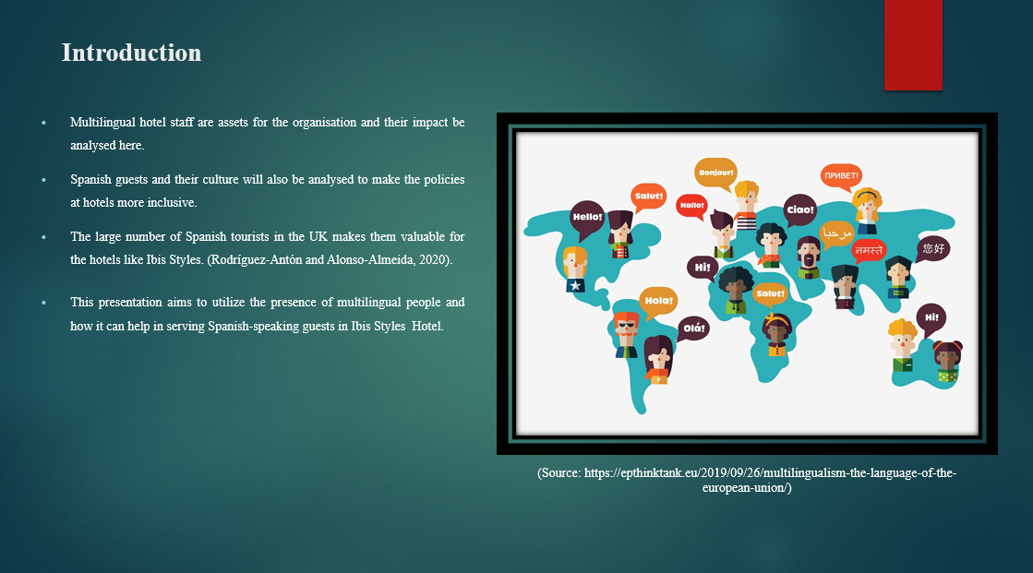
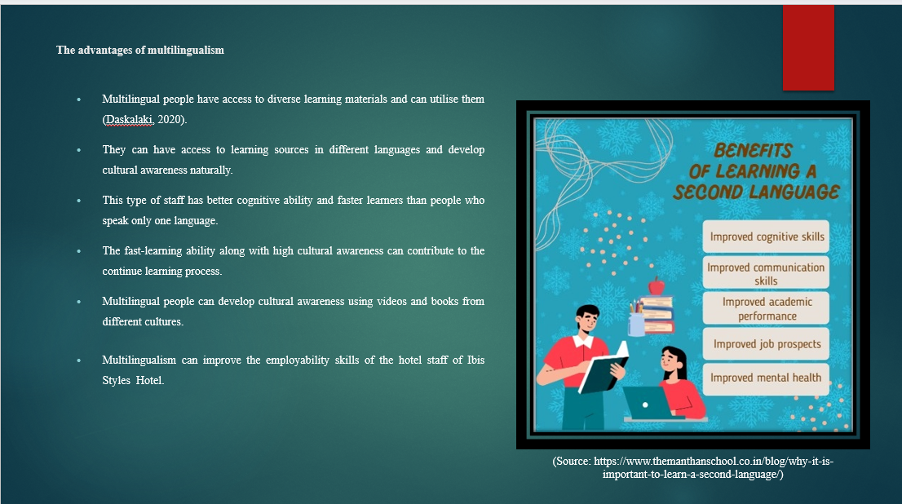

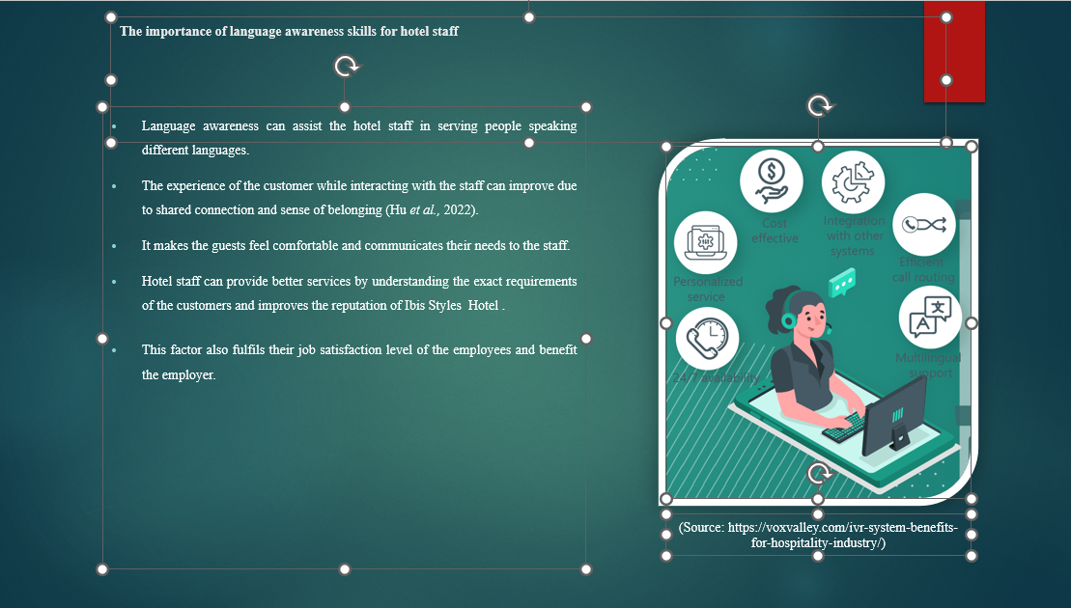
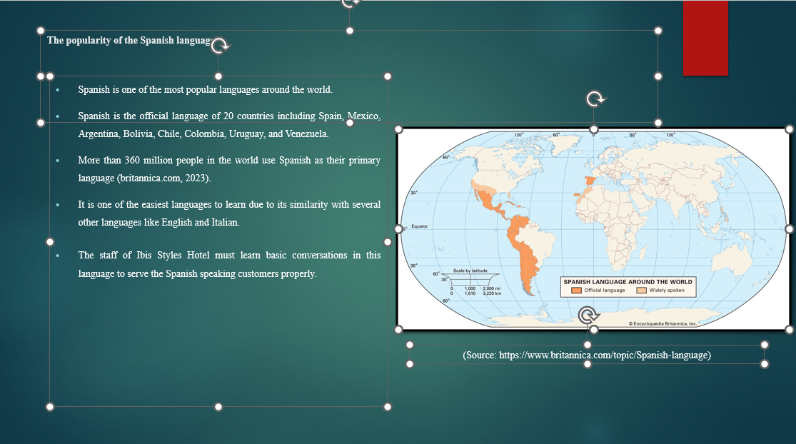

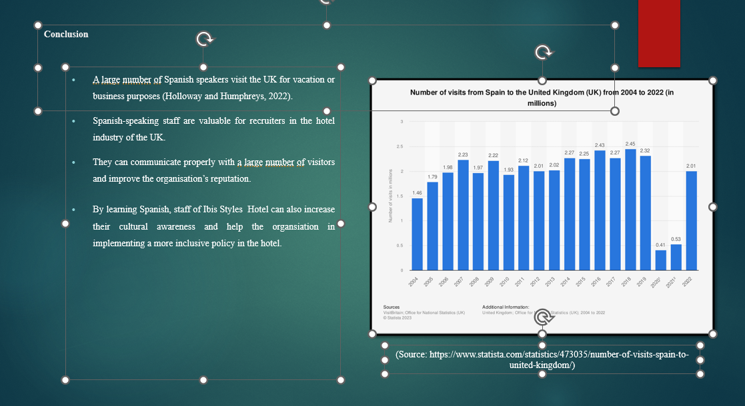
References (no screenshots):
britannica.com, 2023. Spanish language. Available on https://www.britannica.com/topic/Spanish-language [Accessed 23 January 2024].
Daskalaki, E., 2020. Cultural Diversity and Indicated Intercultural Implications in the Hotel Working Environment in the United Kingdom: Underpinning the Employee’s Perspective. The Market: International Journal of Business, 1, pp.91-107.
Holloway, J.C. and Humphreys, C., 2022. The business of tourism. Sage.
Hu, F., Trivedi, R. and Teichert, T., 2022. Using hotel reviews to assess hotel frontline employees’ roles and performances. International Journal of Contemporary Hospitality Management, 34(5), pp.1796-1822.
Rodríguez-Antón, J.M. and Alonso-Almeida, M.D.M., 2020. COVID-19 impacts and recovery strategies: The case of the hospitality industry in Spain. Sustainability, 12(20), p.8599.

