CONTENT – 6,000 – 8,000 words
INTRODUCTION (500) - (1362)
ESTATES
- The Council Estate: A Brief History (500) – (1627)
- Financial Hardship (500)
- Class (Lit. and Sociological Research) (500)
- Economic Oppression: Feminist Approaches, & Intersectionality (500)
- Estates Summary (500)
MINISTRY
- ‘A Church on Every Estate’: Ecclesiology (500)
- Estates-Ministry or Estate -Mission: Current Statistics (500)
- Utopian Vision: Realising Recommendations (500)
- Feminist Liberation Theology (Orthodoxy / Orthopraxis) (500)
- Voices of Christians Living on Estates (500)
- Estate-Ministry Summary (500)
CONCLUSION (500)
BIBLIOGRAPHY

INTRODUCTION
The ‘Estate’s Ekklesia: a vision for the fullness of life in Christ formed by wo/men living in areas in Britain where financial hardship is prevalent’ is a piece of research that will build upon the relatively modern phrase ‘estate-ministry’. The purpose of this thesis is to explore what is meant by ‘estate-ministry’ and to outline how this will inform the broader research. To have a vision for the ‘estate churches’, it is necessary to first understand the context and theology that underpins the notion of ‘estate-ministry’. The term compounds two concepts, each with its own complexity, bringing together; the place of the ‘estate’ and the practice of ‘ministry’, in an effort to convey in one term the context-specific work of Christian churches within social-housing estates in Britain.

The question this research seeks to answer is,
How might engagement with feminist liberation theologies encourage Christian wo/men, living in areas in Britain where financial hardship is prevalent, to form (/continue forming) a vision for fullness of life in Christ?

Feminist liberation theologies may be understood as ‘intersectional theologies’, which Ji-Sun Kim and Shaw argue have a
‘… wider inclusive, lens of gender, race, sexual identity, social class, ability, age, and nation…[which] brings the shifting, and often invisible structures of power and privilege to the fore and demands attentiveness to social location, and the simultaneity of subordinate and dominant identities in our theologizing. With its bias toward justice, in particular, intersectional theology calls us to prioritise the margins, and ensure our theologizing moves us toward a more just world by disrupting dominant paradigms and destabilizing structures of power while envisioning a way forward toward God’s reign of peace’.

Hence, feminist liberation theologies place ‘experience as the starting point of theological reflection’, and combine the defining features of liberation theology, with its prioritisation of the poor, concern for the ideology of class formation, and commitment to tackle societal injustice, with feminist theology that has ‘…a gendered form of suspicion towards ideological themes in theology and in its methods’. Althaus-Reid has shown that, the resulting hermeneutic of this intersection
‘…needs to begin with a shared experience among women from which feminine desire can emerge as a ‘text’ constructed by such community of women, yielding a phenomenological analysis of a hitherto a submerged Other, and ultimately a utopian vision that carries us beyond the present symbolic order from which women are excluded’.

Driving this concept forward, Schüssler Fiorenza suggests that,
‘A critical feminist the*logy of liberation thus seeks to delineate the power of religion as not only a destructive but also an emancipatory force. In analyzing the power of religion, it seeks to engage the theoretical analytics of gender as well as an intersectional analytic of the overlapping structures of oppression that constitute the multiplicative kyriarchal interlacing of domination. Such an intersectional the*logical analysis of religion from within is by definition also political’.

It is anticipated that feminist liberation theology may encourage wo/men to form / continuing forming a vision for fullness of life in Christ, particularly those living in areas where financial hardship is prevalent. It is important to be explicitly inclusive of women, as our voices are least heard despite often being considered the ‘gatekeepers’ of our estate communities. It is thought that women are more visible in these areas, perhaps because women are often the ones,
‘…living in the public sphere of government agencies, schools, healthcare, and they move around the estate with their children’.

Laurie Green describes ‘street mothers’ on estates and their ability to represent Jesus,
‘…there is something of the Street Mother about him – the person you pop round to see, who sorts things out for you, solves your problems and cuddles you when it’s all too much. But Street Mothers have their own lives to lead too and do sometimes tell you ‘…to get on with it and stand on your own feet’. Sometimes Jesus can be difficult like that’.

This notion was developed in my paper, ‘Street Mothers: How might a feminist critique of Christology impact the Christian faith of women on council estates in the UK?’

The context of the estate is inescapably at the fore of this research due to my own positionality as a working-class woman who: lived on estates for the majority of my life; worked in and studied social housing (CIH); whose family continues to live on estates and; now I serve as a priest on estates where people struggle to survive due to ‘severe economic deprivation’. Moreover, it is a key principle of the methodological approach of the feminist liberation theology to begin with the context and intentionally prioritise an exploration of where we begin our theological envisioning. Therefore, it is crucial that the term ‘estate’ must be understood as fully as possible from the outset of this research.

This thesis will be in two parts; firstly ‘Estates’, which covers the following topics: a brief history of estates in Britain, deprivation indicators, class, economic oppression: feminist approaches and intersectionality. The second section, ‘Ministry’, includes: ‘A Church on Every Estate’: Ecclesiology; ‘Estates-ministry’ or ‘Estates-mission’: Current Statistics; Utopian Vision: Realising Recommendations; Feminist Liberation Theology (Orthodoxy / Orthopraxis); and Voices of Christians Living on Estates. This begins the work of the Pastoral Cycle which was created through a theological understanding of urban settings, particularly where there was evidence of significant financial hardship, and, intentionally prioritises ‘context’ from the outset.

Methodologically, this research is intended to be ‘co-research’, which expects to develop a vision for the benefit of the wider Church; a sign and symbol of the disruptive work of feminist liberation theology from wo/men living in areas of financial deprivation. This is a strategic move away from the tendency of feminist theology that often expresses boundaries and can articulate what is not wanted readily, toward a future vision for the Church.

ESTATES
Those living in properties that are mainly state-funded / council housing, often use the term ‘estate’ as a point of reference to the area they live in. The concept of ‘social-housing’ is not unique to the British Isles, though, within this geographical boundary issues of class and social mobility web together in a unique and often inescapable way. The ‘Council Estate’ or ‘Schemes’ in Scotland (‘estate’ from here on) has a history with many political and social layers that have led to the current situation facing those living on estates today.

A BRIEF HISTORY
I remember applying for housing at age 16, when I had nowhere else to go, and being amazed that there were so many possibilities for where I could be housed. A form was handed to me that promisingly listed choices of different housing areas within my hometown, and detailed various types of accommodation. I sat in the council offices and filled in the required information just months before I would take my G.C.S.E exams, and it occurred to me that all might not be lost. What I had not realised was that I really had no option and, there never would be a response to my housing application. Instead, like many others, I found myself at the mercy of those who had space in their house for me to stay until my circumstances finally changed.

My experience is not unusual given the significant decline in the number of social housing properties built in recent years, combined with over two million social housing sales since 1980, and in England, there are over 1.2 million people on council housing waiting lists with less than half a million people being housed each year. A brief history of social housing will demonstrate that though social housing sales have exasperated statutory housing provision, this is not the only hurdle that has impacted the housing situations of many with low incomes in Britain.

Council Housing, and ‘affordable housing’ more generally, in Britain has suffered the whims of governments and economic crises like those experienced by the rest of Europe and elsewhere across the world. There are variations even among the countries that constitute Britain, with statistics for Wales, Scotland, and Northern Ireland often being created using different frameworks to those of England’s. Further, where the data is combined it often remains under the title ‘UK’ and can be difficult to separate into the individual countries, which complicates the task of discerning what the numbers actually represent.

Historically, housing provision for those with the lowest income in Britain was largely unsuitable and dangerous, however, there was an attempt to remedy this after the First World War with the introduction of council housing. In 1919 Christopher Addison, the minister of health at that time, would oversee the Housing and Town Planning Act; a grand vision of decent and affordable housing that would clear the slums and ensure that British people could live with dignity. These were meant to be decent places to live, with enough room and green spaces to enable for human flourishing, rather than the death and disease that had been ordinary for those living in slums and tied housing prior to the war. After the war, the King remarked in his speech that,
‘It is not too much to say that an adequate solution of the housing question is the foundation of all social progress. … A great offensive must be undertaken against disease and crime, and the first point at which the attack must be delivered is the unhealthy, ugly, over-crowded house in the mean street, which we all of us know too well’.

Nevertheless, it would only take two years for this vision to be halted; and in 1921 less than half of the 500,000 properties that the Act had committed to provide had been built, and the budget for slum-clearance throughout Great Britain was cut to an insulting £200,000 (approximately equivalent to £11 million today). It would take the Second World War to reignite the groundwork of the Act. By 1950 there was a surge of social housing construction with the creation of around 147,000 homes a year, and social housing made up a quarter of all housing throughout the 1960s.

It is well known that, under the Conservative Government led by Margaret Thatcher in the 1980s the “Right to Buy” was introduced across England, Scotland, and Wales and in Northern Ireland under a slightly different scheme. This policy, which allowed council tenants to purchase their rented social housing and highly discounted rates, subsequently decimated the housing stock of local authorities and, although it enabled a significant number of people to purchase their own property, it created an unsustainable system for providing social-housing for those most in need and has been a catalyst for animosity between low-income groups.&&

The Right to Buy was abolished in Scotland by 2016, and in Wales by 2018. Conversely, in England there was a reinvigoration of the policy with increasing discounts and reductions in the length of time a tenancy ought to be held before a tenant may qualify to purchase the property. The number of former council homes that are owner occupied has reduced over time. It is difficult to find positive arguments for the Right to Buy, and the outcome of this policy seems to have been to benefit private landlords over low-income tenants: 111 councils in England in 2017 provided data showing that over 40% of former council house are now being rented out by private landlords. Murie explains that,
‘For … those unable to obtain mortgages or buy properties – the long-term consequences of RTB and the failure to adopt policies to mitigate its effects have been very serious. It has reduced access to good quality housing within the public/social rented sector and has increased dependence on insecure private renting and benefits…The RTB delivered short-term gains to individuals but played a part in defunding housing provision. Overall, the policy represented a failure in strategic thinking and contributed to long-term problems of housing supply, condition, security and costs, inefficient use of subsidy and increased social segregation’.

ADD - CURRENT HOUSING LAW - ALLOCATIONS
Even in this very brief history of estates, it is clear that the vision for decent homes for low-income communities was not realised and has been eroded by policies that failed to value the importance of social-housing and estates as places of community. Today, social housing stock continues to diminish, and councils are not afforded budgets to replace housing at an equal rate. From the outset social-housing was a contested concept; in 1922 Lord Addison quoted a letter from the town clerk to a person seeking social housing, which reads:
‘I have to inform you that there are at present no vacant houses on any of the council’s estates. Your application has been received, and these will be considered in the event of a vacancy occurring on any of the estates or when the houses now being erected are completed. There are at present about 6,000 applications on the file’.

Although, I never did receive a letter addressing my own request for social-housing, I expect that it could very easily have been worded as above. Regrettably, during my time working in the social-housing sector, I wrote very similar letters to applicants on the housing register. The history of social housing demonstrates the impact housing policy can have on those with a low income. The notion of council estates, which began with a heroic vision of the working-class returning from war; people who deserved good places to rebuild their lives and communities, swiftly lost momentum and was only rekindled when the image of those in need was re-established after the second world-war. It is the image of those who need social-housing that must be considered if the estate is to be understood for the purpose of creating a fresh vision for the future.

FINANCIAL HARDSHIP
Estates are areas where people live; individuals as diverse and unique as anywhere else, nevertheless, the suitability for social-housing is determined by need, hence, financial hardship is a common factor for those living on estates. This forms part of the picture of generalised opinions of estates.

‘In 2022/23, 11.4 million people (17% of the UK) were living in relative poverty Before Housing Costs were deducted (BHC). 14.3 million people (21% of the UK) were living in relative poverty After Housing Costs were deducted (AHC).’

‘In 2022/23, 9.47m million people (14% of the UK) were living in absolute poverty before housing costs were deducted (BHC). Almost 12 million people (18% of the UK) were living in absolute poverty after housing costs were deducted (AHC).’
https://observatory.leeds.gov.uk/leeds-poverty-fact-book/relative-and-absolute-poverty/
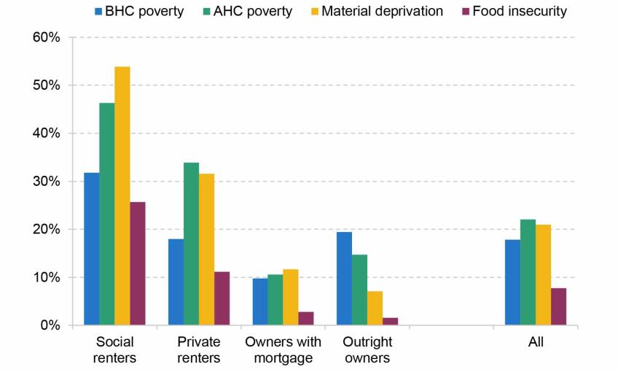
‘Facing higher housing costs, renters are considerably more likely than owner-occupiers to have low living standards on a variety of measures. Social and private renters have poverty rates of 46% and 34% respectively, compared with 12% for owner-occupiers. And they are also far more likely to be materially deprived or to live in food insecurity.’
https://ifs.org.uk/publications/housing-quality-and-affordability-lower-income-households#:~:text=Facing%20higher%20housing%20costs%2C%20renters,12%25%20for%20owner%2Doccupiers. [accessed 29.7.24] Waters, T and Wernham, T. (2023). Housing quality and affordability for lower-income households. London: Institute for Fiscal Studies. Available at: https://ifs.org.uk/publications/housing-quality-and-affordability-lower-income-households (accessed: 29 July 2024).
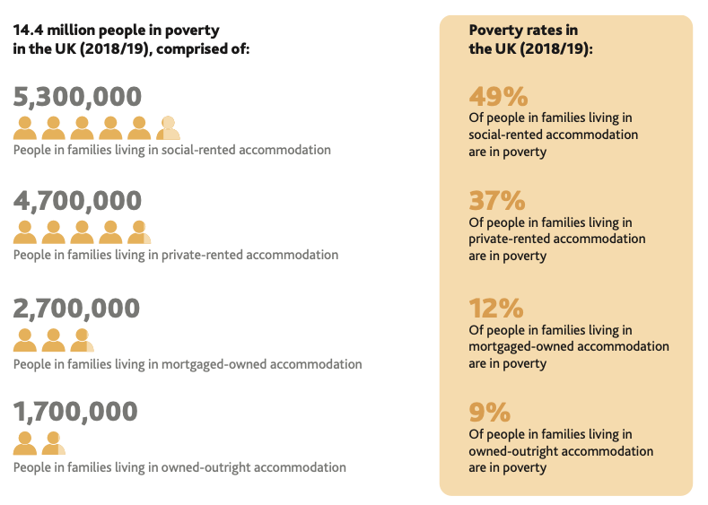
Poverty rates in the UK (2018/19):
- 58% Of children in social-rented accommodation are in poverty
- 51% Of children in private-rented accommodation are in poverty
- 15% Of children in mortgage-owned accommodation are in poverty
- 14% Of children in owned-outright accommodation are in poverty

Poverty rates in the UK (2018/19):
- 29% Of pension-age adults in social-rented accommodation are in poverty
- 26% Of pension-age adults in private-rented accommodation are in poverty
- 14% Of pension-age adults in mortgage-owned accommodation are in poverty
- 6% Of pension-age adults in owned-outright accommodation are in poverty
‘Over the course of the last two decades, the overall rate of poverty in the UK has barely changed. Figure 6 shows that, throughout the course of governments from across the political spectrum, a range of different approaches to tackling poverty, the financial crisis and subsequent recession and significant changes in approaches to fiscal and economic policy, the poverty rate has sat stubbornly between 21% and 24% of the UK population. This raises the question of whether it is possible to sustainably reduce the proportion of the UK population in poverty. In this respect, the Commission’s 2019 report highlighted that there is cause for confidence. In fact, there has been a significant fall in poverty amongst pension-age individuals and lone-parent families in the last two decades. These changes are likely to have been a result of sustained anti-poverty policy interventions targeted at these two broad groups’.

‘Individuals and households at greater risk of poverty include (DWP, 2012a): • self-employed people; • households with one or more people not working; • lone pensioners; • lone parents; • single adult households; • cohabiting rather than married couples; • children; • disabled people and people of minority ethnicity. Other variables known to be associated with poverty risk include migrant status (Ward, et al., 2009), female gender, poorer educational achievement, poor health and non-Christian religion (Hills, et al., 2010)’.

‘Household-level
Able to pay bills without cutting back on essentials
Able to put money aside for unexpected expenses
Cover cost of repair or to replace appliances
Home in good state of decoration/repair
Home adequately warm in cold weather
Home damp free
Reliable access to internet at home
Access to computer/tablet
Adequate access to reliable transport
Heating/electrics/plumbing in good working order
Home contents insurance
Individual-level
Three meals a day
Fresh fruit and/or vegetables every day
Annual break away from home
Without regular money worries
Regular payments to workplace or private pension
Appropriate clothes for work/job interview
Regular dental appointments
Go out socially at least monthly
See friends and family at least monthly
Small amount of money for oneself
School trips
Enough clothes feel comfortable wearing
Organised weekly activity outside school
Friends round monthly
Age suitable toys/games
Enough bedrooms for children 10+ years
Toddler/nursery/playgroup at least weekly
Place for homework’

https://www.gov.uk/government/publications/review-of-the-uk-material-deprivation-measures/summary-review-of-the-uk-material-deprivation-measures#qualitative-research-findings-and-short-listing-necessities [accessed 29.7.24]

Deprivation indicators in Britain do not offer specific data that differentiates areas of social-housing from private developments.
https://www.oxfordreference.com/display/10.1093/oi/authority.20110803095711624 Loss: lacking in desired objects or aims. Within the less developed countries deprivation can be acute: water, housing, or food may be lacking. Within the developed world basic provisions may be supplied but, in comparison with the better-off, the poor and the old may well feel a sense of deprivation. This is relative deprivation, which entails comparison, and is usually defined subjectively. In the UK, inequalities in health seem to be more marked in deprived areas than in more affluent ones (Norman et al. (2005) Soc. Sci. & Medicine 60), and in more affluent Western societies relative deprivation seems to be more important than absolute deprivation in determining population health (R. G. Wilkinson2005). ‘The impetus for social change comes not so much from changes in absolute deprivation, but from relative deprivation and it is this which perhaps above all threatens the sustainability of globalisation’ (Kaplinsky (2008) Geog. Compass 2, 2).
The cycle of deprivation is the transmission of deprivation from one generation to the next: lack of knowledge and skills all contribute to a cycle of deprivation, leaving the poor with few resources and many barriers to overcome.
‘In his 1979 account of Poverty in the United Kingdom Townsend sets out the case for defining poverty in relative terms: ‘Individuals, families and groups can be said to be in poverty if they lack the resources to obtain the types of diet, participate in the activities and have the living conditions and amenities which are customary, or at least widely encouraged or approved in the societies to which they belong’ 6 . Townsend further argues that ‘people can be said to be deprived if they lack the types of diet, clothing, housing, household facilities and fuel and environmental, educational, working and social conditions, activities and facilities which are customary …’ 7 . 2.2.2 Though ‘poverty’ and ‘deprivation’ have often been used interchangeably, many have argued that a clear distinction should be made between them8 . People are in poverty if they lack the financial resources to meet their needs, whereas people can be regarded as deprived due to a lack of resources of all kinds, not just income. ‘Deprivation’ thus refers to people’s unmet needs, whereas ‘poverty’ refers to the lack of resources required to meet those needs. The Index of Multiple Deprivation framework follows Townsend, in defining deprivation in a broad way to encompass a wide range of aspects of an individual’s living conditions. Townsend also lays down the foundation for articulating multiple deprivation as an accumulation of several types of deprivation. This formulation of multiple deprivation is the starting point for the model of small area deprivation which is presented here’.

Deprivation - Cost of living crisis ‘financial hardship’
England - https://data.cdrc.ac.uk/dataset/index-multiple-deprivation-imd#data-and-resources
– living environment
Income.
Health deprivation and disability.
Employment
Education, skills and training.
Crime
Barriers to housing and services
What does Severe Deprivation mean in practical terms?

Wales https://www.data.cymru/wimd & https://www.gov.wales/welsh-index-multiple-deprivation-index-guidance#32829
Income
Employment
Health
Education
Access to Services
Housing
Community safety.
Physical environment.

ENGLAND AND WALES: The dimensions of deprivation used to classify households are indicators based on four selected household characteristics. Education A household is classified as deprived in the education dimension if no one has at least level 2 education and no one aged 16 to 18 years is a full-time student. Employment A household is classified as deprived in the employment dimension if any member, not a full-time student, is either unemployed or economically inactive due to long-term sickness or disability. Health A household is classified as deprived in the health dimension if any person in the household has general health that is bad or very bad or is identified as disabled. People who have assessed their day-to-day activities as limited by long-term physical or mental health conditions or illnesses are considered disabled. This definition of a disabled person meets the harmonised standard for measuring disability and is in line with the Equality Act (2010). Housing A household is classified as deprived in the housing dimension if the household's accommodation is either overcrowded, in a shared dwelling, or has no central heating.

https://cpag.org.uk/child-poverty/what-poverty Individuals, families and groups in the population can be said to be in poverty when they lack resources to obtain the type of diet, participate in the activities and have the living conditions and amenities which are customary, or at least widely encouraged and approved, in the societies in which they belong.
Peter Townsend - sociologist and anti-poverty campaigner
Poverty is about money. It is a relative concept: what a family needs to look after their children and participate in society will depend on what others around them have.
Poverty can affect every aspect of a child’s life, from growing up in cramped, damp homes to going without a warm winter coat and being left behind when there are school trips.
The standard way to measure child poverty uses relative household income. A child is said to be living in poverty if they live in a household with income below 60 per cent of the national average (median) income.
- There are other ways of measuring poverty, including:
- absolute poverty or 'anchored' poverty - where the poverty line stays the same over time in real terms
- material deprivation indicators and things like food bank use
- measures of the depth and persistence of poverty

- https://publichealthscotland.scot/services/geography-population-and-deprivation-support/deprivation/
- Deprivation
- Measures of deprivation are used in analyses, research and publications for a variety of purposes including:
- measuring and monitoring inequalities in health and healthcare activity
- standardising health and healthcare activity measures for more meaningful comparisons between geographical areas.
- Deprivation takes many different forms in every known society.
- People can be said to be deprived if they:
"lack the types of diet, clothing, housing, household facilities and fuel and environmental, educational, working and social conditions, activities and facilities which are customary, or at least widely encouraged and approved, in the societies to which they belong"
(Townsend, P, 1987, cited in Measuring Deprivation in Scotland: Developing a Long-Term Strategy - Final Report).
Ideally, material deprivation would be measured on an individual basis using information on aspects such as income and employment or occupation. In practice, though, this information is not usually available. Instead, an area-based measure is used.
The deprivation level for the population of a small geographical area is estimated from aggregate data derived from the Census and other routine sources.
The area's deprivation level is then often used as the best available estimate of the deprivation level of individuals residing there.

- Northern Ireland https://www.nisra.gov.uk/sites/nisra.gov.uk/files/publications/NIMDM17-%20with%20ns.pdf The 7 domains of deprivation are: • Income Deprivation Domain • Employment Deprivation Domain • Health Deprivation & Disability Domain • Education, Skills & Training Deprivation Domain • Access to Services Domain • Living Environment Domain • Crime & Disorder Domain

CLASS: LITERATURE AND SOCIOLOGICAL RESEARCH
Measures

“‘Council estates’–the term and its negative connotations are retained–have been attacked by critics as ‘ghettos of the poor’. ‘Mixed tenure’, ‘mixed communities’ are the new mantra; the sell-off of council property to raise funds from profitable private development the ubiquitous means. ‘Social cleansing’ is an emotive term but the fact that in nearly all cases social housing stock has been reduced by regeneration and working-class tenants displaced in favour of better-off owner-occupiers and renters is undeniable.”

— Municipal Dreams: The Rise and Fall of Council Housing by John Boughton

https://workingclassstudies.wordpress.com/2016/01/18/estate-life-working-class-communities-and-social-housing/#:~:text=Council%20estates%20are%20social%20housing,working%2Dclass%20people%20for%20decades.
Council estates are social housing projects and part of the fabric of life in Britain. Council estates, whether low-density houses built on urban fringes or high-density inner-city apartment towers, have provided secure homes for millions of low-income working-class people for decades. Many working-class people have been raised on council estates, where they have grown up with a sense of community not often found in other neighbourhoods. Despite the negative stereotypes of council estate residents as welfare-dependent, criminal, and dysfunctional (stereotypes reinforced by television characters such as Little Britain’s Vicky Pollard), council estates have traditionally been close-knit communities whose residents are ready to help each other when times are tough. Because of secure council tenancies, low-income people have been able to enjoy the stability of a home during times of hardship.

Brian Lund Housing in the United Kingdom Whose Crisis? 2019 Manchester Palgrave Macmillan Class The class dimension to housing wealth in old age reflects the social stratification permeating the housing crisis. In recent years class had a low profile in political and academic discourse. In the 1970s and early 1980s there was a reasonable data supply linking class to housing outcomes but, by the 2000s, class as a variable in housing outcome analysis had almost disappeared. Indeed, Charlesworth (2000, p. 14) stated ‘Within the contemporary university, it is seen as a sign of backwardness to have any concern about class and one is met with a mixture of disbelief, ridicule and derision’. Allen (2008) has asserted that, in its preoccupation with consumption and postmodern debates related to urban gentrification , sociological research has neglected working class experiences. New Labour downplayed class focusing on ‘social exclusion ’—an idea including the ‘underclass ’—and highlighted other inequality dimensions such as gender and ethnicity . Its 2010 Equality Act listed nine protected characteristics to which the legislation applied: age ; disability; gender reassignment; marriage and civil partnership; race; religion or belief; sex and sexual orientation. Class was not included, although Part 1 of the Act stated: An authority to which this section applies must, when making decisions of a strategic nature about how to exercise its functions, have due regard to the desirability of exercising them in a way that is designed to reduce the inequalities of outcome which result from socio-economic disadvantage . ‘Socio-economic disadvantage’ may incorporate class but can be interpreted as ‘social exclusion ’, an idea that elevates ‘social’ capital —the value of the social networks people can draw on that may accrue from living in a neighbourhood —and ‘human capital ’—the skills, knowledge, and experience possessed by an individual—to the relative neglect of economic capital. The coalition government axed the socio-economic disadvantage duty. Marx claimed that there were two main classes, a bourgeoisie owning the means of production and a proletariat without capital. Through owning the means of production, capitalists are able to exploit the working class by purloining all the surplus value it produced by workers. Renwick (2017) has recorded how, influenced by concerns about differential fertility rates and ‘degeneration’, the Registrar General’s Office developed a ranked group hierarchy with a manual/non manual dimension running through the classification but with divisions within these groups. This class taxonomy was absorbed into social research with the classifications varying over time but basically consisting of a population division based on occupation. The upper middle class (higher managerial, administrative or professional) was in Grade A. The middle class (intermediate managerial, administrative, professional) were assigned to Grade B. C1 was the lower middle class (supervisory, clerical, and junior managerial, administrative, professional). The working class was split into skilled manual workers (C2) with semi-skilled and unskilled manual workers, labelled D. Grade E consisted of casual workers and those depending on state welfare for their incomes. Academic and state information on social class was based on this classification. In recent years, some sociologists have put forward a class representation downgrading economic capital as only one of three dimensions in class formation, the others being ‘social’ and ‘cultural’ capital with ‘social’ referring to contacts and connections allowing people to draw on their social networks and ‘cultural’ such as the ability to engage in artistic and intellectual circles plus the credentials institutionalised through educational success (Bourdieu 1984; Savage et al. 2015). Demoting the class economic dimension has contributed to a current statistical dearth on how economic class—with occupation the principal class identifier (National Centre for Social Research 2016)—affects housing outcomes with income often having to be used as a proxy for class. Such class indifference has proved unfortunate for power holders as the 2016 European Referendum and 2017 General Election voting patterns revealed (see Chapter 8). The sparse contemporary information on housing/class relationships reveals stark and growing contrasts between social classes in housing outcomes. As examples, Shelter ’s examination of housing conditions on affordability , quality, tenure stability, neighbourhood and space found sharp class divisions on all the dimensions under scrutiny (Shelter 2016a, b). Green (2017) demonstrated that, in 2001, compared with young people with parents in semi-skilled and unskilled jobs, those with parents in professional and associate professional employment were 1.5 times more likely to own a home. By 2013, young people whose parents had professional jobs were 2.39 times more likely to own a home as those whose parents were in semi or unskilled work. Help from the ‘bank of Mum and Dad ’—now the UK’s ninth most important mortgage financier—has contributed to this class divide. Gender In the past, women had few opportunities to obtain a secure income other than to acquire a male partner. Fortunately, these dark days have gone, but gender divisions in housing outcomes remain. Women’s lower earnings—the median gender pay gap was 9.1% in 2017 ( Guardian 2017b)—influence access to homeownership but becoming a homeowner now depends on two incomes with implications for women’s ‘double shift’ work/domestic duties. Reliance on two incomes is manifest in the housing circumstances of single-parent families —91% headed by women—with only 11.7% of never-married single parents living in the owner-occupied sector, 48.5% living in social housing and 39.9% in the private landlord sector (see Chapter 3). Old age also reveals the salience of a partner. By the age of 78 the male/female ratio is 82/100 but, by 90 + , it is 40/100. Reduced resources—with limited income and wealth from past gender differences in pay, pension entitlements and domestic duties—undermines the ability of older women to enjoy good housing conditions (see Chapter 3).
Underclass?
Class and faith
Many
‘... Outer housing estates were quite literally designed with exclusion in view. Planners thought it would enhance the sense of community if they boxed estates in on themselves, served only by a single Rd access. But this only made it more difficult to get off the estate at all, so that access to leisure and shopping facilities was almost impossible for those who could not afford a car. Journeys to work were sometimes impossible. Today, these outer estates have all the deprivation of the inner cities, compounded by the isolation and lack of infrastructure normally found in pockets of rural deprivation… these states have often been plagued by years of local authority mismanagement, which is totally unbalanced communities, leaving the elderly isolated from their families and terrified of the new youth culture which has taken over their streets. With escalating poverty and lack of employment, summer states begin to evidence a dependency culture. At its worst, the professional carers and officers have become dependent upon those who serve for their own sense of worth and even salary, while those receiving care have become adept at working the benefit system and at little else. It is as if there is a conspiracy of dependency.’

Class and the Council Estate using George Orwell’s ‘Keep the Aspidistra Flying’ [Aspiration and inspiration for the working class into middle class lifestyle – leading to dissonance] [Cultural class access to network] [Putnam – Bridging, Bonding, and Linking (Bowling for Soup) – class connections (pseudo-appropriation of slang by middle-classes to communicate with working-class – goes unchallenged – imperialistic language]
In George Orwell’s book ‘Keep the Aspidistra Flying’, we read of a man trapped in poverty and unable to release himself without compromising his integrity. He moves backwards and forwards between the peace of living in freedom, and the hypocrisy of an aspirational life (aspiring to be other than that which he is):
‘He locked the door behind him and lay on the bed, smoking a cigarette. He must get out of this place, and quickly! Tomorrow morning he would clear out. No more sponging on Ravelston! No more blackmail to the gods of decency! Down, down, into the mud-down to the streets, the workhouse and the jail. It was only there he could be at peace’. P.219

‘He was making roughly in the direction of home. He looked up at the houses he was passing…aspidistras in nearly all. A typical lower–middle-class street. But not, on the whole, the kind of street that he wanted to see blown to hell by bombs. He wondered about the people in houses like those. They would be, for example, small clerks, shop-assistants, commercial travellers, insurance touts, tram conductors. Did they know that they were only puppets dancing when money pulled the strings? You bet they didn’t. And if they did, what would they care? They were too busy being born, being married, begetting, working, dying….(p.268)… they lived by the money-code, sure enough, and yet they contrived to keep their decency… They ‘kept themselves respectable’ - kept the aspidistra flying. Besides, they were alive. They were bound up in the bundle of life…The Aspidistra is the tree of life, he thought suddenly.’

George Orwell’s book was first published in 1936; he opens the book with an adaptation of 1 Corinthian’s 13, where he inserts ‘money’ as a substitute for ‘love’: ‘… And though I have all Faith, so that I could remove mountains, and have not money, I am nothing’
Link this to the previous paragraph

The council-estate, the areas of housing provided for those most who have little hope of affording private rental properties and, importantly, who meet the stringent housing allocation policy of local authorities in Britain, are perhaps the places in-between the poverty Orwell describes, and the aspiring middle-class who find a way to the safety net of stable housing and income. The vision was admirable, a strategic step away from the decay and misery of slums and the possibility of respectable living for those who provide the labour at the bottom of an insatiable British economy (REF).

Sam Friedman and Daniel Laurison have shown that that cultural capital functions in such a way that
“... particular tastes and aesthetic styles, [have] a more everyday currency as a signal of cultural distinction. The effects of class origin... Are pervasive and long lasting. And class origin shapes who you are in ways that are simple changing circumstances dash having more money, a university education or a better job than your parents dash will not necessarily erase. This is not to say that people do not learn and change over their lives, and adapt to new situations dash of course we do. But this work suggests our early years leave a deep, and classed, imprint. As I met Kuhn, a British film critic, famously argued, “class is something beneath your clothes, under your skin, in your reflexes, you psyche, at the very core of your being.’

Diane Reays highlights the “many different ways of embodying working-classness…’
‘... It may be confusing to make sense of the changes in working-class composition from the working class of mines, steelworks and factories to one of supermarkets, call centres and offices; but thinking through class is still vital because it makes us confront the issue of who has wealth and power. It also focuses our attention on which stories and versions of the social world are listened to, and encourages us to ask why. Yet, while there is growing commentary on economic and social inequalities in England it rarely uses the language of social class. When it does, as it has post-Brexit, either it is in order to pathologise the working classes or else it is appropriated by one faction within the elite in order to attack another. Class is a zombie category.’

Class: intersections
‘Class, to paraphrase academic and literary critic Raymond Williams, is one of the two or three most complicated words in the English language. This is, indeed, because of both its history and how it has come to be used by academics, governments, individuals and communities. On the one hand ‘class’ Is quite a technical term, based on the jobs people do. On the other, it forms a crucial part of the sense of identity many people in Britain hold as part of their everyday lives, as well as their cultural expressions.’

See the NS – SEC (National statistics, society – economic classification) clusters together, occupations in eight groups.
“Social surveys often show a big gap between the numbers of people who would be classified as working in class, because their occupation is in the NS – SEC VI – VIII categories, and those who describe themselves as working class. Part of this self-description is about describing the feeling of being ordinary, just like everybody else. It is also a self-description that tells us about people’s class origins. People’s class origins, in technical terms are about what parents’ occupations were when they were growing up. This tells us a great deal about the class origin when we’re thinking about the big picture of who is from which occupational NS– SEC starting point.”

… talks about social, mobility, and education, and intersection between gender, ethnicity, disability, sexuality, and immigration.

Mike savage endorses
“... the arguments of numerous other researchers such as Imogen Tyler, Tracy Shildrick, Robert MacDonald and Beverly Skeggs, and social policy experts such as John hills, in insisting that in reality the lives of those at the bottom are not characterised by a moral scrounging on the Benefit Street model, but are in fact based on precariousness. Challenging the stereotypes which abound involves presenting new and more challenging classifications as we have done in our analysis of the Great British Class Survey’.

demographics - For more information on the Great British Class Survey, see Fiona Devine and Helene Snee, “Doing the Great British Class Survey”, sociological review, 63 ( 2 ), 2015, 240-58]
Sociology (structural inequality) vs psychology (personal ability and intellect)
Utopia?
“The issue certain people have with tower blocks is not safety, but the fact that poor people live in them, that they exist at all…instead, we should clamour to make everyone's home safe, require hyper vigilance on building regulations and installations, and demand that everyone had the right to a safe and permanent home. ”

Lynsey Hanley: estates an intimate history
P .97 “There is one phrase in the English language that has come to be larded with even more negative meaning than ‘council estate’, and that is ‘tower block’. There has to be some reason why people who waited years for coveted home from ‘the Corpy’ wouldn't wish the same for their own grandchildren; some reason why the word ‘council’ has become a pejorative term, which can be used to ridicule people's clothing, their hairstyles, their ways of speaking, the brands of cigarette they smoke and the alcohol they imbibe. Housing seems to have been the one great failure of the welfare state. It is the one area where public investment intended to narrow the gap between rich and poor eventually served to create a firm and visible wall between them. The late Chris Holmes, former director of the housing charity Shelter, wrote in 2003 that

“Housing poverty is now the most extreme form of social inequality in Britain.’ It's hard not to agree. Slums may no longer truly exist in absolute terms, but there is no word that [/ P .98] is better suited to describing some of the very worst local authority housing - some of it seventy years old, some of it built in the 1980s - which fails to provide even the basic necessities of dryness and warmth. Tower blocks, in the public mind, represent all that is worst about the welfare state: the failure to provide the kind of housing that most people regard as a prerequisite for happy family life; lack of choice; dependence and isolation; bureaucracy prioritised over standards; individuals placed at the mercy of their faceless local authority that seems to maintain or leave to rot its housing on a whim. And concrete. Ugly concrete.’”

MINISTRY
‘A Church on Every Estate’: Ecclesiology
Ecclesiology mission [marks of mission]
Poor houses – church funded accommodation – national strategy

ESTATES-MINISTRY OR ESTATE -MISSION: CURRENT STATISTICS
Parish System - Log of estate churches - estates evangelism task group
The church of England, which is never quite sure of its own identity,[ Say a little more perhaps at the start where you set out terms and meanings for the work. Where the CofE sits is important to your work] often nestles within, or on the edge of, an estate claiming it as its parish. This act of naming alone serves to stabilise otherwise transient and uncertain areas, and can give a sense of worth to communities that find their resource is more and more limited by the day (REF). There is an irony in the phrase ‘estate-ministry’ when to those who know the meaning it is almost unimaginable that it could be anything other than social-housing estates, public housing, areas in Britain are ……..
The extent to which churches in Britain aim to emancipate those oppressed by economic disparity, or unknowingly exasperate the intersecting tensions, is a debatable and emotive topic. Therefore, it is regrettable that only a small pool of academic study directly deals with these issues.

UTOPIAN VISION: REALISING RECOMMENDATIONS
Faith in the City
Laurie Green
God in the City

VOICES OF THOSE LIVING ON ESTATES (1000)
- Vlogs NECN
- Ellen Clark King
- Speakers at Events
- Research
- (authenticity and integrity)

CONCLUSION (500)

Feminist Liberation Theology (Leading each other to Liberty)
NEW THREEFOLD MODEL TO INTEREGATE: Conservative Christian Tradition / Feminist Issue / Class
‘On the one hand, we cannot produce theologies for which we claim universal applicability; on the other hand, we can only produce theologies that we do from our social locations, and so each of us has something significant to add to the whole of Christian theology. Without each of our contributions, the whole is less adequate, less descriptive of the entirety of theological possibility.’

Bibliography
Addison, C, The Betrayal of the Slums (London: H. Jenkins Ltd, 1922)
Althaus-Reid, M, From Feminist Theology to Indecent Theology: Readings on Poverty, Sexual Identity and God (London: SCM Press, 2004)
Barrett, A, and R Harley, Being Interrupted: Reimagining the Churches Mission from the Outside, In (London: SCM Press, 2020)
Cowan, S, ‘Street Mothers: How Might a Feminist Critique of Christology Impact the Christian Faith of Women on Council Estates in the UK?’, Feminist Theology, 30 (2022)
Friedman, S, and D Laurison, The Class Ceiling (Bristol: Policy Press, 2020)
Green, L, Urban Ministry and the Kingdom of God (London: SPCK)
Green, Laurie, Blessed Are the Poor? Urban Poverty and the Church (London: SCM Press, 2015)
Hanley, L, Estates: An Intimate History (London: Granta Publications, 2023)
Isherwood, Lisa, Embodying Feminist Liberation Theologies: A Special Edition of Feminist Theology: Vol 12.2, ed. by Beverley Clack (London, 2004)
Ji-Sun Kim, G, and S M. Shaw, Intersectional Theology: An Introductory Guide (Minneapolis: Fortress Press, 2018)
L, Green., Let’s Do Theology (London: Mowbray, 1990)
McKenzie, L, Getting By: Estates, Class and Culture in Austerity Britain (Bristol: Policy Press, 2015)
McLennan, D, S Noble, M Noble, E Plunkett, G Wright, and N Gutacker, The English Indices of Deprivation 2019 (London, 2019)
Murie, A, ‘Right to Buy: The Long View of a Key Aspect of UK Housing Policy’, in Housing Policy in a Changing World, ed. by M Stephens (Coventry: Chartered Institute of Housing, 2023), pp. 101–10
O’Brien, D, ‘Class and Publishing: Who Is Missing from the Numbers?’, in Common People: An Anthology of Working Class Writers, ed. by K de Waal (London: Unbound, 2019)
Orwell, G, Keep the Aspidistra Flying (London: Penguin Books, 2014)
Powell, R, ‘Housing, Ethnicity and Advanced Marginality in England’, in Class, Ethnicity and State in the Polarized Metropolis, ed. by J. Flint and R Powell (London: Palgrave, 2019), pp. 187–212
Reay, D, Miseducation: Inequality, Education and the Working Classes (Bristol: Policy Press, 2017)
Savaage, M, Social Class in the 21st Century (London: Pelican Books, 2015)
Schüssler Fiorenza, E, Congress of Wo/Men: Religion, Gender, and Kyriarchal Power (Cambridge: Feminist Studies in Religion, 2016)
Shüssler Fiorenza, E, Wo/Men, Scripture, and Politics: Exploring the Cultural Imprint of the Bible (Oregon: Cascade Books, 2021)
Slee, N, F Porter, and A Phillips, eds., Researching Female Faith: Qualitative Research Methods (London: Routledge, 2018)
Stephens, M, and J Perry, ‘How the Purpose of Social Housing Has Changed and Is Changing’, in Housing Policy in a Changing World, ed. by M Stephens (Coventry: Chartered Institute of Housing, 2023), pp. 65–75
Stroud, P, MEASURING POVERTY 2020 (London, 2020)

Websites and Downloadable Documents
https://publications.parliament.uk/pa/cm5801/cmselect/cmcomloc/173/17305.htm [accessed 23.3.24]

https://www.insidehousing.co.uk/insight/what-europe-can-teach-us-about-social-housing-82579 [accessed 8.4.24]

https://assets.ctfassets.net/6sxvmndnpn0s/1byrK8fEQut88x9kk4w6cP/0d3452ab160befa27c832f1e1ae83f8e/International_examples_of_affordable_housing_-_Shelter_URBED_Trust.pdf [accessed 8.4.24]
https://www.gov.uk/government/collections/local-authority-housing-data [accessed 8.4.24]
https://godwingroup.co.uk/developments/ [accessed 8.4.24]
https://api.parliament.uk/historic-hansard/commons/1919/nov/21/statement-by-dr-addison [accessed 8.4.24]
https://assets.publishing.service.gov.uk/media/5d8e26f6ed915d5570c6cc55/IoD2019_Statistical_Release.pdf [accessed 3.5.24]
https://womenpriests.org/theology/ackermann-feminist-liberation-theology/ [accessed 14.6.24]
https://godwingroup.co.uk/developments/ [accessed 8.4.24]
https://api.parliament.uk/historic-hansard/commons/1919/nov/21/statement-by-dr-addison [accessed 8.4.24]

Appendix
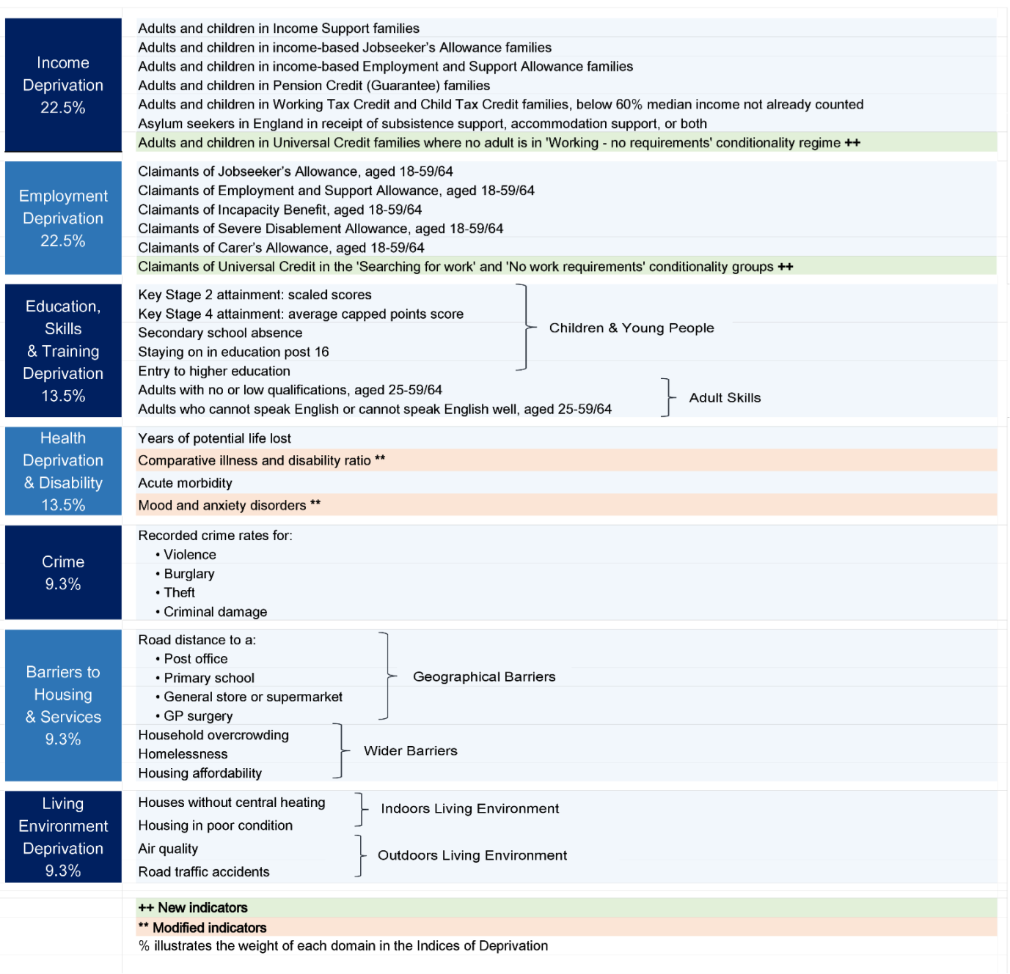
https://assets.publishing.service.gov.uk/media/5d8b387740f0b609909b5908/IoD2019_Technical_Report.pdf [accessed 29.7.24]

https://estatechurches.org/
G Ji-Sun Kim and S M. Shaw, Intersectional Theology: An Introductory Guide (Minneapolis: Fortress Press, 2018), pp. 44–45.
Ji-Sun Kim and M. Shaw, p. 45.
Lisa Isherwood, Embodying Feminist Liberation Theologies: A Special Edition of Feminist Theology: Vol 12.2, ed. by Beverley Clack (London, 2004), p. 148.
M Althaus-Reid, From Feminist Theology to Indecent Theology: Readings on Poverty, Sexual Identity and God (London: SCM Press, 2004), p. 11.
Althaus-Reid, p. 3.
Althaus-Reid, p. 44.
E Schüssler Fiorenza, Congress of Wo/Men: Religion, Gender, and Kyriarchal Power (Cambridge: Feminist Studies in Religion, 2016), p. 7.
Schüssler Fiorenza uses the term ‘wo/men’ to show that, ‘the feminine form of grammar is inclusive of men and to indicate that gender labels are socio-politically constructed rather than given or natural’. E Shüssler Fiorenza, Wo/Men, Scripture, and Politics: Exploring the Cultural Imprint of the Bible (Oregon: Cascade Books, 2021), p. 1.
A Barrett and R Harley, Being Interrupted: Reimagining the Churches Mission from the Outside, In (London: SCM Press, 2020), pp. 57–58.
L McKenzie, Getting By: Estates, Class and Culture in Austerity Britain (Bristol: Policy Press, 2015), p. 51.
Laurie Green, Blessed Are the Poor? Urban Poverty and the Church (London: SCM Press, 2015), p. 146.
S Cowan, ‘Street Mothers: How Might a Feminist Critique of Christology Impact the Christian Faith of Women on Council Estates in the UK?’, Feminist Theology, 30.3 (2022).
CIH (4) Merit in 2014 whilst working for Northampton Borough Council as a Housing Applications Officer https://www.cih.org/education/qualifications [accessed 8.4.24]
https://assets.publishing.service.gov.uk/media/5d8e26f6ed915d5570c6cc55/IoD2019_Statistical_Release.pdf [accessed 3.5.24]
Green. L, Let’s Do Theology (London: Mowbray, 1990), p. 30.
L, pp. 24–25.
Researching Female Faith: Qualitative Research Methods, ed. by N Slee, F Porter, and A Phillips (London: Routledge, 2018), p. 33.
‘Schemes’ in Scotland.
https://assets.ctfassets.net/6sxvmndnpn0s/6mvsDCkpUoz2xLJypI5Wmk/574e0f70d447b24075f89af8c57fb17e/International_examples_of_affordable_housing_-_Shelter_URBED_Trust.pdf [accessed 23.3.24]
https://shelterforce.org/2023/08/03/what-can-we-learn-from-the-u-k-s-council-housing-hint-vienna-isnt-the-only-example-of-transformative-social-housing/ [accessed 27.7.24] & https://www.socialistparty.org.uk/articles/120978/14-02-2024/british-homes-for-british-workers-a-toxic-policy/ [accessed 27.7.24]
https://www.gov.uk/government/statistics/right-to-buy-sales-and-replacements-england-2021-to-2022/right-to-buy-sales-and-replacements-england-april-2021-to-march-2022#:~:text=Since%20the%20start%20of%20the,the%20Right%20to%20Buy%20scheme.&text=In%202021%2D22%2C%20local%20authorities%20reported%2010%2C878%20eligible%20sales.&text=From%20these%2010%2C878%20sales%2C%20local%20authorities%20received%20%C2%A31%2C064%20million. [accessed 27.7.24]
https://www.gov.uk/government/statistics/social-housing-lettings-in-england-april-2021-to-march-2022/social-housing-lettings-in-england-tenants-april-2021-to-march-2022#:~:text=5.1%20How%20long%20is%20the,lists%20has%20fallen%20by%2034%25. [accessed 27.7.24]
https://www.gov.uk/government/statistics/social-housing-lettings-in-england-april-2021-to-march-2022/social-housing-lettings-in-england-tenants-april-2021-to-march-2022 [accessed 27.7.24]
This is the most recent term used through government publications to describe housing that meets the requirements of social housing legislation.
https://www.insidehousing.co.uk/insight/what-europe-can-teach-us-about-social-housing-82579 [accessed 8.4.24]
https://assets.ctfassets.net/6sxvmndnpn0s/1byrK8fEQut88x9kk4w6cP/0d3452ab160befa27c832f1e1ae83f8e/International_examples_of_affordable_housing_-_Shelter_URBED_Trust.pdf [accessed 8.4.24]
https://www.gov.uk/government/collections/local-authority-housing-data [accessed 8.4.24]
https://publications.parliament.uk/pa/cm5801/cmselect/cmcomloc/173/17305.htm [accessed 23.3.24]
https://publications.parliament.uk/pa/cm5801/cmselect/cmcomloc/173/17305.htm [accessed 23.3.24]
https://hansard.parliament.uk/Commons/1931-04-14/debates/d291866e-0b97-4d21-9759-248b57a0b66d/CommonsChamber [accessed 27.7.24]
https://www.insidehousing.co.uk/comment/addisons-framework-was-scrapped-but-its-legacy-is-more-important-than-ever--62374 [accessed 27.7.24]
https://www.housing.org.uk/about-housing-associations/about-social-housing/#:~:text=Social%20housing's%20first%20big%20breakthrough,planning%20how%20to%20meet%20them. [accessed 27.7.24]
A Murie, ‘Right to Buy: The Long View of a Key Aspect of UK Housing Policy’, in Housing Policy in a Changing World, ed. by M Stephens (Coventry: Chartered Institute of Housing, 2023), pp. 101–10 (p. 102).
https://publications.parliament.uk/pa/cm5801/cmselect/cmcomloc/173/17305.htm [accessed 23.3.24]
‘…Right to Buy … has seen the number of social rent homes reduced by 1.5 million since 1980. Around 40 per cent of homes bought under Right to Buy are now in the private rental sector. It has been abolished by devolved administrations in Scotland and Wales. If that political choice is currently unacceptable in the English context, we must at the very least ensure that councils receive the full receipts from Right to Buy sales and that that money is re-invested in the social rent homes of the future’. https://www.local.gov.uk/topics/housing-and-planning/council-housing-100/future-council-housing [accessed 8.4.24]
https://www.crisis.org.uk/ending-homelessness/housing/housing-models-and-types/ [accessed 27.7.24]
M Stephens and J Perry, ‘How the Purpose of Social Housing Has Changed and Is Changing’, in Housing Policy in a Changing World, ed. by M Stephens (Coventry: Chartered Institute of Housing, 2023), pp. 65–75.
R Powell, ‘Housing, Ethnicity and Advanced Marginality in England’, in Class, Ethnicity and State in the Polarized Metropolis, ed. by J. Flint and R Powell (London: Palgrave, 2019), pp. 187–212.
Murie, p. 105. ‘…with increased maximum discounts (£75,000) in 2012; a higher rate for London (£100,000) in 2013; increased maximum percentage discounts (70 per cent) for houses in 2014; and the qualifying tenancy reduced (from five to three years) in 2015. Discounts for houses started at 35 per cent for tenancies between three and five years, rising by one per cent to 70 per cent after 40 years; for flats, started at 50 per cent for tenancies between three and five years, rising by two per cent to 70 per cent after 20 years. From 2015 maximum cash discounts were increased annually in line with the Consumer Price Index (by 2021, £112,800 in London and £84,600 elsewhere)’.
https://lordslibrary.parliament.uk/right-to-buy-past-present-and-future/ [accessed 27.7.24]
Murie, p. 109.
L Hanley, Estates: An Intimate History (London: Granta Publications, 2023), p. 225.
C Addison, The Betrayal of the Slums (London: H. Jenkins Ltd, 1922), pp. 109–10.
P Stroud, MEASURING POVERTY 2020 (London, 2020), p. 46.
Stroud, p. 89.
Stroud, p. 100.
Stroud, p. 27.
D McLennan and others, The English Indices of Deprivation 2019 (London, 2019), pp. 9–10.
https://www.ons.gov.uk/census/maps/choropleth/population/household-deprivation/hh-deprivation/household-is-deprived-in-one-dimension [accessed 27.7.24]
L Green, Urban Ministry and the Kingdom of God (London: SPCK), p. 7.
G Orwell, Keep the Aspidistra Flying (London: Penguin Books, 2014).
S Friedman and D Laurison, The Class Ceiling (Bristol: Policy Press, 2020), p. 17.
D Reay, Miseducation: Inequality, Education and the Working Classes (Bristol: Policy Press, 2017), p. 1.
Reay, pp. 6–7.
D O’Brien, ‘Class and Publishing: Who Is Missing from the Numbers?’, in Common People: An Anthology of Working Class Writers, ed. by K de Waal (London: Unbound, 2019), p. 275.
O’Brien, pp. 276–77.
M Savaage, Social Class in the 21st Century (London: Pelican Books, 2015), p. 405.
https://www.theguardian.com/housing-network/2017/jun/16/help-grenfell-tower-campaign-housing-rights [accessed 8.4.24]
Hanley, pp. 97–98.
Ji-Sun Kim and M. Shaw, p. 41.

