How does Aesthetics Inform an Understanding of Pattern?

Name: Rebecca Williams
Number: P146743

Course: BA Illustration
Tutor: Julia Lockheart
Word Count: 5,600

Contents

List of Illustrations …Page 3

Introduction …Page 4-5

Chapter 1: Cognitive Patterning …Page 6-18

Chapter 2: The Influence of Nature within Pattern …Page 19-24

Chapter 3: Patterning my Own Practice …Page 25-30

Conclusion …Page 31-32

Bibliography …Page 33-34

List of Illustrations

Figure 1. Fruit, William Morris, 1866 …Page 9

Figure 2. Mohnköpfe, Koloman Moser, 1900 …Page 10

Figure 3. Chrysanthemum, William Morris, 1877 …Page 11

Figure 4. 66 Tile panel, William Morris, 1876 …Page 14

Figure 5. The 1953 Coronation Mug, Angie Lewin, 1953 …Page 16

Figure 6. Nature Table Cushion Cover, Angie Lewin, No date …Page 17

Figure 7. Dandelion, Rebecca Williams, 2016 …Page 25

Figure 8. Pink Buds, Rebecca Williams, 2017 …Page 28

Introduction

The aim of this dissertation is to examine whether there is an overall aesthetic answer regarding the form and composition within pattern design on a visual level. It will attempt to understand what the term ‘aesthetically pleasing’ refers to exactly and as a whole what it takes to make a pattern display aesthetic values.

It will consider the role played by cognition and evaluate whether the cognitive process is involved in a general aesthetic response or if it is an emotional response. This then leads to the further discussion of whether it is based on individual thought or if there is a higher collective agreement that commands aesthetic appreciation of pattern. Chapter one will explore theories relating to cognition, such as David Brett (2005) and James Hogg (1969) who similarly consider that cognition is at least partly responsible for aesthetic value. Whereas renowned theorists Immanuel Kant (2005) and Clive Bell (2003) express strong opposing views and deny the cognitive concept involved.

Using Brett’s (2005) two aspects of pattern in which he states that the abstract motif based patterns more aesthetic than those of representational content, I will demonstrate the differences of the two categories through visual examples using patterns of the nineteenth century created by Koloman Moser (1900) and William Morris (1877). Secondly, I will investigate the effectiveness of the eight principles proposed in The Meier Art Judgement Test (1969) in order to evaluate aesthetic quality and its plausibility by analysing the more contemporary works of Angie Lewin (1953).

In Chapter two, the focus will be on Nature and natural forms within decoration. I will look at Owen Jones (1868) who had a strong influence over decoration during the nineteenth century and explore his set of aesthetic principles of the relationship between nature and pattern. The main aim of this chapter will be to understand why nature has such a significant influence within the use of patterns, both representational and abstract. From obtaining this research I aim to analyse the similarities and differences between The Meier Art Judgment Test and Owen Jones’ own principles to see whether there are key factors that help make patterns aesthetic. I will look at the context of the nineteenth century, such as the British Arts and Crafts movement and the shift into Modernism, as these are the things that were happening at the time Jones employed his principles. This will help investigate whether his principles were only relevant at the time or if they can still apply to present day.

Finally, in Chapter three I will use the research of cognition theories and principles that I plan to gather in chapter one and two and apply them to my own illustrative practice. I shall analyse my own patterns using these principles to find out whether they can be understood through an aesthetic framework or not. If not, then I will use what I intend to learn to see if there are ways I can alter them in the future.

Chapter 1: Cognitive Patterning

The definition of Aesthetics has continuously been debated since the Greek origin of the word. According to the online etymology dictionary (Online Etymology Dictionary, 2017) it is defined as “to perceive (by the senses or by the mind), to feel”. As such, this suggests an emotional perception connected to aesthetics. However, is the reaction to art purely emotional or can it be arrived at through contemplation?

In relation to how aesthetics is perceived David Brett has said within his book Rethinking Decoration (Brett, 2005, p. 119) “beauty is, at least in its creation, partly cognitive”. This suggests that it takes prior knowledge, perhaps a level of understanding and experience to determine that something is beautiful. As cognition is an essential brain function and process related to thinking. This means we are responsible for our own individual version or concept of beauty and that we create it within our own minds. Therefore, this would suggest that it is possible for there to be a universal agreed perception of aesthetics but this conflicts with the notion that we all have individual thoughts.

It is interesting how in the 18th Century, Immanuel Kant’s early views on aesthetics deny any conceptual aspect, but rather, he tries to prove that aesthetic values are collective. (Graham, 2005, p. 23)

Kant’s great advance was to see, first, that aesthetic taste is not purely subjective matter but something which claims universal assent; second, that it arises not from any concept of the understanding but from the free play of the imagination.

Kant’s theory differs from Brett’s as he considers aesthetics partly a collective agreement between everyone whereas Brett navigates towards more of an individual response. It is interesting how Kant rejects the idea that aesthetics is linked with each individual’s understanding of the art; however, he does still credit cognition but in regard to imagination. Although, it could be argued that imagination stems from individual experiences, thus, it is unable to remain universal.

This debate is clearly presented within James Hogg’s Psychology and the Visual Arts text (Hogg, 1969, p. 74). In his section on ‘Cognitive Controls and the Experience of Art’ Hogg discusses the aforementioned dispute with the advance that,

Most psychologists would […] reject the notion that a ‘pure’ response to art uncontaminated by cognition is likely. [and] the study of the part played by cognition in the response to art is quite valid.

Thus, there would be difficulty in separating thoughts such as individual opinion, relatability and experiences when observing a piece of art from the supposed uncontaminated aesthetic emotion.
This suggests that a visual response to art could develop through contemplation and indeed involves cognitive process.
However, this also contradicts the theory of aesthetics later put forward by Clive Bell as he does not think that everyday brain functions are connected with the role of aesthetics. (Murray, 2003, p. 32) Indeed, Bell argues,

but art, by its essence, has nothing to do with the emotions of everyday life or history or ordinary perception of the material world, for art must be defined by reference to its purely formal elements, more specifically a quality he calls ‘significant form’.

Chris Murray explains Bell’s term, ‘significant form’ as a harmonious balance of each of the elements, similar to harmony featured within the pairing of musical notes (Murray, 2003, p. 33). He describes further “the combination of purely formal qualities, such as line, colour, picture space and texture” which are the elements that ‘significant form’ is constructed upon. Bell talks of these particular qualities as ‘formal’ to express the idea that there are sets of rules and guidelines to follow in terms of line, colour, et cetera, in order to achieve ‘significant form’. However, he does not describe in detail what the specific rules are for each of the qualities.

Bell deems aesthetics to evoke deep emotions from a place within a person that they are supposedly born with, rather than the idea that a thought process takes place in order to judge whether the art is aesthetic or not. However, this theory may be unrealistic due to the evidence of cognition that takes place when perceiving art because the separation between visual perceptions which is tied with experiences and deep undetermined emotion is unlikely. Although this could be that the theory is associated with enjoying a piece of art visually but the reasons for this enjoyment are unknown.

Bell’s argument is therefore plausible as there are many patterns which contain particular orders or combinations of colours and lines that fit together and complement the design perfectly, and often if just one of these elements are altered it can offset the pattern completely and change the viewer’s outlook. For example, if an object was placed differently or had more or less space. So, this would suggest that patterns are able achieve a ‘correct’ order to appear more aesthetically pleasing to the eye.

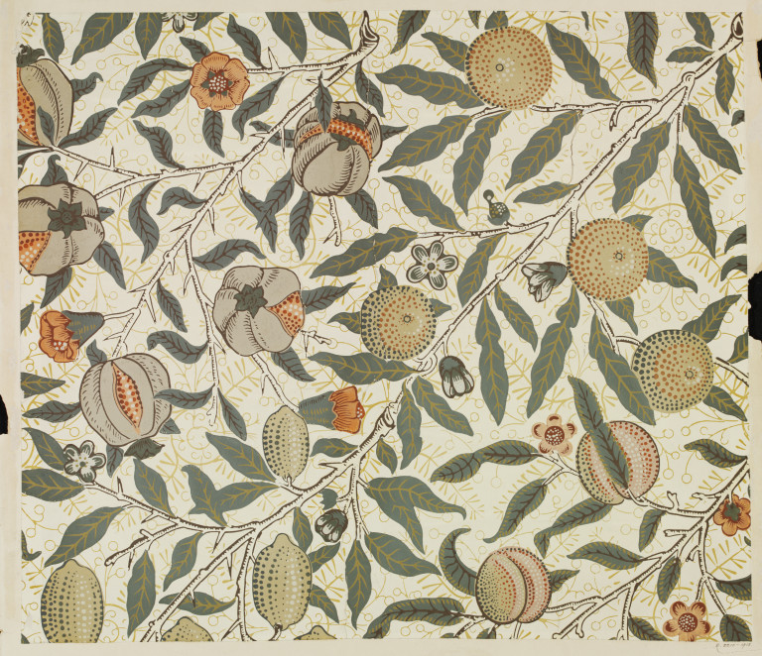
Figure 1. Fruit, William Morris, 1866

The Fruit wallpaper by William Morris (see Fig. 1) displays a disjointed order because of the many variants of shapes situated closely together. The pattern seems off balance perhaps due to the larger and darker fruits featured on one half of the pattern which seem to outweigh the smaller and lighter coloured fruits on the other. This may be because the battle between the mind and the eyes have trouble distinguishing if they are part of the foreground and the background.

When talking about the ‘extension of abstraction into decorative art’ (Brett, 2005, p. 120) Brett talks about two aspects of pattern which form a useful framework for consideration of the use of pattern within design.

First, the idealistic version that is deemed aesthetic according to Brett’s writings, which features nonrepresentational art referred to as motifs. Second, more of a realistic approach which is representational and symbolic.

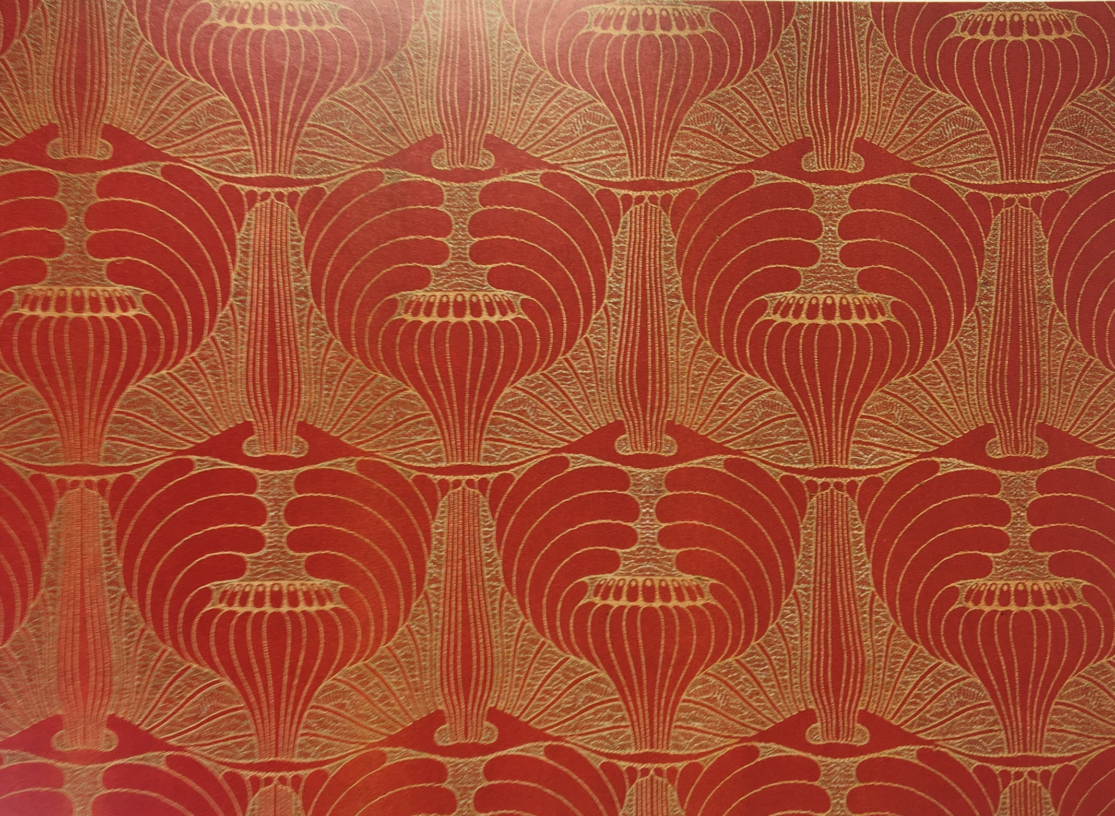
Figure 2. Mohnköpfe, Koloman Moser, 1900

Koloman Moser’s Mohnköpfe (see Fig. 2) is a prime example of a motif-based pattern that has purposefully been created to not represent its inspiration. Its initial symbolic use of poppy heads has been altered so that they are completely unidentifiable. Thus, according to both Brett (2005) and Bell’s (2003) assertion about non-representation, this pattern is more likely to be regarded as aesthetic, perhaps due to the patterns formal composition and elements which Bell has mentioned in order to achieve significant form.

The second category of pattern is evidently shown through William Morris’ wallpaper, entitled “Chrysanthemum” (1877) (see Fig. 3) which features in Brett’s Rethinking Decoration.
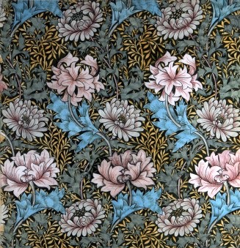
Figure 3. Chrysanthemum, William Morris, 1877

Morris’ pattern differs greatly from Moser’s work, showing evidence that there are clear distinctions of pattern. Figure 3 is extremely pictorial and displays strong representation of the chrysanthemum flowers whereas Moser’s poppies (see Fig. 2) are unrecognisable. Thus, showing the difference between pictorial art and patterns that have been purposefully created using idealistic guides of symmetry and harmony. This leads to the question, why is it that one form of pattern is regarded superior over the other? This could be that the two types of pattern appeal to different audiences as, according to Bell (Brett, 2005, p. 118), not everyone has the ability to experience significant form.

Christopher Dresser in Brett, 2005, claims that,

Pictorial art can, in its highest development, only symbolize imagination or emotion by the representation of idealised reality (but) true ornamentation is of purely mental origin and consists of symbolised imagination or emotion only.

Dresser talks about representational imagery within art and design in a limited sense when referring to ‘purely mental origin’. This suggests that if the pattern only allows thoughts about what the image is based on it holds no aesthetic significance. However, this on the other hand would suggest the image would hold significance of meaning and social understanding.

The representation displayed within pictorial art is not viewed as bad art according to Bell, however, he emphasises that it lacks the ability to be viewed within the “aesthetic dimension of the work” (Murray, 2003, p. 33). This coincides with Dresser’s argument that representational motif based patterns are supposedly more aesthetic.

However, William Morris (Brett, 2005, p. 120) focuses on the realistic and naturalistic portrayal within a pattern,

any decoration is futile (…) when it does not remind you of something beyond itself, of something of which it is a visible symbol (…) must still insist on plenty of meaning in your patterns… those natural forms which are at once most familiar and most delightful to us (…) are best for our purpose.

Morris signifies the importance of representational artwork within decorative art and subsequently pattern design in a larger sense as being the primary purpose of decoration, to highlight natural forms that are familiar and that nature is commonly associated with beauty and admiration. This suggests that although motif based patterns may potentially be more intricate to look at or considered more formal and ‘correct’, the meaning and portrayal wouldn’t be as significant as a pattern with symbolic representation.

Therefore, it seems possible that patterns can be evaluated against specific principles in order to judge the aesthetic value. The Meier Art Judgement Test (Hogg, 1969, p. 366) featured within Hogg’s Psychology and the Visual Arts includes a set of eight principles theoretically used to determine its aestheticism. They include, “unity, dominance, variety, balance, continuity, symmetry, proportion and rhythm” (Hogg, 1969, p. 369). Arguably some of these principles seem to overlap, for example rhythm and continuity, if something was inconsistent it may upset the flow or repeat of a pattern. Similarly, perhaps the principles concerning proportion and balance may intersect as each could be perceived as regulating the uniformity of the motifs. However, these principles can only at best determine the framework of a pattern and its elements and leaves out factors such as the significance or connotations of the representation and symbols used. Because arguably they are the factors related with cognition which debatably can affect the viewer’s outlook of the aesthetics of a pattern overall.
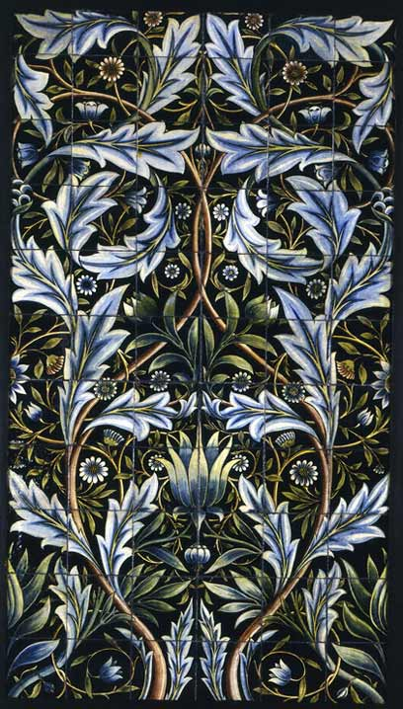
Figure 4. 66 Tile panel, William Morris, 1876

Morris’ 66 tile panel (see Fig. 4) measured against the Meier Art Judgement Test shows partial signs of unity in the sense that the central motifs are closed patterns and in general this is more appealing than those which are open and infinite, however, the edges end abruptly conveying potential disconcertion (Brett, 2005, p. 68).
The black background would be classed as dominant over the light and provides a clear visual. There are limited variants of flowers and leaves, also displayed in the colour palette, however, there are enough elements to avoid monotony and so overall this is not overwhelming. This being said the lack of variation may become boring the more it is viewed. The pattern is fluent in its rhythm as the repeat of the pattern is not blatant and therefore kept interesting. At first glance, it would appear that the symmetry is perfect, however, on closer inspection it is evidently not, but there only minor differences such as darker contouring within the shapes on opposite halves. This could, to some, offset the balance, although may still be classed as aesthetic to others. Morris’ rich dark pattern of the 1900s can be viewed in contrast with Angie Lewin’s 1950s celebration of natural form (see Fig. 5)

Figure 5. The 1953 Coronation Mug, Angie Lewin, 1953

Angie Lewin’s lithograph of the 1953 coronation mug (see Fig. 5) could be viewed as aesthetic due to the delicate line work which suggests elegance and sophistication, there is ample variety shown in different widths of the lines. Using the colour grey for the outlines conveys a softer approach compared to the use of a black outline (which is used often with line illustrations) as this would create more of a severe contrast to the print.

The choice of a limited colour palette further suggests a gentle style as it does not overwhelm the viewer, aided by the subtlety and balance created by the small spot areas of colour rather than big blocks which would contrast the fragility of the overall image. It is also the pastoral and muted colours that have been chosen that connote the delicateness of the plants, they are soft and the pink and yellow suggest femininity.

The shapes are simple and bold which makes their representation clear, however, within the middle section of the image the lines are heavily concentrated and intersected which creates disorder and therefore unaesthetically pleasing to some viewers.

Figure 6. Nature Table Cushion Cover, Angie Lewin (no date)

Similar to the previous example of Lewin’s work shown above, is her Nature Table Cushion (see Fig. 6). It displays muted colours and a similar key image of plants within a mug (see Fig. 5). However, this piece has been created into a repeat pattern containing the similar elements of the individual print featured in figure 5, yet, it appears less aesthetic to look at according to the aesthetic guidelines as it severely lacks spatial awareness and it featured a more organised order previously when it was an individual piece. It now seems overcrowded which may create a sense of chaos for some minds as there are too many bold focus points and disorder.

Overall, the analysis of these patterns suggests that aesthetics are predominantly individual thought, as people tend to attach their own social understanding and individual experiences to the subject portrayed within the pattern. However, by applying the principles of The Meier Art Judgment Test (1969), it has proven to be effective at unpicking the fundamentals of pattern so therefore suggests that on a basic level there are general values that the majority of an audience would respond to in terms of aesthetic quality.

Chapter 2: The Influence of Nature Within Pattern

Throughout time, nature has always seemed to be a key influence within decoration. Nature is a broad term and by definition relates to “The phenomena of the physical world collectively, including plants, animals, the landscape, and other features and products of the earth” (Oxford Dictionary, 2017). Within decoration and ornamentation, the majority feature plants which will be the focus of this particular research of pattern.

Nature is often believed to evoke a sense of beauty which is often considered as aesthetic even if it has been altered or made abstract. This may be due to the fact that nature contains forms of symmetry within leaves and petals for instance, there is often a distinguishable structure within plants which ties in with the guidelines of aesthetics.
Thus, Owen Jones, who was highly regarded during the 19th Century for his architecture and pattern designs which relied heavily on the influence of nature, as his patterns often featured flowers, both representational and abstract. He made the statement within the
The Grammar of Ornament (Jones, 1868, p. 2) that,

First. That whenever any style of ornament commands universal admiration, it will always be found to be in accordance with the laws which regulate the distribution of form in nature.

This means that if there is such a thing as universal admiration within decorative pattern design, then in order to be aesthetic it will conform to the guidelines that are evident in nature. Such as, how flowers and leaves often display a purposeful structure as if their lines of symmetry and equal or proportionate space between their shapes were well thought out in their construction.

Within The Grammar of Ornament, Jones formed 18 general principles that he refers to as propositions to follow within the category of decorative arts regarding form, colour and how they are arranged as a whole in order to achieve an aesthetic outcome. Proposition ten states,

“Harmony of form consists in the proper balancing, and the contrast of, the straight, the inclined, and the curved.” (Jones, 1868, p. 6)

Jones, like Bell (2003), speaks of harmony as one of the very important qualities within a pattern that can aid or diminish the aesthetic value. His eleventh proposition,

“In surface decoration all lines should flow out of a parent stem. Every ornament, however distant, should be traced back to its branch and root.” (Jones, 1868, p. 6).

Continuity has been previously mentioned by Hogg (1969) within the principles of The Meier Art Judgement Test so therefore must hold a level of importance in regard to aesthetics. It would make sense that something which conveys unbroken links and is kept consistent would be pleasing to the eye because there is no abrupt or harsh ending to the motifs. When referring to the ‘parent stem’ it may seem obvious that he speaks of patterns that display nature related motifs, such as two flower heads that have one stem. However, perhaps in the larger sense it could relate to the central motif, regardless of nature, where the whole pattern must originate from.

The 19th Century was associated with many art movements, one of which being the, Arts and Crafts movement, that focused on naturalistic ornamental design with a distinct “enquiry into plants” (Powers, 1999, p. 21). William Morris’ pattern designs and wallpapers were paramount within the Arts and Crafts Movement and recognised for his line work and compiling of primary and secondary patterns. He focused nearly entirely on plants for his decorative artwork and kept within a representational format.

William Morris believed that, “natural forms (…) are best for our purpose.” (Brett, 2005, p. 120)

However, after the 1900s the style of patterns shifted into modernism, which although still looked to nature for inspiration, seemingly rejected prior traditional approaches and instead emphasised abstraction with the use of geometrical shapes and stricter guidelines (Powers, 1999, p. 21). Therefore, Geometrical shapes may be more aesthetically pleasing as the shapes can fit together and reflect each other with cleaner edges rather than shapes that feature untamed lines.

Dresser has written (Brett, 2005, p. 110),

We are not to draw particular plants as they really exist – blown about and deformed, but as we know them to be (…) these representations should not be of objects in their mutilated state but of the given plant in a perfect state.

This theory relates to the ‘idealistic’ approach of pattern design but theoretically can fit both guidelines of abstract-motif based patterns as well as those of representational quality. It suggests that plants are not deemed aesthetic if they are not displayed perfect and therefore do not belong in patterns if they are not the ‘ideal’. Is there not a certain beauty found in decay? How are they representational if they are not portrayed truthfully as they are seen?

Many of the aforementioned theorist discussed have proposed their own principles or reiterated older guidelines regarding the evaluation of aesthetic quality within the decorative arts. Firstly, it is stated by Brett that there are two aspects of pattern. From analysing visual examples of both pattern categories, it has become evident that there is a well-defined difference. Knowing which category between non-representation and realistic imagery that the pattern will fit into allows it to be evaluated in different ways. Brett and Bell seem to have similar thoughts on the numerous aesthetic qualities that could be found within non-representational patterns. They steer towards abstraction and formal structures where motifs that initially were inspired by nature become unrecognisable and this is supposedly meant to allow an individual to express ‘significant form’ (2003) but this process permits the pattern to lose all meaning. Whereas, Morris contests that using pictorial motifs that replicate natural forms hold significance and therefore are a comfort to our minds because they are accustomed and admirable.

Secondly, Hogg’s retelling of The Meier Art Judgement Test (1969) brings forward eight principles that are intended to determine Aestheticism. The principles focus on the very basic foundations a pattern is constructed upon, however, does not credit any signification of symbolic representation which the cognitive process would try and unpick when considering at a pattern. For instance, the social understanding of the motifs chosen. Key values such as patterns that present closed motifs are important as they create finality and are more aesthetic because of the opposing idea leaving a sense that image is incomplete. Another presents variation as crucial to avoiding monotony (Hogg, 1969), indicating that it adds slight mystery so that with each inspection something new is discovered. Rhythm could be responsible for the repeat within a pattern (Hogg, 1969) and therefore suggests avoiding it being blatant or overwhelming. Symmetry that is nearly perfect will prove to be less aesthetic (Hogg, 1969), minor differences can disturb the balance even if the person is unaware, most likely the cognitive mind will sense an offset. Strong contrast is not always considered more aesthetic, as found in Angie Lewin’s work (see Fig. 5) as her subtle use of grey line instead of black conveys softness, supported by her chosen colour palette to symbolise femininity. However, this is not judged within this particular test but is still not disregarded by the brain as the test would expect. Appropriate proportions underpin the relationships between the motifs. Therefore, a lack of space between them would generate a disarray as seen in figure 6.

Lastly, Owen Jones presents his own set of eighteen principles that guide natural forms into decoration. It seems he believes that a collective aesthetic can be achieved if it is in agreement with the rules that are portrayed in nature. Such as, plants that behold deliberate formations of symmetry and correct proportions, as if designed. These values support those presented in The Meier Art Judgment Test (Hogg, 1969). Harmony, corresponding to Bell’s Significant form, is the notion of overall balance of the elements within the pattern. Jones also comments on the variations of straight, inclined and curved lines which suggests the outcome will flow rather than be imprisoned by rigid structures. Finally, there is concept of a ‘parent stem’ which implies that there should be a dominant motif that the whole pattern derives from.

Chapter 3: Patterning my Own Practice

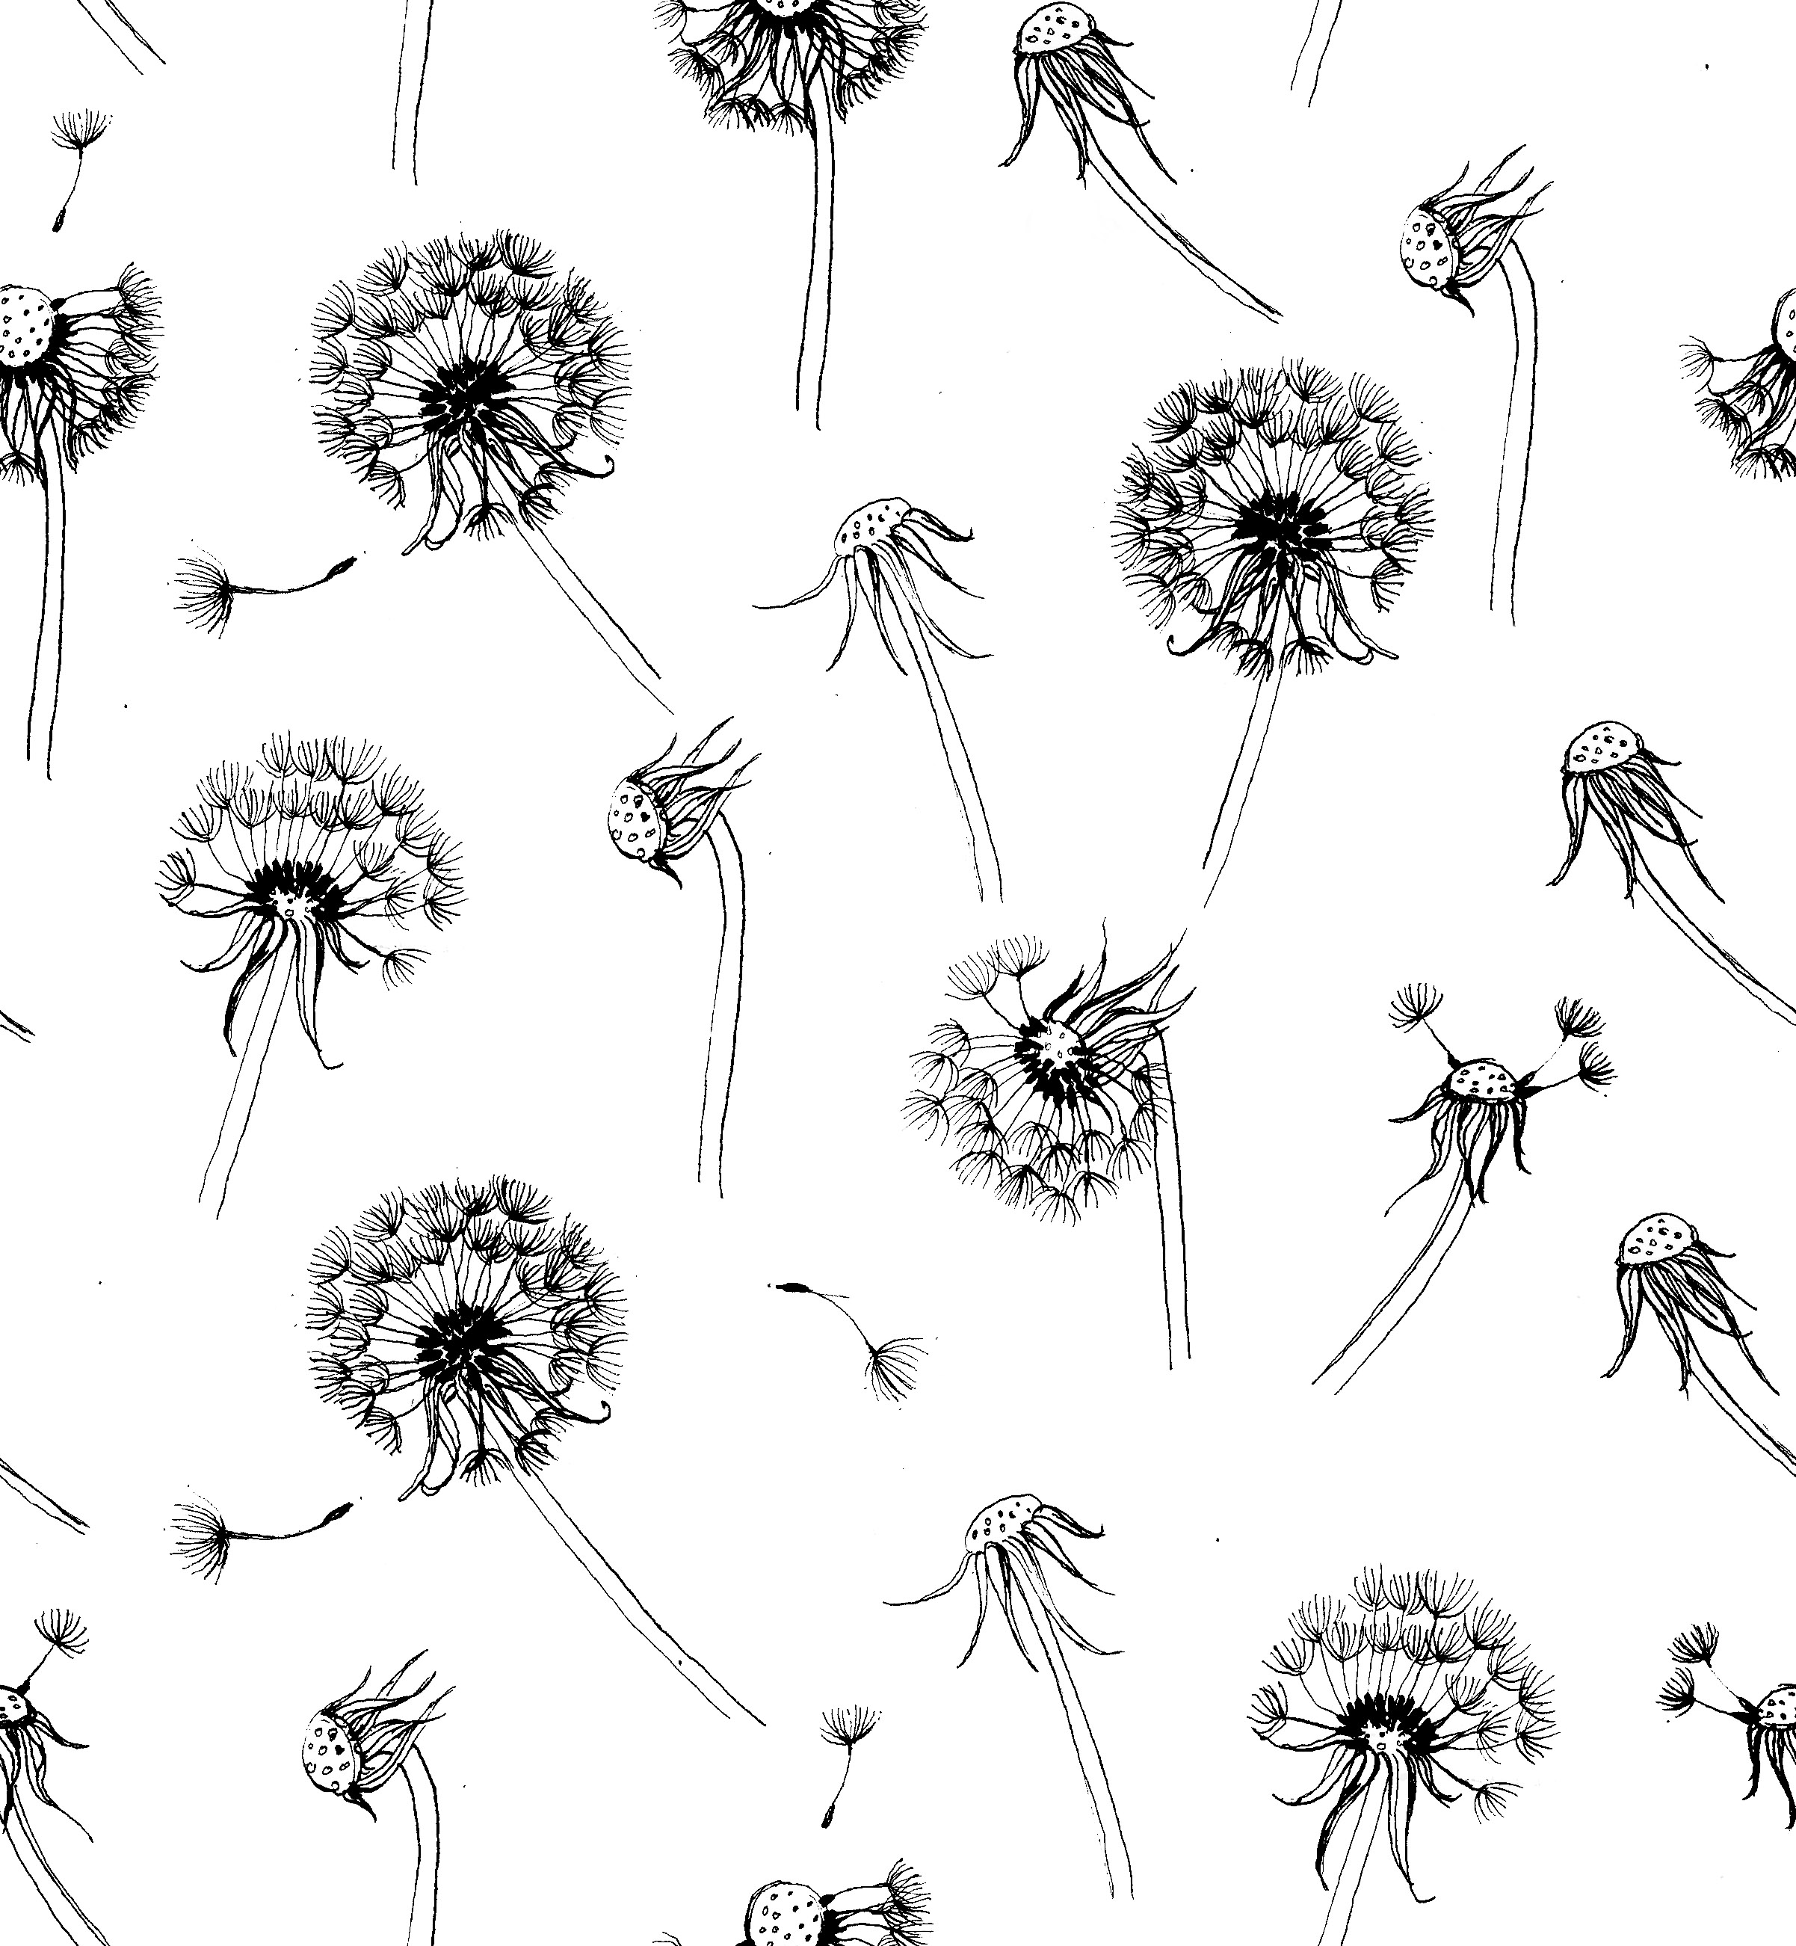
Figure 7. Dandelion, Rebecca Williams, 2016

The main reason for this dissertation has stemmed from the pattern I created in 2016 entitled Dandelion (see Fig. 7). The key question being, is this pattern aesthetically pleasing and if not, what is it about the arrangement that would alter the audiences outlook.

Firstly, it is important to note that the patterns I create also take great inspiration from nature. Taking into consideration Brett’s two aspects of pattern, Dandelion would fit comfortably within the realistic and representational category. However, the dandelions are not portrayed idealistically as Dresser (2005) believes is necessary. In fact, this pattern displays the opposite and indeed, presents them in a mutilated state. Some of the dandelion clocks have been blown off and some are drooping, overall, they are illustrated in their dying phase. This suggests that the pattern would not be aesthetic because even though it shows a truthful portrayal of the impact that climate, humans and the life cycle has over nature, it apparently does not represent the familiar picture we have come to associate with in our minds. However, the sophistication of the dainty line work of each individual seed head could behold a different beauty within in its delicacy and wistfulness of them being blown away.

Comparable to Angie Lewin’s work (see Fig. 5), it conveys similar connotations of fragility due to the delicate thin lines. Her work also features dandelions in an unidealistic form, although, her style has more geometrical aspects than Dandelion, as in figure 7 there are simple lines but lots of them, yet in Lewin’s work (see Fig. 5) there are block shapes for the tips of the seed heads and feature a halo of coloured circle behind them. The time period suggests the noticeable difference because by the 1950’s modernism had made its mark and a lot of the designs were abstract and geometrical (Tate,2017).

The Dandelion pattern has no sense of unity due to the motifs being open and unconnected in anyway, which therefore would not be aesthetic especially in accordance with Owen Jones’ (1868) principles which dictate that there should be a ‘parent stem’. The dandelions appear to be floating with no sense of roots or central source suggesting a lack of belonging and disorder. There is a strong contrast between the black lines and the white background, however, the dominance is unclear due to the small width of the lines and the abundance of space, this could also convey discontentment because of the confusion over the undecided foreground. There is plenty of variation within the numerous withered stages of the dandelions, this helps keep the pattern interesting to look at and assists the rhythm by insuring the repeat is unnoticed, as there are no two dandelions that are the same next to each other. It displays very little symmetry; this could mean that there is an offset in the balance and overall visually displeasing. It does, however, adhere to Jones’ (1868) guidelines of contrasting different angles of lines and conveys an imperfect and quirky style instead. While there seems to be a lot of white area within the gaps, there is still a lack of spatial awareness between the dandelion clocks of one and the stem of another which creates a fragmented structure. After being measured against the acknowledged principles it appears this pattern would not be viewed as aesthetic.

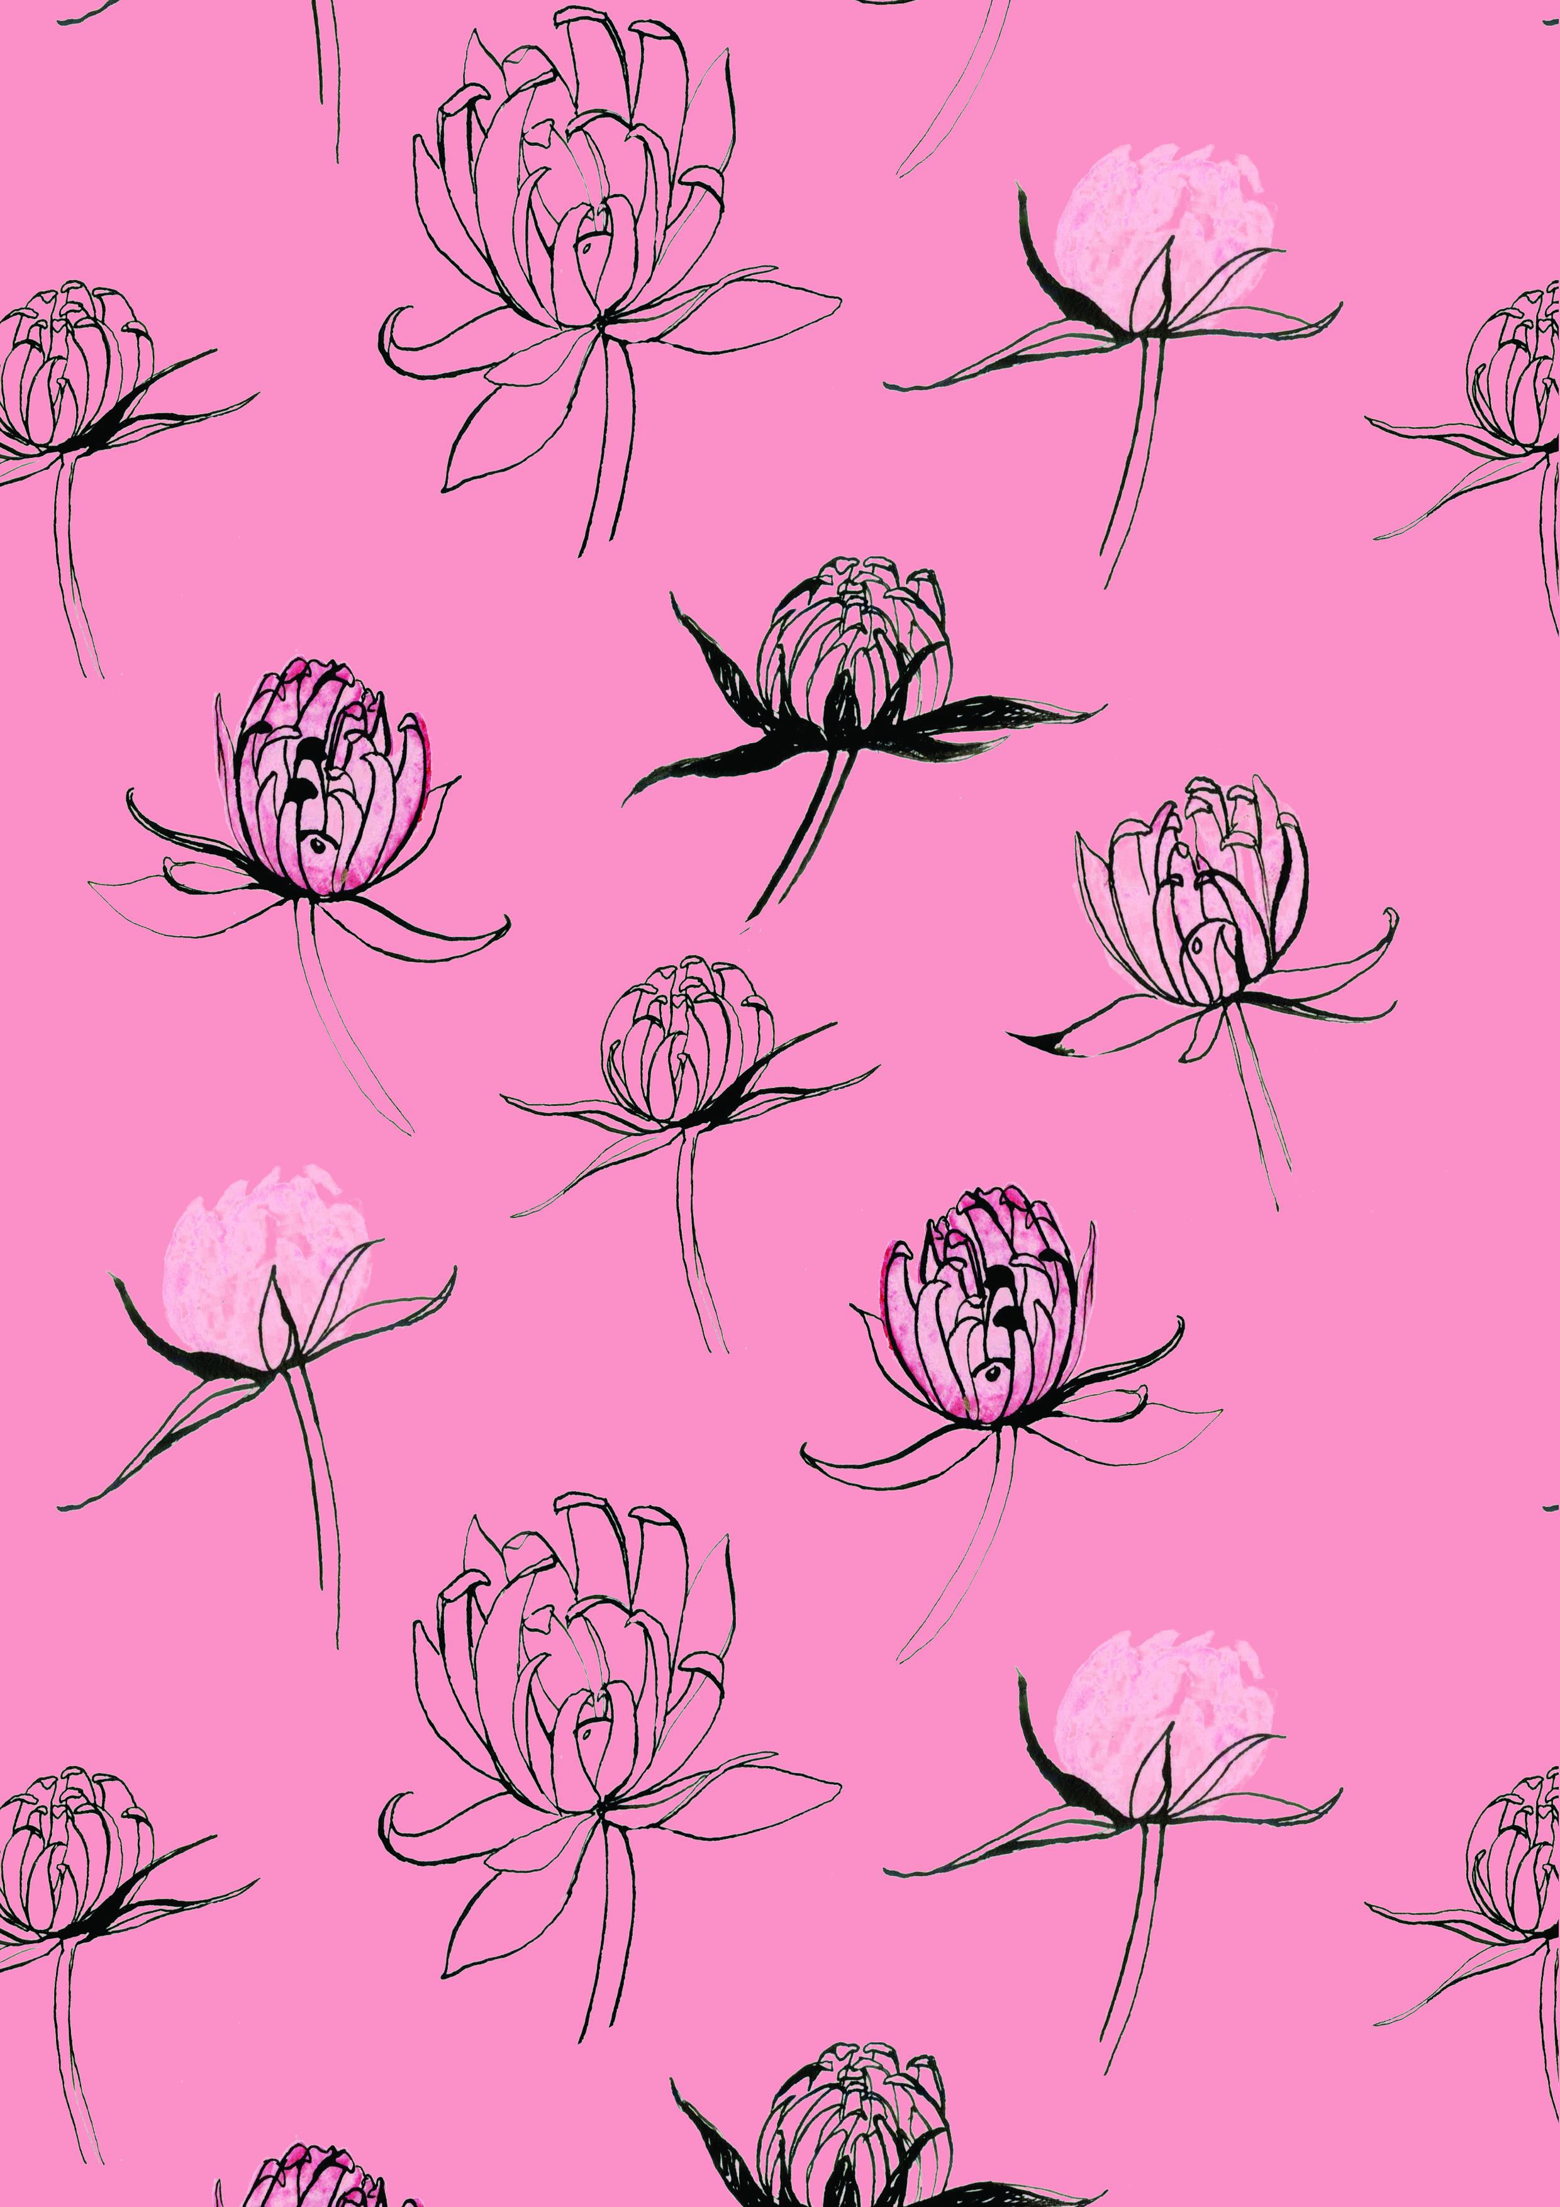
Figure 8. Pink Buds, Rebecca Williams, 2017

The Pink Buds pattern (see Fig. 8) I created a year later also fits the category of representational motifs and still portrays them in an unidealistic manner, although, not nearly as distressed as the dandelions in figure 7. This pattern shows subtle signs of abstraction though, this is because the petals are created using geometrical shapes instead of just lines which add dimension the flowers. Due to these reasons that have been informed by the previous chapter (Hogg, 1969), this pattern would therefore be classed more aesthetic compared to Dandelions. The structure follows the similar floating arrangement that has no sense of continuity or source as seen in figure 7. However, the spacing between the flowers is used more appropriately as it displays equal proportions. This being said, there is one major offset that draws unwanted attention, that is the flower which has a darker stem and is tilted more than the rest. This links with Clive Bell’s (2003) theory of ‘Significant Form” as it cannot possibly convey such if the harmony is disrupted by an ‘incorrect’ order or placing of a rogue motif.

One of the key differences between Pink Buds and Dandelion is colour. The soft spots of colour within some of the petals connote delicateness which may be taken away by the overpowering dark pink background. Overall, it seems that this pattern (see Fig. 8) is more aesthetic than dandelion, but is possibly still unable to achieve complete aesthetic balance due to some of the errors of placement causing disorder as well as it does not seem to flow perhaps due to the motifs being so singular and not connected in any way.

This being said, patterns such as William Morris’ (see Fig. 3) that were created in the nineteenth century featured very elaborate ornamental patterns, which is unlikely to be used as wallpaper in present day as it would perhaps be too rich and overwhelming compared to the current modern style. The appreciation of beauty is forever changing with new trends, meaning that therefore patterns of different eras do not necessarily hold the same aesthetic values as maybe it once did. This could suggest that as the principles were created around the same time period as the over embellished patterns of the nineteenth century, then they can only measure the aesthetic value of their own era. In comparison, the patterns I have created within the 21st Century feature more delicacy and are less sumptuous because the current modern style demands a lighter and less is more approach.
Conclusion

To conclude, there does not seem to be just one answer or one set of principles to follow in order to achieve an aesthetic pattern. There is also not just one version of what the term aesthetic refers to. By looking at many theorists, I have found they address aesthetics in various ways. For example, Bell (2003) refers to it as ‘Significant Form’, whereas Brett acknowledges it as beauty and others speak of it as a ‘pure’ response. This supports the theory that there is not a singular term for aesthetics and possibly the reason for this is that it cannot be defined as a whole because of the difference between individual perceptions. Although, the argument between aesthetic value being universal or individual is unsettled, it seems as though there are elements of both. Such as, primarily it will be the response of the individual and their own tastes and experiences that they impose on the pattern, however this can then be altered by a social understanding of what may be the current trend at the time and therefore influence the aesthetic value overall. The debate concerning whether aesthetics is the result of cognition or deep emotion is also inconclusive as both sides have arguments to support their theory. The reason for this is that there is not a defined term and people do not all react the same way to patterns.

Through my findings it seems evident that Nature has been used so much in decoration because of the natural forms and structures found already in nature that are apparently so familiar and pleasing to us subconsciously. The Meier Art Judgement Test (Hogg, 1969) was successful at providing a framework in which to breakdown patterns to their basic elements and to see how they work together, however, not so successful at evaluating the actual aesthetic value, but I think this is because it cannot be accurately measured. There are key principles that prevail throughout my research. For instance, harmony is mentioned by both Bell and Jones and therefore shows the importance of balance within the order of a pattern so that nothing is visually offsetting and displeasing. Two other key factors are spatial awareness and unity of motifs. Both, The Meier Art Judgement Test (1969) and Owen Jones (1868) express the significance of a central motif that links all visual aspects to create an appealing sense of completeness. By applying these principles to my own patterns, I have found that they may not be viewed aesthetically. However, because of the arguments I have explicated, this conclusion is not conclusive. Nevertheless, I have found areas to improve my patterns and to make them more visually pleasing by using these conceptual tools. This was the overall aim of this dissertation; therefore, in this I have succeeded.

Bibliography

Books

Brett, D., (2005). Rethinking Decoration. Cambridge: Cambridge University Press.

Graham, G., (2005). Philosophy of The Arts: An introduction to aesthetics. Third Edition ed. Oxon: Routledge.
Hogg, J., (1969). Psychology and the visual arts. Middlesex: Penguin Books.
Harrison, C. & Wood, P., 2003. Art in Theory 1900-2000: An Anthology of Changing Ideas. New Edition ed. Oxford: Blackwell Publishing Ltd.
Jackson, L., (2002). 20th Century Pattern Design: Textile & Wallpaper Pioneers. London: Octopus Publishing Group.
Jones, O., (1868). The Grammar of Ornament. London: Bernard Quaritch.
Maquet, J., 1986. The Aesthetic Experience: An Anthropologist Looks at the Visual Arts. London: Yale University Press.

Murray, C., (2003). Key Writers on Art: The Twentieth Century. London: Routledge.

Powers, A., (1999). Nature in Design. London: Conran Octopus Limited.

Websites

Online Etymology Dictionary, (2017). Online Etymology Dictionary. [Online]
Available at: https://www.etymonline.com/word/aesthetic
[Accessed 18 November 2017].
Oxford Dictionary, 2017. Nature. [Online]
Available at: https://en.oxforddictionaries.com/definition/nature
[Accessed 8 December 2017].
Tate, 2017. Abstract Art. [Online]
Available at: http://www.tate.org.uk/art/art-terms/m/modernism
[Accessed 11 December 2017].
Tate, 2017. Modernism. [Online]
Available at: http://www.tate.org.uk/art/art-terms/m/modernism
Victoria and Albert Museum, (2016). A William Morris and William De Morgan Tile-Panel. [Online]
Available at: http://www.vam.ac.uk/content/articles/a/a-morris-and-de-morgan-tile-panel/
[Accessed 27 November 2017].
Victoria and Albert Museum, 2017. A higher ambition: Owen Jones (1809-74). [Online]
Available at: http://www.vam.ac.uk/content/articles/a/a-higher-ambition-owen-jones/ [Accessed 27 November 2017].

Figures
Figure 1. Fruit, William Morris, (1866).
Accessed at:http://collections.vam.ac.uk/item/O250834/fruit-wallpaper-morris-william/ [Accessed on 6th December 2017]

Figure 2. Mohnköpfe, Koloman Moser, 1900 taken from Jackson, L., (2002). 20th Century Pattern Design: Textile & Wallpaper Pioneers. London: Octopus Publishing Group.

Figure 3. Chrysanthemum, William Morris, 1877.
Accessed at: http://collections.vam.ac.uk/item/O249075/chrysanthemum-wallpaper-morris-william/ [Accessed on 29th November 2017].

Figure 4. 66 Tile panel, William Morris, (1876).
Accessed at: http://www.vam.ac.uk/content/articles/a/a-morris-and-de-morgan-tile-panel/ [Accessed on 27th November 2017].

Figure 5. The 1953 Coronation Mug, Angie Lewin, 1953
Accessed at: https://www.angielewin.co.uk/collections/limited-edition-prints/products/coronation-mug-edinburgh [Accessed on 29th November 2017].

Figure 6. Nature Table Cushion Cover, Angie Lewin (no date)
Accessed at: https://www.angielewin.co.uk/collections/textiles/products/nature-table-cushion-covers [Accessed on 29th November 2017].

Figure 7. Dandelion, Rebecca Williams, (2016). Taken by the author.
Figure 8. Pink Buds, Rebecca Williams, (2017). Taken by the author.

