
CertHE in Business Skills

Student Name: Kiril Georgiev
Student Number: 2441418
Course Name: Academic Skills LCLM4001

Contents
1. Introduction 2
2. Description of Experiences 3
3. Feelings 3
4. Evaluation 4
5. Analysis 4
6. Conclusion 5
7. Action Plan 5
References 6

Introduction

Reflective practice involves learners analyzing their experiences, examining successes and challenges, and identifying ways to improve in the future. Reflection is a two-stage process that begins with past successes and failures, requiring a review of inputs from all fronts. In higher education, reflective practice is necessary for developing both academic and professional skills. Students learn not only to link theory with practice but also become more self-aware(Moon, 2004).
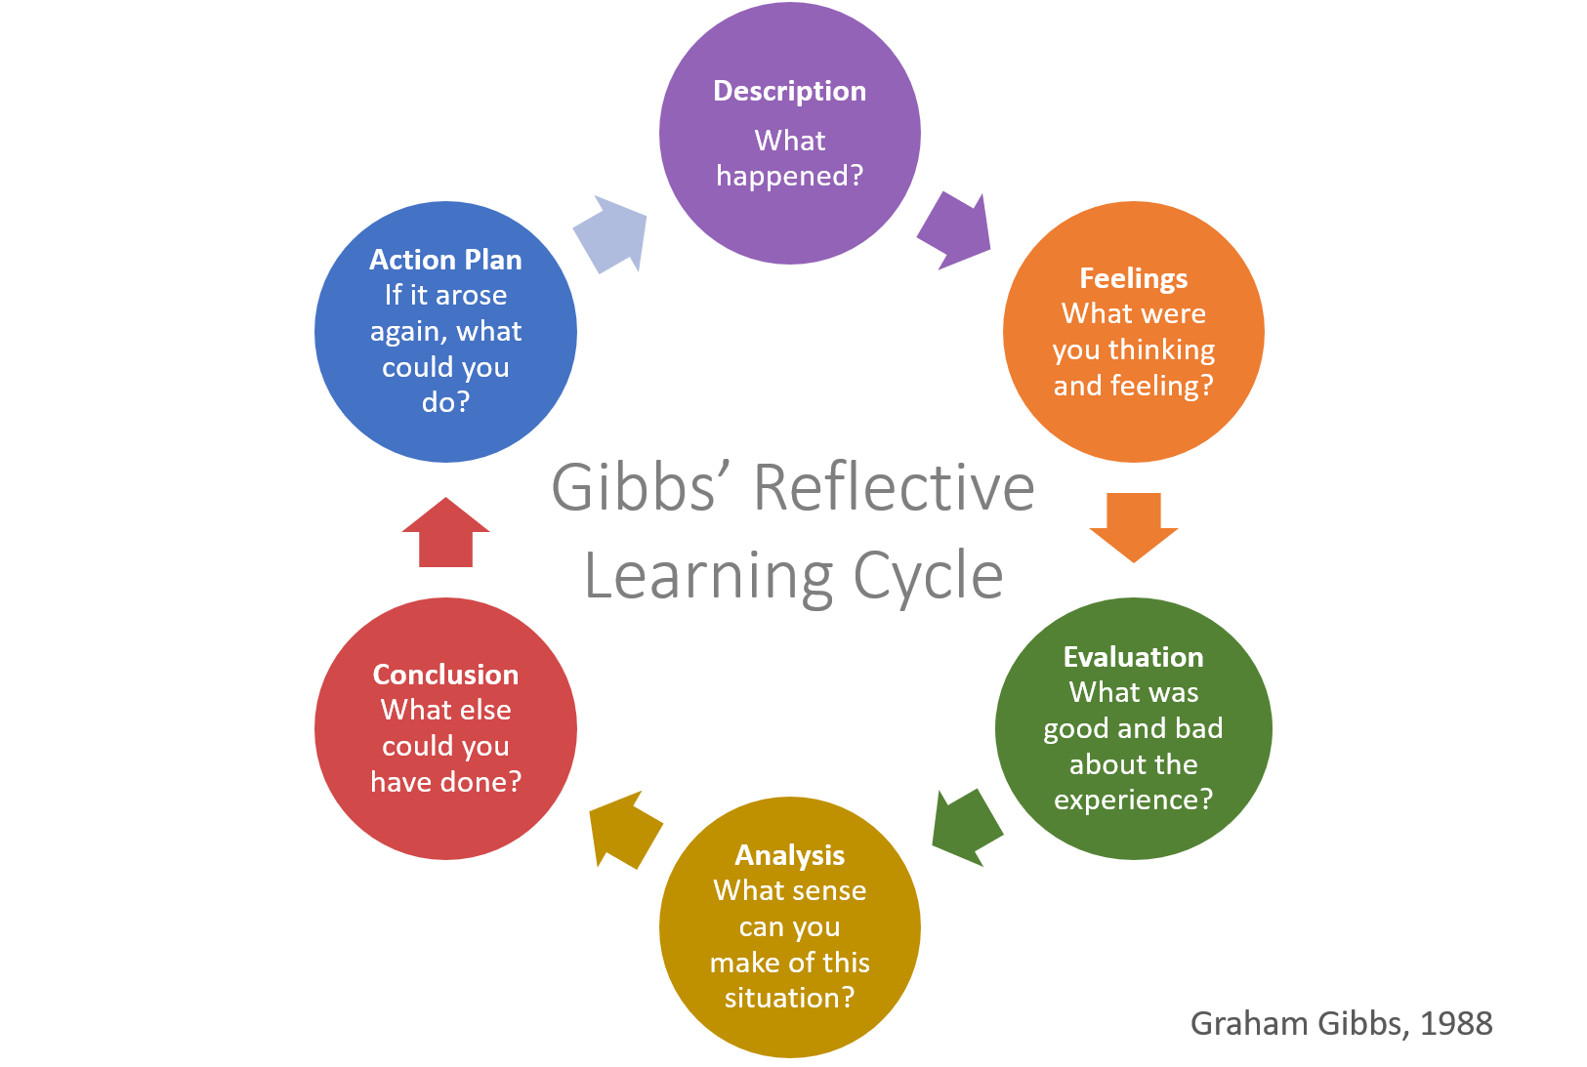
This report aims to critically reflect on my experiences in the Academic Skills module, drawing mainly on Gibbs’ Reflective Cycle (1988): description, feelings, evaluation, analysis, conclusion, and action plan. Although other frameworks exist, such as Kolb’s Experiential Learning Cycle (1984) and Driscoll’s ‘What? Now What?’ (1994, 2000), Gibbs’ model is used here because it offers a structured approach that balances description and deeper analysis. We cannot formulate a conclusion indirectly but must gain firsthand evidence from data obtained during each experience.
The reflection will concentrate on three contact points: Task 1, Task 2, and classroom discussions about referencing, plagiarism, and time management.

Description of Experiences

The Academic Skills module involved several activities designed to prepare students for university success. In Week 5, Task 1 was an academic quiz that tested knowledge about time management, referencing, academic writing conventions (including citation), and plagiarism. I only prepared for the quiz by scanning through my notes but quickly found that I was out of my depth where referencing is concerned.
In Week 7, Task 2 required actual practice in paraphrasing and note-taking. The exercise involved reading a short text, extracting key information, rephrasing sentences, and writing a paragraph. When it came to note-taking, as long as conditions were favorable, I could extract usable information; but under time pressures, it was not so easy.
Classroom discussions provided support while concentrating on these tasks. For instance, one seminar asked students to spot errors in referencing examples. It was very obvious from small examples how easily mistakes can happen—for example, when omitting page numbers or neglecting correct punctuation. Group work also allowed me to compare my understanding with peers and receive feedback from my lecturer.

Feelings

Before Task 1, I felt both anxious and motivated. I wanted to do well but was worried about references. During the quiz, I felt tense when encountering unfamiliar questions but reassured as soon as they were answered with knowledge I had revised.
Task 2 brought mixed feelings. I was sure of my note-taking but got stuck in paraphrasing. I was afraid my attempts were too close to the original text. In classroom discussions, my feelings changed over time. Initially, I was reticent in front of others, but as the weeks went on, I became increasingly confident - not least when I found that everyone else was facing difficulties too.

Evaluation

Several aspects of the module were successful. The quiz showed me which areas were my strong points and where I had room for improvement. Task 2 improved my note-taking; now I consider it a strength. Classroom discussions were especially valuable because they forced me to actively participate, which gave me confidence and understanding.
However, there were difficulties. My paraphrasing in Task 2 was worse than expected, making me timid about academic writing. I also underestimated how long it would take to review referencing style before the quiz. This supports van der Meer, Jansen, and Torenbeek’s (2010) findings that first-year students often underestimate the time required for academic tasks.
Overall, the module clarified which points I am strong at—participation and organization methodology—as well as where there are problems, such as paraphrasing and getting the right references.

Analysis

My success in note-taking is attributable to strategies I had already developed, such as abbreviations and highlighting keywords. Cottrell (2019) points out that structured note-taking supports learning and memory, which matches my experiences completely.
In contrast, paraphrasing was more difficult. Trying too hard to reproduce the writer’s exact words under time pressure, I paid too little attention to meaning. Carroll (2007) indicates that paraphrasing is a skill that needs continual practice to strike a balance between fidelity and originality. This analysis shows that my problem was not so much a lack of comprehension as a failure to practice enough.
Referencing errors arose partly because I was not familiar with the Harvard system. Though I could understand the theory, I overlooked details such as punctuation. My lecturer’s comments confirmed that referencing is a skill developed slowly and consistently through practice.
Finally, my reticence in classroom discussions can be ascribed to a lack of confidence, but the improvement I later experienced points clearly to the advantages of peer interaction. Morgan (2017) argues that group work helps business students acquire essential employability skills such as communication, initiative, and teamwork; this is something I could experience for myself.

Conclusion

The reflection on these experiences showed me that planning and tactics make a difference, as evidenced by my success with note-taking. It also indicated that paraphrasing and referencing require regular practice rather than last-minute effort. Finally, it taught me that speaking up in class, even if uncomfortable, can build both confidence and understanding.
Although Kolb’s cycle (1984) and Driscoll’s model (1994, 2000) offer useful ways of looking at reflection, Gibbs’ six stages provided the most comprehensive framework for this piece. Overall, the module has added something positive to my schooling, boosting my confidence and shaking the tree of self-criticism while providing skills for subsequent modules.

Action Plan

To improve referencing, I will practice weekly with CiteThemRight Online and check all references against Harvard guidelines before submitting. For improved paraphrasing, I will set aside a specific amount of time each week to rewrite short academic passages. In addition, I plan on attending sessions related specifically to academic writing.
For time management, I will produce a weekly planner that balances lectures, independent study, and personal time. As Cottrell (2019) points out, clear planning is critical to success in any academic endeavor.
Regarding participation, I will offer at least one contribution per seminar and prepare questions beforehand. Over time, this should make me more confident. Finally, I will continue to use Gibbs’ cycle as a tool for future modules, tracking my own development with this reflection as part of post-graduation work.

References
Carroll, J. (2007) A Handbook for Deterring Plagiarism in Higher Education. Oxford: Oxford Centre for Staff and Learning Development.
Cottrell, S. (2019) The Study Skills Handbook. 5th ed. London: Red Globe Press.
Driscoll, J. (2000) Practising Clinical Supervision: A Reflective Approach for Healthcare Professionals. 2nd ed. Edinburgh: Baillière Tindall.
Gibbs, G. (1988) Learning by Doing: A Guide to Teaching and Learning Methods. Oxford: Oxford Polytechnic.
Kolb, D. A. (1984) Experiential Learning: Experience as the Source of Learning and Development. Englewood Cliffs; London: Prentice-Hall.
Meer, J., Jansen, E. and Torenbeek, M. (2010) ‘It’s almost a mindset that teachers need to change’: First-year students’ need to be inducted into time management. Studies in Higher Education, 35(7), pp. 777–791.
Moon, J. A. (2004) A Handbook of Reflective and Experiential Learning: Theory and Practice. London: RoutledgeFalmer.
Morgan, P. (2017) The Business Students’ Guide to Study and Employability. London: Sage.

