Two Men in a Trench: Bannockburn 1314 – do we wish they’d just fallen in?
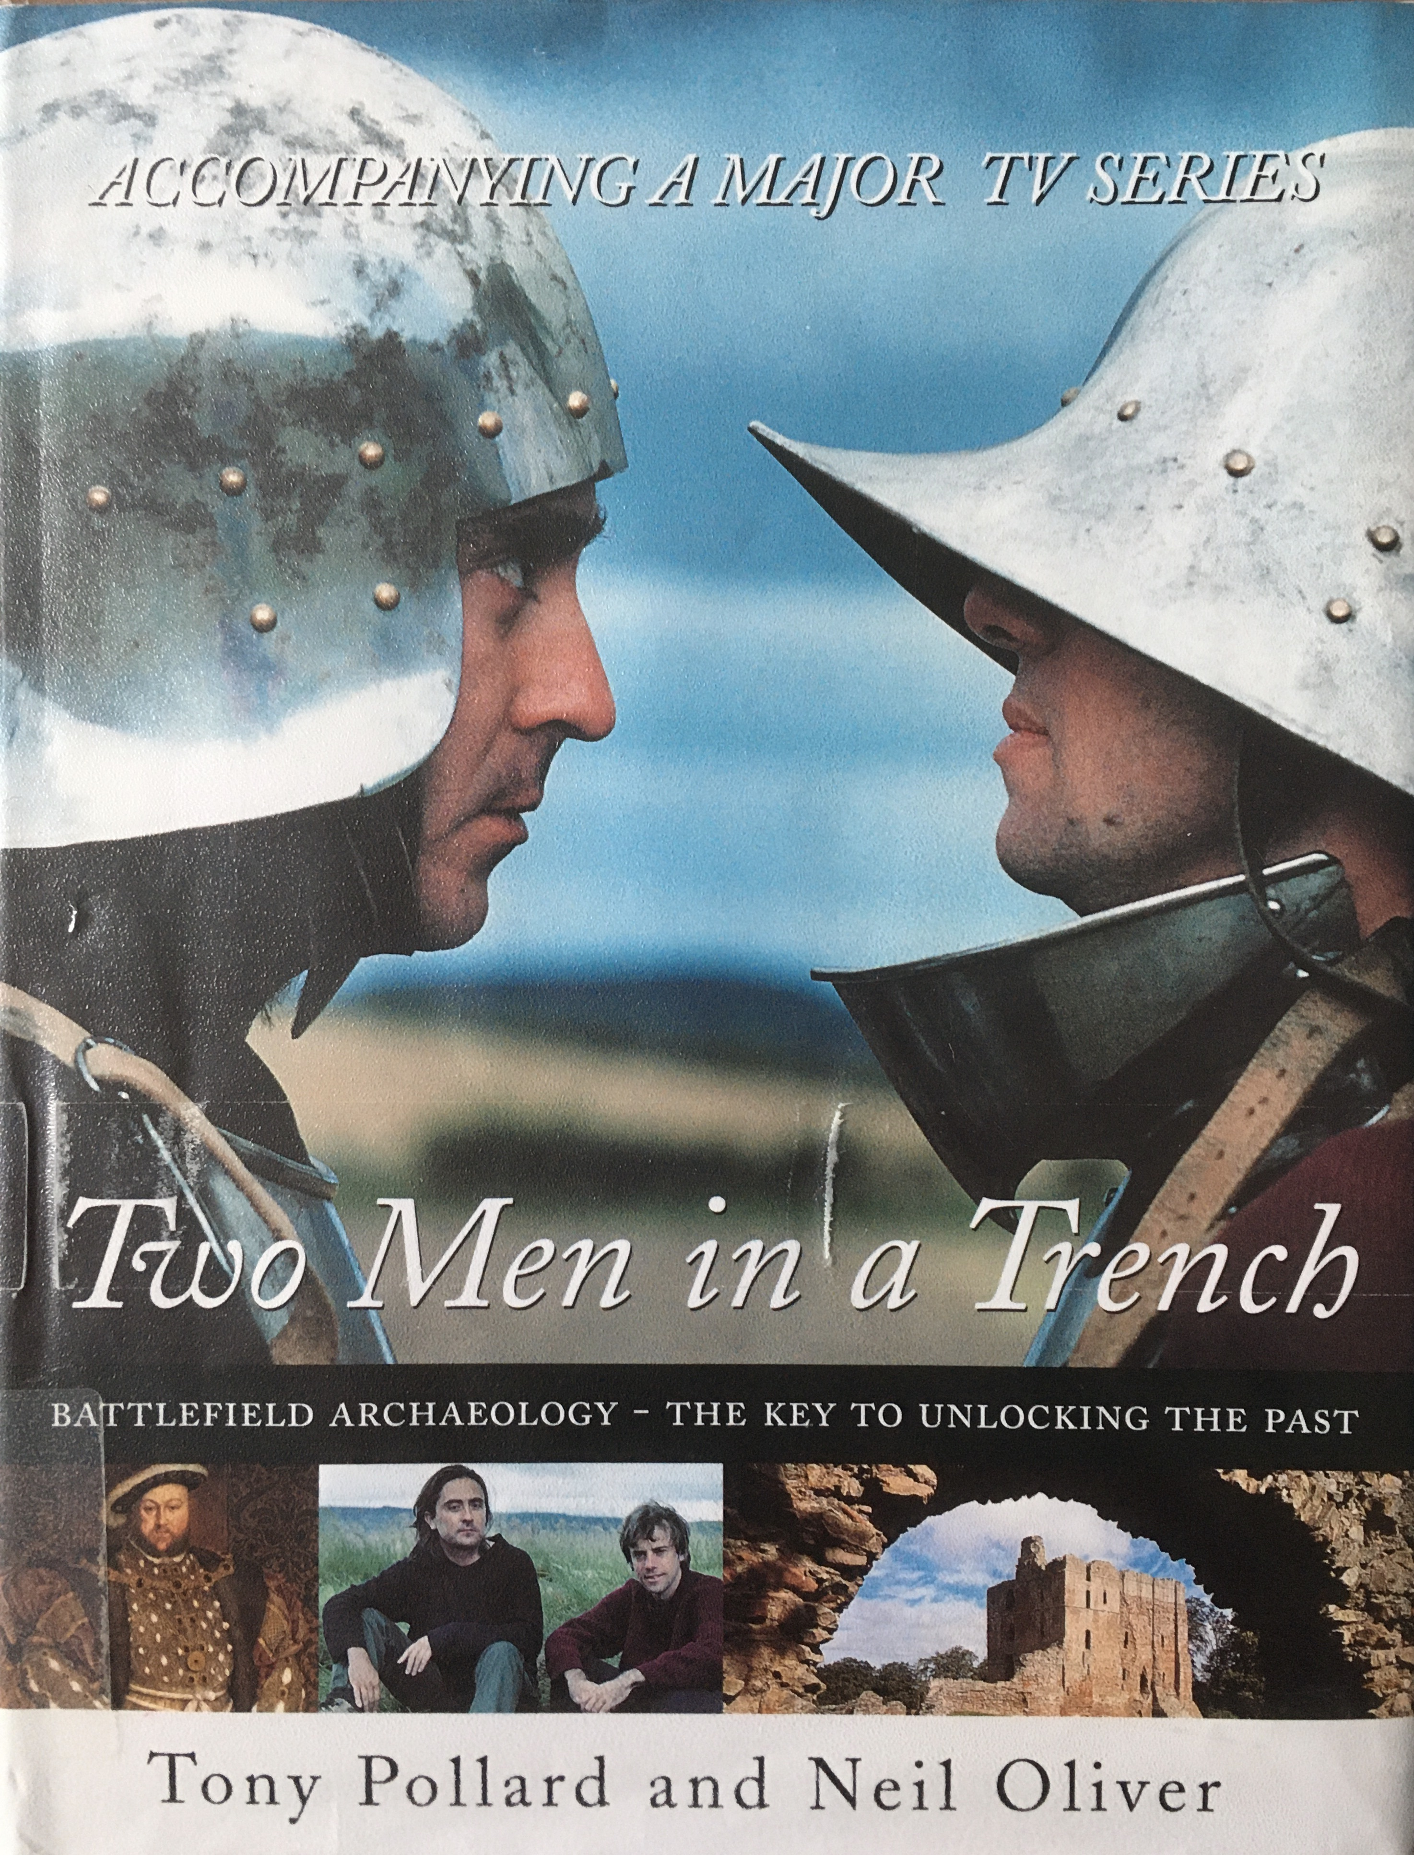
Two Men in a Trench - the book accompanying the TV Series. (Pollard & Oliver 2002)

This review is about the fifth episode in a series of six about battles, in the second season of Two Men in a Trench (2004). This BBC programme tells the story of the Battle of Bannockburn in June 1314, whilst exploring the topography, looking for material remains, and attempting to clarify the precise site of the battle itself. The two presenters are Dr Tony Pollard and Neil Oliver, two friends who are also archaeology graduates from Glasgow University. Season I was broadcast in September to October 2002, and Season II from February to April 2004 originally, although the series is now available on the uktv History channel.

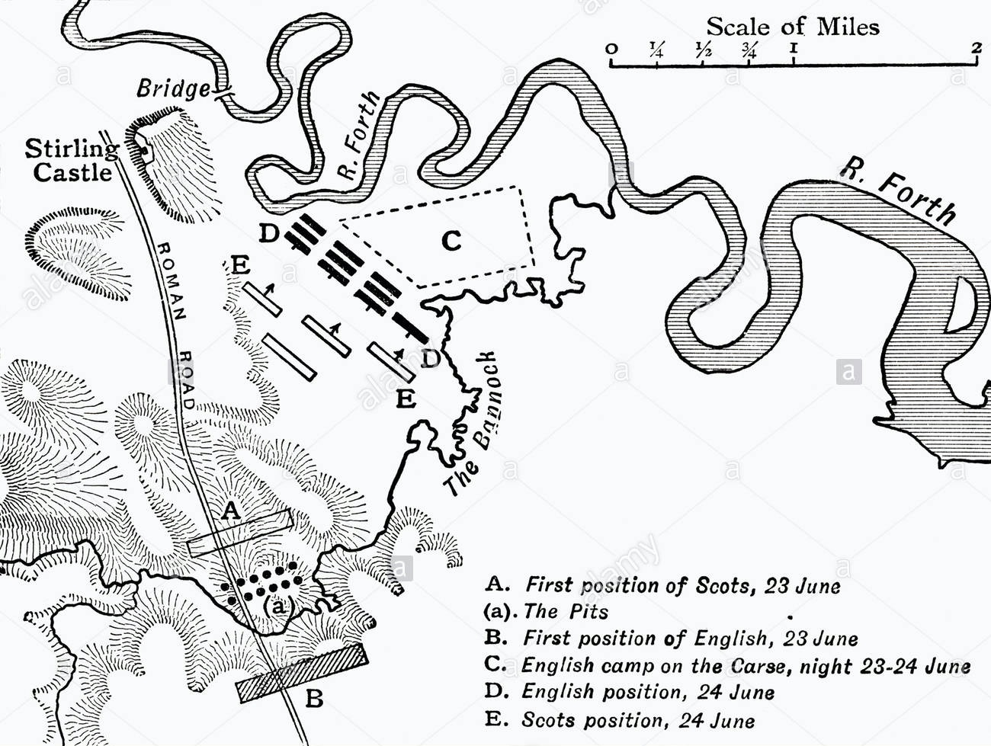
Each of these programmes follows a set formulaic structure, beginning with the pitching of a large canvas tent in which our intrepid team camp on the battlefield site, followed by vignettes of the actual excavation interspersed with cartoon analyses of the conflict in question and a re-construction of the battle uniform and weaponry using Tony and Neil as opposite members of the warring sides. Cameos of local people who are somehow involved with the site are also included in every episode and each night ends with our archaeologists discussing the day’s events and drinking tea. Music is used with abandon throughout the programmes, although the style chosen is baffling, suggestive more of an American 1980s detective series or of Mr T and the A-team than of a British programme introducing the public to battlefield archaeology.
Map of the Battle of Bannockburn (from Tout 1925).
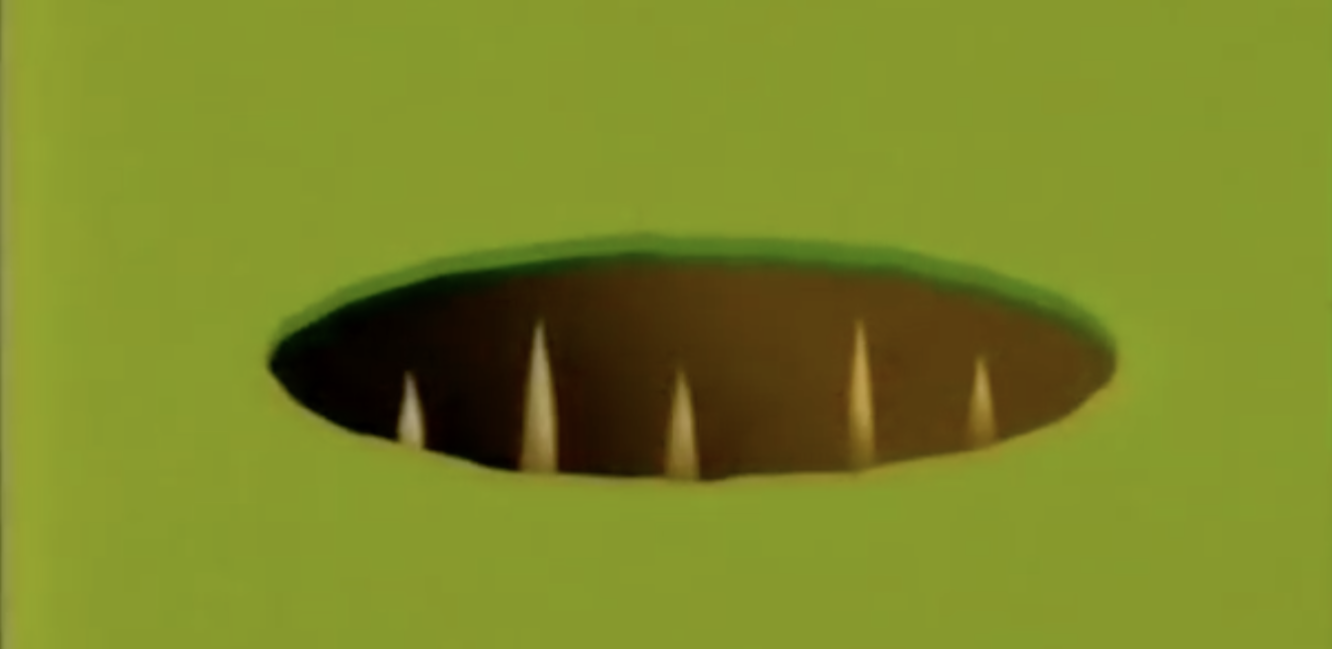
The Bannockburn episode starts with an introduction to Robert the Bruce, Edward II, and Stirling Castle, and an overview of the site to be excavated. We are told that no archaeology has been done at Bannockburn, the lack of which does add to the excitement and anticipation of the excavation. Aerial footage is used to identify the possible site of the Roman road along which Edward II marched towards Bannockburn, and a trench dug. Scenes of the excavation were interspersed with a display by the Glasgow mounted police, ostensibly to give an idea of the impact of Edward II using warhorses – really? Is there any comparative purpose in this? Different archaeology was found at either end of the trench, with the bottom end providing evidence of the Roman road, and the top end producing coal dust and other artefacts from an 18th/19th century industrial working site. Tony and Neil discuss the clues of the battle from literary sources, and further excavation areas were dug following perusal of aerial photos searching for pits dug by Robert the Bruce on either side of the Roman road.
These pits had sharpened wooden stakes within, and the only artefacts associated with the Battle of Bannockburn at the time of programme making were the tips of three stakes found in 1923. Tony organised a palaeobotanist to date these stakes, which were found to be 8,000 years old. Despite this dating evidence and the lack of toolmarks on the ‘stakes’, the Director of Stirling Smith Museum refused to accept they were unlikely relics of Bannockburn, stating:
Cartoon illustration of pits (Two Men in a Trench still 2004).

“They [local archaeologists who found the stakes] wrote with such clarity, and without the mumbo-jumbo associated with archaeology these days, that I believe the stakes are authentic relics from the battle.... They [the BBC Team] are disbelieving an earlier generation of archaeologists." (The Scotsman 2004)

This added an element of dramatic tension to the episode, displaying evidence of vested interests in the site and resistance to new evidence; I note the Historic Scotland (2012) record of the battle now states these stakes have no connection to Bannockburn, so Tony was vindicated in the end. But did this attitude betray an underlying problem – people did not take the programme seriously? The blokey camaraderie, the jarring music, the dressing up – did these elements detract from the obvious passion and erudition of Tony and Neil?

Returning to the excavation, Tony and Neil brainstormed ideas for the precise battle site, with Neil deciding on the high ground - the Dry Field, and Tony the marshy area - the Carse. They split into two teams and investigated the areas using metal detectors. The battlefield was looted after the battle and, although they found possible artefacts, there appeared to be nothing dating definitively from 1314. Andy Robert Shaw from the National Army Museum then makes his usual cameo appearance, bringing Scots and English military uniform and equipment for Tony and Neil to perform in, which they do, demonstrating their idea of how a schiltron would work. As a schiltron is a battle formation with as many as 2,000 men lined up tightly packed and holding 12ft long spears pointing towards the enemy (SATH 2020), the full drama and fearsomeness of such a formation is not easily evident from two men standing side by side holding two spears, and it ends up looking just a bit silly. Two more specialists are brought on site – Derek Alexander, National Trust Scotland, and Fiona Watson, University of Stirling – to pronounce on which area they prefer for the battle site, and to give their reasons for their choices, with Derek choosing the Carse and Fiona the Dry Field. Tony and Neil then walk around their respective areas to try and align the topography with the areas described in literary sources. Finally, Andy is brought back to have a look at their metal detecting finds, none of which is conclusive, and the episode ends rather abruptly and inconclusively, leaving, I suspect, dissatisfied customers.

Tony is an enthusiastic and knowledgeable archaeologist with a real zest for battlefield archaeology, but this zeal is insufficient: he is wooden as an actor and it is only when overcome with excitement that his performance becomes appealing. The camera loves Neil, as evidenced by his subsequent career in television. My opinion is that here his performance is mannered and his voiceover grating. The filming appears jerky with clips being very dark, and the presenters’ constant looking to the side of camera when speaking is an odd conceit. This episode’s pitch appears to fail at every turn: it is neither funny or engaging enough for the younger audience (and why should we be making battlefield archaeology funny?), nor does it have enough scholarly content to appeal to the more bookish audience. I can see why Two Men in a Trench only ran for two series.

Reference List

Historic Scotland. 2012. The Inventory of Historic Battlefields – The Battle of Bannockburn. http://data.historic-scotland.gov.uk/data/docs/battlefields/bannockburn_summary.pdf [accessed 18 February 2020].

Pollard, T. & Oliver, N. 2002. Two Men in a Trench. London: Michael Joseph.

SATH (Scottish Association of Teachers of History). 2020. Schiltron. http://www.sath.org.uk/edscot/www.educationscotland.gov.uk/scotlandshistory/warsofindependence/schiltron/index.html [accessed 18 February 2020].

The Scotsman. 2004. Stakes high in row over Bannockburn relics. https://www.scotsman.com/news-2-15012/stakes-high-in-row-over-bannockburn-relics-1-519102 29 March 2004. [accessed 18 February 2020].

Tout, T. F. 1925. A First Book of British History. London: Longmans, Green & Co.

Two Men in a Trench. Episode 5. Series 2. The Battle of Bannockburn. BBC2. 25 March 2004.

Illustrations

Two Men in a Trench book cover, from Pollard, T. & Oliver, N. 2002. Two Men in a Trench. London: Michael Joseph.

Map of the Battle of Bannockburn, from Tout, T. F. 1925. A First Book of British History. London: Longmans, Green & Co.

Cartoon illustration of pit with stakes, from Two Men in a Trench. Episode 5. Series 2. The Battle of Bannockburn. BBC2. 25 March 2004

