

LOCATION: Swansea | LLEOLIAD: abertawe
LEVEL 5 | LEFEL 5
EXAMINATION PERIOD | CYFNOD ARHOLIADAU
January 2025 | Ionawr 2025
MODULE CODE: ACCA5024
ADVANCED NETWORKING

Student Name: Chloe Roberts

STUDENT ID: _________________________________

TIME: 2 HOURS

This is an individual practical lab-test, held under examination conditions. You will be assigned TWO Routers, ONE Switch and THREE PCS. configure these devices based on the following specifications.
The routerS ARE HQ, BRANCH, the switch As1, and the PCs PC1, PC2, and PC3.

This paper contributes 75 % to overall module ASSESSMENT.

Task 1: In class activities (20 Marks)
- Subnet and VLSM (10%) complete by 10/4/25
- Final exam on NetAcad (10%) complete by 10/4/25

Task 2: Network Configuration (80 Marks)

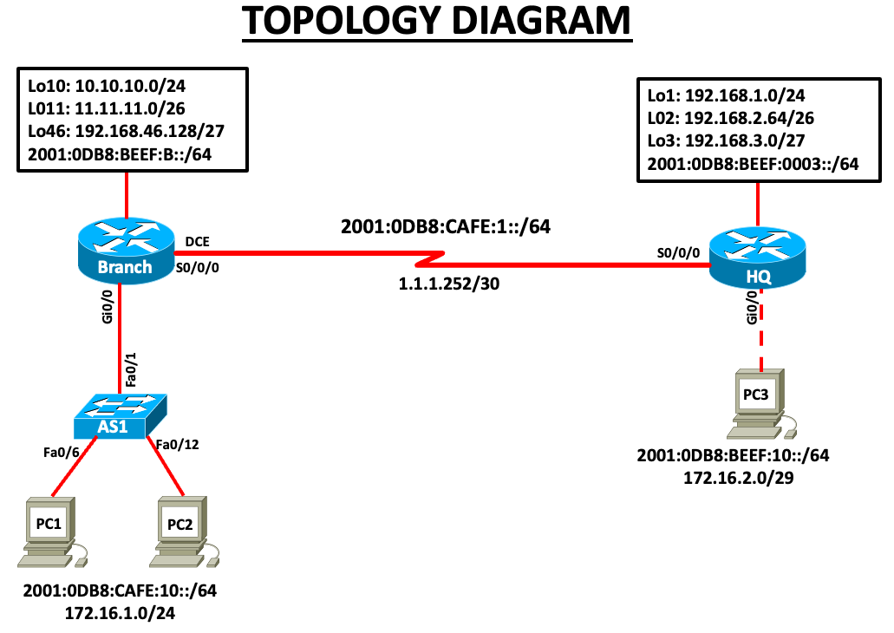

2.1 IP Addressing table
From the topology diagram, fill the below IP Address table. For LAN, assign the first usable address to Router interface and last usable address to PCs. For IPV6 use the first, second and third addresses.
Device | Interface | IP Address | Subnet mask | IPv6 Address | Default Gateway
Branch | S0/0/0 | 1.1.1.253 | 255.255.255.252 |  | N/A
 | Gi0/0 | 172.16.1.1 | 255.255.255.0 |  | N/A
 | Lo10 | 10.10.10.1 | 255.255.255.0 |  | N/A
 | Lo11 | 11.11.11.1 | 255.255.255.192 |  | N/A
 | Lo46 | 192.168.46.129 | 255.255.255.224 |  | N/A
HQ | S0/0/0 | 1.1.1.254 | 255.255.255.252 |  | N/A
 | Gi0/0 | 17.16.2.1 | 255.255.255.248 |  | N/A
 | Lo1 | 192.168.1.1 | 255.255.255.0 |  | N/A
 | Lo2 | 192.168.2.65 | 255.255.255.192 |  | N/A
 | Lo3 | 192.168.3.1 | 255.255.255.224 |  | N/A
AS1 | VLAN 1 | 172.16.1.2 | 255.255.255.0 |  | 172.16.1.1
PC1 | NIC | 172.16.1.253 | 255.255.255.0 |  | 172.16.1.1
PC2 | NIC | 172.16.1.254 | 255.255.255.0 |  | 172.16.1.1
PC3 | NIC | 17.16.2.6 | 255.255.255.248 |  | 17.16.2.1

2.2 Initial Setup (0 Marks)
- Using packet tracer, check the above topology using Routers, Switches and PC’s

2.3 Basic Router configuration (5 marks)

- On both routers configure the following
  - Host name
  - Disable domain lookup.
  - Banner “No Unauthorised Access”
  - Privilege EXEC password to “C15coPa55”
  - Access port password to “Con@C15co”

2.4 Interface configuration (10 marks)

- Configure IP Addresses according to the Addressing Table and make sure the interfaces are active.
- Use appropriate labels for all connected links.
- Set the bandwidth on serial links to 2048kbps.
- Set the clock rate on DCE to be 128000

2.5 Routing configuration (25 marks)

- Enable RIPv2 on both routers and advertise all connected networks.
- Disable auto summarisation.
- Enable IPv6 Routing
- On Branch, configure IPv6 static route to HQ network as appropriate.
- On HQ, configure IPv6 static route to Branch network as appropriate.

2.6 Switch configuration (15 marks)

- Configure – hostname, privileged EXEC password, access password “C15co!CON”, vty line password “C15co!VTY” and banner “No Unauthorised Access”.
- Configure VLAN 1 IP Address according to the Addressing Table
- Configure switch AS1 to accept only SSH connection from remote locations.
        - Configure the username SSHadmin with an encrypted password of 55HAdm!n2024
        - The switches domain name should be set to soac.com
        - The key modulus should be 1024 bits

Task 3: Network connectivity (20 marks)
- Using ping command, verify end-to-end connectivity for both IPv4 and v6 networks:
  - From PC1, ping PC3. Is it successful? No
  - From PC1, ping any Loopback on HQ. Is it successful? No
  - From PC3, ping PC2. Is it successful? No
  - From PC3, ping any Loopback on Branch. Is it successful? No

SSH Verification:
- From PC1 or 2, establish telnet access to AS1. Is it successful? No
- From PC1 or 2, establish SSH access to AS1. Is it successful? Yes

Examiner Comments and Signature:
Note: Ask the invigilator to check and sign off the Task 3. If not signed off by the invigilator, marks will not be awarded for this step.
Network Connectivity Verification:

Signature:

Submission Requirement:
For each device you configured a txt file containing the following outputs must be submitted on Moodle. The file name should be StudentID_devicename.txt
show run
show ip int brief
show ip route
show ipv6 int brief
show ipv6 route
All documentation for your solution should be submitted electronically on Moodle within the time allocated. It is your responsibility that you copy all the files correctly. Any files submitted after the deadline will be capped at 40%

Diwedd/End

