Module: ECYW5010
Student ID: 2308058

Introduction
This analysis explores a participatory session I developed and delivered with Connect Voices, the youth council established by Adoption UK. According to Connect Child and Young People Services (2022–2026) Connect Voices provides a platform for adopted young people aged 14+ to share experiences and influence services that affect them. Participation is voluntary and should emphasise empowerment, inclusion, and voice. (CLD Standards Council Scotland (CLDSCS), 2019, p.4)
Connect Voices works collaboratively with the National Adoption Service for Wales (NAS), which leads adoption services across Wales. National Adoption Service (2026) describes how, through their Life Journey Work framework, they are developing a leaflet informing young people about their early life records and how they can access their files at age eighteen. Connect Voices was invited to provide feedback to ensure the leaflet was accessible, relevant, and sensitive.
This presented an opportunity to design and facilitate a participatory session grounded in youth work values and children’s rights.

Planning and Delivery of the Session
After identifying young people who wished to participate, I structured a session to gather their views. A draft of the leaflet was shared in advance. During the session, I provided focused questions addressing:
- First impressions and usability
- Clarity of purpose
- Wording and language
- Layout and design
- Practical improvements
Each question was allocated to an individual to encourage engagement and reduce the risk of dominant voices overshadowing others. Clear boundaries were established to clarify that the discussion concerned the leaflet’s content rather than personal experiences of accessing records. Anonymous feedback was offered to support emotional safety.
The structure aimed to reflect youth work principles of voluntary participation, empowerment, and respect for voice. However, on reflection, aspects of the process remained adult-led. Although the young people contributed in meaningful ways, I recognise that I could have involved them more fully in shaping the questions and co-creating the agenda, thereby strengthening their ownership of the session.

This practice can be analysed using the Lundy Model of Participation, developed in line with Article 12 of the United Nations Convention on the Rights of the Child as outlined by UNICEF (nd). The model identifies four elements as per the image below.

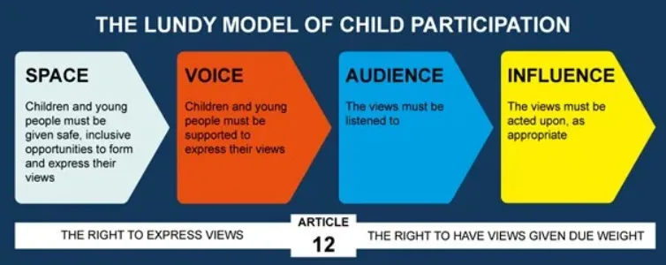
(UNICEF, ND).
A safe space was intentionally created. Breakout discussions and anonymity reduced pressure and acknowledged the sensitivity of adoption records. This demonstrates trauma-informed awareness and aligns with CLDSCS (2019, p.5) values of inclusion and safety.
Young people were supported to share views, with structured prompts. Allocating questions encouraged quieter participants to engage. On reflection, by co-designing the questions this could have strengthened ownership and voice.
NAS requested feedback, demonstrating a willingness to listen. To ensure that a meaningful audience was achieved, I needed to be transparent in how the feedback was recorded and communicated to NAS. I shared this information with the group at our next meeting, and through further discussion, we reviewed the responses together and agreed on any changes they felt were necessary before submission.
Influence is the most critical element. While the session created an opportunity for voice, Article 12 requires that views need to be listened to and whether young people’s contributions result in tangible changes to the final leaflet.

This session reflects the principles set out by CLDSCS (2019, p.5) by:
- Providing voluntary engagement
- Enabling young people to influence service development
- Working in partnership with a national service

Although the voices and participation of young people were at the core of this, decision-making authority remained with NAS. If their views are not meaningfully considered or acted upon, this may lead to disengagement and a perception that contributing their opinions has little value in future consultations.

Given the sensitive nature of adoption and identity, establishing clear boundaries within the session was ethically essential. Adopted young people are statistically more likely to have experienced early trauma, with figures reported as high as 71%, as stated by Parliament UK (2023). This highlights the importance of adopting a trauma-informed approach when facilitating discussions linked to personal history.
Bath, H (2008) identifies three therapeutic pillars necessary when working with individuals affected by early trauma. These are safety, connection, and emotional regulation. These pillars provide a framework for ensuring that practice minimises the risk of re-traumatisation. These core principles must be carefully considered when addressing sensitive topics that may potentially dysregulate a young person due to their early experiences. By clarifying that the session focused on leaflet design rather than personal histories, protected emotional well-being. Offering anonymity further reduced pressure.

Conclusion
To conclude this piece of practice demonstrates strong alignment with youth work values, CLD standards, and Article 12 of the UNCRC. This session created safe space, enabled voice, and respected voluntary participation. Through application of the Lundy Model, elements of space and voice were included, however audience and influence remain dependent on organisational response.
I feel although this was a positive example of consultation, it also shows that decisions and power will still remain with the service. Young people were listened to and involved, but the final decisions will be made by professionals. Because of this, the real value of their participation depends on whether NAS actually makes changes based on what they said and shows them that their input mattered.
Overall, this experience shows that youth participation within organisations can be complex. While the session was planned well, involving young people earlier in the process could help strengthen participation even further.

REFERENCES
Bath, H. (2008) ‘The three pillars of trauma-informed care’, Reclaiming Children and Youth, 17(3), pp. 17–21. Available at: https://elevhalsan.uppsala.se/globalassets/elevhalsan/dokument/psykologhandlingar/trauma-informed-care.pdf (Accessed: 19 February 2026).
CLD Standards Council Scotland (2019) Youth work national occupational standards: Introduction. Glasgow: CLD Standards Council Scotland. Available at: https://cldstandardscouncil.org.uk/wp-content/uploads/YouthWorkNOS2019Intro.pdf (Accessed: 15 January 2026).
Connect Children and Young People Service (n.d.) Youth council. Available at: https://www.connectcymru.com/voices/youth-council/ (Accessed: 15 January 2026).
National Adoption Service (2026) Who we are. Available at: https://adoptcymru.com/who-we-are/ (Accessed: 15 January 2026).
UK Parliament (2023) Written evidence submitted by Adoption UK. London: UK Parliament. Available at: https://committees.parliament.uk/writtenevidence/118292/pdf/ (Accessed: 19 February 2026).
UNICEF (n.d.) The Lundy Model: Article 12 in practice. Available at: https://www.unicef.org.uk/rights-respecting-schools/resources/teaching-resources/guidance-assemblies-lessons/the-lundy-model-article-12-in-practice/ (Accessed: 21 January 2026).

