Objective 1: Outline the different types of vehicle crime and how advanced technology has increased organised crime groups capabilities.
Objective 2: Analyse the impact of new generation vehicle crime by researching statistics and established articles.
Objective 3: Examine the public’s perception on vehicle crime and how it impacts the confidence in the police.
Objective 4: Recommend improvements needed to boost public confidence in the polices ability to resolve vehicle theft.

Finding’s Chapter 4.0
Introduction 4.1
The main focus of the survey was to examine the public’s perception on vehicle crime and how it impacts the confidence in the police as part of the primary research and important in being a main objective for the research project. By achieving this research, it supports the claims of the information from the literature review where it displayed the issue of car theft not being focused on and new technology impacting the crimes effectiveness. Main data that needed to be collected was the public’s perception of vehicle crime primarily vehicle theft. This was done by asking questions orientated towards gaging public opinion on how vehicle theft and crime have impacted them, how the police were able to deal with the crime, asking about the perception of technology used and how the future of vehicle crime may look.
The empirical results will be displayed primarily with the use of pie and bar charts, with written answer questions being shown through the use of words that were most common in the answers. This way of displaying data is best for the reader and will support the literature reviews findings. All the data shown is collected through the use of the survey that was made available to anyone who had access to social media such as WhatsApp, Facebook, Instagram and Snapchat managing to get 82 responses in total which although less than 100 still more than supports the literature review data.

Findings 4.2
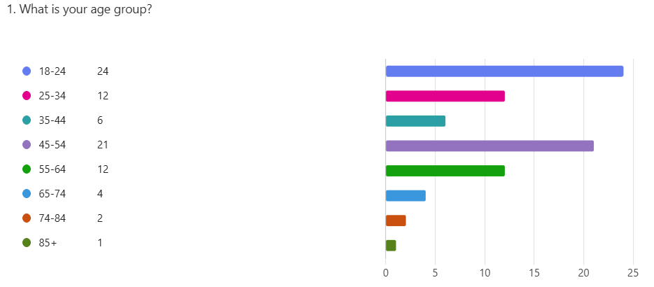
There was an age restriction in this survey as participant’s needed to be of driving age (17+) and be in line with ethics hence the 18 year old starting age. This graph displays the age range of survey participant’s giving an idea of the different age groups who have had access to the survey. The main age range was individuals between 18 and 24 with there being 24 participants at this age.
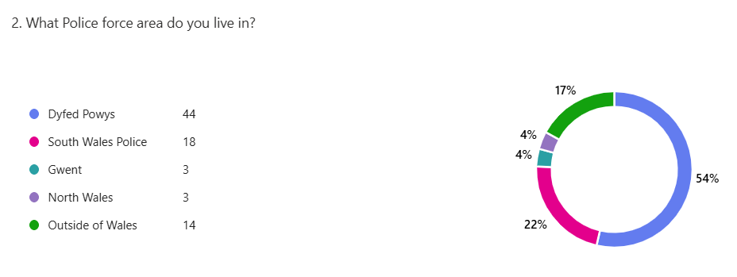
This pie chart displays the areas of where participants police forces are in which can help show the range of areas. 54% of participants were within Dyfed Powys policing area. This means the primary range of statistics are from individuals in Dyfed Powys police services area.
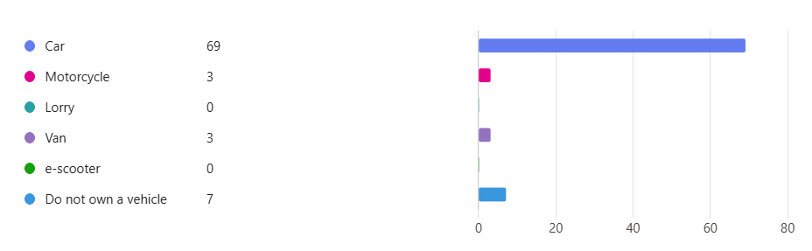
Most participants own a vehicle as displayed in the above bar graph, but there have been other vehicle owners including those who don’t own a vehicle. 69 participants own a car which is useful in data collection when comparing to the literature review.

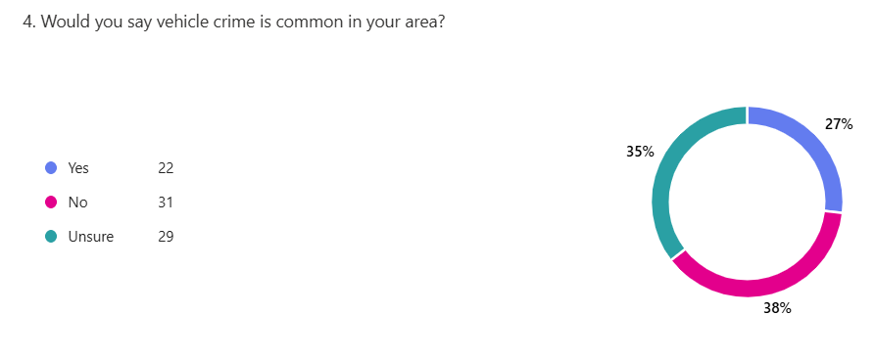
When asked if vehicle crime is common in your area, the participant’s had a varied range of the three possible answers. The publics perception towards vehicle crime in general is very similar giving no clear evidence regarding it’s increase or decrease. The literature review found that there has in fact been an increase in vehicle crime (Grieg 2025). This shows that public perception isn’t necessarily aware of vehicle crimes increase or haven’t witnessed an increase themselves.

If yes why?
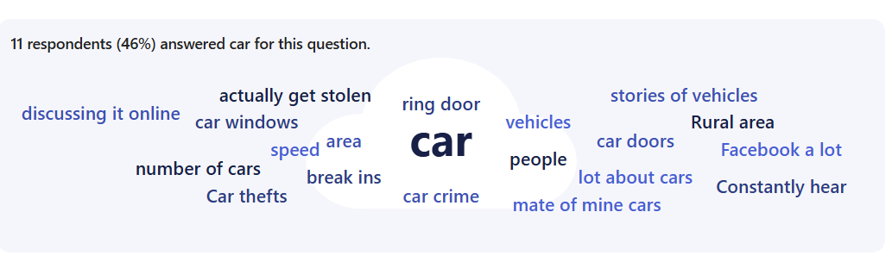
When asked if yes why many participant’s answers break ins/ theft, speeding and criminal damage showing that there is a range of vehicle crime in participants areas. Vehicle crime has had an increase as stated by (Grieg 2025). But public perception from the survey shows more of a range of vehicle crime compared to the findings in the literature review.
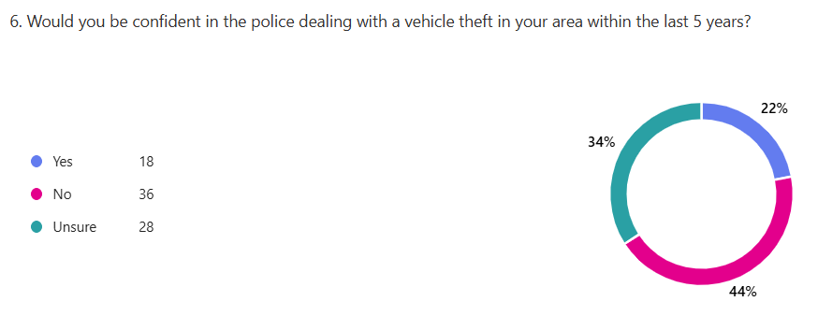
When asked if participants would be confident in the police dealing with vehicle theft in the past 5 years there was shockingly high results with 44% of people saying “no” showing that there is an issue with policing effectiveness of vehicle theft. This match finding stating that there has been a high amount of vehicle theft without the cars being returned to the owner (Hale 2025).

Why?
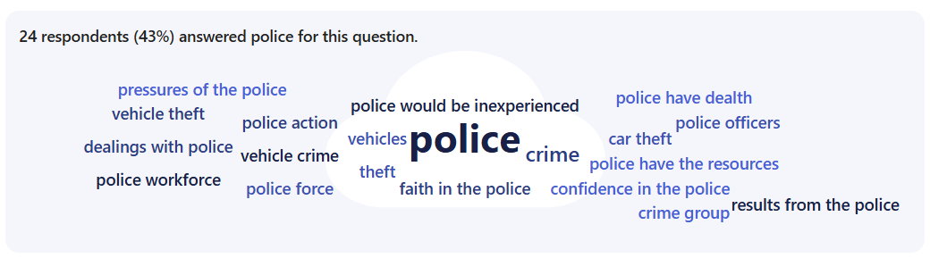
When asked why many answered “police inexperience”, “lack of resources” and “police not seeming to be prioritising vehicle theft”. This shows a concern from the public on how the police are responding to vehicle theft. Which was also a key part in literature findings where it was mentioned there is a difficulty applying resources to all areas of policing.
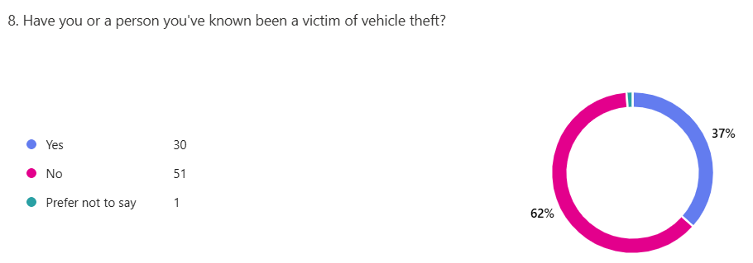
The pie chart above displays the amount of participant’s who have been a victim of or known a person who has been a victim of vehicle theft. 37% said yes making light on how present vehicle theft is in Wales and other parts of the UK.
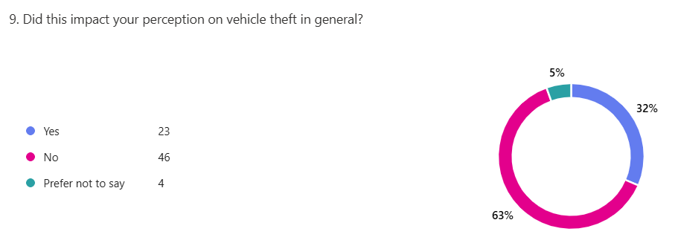
63% decided no when asked if there experience of vehicle theft impacted their perception of vehicle theft but this does include those who have not experiences vehicle theft. But with 32% of participants being impacted it shows the need for changes to be made. It was shown in the literature review the impact vehicle crime has on the public’s perception showing similarities with the survey (Crimestoppers 2025).
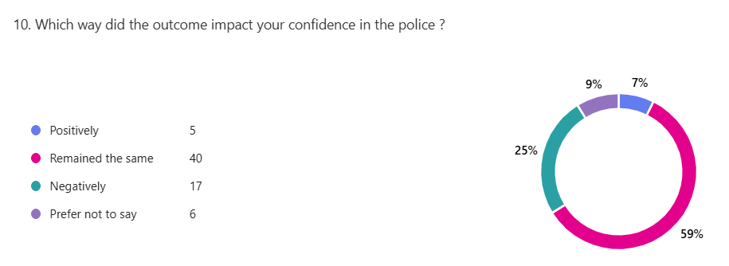
When asked about the impact in confidence toward the police participants mainly remained the same but there was 25% who were negatively impacted from how the police dealt with the vehicle theft. Crimestoppers 2025, acknowledged the mental impact of vehicle theft in how it impacts the public which coexists with the surveys finding.
Could you explain your answer?
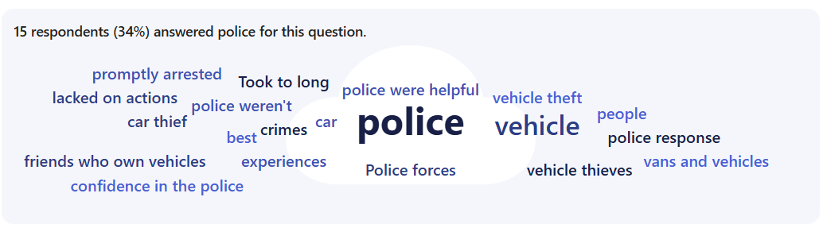
When asked to explain their answer participants stated there wasn’t enough police “action” to the vehicle theft with many believing that the police didn’t see vehicle theft as an important crime to be responded to. The literature review displayed often how vehicle theft isn’t prioritised enough by the police service.
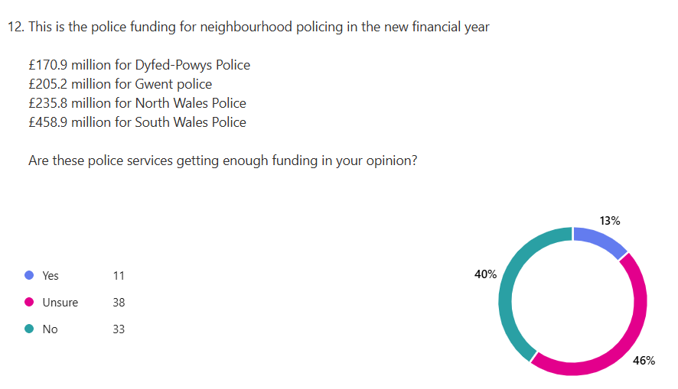
40% of participants believe that their police services are not getting enough funding displaying the belief that the police do not have enough resources for policing vehicle theft. This combines with the literature reviews finding’s showing lack of resources (Glantz 2025).
Explain your answer here…
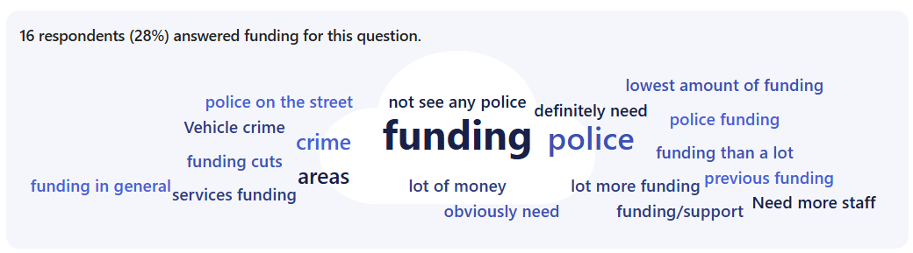
When asked to explain their answer many stated that there isn’t enough funding but to counter that there were also people stating there is enough funding but it is not being dispersed efficiently to the right areas, also comparable to the literature review findings.
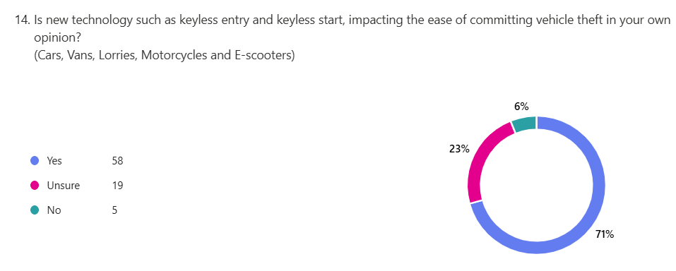
71% of participants said yes when asked if the new technology such as keyless entry are impacting how easy vehicle theft can be for criminals. Which supports the claims from the literature review where it was stated that 60-70% of vehicles stolen had keyless entry (BBC 2025).
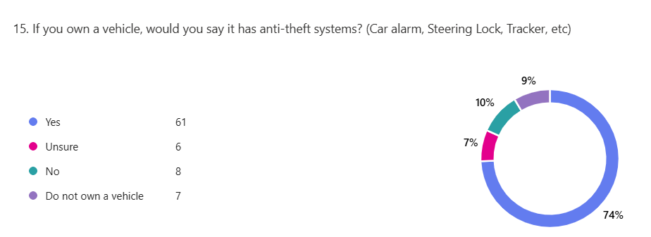
74% of participants were aware of anti-theft systems in their vehicles, with 7% being unsure on if they had anti-theft systems. This shows that the majority of participants are aware of the security that cars have.
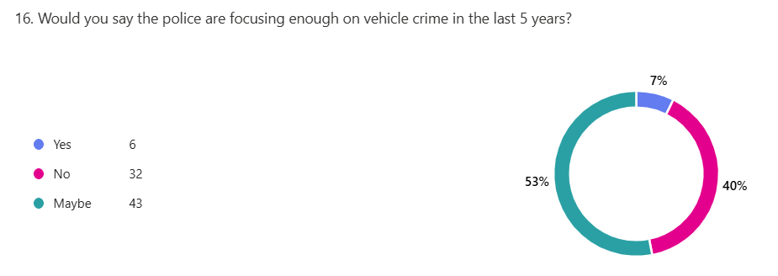
When asked if the police have been focusing enough on vehicle crime in the last 5 years 40% said no with 53% saying maybe which displayed that vehicle theft may not be the polices main focus which is why people feel although it’s not an important crime to the police. This links to the literature reviews findings when it was said that vehicles are very rarely recovered (Hale 2025).

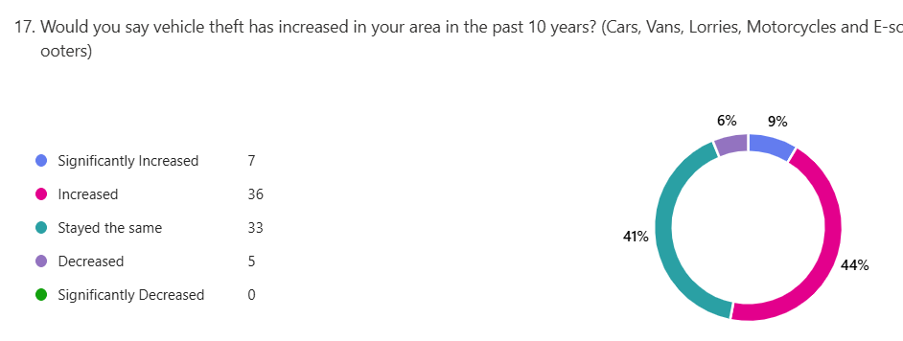
44% of individuals believe that vehicle theft has increased in the past 10 years showing just how much it needs to be addressed by the police and government focus. Comparing this to the statistics found in the literature review with it stating there has been a 75% increase in vehicle theft since 2013 (Glantz 2025). This shows that the public perception is ranged towards vehicle theft increase but it’s majority do believe vehicle theft has in fact increased.
If yes why?

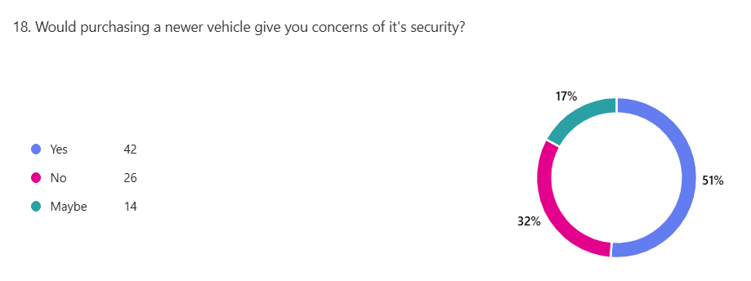
51% of participants believe that a newer vehicle would give them concerns on security possibly displaying that newer technology isn’t always better security for vehicles. Which is why there is tougher penalties being put in place for those who use technology such as signal jammers for vehicle theft (Kepinska 2025).
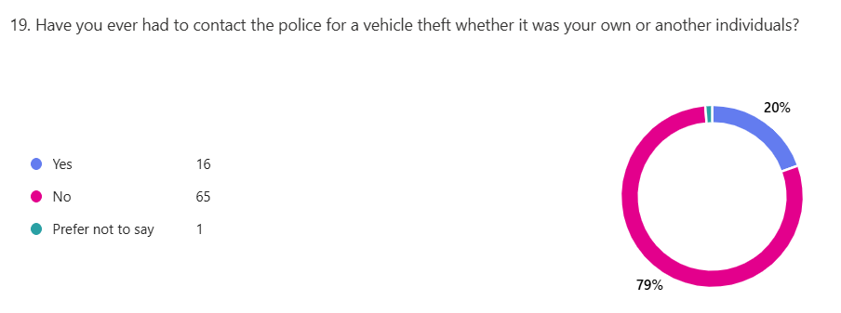
79% of participants have not had to contact the police about a vehicle theft, with 20% needing to contact the police for a vehicle theft. This displays that even with a group of 82 participants there is still a high number of people needing to contact the police for vehicle thefts possibly displaying why the police is becoming overwhelmed.
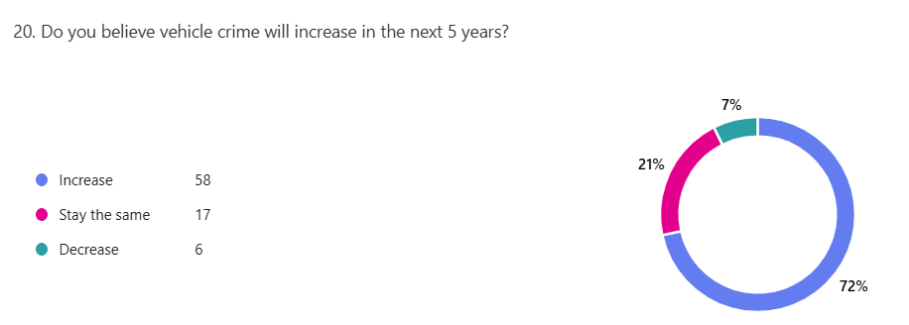
72% of participant’s believe that vehicle crime will increase in the next 5 years displaying the need for change in how vehicle crime is being committed. This aligns with the dramatic rise in vehicle theft already and its likelihood to keep increasing if more is not done to decrease it (Grieg 2025).

Summary 4.3 100
Data analysis has shown a very similar response from the literature reviews finding’s which is why vehicle crime and theft needs further attention. There was a lot of similarities shown in the survey with how vehicle theft and crime is very much in the view of the public, with many blaming the lack of resources and the lack of care towards policing vehicle theft. In summary the public perception of vehicle crime is that vehicle theft will increase and participants believe there is not being enough done to challenge it, showing just why there needs to be more of a focus on vehicle theft in the UK.

Referencing
- BBC (2025) Keyless car theft devices used by criminals sell for £20k online. Available at: https://www.bbc.co.uk/news/articles/c74jgvp1x49o (Accessed: 13th March 2026).
- CrimeStoppers (2025) New campaign highlights long- lasting impact of theft, robbery & burglary. Available at: https://crimestoppers-uk.org/news-media/news/2024/jul/new-campaign-highlights-long-lasting-impact-of-theft-robbery-burglary-as-risk-rises-over-summer#:~:text=It%20can%20lead%20to%20some,being%20left%20with%20physical%20injuries.&text=The%20average%20cost%20of%20a,emotional%20impact%20can%20be%20priceless. (Accessed: 12th March 2026).
- Glantz, E. Williams, M. Greig, A (2025) Organised vehicle theft in the uk. Available at: https://static.rusi.org/organised-vehicle-theft-in-the-UK-trends-and-challenges-june-2025.pdf (Accessed: 12th March 2026).
- Grieg, A. (2025) The dramatic rise of vehicle crime in the uk. Available at: https://www.rusi.org/news-and-comment/video-commentary/dramatic-rise-vehicle-theft-uk#:~:text=Car%20thefts%20in%20the%20UK,effort's%20key%20findings%20and%20recommendations. (Accessed: 12th March 2026).
- Hale, C. (2025) 342,000 cars stolen in four years- the uk’s vehicle theft crisis. Available at: https://www.cinch.co.uk/news/car-theft-statistics (Accessed 12th March 2026).
- Kepinska, N. (2025) Tougher penalties for those who use of supply signal jammers. Available at: https://www.lawgistics.co.uk/blog/legal_updates/tougher-penalties-for-those-who-use-or-supply-signal-jammers/ (Accessed: 13th March 2025).

