Laura Stephens 2305554
Word Count - 4876
Design, conduct and critically evaluate a close-to-practice research project focusing on the model of the transformative teacher in developing practice that has a positive impact on the learner.
Introduction
This assignment will investigate the design, implementation and evaluation of a research endeavour centred around the transformative teacher model, with a specific focus examining the intricacies of mixed gender groupings within the drama classroom. Through an exploration of students’ perspectives on this nuanced aspect of pedagogy, the aim is to uncover insights that illuminate the path towards more inclusive and effective teaching practices. The research focuses on examining the dynamics and consequences associated with mixed - gender grouping within the context of drama education. This topic stems from the observation of students challenging behaviour when working in the same gender grouping which impacted on both teaching methodology and student experiences. In coherence with the Welsh Government’s (2019) Professional Learning Passport (PLP), the research focuses on a domain of pedagogical significances, leadership, collaboration, innovation and professional learning. Through exploration of students’ perspectives between same gender and mix gender groupings, the aim is to refine the ongoing growth of teachers understanding on what strategies work best for successful student outcomes alongside maintaining effective behaviour control. In compliance with the British Educational Research Association (BERA) (2018) guidelines, the school will remain unnamed and be referred to as School X. Located on school X’s website the headteacher (Clake, 2019) states that their goal is to ensure that every student achieves academic success and personal growth within a nurturing and welcoming environment, which helps cultivate creativity, intellectual and social confidence in every student. According to Estyn’s report (2018) school X has 1352 pupils enrolled with 1280 pupils of statutory school age. The school is a new 3-16 co-educational school featuring both a primary and secondary phase and has 19.1% of pupils identified as having additional learning needs (ALN) which is below the national percentage of all ages of 22.3%. Stated by Teacher A (2024), the class context in which the research will take place in holds 26 students divided into 15 boys and 11 girls with 9 students who suffer with either additional learning needs (ALN), social and emotional behaviour difficulties (SEBD) and autism spectrum disorder (ASD). Therefore, the question chosen for this assignment is “To investigate pupil’s perspective on mixed gender grouping in the drama classroom”.
Literature Review
In the context of challenging behaviour in a classroom Bandura (1988) highlights the importance of observational learning in his social learning theory, stressing the acquisition of behaviours through copying, observing and imitating others particularly when those behaviours are either unreprimanded or rewarded. Bandura (1988) continues by emphasising a key factor throughout his research was an extraordinary lack of punishment at home for children that displayed aggressive or challenging behaviour. Given the absence of consequences for children’s actions within their home environment Bandura’s investigation posits that boundaries aren’t firmly established, potentially leading to a lack of discernment between right and wrong, a tendency to violate rules and failure to recognise acceptable behaviour therefore impacting their developmental journey into adulthood (Bandura, 1998). This implies that observational learning's significance in behaviour formation is underscored. Students may imitate peers to gain attention or control classroom dynamics. Bandura's theory highlights observation and modelling as core to human learning, challenging the notion that learning solely stems from firsthand experiences, suggesting knowledge and skills can be acquired by observing others' behaviour.
Vygotsky’s socio-cultural theory of zones of proximal development offers valuable insight into the social interactions and dynamics that occur within a classroom. According to Mcleod (2024) cognitive development is understood as a socially mediated progression, whereby children acquire cultural values and problem-solving strategies through engaging in collaborative dialogues with individuals who possess greater knowledge within society. Mcleod (2024) asserts that Vygotsky believed social interaction plays a significant role in the development of mental abilities. Vygotsky's emphasis on social interaction in cognitive development highlights how children's behaviour is influenced by social engagement, reflecting cultural and social contexts. Mcleod (2024) argues teachers are pivotal in guiding children, fostering problem-solving skills beyond specific situations, stressing optimal learning through interaction with peers and mentors for guidance and encouragement.
Rose (2023) critiques prevailing behavioural policies, arguing they inadequately address the intricate emotional needs of vulnerable students, potentially exacerbating academic challenges. Rose (2023) implies that reliance on external behaviour conditioning methods, such as reward systems and punitive measures, may fail to yield long-term effectiveness, especially among students who have experienced trauma. Instead, Rose (2023) claims nuanced approaches acknowledging individual differences and trauma-informed practices may better support student well-being and academic success. Reward systems can lose efficacy over time and punitive measures may trigger adverse reactions (Rose, 2023). This indicates a deeper understanding of student behaviour is needed and the implementation of alternative and more holistic behaviour management strategies are essential for promoting student well-being fostering a conducive learning environment in schools effectively supporting students and their academic success.
According to a report by the National Assembly for Wales (2018), stress and anxiety levels among students have notably increased, with a doubling in self-reported anxiety or depression among 15–16-year-olds. Additionally, one in ten 5–16-year-olds suffer from diagnosable mental health disorders, while 10-15 percent of teenagers exhibit symptoms of depression at any given time. These findings emphasize the urgent need for substantial improvements in emotional and mental health support for children and young people in Wales, including addressing stigma and providing comprehensive services. The Welsh Government (2022) emphasizes a commitment to a curriculum focused on equipping young individuals with life skills to adapt positively to their environment. Furthermore, the evidence suggests that limited support and delayed access to services may contribute to the emergence of challenging behaviours..
O’Donohue and Ferguson (2012) argue that Skinner's radical behaviourism dismisses the influence of unobservable mental states on behaviour, focusing instead on environmental factors and consequences. Skinner's operant conditioning emphasised observable behaviour and its consequences, laying the groundwork for behaviour regulation through rewards and punishments. Bennet (2017) emphasizes the importance of encouraging positive behaviour in schools, linking student behaviour to academic, professional, and personal success. This implies that Positive behaviour correlates with better outcomes such as improved academic performance and social-emotional well-being, while negative behaviour may hinder achievement. Bennet (2017) outlines schools should establish clear protocols for consequences and rewards as evident today suggesting Skinner's theory has significantly influenced educational policies aiming to create safe and respectful learning environments, highlighting the importance of behaviour management strategies aligned with his principles.

Boys and girls may avoid mixing in school due to social, cultural, and personal factors. Ko (2011) stresses the significance of adolescent friendships for development and his interdisciplinary research examines friendships' impact on social connections, learning, and mental well-being. Understanding this importance aids educators in supporting adolescents, promoting positive outcomes in school. It implies that friendship dynamics are crucial for navigating social environments during the formative school years, influencing adjustment and overall well-being.
Kimmel (2000) notes societal norms shape friendships between genders, impacting adolescent social dynamics. Kerig, Schulz, and Hauser (2012) challenge stereotypes, suggesting boys value intimate friendships despite fewer during certain stages. Their research emphasizes emotional closeness among adolescents. Understanding friendship complexities is crucial for emotional resilience in school, they claim. Despite stereotypes, fostering positive relationships is vital for development. Thus, recognizing diverse influences allows educators to create supportive environments promoting meaningful connections among adolescents at school.
Cook-Sather (2004) observes the absence of student voice in educational discourse, urging its incorporation. She emphasizes students' potential to revolutionize education by participating in traditionally adult-dominated discussions and initiatives. Yet, Cook-Sather (2004) acknowledges potential obstacles to this transformation, suggesting that student involvement could impede desired cultural shifts. While students' engagement holds promise for educational reform, it may also present challenges, she highlights. Therefore, this suggests integrating student perspectives is essential for catalysing meaningful change in educational research and practice. By valuing and including students' voices, educators can foster a more inclusive and effective learning environment, promoting a shift towards student-centred approaches to teaching and schooling.
Thiessen (2006) contents that classroom and school life research aim to reveal students' cognitive, emotional and behavioural patterns, their interaction with teachers, social environment, and its link with academic performance. Fielding (2002) highlights disillusionment in empowering student voices due to methodological shortcomings or overlooking their assimilation into norms. Genuine transformation requires challenging conventional practices, as emphasized by Fielding. Thus, research objectives should prioritize empowering student voices while addressing the challenges raised by Fielding to achieve meaningful change in education.
Case Study
Simons (2009) defines that case studies involve a thorough examination from various angles of the intricate and distinctive aspects of a specific project, policy, institution, program, or system within a real-world setting. Simons (2009) continues stating that it employs research-based approaches, encompassing diverse methodologies and relying on evidence. Its principal aim is to cultivate a comprehensive comprehension of a particular subject, endeavour, or framework, thereby contributing to knowledge generation and informing policy formulation, professional conduct, and community initiatives, highlights Simons (2009). Similarly, Thomas (2011) claims that case studies entail thorough examinations of individuals, events, decisions, projects, policies, institutions or systems, analysed holistically through multiple methods. The chosen case serves as a representative instance, providing a framework for understanding and elucidating the subject matter, emphasises Thomas (2011). This indicates that case studies thoroughly explore real-life subjects, employing diverse methods and evidence-based approaches to gain a comprehensive understanding. Case studies involve detailed analyses within specific contexts, utilizing various research methods.

Adelman, Jenkins and Kemmis (1980) claim that the study is analysing a case in motion which implies examining a subject or situation as it unfolds over time, rather than focusing solely on static data. The approach allows for a dynamic understanding of the complexities and changes within the case context. Furthermore, as highlighted by Gall and Borg (2005),
case study entails thoroughly examining a phenomenon within its natural context, considering the perspectives of participants involved, crucial for understanding its evolving nature. This implies that in a case study, it is essential to deeply investigate a phenomenon in its real-life setting, considering the viewpoints of those involved which is vital for comprehending its dynamic nature. Similarly, Robson (1993) indicates that case study is a method for conducting research that entails an empirical examination of a specific modern phenomenon within its real-world setting, drawing upon various sources of evidence.

According to Yazan (2015), despite being commonly employed in qualitative research, case studies lack a formal recognition as a social science research method due to the absence of clearly defined and structured protocols. Consequently, researchers intending to employ case studies often encounter confusion regarding its distinctiveness from other qualitative approaches, emphasises Yazan (2015). This indicates that case studies, though common in qualitative research, lack formal recognition as a social science method due to unclear protocols which leads to confusion among researchers. To conclude, from the literature above case studies offer in-depth insights into specific phenomena within real-world contexts, allowing for a rich understanding of complexities. This indicates that they provide flexibility in research design and facilitate the exploration of dynamic processes over time. However, it suggests that they may lack generalizability due to their focus on specific cases and subjective biases in data collection and interpretation can affect validity and reliability.

In this study, stratified random sampling will be used to highlight students who possess challenging behaviour characteristics that are of interest to the research question. Highlighted by Hayes (2024), stratified random sampling divides a population into smaller subgroups called strata based on shared attributes like attitudes, characteristics or education, ensuring representation. This implies that dividing the population into subgroups based on common characteristics, stratified random sampling ensures that each subgroup is adequately represented in the sample. There will be 8 students involved in total containing an equal split of 4 boys and 4 girls. These students all fall under the umbrella of special educational needs and disabilities (SEND) highlighting challenging behaviour and their perspectives of being placed into mix gender groupings in the drama classroom when completing tasks.

Research Methods

Cohen (2017) underscores the multifaceted nature of research, particularly in education, emphasizing the need to prioritize "fitness for purpose" in research methodologies. He argues that this concept highlights distinct research paradigms aligned with specific research aims, reflecting the evolving nature of educational research with the emergence of numerous paradigms. This implies that researchers should prioritize methods that align with their objectives, recognizing the dynamic nature of the field with fresh approaches continually emerging. Mouly (1978) complements this perspective by highlighting humanity's enduring quest to comprehend and interpret their environment through various methods, such as personal experience, logical reasoning, and systematic research. Both Cohen and Mouly stress the dynamic essence of research and the importance of aligning methodologies with precise goals. Their perspectives emphasize the necessity of selecting appropriate methodologies tailored to the specific objectives of the research pursuit, reflecting humanity's persistent inclination to understand and interpret their surroundings throughout history.

Action research, as described by McNiff (2012), involves examining teaching practices to align with teachers' professional standards, through critical reflections or professional development evaluations. McNiff stresses substantiating assessments with evidence and taking proactive measures for improvement. Additionally, she discusses how learning informs skill refinement. Noffke (2009) notes action research's varied procedural methodologies and objectives, including innovative data acquisition methods and alignment with theoretical frameworks. Some manifestations resemble traditional research paradigms, while others focus on specific classroom elements or societal paradigms. McNiff emphasizes individual teacher assessment and improvement, while Noffke explores broader methodological variations and goals within action research. Together, their insights enrich our understanding of action research, spanning from individual practice evaluation to broader methodological landscapes within education.
Denscombe (2014) asserts that social research offers myriad pathways to excellence, highlighting the importance of decision-making in selecting research strategies. Lewis et al. (2012) notes that when adults research children, they often wield power, potentially reinforcing existing inequalities. Lewis et al. (2012) outlines researchers must exercise judgment in selecting research strategies and be mindful of power dynamics, aiming to understand diverse perspectives and experiences to avoid perpetuating inequalities. Thus, navigating social research involves exploring diverse pathways to excellence, exercising discretion in strategy selection and recognising and mitigating power differentials when studying children.

Hurley and Underwood (2002) stress the pivotal role of consent and assent in developmental research with children. They assert that psychologists are ethically mandated to provide clear explanations of research procedures to children, urging researchers to obtain assent from those aged 7 and above. They state assent implies children understanding the voluntary nature of participation, their right to dissent, and the potential risks and benefits involved. Children must comprehend their autonomy in refusing participation and grasp the implications of their involvement fully, highlights Hurley and Underwood (2002). The inclusion of a parental consent letter (Appendix 1) and an assent letter for the 8 students chosen for this study (Appendix 2) underscores the importance of documented informed consent and assent. This documentation ensures compliance with ethical standards and confirms children's understanding and agreement to participate voluntarily in the research process. Hurley and Underwood underscore the ethical obligation to inform children about research procedures and seek their assent, highlighting the significance of consent and assent in research involving children. This commitment to informed participation safeguards children's rights and welfare, ensuring their autonomy and protection in the research process.
Punch (2014) underscores qualitative research's deep engagement with real-life contexts, employing language as the primary analytical tool to identify patterns within words. Similarly, Yilmaz (2013) distinguishes qualitative research from quantitative methods, which rely on numerical data and statistical analysis. Qualitative research generates conclusions without statistical methods, emphasizing the importance of contextual understanding and linguistic analysis. In this study, qualitative methods such as participant observations and interviews will be utilized to address the research question, allowing for a nuanced exploration of real-life contexts. This approach aligns with Punch's emphasis on the immersive nature of qualitative research and its reliance on language for analysis. By focusing on everyday experiences and utilizing linguistic analysis, qualitative research offers insights into complex phenomena that may not be captured through quantitative methods alone. Therefore, employing qualitative methods in this study enables a comprehensive exploration of the research question, providing valuable insights into the intricacies of the research matter.

Observation

Bruce, Louis, and McCall (2015) stress the importance of examining students in diverse scenarios to understand each individual comprehensively. They advocate for observing spontaneous interactions to aid in strategic planning and highlight the fundamental role of maintaining detailed records in collaborating with young children. Forman and Hall (1999) emphasize the value of observations in assessing developmental stages, identifying skill refinement needs, and understanding personality dynamics. This insight is relevant for understanding pupils' perspectives on mixed-gender groupings in the drama classroom by discerning how these groupings affect their developmental needs, social interactions, and personality dynamics.

Participating in observer-participant activities for this research involves actively witnessing and recording classroom interactions associated with mixed-gender groupings. The researcher will observe collaborative drama tasks to gather immediate data on behaviour management, communication styles, teamwork dynamics and gender-related aspects. Examining students in diverse scenarios through observation is crucial for comprehensive understanding, aiding in strategic planning and enhancing learning experiences. However, limitations such as subjectivity, time consumption, and the potential for observer effect must be considered.

The observation schedule (Appendix 3) encompasses three scenarios: same-gender groupings, mixed-gender groupings, and mixed-gender groupings based on personal affinities. Each session involves closely monitoring classroom interactions, verbal and non-verbal cues, and changes in emotional expressions. Factors such as age, developmental stage, individual needs, and social dynamics influence the research method and interpretation of observations, impacting students' participation and engagement within different grouping configurations. Considering specific interests, preferences, and social dynamics is essential for understanding how students interact within designated grouping scenarios.

Interviews

Interviews, according to Mathers, Fox, and Hunn (2002), are essential for data collection, varying from unstructured to highly structured formats. They stress the importance of interview design and interviewer proficiency for data quality, cautioning against leading questions and interviewer bias. Effective listening, as noted by the University of Leicester (n.d), involves interpreting verbal and non-verbal cues to discern genuine expression from reserved language. Opdenakker (2006) highlights the significance of social cues like voice and body language in supplementing verbal responses. Understanding both verbal and non-verbal cues enhances researchers' ability to interpret interviewees' sentiments and communication dynamics effectively.

Student interviews (Appendix 4) for this study will feature structured open questions, ensuring focused and consistent data collection. Predetermined questions facilitate systematic gathering of insights, aiding analysis and comparison across participants while maintaining objectivity and minimizing interviewer bias. Following University of Leicester's advice, the interviews will conclude with inquiries about overlooked topics, allowing interviewees to share additional thoughts, ensuring thorough data collection.

Interviews offer strengths such as in-depth exploration, providing rich qualitative data, flexibility to adapt questions, promoting participant engagement and rapport, and facilitating contextual understanding within social and cultural contexts. However, limitations include subjectivity, social desirability bias, and being resource intensive. These insights from the literature contribute to a comprehensive understanding of interviews as a crucial data collection method, acknowledging both their advantages and challenges in research.

Data Presentation and Analyse Methods
To report the collected data, a methodological approach integrating qualitative observation and structured interviews will be utilized. Qualitative observation, as advocated by Bruce, Louis, and McCall (2015), allows for a nuanced understanding of student interactions within mixed-gender groupings. By closely monitoring verbal and non-verbal cues across various scenarios, this method ensures comprehensive insights into communication patterns and collaboration dynamics. Complementing the observations, structured interviews, following the guidelines of Mathers, Fox, and Hunn (2002), provide a platform for students to express their views directly. By employing open-ended questions, the interviews aim to delve deeply into participants' perceptions of mixed-gender groupings, ensuring rich qualitative data while minimizing interviewer bias.
In addition to these considerations, Cohen (2017) emphasizes that choosing data collection tools is not an arbitrary decision, but a deliberate process guided by the concept of ‘fitness for purpose’. This approach aids researchers in selecting suitable instruments, ensuring practical design and use, and outlining strengths and weaknesses to facilitate decisions aligned with fitness for purpose criteria. Furthermore, LeCompte (2010) underscores the importance of converting data into meaningful research outcomes through analysis. This process, essential for improving studies or addressing problems, transforms data into concise statements that describe, explain, or predict aspects of the research, highlights LeCompte (2010) enhancing understanding and facilitating solutions to the issues studied.
To ensure trustworthiness, researchers underwent research training in qualitative methods, aligning with Punch's (2014) recommendations. Member checking was employed, allowing participants to confirm the accuracy of their statements, enhancing credibility and confirmability. Detailed documentation of research procedures was maintained to promote dependability, and an audit trail was established to ensure transparency and transferability of findings. By employing a methodological framework grounded in literature and supported by processes to enhance trustworthiness, the reporting of data aims to provide comprehensive insights into students' perspectives on mixed-gender groupings in the drama classroom, contributing valuable knowledge to educational research.

Ethic Consideration

The University of Wales Trinity Saint David (2022) commits to rigorous ethical standards in all research, guided by the Concordat to Support Research Integrity. Similarly, BERA guidelines (2018) mandate alignment with ethical principles, fostering trust in educational research. This emphasizes adherence to established standards and principles, regardless of funding sources, ensuring integrity and governance. Such commitment implies that BERA aims to maintain ethical conduct among its members, enhancing the credibility and reliability of research outcomes within the field.

Cohen (2017) stresses the complexity of ethical decision-making in research, emphasizing the need for consideration of various factors such as codes of practice and legal frameworks. Iphofen (2009) underscores the importance of maintaining confidentiality and anonymity to protect participants' privacy rights, highlighting the necessity for compliance with legal requirements. Similarly, Alderson and Morrow (2011) emphasize the significance of privacy, especially in research involving children, asserting their rights to confidentiality. Overall, maintaining confidentiality and anonymity is crucial for upholding ethical integrity in research, ensuring compliance with legal standards and safeguarding participants' privacy rights.

Before commencing this study, obtaining informed consent from participating pupils and their guardians is imperative and anonymity safeguards participant privacy by removing identifying details from collected data. Confidentiality must be upheld, ensuring that personal information remains secure and accessible only to authorized individuals for research purposes, as outlined in the Ethics Form (Appendix 5).

Results
The observation schedule guided the investigation across three distinct lessons, each illuminating the dynamics of different group compositions within the drama classroom. The 8 students were labelled Student A, B, C, D, E, F, G and H in coherence with BERA (2018) guidelines.
In lesson 1, students were grouped by gender, resulting in two same-gender groups, each consisting of 4 girls and 4 boys. The focus was on observing behaviour management, communication patterns, interaction dynamics and engagement levels, with particular attention to deviations of the drama skills used when creating a freeze frame. In Group 1, Student A and Student B, both male, demonstrated competitive tendencies, seeking to surpass each other during the set task. Their exchanges were filled with playful teasing and occasional interruptions, eliciting laughter from their peers. However, Student C and Student D, both male, felt somewhat awkward, as their characters in the class aren't as confident or popularized, leading them to observe the interactions with a sense of hesitation and reserve. On the other hand, in group 2 Student E, Student F, Student G and Student H, female members of the group, veered off topic to share personal stories not staying on the set task leading them to fall behind when it came to presenting their work. Despite these diversions, the group managed to sustain a performance, albeit not meeting the set standard.
Lesson 2, continuing with freeze frames, shifted to mixed-gender grouping, forming two groups of 4 with an equal distribution of 2 girls and 2 boys in each. In group 1, Student A and Student C, both male, and Student E and Student G, both females. In group 2, Student B and Student D, both males, and Student F and Student H, both females. Here, the emphasis was on assessing behaviour management, communication dynamics and collaboration processes across genders. In group 1, Student E, a girl, provided creative inputs, building upon her peers' ideas to enhance the group's performance. Meanwhile, Student C, a male, and Student H, a female, maintained supportive interactions, providing encouragement and constructive feedback throughout the set task. Additionally, Student A, a male, effectively maintained his behaviour and worked effectively with the group creating a nice performance. However, in group 2, Student B, a boy, took on a leadership role within his group, offering suggestions and facilitating discussions but not all his suggestions were sensible or suited to the task. Student B, a male with a perceived dominant status, assumed a dominant role, often overshadowing contributions from Student D, male, causing frustration among Student F and Student I, both females. Their discomfort with Student B's assertiveness hindered collaboration, leading to tension and dissatisfaction within the group. Despite these challenges, Student D attempted to maintain harmony by supporting Student B's ideas, while Student F and Student I struggled to assert themselves amidst Student B's dominating presence.
Lesson 3 introduced mixed-gender grouping based on personal affinities but consisted of 2 girls and 2 boys. Here students picked which girls and which boys they preferred to work with based on their personal preferences. In group 1, Student E and Student H, both girls, who shared a common interest in music outside of class, exhibited high levels of engagement to their group interactions and seemed more conformable working the boys, Student A and Student B, maybe because they choose to work together. Despite Student A and Student B’s, both males, competitive and frivolity behaviour in lesson 1 they remained focussed and participated successfully to the set task suggesting that their behaviour can be controlled when they're not in a group only consistent of the same gender. In group 2, Student C and Student D, both boys, despite not having common interests, quickly formed a bond over their shared ideas for freeze frames, which translated into collaborative storytelling and skill development during the lesson. Student F and Student G, females, occasionally veered off topic but with the creative and enthusiastic ideas from the boys managed to keep them engaged producing high quality work.
Interviews
Structured interviews were conducted with open-ended questions to gather in-depth insights into participants' experiences working in mixed-gender groups during drama activities (Appendix 4). Participants were asked to reflect on their experiences working in mixed-gender groups during drama activities, considering how gender influences interactions, creativity, collaboration, challenges, benefits and specific instances where group composition affected their performance and engagement. Additionally, students were asked to consider how teachers could support and enhance their experiences in mixed-gender groups.
Pupils' perspectives on working in mixed-gender drama groups often highlighted a blend of benefits and challenges. They acknowledge the diverse dynamics and interactions brought about by the presence of both genders, impacting creativity, collaboration and enjoyment. Drawing from Bandura's emphasis on observational learning and Vygotsky's socio-cultural theory, students recognize the significance of social interactions in shaping their experiences. Challenges such as navigating stereotypes and communication differences are balanced by the advantages of diverse perspectives and enhanced problem-solving.
Moreover, considering the study involved students with anger difficulties and social-emotional behaviour dysregulation, it was essential to explore how these factors intersected with group dynamics and behaviour. Observations and interview responses were analysed through this lens to understand the impact of mixed-gender groupings on students with diverse needs.

Discussion
The combination of observation and interviews offered a nuanced understanding of how group composition, particularly mixed-gender groupings, influenced student behaviour and experiences in the drama classroom. By linking observed behaviours to theoretical frameworks and insights from literature, the researcher gained deeper insights into the underlying mechanisms shaping group dynamics.
Furthermore, interviews provided a platform for students to articulate their experiences and perspectives, shedding light on the benefits and challenges of working in mixed-gender groups. Even when interviewed individually some students had similar responses to others. This qualitative approach allowed researchers to explore the intricacies of group interactions and the role of personal affinities in shaping collaboration and communication dynamics.
Conclusion & Recommendations

In undertaking the research study, the researcher critically examined various aspects of the research process. While the combination of qualitative observation and structured interviews provided valuable insights into students' experiences in mixed-gender groups during drama tasks, certain considerations merit reflection. The reliability of data collection methods within the context was supported by rigorous adherence to ethical principles and guidelines. However, the subjective nature of qualitative observation and the potential for interviewer bias in structured interviews may raise concerns regarding the validity of the findings. Generalization of the findings may be limited due to the specific context and characteristics of the sample population. In future research endeavours, the researcher aims to explore strategies for enhancing the validity and generalizability of findings, perhaps by incorporating mixed method approaches or conducting longitudinal studies. Aligning with Professional Standards, future research could focus on developing interventions tailored to address the challenges identified, such as navigating stereotypes and improving communication dynamics within mixed-gender groups. Recommendations include focusing on either student with social and emotional behaviour difficulties or behaviour challenges for reliable data. Moving forward, the findings from this study could serve as a foundation for further research exploring the complexities of group dynamics in educational settings and informing evidence-based interventions aimed at promoting inclusive learning environments.

Appendices

Appendix 1 – Parental Consent Letter.

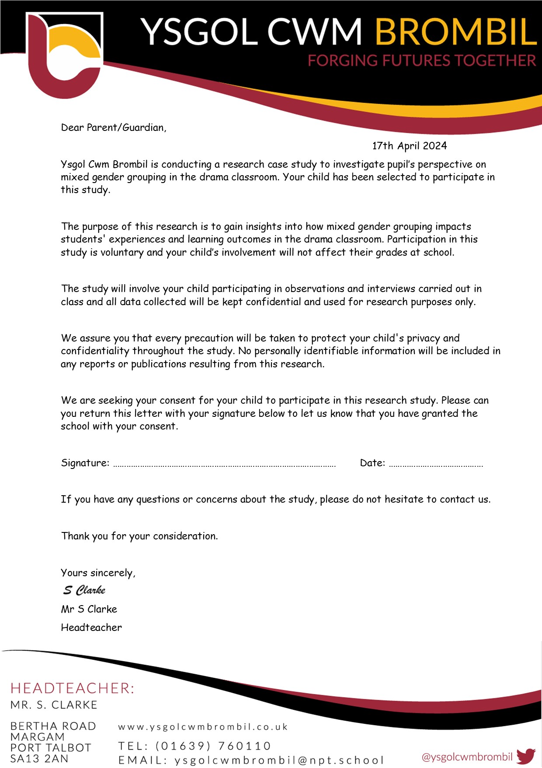

Appendix 2 – Student Assent Letter and Form.

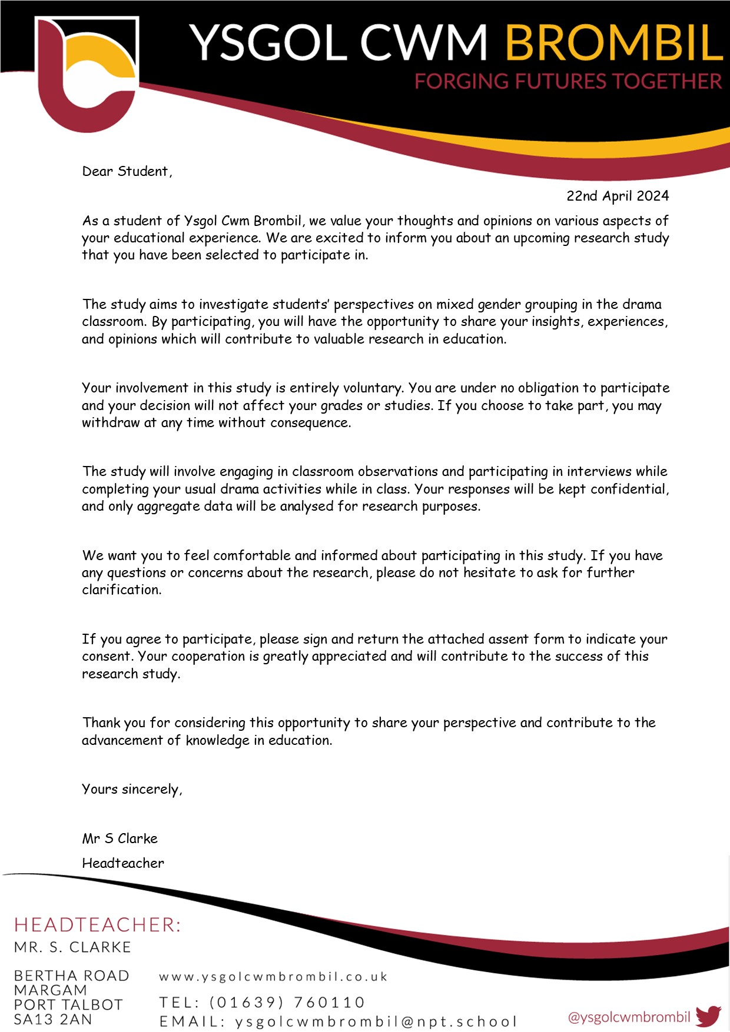


Appendix 3 – Observation Schedule

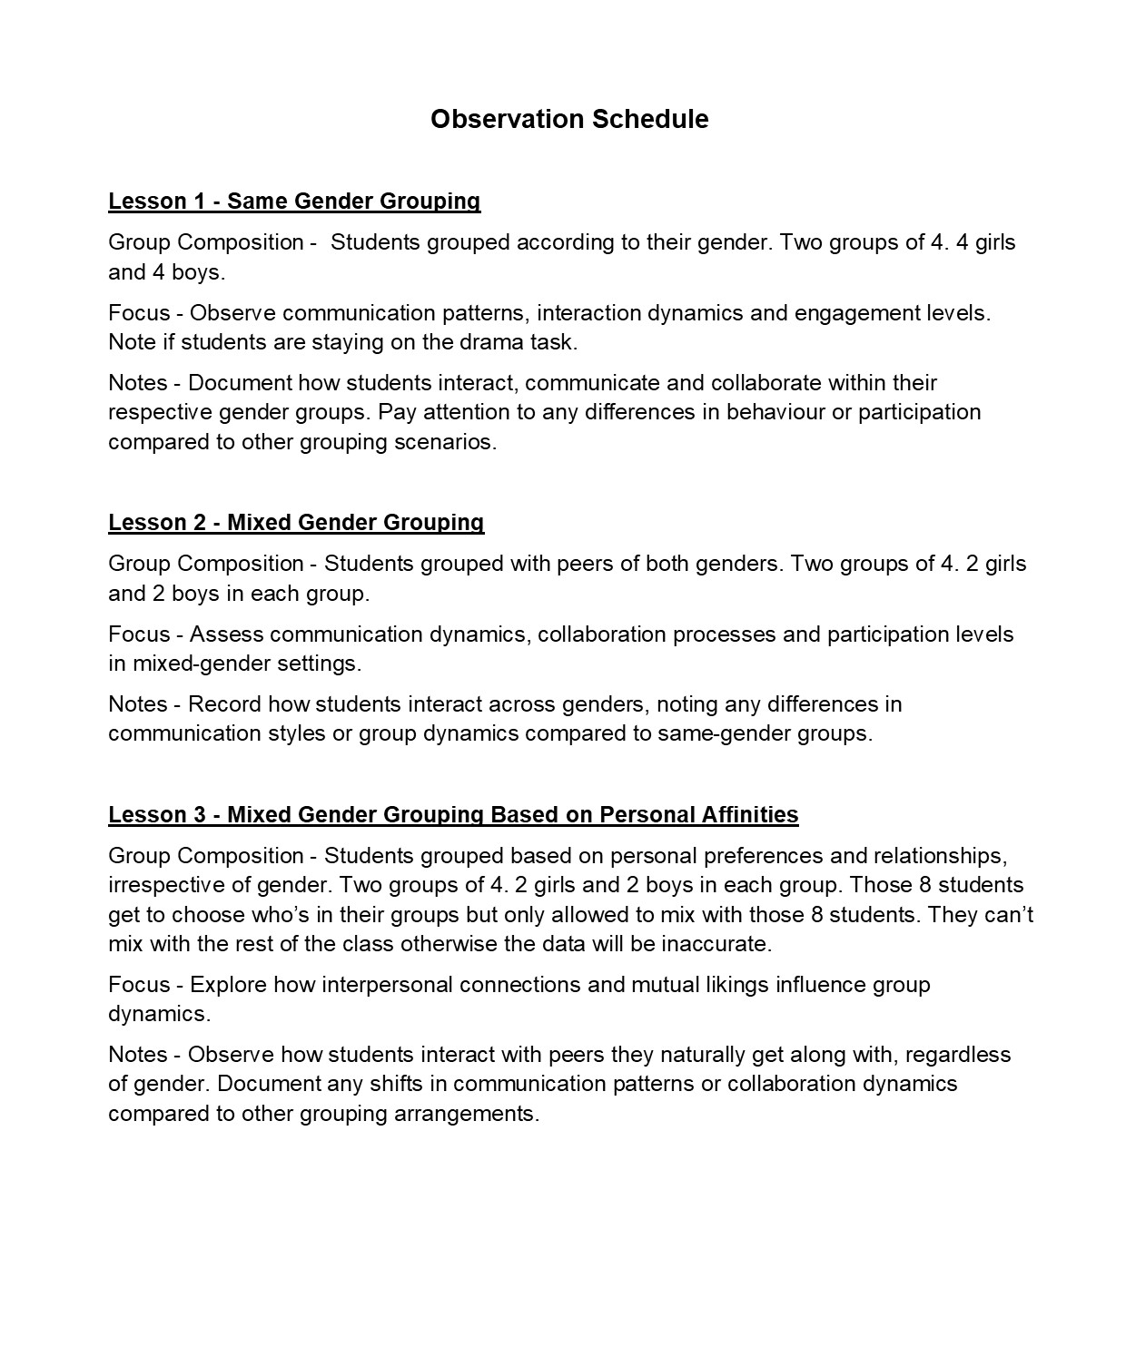

Appendix 4 – Interview Questions

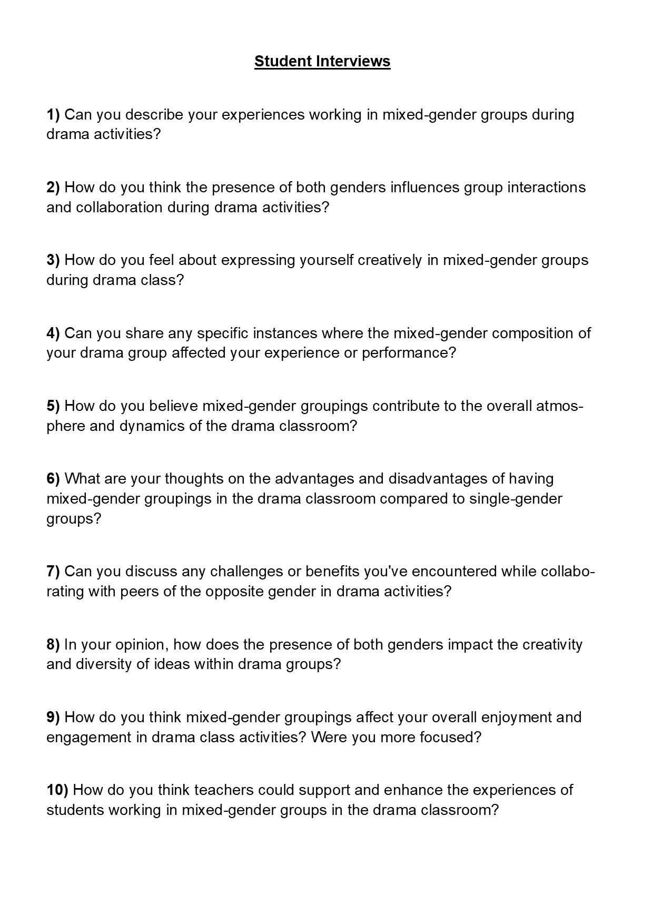

Appendix 5 – Ethics Form

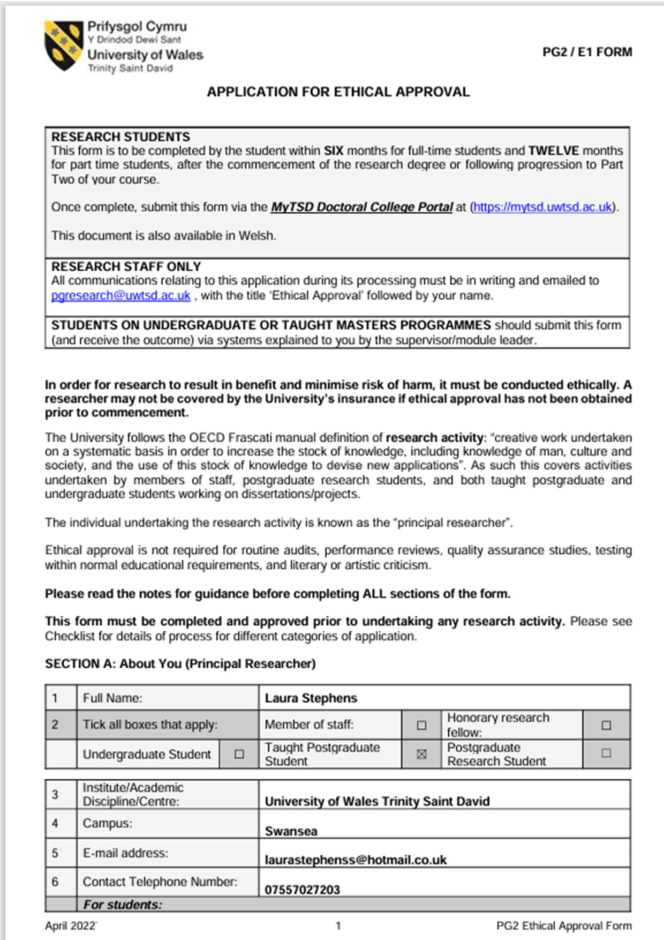

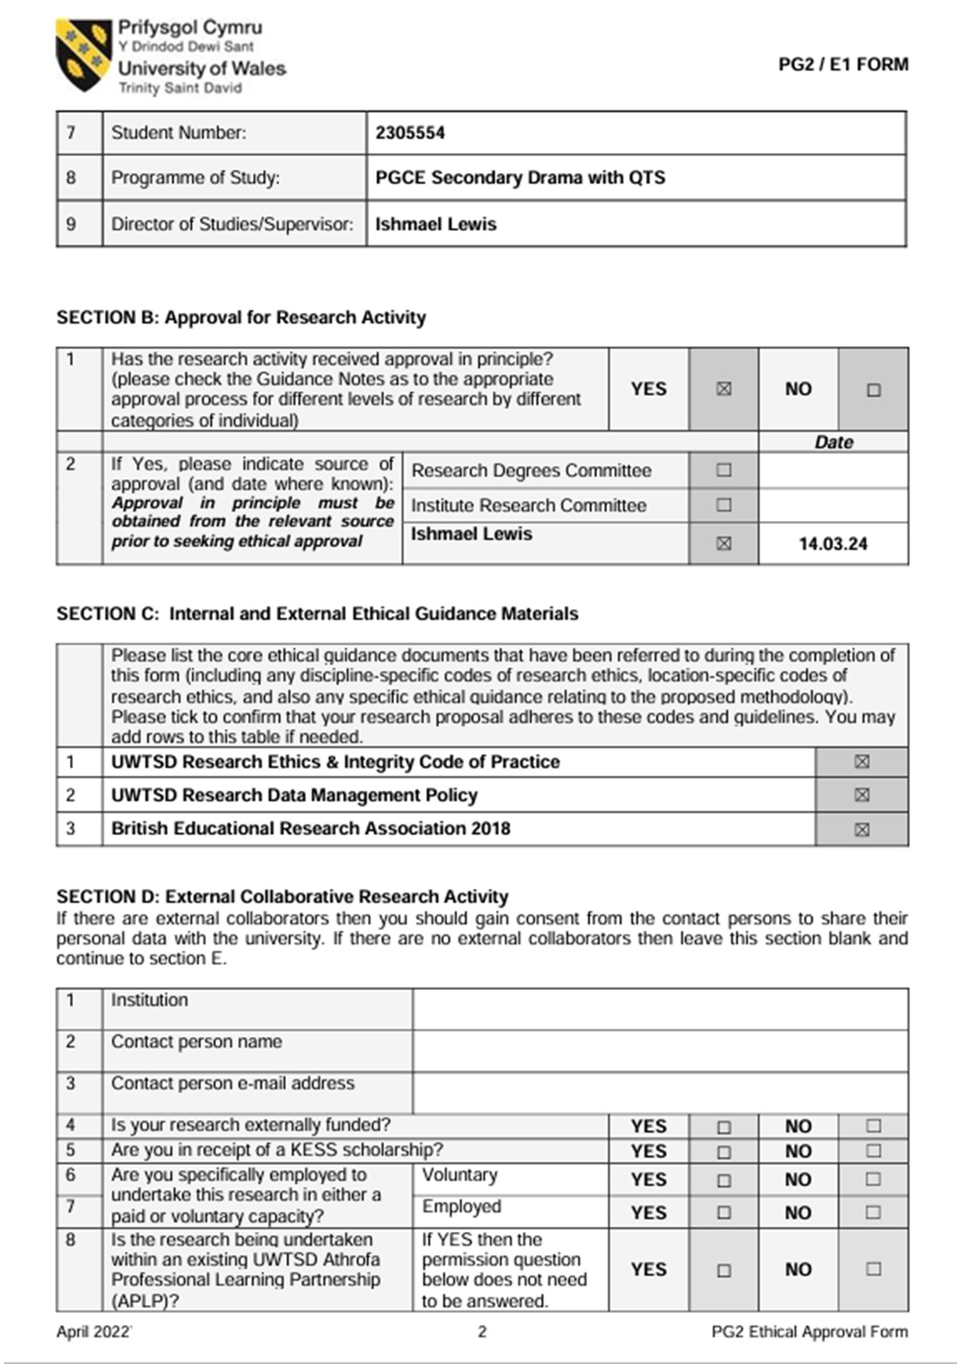

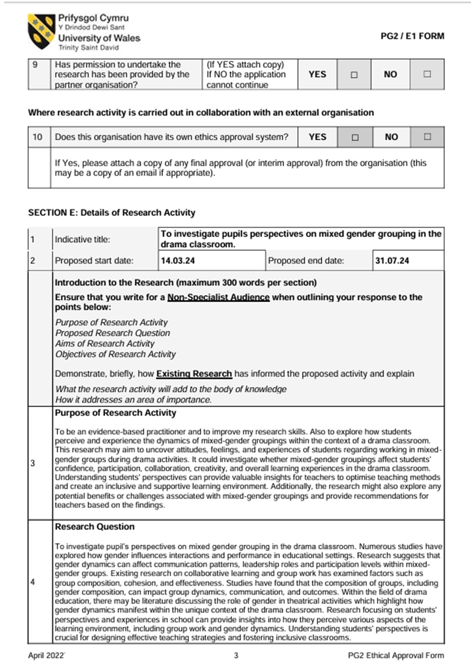

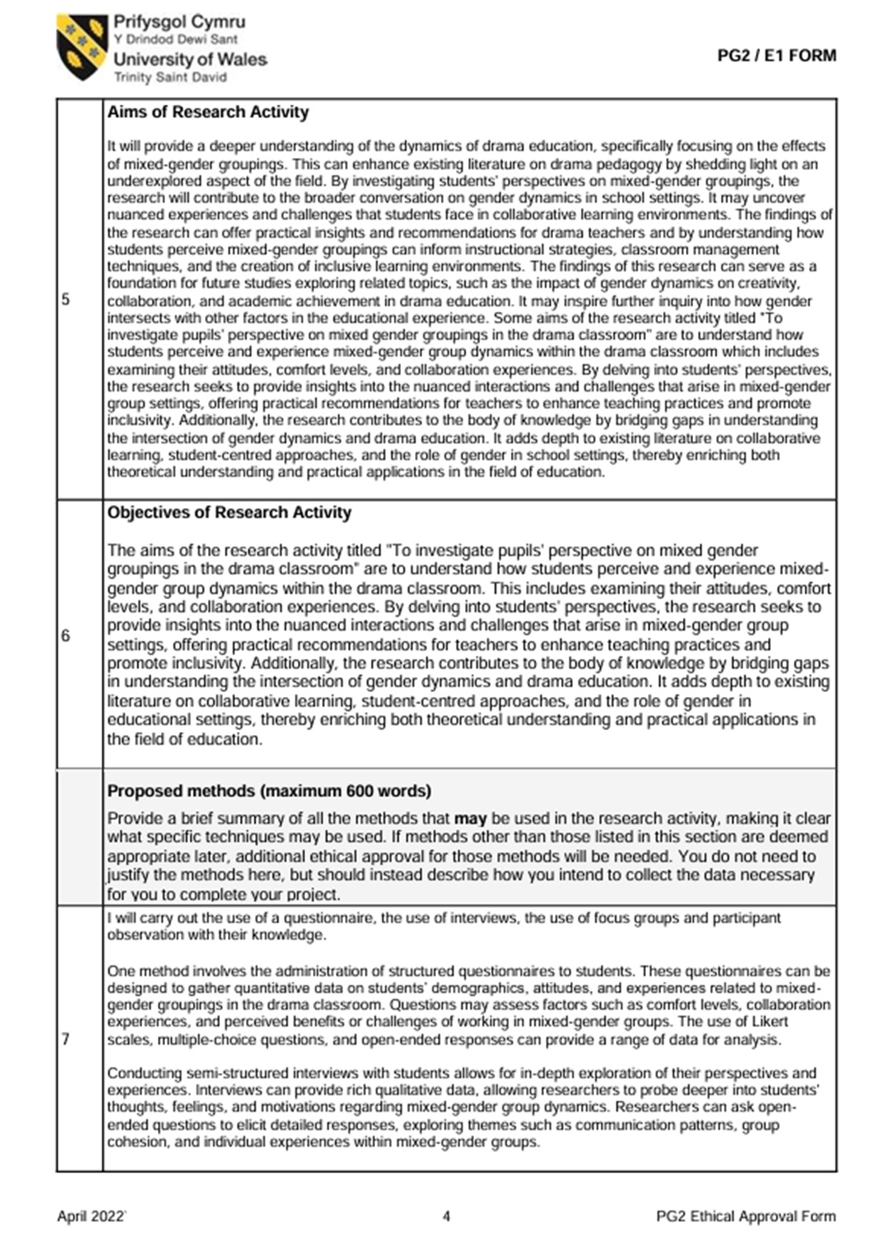



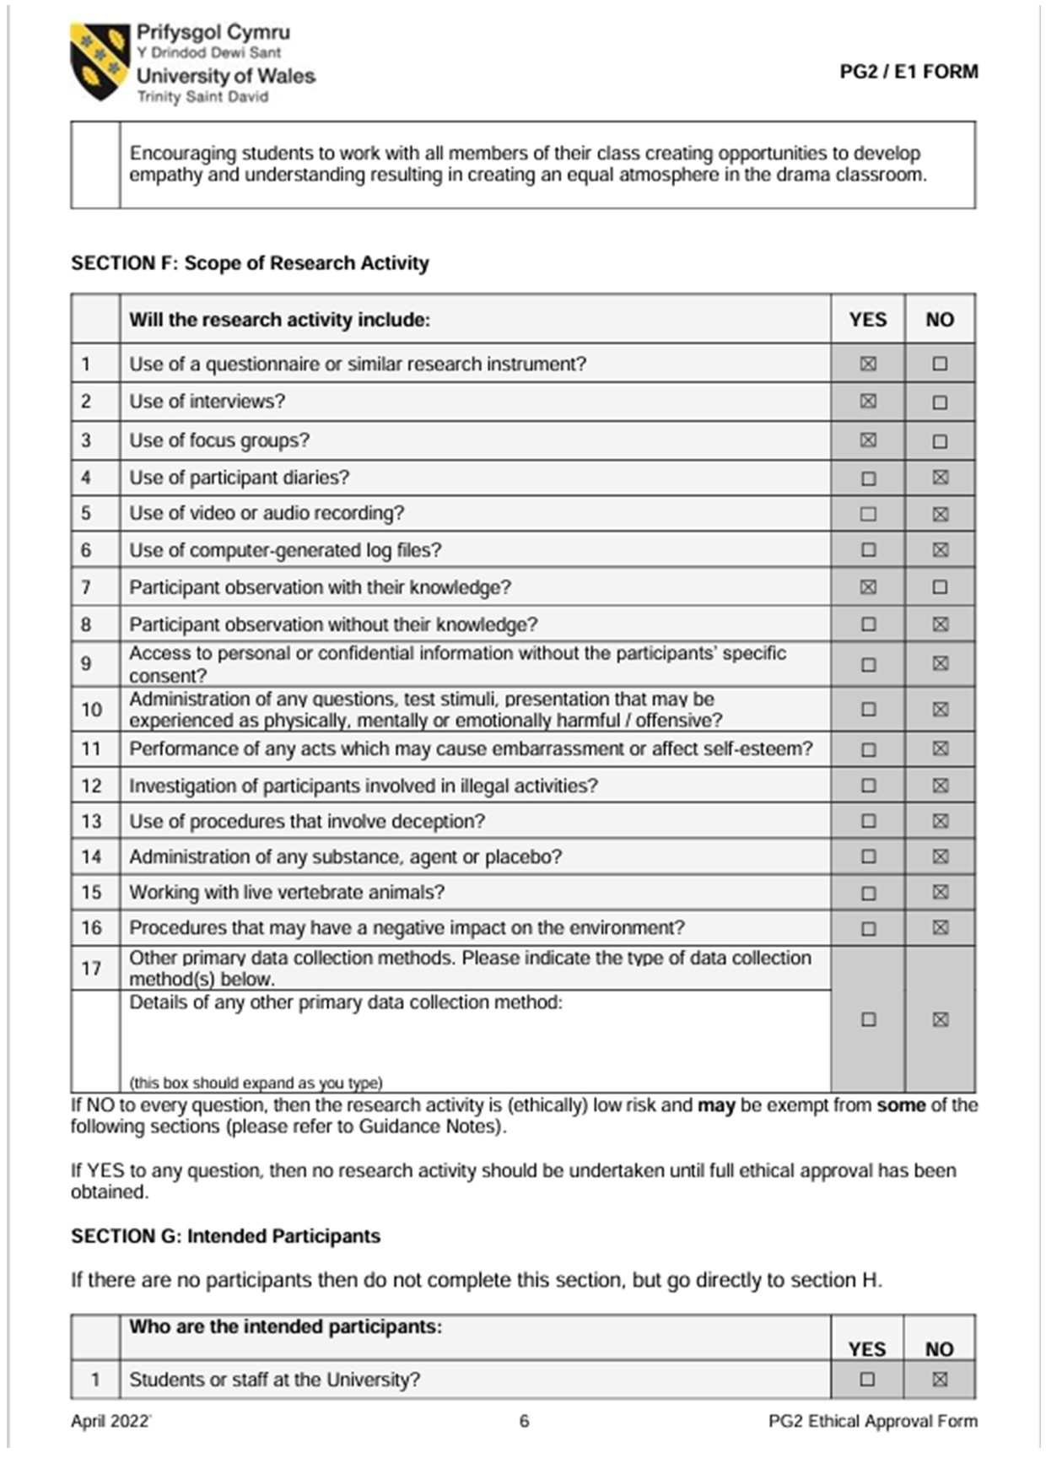

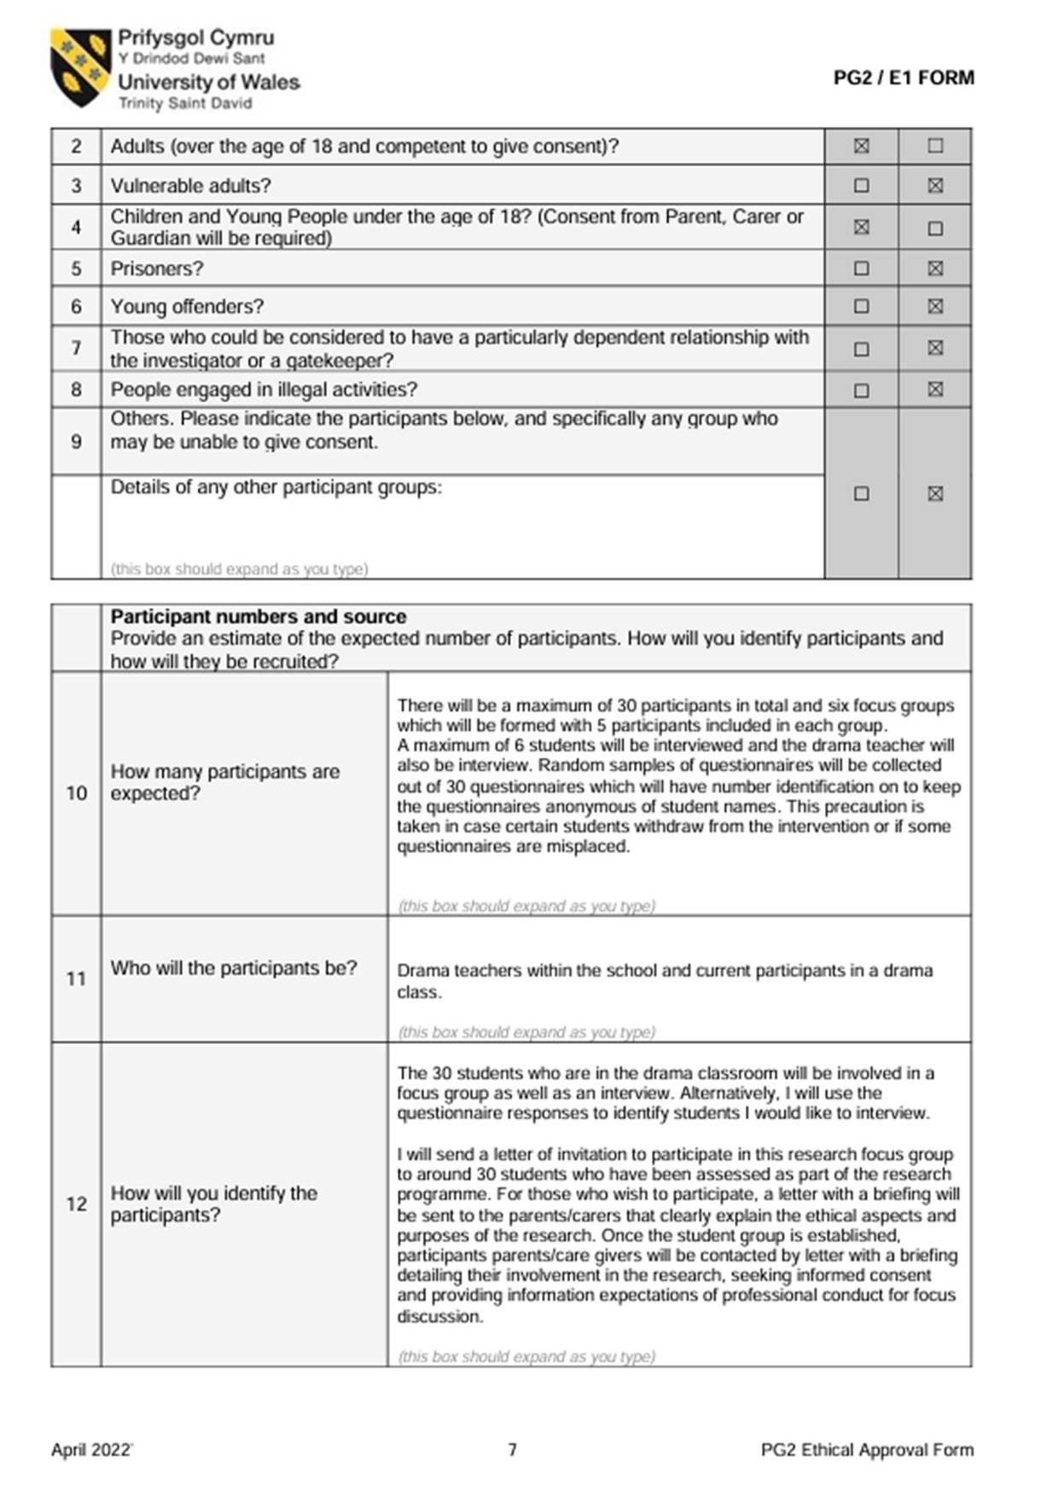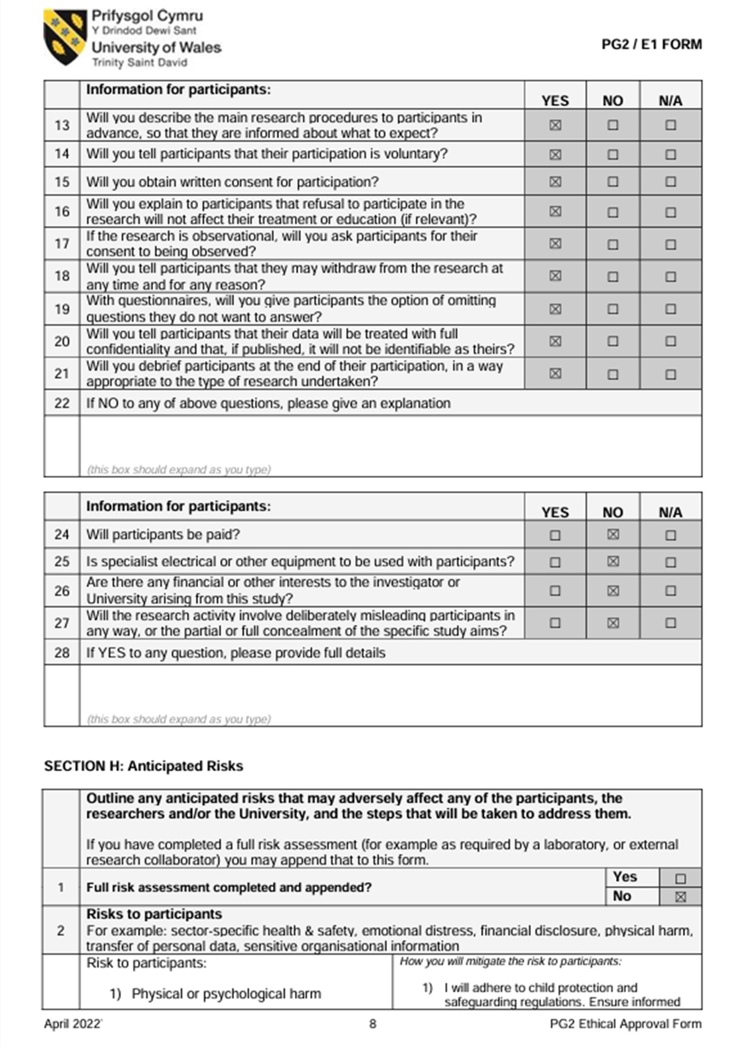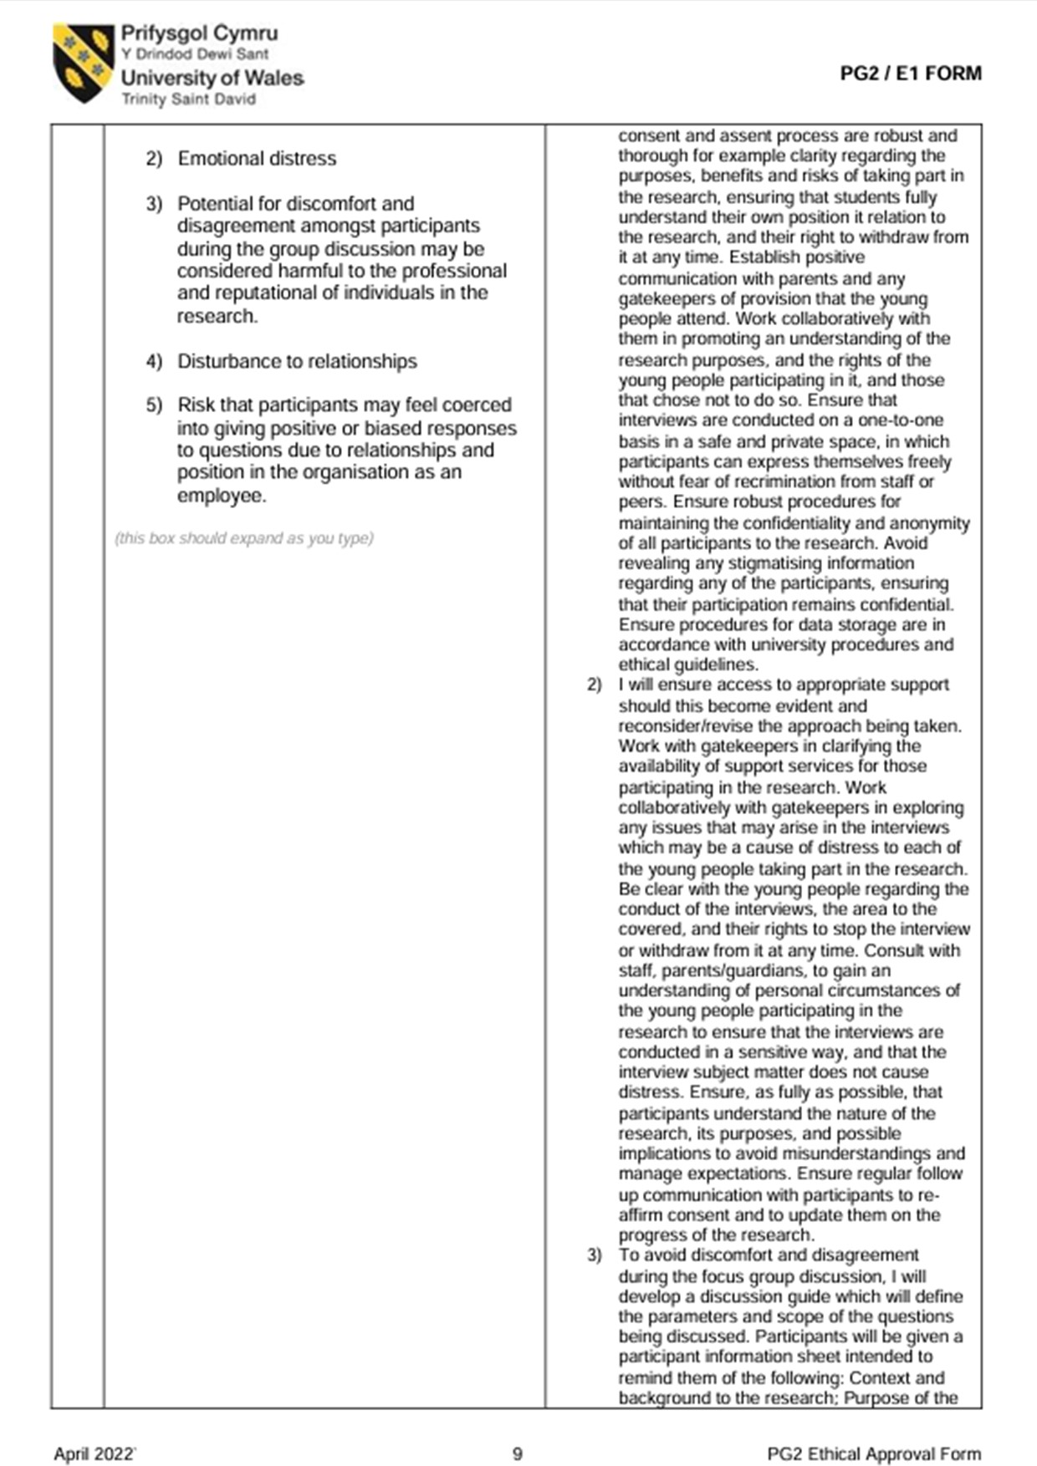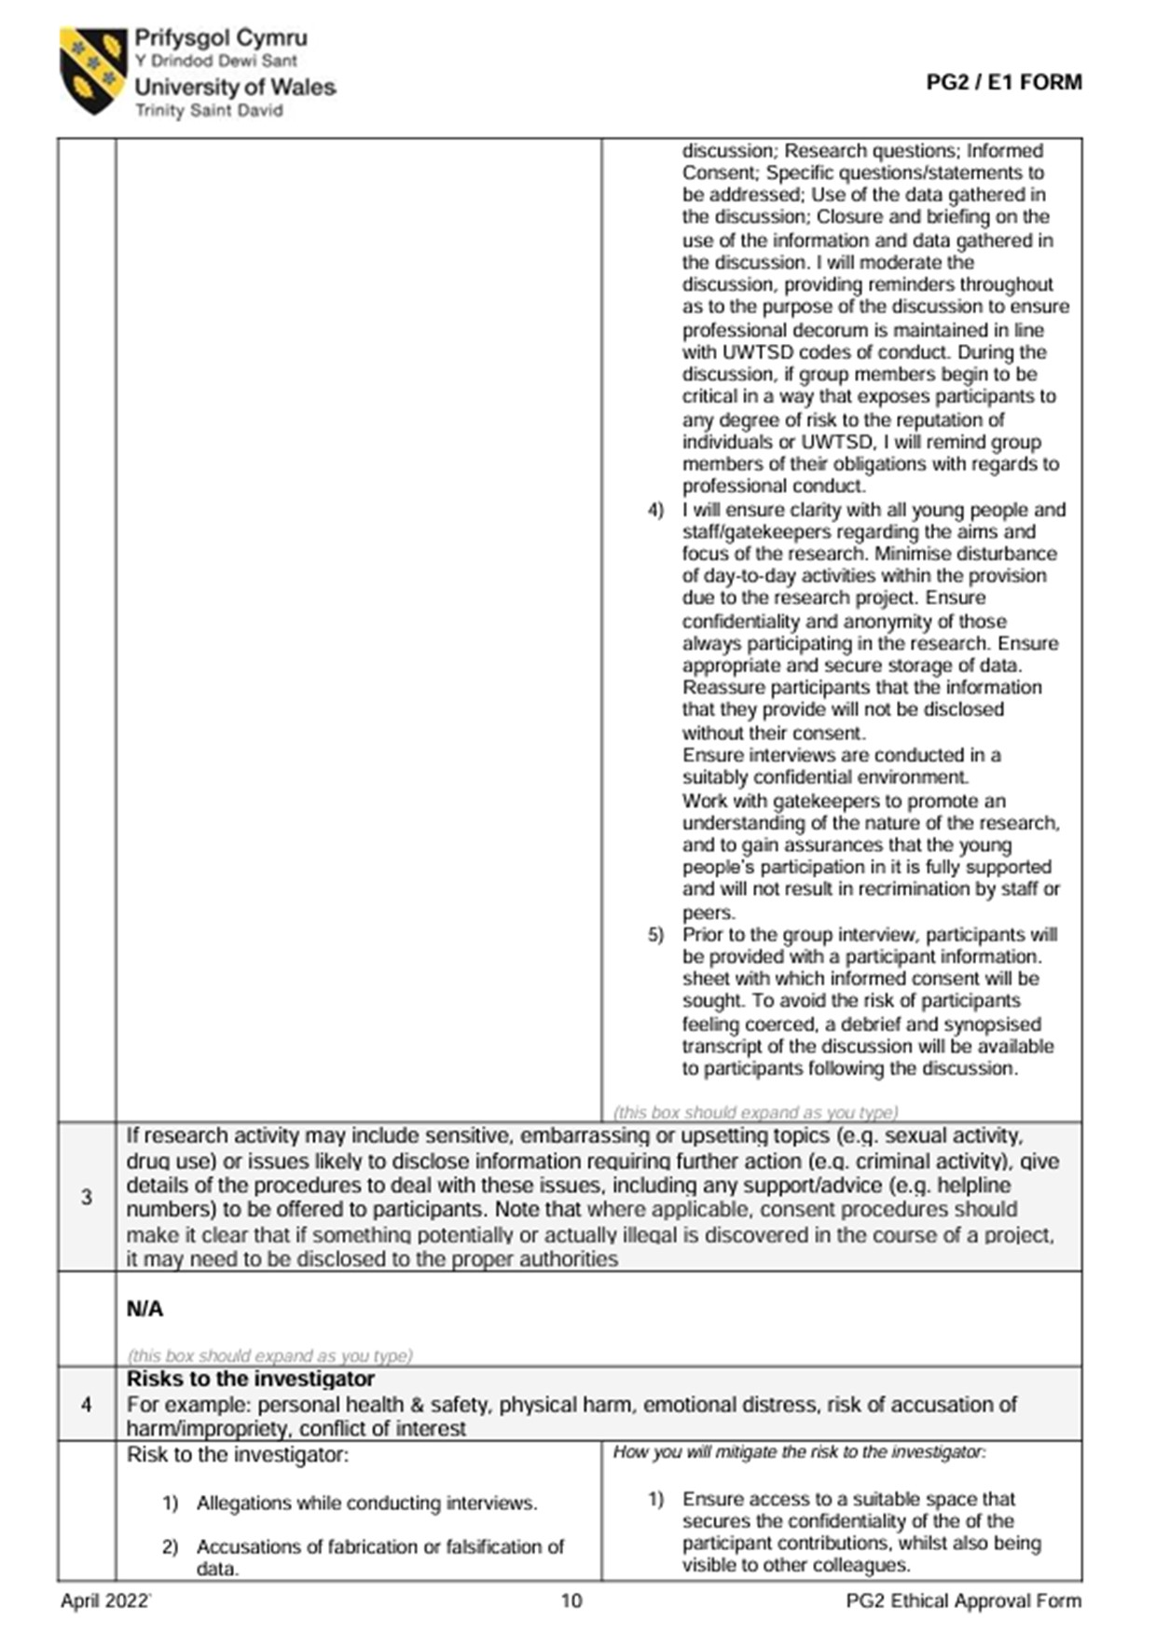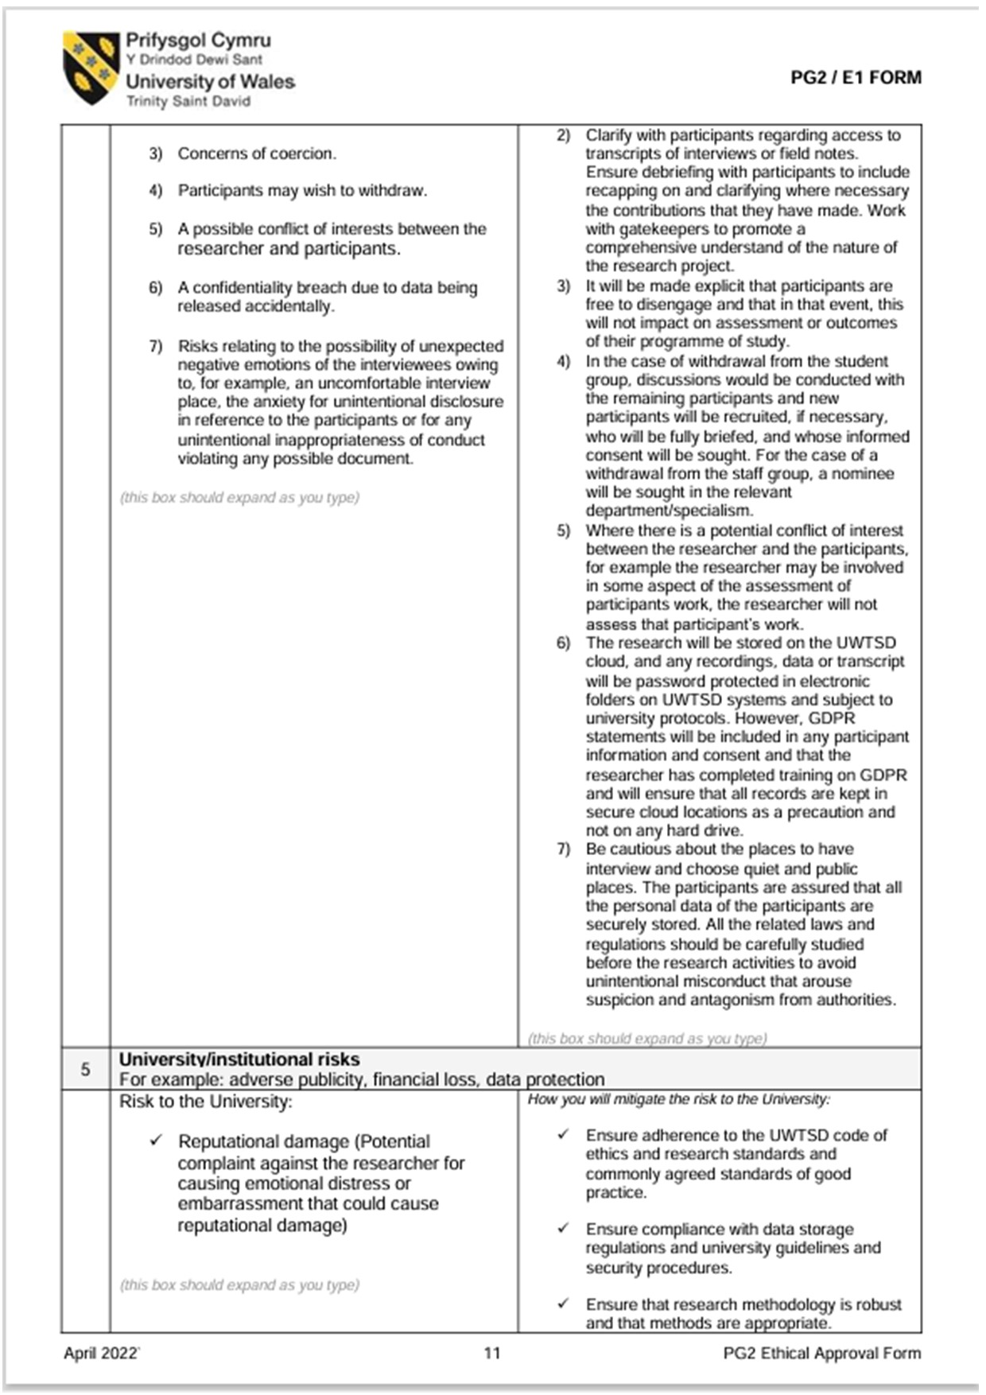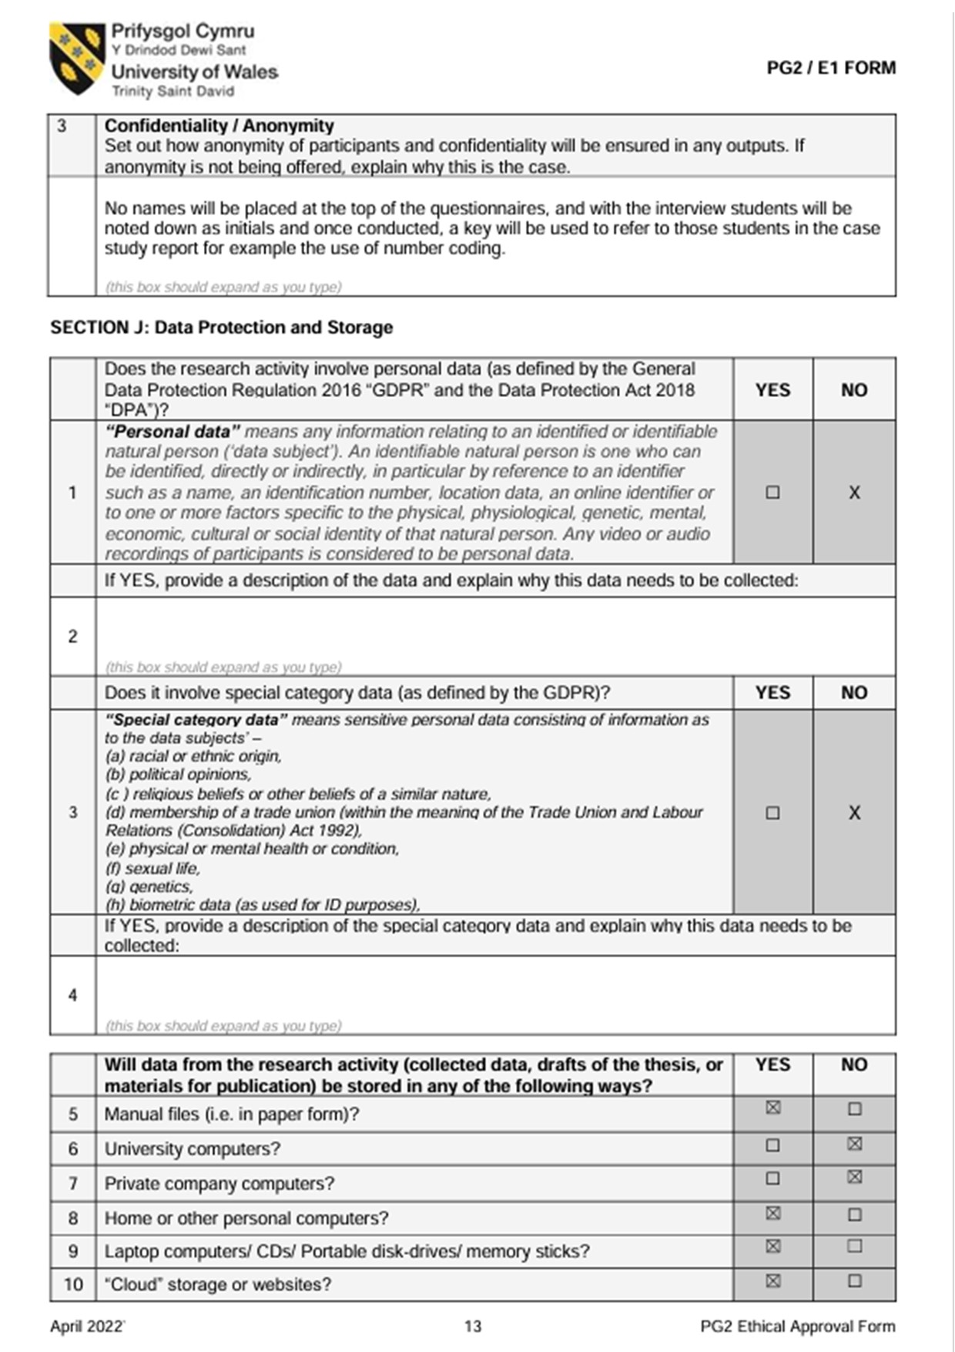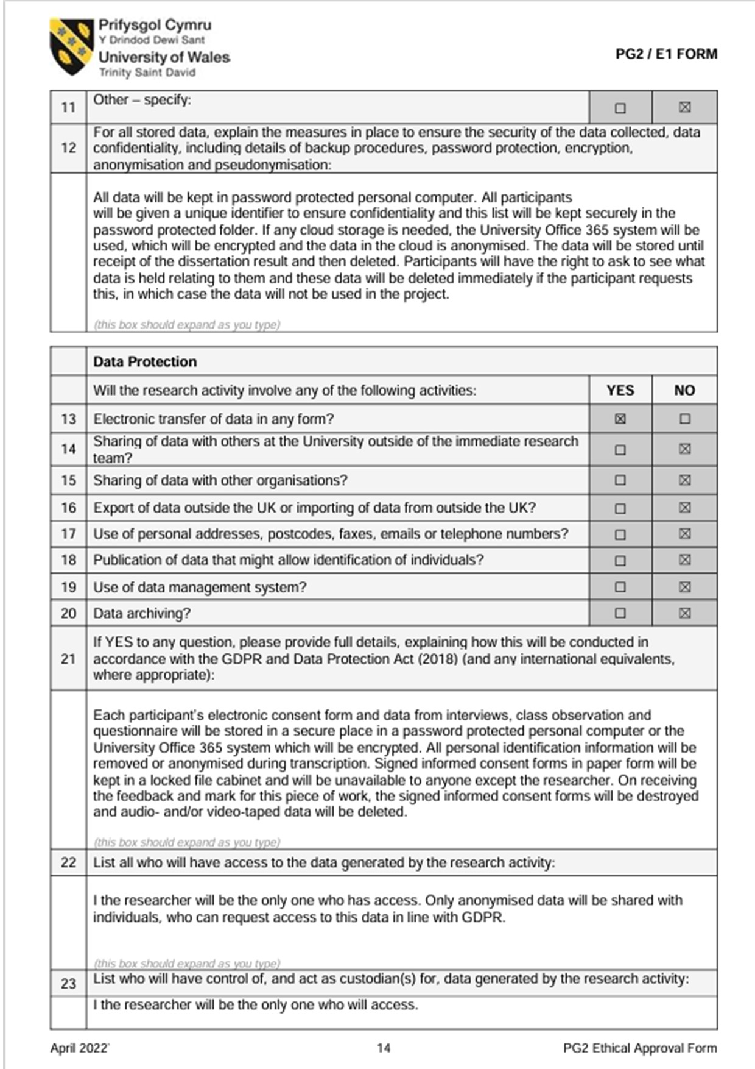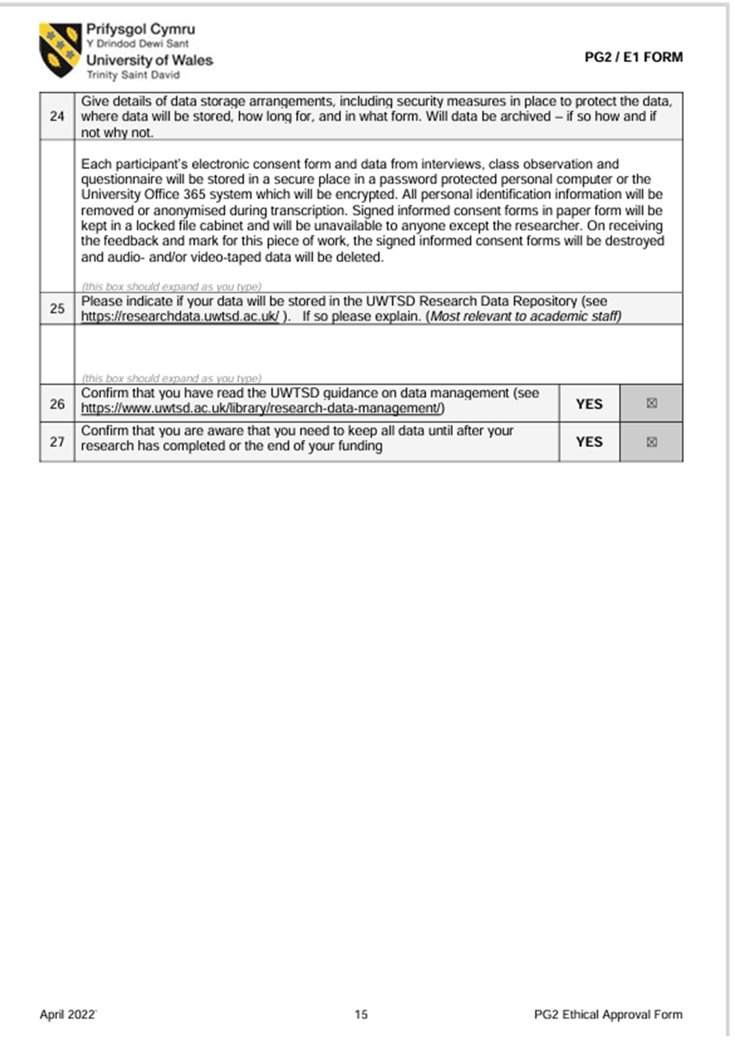

These must include:
• Any research tools that you created - Observation Schedule and Interview Questions.
•

These can include:
• Lesson Plan (if relevant)
• Anything else that you think would be useful so that the reader can fully understand your research study.

Reference List
Adelman, C., Jenkins, D., & Kemmis, S. (1980). Rethinking case study: Notes from the second Cambridge Conference. In H. Simons (Ed.), Towards a Science of the Singular: Essays about Case Study in Educational Research and Evaluation. Norwich: Centre for Applied Research in Education, University of East Anglia.
Alderson, P and Morrow, V. (2011) The Ethics of Research with Children and Young People. Available at: The Ethics of Research with Children and Young People : A Practical Handbook (uwtsd.ac.uk) (Accessed 30 April 2024)
Bandura, A. (1988) Albert Bandura, part 2 – Alexander Street, a ProQuest Company (uwtsd.ac.uk). Available at: Albert Bandura, Part 2 - Alexander Street, a ProQuest Company (uwtsd.ac.uk) (Accessed: 21 April 2024)

Bennet, T. (2017) Creating a Culture: How school leaders can optimise behaviour. Available at: Tom_Bennett_Independent_Review_of_Behaviour_in_Schools.pdf (publishing.service.gov.uk) (Accessed: 22 April 2024)
British Educational Research Association [BERA] (2018) Ethical Guidelines for educational research. Available at: BERA-Ethical-Guidelines-for-Educational-Research_4thEdn_2018.pdf (Accessed: 19 April 2024).

Bruce, T., Louis, S and McCall, G. (2015) Observing Young Children. Available at: Sage Academic Books - Observing Young Children (uwtsd.ac.uk) (Accessed: 28 April 2024)

Clarke, S. (2019) A headteacher’s welcome. Available at: Ysgol Cwm Brombil (npted.org) (Accessed: 19 April 2024)

Cohen, L., Mansion, L. and Morrison, K. (2017) Research methods in education. Available at: Available at: Full details and actions for Research methods in education (uwtsd.ac.uk) (Accessed: 19 April 2024)
Cook-Sather, A. (2006) Sound, Presence and Power: “Student Voice” in Educational and Reform. Available at: Sound, Presence, and Power: "Student Voice" in Educational Research and Reform on JSTOR (Accessed: 24 April 2024)

Denscombe, M. (2014) The Good Research Guide. Available at: Full details and actions for The Good Research Guide (uwtsd.ac.uk) (Accessed: 27 April 2024)

Estyn. (2022) A report on Ysgol Cwm Brombil. Available at: Inspection report Ysgol Cwm Brombil 2022.pdf (gov.wales) (Accessed: 19 April 2024)

Fielding, M. (2022) Transformative Approaches to Student Voice: Theoretical underpinnings, Recalcitrant Realities. Available at: Transformative Approaches to Student Voice: Theoretical Underpinnings, Recalcitrant Realities on JSTOR (Accessed 24 April 2024)
Forman and Hall (1999) Observing Children. Available at: Course: Ymchwilio i'r dysgu / Researching the Learning (ECAD7004/6010), Tile: Wider Reading / Darllen Ehangach (uwtsd.ac.uk) (Accessed 27 April 2024)
Gall, M. D., & Borg, W. R. (2005) Applying educational research: A practical guide. USA: Pearson Education, Inc.
Hayes, A. (2024) How Stratified random sampling works, with examples. Available at: How Stratified Random Sampling Works, With Examples (investopedia.com) (Accessed 26 April 2024)

Hurley, J.C. and Underwood, M.K. (2002) Children’s Understanding of Their Research Rights before and after Debriefing: Informed Assent, Confidentiality, and Stopping Participation. Available at: Course: Ymchwilio i'r dysgu / Researching the Learning (ECAD7004/6010), Tile: Wider Reading / Darllen Ehangach (uwtsd.ac.uk) (Accessed 27 April 2024)

Iphofen, R. (2009) Ethical Decision Making in Social Research. Available at: Ethical Decision Making in Social Research - Google Books (Accessed 30 April 2024)
Kerig, P.K., Schulz, M.S., Hauser, S.T. (2012) Adolescence and Beyond Family Processes and Development. Available at: Adolescence and Beyond - Google Books (Accessed: 23 April 2024)

Kimmel, M. (2000) The Gendered Society. Available at: The Gendered Society - Google Books (Accessed: 23 April 2024)

Ko, P. (2011) Dynamics of Adolescent Friendships: The Interplay between Structure and Gender. Available at: Dynamics of Adolescent Friendships: The Interplay between Structure and Gender | IEEE Conference Publication | IEEE Xplore (Accessed: 23 April 2024)

LeCompte, M. (2010) Analysing Qualitative Data. Available at: Analyzing Qualitative Data: Theory Into Practice: Vol 39 , No 3 - Get Access (tandfonline.com) (Accessed 29 April 2024)

Lewis, V., Kellet, M., Robinson, C., Fraser, S. and Ding, S. (2012) The Reality of Research with Children and Young People. Available at: The Reality of Research with Children and Young People - Google Books (Accessed: 27 April)

Mathers, N., Fox, N. and Hunn, A. (2002) Using interviews in research. Available at: Course: Ymchwilio i'r dysgu / Researching the Learning (ECAD7004/6010), Tile: Wider Reading / Darllen Ehangach (uwtsd.ac.uk) (Accessed: 28 April 2024)

Mcleod, S. (2024) Vygotsky’s Theory of Cognitive Development. Available at: Vygotsky's Sociocultural Theory Of Cognitive Development (simplypsychology.org) (Accessed 22 April 2024)
McNiff, J. (2012) Action research: principles and practice. Available at: Action Research : Principles and Practice (uwtsd.ac.uk) (Accessed: 20 April 2024)

Mouly, G. J. (1978) Educational Research: The Art and Science of Investigation. Boston, MA: Allyn & Bacon.
National Assembly for Wales. (2018) Mind Over Matter. Available at: The Emotional and Mental Health of Children and Young People in Wales (senedd.wales) (Accessed 21 April 2024)
Noffke, S. (2009) The SAGE handbook of educational action research. Available at: Full details and actions for The SAGE handbook of educational action research (uwtsd.ac.uk) (Accessed: 20 April 2024)

Opdenakker, R. (2006) Advantages and Disadvantages of Interviews. Available at:
Course: Ymchwilio i'r dysgu / Researching the Learning (ECAD7004/6010), Tile: Wider Reading / Darllen Ehangach (uwtsd.ac.uk) (Accessed: 28 April 2024)
Punch, K. (2014) Introduction to Social Research. Available at: Introduction to Social Research - Google Books (Accessed: 27 April 2024)
Robson, C. (1993) Real World Research: A Resource for Social Scientists and Practitioner Researchers. Oxford: Blackwell Publishers Inc.
Rose, J. (2023) Improving Behaviour – Why rewards and sanctions are just not enough. Available at: Improving Behaviour – Why Rewards And Sanctions Are Just Not Enough - TeachingTimes (Accessed: 21 April 2024)
Simons, H. (2009) Case Study Research in Practice. London: Sage.
Thiessen, D. (2006) Student Knowledge, Engagement and Voice in Educational Reform. Available at: Editorial: Student Knowledge, Engagement, and Voice in Educational Reform on JSTOR (Accessed 24 April 2024)
Thomas, G. (2017) How to do your research project: A guide for students. 3rd ed. Sage Publications.
University of Leicester (n.d.) Interviewing for research. Available at: Course: Ymchwilio i'r dysgu / Researching the Learning (ECAD7004/6010), Tile: Wider Reading / Darllen Ehangach (uwtsd.ac.uk) (Assessed 28 April 2024)
University of Wales Trinity Saint David (2022). Research Ethics & Integrity Code of Conduct. Available at: uwtsd Research Ethics & Integrity Code of Practice - Google Search (Accessed 29 April 2024)

Welsh Government (2019). Professional standards for teaching and leadership. Available at: professional-standards-for-teaching-and-leadership-interactive-pdf-for-pc.pdf (gov.wales) (Accessed: 19 April 2024)

Welsh Government. (2022) Curriculum for Wales Overview. Available at Curriculum for Wales: overview | GOV.WALES (Accessed: 21 April 2024) (CHECK LINK)
William O’Donohue and Kyle E. Ferguson. (2012) The Psychology of B. F. Skinner. Available at Sage Academic Books - The Psychology of B. F. Skinner (uwtsd.ac.uk) (Accessed: 22 April 2024)
Yazan, B. (2015) Three approaches to case study methods in education: Yin, Merriam and Stake. Available at Course: Ymchwilio i'r dysgu / Researching the Learning (ECAD7004/6010), Tile: Wider Reading / Darllen Ehangach (uwtsd.ac.uk) (Accessed: 26 April 2024)
Yilmaz (2013) Comparison of Quantitative and Qualitative Research Traditions: epistemological, theoretical and methodological differences. Available at Comparison of Quantitative and Qualitative Research Traditions: epistemological, theoretical, and methodological differences on JSTOR (Accessed 27 April 2024)

