Student Name: Austin Agnelo Fernandes  Student ID: 2228678  ModuleTitle:Foreign Language & Cultural Awareness  Module Code:BMIH5003  Lecturer:Heidi Prosser  Date:05.02.2024 | 
ASSIGNMENT 1: PORTFOLIO
(4 Components)

Component 1: Professional Reflection (500 words +/- 10%)

Weighting: 25%
The hospitality sector, with teams made up of people from all backgrounds, is a cultural melting pot in today's globalized globe (Ting et al.,2018). I have witnessed firsthand how various cultural customs have grown and shown themselves in the hotel industry. To establish a corporate culture, this has led to the interaction of several diverse cultural behaviours. In my capacity as Director of Hotel Operations at Four Seasons Hotel London, I recognize the value of encouraging cultural adaptation in teams. It is a deep commitment to fostering an inclusive and peaceful workplace, not just a box to be checked off on the HR list. Due to cultural differences, I was exposed to an experience including cultural differences. One of the biggest cultural misunderstandings I have seen is the differences in word choice and usage in the hotel sector. I had the opportunity to serve a variety of guests from diverse backgrounds while working at the hotel restaurant. The emergence of argument was caused by the lack of a common language. Another viewpoint that may be helpful in the event of a language barrier is the use of sign language. After a misunderstanding, I chose to serve my client because I was able to comprehend their needs while pouring beverages at the bar. I served the client an alcoholic drink even though they had requested a drink without alcohol since I chose to serve them without a waiter. As a result, there was a disciplinary case, and the client threatened to sue the hotel. I found myself at a crossroads. I could not figure out why I was to blame for the client's inability to communicate or for my own ignorance of the situation. It took me some time to absorb and comprehend the significance of various cultural traditions that could be influenced by language usage. I was able to understand the meaning of A clear and gained a deeper understanding of the effects of linguistic barriers. During an argument that resulted in a client's termination, I made an emotional mistake. This led to a suspension from employment. I got the opportunity to learn about the implications of language difficulties. Miscommunication can result in miscommunication (Wollin,2018). It has helped me to learn and comprehend language better. This also improved my appreciation of language. I have given myself permission to keep learning and growing in areas like interpersonal skills. Gaining a deeper understanding of oneself helps facilitate understanding others. I have also come to realize how important communication skills are. Effective communication plays a crucial role in the hospitality sector. I have also improved my leadership abilities. In conclusion, a practical strategy is needed to overcome the difficulties brought about by cultural differences in hospitality teams. Through recognition of these obstacles and the application of tactics such as cultural sensitivity training, well-defined leadership protocols, and efficient channels of communication, you may foster equitable comprehension and collaborate towards shared objectives. Success in the hospitality sector requires striking a balance between a dedication to diversity and respect for local cultures (Pei et al,2015).
References
Ting-Toomey, S. and Dorjee, T., 2018. Communicating across cultures. Guilford Publications.
Pei, X., Howard-Jones, P.A., Zhang, S., Liu, X. and Jin, Y., 2015. Teachers’ understanding about the brain in East China. Procedia-Social and Behavioral Sciences, 174, pp.3681-3688.
Wolin, R., 2018. The wind from the east: French intellectuals, the cultural revolution, and the legacy of the 1960s. Princeton University Press.
Component 2: Training Plan (500 words +/- 10%)

Weighting: 25%

Identified cultural misunderstanding (in a few words):
When two or more people speak the same language but have distinct meanings or comprehensions of it, this is known as a cultural misunderstanding. Cultural differences make it difficult to relate to and communicate with others, which is a regular occurrence in the hotel sector (Zeng et al.,2022). The conversation on cultural differences has also increased because of the choices and preferences of the clientele. Their experiences and cultural background are typically to blame for this. We frequently are unaware of the extent to which our past experiences influence how we interpret the words and deeds of others. The development of appropriate cultural practices can also be aided by the effects of consistent, effective communication.
Training plan (Why/What//Who/Where/When):
A training plan is, in its most basic form, just a written program description. It covers the objectives of the course, the expected learning results, and the delivery method. It can be used to give a broad overview of the training requirements for your entire company or to support individual workers in enhancing their output and gaining new abilities. To make sure new hires receive all the training needed to do their jobs well, you may also utilize a template for a training plan. Although the terms are occasionally used synonymously, a training plan differs from an employee development plan. Employee development plans concerned with the long-term career development of your staff members than training plans, which consider the immediate needs of both the organization and your personnel (Yang,2010).
Despite having various objectives, a good training strategy will take employee development into account. Opportunities for training are yet another crucial element of a skilfully crafted development plan. Seeing the two agreements as one cohesive contract can help you ensure that your employees are properly taught and equipped with the skills needed to support your company's growth.
Improving the output of employees (Hogan et al.,2015). Workers might acquire new skills that improve their performance on the job by routinely attending training. Additionally, training helps them remember abilities they might otherwise forget. They can be more productive thanks to this increased confidence. being constant. Everyone can operate from the same knowledge base if there is a robust training program in place, especially for new hires. A staff that is uniformly taught will have consistency, and the company's standards and processes will be more likely to be adhered to.

References
Yang, X., 2010. The Importance of Staff Training in the Hotel Industy: Case study: Renaissance Shanghai Yuyuan Hotel.
Hogan, A., Knez, N. and Kahng, S., 2015. Evaluating the use of behavioral skills training to improve school staffs’ implementation of behavior intervention plans. Journal of Behavioral Education, 24, pp.242-254.
Zeng, Y.Z., 2022. Risk management of staff training. Indian Journal of Power & River Valley Development, 72.
Component 3: Student Self-Reflection (500 words +/- 10%)

Weighting: 25%
[insert written text]

Gibbs reflective angle
Gibbs' reflecting cycle decomposes this into further phases. The way that Gibbs' model presents the situation and how you have started to think about it is sensitive to your own feelings (Gibbs,2016).
Feelings. One important development in the hotel industry is the topic of cultural sensitivity. By fostering bridges across cultural divides, cultural awareness teaches us to accept and value individuals who are different from us. Possessing a cultural background relevant to the hotel industry facilitates the development of relationships that are valuable for the sector. As we grow in self-awareness, I find that I can relate to people from diverse cultural backgrounds better. Cultural harmony increases and conflict between cultures decreases as a result (Zhenyu et al.,2016).
Evaluation. The second stage of Gibbs' self-reflective cycle is feelings experiences are accompanied by feeling. The emotions that arise during an experience might be linked to the activities that are happening. the capacity to relate the emotion to the behaviour. Establishing a culture of balance within a company that does not show itself in a clear manner is difficult. Knowing has proven to be difficult. It can be difficult to learn about other cultures in a setting consisting with varied civilizations. I was disappointed that I would not be able to relate to the clients who needed my help. the capacity to communicate effectively with one another and provide the necessary services.
Cultural sensitivity is a delicate topic in the hospitality sector that affects many of its daily operations (Shahir et al.,2016). Analysis. Understanding and appreciating the beliefs, practices, and values of others allows you to engage with them without bias or condemnation. This feature enables you to make sure that you have a deeper understanding of your clientele. Respecting and understanding the many cultural activities throughout society is made possible by having an appreciation for them. As a result, there are more cross-cultural exchanges and less interpersonal disputes brought on by cultural differences. Effective cultural sensitivity within an organization aid in maintaining and advancing cultural practices. Employees can get several benefits from a workplace that is culturally sensitive. This company can provide its clients with services that are clearly at the highest calibre. Cultural anthropology plays a significant part in the hotel industry's development and maintenance of positive cultural practices, which are crucial for satisfying guests' needs. It can demonstrate to employees that it embraces diversity and extends a warm welcome to individuals from all backgrounds. Understanding other cultures fosters a friendly and hospitable atmosphere that improves the organization's ability to provide its services. More likely to make well-informed decisions that consider a variety of viewpoints are personnel who exhibit greater cultural sensitivity. Conclusion. Cultural sensitivity is essential to an organization's daily operations. Everything You Need to Know Understanding the shifting values and ideologies of various cultures is known as cultural awareness. The application of cultural authenticity determines how to foster appreciation and comprehension of varied cultural practices. Respecting and comprehending diverse cultures are essential for better possibilities. People from various backgrounds can collaborate swiftly in this way. Cultural ignorance could cause major decisions to be made incorrectly. Action plan. I will make sure to attend other language usage trainings in the future. My level of understanding will grow and improve because of the necessity to learn and comprehend diverse cultural customs. Establishing inclusive communication and facilities requires cultural awareness, which is the ability to recognize and appreciate the distinctions and similarities across many cultures.
References
Shahir, A.A., Nguyen, K.T. and Nguyen, A.V., 2016. A sum-frequency generation spectroscopic study of the Gibbs analysis paradox: monolayer or sub-monolayer adsorption. Physical Chemistry Chemical Physics, 18(13), pp.8794-8805.
Shahir, A.A., Nguyen, K.T. and Nguyen, A.V., 2016. A sum-frequency generation spectroscopic study of the Gibbs analysis paradox: monolayer or sub-monolayer adsorption. Physical Chemistry Chemical Physics, 18(13), pp.8794-8805.
Gibbs, J.A., Pound, M., French, A.P., Wells, D.M., Murchie, E. and Pridmore, T., 2016. Approaches to three-dimensional reconstruction of plant shoot topology and geometry. Functional Plant Biology, 44(1), pp.62-75.
Component 4: Training Presentation (6 Slides)

Weighting: 25%
Multilingualism is the capacity to speak and understand multiple languages (Clyne et al.,2017). When it regards the number of workers with multilingual skills, the hotel industry leads. Speaking numerous languages is therefore referred to as multilingualism. With some being able to speak three, four, or even more languages, more than half of the world's population is multilingual. London's hotel businesses provide services to every culture on the planet. You broaden your perspective and thinking when you learn a new language. It allows you to enjoy the benefits of diversity and encounter new civilizations. Gaining proficiency in a second or third language will raise one's self-worth and confidence.
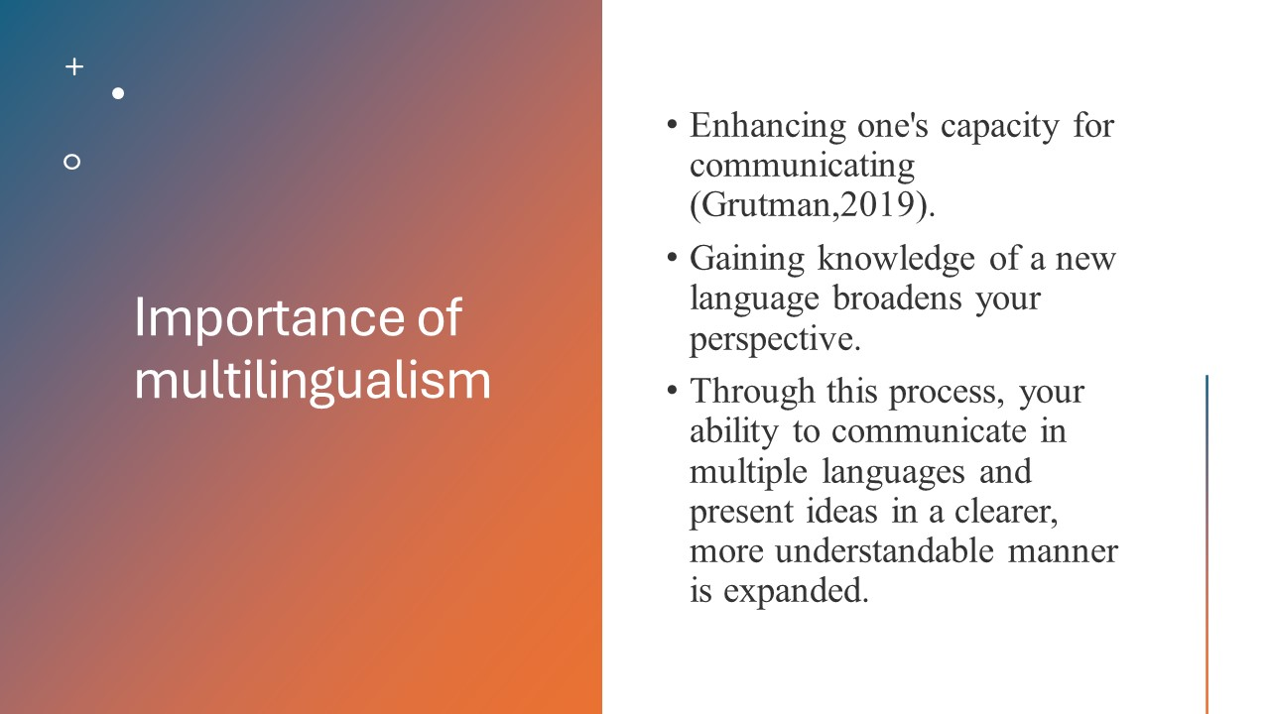
Enhancing one's capacity for communicating (Grutman,2019). Gaining knowledge of a new language broadens your perspective. Through this process, your ability to communicate in multiple languages and present ideas in a clearer, more understandable manner are expanded. It exposes you to various cultures and the benefits of diversity. Confidence and self-esteem will rise when one speaks a second or third language.
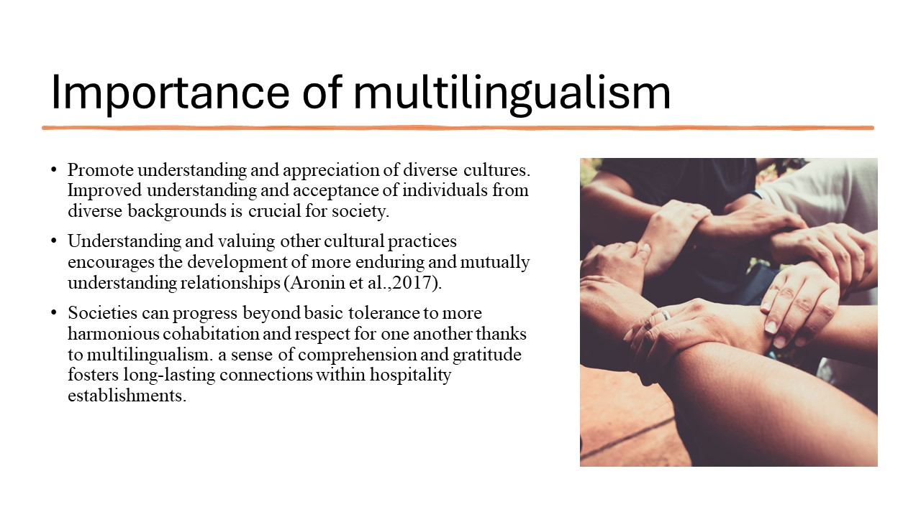
Promote understanding and appreciation of diverse cultures. Improved understanding and acceptance of individuals from diverse backgrounds is crucial for society. Understanding and valuing other cultural practices encourages the development of more enduring and mutually understanding relationships (Aronin et al.,2017). Societies can progress beyond basic tolerance to more harmonious cohabitation and respect for one another thanks to multilingualism. a sense of comprehension and gratitude fosters long-lasting connections within hospitality establishments.
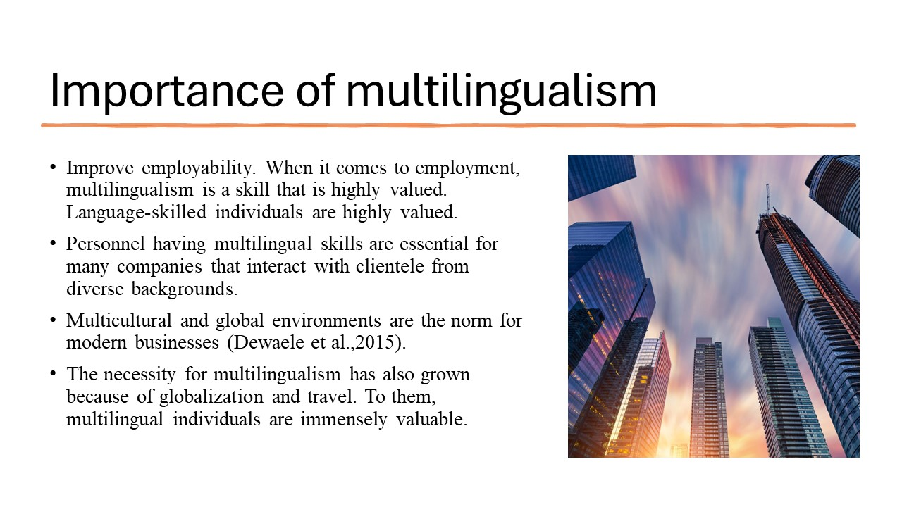
Enhancing one's capacity for communicating (Grutman,2019). Gaining knowledge of a new language broadens your perspective. Through this process, your ability to communicate in multiple languages and present ideas in a clearer, more understandable manner is expanded. It exposes you to various cultures and the benefits of diversity. Confidence and self-esteem will rise when one speaks a second or third language.
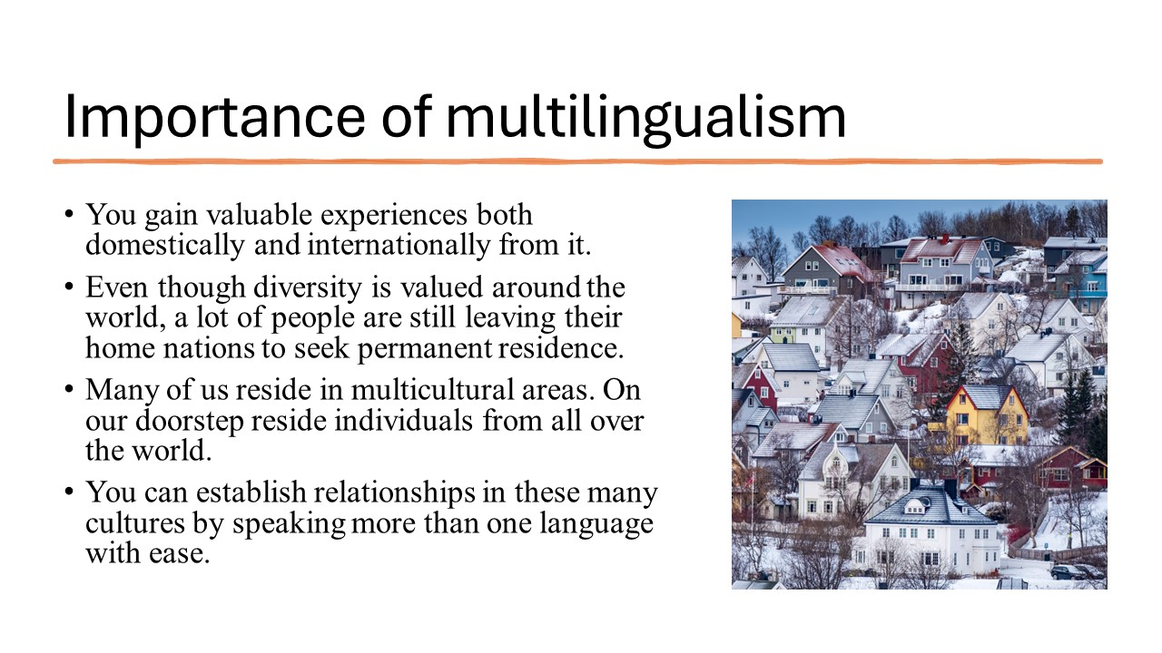
You gain valuable experiences both domestically and internationally from it. Even though diversity is valued around the world, a lot of people are still leaving their home nations to seek permanent residence. Many of us reside in multicultural areas. On our doorstep reside individuals from all over the world. You can establish relationships in these many cultures by speaking more than one language with ease.
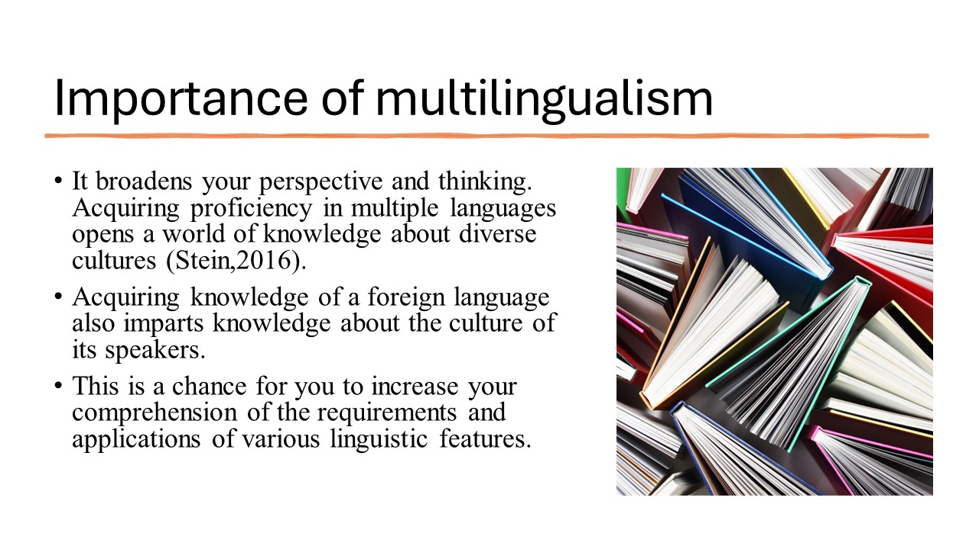
It broadens your perspective and thinking. Acquiring proficiency in multiple languages opens a world of knowledge about diverse cultures (Stein,2016). Acquiring knowledge of a foreign language also imparts knowledge about the culture of its speakers. This is a chance for you to increase your comprehension of the requirements and applications of various linguistic features.
References
Clyne, M., 2017. Multilingualism. The handbook of sociolinguistics, pp.301-314.
Dewaele, J.M., 2015. Bilingualism and multilingualism. The international encyclopedia of language and social interaction, pp.1-11.
Grutman, R., 2019. Multilingualism. In Routledge encyclopedia of translation studies (pp. 341-346). Routledge.
Aronin, L. and Politis, V., 2015. Multilingualism as an edge. Theory and practice of second language acquisition, 1(1).
Stein-Smith, K., 2016. The role of multilingualism in effectively addressing global issues: The sustainable development goals and beyond. Theory and Practice in Language Studies, 6(12), p.2254

