Programme: BA (Hons) Leadership and Management Skills for the Workplace
Module: Organisational Culture
Module code: LCLM 5005
Assignment Title: Component 1 Organisational Culture: Individual Report
Student Name: Ashraf Uddin Ahmed
Student ID number: 2413303
Table of Contents
Introduction 1
Discussing the Organisational Culture of Toyota 1
Organisational Culture Shapes Toyota’s Structure and Decision-Making 2
Models to Identify Varied Types of Culture in Toyota 3
Levels of Organisational Culture 4
Hofstede’s Cultural Dimensions 5
Competing Values Framework (CVF) 6
Toyota Using the Influence of Organisational Culture to Adapt to the External Environment 7
Organisational Culture as A Barrier to Effective Functioning 8
Evaluating the Influence of Organisational Culture on Organisational Performance 9
Conclusion 10
References 11

Introduction
Management includes coordinating resources to attain organisational objectives, whereas organisational behaviour is the study of how people act in these environments (Mullins and Christy, 2016). Toyota, a Japanese multinational automotive manufacturer, is recognised for its positive organisational culture that helps to shape its structure and decision-making prospects. The business was founded by Kiichiro Toyoda in 1937, with the mission of producing happiness for all (Verma and Venkatesan, 2021). Now, the business has a net asset of 93.6 trillion pounds and has recruited around 383,853 workers (Arumugam, Kannabiran and Vinodh, 2020). All those are compelled to follow the organisational culture of Toyota. The report aims to analyse the organisational culture of Toyota to recognise how it affects the structure and decision-making, and identify different types of culture in it. The report will examine the organisational culture, its effect, recognise different cultures using models and its usage of organisational culture to adapt to the external environment. Afterwards, the discussion will be offered to recognise if its culture is a barrier to proper functioning, and an evaluation will be presented on the influence of organisational culture on organisational performance.

Figure 1: Toyota.
Source: (Toyota, 2024).

Discussing the Organisational Culture of Toyota
Continuous Improvement (Kaizen)
The organisational culture of Toyota is recognised as "The Toyota Way", which structures over two bases: Respect for People and Continuous Improvement (Ganesh and Liu, 2022). The major functions, such as a family-style environment and collaboration, can prefer long-term stability, mutual trust and quality over constant and aggressive extension. Moreover, the culture is performed with the different major operating traits and behavioural traits. In this regard, the continuous improvement (Kaizen) traits are as follows, where all things are tried to be made better (Rizzi, Gigliotti and Annunziata, 2022). Workers are motivated to make small, regular improvements instead of waiting for a huge blunder in the organisation. Moreover, the Go and See of Genchi Genbutsu’s cultural philosophy, where managers and engineers are compelled to directly source the issue to recognise the approaches before making decisions and changes are required to be considered (Erthal and Marques, 2020). Here, workers are given the power to take limited risks and view the issues not as failures, but as chances that can lead them to growth.
Respect for People
Here, all workers are respected, where all the business depends on the different perspectives and collective decision-making that alter variances into fortitude. Moreover, the Toyota Production System largely depends on the bottom-up management structure (Dimitrantzou et al., 2021). That means, here bosses do not react traditionally, rather they serve as coaches and coordinators. These are supportive to empower the frontline workers to stop the production line while any defects are spotted. Here, leaders are noticeably showing that they are caring by requesting input, and the business largely signifies confirming cheers for the clients and team members.
Structure and Decision Making
Most of the time, Toyota’s decisions are guided by long-term vision, instead of short-term gains. The business also ignores the solely profit-driven decisions as it tries to attain sustainable value creation and maintain harmony with the international community (Pangarso et al., 2022). Therefore, the major strategic decisions and changes are made with collaborative dialogue and reaching wider consensus, instead of top-down rulings.
Overall, the alignment of strong human-centric values and technical precision is supportive of Toyota in managing a comprehensive international culture, thereby allowing the business to balance adaptability and maintain exceptional quality.

Organisational Culture Shapes Toyota’s Structure and Decision-Making
The discussion in the past mentioned that the organisational culture of Toyota is encapsulated by "The Toyota Way”, which is based on Respect for People and Continuous Improvement (Kaizen). Such a concept does not just indicate how cars are formed, but rather they serve as the architectural blueprint for the business’s organisational format and its exceptional and consensus-centric approach to making decisions. However, as per Chourasia, Dhama and Bhardwaj (2024), the cultural centricity over the operational excellence, standardised procedures and teamwork largely affects the ways businesses like Toyota structures its business. Firstly, the business maintains its workers in cross-functional teams, avoiding strict silos. That showcases the cultural value that solves issues and necessitates input from all departments, thereby allowing for the seamless flow of data (Chenarboo, Hekmatshoar and Fallahi, 2022). For encountering the risks of rigidity and headquarters-dominated design, the business also reformatted product- and region-based business units into automation. Such structural changes influence the workers to innovate and work on making market changes, while maintaining the major business principles. Thirdly, the business has been balancing the old-style corporate hierarchy with the Genchi Genbutsu (go and see) concept (Arumugam, Kannabiran and Vinodh, 2020). There, the upper and middle management structures are formatted to bridge the gap between the frontline executive boards and operations, thereby confirming that the leadership decisions are completely grounded in the on-the-ground and firsthand reality. On the other hand, the following of such culture affects the decision-making of Toyota, as the slow decisions and rapid execution are followed with consideration of all options and employing all the decisions constantly (Chenarboo, Hekmatshoar and Fallahi, 2022). All participants are given the chance to confirm alignment and avoid future resistance. In the meantime, decisions at Toyota are noticeably dependent on personal authority and intuition alone. Therefore, the business culture necessitates proper research and objective information, thereby making a largely methodical and transparent decision-making process.

Models to Identify Varied Types of Culture in Toyota
The corporate culture of Toyota is a mixture of Japanese lean management and societal values. For understanding and identifying varied dimensions of Toyota’s culture, the usage of organisational models such as Hofstede’s Cultural Dimensions, Schein’s Levels of Organisational Culture and Cameron's Competing Values Framework (CVF) can prove to be supportive for proper exploration (Chourasia, Dhama and Bhardwaj, 2024).

Levels of Organisational Culture
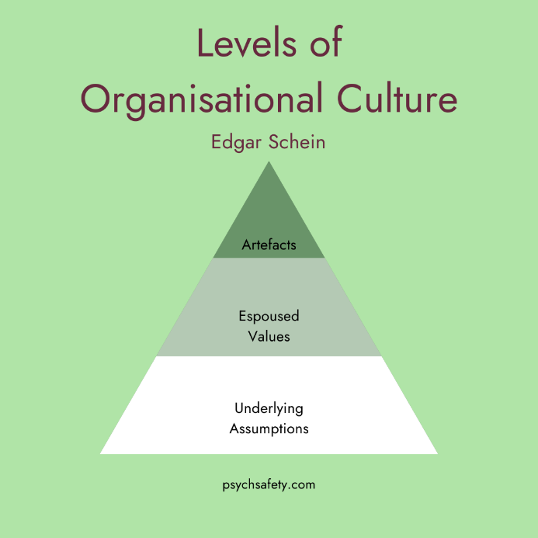
Figure 2: Levels of Organisational Culture.
Source: (Geraghty, 2023).
The model suggests that corporate culture relies on three interrelated levels, ranging from highly visible and unconscious psychological formats (Erthal and Marques, 2020). The levels are artefacts, espoused values and basic underlying assumptions. Within the artefacts prospect, Toyota’s Genchi Genbutsu concept can be recognised in the action. The workspaces consist of common cafeterias, open-plan offices, and uniform dress codes that can blur the hierarchy between the frontline workers and executives (Ganesh and Liu, 2022). The major artefact is the Andon cord or a physical rope over the assembly line that any worker can pull to stop the manufacturing while they are recognising any defects. In the meantime, while determining the business's sayings and Espoused Values, it was recognised that the business’s core values centred around Respect for People and Continuous Improvement (Kaizen) (Pangarso et al., 2022). The business has indicated these concepts and compelled the workers to follow them in daily business operations. On the other hand, the basic underlying assumptions can be recognised that all the workers are capable of solving issues (Rizzi, Gigliotti and Annunziata, 2022). Moreover, it was perceived that the collective team is smarter than any single individual, and the business recognises the long-term workers' growth, which is more crucial than the short-term financial gains.

Hofstede’s Cultural Dimensions
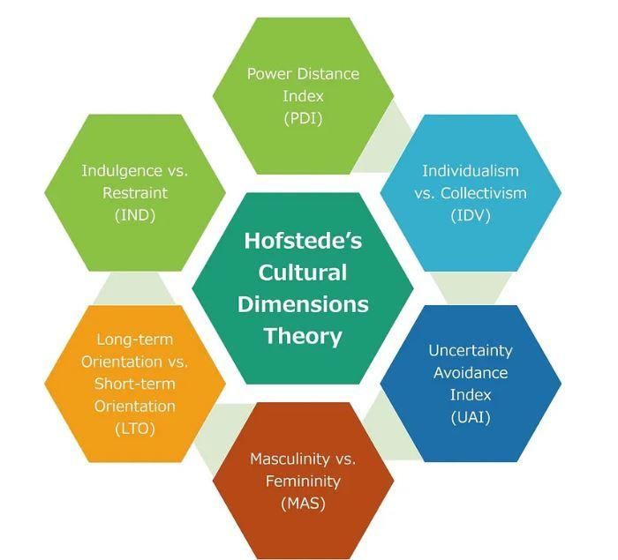
Figure 3: Hofstede’s Cultural Dimensions.
Source: (Vinod et al., 2023).
The model signifies how national cultural influences in any business assist in recognising the drivers surpassing varied management styles in Toyota.
Collectivism vs. Individualism: The culture of Toyota is largely leaning toward the collectivism perspective instead of individualism (Arumugam, Kannabiran and Vinodh, 2020). There, the success of the team and group harmony are preferred over personal accomplishment, which is the basis of reliance on cross-functional teams and sharing issues.
Long-Term vs. Short-Term Orientation: The organisation also showcases long-term orientation. Following Kaizen and going to the source to see the facts, concepts demand huge time for steady and slow growth with a sustainable future rewarding instead of prompt financial gains.
Power Distance: The business has been operating with relatively lower power distance. The Japanese society respects the hierarchy, whereas floor-level operations in Toyota allow the workers to share their concerns and contribute to the decision-making (Chenarboo, Hekmatshoar and Fallahi, 2022).
Masculinity vs. Femininity: From the beginning, the masculine culture was recognised in Toyota as it considers assertiveness, ensures high performance and material triumph. Conversely, the focus on consensus-based decision-making and "Respect for People" reveals maintaining balance to the feminine traits, such as nurturing long-term workers' growth and well-being (Chourasia, Dhama and Bhardwaj, 2024).

Competing Values Framework (CVF)
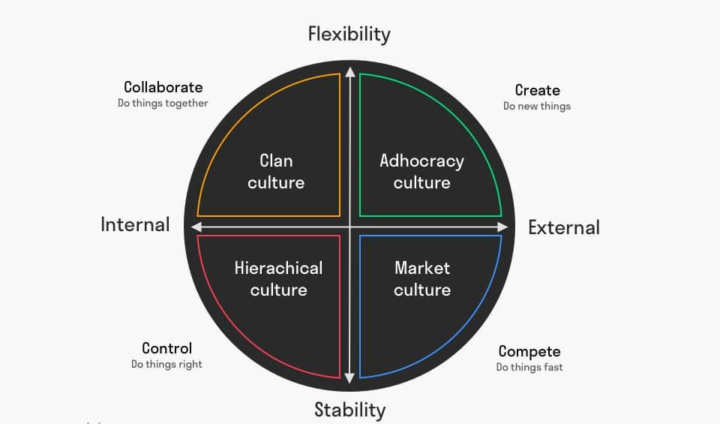
Figure 4: Competing Values Framework (CVF).
Source: (Mulder, 2023).
Recognising the failures of Toyota over the axes related to the Competing Values Framework (CVF) model, it will be supportive to recognise varied cultural types that relate to the business.
Clan Culture: The business focuses on mentoring, teamwork and mutual trust, whereas the focus is maintained on the human element and motivating open communication with the shared responsibility around departments (Erthal and Marques, 2020).
Hierarchy Culture: The internal centricity and stability can be noticed in the Toyota Production System (TPS). The prospect confirms proper role directions, strict standardisation and largely disciplined operational process for eliminating wastage (Ganesh and Liu, 2022).
Adhocracy Culture: The organisation has a focus on innovation and challenges. Since the automotive industry has been shifting towards autonomous driving and mobility, Toyota depends on the dynamic aspect of the culture to adapt, make experiments and disrupt its own established procedures.

Toyota Using the Influence of Organisational Culture to Adapt to the External Environment
Toyota has been using the foundational organisational culture, which is also recognised as the internal scope of adapting to the international changes, such as electrification, supply chain shifts, and AI integration (Pangarso et al., 2022). Depending on the major values such as respect for people and continuous improvement, the business has empowered the frontline workers with seamless adaptation of external industry demands. Here, continuous improvement (Kaizen) is followed to drive innovation. Since the automotive industry has shifted toward electric and autonomous vehicles, the following of the Kaizen concept in Toyota can be supportive as it pursues the idea that all actions can be reshaped (Rizzi, Gigliotti and Annunziata, 2022). Instead of sticking to mechanical production, the culture of Toyota now focuses on software and digital Research and Development around the cross-functional teams, thereby confirming technological integration smoothly into the assembly lines. Moreover, the business has been applying automation focused on people, indicating that the technology has been evolving, and workers are constantly trained to keep pace with the machines. In the meantime, respect for people and cross-functional agility can be noticed in Toyota (Verma and Venkatesan, 2021). The following of "Jidoka" concept, with the empowerment of any worker to halt the whole manufacturing line while they spot the quality issues, is recognised. These decentralise the trust and contribute to the business to promptly detect the mechanical and external failures before escalating the international recalls. Moreover, the adaptation to different international markets and regional client priorities requires Toyota to integrate the cultural principles with the matrix structure. It may break down the siloed hierarchies that can contribute to varied international hubs to participate, react and share knowledge on the local economic and regulatory challenges properly. Along with this, the business has been maintaining supply chain partnerships by valuing network and trust (Chenarboo, Hekmatshoar and Fallahi, 2022). Instead of using top-down and aggressive negotiations, the business culture signifies trust with the external suppliers. The shared cultural concept allowed Toyota to deal with the crises when any type of shortages occurred. That helped Toyota to deal with the disruptions and resolve the issues collectively with the suppliers. In addition, the long-term mentality with the focus on sustainability shift can be recognised in Toyota, which compelled it to invest largely in alternative and sustainable mobility solutions (Arumugam, Kannabiran and Vinodh, 2020). There, the cultural preferences of long-term environmental value over the short-term market trends can be recognised as suitable.

Organisational Culture as A Barrier to Effective Functioning
The Japanese business traditions followed by Toyota with the "Toyota Way" serve as a competitive advantage and a structural barrier for constant adaptation. The following of such culture leads to legendary operational efficacy, while its complicated elements mostly lead to struggling circumstances to keep pace with the constant international shifts and localised innovation. The organisational culture of Toyota can be recognised as an asset. The Toyota Production System or TPS was developed over the automation and Kaizen method, which empowers the workers to pause manufacturing to deal with the presented errors and confirm that the business can deliver industry-leading products (Chenarboo, Hekmatshoar and Fallahi, 2022). Moreover, the maintenance of long-term relations with the suppliers and workers, with a preference for stable and high-quality production over short-term financial gains, is supportive. Along with this, the business has been promoting decision-making and cross-functional teamwork, with a dependence on facts and ground-level observations. On the other hand, the same culture in Toyota can be recognised as a barrier, as the cultural concept may lead to internal challenges. The centralised and decision-making challenges are rooted in high power distance, where the most complicated strategic decisions are routed back to the Japanese headquarters (Dimitrantzou et al., 2021). These are slowing down the responses and making it complicated for the regional subsidiaries in the fast-moving markets to adapt promptly. In the Japanese corporate horizon, big differences can be noticed in the consensus and authority. Such a cultural norm has historically made it complicated for workers to challenge design decisions and report critical failures. The organisation’s historical paranoid but meticulous culture of taking actions can most of the time obstruct agile pivots toward the presented technologies, like the constant EVs progress and software integration (Erthal and Marques, 2020). The leadership in Toyota identified these barriers and determined them as liabilities. In this regard, the business intended to restructure the organisational structure and move to a role-based structure for accelerating internal power and enhancing the massive item portfolio.

Evaluating the Influence of Organisational Culture on Organisational Performance
The organisational culture of Toyota noticeably affects the performance through the balancing of firsthand problem-solving and constant growth. Such an environment initiates exceptional operational efficiency and maintains high-quality standards with the empowerment of human resources. There, the preferences of constant growth over quality control have noticeably led to temporary operational risks. Continuous Improvement (Kaizen) is maintained with the elimination of wastage and constant daily growth. That helps to improve the efficacy and reduce the costs. Along with this, the engagement of frontline workers in solving issues with the noticeable lowering of production can present defects in the production expenses (Pangarso et al., 2022). Further, valuing workers to build trust and confirm long-term job security are examples of respect for people. These are driving high morale value among the workers and increasing the retention rate by 12% from the industry trends. These are cultivating a loyal and highly motivated workers group to contribute optional action and innovative notions. The organisation also intends to learn and solve issues promptly. Such doings are supportive of accelerating the problem-solving dynamics and reducing the downtime (Verma and Venkatesan, 2021). These are also helpful to avoid minor production hiccups from escalating into huge product recalls. Moreover, the maintenance of teamwork and collaboration can be noticed in Toyota. The promotion of cross-functional cooperation, along with decentralising the decision-making, prospects are improving adaptability. These are supportive of the business to integrate functional hierarchies and manage regional divisions promptly to react to the international market demands. The focus on the continuous flow and built-in quality has confirmed high standards and allowed the business to take control over the supply chain. In the meantime, prioritising the workers' coaching and curiosity is transforming the workforce into a constant engine for technological innovation and performance optimisation. While Toyota altered its cultural centricity over the constant international extension, the business avoided huge worldwide recalls and hampered the business reputation (Vinod et al., 2023). The pressure on workers to meet the aggressive manufacturing targets are maintaining over quality to decline in adherence to quality assurance.

Conclusion
The analysis revealed that Toyota has been using the continuous improvement (Kaizen) and Go and See of Genchi Genbutsu’s cultural philosophy. There, the workers are given the power to take limited risks and view the matters not as failures, but as chances that can lead them to growth. Along with this, the Toyota Production System largely hinges on the bottom-up management structure. In addition, the decisions are propelled by long-term vision, instead of short-term gains. Moreover, the cultural focus on operational superiority, standardised measures and teamwork largely disturbs the way businesses like Toyota structures its business. The findings continued with the identification that for encountering the risks of rigidity and headquarters-dominated design, Toyota also reformatted product- and region-based business units into automation. Afterwards, using the Levels of Organisational Culture model, it was determined that the business has indicated these concepts and compelled the workers to follow them in daily business operations, and here, all the workers are capable of solving issues. In the meantime, using Hofstede’s Cultural Dimensions, it was identified that Toyota is largely leaning toward the collectivism perspective, has a long-term orientation, and has been operating with relatively lower power distance. Furthermore, the business is using the Toyota Production System or TPS, which confirms proper role directions, strict standardisation and largely disciplined operational process for eliminating wastage, and it focuses on innovation and challenges. Along with this, the automotive industry has shifted toward electric and autonomous vehicles, and the following of the Kaizen concept in Toyota can be supportive, as it follows the idea that all actions can be reshaped. The following "Jidoka" concept, with the empowerment of any worker to halt the whole manufacturing line while they spot the quality issues, was recognised. Furthermore, the business has been maintaining supply chain partnerships by valuing network and trust, which was recognised. While determining the barriers in organisational culture, it was recognised that the Toyota Production System or TPS, empowers the workers to pause manufacturing and promote decision-making and cross-functional teamwork. Again, the centralised and decision-making challenges are rooted in high power distance, where the most complicated strategic decisions are routed back to the Japanese headquarters.

References
Arumugam, V., Kannabiran, G. and Vinodh, S. (2020). Impact of technical and social lean practices on SMEs’ performance in the automobile industry: a structural equation modelling (SEM) analysis. Total Quality Management & Business Excellence, pp.1–27.
Chenarboo, F.J., Hekmatshoar, R. and Fallahi, M. (2022). The influence of physical and mental workload on the safe behaviour of employees in the automobile industry. Heliyon, 8(10), p.e11034.
Chourasia, S., Dhama, A. and Bhardwaj, G. (2024). AI-Driven Organisational Culture Evolution: A Critical Review. 2024 International Conference on Communication, Computer Sciences and Engineering (IC3SE).
Dimitrantzou, C., Psomas, E., Bouranta, N. and Kafetzopoulos, D. (2021). The role of organisational culture in total quality management adoption and cost of quality. Total Quality Management & Business Excellence, 33(15-16), pp.1–19.
Erthal, A. and Marques, L. (2020). Organisational culture in lean construction: managing paradoxes and dilemmas. Production Planning & Control, pp.1–19.
Ganesh, R. and Liu, Y. (2022). Employee satisfaction in the sales department of the automobile industry in Beijing, China: an approach with Herzberg’s two-factor theory. International Journal of Services, Economics and Management, 13(1), p.57.
Geraghty, T. (2023). Edgar Schein’s Three Layers of Organisational Culture. [online] Psych Safety. Available at: https://psychsafety.com/psychological-safety-edgar-scheins-three-layers-of-organisational-culture/.
Mulder, P. (2023). Competing Values Framework and Culture Typology | ToolsHero. [online] ToolsHero. Available at: https://www.toolshero.com/leadership/competing-values-framework/.
Mullins, L.J. and Christy, G. (2016). Management & Organisational Behaviour. 11th ed. Harlow: Pearson.
Pangarso, A., Winarno, A., Aulia, P. and Ritonga, D.A. (2022). Exploring the predictor and the consequence of digital organisational culture: a quantitative investigation using sufficient and necessity approach. Leadership & Organization Development Journal, ahead-of-print(ahead-of-print).
Rizzi, F., Gigliotti, M. and Annunziata, E. (2022). Exploring the nexus between GSCM and organisational culture: insights on the role of supply chain integration. Supply Chain Management: An International Journal, ahead-of-print(ahead-of-print).
Toyota (2024). New Cars, Trucks, SUVs & Hybrids | Toyota Official Site. [online] Toyota.com. Available at: https://www.toyota.com/.
Verma, A. and Venkatesan, M. (2021). Industry 4.0 workforce implications and strategies for organisational effectiveness in the Indian automotive industry: a review. Technology Analysis & Strategic Management, 35(10), pp.1–9.
Vinod, R., Ramasamy, N., Anand, M.D. and Santhi, N. (2023). Supply Chain Management Efficiency Improvement in the Automobile Industry Using Lean Six Sigma and Artificial Neural Network. IEEE Transactions on Engineering Management, pp.1–21.

