

LOCATION: Swansea | LLEOLIAD: abertawe
LEVEL 5 | LEFEL 5
EXAMINATION PERIOD | CYFNOD ARHOLIADAU
may 2024 | mai 2024

MODULE CODE: GOEE5000

Electrical Power

TIME: 2 HOURS

answer all questions

Equipment or materials required – Calculator &Formula booklet

Question One (30 marks)

- The circuit in Figure 1-a shows a load of $\left(20-j15\right)$Ω being fed by a 240V source through a transmission line. The impedance of the line is represented by $\left(6+j3\right)$ Ω. Find the power factor of the circuit.
[5 Marks]

Figure1-a

- In Figure 1-b shown below, determine the complex power S, total real power P and reactive power Q.
[25 Marks]

Figure1-b

Question Two (25 marks)

- A load absorbs 120 kVA at lagging power factor of 0.65. Given that the voltage and the frequency of the source is 220V and 50Hz, compute the value of the capacitor that would correct the power factor to 0.9 if placed in parallel with the load.
[20 Mark]

- Figure 2-a shows a generator circuit ( $V_{s}$) connected to a distant load by a extended coaxial transmission line. The equivalent circuit is shown in figure 2-b, where the transmission line is represented by equivalent impedance${ Z}_{L}=5+j2 Ω$. Calculate:
- The power factor of the voltage source$V_{s}$. [3 Mark]

- The capacitance (C) of a shunt capacitor of reactance (X_{C} =114 Ω) connected between terminals (a&b). The source frequency is 1.5 kHz. [2 Mark]

Figure 2-a Transmission-Line Circuit

Figure 2-b Equivalent Circuit
Question Three (30 marks)

- A balanced Delta (Δ) connected load having impedance $10-j5 Ω$ is connected to a Delta (Δ) connected, positive sequence generator having $V_{ab}=220 ∠ 0°$, as shown in figure 3-a below. Calculate:

- The phase voltages $V_{ab}, V_{bc}, V_{ca}$ [5 Mark]
- The phase currents $I_{AB}, I_{BC},I_{CA}$ [5 Mark]
- The line currents $I_{a}, I_{b},I_{c}$ [5 Mark]

Figure3-a

- A three-phase load has a resistance and reactance of 6Ω each for all the three phases. The load is connected in star configuration. A 400V 50 Hz, three-phase supply is connected across the load as shown in Figure 3-b. Calculate the following:

- The phase voltage [2 Mark]
- The phase current [4 Mark]
- The power factor [2 Mark]
- The power consumed per phase [4 Mark]
- The total power consumed by the load. [3 Mark]
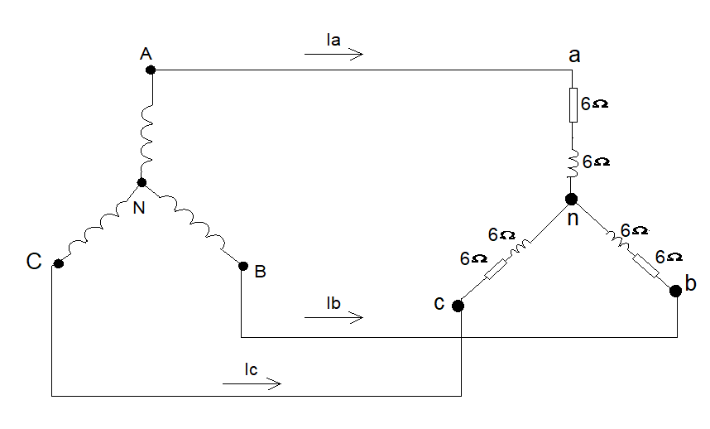

Figure3-b

Question four (15 Marks)

- A 240V separately excited DC motor takes a no-load current of 3A and has a no-load speed 1500 rev/min. If the armature resistance is 0.2 Ω and the full load current is 30A, Calculate the full load speed. Assume the flux remains constant.
[10 Marks]

- A single-phase transformer has a voltage ratio of 4:1, and the high voltage winding
is supplied at 440 V. The secondary winding provides a full load current of 20 A
at a power factor of 0.9 lagging. Neglecting losses, find:

    - the power supplied to the load, and
    - the primary current.
[5 Marks]

