Module Title: Problem Solving and Decision Making

Module Code: LCLM 4004

Assessment: Component 2 Report

Student Name: Kazi Nelima Begum

Student Number: 2330804

Lecturer’s Name: Chijioke UBA

Contents Page Number

Brief Explanation ……………………………………...………………………....….3

Suggested Two Alternative Solutions……………………………………………...3

Justification for Selected Solution…………………………………………….…...3/4

Risk Analysis of the Selected Solution……………………………………..….….4

Plan to Implement the Selected Solution………………………………….….…..5

KPI and SMART…………………………………………………………………..…5/6
Reference List………………………………………………………………………..7

Appendix 1: Grid Table……………………………………….……………………..8

Appendix 2: Risk Analysis ………………………………………………………….9

Appendix 3: Implementation Plan………………………………………………..10/11

Appendix 4: KPI and SMART Table………………………………………………12

Brief Explanation of the Specific Business Problem
Green Haven Florists, founded by Liam and Priya Patel, is known for bespoke floral designs, eco-friendly packaging, and community ties. Recently, the shop has faced a 30% drop in in-store sales due to changing consumer habits favouring online flower delivery. Reduced foot traffic on the high street has worsened the decline. They have outdated website and reliance on word-of-mouth marketing. Competition has intensified with the arrival of a trendy Instagram-savvy florist and a national chain offering lower prices.

Suggested Two Alternative Solutions

Solution 1 – Improve digital infrastructure
A solution for Green Haven Florists is upgrading its website and digital systems. A modern, user-friendly site can boost online traffic and offer custom orders, delivery system, and subscription service. Enhanced digital presence will attract more customers and improve convenience. Additionally, updating internal computer systems will streamline operations by digitising accounting, finances, and records, reducing reliance on paper. These improvements will strengthen their digital infrastructure.
Solution 2 - Increase social media presence
Social media is a powerful, low-cost way for the shop to boost visibility and revenue. Networks like Instagram, Facebook, Twitter, and TikTok can help the business reach customers beyond the local area. A stronger online presence will improve marketing efforts and help them compete with rivals. Unlike word-of-mouth, social media allows targeted advertising, making it an essential for growth awareness.

Justification for Selected Solution
Improving the digital infrastructure will strengthens the company’s customer base.
An updated user-friendly website would allow Green Haven to showcase its business, the product its sells and its bespoke arrangements and eco-friendly biodegradable packaging.
Digital improvement also offers significant potential over social media presence. Although social media presence has a high potential to reach out to wider consumers, ultimately, consumers will have to visit the company website for further details or ordering flowers.

Risk Analysis of the Selected Solution
See Appendix 1 table
Chosen criteria and reason:
- Cost effective – need to know how much it will cost to set up
- Implementation – how easy is it to set up and if it will be time consuming
- Impact – How much impact will it have on the customers and would it be beneficial
- Increase customers
- Potential to increase revenue

Weighting
- Digital infrastructure – 5
- Social media - 4
In evaluating two options, improving digital infrastructure was rated with the highest importance (score of 5). This prioritisation is based on the role that digital infrastructure plays in enabling and supporting all other digital initiatives, such as upgraded computer systems, faster internet connectivity, and a modernised website.
While social media presence is valuable for customer engagement and marketing, its effectiveness is dependent on having a good infrastructure. Improving digital infrastructure is not only urgent but also necessary before investing in social media enhancements.
Green Haven Florists plan to improve its digital infrastructure does faces several challenges. These include high costs for design and hardware upgrades, the need for staff training, potential negative feedback from long-time customers, and risks related to GDPR compliance.
Reason for Criteria used
- Cost to improve digital infrastructure – This is key to ensure the project does not exceed budget
- Training – Criteria required to ensure right and sufficient training is provided to staff on the new system
- GDPR and Data security – Vital that all information used is secure, breach of data could cause reputational damage
- Length of time – How long would the project take
- Customer and staff feedback – Criteria required to ensure staff are comfortable using the system and positive feedback is gained from customers
The weighting scale helps Liam and Priya assess how probable each risk is based:
- Budget overruns are common in small business digital upgrades therefore the likelihood is 3
- Data breaches are common, likelihood is 5, impact is rated as 5 as this can cause criminal and reputational risks
- No major concerns with training providing the documentation are relevant, therefore likelihood is 3
- A technical issue on the website could cause customer dissatisfaction therefore rated as 3, Impact is rated at 2 as this does not affect the overall business

Plan to Implement the Selected Solution

See Appendix 3 table
- Finalise budget and select developers before starting improvements.
- Redesign website and purchase updated hardware and software.
- Install firewalls and data security to protect customer information.
- Provide staff training on new systems for smooth transition.
- Launch the new website for online viewing, ordering, and delivery.
- Promote the updated website to attract and inform customers.
This sequence ensures each step builds on the previous, reducing rework and creating a reliable workflow.

KPI and Smart

The first KPI focuses on improving infrastructure to boost revenue through digital upgrades like a redesigned website. The second KPI targets enhancing user experience, which directly influences online sales. The third KPI measures staff performance, supported by new systems that simplify administrative tasks. Using the SMART framework ensures these KPIs are specific, measurable, and achievable delivering short-term wins through website improvements and long-term gains via subscriptions and increased revenue.

Key Findings
- Risk analysis suggests improving digital infrastructure is key for Liam and Priya
- Areas to focus are improving website, purchasing computer systems for the company and training staff
- Highest risk are budget overrun and the importance of GDPR
- Implementation plan is structured into 6 phases
References
Wittwer, J. (2024) Risk Assessment Matrix Template. Vertex42. Available at: https://www.vertex42.com/ExcelTemplates/risk-assessment-matrix.html (Accessed: 28th October 2025)
Tableau Software (n.d) What are SMART goals? Definition & best practices. Available at: https://www.tableau.com/learn/articles/smart-goals-criteria (Accessed: 5 November 2025)
Uba, CU, (2025) Problem Solving and Decision making, LCLM 4004,
Week 4 – Cause effect (Lecture slides)

Uba, CU, (2025) Problem Solving and Decision making, LCLM 4004,
Week 3 – Pestel (Lecture slides)

Uba, CU, (2025) Problem Solving and Decision making, LCLM 4004,
Week 9 – Effective measurements (Lecture slides)

Uba, CU, (2025) Problem Solving and Decision making, LCLM 4004,
Week 8 – Risk Analysis (Lecture slides)

Uba, CU, (2025) Problem Solving and Decision making, LCLM 4004,
Week 7 – Evaluation methods (Lecture slides)

Appendix 1
Grid Analysis

Factors to consider | Increase Digital Infrastructure | Increase in Social Media Presence
Weighting | 5 | 4
Cost effective | 2 10 | 5 20
Implementation | 3 15 | 4 16
Impact | 4 20 | 3 12
Customers | 5 25 | 5 25
Increase revenue | 5 25 | 4 16
Total | 95 | 89
Appendix 2 Risk Analysis

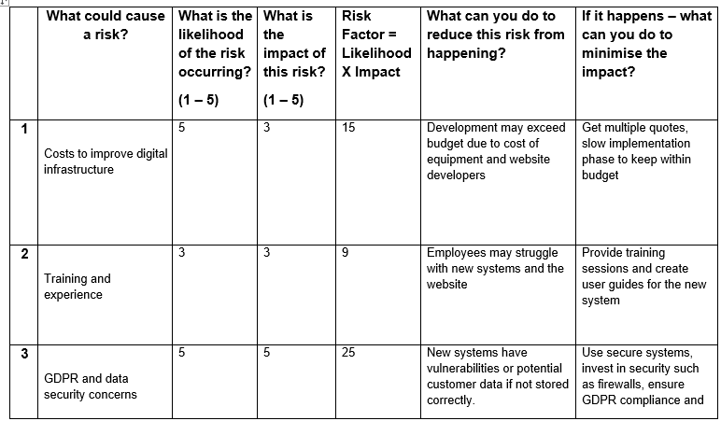
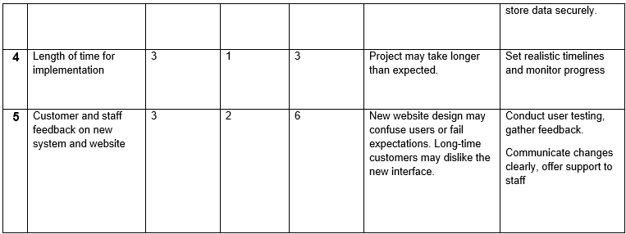
Appendix 3 Implementation plan

Name the problem you are solving: Decrease in revenue
Name the solution you are implementing: Improving digital infrastructure

 | Task | WHAT | WHEN | WHO | Done
1 | Budget & select website developer and equipment required | Set budget for the website redesign, budget on the computer equipment’s required, get quotes, select web developer  Identify what software is required | Week 1 | Liam and Priya | Balance sheet to ensure project is within budget  Project plan from website designers
2 | Website Redesign and purchase new computer equipment and software | Once website design chosen, designers to create website with the relevant content.  Purchase software required for staff to use in store | Week 2-4 | Liam and Priya  Website developers | Website design complete  Computer and software up and running
3 | Firewalls and security for data storage | Identify and purchase security systems and storage of customer data and company information  Add secure payment gateway and delivery system. | Week 2-4 | Liam and Priya | Firewalls and security systems installed
4 | Organise Training to deliver to the staff | Identify if a trainer is required or if Liam and Priya can offer the training to staff  Provide training | Week 4-5 | Liam and Priya  Trainer
5 | Launch new website | Once website is designed, publish the on the internet to allow customers to view and use the website functions | Week 5-6 | Liam and Priya  Website developer | Website on the world wide web  Contract completed by the developer
6 | Advertise and market new website | Make customers aware of updated website. Create leaflets and market campaign for awareness | Week 6-7 | Liam and Priya  Developer | Website on the world wide web  Customer feedback and delivery requests

Appendix 4 – KPI and SMART

Specific | Measurable | Attainable | Relevant | Time-Bound
Increase revenue by online flower orders through the new website | Increase revenue to at least 30% | Based on customer feedback and increase in sales | Builds customer loyalty and delivery services, | Within end of the financial year
Website upgrade | Speed of the site and positive feedback from customers | User friendly site | Customers can navigate quickly through user friendly sites | Within 3 months
Staff performance | Use of new computer systems for administrative duties | New system for staff to use | Staff performance increases using computers rather than manual tasks | Within 6 months

