BMLW4000 Criminal Litigation
Topic: Explain the role of a Crown Prosecutor and identify the tests used when making charging decisions

By

Student Name: Gabriel George ABRANI
Student ID: 2244462

Executive summary
The report is based on the role of the Crown Prosecutor in identifying the criminals in case of deciding on charging based on the evidence. The structure of the court has been discussed and it is divided into three courts including Magistrates courts Crown courts and Youth courts. The criminal justice system in the UK is followed by reporting crimes to the police where the powers are conducted for making the investigation and assuming the suspects. Further, the role of the police in gathering investigation and the role of the crown prosecutor in initiating the criminal proceeding are discussed.

Table of Contents
1. Introduction 4
2. Analysis 4
2.1 Knowledge and understanding of the key concepts of the court structure 4
2.2 Key concept of the structure of criminal Jurisdiction 5
2.4 Role of criminal proceedings and its stages 7
2.5 Understanding the role of bail and funding and its stages for preparing advice for criminal proceedings 10
3. Conclusion 11
References 12

1. Introduction
According to Li et al., (2019, p. 5), criminal litigation refers to the trial conducted in the criminal court. Criminal law sets out the concept regarding criminal offences and rules which is applicable in case of a police investigation. In terms of this, the crown prosecutor's role enforces the jurisdiction's laws in case of exercising discretion in a specific case. Criminal litigation is applicable for understanding the police powers in arresting and detaining a person for making an investigation regarding any crime or criminal offence.

2. Analysis

2.1 Knowledge and understanding of the key concepts of the court structure
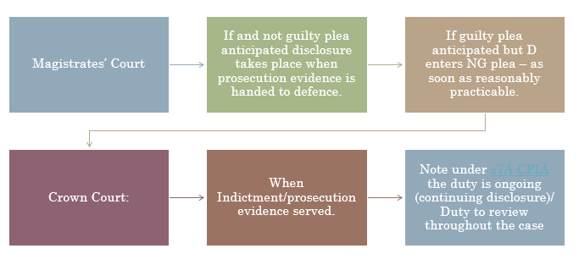
Figure 1: Structure of the court in the UK
(Source: Taken from the material)
As opined by Kudratillaev, (2022), the structure of the court is referred to as a pyramidal structure with the original jurisdiction over the importance of national matters including disputes among states and appellate jurisdictions against several decisions made by the lower structure of the court. In the country UK, the structure of the court is divided into Magistrates’ courts, Youth courts, and Crown courts respectively.
Magistrate’s courts
Magistrate Court administration is appointed by Lord Chancellor under the act of Courts Act 2003. The cases which have to be dealt with by the magistrate's court are motoring offenses, minor criminal damages, and the common assault which are not caused any significant injury to the parties (gov.uk, 2015).
Crown court
A crown court normally comprises a jury who has the ability in deciding whether a person is guilty or not. It also has a judge deciding the type of punishment served to the individual. It determines the appeals against any conviction and makes the sentence from the collected decisions from the Magistrates court.
Youth courts
In terms of the structure of courts, Youth courts are fewer compared to other courts. For example, in this Youth Court, members are not allowed in entering the court unless they get permission or authority. The cases dealt with by the court are theft, burglary, drug offenses, and anti-social behaviour.

2.2 Key concept of the structure of criminal Jurisdiction
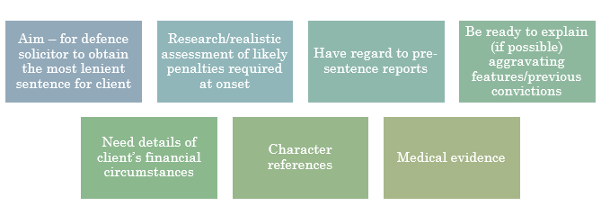
Figure 2: Plea for mitigation
(Source: Taken from the material)
According to Cormack, (2019), the concept of jurisdiction is the power held by a court or law for carrying out legal judgments or for enforcing laws. In terms of the structure of criminal jurisdiction, the court has the right against any offenses which are committed by the territorial waters for the nationality of the offender. The criminal court system in the UK is conducted comprising three divisions including the Courts of England and Wales, Courts of Scotland, and Courts of Northern Ireland whose jurisdiction area is categorised in geographical aspect.
In terms of the criminal trial, the case is divided into two categories including the defence case and the prosecution case. According to Forrester et al., (2020, p. 71), the initiation of the defence case can occur after the completion of the prosecution case. The procedure of plea before the venue is followed in case of charge being read to the defendant and the court explains to the person indicating to plead guilty in offense for trial proceedings.
2.3 Understanding of the role of the police
As per the s56 PACE 1984/Code C, it provides that the arrested person is entitled in requesting another person to get informed of their whereabouts and arrest (Rowe and Rowe, 2021, p. 764). The duty of custody officer is required to have access to suspecting vulnerable persons and is likely to make an assessment for the need of the suspect. Further, in the Police Reform and Social Responsibility Act 2011, there is a provision for the administration and governance of the forces regarding performing the duty of the police in an effective manner.

Figure 3: Police forces in Wales
(Source: Taken from the material)
As per Police and Criminal Evidence Act 1984, the role of the police in the country is to develop a community with knowledge for identifying the individual the location risks, and the factors being involved in crime. The power of the police needs to be followed by s61 PACE, s62 PACE and s63 PACE where the fingerprints are taken in consent to the suspected and the intimate samples can be taken from authorised inspector.

2.4 Role of criminal proceedings and its stages
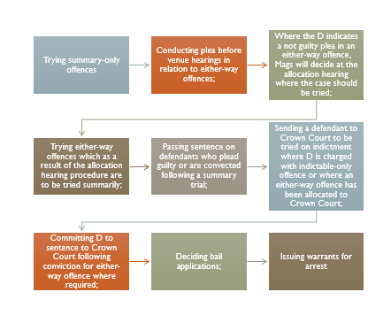
Figure 4: Functions of Magistrates Court in criminal proceedings
(Source: Taken from the material)
Criminal proceedings are defined as the action which is taken in the court for bringing a criminal prosecution against the person who is guilty. Criminal proceedings take place in case of an offense is being committed. This stage is not a part of the trial but can lead to proceedings. As per the Criminal Justice Act 2003, it creates a presumption of the criminal proceedings whilst having the evidence for indicating the documents in favour of the accused.
Step 1: Investigation of the police
Police are responsible for investing crime and suspecting suspects based on the information gathering. In case of having relevant information such as criminal damage under £5000 s22 MCA, they have the power in identifying the suspect and file it to the Public Prosecution Service. In the case of sentencing, the court has taken into account of offense, the timing of the plea of guilty, and the character of the defendant.
Step 2: Prosecution of the case
In case of the case is the centre interest of the public and the availability of enough information, the role of crown prosecutors is to prosecute the charges laid by the police department against the person who is being accused. In case of unavailability of the information, the crown prosecutor withdraws the charges or initiates the stay in proceedings. Crown prosecutors have the right to review investigations carried out by police and decide a prosecution case with the help of legal procedures. In the case law of Elkington v DPP (2012) the appellant's conviction for the police constable in the execution has been held upheld further the appeal was disregarded.
Step3: Prosecution in courts
There are mainly three types of important pillars in terms of criminal justice administration police, court, and the process of prosecution. The task of the prosecution is to generate justice for the victim through courts and provides punishment to the offender with the presentation of proper evidence collected by police and their investigation. S78 PACE act is preserved for treating with fairness in the preceding session as it is applied to evidence by the prosecution but not applicable to the defendant.
Step 4: Trial and outcome of the case
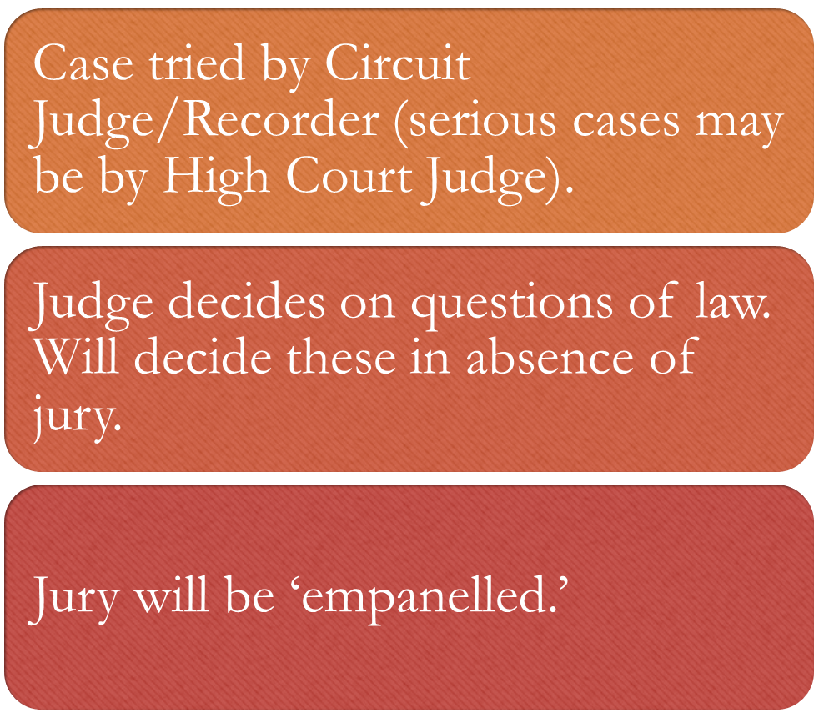
Figure 5: Trial Preliminary Stages
(Source: Taken from the material)
In case of a matter proceeds to the trial procedure, the role of the Crown Attorney is to present the evidence in a clear matter. It is the responsibility of the Crown prosecutor to argue for the proper verdict against the evidence (Gov.uk, 2015). The aim of the trial is to understand the function of the principles of criminal proceedings in the following Crown courts and Magistrate courts respectively.
Step 5: Appeal
This stage signifies the affirmation of the trial court decision in which the verdict is being on trial stands. For the appeal from the crown court, the leave needs to be appealed for the requirement of granting of the judge granting. Attorney General’s reference leave the Court of Appeal for any sentences imposed by the Crown Court under the ss35 and 36 Criminal Justice Act 1988.

2.5 Understanding the role of bail and funding and its stages for preparing advice for criminal proceedings
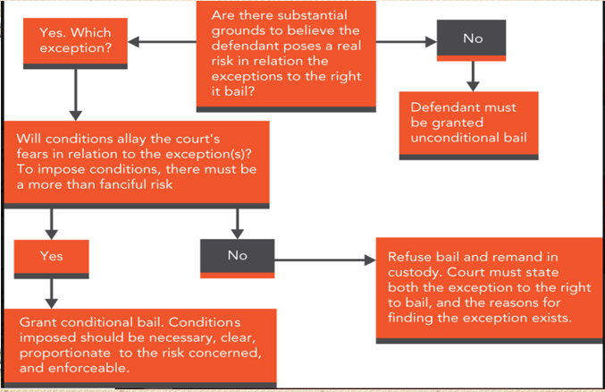
Figure 6: Procedure of bailing
(Source: Taken from the material)
As per Lach, (2021), the purpose of bail and funding in the criminal case is to provide relief to the accused of imprisonment and provide relief to the state of burden for keeping the accused, pending trial, and keeping the accused in custody in a constructive way. The bail application needed to be filled out before the Magistrate, responsible for conducting the trial. The concept of bail is the legal written request made to the court as a representation of release seeking from custody in the legal proceedings (Cps.gov.uk, 2023). The stages of bail in criminal proceedings are two steps.
Step1: Arrest
In terms of arresting the accused, the role of the crown prosecutor is to prove the fact based on the provided evidence by the police and make a decision on whether to arrest the accused. The right to legal advice can be noted in the record custody. Following s128 Migrates Court Act 1980 (MCA 1980) the act provides a subsequent procedure for adjourning and remanding in custody to the Crown court or case of summary trial.
Step 2: Bail
Crown prosecutors need to keep the bail issue under review during the life of the case. The condition for applying bail can only be imposed where it is necessary to ensure addressing the exceptions for bailing. According to Bail Act 1976, all the defendants are granted bail except for those accused of an imprisonable offense (Legislation.gov.uk, 2023).

3. Conclusion
It can be concluded that the legal system in the UK is the justified verdict given by courts for the conviction of the accused. The case of criminal needs to pass from several cases for the prosecution to be valid. The steps are discussed where the evidence has been taken palace in the arising of the trial.

References
Cormack, B., (2019). A power to do justice: Jurisdiction, English literature, and the rise of common law. University of Chicago Press. https://www.degruyter.com/document/doi/10.7208/9780226116259/html
Cps.gov.uk, (2023). Bail | The Crown Prosecution Service (no date). Available at: https://www.cps.gov.uk/legal-guidance/bail.
Forrester, A., Hopkin, G., Bryant, L., Slade, K. and Samele, C., (2020). Alternatives to custodial remand for women in the criminal justice system: A multi‐sector approach. Criminal behaviour and mental health, 30(2-3), pp.68-78. https://onlinelibrary.wiley.com/doi/abs/10.1002/cbm.2144
Gov.uk, (2015). Government Digital Service (2015) “Being charged with a crime,” GOV.UK [Preprint]. Available at: https://www.gov.uk/charged-crime/bail
gov.uk, (2015). Government Digital Service (2015) “Criminal courts,” GOV.UK [Preprint]. Available at: https://www.gov.uk/courts.
Kudratillaev, X.Z., (2022). Evaluation of evidence in criminal proceedings (international experience). Herald pedagogiki. Nauka i Praktyka, 2(2). https://www.ejournals.id/index.php/HP/article/download/499/470
Lach, A., (2021). Individual Prevention in Criminal Procedure. Baltic JL & Pol., 14, p.1. https://heinonline.org/hol-cgi-bin/get_pdf.cgi?handle=hein.journals/bjlp14&section=3
Legislation.gov.uk, (2023). Participation, E. (2023) Bail Act 1976. Available at: https://www.legislation.gov.uk/ukpga/1976/63.
Li, N., Wang, Z. and Dear, K., (2019). Violence against health professionals and facilities in China: evidence from criminal litigation records. Journal of forensic and legal medicine, 67, pp.1-6. https://www.sciencedirect.com/science/article/pii/S1752928X19300745
Rowe, M. and Rowe, M., (2021). Understanding the quiet times: The role of periods of “nothing much happening” in police work. Journal of Contemporary Ethnography, 50(6), pp.751-774. https://journals.sagepub.com/doi/abs/10.1177/08912416211017277

