

Managing and Mitigating Cyber Threats in Supply Chains

BSc (Hons) Logistics and Supply Chain Management

Christopher Peter Ashmead

Supervisor - Irina Neaga

Appendix 1.0: Declaration

I, Christopher Peter Ashmead, declare that I am the sole owner of this dissertation, that all the references cited have been consulted; that I have conducted all work of which this is a record, and that the finished work lies within the prescribed word limits.

This has not previously been accepted as part of any other degree submission

Date 16/05/2022

Appendix 2.0: Form of Consent

I, Christopher Peter Ashmead, hereby consent that my dissertation, submitted in candidature for the BSc (Hons) Logistics and Supply Chain Management Degree, if successful, may be made available for inter-library loan or photocopying (subject to the law of copyright) and that the title and abstract may be available to outside organisations.

Date: 16/05/2022

Abstract

This project and dissertation analyse the approach to managing and mitigating cyber threats within supply chains especially within the context of digital transformation and support provided by IT systems. The research aims to uncover the various strategies and practices currently applied within a logistics organisation and aims to highlight whether more stringent measures can be imposed to further eliminate or reduce the impact of cyber threats. The study took into consideration primary data that was sourced through a series of semi structured interviews together with secondary data that was sourced through a compiled review of pre-existing literature on the area of cybersecurity and supply chain management. On conclusion of the findings of the study it revealed that the most justified response to the overall main research question and objectives of the conducted study was the need for organisations to increase their awareness of cyber threats and introduce more regulated cyber based training to better prepare for, during and post a cyber-attack. Therefore, based off these findings, the study suggests that further research should be focused on the application of a simulation model that can be applied within different sectors of an organisation to assess in level of resilience towards a cyberthreat within the various areas of the supply chain in order to better understand and obtain a clear direction on where further cyber based training initiatives are needed.

Table of Contents
Chapter One - Introduction 8
1. Introduction 8
1.1. Aims of the study 8
1.2. Methodology 9
1.3. Overview of research 9
Chapter Two - Literature review 11
2.1. Introduction 11
2.2. Research aims and objectives 11
2.3. Defining cybersecurity and associated concepts 12
2.3.1. Cyberspace 12
2.3.2. Cyber threat 13
2.4. Sources of cyber threats 13
2.4.1. Cybercriminals 14
2.4.2. Nation-state actors 14
2.4.3. Hacktivists 14
2.4.4. Terrorists 14
2.4.5. Insider 14
2.5. Overview of existing research and reported issues 15
2.6. Identification of gaps in research 17
2.7. Conclusion of literature review 18
Chapter Three - Methodology 19
3.1 Introduction 19
3.2. Research Philosophy 20
3.3. Varying philosophical approaches 20
3.3.1. Positivism 20
3.3.2. Realism 20
3.3.3. Interpretivism 20
3.3.4. Pragmatism 20
3.3.5. Selected philosophical approaches 21
3.4 Research Approaches 21
3.4.2. Inductive approach 22
3.5 Research Strategy 22
3.5.1. Action research 22
3.5.2. Applied research strategy 23
3.6. Data Collection 23
3.6.1. Pilot interviews 23
3.7 Conducting semi-structured interviews 25
3.7.1. Advantages and disadvantages of interviews for data collection 26
3.9. Data Sampling 26
3.10. Data Analysis 27
3.13. Credibility of the research 28
3.13.1. Reliability 28
3.13.2. Validity 28
3.14. Triangulation 28
Chapter Four - Data Analysis and Findings 30
4.1 Introduction to data analysis 30
4.2.2. Stage two: Coding 31
4.2.4. Stage four: Developing and reviewing themes 32
4.2.5. Stage five: Refining, defining, and naming themes 33
4.2.6. Stage six: Writing up 33
4.3.1. Cyber participants 34
4.3.2. Logistics Participants 36
4.4 Conclusion and summary of the main findings 37
Chapter Five - Results and Discussion 39
5.1 Introduction 39
5.2 Summary of the main findings 39
5.3 Discussion of the results 40
5.5 Appropriate actions for cyber training within logistic organisations 41
5.6 Acknowledgement of limitations 42
5.7 Future research directions 42
Chapter Six - Conclusion 44

List of Tables

Table 2. 1 - Definitions of cybersecurity 13

Table 4. 1 - Initial codes produced for cyber participants 31
Table 4. 2 - Initial codes produced for logistics participants 32
Table 4. 3 - Finalised codes for cyber participants 33
Table 4. 4 - Finalised codes for logistic participants 34

List of figures

Figure 3. 1 - Saunder’s Research Onion 19
Figure 3. 2 - LinkedIn post 25
Figure 3. 3 - Distinctions between Quantitative and Qualitative data 27
Figure 3. 4 - Triangulated data methods 28

Figure 5. 1 - Triangulation of results 41
Figure 5. 2 - Future Research Directions 43

Appendices

Appendix A - Ethics Form 48
Appendix B - Copies of interview transcripts for cyber participants 62
Appendix C - Copies of interview transcripts for logistic participants 73

Chapter One - Introduction

1. Introduction

Over the course of the last twenty years, the significance of cyber risk within supply chains has grown at an exponential rate. Therefore, as a result many companies have begun placing cyber threats within their supply chains as being one of their top concerns. As the supply chains of organisations only continue to increase and become more digitalised to cope with the persistent pressures at the hands of consumer demand and to branch out into new markets, this has made companies more susceptible to cyber threats as highlighted by the 2013 cyber-attack of the American retail company Target that amounted losses of over $200 million (Manworren et al, 2016), or the 2017 ransomware virus “Petya” that completely immobilised the supply routes of the global transport and logistics conglomerate Maersk (Alcaide and Llave, 2020). From these events it highlighted not only the overall fragility of these companies’ supply chains, but it also accentuated the level of unawareness, the lack of preventative measures and the absence of a suitable contingency plan that would be deemed necessary to neutralise cyber threats. Furthermore, in more recent times, the lacklustre approach to cyber threats within organisations has been further highlighted by recent governmental findings which stress that as it currently stands, only 19% of businesses have an instant response plan in place to deal with a cyber-attack (Gov, 2022).Even more alarming statistic was outlined by the UK’s national reporting centre which revealed that the effects of cyber related crime costs the UK economy approximately twenty seven billion pounds per annum (Detica, 2022). As a fallout from such incidences, there have been an array of attempts within literature to address such problematic issues and seek to establish appropriate solutions and strategies that can be applied to manage and mitigate the risk that malicious actors present. However, much of the research that has been undertaken within this area has been primarily based off theory from secondary sources rather than that of primary conducted research.

1.1. Aims of the study

The overall aim of this dissertation is to analyse an organisation’s approach to managing and mitigating cyber risk within their supply chains. Therefore, the research project will aim to address and assess the current state of supply chain cybersecurity risks, the varying strategies that organisations have in place presently as counteractive measures and aim to provide a series of new recommendations and superior practices that can be implemented to create an increased level of resistance to cyber risk within supply chains. Hence, the following research question and objectives for this study will be:

How can organisations manage and mitigate cyber threats in their supply chains?

- Evaluate the present condition of supply chain cybersecurity risks
- Critically discuss the varying strategies that can be imposed to reduce cyber risks
- Propose a series of solutions and best practices that can be implemented

1.2. Methodology

To acquire a more in depth understanding of cyber threats within the logistics and cybersecurity industry, a series of semi structured interviews were conducted. The purpose of conducting interviews was to establish the common perceptions of cyber risks within supply chains and the current strategies that are widely implemented within both sectors whilst also establishing whether the current mitigation strategies used to neutralise cyber threats can be altered and whether new strategies can be applied.

1.3. Overview of research

Chapter Two: Literature review

Chapter two is comprised of a literature review and accordingly, covers a thorough analysis of a range of pre-existing literature that has been discussed on the topic of cybersecurity and supply chain management. Moreover, this chapter also includes detailed explanations of the main themes that have been found within the research area whilst establishing from those themes where further research is further required.

Chapter Three: Methodology

Chapter three explains in detail, how the researcher has applied the Saunders’ research onion to develop the overall research process. Moreover, the chapter then gives a clear account of the various phases within research design as well as highlighting the appropriate method that will be used for data collection.

Chapter Four: Data Analysis and findings

Chapter four presents how the primary data that was gathered from semi-structured interviews was transcribed through Otter AI and then thematically analysed in order to produce a series of codes. In addition, the chapter then goes on further to highlight how that the subsequent codes were then grouped into two different themes to see if a further distinction could be established.

Chapter Five: Discussion

Chapter five builds off the main findings that have been identified within the previous chapter. This chapter provides a much more concrete and detailed explanation of the various findings of the study and brings to the fore whether there appears to be any clear correlation and noticeable significance between the findings of the semi structured interviews and the secondary data that was presented within the literature review which can pose a tangible answer to both the main research question and the main objectives of the study. Furthermore, the chapter the goes on to give clarification of the various limitations that the researcher had encountered throughout the entire process of consolidating all the primary data. The chapter is then finally concluded whereby the researcher states a series of potential future research directions that can be used either to enhance the study by build upon those areas that the research has been unable to address or be used to support pre-existing studies.

Chapter Two - Literature review

2.1. Introduction

Over the last decade, there has been a seismic shift towards a more digitalised world. Consequently, this has changed the way people, businesses and their supply chains operate, interact, and share important information. However, the readily sharing of information over digital platforms has made businesses, their customers, and their supply chains, at times, extremely susceptible to cyber-attacks from a multitude of malicious actors. Therefore, in a bid to neutralise and mitigate against cyber threats, many countries and companies have begun to increase their focus by investing heavily to improve their overall cyber presence and address cyber security risks. Furthermore, a recent UK cyber security breach survey has further reiterated the need to implement more stringent cyber measures. It claimed that as of 2021, thirty-nine per cent of businesses had been subjected to a series of cyber-attacks, whilst twenty-seven per cent of companies have stipulated that cyber threats are occurring weekly (Lopez, 2022).

The literature review within this paper is compiled from a multitude of various peer-reviewed journals and alternative quality sources. The research on cyber security risks within supply chains will span multiple disciplines. These disciplines will include cybersecurity, supply chain risk management, information systems, strategic risk management and cyber risk management.

2.2. Research aims and objectives

The overall goal of the dissertation is to analyse an organisation's approach to mitigating cyber risk within their supply chains. Therefore, this leads to the following research question that will be answered:

How can an organisation manage cyber risks in their supply chains?

Whilst also addressing the objectives, which are:

- Evaluate the present condition of supply chain cybersecurity risks
- Critically discuss the varying strategies that can be imposed to reduce cyber risks
- Propose a series of solutions and best practices that can be implemented to build greater cyber resilience within supply chains

2.3. Defining cybersecurity and associated concepts

Cybersecurity has been a theme within academic literature that has predominately been seen from a specific angle that is directly correlated to engineering and information security. The varying opinions of the definition of cybersecurity are further addressed in Table 1. Moreover, "cybersecurity" can be considered a phrase that is extensively used, and its various definitions appear exceptionally diverse, context-bound, and on occasions, ambiguous (Craigen et al, 2014). Several definitions are presented below as follows:

Table 2. 1 - Definitions of cybersecurity

(Source: Own)
(Kemmerer, 2006) | Comprises mainly of a series of protective measures that are accustomed to identifying and obstructing potential malicious actors.
(Lewis, 2006) | Directly focused on preserving computer networks and protecting the various forms of data that they hold from severe damage and disruption.
(ITU, 2009) | An accumulation of various instruments, strategies, conceptions, guidelines, and risk management suggestions can be applied to safeguard the digital environment, an organisation, and its valuable assets.
(CISCO, 2022) | Cybersecurity is considered the method used for safeguarding systems and programmes from cyber-attacks.
(NICCS, 2022) | The activity of ensuring that information stored within a data network is protected against harm, misuse and alterations caused by malicious intentions.
(Schatz et al, 2017) | A method and series of activities are intrinsically linked to a variety of security risk management procedures carried out by a nation or company to protect the integrity of confidential information stored within cyberspace.
(Steinberg, 2019) | Cybersecurity is the safeguarding that is opposed to the unsanctioned and unlawful use of computerised data

However, Bay (2016) has stipulated that the definitions of "cybersecurity" have very little meaning without establishing accurate depictions of the other associated concepts ( cyberspace, cyberthreat)

2.3.1. Cyberspace

Many scholars and governments still have divided opinions and found it hard to define the term "cyberspace" properly. In practice, the American Department of Defense has grappled with different variations of the meaning of such terminology. The most formal definition of cyberspace that the Department of Defense managed to conjure up was that cyberspace is a:

"Global domain within the information environment consisting of the interdependent network of information technology infrastructures and resident data, including the Internet, telecommunications networks, computer systems, and embedded processors and controllers" (DOD, 2016).

However, Carnovale and Yeniyurt (2021) define cyberspace as being two - dimensional and comparable to that of the human form as both have a "mind" and "body" that is forever evolving. Within the context of cyberspace, the first dimension, 'the body', refers to the persistent changes that occur due to human invention,
whereby changes and alterations are made to the digital apparatus that resonate within cyberspace. The second dimension, "the mind," is considered the various unionised concepts and procedures used to create, delete, and manage the various forms of data that has been stored and transferred across the "body" of cyberspace. Moreover, the scholars further reiterate that acknowledging cyberspace as being two separate entities can help to establish what information should be secured and how it should be secured.

2.3.2. Cyber threat

A cyber threat can be defined as any given situation or incident that has the ability to cause significant damage to the integrity of a company, its employees and all its assets through the unauthorised access to sabotage, alter and expose the information held within an information system (NIST, 2012).

2.4. Sources of cyber threats
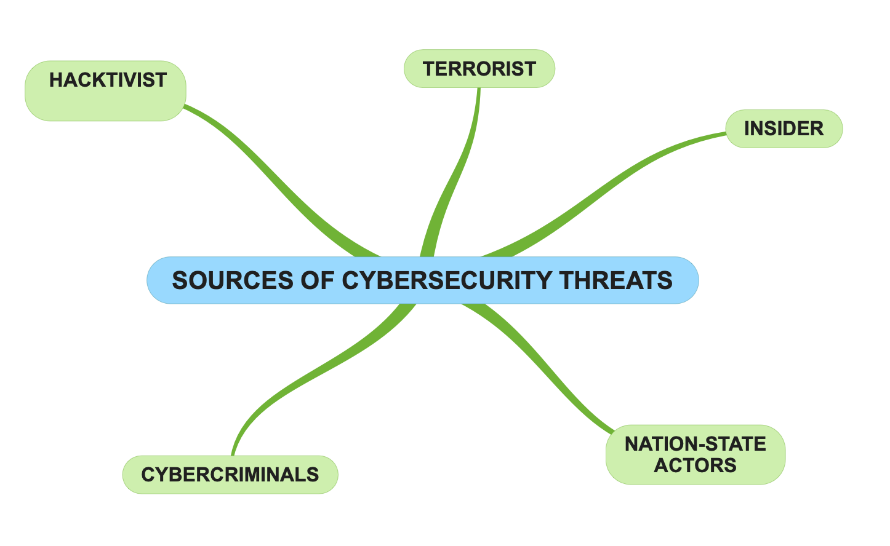

Figure 2.1 - Sources of cyber threats

(Source: own)

2.4.1. Cybercriminals - cybercriminals are focused on the exploitation of those weak points within a network for the sole intention of eliciting prized possessions, critical information and monetary gain whilst seeking to avoid any legal ramifications whilst doing so. Within the context of a business environment, cybercriminal activity can be clustered into three main groups:

- Mass scams and automated hacking - such activities are utilised by cybercriminals for the purpose of infecting a large portion of computers and accounts. Moreover, they would use introduce various trojans to pilfer and extort a wide range of data (passwords and credit card numbers).
- Criminal infrastructure providers - such cybercriminals utilise various automated hacking equipment to defile as many information networks as possible. Furthermore, the infected network would then either be used by a cybercriminal to assist them in further cyber-based crimes or potentially be sold to a third party to help them with their own personal campaigns.
- Big game hunters - these criminals focus on attacking singular high priority targets, primarily banking institutions. Furthermore, in practice, such attacks will usually be orchestrated using a myriad of specifically designed software or carrying out attacks through an associate within the supply chain. Additionally, such criminal activists would also devote a great deal of time and effort to carefully scrutinise the various technologies and current network configurations that a company would have in place currently whilst ensuring that they take the necessary precautions to cover their tracks.

2.4.2. Nation-state actors - are regarded as active threat actors within cybersecurity. Although the aims of a nation-state actor are considered more diverse than that of an ordinary cybercriminal, they focus their attention on collecting data and gathering intelligence that can be used to support state interests. To obtain confidential data, these cybercriminals will utilise a wide range of techniques, the most notable being strategic sabotage (Sailio et al, 2020).
2.4.3. Hacktivists - are advocates who breach network security legalisation to support a political cause. Furthermore, hacktivists generally seek to prey on those companies whose political beliefs and activities do not align with their own. However, there are specific scenarios, where hacktivists have attacked those companies not based on their political views but because of the businesses they choose to associate with (Fowler, 2016).
2.4.4. Terrorists - are individuals or organisations that seek to inflict terror through a series of calculated activities within cyberspace that are politically or religiously motivated.
2.4.5. Insider - a threat actor that carries out cyber-attacks from within the confines of an organisation. The reason for carrying out an attack can be construed from two different perspectives. Firstly, a cyber-attack may be caused by a disgruntled employee's malevolent intent that feels mistreated or undervalued by the company, so in retaliation, they may decide to divulge sensitive information. Secondly, a cyber-attack may transpire due to human failures whereby individuals might have left the company's firewall exposed (Aiello, 2021).

2.5. Overview of existing research and reported issues

Within the field of cybersecurity and supply chain management itself, several scholars have discussed the severity of cyber threats and in supply chains as highlighted by fig 2. Yet, much research within this field of cybersecurity appears to be extremely scarce due to the infant nature of the topic (Cheung et al, 2021). The main areas of research within the realms of cybersecurity and supply chain management have been primarily focused on the causes and the consequences of cyber-attacks on the maritime industry.

De la Peña Zarzuelo (2021) examined the critical need for promoting greater awareness of cyber risks within the maritime industry. This approach highlights that the increased level of digital devices and the interconnectivity between various global ports can make the maritime sector extremely vulnerable to cyber-attacks. Moreover, to facilitate and neutralise potential threats, the article proposes the need for maritime organisations and the industry to continually communicate with policymakers to ascertain that more significant cyber measures are implemented whilst offering the highest level of protection. Similarly, the article by (Duzha, Gouvas and Canepa, 2020) also emphasises that there is a considerable lack of concern surrounding the issues of cyber security within the domain of the maritime sector, so introduces a highly advanced digital system known as Mitigate, which can provide the maritime industry with real-time simulation capabilities that can be used to actively predict how a cyber-attack could affect an overall maritime operation. Also, Mileski et al (2018) have investigated the various fragilities that reverberate throughout the maritime sector due to the increased use of the internet of things (IoT) to manage the automation of ships and the different port activities. To establish a clear understanding of the overall causes and effects of the cyber risks that are imposed, (Mileski, Clott and Galvao, 2018) reviews and compares two automatic identification systems (AIS's) that are found at the port of Huston, which are employed to detect potential cyber threats. Through a critical assessment of the two systems, the authors clarify the best possible solutions and mitigation strategies that can be put into effect to strengthen the AIS's and build up a better resistance to withstand any future cyber-attacks. Furthermore, Mileski (2018) also imposes an array of methods and contingency plans that can be applied to alleviate cyber threats to AIS's.

However, other research conducted within cybersecurity and supply chain management can be considered as being much broader and not aimed at just one particular area. To exemplify, Boiko et al (2019) investigated the effects of cyber threats on companies' information systems that have multiple production processes. To address such issues, the authors offered an array of strategies and different methods that can be implemented to help to effectively identify and manage information within a production process that is more exposed to potential cyber-attacks than others. Similarly, Colicchia et al (2018) has examined the various methods for managing cyber risk and information risk in the supply chains of five international organisations and outlined a series of plans that can be used to provide guidance to help to eliminate cyber threats. Moreover, the varying measures Colicchia et al (2018) propose give clear direction and understanding of how to build greater cyber resilience before, during and after a cyber-attack. In addition, the findings of the article have also extended out the existing theory on cyber and information threats within a company's supply chain from a traditionalist point of view, that focused only on the internal members of the supply chain to a more multi-faceted approach to which the authors analysed both internal and external supply chain members.

A similar approach is also introduced by Windelberg (2015) that suggests a series of objectives (safety, quality, reliability, security) for managing and reducing cyber risk and further assesses each of those objectives individually. Furthermore, the authors then investigate the comparative advantages between the various goals that producers and suppliers make and the assumptions that can bring about greater supply chain vulnerability. Moreover, the authors stipulate that having a grasp of the trade-offs and the extent to which companies appraise one goal against another helps establish an objectives overall tolerance to potential cyber risks.

Furthermore, Radanliev et al (2019) discuss how cyber risk in supply chains can be better observed by devising better supply chain strategies by building upon pre-existing frameworks of current supply chain models. To ascertain a greater understanding, the authors conducted a case study of two IoT companies. Through thorough observance, the authors proposed various methods that can be applied to further reduce cyber risks by integrating a decision support system (DSS). The article's findings revealed that using a decision support system effectively can provide practitioners with explicit instruction on how to mitigate against cyber risk in supply chains. Similarly, Radanliev et al (2020) identify how creating a system that utilises both artificial intelligence, Machine Learning, and real-time capabilities can be highly effective at accurately predicting potential cyber threats within supply chains. Furthermore, the study reveals that through its practical application, the system provides a much more thorough understanding of how companies can be better prepared for and recover from the aftermath of a cyberattack much faster.

Another noticeable area within research that various academics have begun to pay particular attention to has been the impact of cyber-attacks on military supply chains. Turnbull et al (2018) provide a definitive overview of the varying types of and potential threats that a military supply chain will be faced with in the future as it evolves to become more digitalised. In addition, the authors give a coherent account of the varying steps and changes that need to be applied to the current military supply chain design to improve its overall level of resilience to a cyber-attack. In the same manner, Sobb et al (2020) discuss how the introduction of new technologies can adversely affect the security of military supply chains. So, the authors subsequently address that there is the need for militaries to have the tools and capabilities available to enable them to critically evaluate the potential cyber threat that the new technologies may impose upon the supply chain so that they are better equipped in being able to oppose all forms of cyber threats and build better cyber resiliency. Also, the article by Sobb et al (2020) proposes a generic model that can be implemented to assist military personnel in better comprehending the potential cyber security impact that the integration of new technologies may have on a supply chain.

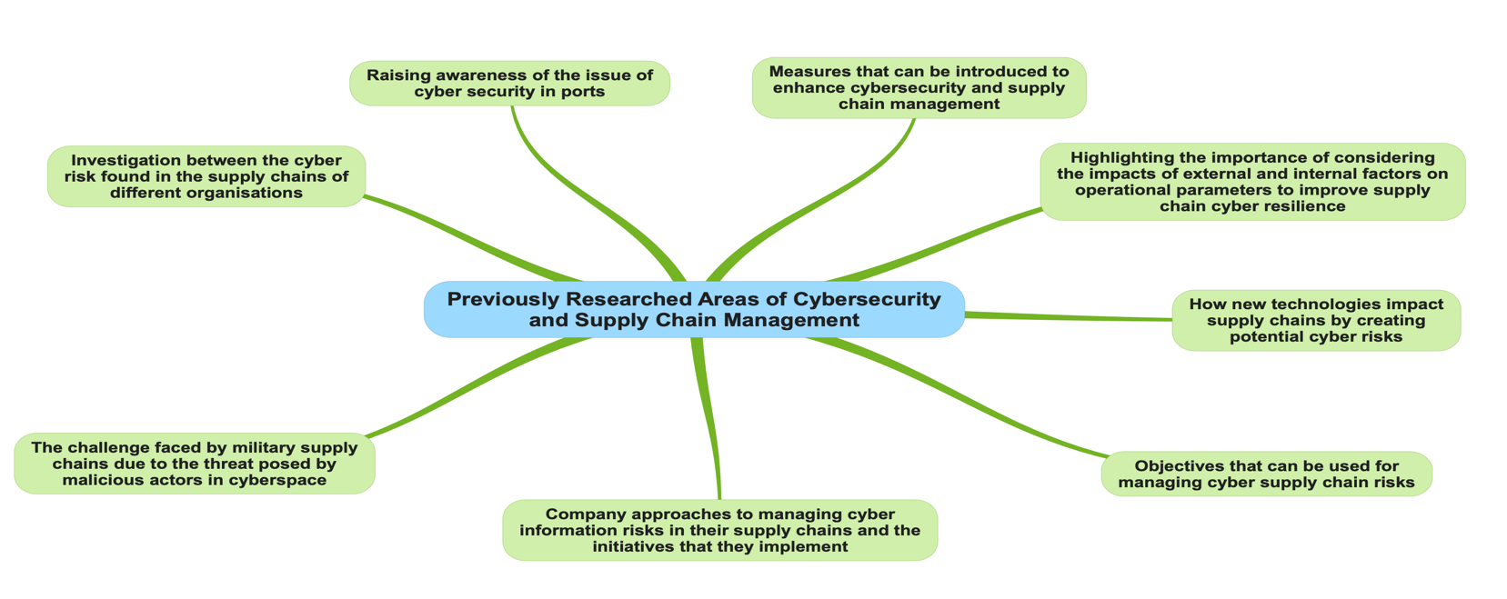
Figure 2.2 - Previously Researched Areas of Cybersecurity and Supply Chain Management (Source: own)

2.6. Identification of gaps in research

From the sparse literature papers that have addressed cybersecurity and the implications of cyber risks on supply chains, many scholars have tried their best to orchestrate a clear and definitive direction on where future research within the field of cybersecurity and supply chain management that needs further exploration. Therefore, this section of the literature review aims to accentuate where several gaps within the area currently lie. For example, Cheung et al (2021) stipulate that further research is required to develop the use of attacker and defender simulation models to understand better how cyber threats in real working scenarios may impact their supply chains. Furthermore, the authors further reiterate that to improve and protect data systems from cyber-attacks, future researchers should direct their attention towards the development and upgrading of digital tools as this would assist companies in being able to fix those breach points within their information systems that are usually susceptible to cyber-attacks. Moreover, Pal et al (2017) address that further research should be introduced to establish a standardised framework that includes precise instructions on how to reduce the possibility of the digital components (smartphones, tablets and computers) within a supply chain falling victim to malicious cyber acts.

Furthermore, although Carnovale and Yeniyurt (2021) have stipulated that whilst several scholars have made some significant headway in addressing the area of cybersecurity and supply chain management, the authors point out that there is still a considerable number of research gaps that remain unfulfilled. Firstly, they propose that academics need to examine how supply chains should not only adjust their current strategies so that they conform with governmental policies on cybersecurity but also implement more stringent measures to ensure that those cyber risks that appear at a national level do not manage to seep down into the confines of their own supply chains. Secondly, the dramatists suggest that another understudied area within cybersecurity and supply chain management is centred around supply chain design. The authors claim that introducing more cyber resources within a supply chain will increase the size of the supply chain and make it more susceptible to potential cyber threats. Therefore, it is suggested that further study should aim to address the effects of a cyber threat on each of the critical areas within a supply chain (inventory, production, transportation, and distribution) as well as establish better measures that can be introduced within these areas if a supply chain was to become further exposed. Thirdly, Carnovale and Yeniyurt (2021) specify that another unexplored area within cybersecurity and supply chain management has been how a supply chain within cyberspace can affect a company's overall strategy and its ability to sustain a level of competitive advantage over its rivals.

2.7. Conclusion of literature review

This chapter has critically reviewed the various pre-existing studies within cybersecurity and supply chain management. Many of those papers and sources have revealed the significant impact that cyber risks currently impose upon supply chains. Moreover, although many academics have presented a variety of methods and strategies to prevent and mitigate cyber risk, many approaches still, unfortunately, seem to fall by the wayside. Therefore, it is recommended that more stringent measures should be introduced at the company level to fully assess their current cyber risks, establish, and introduce better cyber risk management strategies whilst suggesting a variety of resolutions for building greater cyber resilience.

Chapter Three - Methodology

3.1 Introduction

The methodology chapter addresses and validates the approaches that will be applied for the research project and investigation study leading at achieving the aim and answering the research question. The appropriate selection of the methodology to be implemented will predicated upon the aims and objectives which were discussed previously in chapter one. Moreover, from the secondary data that was compiled and identified by the pre-existing review of literature including reports and academic journals it revealed that there was significant need to address the issue of cyber risks within supply chains. Furthermore, the methodology section aims to provide greater clarity on the philosophical approach that will be adopted whilst carrying out the research project. To establish a clear direction and the overall maturation of the research, Saunders research onion methods are applied (Saunders et al, 2019).
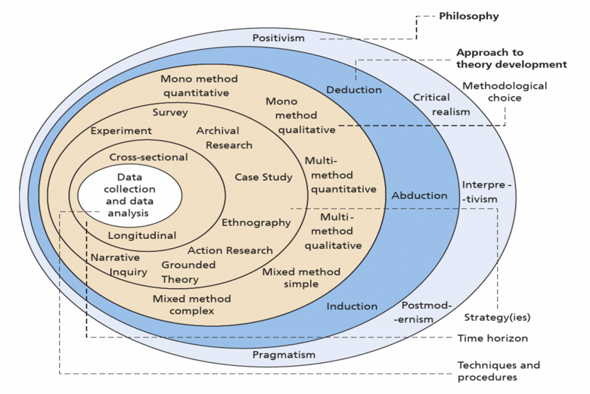

Figure 3. 1 - Saunder’s Research Onion

(Saunders et al , 2019)

Fig 3.1 shows a full representation of the Saunders’ research onion, an instrument that enables researchers and practitioners to establish a better grasp of the six phases of conducting research. The outer layer of the research onion distinguishes the type of philosophy that is or can be adopted for the selected research. The third layer provides direction and helps to determine the best research approach to be employed. The fourth provides clarity of the various research strategies that can be utilised to gather data. The fifth describes the range of time that is taken for the research to be carried out. The concluding layer describes the methods and approaches that are applied throughout the entire investigation of research.

3.2. Research Philosophy

The generalised term research philosophy is characterised by Saunders et al (2019) as a collection of theories and opinions about the progression of knowledge. Furthermore, Crotty (1988) stipulates that such assumptions will undoubtedly help to establish how the research questions are interpreted, the type of methods employed, and how the findings are examined.

3.3. Varying philosophical approaches

As specified by Saunders et al (2019), there are four primary research philosophies which can be implemented to carry out research - Positivism, Realism, Interpretivism and Pragmatism.

3.3.1. Positivism
The theory of positivism stipulates that only substantiated knowledge is considered as reliable (Crotty, 1988). This is further addressed by Dudovskiy (2022), who enunciates that positivism agrees with a belief that only authentic knowledge that has been readily obtained through observation is considered as being reputable. From a different perspective, Saunders et al (2019) refers to positivism as being “the philosophical stance of the natural scientist and entails working with observable social reality to produce law-like generalisations”.

3.3.2. Realism
Saunders et al stipulates that realism can be viewed in two different forms - direct realism and critical realism. Direct realism puts forward the ideology that “what we experience through our senses portrays the world accurately”. Whilst comparatively, critical realism recognises that there are several measures that need to be implemented to gain a full comprehension of the world. Firstly, there is the various emotions and activities that we encounter and secondly the time that is needed after the encounter to establish a full understanding of what has caused such an experience (Saunders et al, 2019).

3.3.3. Interpretivism
Interpretivism is closely associated with a philosophical view of idealism (Collins, 2018). An interpretivism research philosophy is a combination of two varying approaches - constructivism and phenomenology (Collins, 2018). Interpretivism comprises of short samples and a range of comprehensive investigations to which data is interpreted through qualitative analysis (Saunders et al, 2019).

3.3.4. Pragmatism

The philosophy of pragmatism is the adoption of using a variety of methodological approaches to establish whether that they can work on an empirical basis to achieve a desirable outcome. Furthermore, Saunders et al clarifies that pragmatists acknowledge that there are several ways of “…interpreting the world and undertaking research, that no single point of view can give the entire picture and that there may be multiple realities” (Saunders et al, 2019). Moreover, Christensen et al (2015) stipulates that a pragmatic philosophy aims to establish the “hypothetical question” of whether combining qualitative and quantitative methods is deemed effective from a practical point of view.

3.3.5. Selected philosophical approaches

In relation to this project, a combination of two philosophies will be adopted - pragmatism and interpretivism.

The first philosophy, pragmatism was selected because:

- It offers a wide variety of pathways to how the research can be interpreted
- Such an approach focuses on utilising qualitative data which in the case of this project will be compiled from an array of secondary sources and semi structured interviews.
- The qualitative data acquired from this research project can be used in the future to help contribute towards finding practical solutions to the research topic as stipulated by Saunders (2019) “ For a pragmatist, research starts with a problem, and aims to contribute practical solutions that inform future practice”.

The second philosophy, interpretivism was chosen because:

- Such an approach is focused on generating new and clearer understandings of the varying opinions from the experiences and practices of different groups of people regarding a particular subject.
- It will assist the researcher to establish their own personal interpretation of the problem that is being addressed
- It enables the researcher to obtain real facts from individuals that can help to address the research objectives

3.4 Research Approaches

Saunders et al, (2019) have stipulated that there are two different approaches that can be adopted for developing the appropriate theory for a research project - deductive and inductive.

3.4.1. Deductive approach

A deductive approach is implemented when a researcher is carrying out a study from various theories that have been addressed within scholarly literature on a particular subject area. Furthermore, when data has been collated, the researcher would formulate a plan to test it against a hypothesis to establish whether or not to accept or reject it (Saunders et al, 2019).

3.4.2. Inductive approach

With an inductive research approach, data is collected by the researcher that considered as being most appropriate to the selected topic of study. After all the data has been gathered, it will be monitored to establish whether any distinct patterns are beginning to emerge. From there, the researcher will develop a theory as to why such patterns may or may not be occurring (Christensen et al , 2015).

The type of research approach that is the best for addressing the research project will be that of an inductive approach. It has been selected as it will provide a more detailed understanding of the varying views and opinions and see if there any patterns or themes that emerge from the data collected on cyber risks within supply chains from a practical element (participants) and see whether it is directly correlated to those speculative conclusions that have been presented within pre-existing literature. Furthermore, an inductive approach its deemed beneficial for the research project as it provides the researcher with a level of flexibility which can help to establish new theories within the selected field of study (Saunders et al, 2019).

3.5 Research Strategy

A research strategy is viewed as logical process that is performed by a researcher to address the research objectives and answer the research question competently. Furthermore, a research strategy is a systematic approach that comprises philosophy and a combination of methods that can be implemented to gather and analyse data (Denzin and Lincoln, 2011).The seven strategies that can be employed by a researcher are : case studies, experiments, surveys, archival and documentary research, action research, grounded theory and narrative inquiry.

3.5.1. Action research

For the research project, the most feasible research strategy to be applied is action research. It has been selected because such an approach focuses on addressing those themes found within the realms of academic literature that focus on a specific organisational problem, in the case of this research study - cyber risk in supply chains. Moreover, in order to address such a problem, action research utilises human participation and knowledge to find distinctive patterns and themes to see if they are directly correlated to those that have been found previously within literature and develop them to resolve the research problem in a practical way (Saunders et al, 2019) .Furthermore, action research was selected for this study to not only help the researcher to collect data through the active participation of others, but to obtain an increased understanding of the research topic and its results which can then be used by the participants to address cyber risk within their own organisations.

3.5.2. Applied research strategy

Following on from establishing the most suitable philosophical approach that is necessary to develop the research. The next phase was focused on identifying the most appropriate way of carrying out the research. Having previously determined that the research will be a combination of a pragmatic and interpretivist approach. It was therefore established that the most suitable method to collect data would be semi structured interviews and secondary sources.

3.6. Data Collection

Data collection is seen as the practice of gathering data for the purpose of finding an answer to a research question or used to test a hypothesis. The approach of data collection is composed of two parts: primary and secondary data.

- Primary data - is data that is gathered for a particular research problem that utilises varying techniques without drawing on any pre-existing resources (Hox and Boeije, 2005).
- Secondary data - is data that has been acquired through the analysis of pre-existing data that was previously gathered for a different area of study (Saunders et al, 2019).

For the research project, a combination of both primary data that has been gathered through semi structured interviews and secondary data that has been obtained through multiple secondary sources.

3.6.1. Pilot interviews

Prior to executing any semi structured interviews with any potential participants of the study, two informal pilot interviews were carried out. The first interview was conducted with a family member working within the cyber sector and the second interview was undertaken by a friend working within the logistics sector. Such an approach was implemented to establish and test whether the research questions that were going to be asked to potential participants of the study were deemed as being appropriate in terms of addressing both the research question and the associated research objectives. In addition to the research questions, another four questions were also presented to the interviewees to establish the effectiveness and appropriateness of the main research questions.

Questions for cybersecurity participants

- How well protected do you think the logistics and supply chain sector is as whole currently?
- Where do you think the threats are different for the supply chains of logistic organisations?
- What should or could the supply chains of logistics organisations’ do more of or differently to reduce cyber threats and risks?
- Do you feel specific employee training is required to improve cyber awareness within logistics companies and their supply chains?

Questions for logistic participants

- What do you consider the greatest cyber threat your organisation is at risk from?
- What are your main concerns with cyber threats within your organisation?
- What can organisations do to manage cyber threats better?
- What current strategies do you currently have in place to manage cyber threats?

The four questions that were used alongside the other eight questions are highlighted as follows:

- Do you feel the interview questions that you have been asked can be contrived as being misleading?
- Do you feel that the interview questions you have been asked warrants a positive and thought-out response?
- Do the interview questions appear to come across as complicated?
- How do you feel the interview questions that you have been presented with could be improved?

Furthermore, by conducting the pre-rehearsed interviews it enabled the researcher to capture both verbal and non-verbal cues, which allowed the researcher to ascertain how that both participants reacted to the various questions that were being asked. It was noticed that, on questioning the second interviewee they appeared perplexed when they were asked certain interview questions to which they only gave a short response. Subsequently, this resulted in the researcher making subtle changes to the wording of the questions to not only eliminate the interviewees confusion but also to steer them in such a way so that the researcher was able to obtain more appropriate and thought-out answers. After the changes had been applied it was revealed that the second interviewee had a better overall understanding of the questions that they were being asked and the answers they gave were much more justified. So, in conclusion from both pilot interviews, it was established that the research questions were of a suitable nature to produce a credible response, so therefore the questions were deemed as being suitable to be presented to any future participants of the study.

3.7 Conducting semi-structured interviews

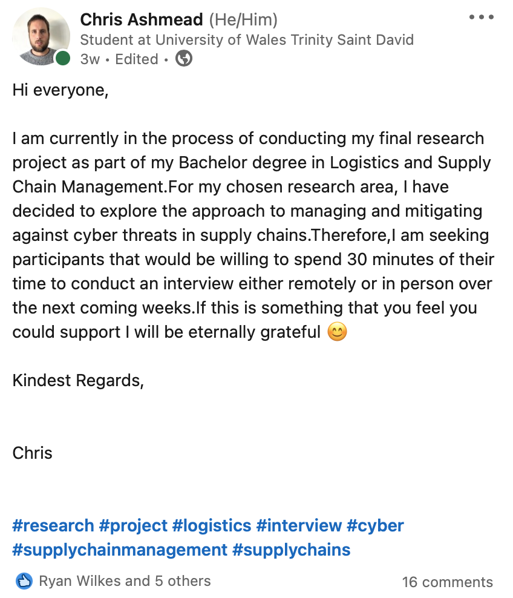
Once all the amendments had been made to the research questions the researcher sought to carry out more formal semi structured interviews with relevant personnel within both the cyber and logistics sector. For this to be achieved various methods were utilised, including networking at corporate events and through posts placed on professional social media platforms as highlighted in fig 3.2.
Figure 3. 2 - LinkedIn post
(Linkedin, 2022)

After exploiting both methods as a strategy to obtain data, the researcher had received twenty positive responses from individuals working in both sectors that would be willing to carry out interviews. Based on this, the researcher then decided to evaluate and assess those twenty individuals based on their current expertise to see whether they would be deemed as appropriate to produce a detailed and well executed answer to the research questions. Moreover, through a process of elimination, of those twenty potential interviewees only nine were considered.

Of those nine participants selected for interviews, one was conducted face to face and the remaining eight were performed via the internet by using two video conferencing programmes Zoom and Microsoft Teams. The first four participants were selected from the cyber security sector and the second set of four participants were individuals that reside within the logistics sector. Additionally, there were eight questions produced, with four questions being directed towards the four cyber participants and the other four questions for the participants from the logistic industry. After carrying out all nine interviews and reviewing them all in greater depth, the researcher decided to remove one of the participants from the study as they believed their responses were lacking in substance as they were too short.

3.7.1. Advantages and disadvantages of interviews for data collection

The use of interviews for qualitative data collection can provide a broad range of advantages and disadvantages for both the researcher and the interviewee, a number of these are highlighted as follows:

Advantages of interviews

- Capturing of verbal and non-verbal cues - Interviews can enable a researcher to capture nonverbal cues through body language which can sometimes suggest that an interviewee may feel some level of uneasiness to the various questions that they are being asked. However, in contrast, the body language of the responder may suggest that they feel a sense of avidity to the topic that is being addressed within the interview.

- The ability to maintain focus - The interviewer has the control over the interview so therefore can keep a respondent focused so that they are able to keep on track to completing the entire interview. Additionally, as there is a significant difference in terms of power this also suggests that the interviewer is compelled to ensure that the respondent and data that has been generated is handled with care.

Disadvantages of interviews

- Accessibility - To carry out an interview it may require either the interviewer or respondent to travel to a location which can create additional costs.

- Time constraints - Carrying out interviews can often require more time for them to be carried out. Additionally, it can present issues in establishing when a suitable time would be for both parties to conduct an interview

3.8. Time Horizon

Due to the significant lack of time available to conduct this research, a cross sectional study will be considered as the most suitable option as it considerably cheaper and less time consuming than that of a longitudinal study (Saunders et al, 2019).

3.9. Data Sampling

As a result of time constraints, resources, and availability to carry out the study it was therefore not possible to carry out more than nine interviews. On this basis, nine interviewees were selected as the researcher believed that they would be deemed as being the most appropriate and in the best position to provide the best answer to the research questions.

3.10. Data Analysis

After gathering all data, this the section will address how that it is to be analysed, there are two methods: qualitative analysis and quantitative analysis. The differences between both approaches to analysing data are denoted by fig 3.3.
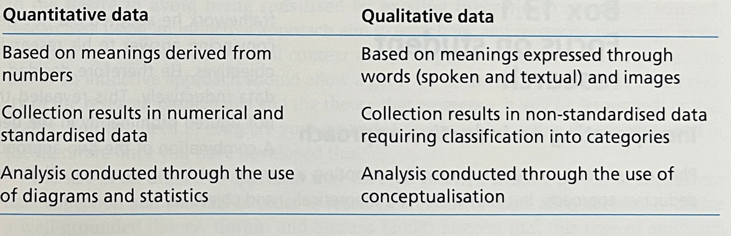
Figure 3. 3 - Distinctions between Quantitative and Qualitative data

(Saunders et al, 2016)

3.11. Application of thematic analysis

The method the researcher considered as the most suitable for analysing and interpreting the primary data obtained through the semi-structured interviews would be thematic analysis. The reason for its selection was based on several contributing factors. Firstly, thematic analysis would allow the researcher to effectively identify, analyse and report any key distinguishing themes that are present within the primary data. Consequently, this would enable the researcher to have a much better overall understanding of the research problem and establish where the main issues that contribute towards the overall research problem lie. Secondly, thematic analysis is extremely flexible in its nature meaning that it a relatively easy to use in relation to other analytical methods, for this reason due to that the researcher’s lack of knowledge and experience of conducting data analysis the implementation of thematic analysis was considered as being the best suited for the study. Thirdly, from the various themes identified, the researcher would then be able to analyse and cross reference it against the secondary data collected during the literature review to see if further distinct patterns emerge.

3.12. Research ethics

Throughout the course of carrying out a research project, it is likely for a researcher to be meet with a series of dilemmas when they are attempting to gather data, such issues may be because of the limited access to a particular organisation or the relevant personnel. Therefore, to establish future interactions, it is imperative for a researcher to ensure that they are abiding by the ethics of research. These such ethical practices are predicated on ensuring that the researcher is carrying out research in a manner that is deemed as being appropriate and ethical. To be sure that a researcher remains ethical they are able follow a code of ethics which is a set of standards which can be used to ensure that data is collected in a responsible way. On fulfilling these standards it can bring forth a level of trust between a researcher, the organisation and an individual (Saunders et al , 2019).The completed ethical form and approval is presented in the Appendix A.

3.13. Credibility of the research

3.13.1. Reliability

Reliability is related to the degree to which the same answers can be achieved when a researcher utilises similar instruments repeatedly to produce consistent results (Dudovskiy, 2022). There are three different constructs of reliability that can be implemented to produce coherent results these are: parallel-form reliability, test-retest reliability, internal consistency, reliability and inter-rater reliability (Ahmed et al., 2022).

3.13.2. Validity

Validity is establishing the extent to which a researcher has followed a particular research method to produce credible research findings. Saunders et al (2019) highlights that there are seven different forms of validity: construct validity, ecological validity, criterion related validity, face validity, measurement validity, predictive validity.

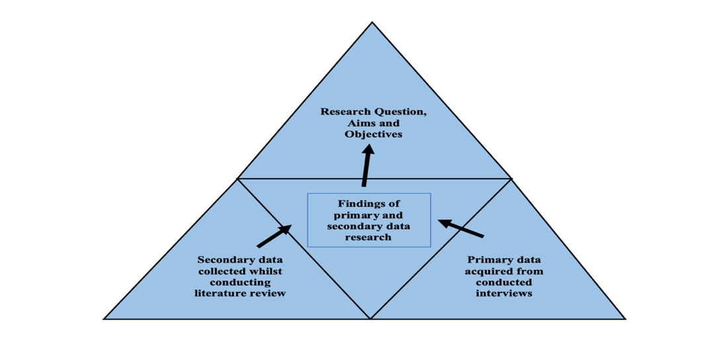
3.14. Triangulation

Figure 3. 4 - Triangulated data methods
To determine the integrity of the consolidated primary and secondary data a researcher can apply triangulation. Throughout the research, secondary data will be extracted from pre-existing literature on the topic of cybersecurity and supply chain management. Thereafter, the secondary data can then be comparatively analysed against the primary qualitative data that has been collected via semi structured interviews. Once all the research findings of the primary and secondary data have been culminated, direct associations between the data will be highlighted thus enabling the researcher to see if the research question and the objectives have been successfully answered.

Chapter Four - Data Analysis and Findings

4.1 Introduction to data analysis

This chapter aims to identify how the primary data from the transcripts of the semi-structured interviews as highlighted in Appendix B and Appendix C were thematically analysed. Furthermore, the chapter then describes how interviews were organised into a single round due to time restrictions. In addition, this chapter provides statistical information regarding the interviewees, their job roles, and the cyber and logistics industry sector in which the participants currently reside. It also explains how the researcher formalised a series of codes based upon the analysis of the interview data. Subsequently, it was then placed in categories to see if there were any emerging themes present that address and pose definite answers to the overall research question and see whether there was in fact, a direct correlation between the findings that have previously been identified and discussed within pre-existing literature.

For greater clarity of this chapter, Fig 4.1 shows a schematic representation of the varying stages of the thematic analysis process that were implemented by the researcher when analysing the primary data from the semi structured interviews.
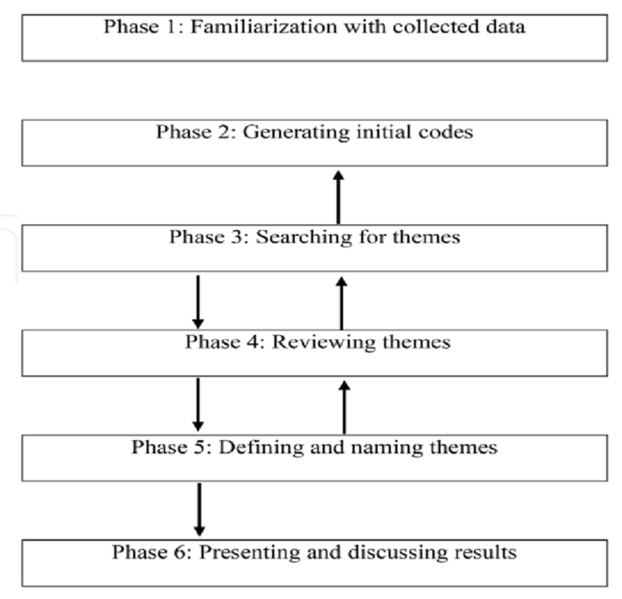

Figure 4. 1 - Varying stages of thematic analysis

(Labra et al., 2019)

4.2. Application of thematic analysis

For the study, the researcher utilised the six-stage guide as highlighted by Braun and Clarke (2022) and Braun and Clarke, (2006) to conduct the thematic analysis of the compiled data.

4.2.1. Stage one: Familiarising yourself with your data

“Here, you become deeply and intimately familiar with the content of your dataset, through a process of immersion. Practically, this involves reading and re-reading your data and making brief notes about any analytic ideas or insights you may have…” (Braun and Clarke, 2006). To ensure the researcher adequately carried out this stage of analysis thoroughly and immersed themselves in the data, the researcher transcribed all corresponding interviews in great depth by re-reading the various transcripts multiple times to try and find any patterns, anything that was considered as being significant was also noted down. Furthermore, the researcher then decided to employ Otter AI, a transcription software to be used as a tool for further analysis. The transcripts were then uploaded to the Otter AI transcription software, and an analysis was conducted. From this, the researcher effectively cleaned the interview text to remove any irregularities and discrepancies, making it more eligible, which made the whole process easier to highlight any meaningful language, patterns, and themes from the different interviewee transcripts.

4.2.2. Stage two: Coding

“Here you work systematically through your dataset in a fine-grained way. You identify segments of data that appear potentially interesting, relevant, or meaningful for your research question, and apply pithy, analytically- meaningful descriptions to them” (Braun and Clarke, 2022). Within this analysis stage, the researcher focused on condensing the data into more practicable pieces of text such as single words and sentences to generate a series of initial codes. Table 4.1 and Table 4.2 highlight the initial themes that were produced when carried out the thematic analysis for the two different sets of participants.

Interview question number | Interview Questions | Initial codes produced
1 | How well protected do you think the logistics and supply chain sector is as whole currently? | - Unpreparedness  - Awareness  - Vulnerability  - Unprotected  - Incoherent  - Unregulated  - Non-priority
2 | Where do you think the threats are different for the supply chains of logistic organisations? | - Time sensitive  - Strategic  - Lack of continuity  - Fake carriers
3 | What should, or could the supply chains of logistics organisations’ do more of or differently to reduce cyber threats and risks? | - Vulnerability  - Visibility  - Trust  - Integrity  - Prioritise  - Supplier checks  - Control  - Assessment
4 | Do you feel specific employee training is required to improve cyber awareness within logistics companies and their supply chains? | - Awareness  - Collaboration  - Consistency

Table 4. 1 - Initial codes produced for cyber participants

(Source: Own)
Interview question number | Interview Questions | Initial codes produced
1 | What do you consider the greatest cyber threat your organisation is at risk from? | - Human error  - Ransomware  - Malware  - Risk to key infrastructure  - Lack of control  - Targeted
2 | What are your main concerns with cyber threats within your organisation? | - Preventative measures  - Security element  - Education  - Training  - Communication  - Remote working  - Priority  - Human error
3 | What can organisations do to manage cyber threats better? | - Outsource  - Invest in technology  - Systematic approach  - Educate  - Training
4 | What current strategies do you currently have in place to manage cyber threats? | - Introduction of Artificial intelligence  - Using multiple vendors  - Reactive  - Contingency planning

Table 4. 2 - Initial codes produced for logistics participants

(Source: Own)

4.2.3. Stage three: Generating initial themes

“Here, you aim to start identifying shared patterned meaning across the dataset. You compile clusters of codes that seem to share a core idea or concept, and which might provide a meaningful “answer” to your research question” (Braun and Clarke, 2022). At this stage of the analysis, the researcher thoroughly scrutinised the data and organised the codes to establish whether there were any emerging themes. Furthermore, the researcher utilised this stage of analysis to present an initial outline of the creation of varying themes and how different codes would be applied to the data.

4.2.4. Stage four: Developing and reviewing themes

“Here, your task is to assess the initial fit of your provisional candidate themes to the data, and the viability of your overall analysis, by going back to the full dataset. Development and review involves checking that themes make sense in relation to both the coded extracts, and then the full dataset” (Braun and Clarke, 2022). Within this stage of the analysis process, the researcher concentrated on fine-tuning the initial themes that had been defined previously in stage three. This was conducted by applying a two-level analysis of the various codes. In the first level, the researcher went back through and studied the codes for every theme to establish whether a lucid pattern had been produced (Braun and Clarke, 2006). If the researcher had discovered that a logical pattern had emerged from the data, the researcher then carried out the second level of analysis. The second level of analysis involved re-reading the whole data set to ascertain whether the themes that the researcher had produced were correctly aligned with the data. In addition, this also allowed the researcher to verify whether any data that was missed out initially was required to be coded (Braun and Clarke, 2006).

4.2.5. Stage five: Refining, defining, and naming themes
“Here you fine-tune your analysis - ensuring that each theme is clearly demarcated and is built around strong core concept or essence...Key activities in this phase involve writing a brief synopsis of each theme. You also decide on a concise, punchy and informative name for each theme” (Braun and Clarke, 2022).The overall purpose of this analysis stage was to “…clearly define what your themes are and what they are not” (Braun and Clarke, 2006). To achieve this objective, the researcher concentrated on defining the themes individually and establishing which portion of the data and the research question the themes best matched up with (Braun and Clarke, 2006).

4.2.6. Stage six: Writing up

“In writing up, you finesse and finish the writing process. Ultimately, you’re aiming to weave together your analytic narrative and compelling, vivid data extracts, to tell your reader a coherent and persuasive story about the dataset that addresses your research question”(Braun and Clarke, 2022).Within the final stage of the analysis process, the researcher was focused on examining the data and composing a written account about the data which “ …goes beyond description of the data, and make an argument in relation to your research questions” (Braun and Clarke, 2006).

Interview question number | Interview questions | Final codes produced
1 | How well protected do you think the logistics and supply chain sector is as whole currently? | - Unpreparedness  - Awareness  - Vulnerability
2 | Where do you think the threats are different for the supply chains of logistic organisations? | - Time sensitive  - Strategic
3 | What should, or could the supply chains of logistics organisations’ do more of or differently to reduce cyber threats and risks? | - Vulnerability  - Visibility  - Trust
4 | Do you feel specific employee training is required to improve cyber awareness within logistics companies and their supply chains? | - Awareness  - Collaboration  - Consistency
After further investigating and scrutinising the codes in much greater depth for a second time, the researcher decided to make the codes more redefined. This was achieved through a process of elimination, whereby the researcher highlighted only those codes that appeared within the text more than once or that were distinctively like another code. The final codes produced by the researcher are depicted in Table 4.3 and Table 4.4.
Table 4. 3 - Finalised codes for cyber participants
(Source: Own)

Interview question | Interview question | Final codes produced
1 | What do you consider the greatest cyber threat your organisation is at risk from? | - Human error  - Ransomware
2 | What are your main concerns with cyber threats within your organisation? | - Education  - Training
3 | What can organisations do to manage cyber threats better? | - Educate  - Training
4 | What current strategies do you currently have in place to manage cyber threats? | - Outsource  - Cloud infrastructure

Table 4. 4 - Finalised codes for logistic participants
(Source: Own)

Having established a series of finalised codes based on the responses for both sets of participants the researcher then decided to group them into a series of themes that they believed not only addressed the various interview questions but felt they were the best suited in producing a coherent and definitive response to the various research objectives and main research question of the study. The distinctive themes generated by the researcher are depicted in fig 4.2 (cyber participants) and fig 4.3 (logistic participants).
Awareness

Unpreparedness
Uncollaborative
Vulnerability
Visibility

Training

Educate
Human error
Reactive
Priority

Figure 4. 3 - Theme for cyber participants

Figure 4. 4- Theme for cyber participants

Figure 4. 5- Theme for cyber participants

Figure 4. 6- Theme for cyber participants

Figure 4. 2 - Theme for logistic participants

(Source: Own) (Source: Own)

4.3 Findings from primary data

4.3.1. Cyber participants

1) Unpreparedness

Unpreparedness was seen as a distinguishing and consistent term used throughout the participants response when answering the first and second interview questions. Participant B stipulated that “the logistics and the supply chain sector still appear to be unprepared by still utilising immature tooling which is often outdated and completely impractical for addressing cyber threats”. The respondent then went on to state that “on average between 50-60% of logistics organisations and their supply chains are acutely aware of the disruption that a cyber threat can impose upon their business”. They also pointed out that “this same percentage also represents the amount of those organisations that are completely unprepared for a cyber-attack”. Furthermore, participant A expressed their concerns on this issue highlighting that “From my experience of assessing some of the largest international logistics firms I am often shocked to see how under sourced their cybersecurity capabilities are in terms of their manpower. In one particular situation, I was completely astounded when I visited one such company and I was informed that only five employees within the organisation were responsible for cyberthreat mitigation even though they were dealing with thousands of suppliers and customers!”.

2) Uncollaborative

Uncollaborative was also highlighted by the researcher as a regular term used in response to question four of the interview questions. Participant B stresses that “most logistics companies don’t have the coherent processes in place, so they don’t have the necessary means or capability to effectively collaborate with the other parties of their supply chains in order to better protect themselves from a cyber threat”. Furthermore, a similar view was also reflected by Participant C who emphasised that “...many logistics organisations continue to use outdated versions of software from 2013.Consequently, this has therefore made those organisations increasingly more susceptible to the cyber threats that resonate within the modern era. As a knock-on effect, this in turn has made it harder for those logistic companies to effectively collaborate with other members of their supply chains, especially those companies that are seen to be using the latest and most up to date cyber threat mitigation software such as Bitdefender”.

3) Vulnerability

Vulnerability was also noted by the researcher as a re-occurring term that was used by several participants when they were answering question one and question three of the interview questions. Participant D claimed that “malicious actors are moving away from attacking the larger logistics companies and focusing their attention on those small firms within their supply chains. They do this because they are often seen as less mature in their security posture which therefore makes them considerably more vulnerable to a cyber-attack”. From an alternative point of view, put forth by participant A they stipulated that “To mitigate against the impact of cyber threats on supply chains a more concentrated effort needs to be applied by the organisations to manage their vulnerabilities, by making sure that they get the basics right such as having a robust patching process in place if and when a cyber threat was likely to arise. But it seems in most cases that need to implement such measures is still very much an area within the logistics sector which is still largely overlooked”.

4) Visibility

Visibility was also seen as a re-emerging term that was regularly used by multiple participants when replying to question three of the interview questions. Respondent B stated that “As all logistics companies often differ considerably in terms of their size this can often impact heavily upon the visibility across the entire supply chain. Coincidentally, this can therefore make the act of establishing which part of the supply chain has been affected by a cyber-attack extremely difficult to notice if it was to occur”. The interviewee went on further to stipulate that “… the best approach that could be implemented by a logistic organisation to reduce and minimise cyber threats is to conduct regular assessments of their suppliers. From these independent assessments it can provide an organisation with a much greater incite to which areas of the supply chain are most at risk from a cyber threat thus providing them with a much greater amount of overall visibility”.

4.3.2. Logistics Participants

1) Educate

Educate was noted as a consistent term used by the logistics participants when answering question two and three of the interview questions. Participant C stressed that “… it does not matter what technology you have in place to mitigate cyber threats, the biggest risk to an organisation is often the employees themselves. So, I think companies need to educate their staff by training them better. They need to focus their attention on the latest security awareness training.” In addition, the respondent then went on to state that “It is extremely important to keep educating your staff so that they have a better comprehension of the various cyber threats that are out there”. Although seen in a similar vein, participant A offered an alternative point of view stipulating that “since the covid pandemic there has been a monumental shift towards a remote working environment to reduce the spread of infection. Consequently, this has brought with it an increased number of cyber-attacks mainly through phishing emails as individuals are now working off their own home servers which in most instances are usually unsecure in comparison to that of a company server. Therefore, to reduce cyber risk to both an individual and the organisation it is imperative that more regulated employee training is carried out to raise awareness”.

2) Human Error

Human error was highlighted as another emerging term that was often utilised by the logistics participants when they were answering question one of the interview questions. Participant B pointed out that “There is a tremendous amount of expectation placed upon individuals by senior management within organisations to prevent, rectify and reduce cyber threats. However, to seem compliant a large percentage of these individuals often say that they have the necessary skillsets in place to deal with such threats when in fact that does not appear to be the case. As a result, this often gives rise to a substantial amount of human error through ineffectively misconfiguring a security network or incorrectly updating security software”. From an alternative angle, participant D claimed that “many logistics companies are more heavily focused on making sure that their lead times and that the expectations of their customers are met rather than considering the safety and security element that is associated with a product. Therefore, in many circumstances and through my own personal experience, when a cyber threat emerges in this scenario this straight away creates a sense of hysteria and mass panic throughout the whole organisation as well as through the rest of the chain which often leads to a myriad of human errors.”

3) Reactive

Reactive also appeared as a regular term used by the participants when responding to question four of the interview questions. Participant D proclaimed that “the recent emergence of the conflict between Russia and the Ukraine has brought about an even greater need for the logistics industry to be more reactive to deal with the devastating consequences that a potential cyber-attack could have on their supply chains. Therefore, for me and my team our approach to security within the organisation has significantly shifted over these last few weeks. The main focus for us now is to be more vigilant by increasing the number of backups that we carry out, and then making secondary backups of those backups and then regularly testing them to check their penetrability.” Further, participant B then noted that “Organisations need to continuously keep addressing those the critical questions of are we secure and what strategies can be applied to make us more reactive to a potential cyber threat?”.

4) Priority

Priority was also seen as term frequently used by the respondents when they were answering question two of the interview questions. Participant B stated that “there still appears to be a distinctive divide in opinions from individuals within the logistics sector on whether cybersecurity is deemed as being a vitally important necessity. From my own personal experience, there have been numerous occasions when I have stressed the need for more stringent security measures to be implemented but the response from CEO’s and those in senior management within a logistics company is often the same, why would we consider investing a considerable amount of time, money and resources on cybersecurity when we have not found ourselves the victim of a cyber-attack, for that reason we do not see cybersecurity as a priority, especially when the money can be spent in more important areas of the business” .

4.4 Conclusion and summary of the main findings

The purpose of this chapter was to highlight how the researcher applied a thematic approach to analyse the semi-structured interviews effectively and thoroughly to bring about key findings from the interviewees. Furthermore, the chapter then went on to present those findings in the forms of codes which were then subsequently grouped into two main themes, one for cyber participants and the other for logistic participants. The reasoning for this was because the researcher believed that this was the most plausible way to further emphasise the direct interconnection between the answers that both sets of participants have provided with regards the various interviews questions but also considered it as being the most suited to addressing the main research question as well as the main objectives of the study.

Chapter Five - Results and Discussion

5.1 Introduction

This chapter aims to provide an interpretation of the main findings from the analysis of primary data that were identified and presented within the previous chapter. Additionally, it will also highlight whether there is in fact a direct correlation and an overall significance between the findings of the interviews and the opinions from the various scholars that were discussed previously within the literature review as well as resulting from triangulation with secondary data. Also, the chapter will then try to establish whether the respondents’ answers to both sets of the interview questions pose a credible and justifiable answer to not only the main research question but to the various research objectives of the study. Furthermore, the chapter will then aim to present an accurate account of the various limitations and subsequent issues that were encountered throughout the entire process of gathering and analysing the data whilst giving a thorough explanation of how that it influenced the overall result of the study. The chapter will then finally conclude by giving clear and definitive recommendations of where future research within the field of cybersecurity and supply chain management is required.

5.2 Summary of the main findings

The main findings of the semi-structured interviews have shown that there is indeed a clear association between the answers that both the cyber and logistics participants have given when responding to the various interview questions. Furthermore, it has also been established that there is also a positive correlation between the two themes that were formalised. From the main findings and the themes of this study it clearly suggests that for logistics organisations to better manage the cataclysmic effects that a cyber-threat can impose upon their supply chains there are an assortment of factors that need to be realised from both a cyber and logistics perspective. From a cybersecurity point of view, the study has identified there is an inherent need for organisations to be more aware of how that there day to day undertakings can make them more susceptible to a cyber-attack. The findings have also revealed that for an organisation to improve its level of awareness towards a cyber threat there are four vitally important factors that need to be considered - unpreparedness, uncollaborative, vulnerability and visibility.

From a logistics viewpoint, the study has indicated that there needs to be a much greater emphasis on introducing more specialist cyber based training. By being effectively implemented the training will help organisations to better educate their employees by keeping them more regularly updated on the new approaches that malicious actors are taking to infiltrate the company whilst also establishing better ways for them to be counteracted. Secondly, more training will allow an organisation to minimise the amount of human error, thus reducing the possibility of both employees and the organisation being susceptible to cyber threats. Thirdly, by having more regulated training it will enable an organisation to improve an employee’s overall reactions therefore meaning it would help to reduce the disruption during and after a cyber-attack.

Finally, through the effective application of more specialist cyber based training within an organisation it can be seen as a way of effectively changing the opinions of those senior members of a logistic company that the implementation of cyber initiatives is in fact a critically important asset and not a waste of company expenditure.

5.3 Discussion of the results

After having discovered that there is a clear association between the findings from both sets of participants from the semi structured interviews, it is also apparent they offered valuable evidence and support to the answering of the main research question and objectives of the study. The researcher then went about trying to establish whether the findings can be used as means to support and contextualise those findings and theories that have been addressed previously by an array of scholars within the literature review.

Revisiting the research gaps that were identified and discussed within the literature review, the researcher was able to ascertain that there were a series of emerging patterns between several of the findings of the study that can be considered as being the most plausible for addressing those understudied areas which are focused on the managing and mitigation of cyber threats. The study has revealed, based upon the two main themes that the most effective strategy and recommendation to be introduced to reduce cyberthreat within a logistics organisation is the implementation of better cyber based training. Therefore, it can be established that the findings present a legitimate response to the research gap previously outlined by Pal et al (2017) who proposed that a focus for organisations should be to establish a standardised framework and set of instructions to reduce cyber threats. Thus, it can be said that through the efficient implementation of cyber based training it would enable an organisation to either reconfigure or produce a new set of standards and procedures that are deemed as being better suited for the purpose of cyberthreat mitigation. Further, from a different perspective, the introduction of more stringent and specialist cyber training can be considered as a probable solution to address the research gap outlined by Carnovale and Yeniyurt (2021) on the effects of cyber threats on the distribution, transportation, and production elements of an organisation. Due to the significant difference by the way in which these organisational sectors operate, it therefore means that a cyber-attack can expose each of those areas of the company differently. Therefore, organisations could implement cyber training that is more specifically tailored to that particular sector of an organisation.

Therefore, on the basis of the interconnection between the results of the primary and secondary data it has been established that the main question and the research objectives have been achieved.
5.4 Triangulation of results

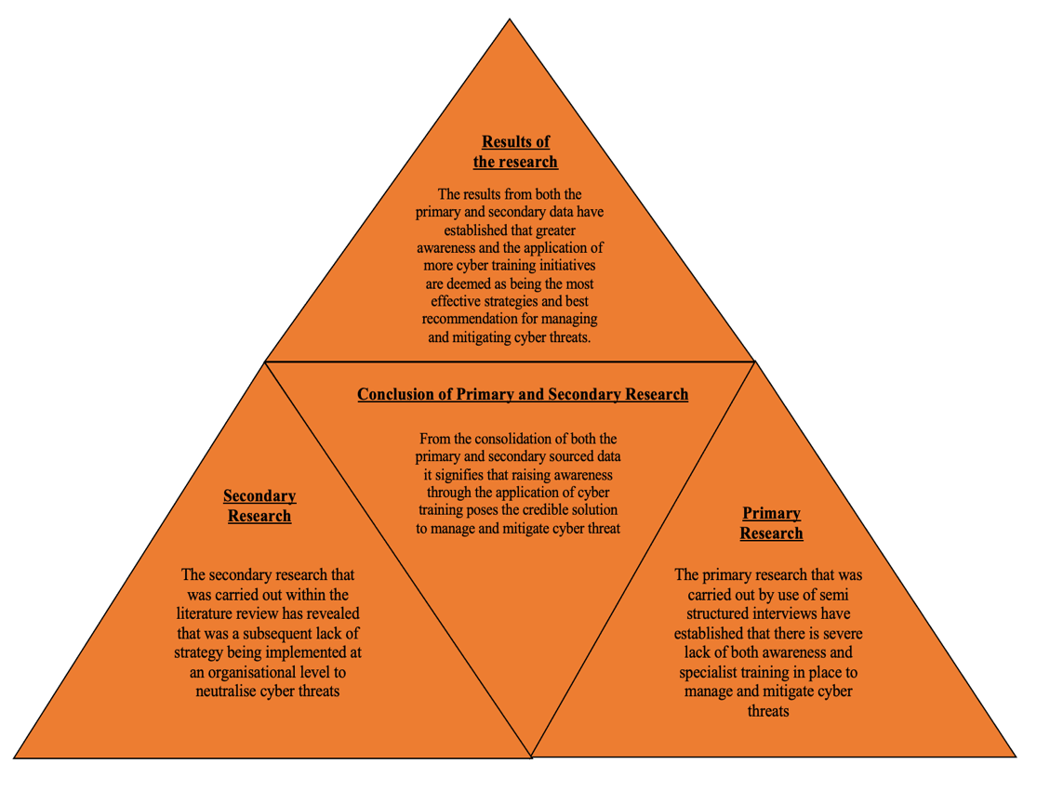
The results of this study are based on triangulation, and these are leading to actions for companies and further recommendations. Fig 5.1 provides a pictorial representation of the results found within the study of primary and secondary and proposes a series of appropriate actions with regards to cyber training initiatives that can and should be implemented to manage and mitigate cyber threats better.
Figure 5. 1 - Triangulation of results
(Source: Own)

5.5 Appropriate actions for cyber training within logistic organisations

The following points below outline several actions that companies should look into when trying to improve their current approach to cyber training:

Carry out cyber training as regularly as possible - regardless of the size of the organisation and the budget that they have available, cybersecurity awareness training should be routinely implemented. There is a plethora of opportunities for organisations to receive the necessary cyber awareness training either through free online courses or they could appoint a cybersecurity professional who would carry out more formalised training.
Make cyber training mandatory for all employees - management should make sure that cyber training is made a compulsory undertaking for all employees throughout their organisation and ensure that it is treated in the same vein and gravity as all the other risks that resonate throughout the organisation. Irrespective of a person’s status within the company, everyone needs to have a basic overall awareness of all the frequent types of cyber threat that they can be subjected too.

5.6 Acknowledgement of limitations

Throughout the course of collecting the primary data from the semi structured interviews, there were several occasions the researcher was subjected to some limitations, these were due to time constraints and the scope of the discussion. The first of these limitations, time constraint was due to the lack of time that a participant had available to answer the interview questions, participants and the researcher had underestimated time needed due to in the in-depth nature and scope of the questions. The scope of the questions and the sometimes-confidential nature of the position that a participant held, and their inability to share company critical information, or the busy working schedule that they had within the organisation made it unfeasible for them to commit to carrying out an interview to the full extent or at all. Coincidentally, this in turn presented an issue for the researcher to not only find a suitable replacement within the limited time that they had available but also reduced the amount of time that the researcher had to effectively and thoroughly analyse the data which subsequently also impacted upon the time that the researcher had to complete the other remaining chapters within the dissertation.

Another significant limitation of the study was centred around the quality and relevance of the experiences and knowledge that certain participants had within the field of cybersecurity and supply chain management. To further elaborate, in certain cases the researcher often found that although several participants were forthcoming with regards to carrying out an interview it was revealed from the responses of those individuals it highlighted gaps within their knowledge that did not provide much of an additional contribution to the study. The final limitation of the study for the researcher was the scope of the discussion. This was because the researcher did not have any prior experience in carrying out research or producing academic papers of such a considerable size individually therefore it can be established that the scope and depth of the discussions conducted and presented by the researcher can appear compromised to a certain degree when compared against the work of more accomplished scholars. Questions asked were possibly too wide-ranging and open to a number of interpretations, causing some participants to misinterpret and give irrelevant responses.

5.7 Future research directions

Although the researcher within this study has focused on addressing several of the critical gaps found within the realms of cybersecurity and supply chain management by providing a range of strategies, solutions and recommendations that could be applied to manage and mitigate cyber threats within the supply chains of logistics companies. The study has brought to light that there are still a considerable number of gaps within the field that require further exploration. For a future practitioner, a potential area for further research could be to carry out an in-depth case study of a single logistics organisation. The use of a series of simulation models to test a range of different scenarios that could materialise either pre, during or post a cyber-attack, would offer a further insight into how a logistics organisation can effectively manage, mitigate and be much better prepared for cyber risk within their supply chains. In addition, from the identified issues that arise from the simulated scenarios it would help an organisation to establish where further training could be needed within certain areas whilst identifying how that it could be applied. Additionally, another potential opportunity for future research could be to co-ordinate a comparative analysis of two opposing logistics organisations that way it would allow for the various strategies that both organisations currently have in place to reduce cyber threat to be assessed which could potentially bring about new cyber training initiatives. Furthermore, a full range of the future research directions proposed by the researcher are further depicted by fig 5.2.
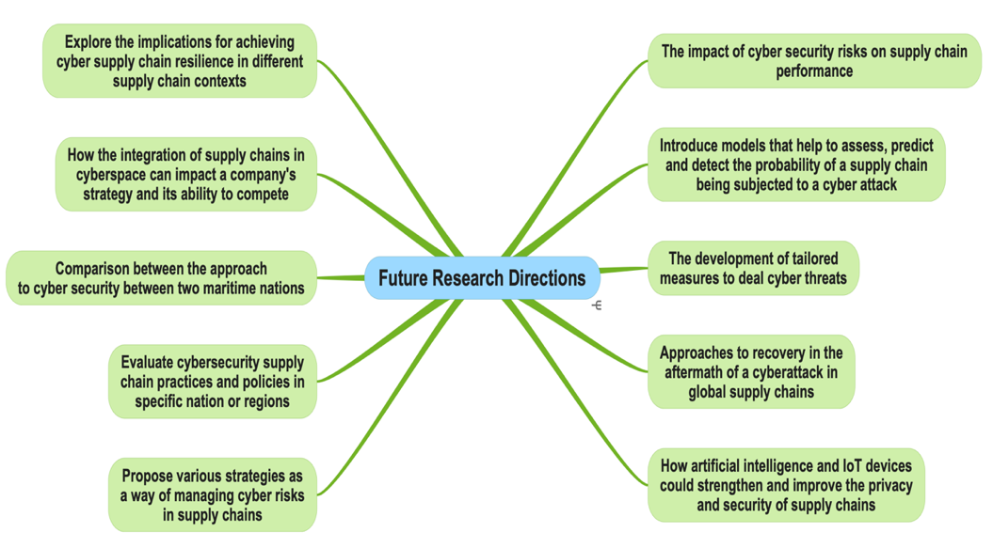
Figure 5. 2 - Future Research Directions

(Source: Own)

Chapter Six - Conclusion

This project has aimed to identify solutions and best practise to manage and mitigate cyber threats in the supply chains of logistics organisations enabled using digital technologies. The project has demonstrated the critical importance of managing and mitigating cyber threats that is an extremely complex endeavour for the logistics industry due to their continuous rise and the sectors increasing dependency on digitalised technology. This, in combination with the need to improve the efficiency of all its operational processes and expand current supply networks, sees continuous pressure. However, because of the increased growth of supply chains, the overall visibility can become compromised, which can inadvertently provide a much greater scope and potential opportunity for malicious actors to exploit further and disrupt supply chains. Therefore, to address such an ongoing issue, this study has offered an insight into how different strategies, solutions and recommendations can be applied at an organisational level to manage and mitigate cyber threats using primary data collected from an array of participants and that of secondary data which is affiliated within the cyber and logistics industry. Through the thematic analysis of the primary data, from the various codes and two themes it has produced, it has concluded that a greater awareness of cyber threats across whole companies and workforces combined with specialist cyber security training is crucial and provides the most justified response to answer to the main research question and objectives of the study. The existing literature review identified a gap in the knowledge regarding the logistics sector’s strategic approach to cyber security. Due to the confidential nature of the study’s remit, an open-source approach was used to gather information, and limitations came from who responded and the lack of ability to do face to face interviews with participants. The results were unexpected in that it was clear across the study that both sets of participants felt the sector was under resourced, unprepared, lacked awareness and priority, specifically within areas of senior management. Therefore, to better understand the implications of these results, various future studies have been identified. One potential avenue for future research would be to carry out a comparative analysis of two opposing logistics organisations with regards to their current approaches to managing and mitigating cyber threats. By conducting the study, it could potentially bring about new approaches to reduce cyber threats and shed light on how cybersecurity training within the logistics sector as a whole, could be improved and its ongoing impact assessed. Another possible future research direction would be to use simulation modelling to not only assess the impact of a cyber-attack on a range of different scenarios throughout the various sectors within an organisation, but it could help to establish where further training initiatives could be applied. This study has looked at both the logistic and cyber security industries perspectives and it is clear that there are areas for improvements to mitigate risk within the logistics sector, and on the basis of these findings it also clearly apparent that organisations would also benefit if they were to action them.

References

Ahmed, V., Opoku, A., Olanipekun, A. and Sutrisna, M., 2022. Validity and Reliability in Built Enviroment Research. CRC Press.
Aiello, S., 2021. Human/Personnel Security Threats: When Employees Turn Insider Threat Actors. SSRN Electronic Journal. [online] https://doi.org/10.2139/ssrn.3944220.
Alcaide, J.I. and Llave, R.G., 2020. Critical infrastructures cybersecurity and the maritime sector. Transportation Research Procedia, 45, pp.547–554. https://doi.org/10.1016/j.trpro.2020.03.058.
Bay, M., 2016. In search of an encompassing definition for the post-Snowden era. p.28.
Boiko, A., Shendryk, V. and Boiko, O., 2019. Information systems for supply chain management: uncertainties, risks and cyber security. Procedia Computer Science, 149, pp.65–70. https://doi.org/10.1016/j.procs.2019.01.108.
Braun, V. and Clarke, V., 2006. Using thematic analysis in psychology. Qualitative Research in Psychology. Taylor & Francis Group.
Braun, V. and Clarke, V., 2022. Thematic Analysis - A Practical Guide. Sage publications.
Carnovale, S. and Yeniyurt, S., 2021. Cyber Security and Supply Chain Management. World Scientific.
Cheung, K.-F., Bell, M.G.H. and Bhattacharjya, J., 2021. Cybersecurity in logistics and supply chain management: An overview and future research directions. Transportation Research Part E: Logistics and Transportation Review, 146, p.102217. https://doi.org/10.1016/j.tre.2020.102217.
Christensen, L.B., Johnson, R.B. and Turner, L.A., 2015. Research Methods,Design and Analysis - Global edition. 12th ed. Pearson Education Ltd.
CISCO, 2022. What Is Cybersecurity? - Cisco. [online] Available at: <https://www.cisco.com/c/en/us/products/security/what-is-cybersecurity.html> [Accessed 30 January 2022].
Colicchia, C. and Creazza, A., 2018. Managing cyber and information risks in supply chains: insights from an exploratory analysis - ProQuest. [online] Available at: <https://www.proquest.com/docview/2190427534?accountid=130472&parentSessionId=T2RBn07keoOBGwLiSS%2BSBr06H7S1aTG7uf9rFvMYr3c%3D&pq-origsite=primo> [Accessed 2 January 2022].
Collins, H., 2018. Creative research the theory and practice of research for creative industries. 2nd ed. Bloomsbury Publishing.
Craigen, D., Thibault, N., Diakun and Purse, R., 2014. Defining Cybersecurity. Technology Innovation Management Review, p.9.
Crotty, M., 1988. The foundations of social research. Sage publications.
De la Peña Zarzuelo, I., 2021. Cybersecurity in ports and maritime industry: Reasons for raising awareness on this issue. Transport Policy, 100, pp.1–4. https://doi.org/10.1016/j.tranpol.2020.10.001.
Denzin, N.K. and Lincoln, Y.S., 2011. Introduction: The discipline and practice of qualitative research.
Detica, 2022. the-cost-of-cyber-crime-full-report.pdf. [online] Available at: <https://assets.publishing.service.gov.uk/government/uploads/system/uploads/attachment_data/file/60943/the-cost-of-cyber-crime-full-report.pdf> [Accessed 14 May 2022].
DOD, 2016. DEPARTMENT OF DEFENSE STRATEGY FOR OPERATIONS IN THE INFORMATION ENVIRONMENT.
Dudovskiy, J., 2022. The ultimate guide to writing a dissertation in business studies - A step by step assistance.
Duzha, A., Gouvas, P. and Canepa, M., 2020. MITIGATE*: An Innovative Cyber-Security Maritime Supply Chain Risk Management System. p.5.
Fowler, K., 2016. Data Breach Preparation and Response. Elsevier Science.
Gov, U., 2022. Cyber Security Breaches Survey 2022 - GOV.UK. [online] Available at: <https://www.gov.uk/government/statistics/cyber-security-breaches-survey-2022/cyber-security-breaches-survey-2022> [Accessed 2 May 2022].
Hox, J.J. and Boeije, H.R., 2005. Data Collection,Primary vs. Secondary.
ITU, 2009. Overview of Cybersecurity.
Kemmerer, R.A., 2006. Cybersecurity. In: 25th International Conference on Software Engineering, 2003. Proceedings. 25th International Conference on Software Engineering, 2003. Proceedings. pp.705–715. https://doi.org/10.1109/ICSE.2003.1201257.
Labra, O., Castro, C., Wright, R. and Chamblás, I., 2019. Thematic Analysis in Social Work: A Case Study. pp.1–20. https://doi.org/10.5772/intechopen.89464.
Lewis, J.A., 2006. Cybersecurity and Critical Infrastructure Protection.
Linkedin, C., 2022. Post | Feed | LinkedIn. [online] Available at: <https://www.linkedin.com/feed/update/urn:li:activity:6897892911288324097/> [Accessed 4 March 2022].
Lopez, julia, 2022. 2022 cyber security incentives and regulation review. [online] GOV.UK. Available at: <https://www.gov.uk/government/publications/2022-cyber-security-incentives-and-regulation-review/2022-cyber-security-incentives-and-regulation-review> [Accessed 27 January 2022].
Manworren, N., Letwat, J. and Daily, O., 2016. Why you should care about the Target data breach. Business Horizons, 59(3), pp.257–266. https://doi.org/10.1016/j.bushor.2016.01.002.
Mileski, J., Clott, C. and Galvao, C.B., 2018. Cyberattacks on ships: a wicked problem approach. Maritime Business Review, 3(4), pp.414–430. https://doi.org/10.1108/MABR-08-2018-0026.
NICCS, 2022. Cybersecurity Glossary | National Initiative for Cybersecurity Careers and Studies. [online] Available at: <https://niccs.cisa.gov/about-niccs/cybersecurity-glossary> [Accessed 30 January 2022].
NIST, 2012. Guide for conducting risk assessments. 0 ed. [online] Gaithersburg, MD: National Institute of Standards and Technology.p.NIST SP 800-30r1. https://doi.org/10.6028/NIST.SP.800-30r1.
Pal, O. and Alam, B., 2017. Cyber Security Risks and Challenges in Supply Chain. 8, pp.662–666.
Radanliev, P., De Roure, D., Page, K., Nurse, J.R.C., Mantilla Montalvo, R., Santos, O., Maddox, L. and Burnap, P., 2020. Cyber risk at the edge: current and future trends on cyber risk analytics and artificial intelligence in the industrial internet of things and industry 4.0 supply chains. Cybersecurity, 3(1), p.13. https://doi.org/10.1186/s42400-020-00052-8.
Radanliev, P., La, T., Santos, O. and Montalvo, R., 2019. Cyber risk from IoT technologies in the supply chain-discussion on supply chains decision support system for the digital economy. https://doi.org/10.13140/RG.2.2.17286.22080.
Sailio, M., Latvala, O.-M. and Szanto, A., 2020. Cyber Threat Actors for the Factory of the Future. Applied Sciences, 10(12), p.4334. https://doi.org/10.3390/app10124334.
Saunders, M., Lewis, P. and Thornhill, A., 2016. Research Methods For Business Students. 7th ed. Pearson.
Saunders, M., Lewis, P. and Thornhill, A., 2019. Research Methods for Business Students Ebook. 8th ed. Essex,England: Pearson Education Ltd.
Schatz, D., Bashroush, R. and Wall, J., 2017. Towards a More Representative Definition of Cyber Security. The Journal of Digital Forensics, Security and Law. [online] https://doi.org/10.15394/jdfsl.2017.1476.
Sobb, T., Turnbull, B. and Moustafa, N., 2020. Supply Chain 4.0: A Survey of Cyber Security Challenges, Solutions and Future Directions. Electronics, 9(11), p.1864. https://doi.org/10.3390/electronics9111864.
Sobb, T.M. and Turnbull, B., 2020. Assessment of Cyber Security Implications of New Technology Integrations into Military Supply Chains. 2020 IEEE Security and Privacy Workshops (SPW), pp.128–135. https://doi.org/10.1109/SPW50608.2020.00038.
Steinberg, J., 2019. Cybersecurity For Dummies. Wiley.
Turnbull, B., 2018. Cyber-resilient supply chains: Mission assurance in the future operating environment. [online] https://doi.org/10.3316/ielapa.344417545553155.
Windelberg, M., 2015. Objectives for managing cyber supply chain risk. International Journal of Critical Infrastructure Protection, 12, pp.4–11. https://doi.org/10.1016/j.ijcip.2015.11.003.


Appendix A - Ethics Form
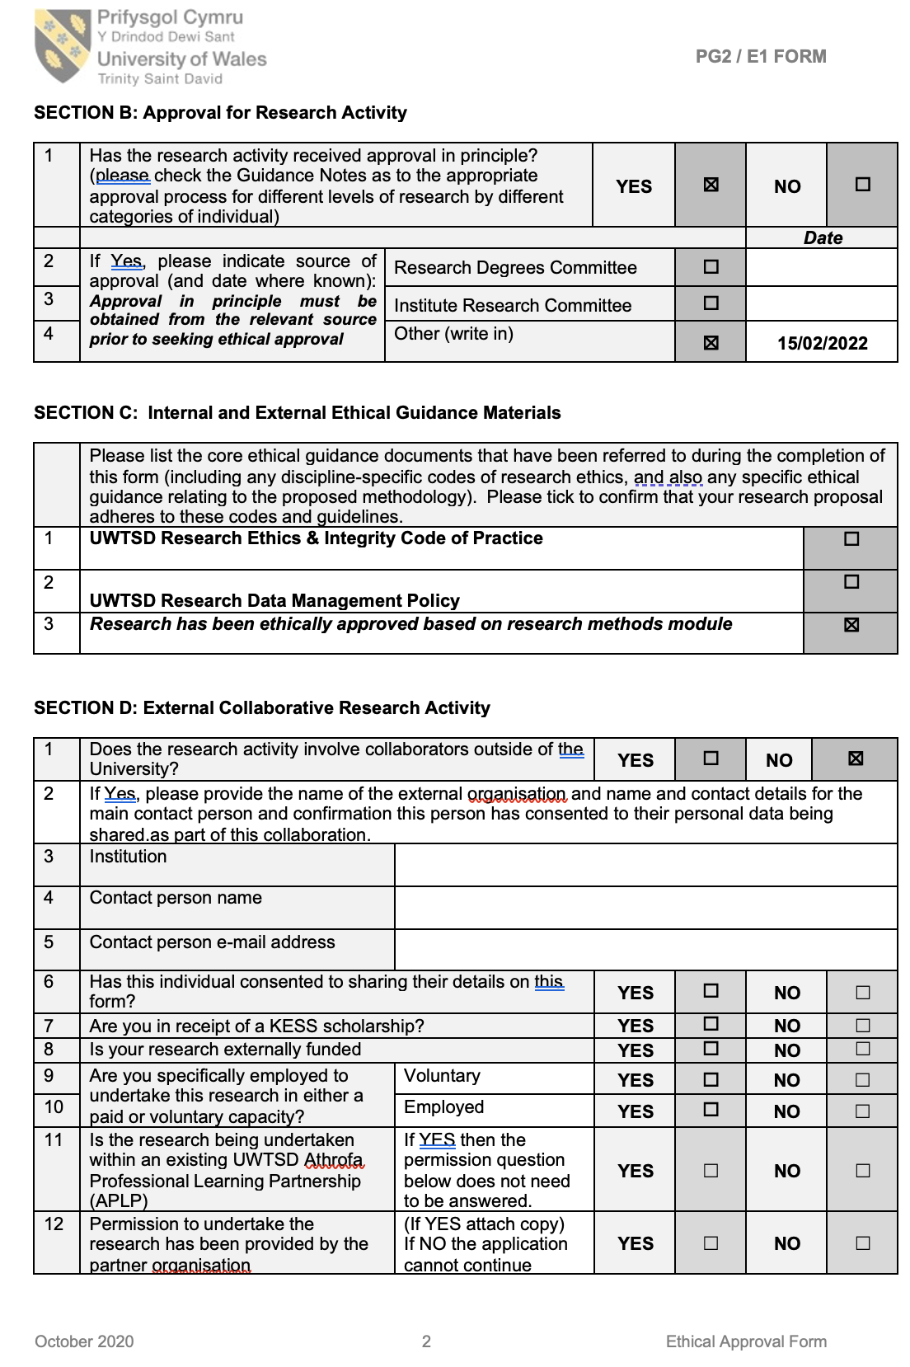

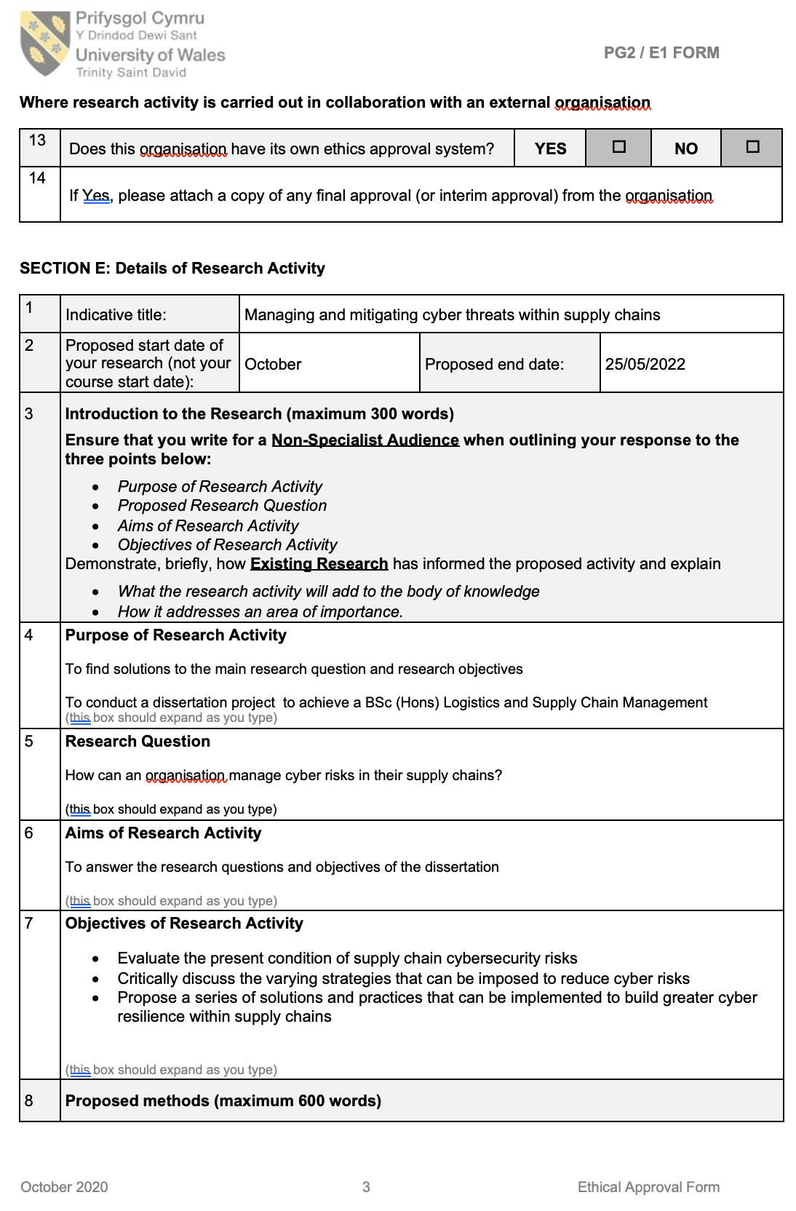
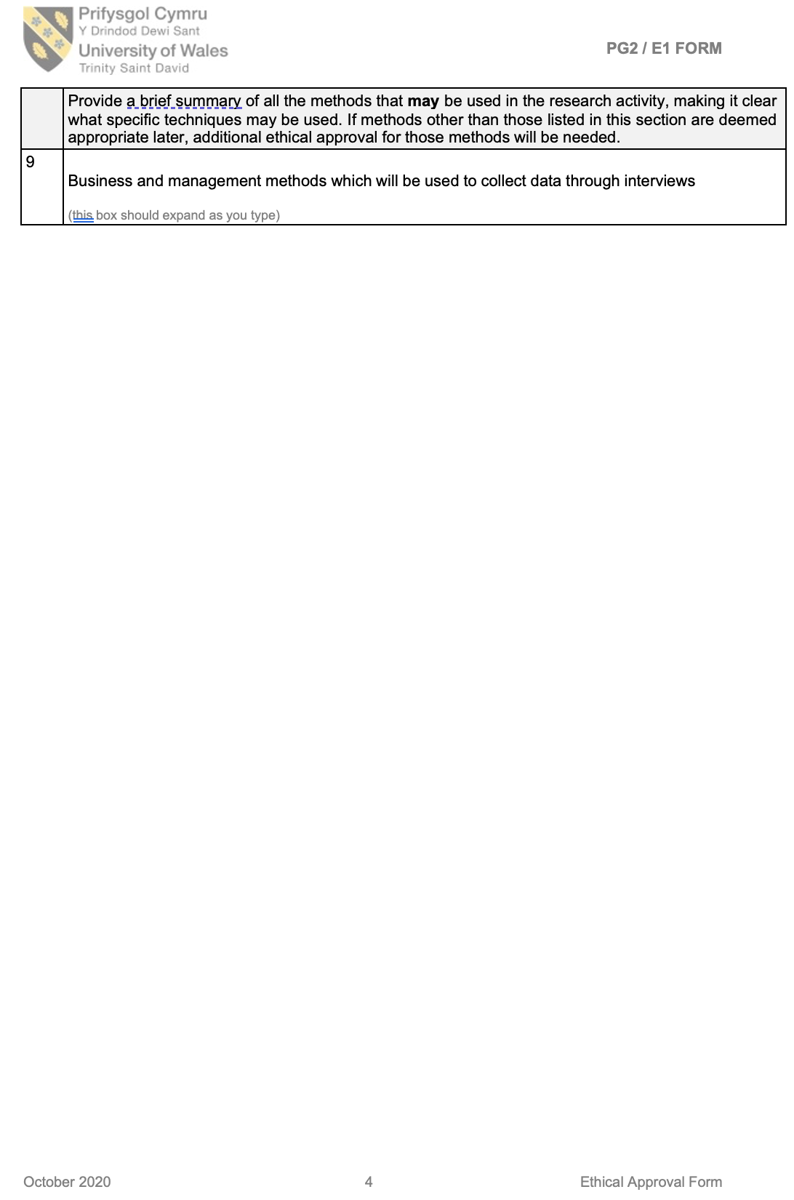
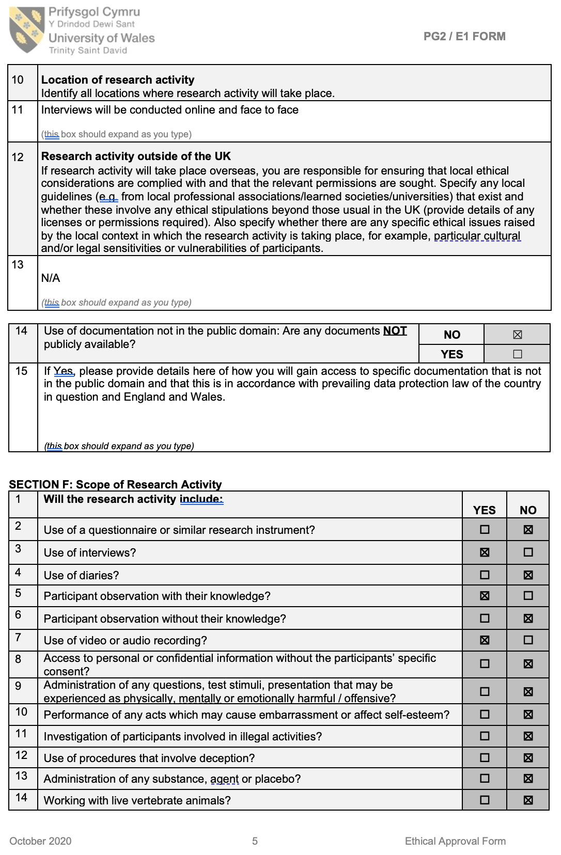
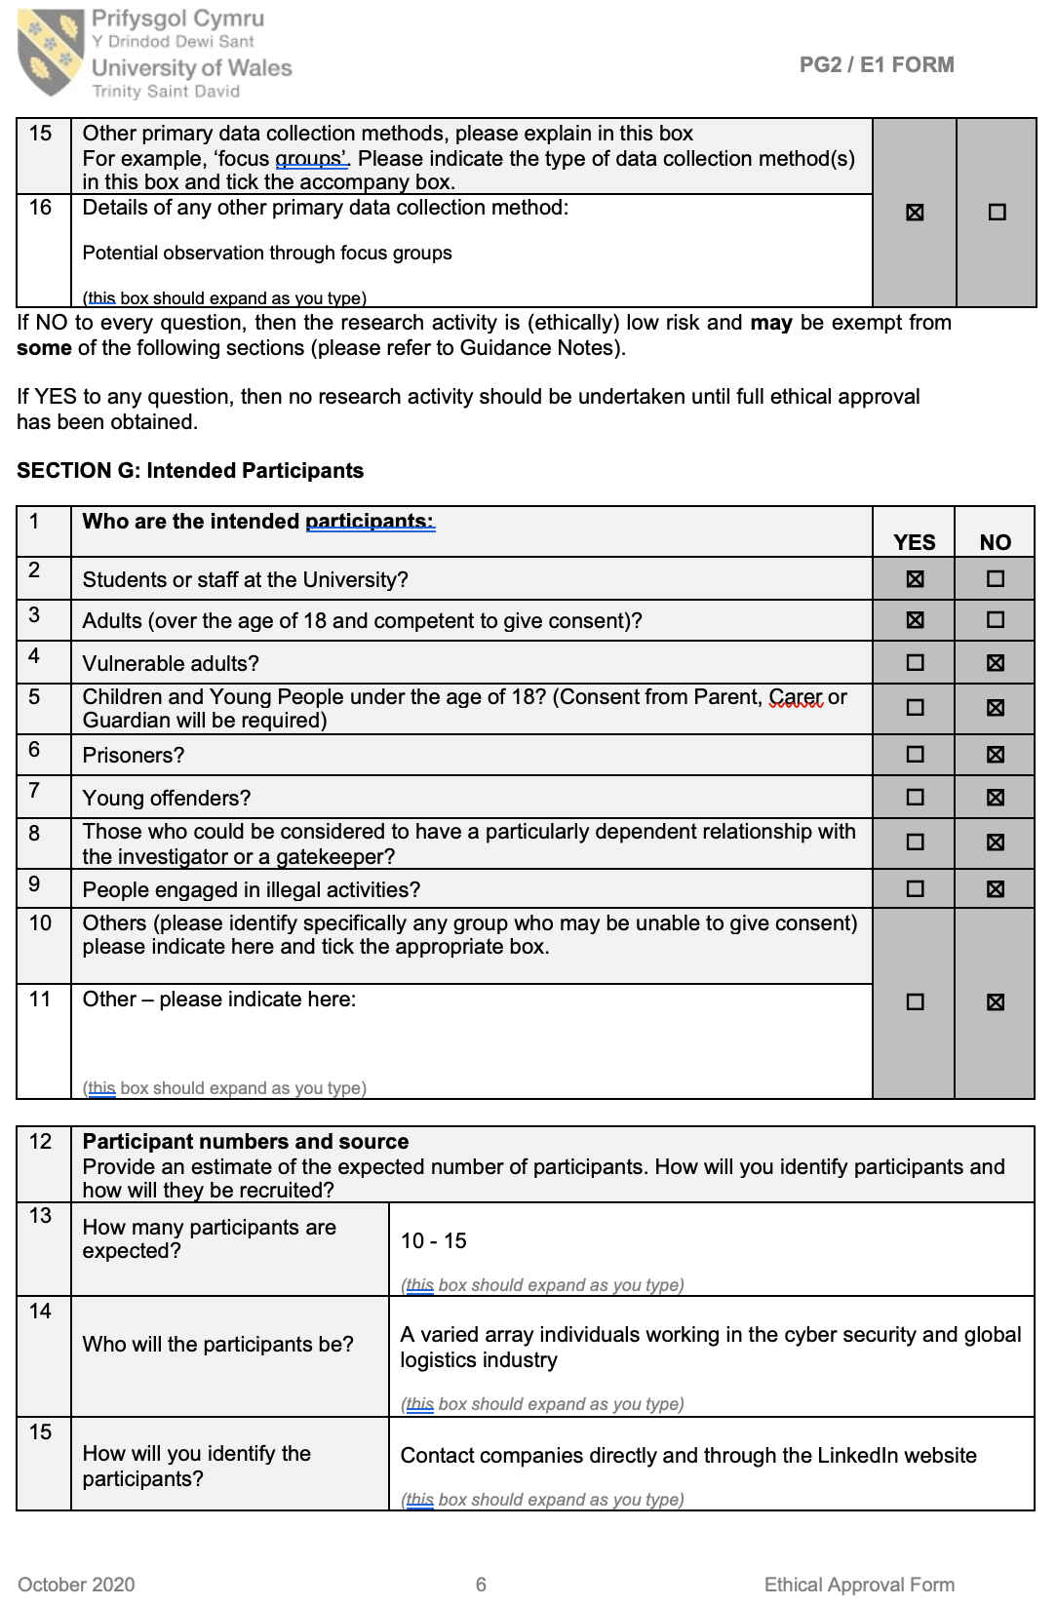
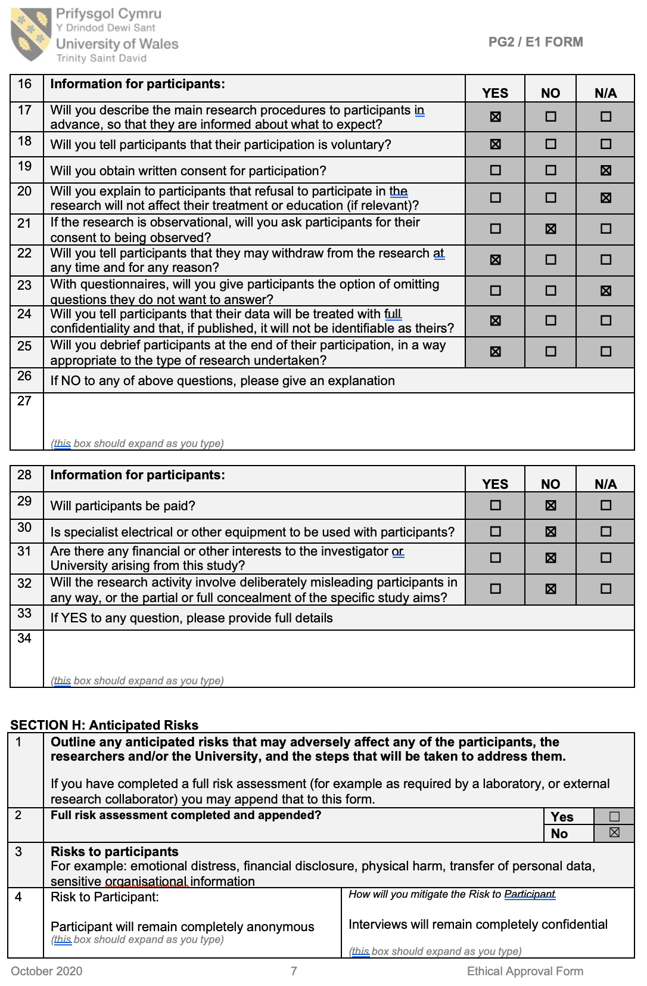
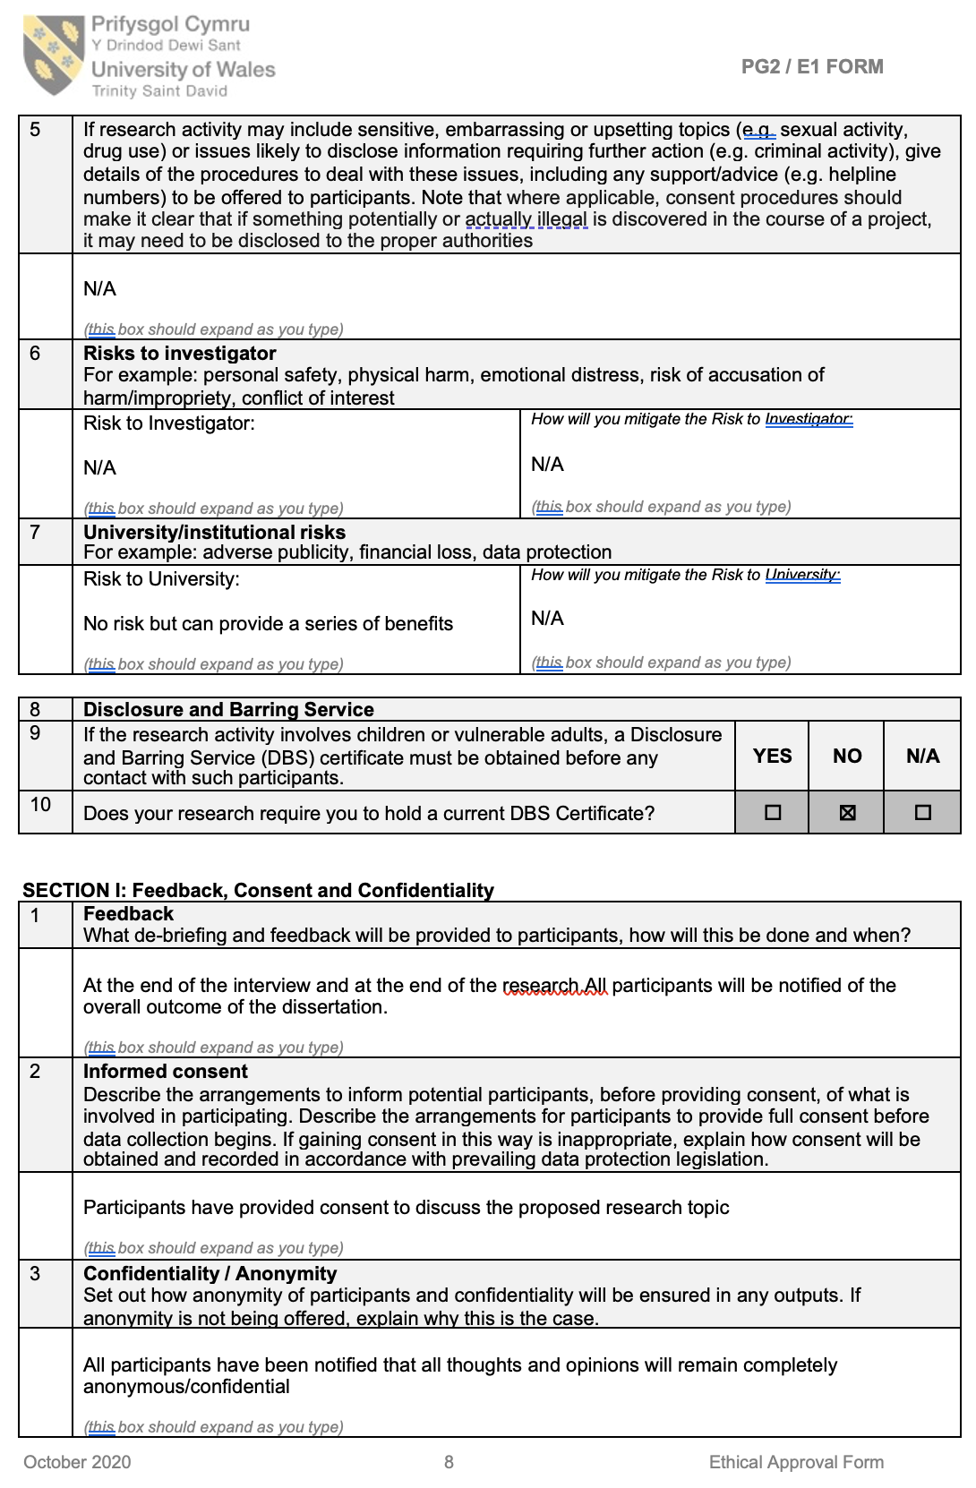
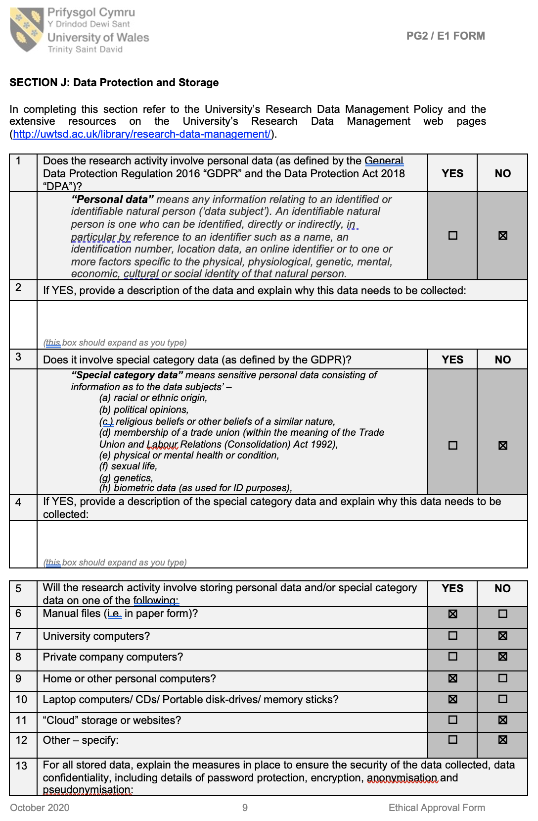
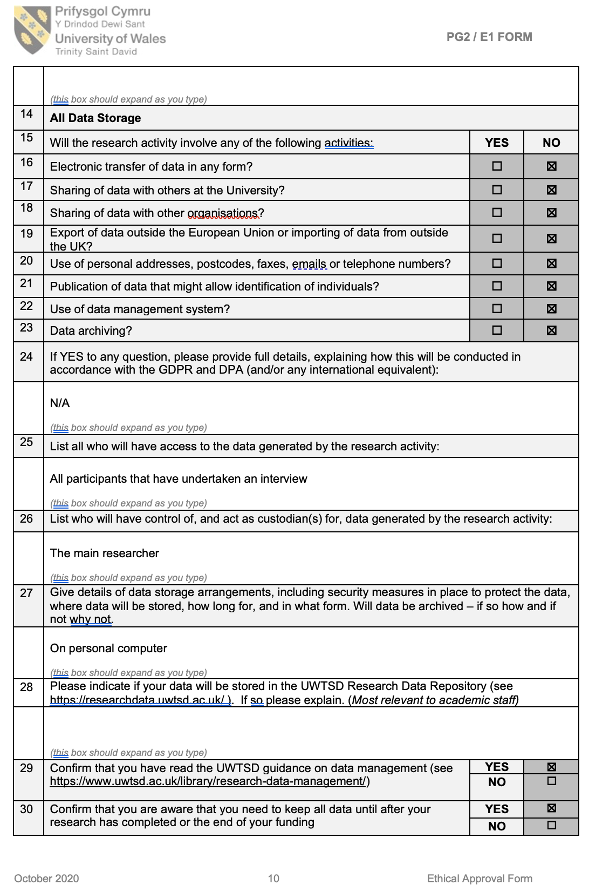

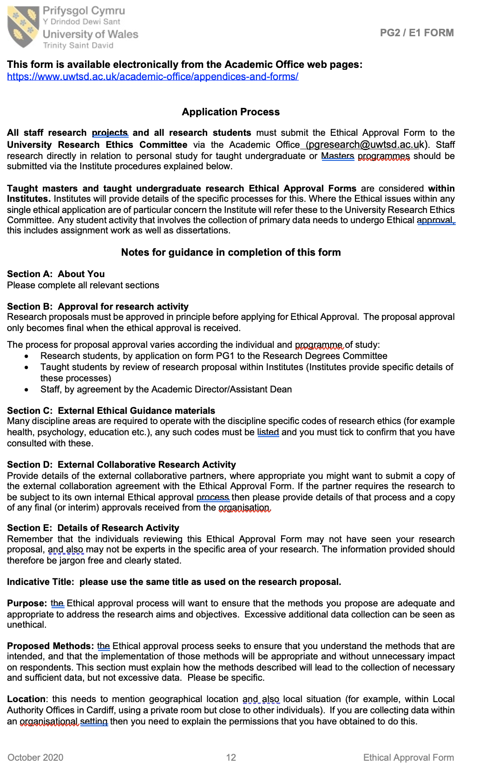
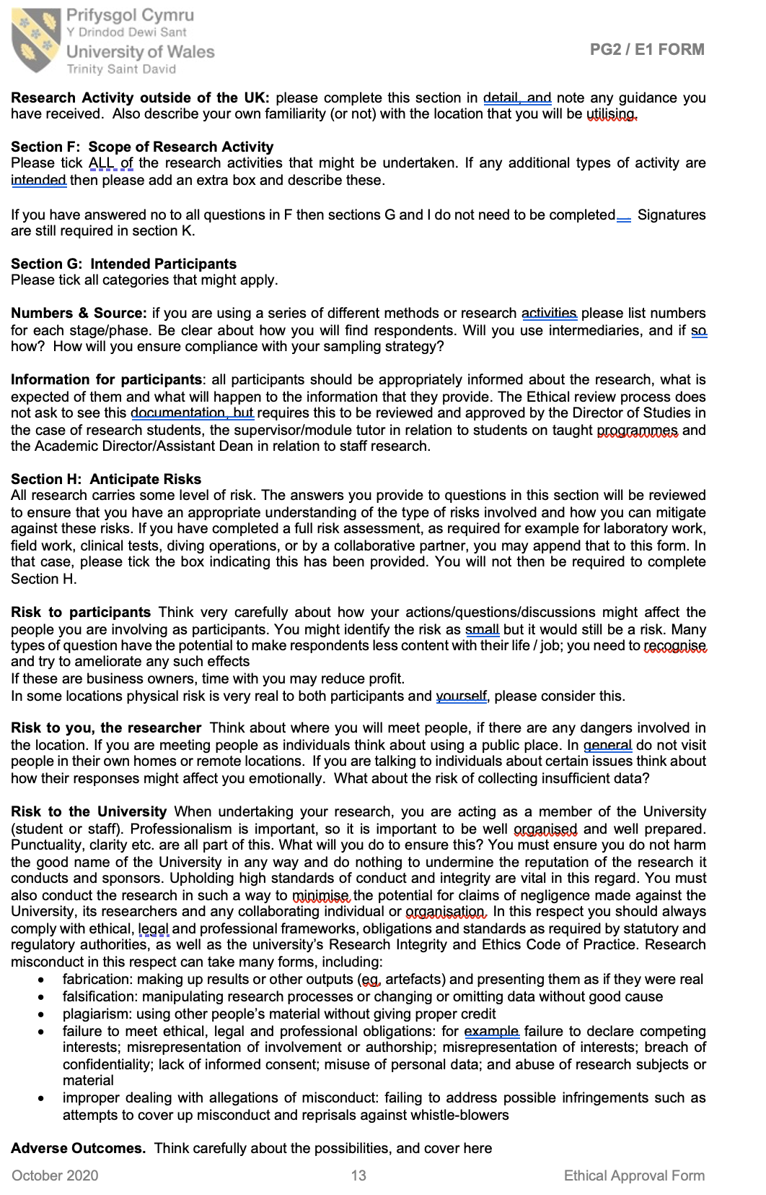
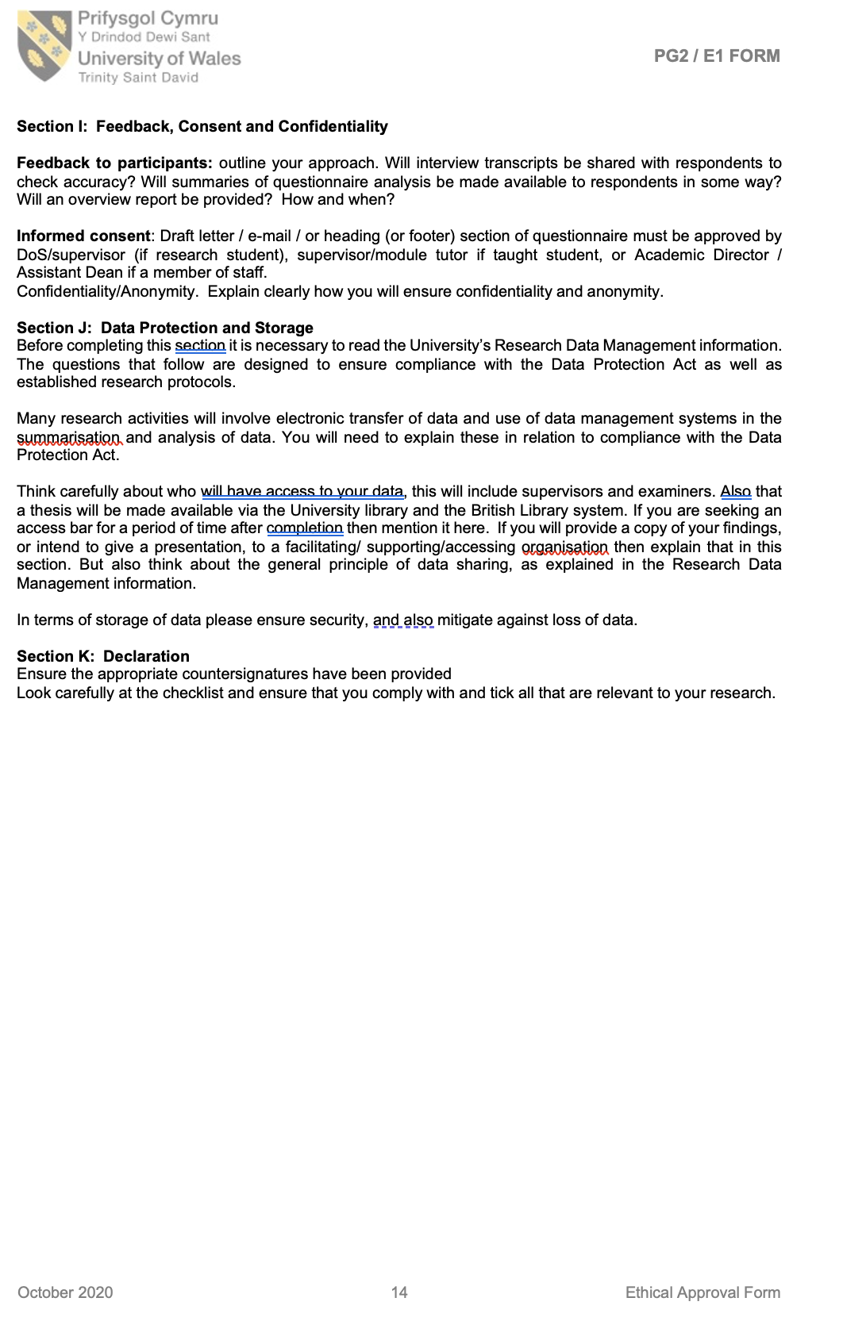
Appendix B - Copies of interview transcripts for cyber participants

Q1) How well protected do you think that the logistics and supply chain sector currently?

Participant A

“From my experience, not very well protected at all. I've even engaged with organisations where, the process might be quite mature, but they are using immature tooling to access simple day to day things like spreadsheets and emails, and therefore it falls on the other side of the coin where they've got all the tools in the world, but they don't have a coherent process to apply them. There isn't enough focus in most of the regulatory standards. On driving supply chain assurance. For instance, ISO 27,001, it's recently had an update. but the version that most organisations and employees are working is from 2013 therefore this puts real pressure on the efficiency of that process. For example, for the likes of BA, and Target in America, the were subjected to massive data breaches, Experian was another big one, they are almost all Third-party breaches. It's not the BA had their systems breached directly. It's that one of their supplier’s security controls was, whether that be around something basic like a joiner’s, movers, or leavers policy. If somebody leaves the company and they're supposed to have their credentials cancelled as part of that leaving process very often that does not get done or it does not get done for months because of a backlog. So consequentially, it’s an open door to a potential cyber threat. So as reiterate and put greater context on my answer to your question, from my experience of assessing some of the largest international logistics firms I am often shocked to see how under sourced their cybersecurity capabilities are in terms of their manpower. In one particular situation, I was completely astounded when I visited one such company and I was informed that only five employees within the organisation were responsible for cyberthreat mitigation even though they were dealing with thousands of suppliers and customers!”

Participant B

“Not particularly well protected, to be perfectly honest with you. I think that's obvious by if you look at if you look at you know, many logistics organisations that I have worked with have stated that they lack a level resilience and unprepared for events that disrupt their business and cyber threat for that matter are considered as being no different. when we look at when we ask Routinely, organisations see that their biggest risk and the biggest threats to their business are perceived risks are out of the cyber risks. So, all in all the logistics and the supply chain sector still appear to be unprepared by still utilising immature tooling which is often outdated and completely impractical for addressing cyber threats. On average between 50-60% of logistics organisations and their supply chains are acutely aware of the disruption that a cyber threat can impose upon their business. This percentage also represents the amount of those organisations that are completely unprepared for a cyber-attack”.

Participant C

“Every organisation is struggling to understand its position with cyber, every organisation is struggling to invest at appropriate levels is constant threats whilst making sure that they have got the appropriate skills. Certain logistic organisations for example, that are kind of well-funded and have probably got reasonable security practices, you know, players like DHL. Whilst at the other end of the spectrum, we've got different business models emerging as the like SMEs, for example, where a large number of logistics fulfilment, that is done through individual contractors therefore the risk of cyber threats is considered fair greater. So, you know, those are individuals, or maybe small businesses have like four or five employees that have Amazon branded. But, you know, they cover, oh, x one through x, 15 postcodes and they'd all delivery but they're not actually employees or kind of Amazon limited, as the company that Chris and Robin deliver parcels limited, you know, acting on behalf of them. So, I think there's a real, real broad spectrum of those kind of levels of cybersecurity throughout organisations”

Participant D

“That's a really good question, I suspect it’s a much better position than it used to be. So, a couple of years back, you have had Petya a ransomware case that wiped out a whole load of sectors and industries which pretty much destroyed the idea of shipping for Maersk. This consequently took the company along time for them to basically rebuild everything. So, my view is that the logistics industry would have would have looked at that and gone, you know what that could have been us and looked at their dependency systems for their business operations. Similarly, if you look at the wider field of logistics organisations, there's more focus on supply chain than they would have been three or four years ago. So particularly when you got say tech financial services for instance the regulators are asking a lot of questions of your organisations that are regulated, financial banks, insurance companies, etc whilst also asking them about their supply chain, how resilient is your supply chain and what safety measures against cyber risks are currently in place? But similarly, in other sectors, the UK Government is always asked organisations look at the same thing, which so if you compare it to three or four years ago, I think there would have been a big shift forwards, however, you're going to see a lot of variety in the level of maturity and resilience. And I think probably what’s going to be interesting is really increasing the amount of IoT within logistics and supply chain. We're introducing a whole new attack surface or increasingly attack surface, the history of securing things like IOT patching it, protecting them against vulnerabilities”.

“So how well protected are they? Let’s just say that the kind of what I sense is that there's a long way to go and there's a lot more that can be done. And why do I say that? I think my reasoning is that I mean, 20 years ago IT security was not really a thing, right? People didn't worry so much about information security when they were taking on a new supplier. But over the last several years, it's becoming increasingly de facto that you don't you have to do the due diligence on InfoSec. Before you take on a new supplier. What that means is that big companies have got huge backlogs of existing suppliers that have never been assessed security checks. Right. And they don't really have the bandwidth to do that. And what's typically happening is that they are sort of doing point in time assessments of their suppliers when they take them on as a new supplier when they're contracting with them. And then they're that's all that happens. So, there's no there's no addressing of backlog of suppliers of which for large companies, there can be lots I mean, hundreds or 1000s, in some cases, 10s of 1000s. Because they just don't have the bandwidth, and then when they are assessing your company this point in time, and then that's it. So that's the first observation, I think was my second observation is that more and more big, big enterprises are starting to look at their supply chains, because they've sort of spent a lot of effort usually getting their own houses in order, right. And to get their own defences, their own protections, etc, threat monitoring, and all that good stuff, they've kind of been putting their own house in order”.

“It is getting increasingly hard for attackers to break into big companies, because they've actually done it, you know, they've done a reasonably good job. So, what's happening is that malicious actors are moving away from attacking the larger logistics companies and focusing their attention on those small firms within their supply chains. They do this because they are often seen as less mature in their security posture which therefore makes them considerably more vulnerable to a cyber-attack. So, they're finding, because supply chains are more connected technically now than they were years ago. So, malicious actors now have basically an assortment of ways in which to gain entry through the supply chain”.

2) Where do you think the threats are different for the supply chains of logistics organisations?

Participant A

“From my own personal experience of working for and then assessing the security capabilities of an array of logistics organisations and their supply chains throughout my career. The main difference in terms of the associated threats is largely manifested due to a number of reasons. Firstly, due to the inherent complex nature of supply chains within a logistics organisation this provides multiple avenues for malicious actors to breach a company’s security network which is subsequently harder to achieve within a company where their supply chains are more closely intertwined because they often only use a minimal number of suppliers etc. Secondly, another reason cyber threats are different for a logistics company is often due to antiquated systems or lack of the technology that they have in place, as technology has continued to move on, I feel that in most cases logistics companies are constantly still trying playing catch up. So, as to reiterate my point here, what I am trying to state is that a cyber threat appears different with a logistics is primarily based upon it lack lustre approach on being up to date with the appropriate technology to deal with cyber related issues”.

Participant B

I would say that cyber threats within the logistics industry more often than not appear different in terms of time. By time what I mean is that for a logistics company one of the main focuses is to establish the shortest lead time possible for the delivery of goods and services. Therefore, for a malicious actor they would see this as the best possible opportunity to cause disruption to the company.

Participant C

There's a perfect example around the fake carrier threat relevant and current as we speak, it seems to be growing on a monthly basis, you know, the Interpol are aware of it, the industry is aware of it. organised criminal groups are clearly aware of it, because they're, they're utilising that that very means to tap into, into the legal supply chain to do bad things, you know, and unexploited

Participant D

So, the first thing is just understanding of the risks to their business, and also an understanding that it's you might just be the go between, a way of getting to someone else. An approach that makes sense right the way down so people can say logistics providers and their supply chain and their IT providers and that same applies. So there needs to be a mutual understanding of risk throughout all elements of the chain. So, people need to realise the associated risk is not aimed just solely as one area of the organisation etc. For example, you might be small-time delivery company for a well-known supermarket franchise. The reason why a threat actor may try to take you out the equation is not only to disrupt you but more so to impact the supermarket as it is seen as an easier method of entry than trying to attack the supermarket at its source.”
3) What should or could the supply chains of logistics organisations do more of or differently to reduce cyber risks and threats?

Participant A

“So, language is important here and the threats and the risks exist regardless of what you're doing. What you can reduce or manage more effectively are your vulnerabilities. Although there is a small chance that a cyber risk can be neutralised, but it is more often in fact that all you can actually reduce is the likelihood of a risk occurring and you do that by managing your vulnerabilities. It is the simple stuff, that gets overlooked, it’s making sure that you have a robust patching process in place it's making sure that you have strict security protocols in place. Additionally, if somebody leaves or moves that their role-based access controls are easily attainable. It is about having an awareness of the fundamentals making sure that Email security has been implemented and is checked regularly. I was having a conversation with someone on LinkedIn earlier and was contacted by a security vendor that were trying to send me a report about the state of email security. However, the email that was sent that was unsolicited. The first contact they had with me about it included a link for me to read a report and then a separate link for me to arrange a 15-minute meeting. I'm not clicking on a link from somebody I don’t know that is ingrained in me due to the potential cyber risk that it can potentially impose. Therefore, in order to mitigate against the impact of cyber threats on supply chains a more concentrated effort needs to be applied by the organisations to manage their vulnerabilities, by making sure that they get the basics right such as having a robust patching process in place if and when a cyber threat was likely to arise. But it seems in most cases that need to implement such measures is still very much an area within the logistics sector which is still largely overlooked”.

Participant B

“Logistics organisations should be more diligent on who they decide conduct business with. I suppose that'd be necessary to ensure that you have good fundamental security in place is critical. So, you know, the challenge for businesses is just in time, generally just in time supply chains, are under pressure to deliver and therefore, in many cases, you know, the process of reviewing and assessing suppliers and the supplier base in the in a proper manner falls by the wayside. Therefore, companies should make sure a proper due diligence process are implemented to check the security of their suppliers but because of the importance of just in time it tends to take a backseat. And, you know, the price and the speed of requirement take precedence over the due diligence process. And that increases the risk, of course, the possibility of engaging with a bad actor. So fortunately, it is more along the lines of that, like a lot of businesses, they're more heavily focused on novelty. Like, like you said, like, just in time getting the product out to the customer, rather than having a direct focus on the actual risks that are involved in getting that product for me to be sort of thing. So, I see all the time, where logistics companies and their operations are driven to deliver. Whereas quality and the risk guys are saying, well hang on a minute here. Let's look at this supplier base, let's do some due diligence, which takes a bit of time. And then of course, the operations and the logistics, companies are saying well we don't have that time. And they don't have the time to sort of, you know, prove that the individual supplier or you know, the suppliers that they're about to engage with are legitimate or not. But it also might be that supplier is subcontracting to tier one, tier two, tier three levels that the organisation doesn't have visibility into. And that's where the real problems, you know, that's when they get into real big problems. They have no visibility as to where their product has been handed off too. Furthermore, in a different light as all logistics companies often differ considerably in terms of their size this can often impact heavily upon the visibility across the entire supply chain. Coincidentally, this can therefore make the act of establishing which part of the supply chain has been affected by a cyber-attack extremely difficult to notice if it was to occur. The best approach that could be implemented by a logistic organisation to reduce and minimise cyber threats is to conduct regular assessments of their suppliers. From these independent assessments it can provide an organisation with a much greater incite to which areas of the supply chain are most at risk from a cyber threat thus providing them with a much greater amount of overall visibility”.

Participant C

“So, I think there's probably a lot that they need to do in understanding what the systems are, what the risk related to that they got the appropriate controls in place. So, ultimately, it's kind of up to them as an organisation, what's right for their business. You can apply regulation and mandates in place, but ultimately, a lot of that's going to come down to what's there, risk appetite, what's their risk tolerance, you know, if they want to operate a cheap and cheerful security-based service that has less protections in place to deal with disruption. They can offer a lower price point, then that's up to them, I suppose a bit like comparing kind of EasyJet or Ryanair with a private jet, right, year one costs a lot more, but you get a different service. So, you know whether that becomes a bit of a differentiator for people. Yeah, I think a little bit we'll start with understanding what the risk is for their individual organisation and actually drive out what they need to do about it”.

Participant D

“So, the first thing is just understanding of the risks to their business, and an understanding that it's you might just be the go between? Yes. A way of getting to someone else. And that makes sense, right the way down so people can say logistics providers and their supply chain and their IT providers and that the same applies. So, it's not just about why would anyone target me? And well, maybe it's not you but maybe we ought to take out you know, the supermarket or you know, your delivery of fuel and disrupt the delivery of fuel for instance, or, or just cause chaos taking out your tracking system etc. So, you've got lots of containers or various ships, and you've no idea what any of them have got in them anymore. Yes, happened to my desk? So, therefore is that understanding of the risks and also why, why people might be interested in your organisation. The second piece is an awareness within the people within the organisation”.

“Yeah, so it's almost like as long as like sustaining a level of trust between the parties along so it's about awareness within all the employees are working to understand what part I want to play in this you know. What's good behaviour look like and understanding of how these things can come about and how I could inadvertently be effective if a cyber-attack was to happen. The third part is around having a good handle on the technology. So just start with, you know what you've got, what you've got where it is, you know, who manages it? Is it managed? Is it patched? Is it controlled and secured? Do you know what's visible outside your organisation? Do you know if it's visible from inside your organisation? You don't even know what's where wave vulnerabilities are. And the next step is around understanding where your vulnerabilities are, how you manage it, and having discipline and control around these things. And somewhat higher up the stack. People start talking about security technologies and securing this, but you have got to get your basics of security right first”.

“Speaking from my experience, right, in the role that I currently do is to get an independent assessment done, I mean, that that's kind of what we do with the company I work for, right. But the thing is, all companies are different sectors are different, different sectors, different company sizes, every, every organisation is different, and you don't really know what the problems are, until you, you need to shine a light on that to get visibility of what the problems are. So, it tends to start with assessment to get some independent analysis, if you like, of your security posture. So, if you do that, if you if you go and get some sort of external objective, independent analysis of your security posture, then there is a very good likelihood is that you will start to understand where the risks are. It is about establishing what you can do about those risks and how you can remediate them, so there is a need to be proactive about them, and to embark upon a programme of remediation. What we are tending to find is that a lot of the time, I mean, apart from the fact that a lot of a lot of suppliers simply aren't kind of getting that initial assessment and gain and a lot of companies aren't assessing their own supply chains. Which are often been done in a very unreliable way”. “So, what I mean by that is that they might be using some kind of screening some sort of automated software that screens, which is very limited and can be unreliable, or they are using questionnaires. But the best way of doing an independent assessment is like an on-site audit. But those are very, very expensive. And that is prohibitively expensive to do that, for anything more than a tiny fraction of your supply chain. So, actually, having suppliers or being assessed or having your suppliers assessed on the basis of evidence is really important, because that's the only way that you get a true view or true visibility of where your vulnerabilities are. So therefore, my recommendation would be getting the assessment, get visibility, make sure that it is evidence based, and not just some sort of automated screen or, or sort of felt filling out a questionnaire and then ensure that the vulnerabilities are associated with recommended improvements and then get help implementing those improvements”.

4) Do you feel specific employee training is required to improve cyber awareness within logistics companies and their supply chains?

Participant A

“I believe that it goes both ways, every individual bears responsibility for the security of the organisation, it's just how you develop and engrain a security aware culture. There's a lot of chatter about people being considered as an organisation’s greatest weakness because they're the ones that make the mistake. There’s a guy called Gabriel Friedlander. Who, uh, runs, I think it is called wiser security awareness, and he likes to flip that on its head and implicates that people can be your strongest asset? I think if you communicate it that way through your organisation, risks exist, and threats exist you cannot do anything about them. That's why I said earlier on like, the language is important, those are two things that aren't going to change. when you can create and us against them, them being the eight side threat actors within an organisation that can help foster a better security. Too often when people take the notion that people are our greatest weakness that then becomes an asset, then the training or anything that's provided is taken begrudgingly and not taken seriously when it's us against them”.

“So, to give you an example of how easy it can be to fall victim to a cyberthreat, a friend of mine who will remain nameless, received an email after recently having had his first child. He was fresh back from paternity leave. So, he was not getting any sleep. Basically, it was back at his desk work, and he was relatively new into his organization, into the organisation he was at the time, and he received an email, that was from the CEO. It was asking him to arrange for some gifts tokens as part of internal incentive on the CEO's behalf. With no sleep and eager to impress in his new company, he spent eight hundred pounds or something on a securing these Amazon vouchers and sent them back to the link and then realised that that was a phishing attack. These kinds of things can happen. There's always going to be a weak link, Like I say, the threat exists, and the vulnerabilities will crop up. That is the vulnerability. That was, he was just completely not on his game because he had no sleep for weeks on end. But in a security aware culture, even in the scenario where you haven't had a great deal of sleep and you not necessarily concentrating if there's a greater focus on other things. By talking about such things more regularly within an organisation, will raise greater awareness of cyberthreats significantly”.

Participant B

“I think there's a good level of awareness in terms of there's a slight cyber threat out there. You know, and cyber is a threat and is a potential problem for organisations. When I go around organisations and I look at you know, warehouses, logistics organisations, 3PL’S, am I seeing training across the organisation? Consistently, no, I'm not seeing it. I see it in, in, you know, organisations that are committed, that have a commitment to it and are, you know, sort of organised and structured and manage risk effectively. But it's not, you know, it is not consistent across many organisations. So, just to clarify my answer to your question, most logistics companies don’t have the coherent processes in place, so they don’t have the necessary means or capability to effectively collaborate with the other parties of their supply chains in order to better protect themselves from a cyber threat. Additionally, when I speak to cybersecurity professionals, there is a unanimous understanding that almost all data breaches are ultimately the result of human error. They are not the result of some bit of tape going wrong they are the result of human error and that is the biggest weakness in organisations. So, and that is one reason why I say kind of doing automated external scans is great, but it's not really getting to the heart of the problem, which is people. But yeah, cyber awareness. InfoSec awareness and training, and testing, not just training, but measuring and testing people and keeping them alert on a regular basis about the potential threats, I think it is really important. I definitely see roles, specific roles in companies that I talked to, for you know, for people whose job is cyber awareness, you know, head of cyber awareness, for example. So, I think that exists. I think it's really important”.

Participant C

I think it's important that it's tailored and individual roles and the risks that they're likely to be exposed to. So, it may be, as a delivery driver outdated a company, there's comparatively very little risk in your day-to-day job. Actually, you have got a PDA that tells you where you've got to go next, but you can't browse people's names and press this real PDA, just tell the next stop, drop last and 17 off. You need that information to be able to do your job, there's not a huge amount of risk associated with that, once you've delivered it, it disappears, you know, you browse a whole customer database or see wherever whatever else is doing. If you've got that limited information, then, you know, realistically, there's more limited exposure there to kind of what they're wrong. And when you compare that to the physical safety risks of driving vehicles around the roads and things like that, maybe there is an argument to say that they don't need the same extent of training as an IT administrator or as a as a finance professional, working for the same organisation. So, I think it's important if you're going to give people more training that is tailored to their, to their job and what they do. What I am trying to get at is that many logistics organisations continue to use outdated versions of software from 2013.Consequently, this has therefore made those organisations increasingly more susceptible to the cyber threats that resonate within the modern era. As a knock-on effect, this in turn has made it harder for those logistic companies to effectively collaborate with other members of their supply chains, especially those companies that are seen to be using the latest and most up to date cyber threat mitigation software such as Bitdefender”.

Participant D

Almost undoubtedly, you have to raise your decision makers and your doers, knowledge, and awareness of cybersecurity to a common level and what it will give you is the foundation for when you want to start having more complicated conversations when you want to start addressing particular risks, or when you start wanting to be raising like particular concerns. So for me I would start at the board level awareness to understand what the risks and threats are, what it would mean, in terms of, you know, if you were shut down for a day, what's it gonna cost you? What's not company customers? A week was four weeks, and you recover from that. Automated? Yeah. And at what point is something happened to you? Do other people start to become very agitated about it? Yeah. And, you know, obviously, that ramps up if it's not just you, but your peers as well. So, where it's that's that part and then usable, individual user basis, is just a staff member, it's an actual genuine awareness of cybersecurity, understand the impact on what you do, has a real impact that in the first line of defence is, as people, you know, spot something that's unusual spot, something that doesn't feel quite right and having a sense of what not feeling like looks like. And then, I guess the other point is around governance and control in terms of how you do things. So even if you get to the point where you understand what everything is and where the is, having dominance and control over changes, what happens so that things are done securely, so that things are done. With a view to how do we ensure things are protected as opposed to just leaving things open or not turning not turning things off when you don't need them and leaving them exposed and this sort of stuff. So, for me personally there's a misunderstanding among almost everyone in society apart from people who work in technology, about the about that connectedness. As an example, I was hosed off with, with police the last couple of days, training police officers on assignments, cyber vulnerabilities. And essentially things that they do in their personal life, which they haven't considered, exposes things about what they do in their sort of police officer career. Okay. And that's not I'm not having a dig. You say your average person whether it be someone who again tries to stick to logistics, whether it be someone who works in a warehouse or whether they work on a dockside or whether they're a truck driver, or whether they're a logistics admin support sitting in an office, you know, do you think is a problem that you plug your phone into charge? In this truck, or in your computer on your desk? On I'm just charged, no. Problem. Well, have you had any technical security around that phone, though? That's quite interesting point. Again, thinking hypothetically, let's say I am a generic members staff, again, not picking on any principles, or trade or expertise or area. I'm a generic member of staff in a company working in the logistics industry, and I click on some dodgy websites, or I download a random apps that I thought would be fun, or on Twitter, and I clicked on the link. and I've now somehow got an exploit onto my phone, some kind of malware or whatever. I don't know the difference doesn't really bother me; it doesn't cause me any harm. By then I plug that device into a computer then it infects the whole computer server. Therefore, most people often unaware of the consequences of doing these such things, they don’t know easy it is to be on the receiving end of potential a cyber risk.”

Appendix C - Copies of interview transcripts for logistic participants

Q1) What do you consider the greatest cyber threat your organisation is at risk from?

Participant A

“From our point of view the greatest cyber threats we have witnessed has arisen through phishing emails that have been opened in error or ransomware breaches. So that is what I believe to be the biggest things that will pull the company to the ground but if go of the number of cyber related incidences we have had ransomware would be considered as our biggest fear due to the reputational damage that it can cause. However, we don't directly deal with people's accounts and bank details or nothing. We just sell fruit and veg, we export fruit and veg. So, it's all about quantities, products, and number so our worry with regards to a cyber-attack is the effects it could have on supply routes. It's not our systems, it's not about GDPR type of thing. And people's personal information, we don't have any of that at all. It's just a name. That's it really is companies a company name. So, we're not dealing with people personally, it's a company that we're dealing with buying and selling fruit and veg and exporting fruit and veg. But as far as our IT systems, we couldn't be with our systems that will pull us to the ground. Therefore, a product we have used to protect the company over the last five years is Bitdefender. So, to minimise cyber risk even more in the last few years we just started moving stuff to the cloud”.

Participant B

“I think we are very much in a place where we can do better. There is a tremendous amount of expectation placed upon individuals by senior management within organisations to prevent, rectify and reduce cyber threats. However, to seem compliant a large percentage of these individuals often say that they have the necessary skillsets in place to deal with such threats when in fact that does not appear to be the case. As a result, this often gives rise to a substantial amount of human error through ineffectively misconfiguring a security network or incorrectly updating security software”.

Participant C

“I would say, from human error because obviously, there's going to be a lot of cyber-attacks going on now due to the ongoing conflict between Russia and Ukraine. So therefore, mistakes will be made due to the pressure in ensuring that company networks are secure. I mean, I don't know if you're familiar with log hacking groups, and things all happen as a group called Anonymous. They all were, they were the white mask and the black stuff. And they've just weighed a cyber war on Russia, Russia, if they want to disrupt anything in Europe could go out and do cyber-attacks. And where are they going to do the cyber-attacks and go to do on key infrastructure. And we are key infrastructure to the UK because obviously, we move into products around the UK to keep the economy going to keep businesses going. So, if they target, for instance, logistics companies and the supply chain, they could quite quickly cripple the UK economy and economies around the world. So, I think is the biggest risk at the moment is purely based off human error. Because, you know, we've just put all sanctions on to these people. They're not going to log them. So, they're going to have their own security teams, wanting to you know, fight back and you know, it's not always fought in the field anymore. It's fought at the keyboard, unfortunately. So, as to reiterate my answer I think the main cyber threat for the logistics sector comes from individual human errors”.

Participant D

“Many logistics companies are more heavily focused on making sure that their lead times and that the expectations of their customers are met rather than considering the safety and security element that is associated with a product. Therefore, in many circumstances and through my own personal experience, when a cyber threat emerges in this scenario this straight away creates a sense of hysteria and mass panic throughout the whole organisation as well as through the rest of the chain which often leads to a myriad of human errors”.

Q2) What are your main concerns with cyber threats with your organisation?

Participant A

“Since the covid pandemic there has been a monumental shift towards a remote working environment to reduce the spread of infection. Consequently, this has brought with it an increased number of cyber-attacks mainly through phishing emails as individuals are now working off their own home servers which in most instances are usually unsecure in comparison to that of a company server. Therefore, to reduce cyber risk to both an individual and the organisation it is imperative that more regulated employee training is carried out to raise awareness. Also, before covid we had five people working from home. That was really the directors and couple of managers whereas now because of covid we have probably fifty workers so for that reason there was a need to introduce two factor authentication”.

Participant B

“The top level of the supply chain has got it all tied up they have got the policies in place with compliance and ISO standards. However further down the chain to smaller companies’ security is not seen as priority. More emphasis is on making sure that products and services leave on time and in the correct quantity. There is kind of just more emphasis on like getting the product to the customer and then dealing with like maybe the repercussions on security related issues after that. There still appears to be a distinctive divide in opinions from individuals within the logistics sector on whether cybersecurity is deemed as being a vitally important necessity. From my own personal experience, there have been numerous occasions when I have stressed the need for more stringent security measures to be implemented but the response from CEO’s and those in senior management within a logistics company is often the same, why would we consider investing a considerable amount of time, money and resources on cybersecurity when we have not found ourselves the victim of a cyber-attack, for that reason we do not see cybersecurity as a priority, especially when the money can be spent in more important areas of the business”.

Participant C

“For me, you got three threats in the in the tech world, you got somebody in the supply chain industry, you got the tech itself, and the people and in the processes to back those up. So, from the tech side, you know, what, what have you got in place from the soul protection point of view? You know, if you got a good response plan, if you got a good contingency plan in place. What type of malware protection are you going for claim protection, you need to start using things like biometrics to form factor authentication. So, you've got all that piece of technology perspective. It does not matter what technology you have in place to mitigate cyber threats, the biggest risk to an organisation is often the employees themselves. So, I think companies need to educate their staff by training them better. They need to focus their attention on the latest security awareness training. It is extremely important to keep educating your staff so that they have a better comprehension of the various cyber threats that are out there. So as a company we must send a regular campaign to individuals, that will give us a risk factor to say these are businesses currently sat at the 16% risk, and these individuals are the highest risk. So, I think if you can reduce the risk by educating people, you've reduced the risk to the supply chain in general and the business in general, because you know, Tech's only one aspect of it”.

Participant D

“The biggest weakness with organisations with regards to cyber threats is the people. So, you've got to keep educating people to understand the threats that are out there. And then you've got to have the technology to back it up. So, when the people don't do the right thing hopefully the technology you've invested in will capture it, and then you've got to also make sure your processes are very tight in and people you know can only do what I'm allowed to do”.

Q3) What can organisations do to manage cyber threats better?

Participant A

“For me personally, I think that it is in the company’s best interest to introduce more training based around security. I mean most companies can afford to schedule in a few hours a month to go through with their employees the basics of security, like how to correctly open emails and what are the tell-tale signs of an infected emails to name just a few. Or a company could get external cyber specialists to come in if they felt that they did not have the necessary cyber training experts in house. I also feel that companies could introduce cyber training into the induction phase of when they have just taken on a new employee as they are the ones that could cause immediate issues as they are not familiar with the organisation approach to security so therefore, they would be much greater risk to the organisation. Companies need to realise that as tech changes so does the potential threat and the approach needed to deal with those threats changes too”.

Participant B

“In terms of the cyber side, I think it is important to invest in technology and making it easier to use is a good way to go. Some of the systems now are requiring you to change your password every three to four weeks, because they think that makes it safer. What it generally means is people can't remember it so often they are constantly writing down. So, I think investing in the technology and not making it available to everybody in your organisation so that they can gain access, pass information safely and easily internally reduces the chances of the company and an employee becoming the victim of a cyber-attack. Additionally, another suggested approach to manage cyber threats better is the application of better and well-coordinated cyber training, I feel this is important as all employees day to day approach to using technology differs significantly with regards to their job roles and their own individual abilities of using technology.Therefore,the implementation of cyber training will ensure that all employees are singing off the same song sheet with regards to ensure that their use of technology in such a way that does not bring about potential breaches in security”.

Participant C

“Firstly, I think it is important for organisation to consider what they are doing currently with regards to cyber threats like what approaches that they are currently taking and what measures that they have in place. By doing that they could assess where potential downfalls lie such as whether they are using outdated protection software on their current operating systems and see what software would be deemed as a better replacement. Another possible way that an organisation could manage threats better on the basis of their current approaches could be the introduction of or improving their current approach to cyber training to make sure that all employees are conducting themselves in the most efficient way to reduce cyber risks”.

Participant D

“I think companies need to train more people, and they need to invest more in people and get the people to understand the risks. Because you know I am not being funny but there is a lot of older people in an organisation particularly tech savvy. So, you have got to educate these people on basic day to day tasks such email hygiene by helping them to identify the difference between what to open and what not to open. Currently throughout our organisation we started to produce various posters which are placed throughout the organisation as means to address the potential severity of cyber threats so I think that is something that all companies should be implementing. By introducing these small measures will hopefully help to reduce the large-scale consequences of a potential threat on the organisation. All it takes is one click on an email and the whole company would be comprised. So, to reiterate main point to answer your question for me companies have got to invest more in the people and training and education from a cybersecurity perspective, rather than putting loads and loads of money in the technology because it doesn't matter who's on the technology the core to ensure the safeguarding a company from a cyber threat is the people”.

Q4) What current strategies do you currently have in place to manage cyber threats?

Participant A

“Within the company currently use a range of strategies in order to manage the cyber threat within the organisation. The first main strategy always focus on is ensuring that we have a good security software programme in place that covers a wide range of potential vulnerabilities and that doesn’t focus on one main type of threat. For the company we have found that Bitdefender seems to be the best and for the reason we have used it for many years as result. Having a good protection software programme in place should be considered as main fundamental for an organisation. A second strategy that the organisation has in place to manage cyber threats is using a combination of both the cloud as well as a backup server because if one was to get comprised, we still can obtain access to potential sensitive information about our customers or suppliers etc. Another strategy that we use is limiting the number of employees that work on the company’s main server. By having a smaller team helps to reduce confusion as well ensures better overall visibility of what is going on whereas if there were more people involved there is a much greater chance of human error”.

Participant B

“In order to better manage the risk associated with a cyber-attack or threat, our first point of call with regards to strategy in most cases is to conduct a board meeting that is carried monthly in order to establish the whether the current strategies that being are used are the most effective and how that they can be changed. As it stands, we a currently in the final year of a three-year strategy plan. The strategies during this period that were deemed as being the most successful was investing in more automation capabilities such as the use of twenty-four-hour monitoring system which allows us to identify threats much more quickly than through the use of human invention and ultimately enables us to disable the threat before it harms the organisation”.

Participant C

“For us we do use multiple strategies in order manage the threat effectively. We have recently began using multiple vendors for our security products throughout the company this is because having the same products from the same vendor makes it obviously much easier for a malicious actor to bypass our security systems and gain access to our information systems. With these products we always make sure that are layered up as much as possible that way if one layer was breached then we still have multiple layers of security in place. Another key strategy that we use within the company is carrying out regular staff training that is heavily focused on the risk awareness and risk identification strategies, furthermore this training is also focused on email hygiene by that I mean being safe when open emails and discarding those that look dodgy, it is all basic stuff really that all employees within a company should know, everyone should have a basic understanding of the threat and know it is very real!”

Participant D

“The primary strategy for our company predominately is to make sure that we carry out regular cyber risk assessments, that way we can clearly establish whether or not we could be doing more to neutralise the of a cyber threat. The assessment allows us to identify the various information assets such as different hardware and computers and data which could become vulnerable if a cyber-attack within the company was to ensue.
Additionally, from the assessment we are then able to determine what would be the biggest risk to those individual assets and what methods, or strategies could be better applied to null the threat”.

