

Task 1 – Reading Task Template
Upload your photo of your A3 in-class notes here:
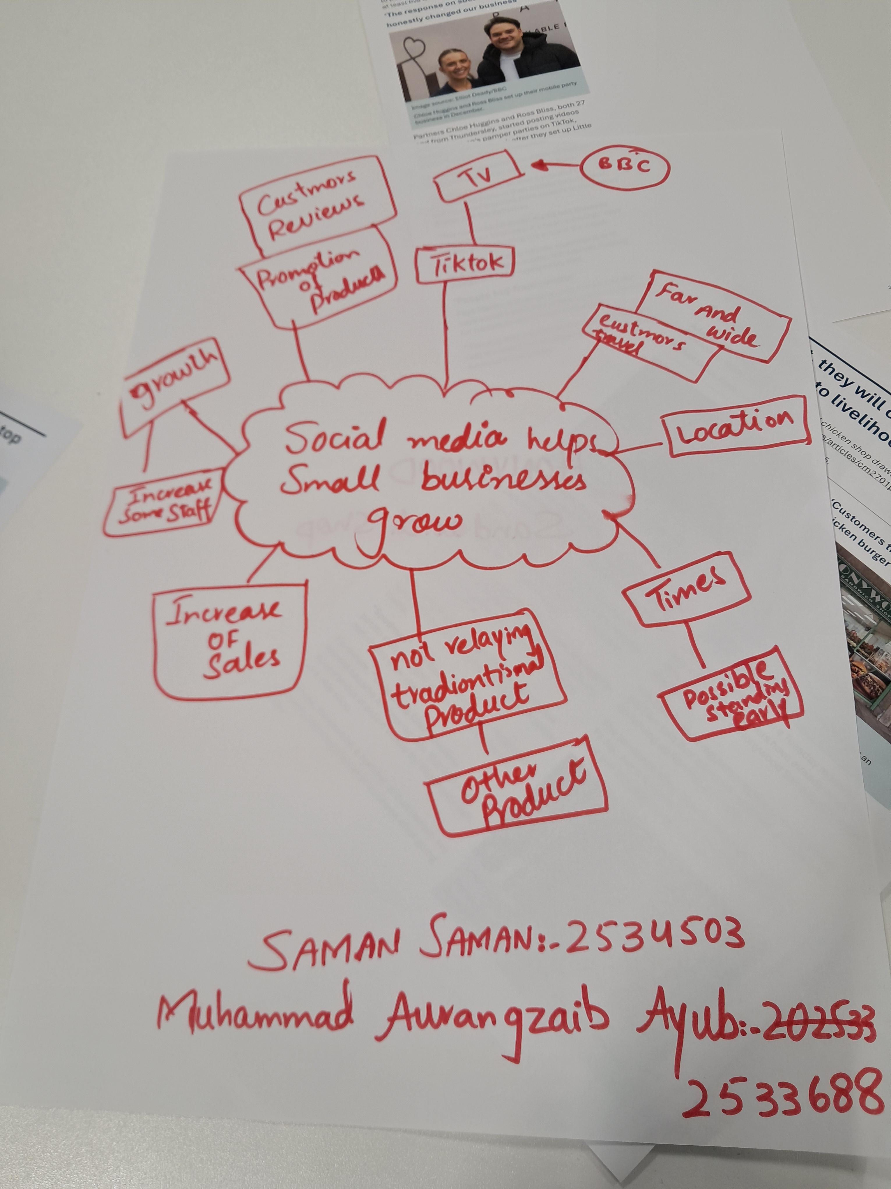

1. Answer these questions using the sentence starters below
a. What is the main idea of the text?
The main idea is that to help understand how useful social media is for any type of business.
b. What are two key points?
One key point is the actual use of social media platforms such as Tik Tok, Instagram and BCC (TV/ News).
Another key point is this helps business promote what product and service they offer. This is a great for businesses to analyse trends and patterns
c. What part of the text did you find most important? Why?
The most important for me was when the article stated someone travelled 3hours for there chicken burger; that suggests the business takes pride in how it operated and the quality of its food is really good.
d. Was anything unclear or difficult to understand?
I was not sure about how Honywoods’ regular products are not going viral where as the non traditional products are catching attention. Could it be some form of promotional offer?
e. How did your group help you understand the text better?
My group helped me by discussing their view on the topic and sharing their opinions. It helped me pick up on things I missed out on
3. One sentence reflection
Question: What did you find challenging about this task?
The hardest part was working in a group as I have always worked on my own, I am a leader and people usually follow instructions from me..

