  MArriott  “Management of the Relaunch Project” | Lecturer: Dan Hart  Module: BMSW5104  Student: Andrei Alexandru Agopian (1905498)  Managing Projects in the Organisation  

Executive Summary

The purpose of this academic report is to detail the inner workings of managing a project at Marriott Hotel Park Lane London, revolving around providing a face-lift of the property under the spectre of SarsCov2 outbreak.
After a presentation of the property and the current situation, we look at how the project idea came to be and focus on unpacking its implications, identifying the beneficiaries, setting the timeframe, and reflect on the outcome.
Furthermore, we look at various styles of project management techniques and select one that is suitable for the works being undertaken. With that in mind, we move into the implementation phase where the initial consultation is discussed, alongside the organizational chart, project stakeholders, costs and benefits, milestones, schedule, and the Gantt chart. We conclude this section with a communication plan.
The next stage opens with a two-part personal reflection on the skills and abilities a project manager must possess, coupled with a self-assessment and a direction for the future.
Finally, we discover how interwoven the relation between all the moving parts of a project is and the various layers to which it expands to, as well as making a case for the importance of communication between the stakeholders. The conclusion is then that by training people to a higher degree and providing them with opportunities to enhance their skillset, we thrive as a business and deliver an enhanced quality of service.
Contents
Executive Summary 1
Introduction 3
Project Management 3
Marriott Relaunch Project 3
Implication 3
Timeframe 4
Origin 4
Beneficiaries 4
Outcome 4
Development Scenario and Setup 4
Project management tools and techniques 4
Prince 2 4
Agile 5
Scrum 6
Waterfall 6
Traditional Project Management 6
Marriott Relaunch MPL Technique 7
Implementation Plan 7
Initial consultation 7
Organizational chart and human resource requirement 8
The employees and how they interact 8
Project stakeholders 9
Costs and benefits of the project 10
Gantt chart expanded 11
Communication plan 13
Personal Evaluation 13
SWOT perspective 13
Self-assessment and development 14
Conclusion 14
Key findings 14
Recommendations 15
References 15

Introduction

Marriott International is a multinational business in the hospitality industry, with a history spanning across nearly a century. From humble beginnings in 1927 as a root beer stand with 9 seats, it grew today to be known as one of the pillars of the tourist-oriented businesses, consisting of 30 different brands each with their own hotel portfolio: Marriott currently means over 7000 properties in 131 countries (Marriott International , 2021).
Despite its imposing global presence, at the time of writing this report, most Marriott properties remain shut or working at a relatively low capacity of 10-20% occupancy, due to a worldwide viral outbreak that took place at the end of 2019. Globally, the governments are trying to find a feasible solution to the enormous loss of life, high disturbance of trade, and a looming potential financial crisis (Gursoy, et al., 2021).
For the purpose of this academic report, we will analyse a project currently underway at the hotel where I am employed – part of the “Marriott family” - which revolves around preparing the property for reopening. The main objective of the project is updating the property and elevating its standards, making the most of the fact that with no guests present, the level of disturbance any refurbishment works may create is minimal.
As it is the case with most multi-layered projects involving different contractors, our main control tool will be a Gantt chart. This will contain the different parts of the proposed modifications, alongside a start and end date, coupled with the main actors involved.
Our final goal is to highlight how the Covid situation impacted the standard operating procedures and project management techniques, where people now must wear a mask and work long hours, all the while maintaining social distance, yet having to work together. These contrasting aspects will render certain management features obsolete, and at the same time, there will be an increasing need for innovation.

Project Management

The totality of applications of processes, alongside methodology, abilities, knowledge, and experience, merged to achieve specific predetermined objectives represents project management. At its core, we can say that project management is all about getting things done (Hornby, 2017).

Marriott Relaunch Project

Implication

The situation created by the lockdown provided the right environment for this type of project and the challenges it brings about have appealed to me.

Timeframe

We started making plans and come up with a rough idea towards the end of January, therefore the start date convened upon was 8th of February and we aim to be ready for the public on the 17th of May.

Origin

During a meeting of the Executive Committee the owners of the hotel showed a vested interest in updating the property. Various suggestions have been made, but the one that caught on came from the Director of Operations, who proposed that we focus on things that are almost impossible to refurbish during normal hotel operation.

Beneficiaries

The main beneficiaries of the project are first and foremost the guests who will get more value for their money and overall a better property. Of course, we must note that from a marketing perspective, we gain an upper hand, as well as being able to sell the rooms at a better daily rate.

Outcome

Failing to deliver the project on time means our opening day will get pushed back further, therefore a major loss of revenue. Currently, the system shows an occupancy of 13%, but that is likely to grow sharply once the government guidelines become more permissive.

Development Scenario and Setup

Project management tools and techniques

Despite every project being unique in terms of what resources it needs to be completed, the problems that may arise, or the environment in which it takes place, certain attitudes to project management – tools and techniques – are similar in nature. Below we are going to look at some of the most popular ones and choose one that is most adequate for our project (Carstens, et al., 2016).

Prince 2

An abbreviation of “projects in controlled environments”, Prince 2, is the UK de facto standard tool for the job. Characterized by a Project Board and comprising of customer, user representative and supplier, Prince 2 relies on the manager constantly updating the board on the progress. It is all about creating a standard system and its benefits are a better resource distribution, increased justification for continuing the project, and early problem warning system. Alongside those factors mentioned above, it is a tool that ensures good communication between the implementers and stakeholders (Hinde, 2018).
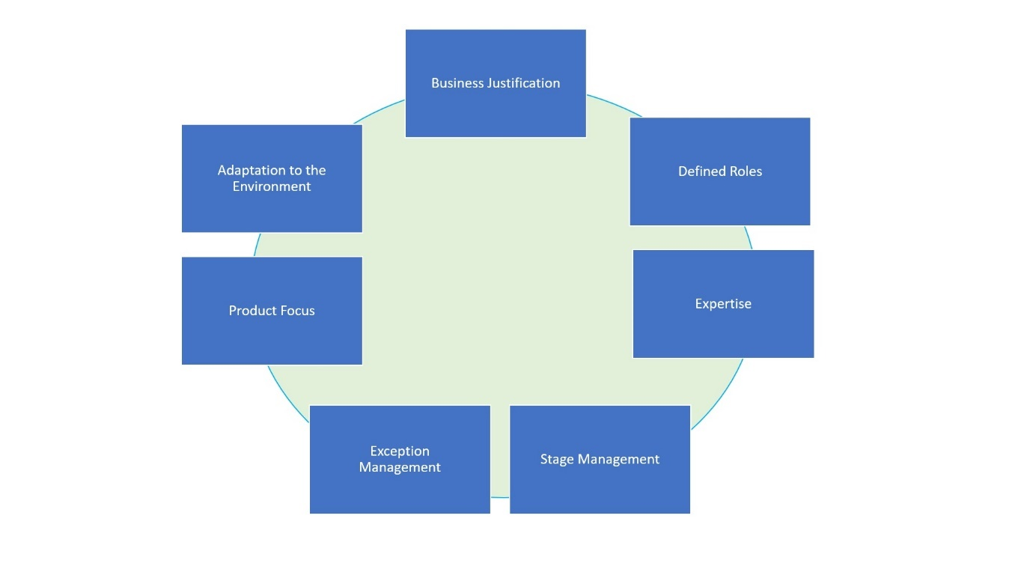

Agile

Agile project management is based on the repetition of a process with the purpose of obtaining the desired outcome. It starts with a “vision” of the final destination, and similar to a boat on the ocean, it takes small adjustments of the wheel to keep it on course, and with small increments gets closer to the target. It is built around a core of values and reciprocal trust between implementers and is driven by flexibility and empowerment (Schwaber, 20004).
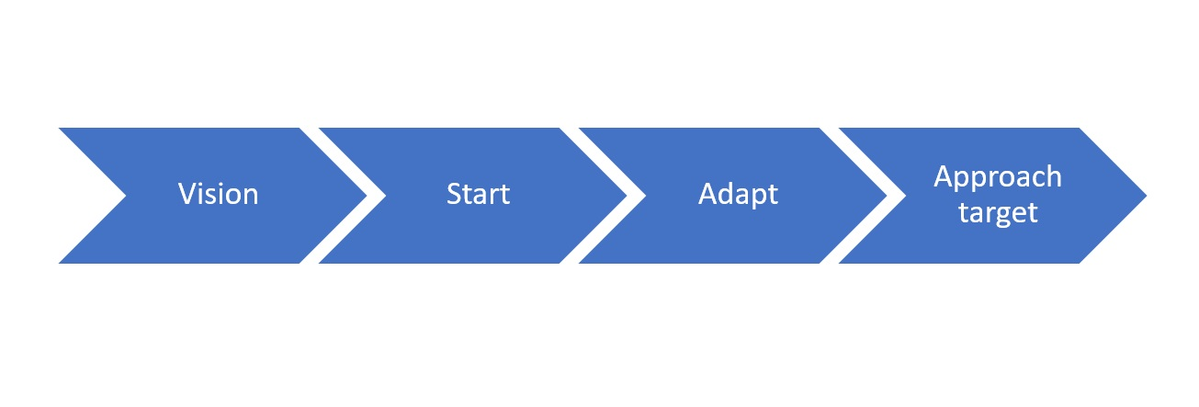

Scrum

A derivation of the agile method, Scrum, maintains the same characteristics, but rather than being focused on business value, it centres on speed. Most commonly the two are employed in IT, namely in software development (Schwaber, 20004).
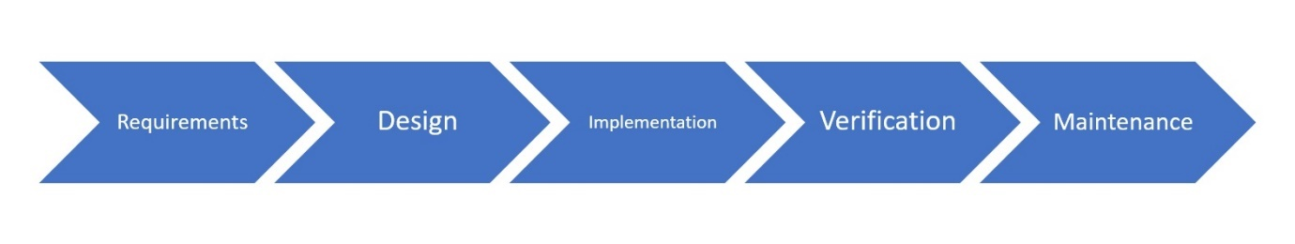

Waterfall

This technique is best portrayed as a relay race, where one contender cannot start until he/she has received the relay. As the name suggests, each task is reliant on the completion of the prior, thus issues arise from the ability to test up until the process is complete. It also makes changes difficult and has a smaller emphasis on the customer. On the upside, it benefits from financial transparency, everyone is kept in the loop, and there is little space for surprise (Phillips, 2019 ).
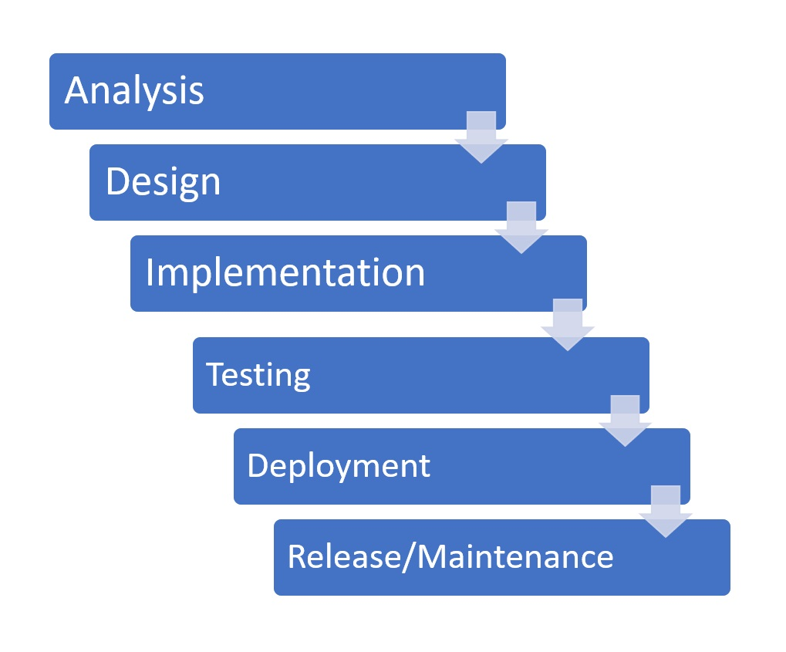

Traditional Project Management

Perhaps the most common way of handling projects is through a traditional lens. If compared to physical action, it would be best seen as the act of firing a bow. You see the target, aim, shoot, and from that point on, all that is left to do is hope for the best. If we were to divide it in stages, we would have the initiation, planning, execution, control, and closing (Wysocki, 2011).
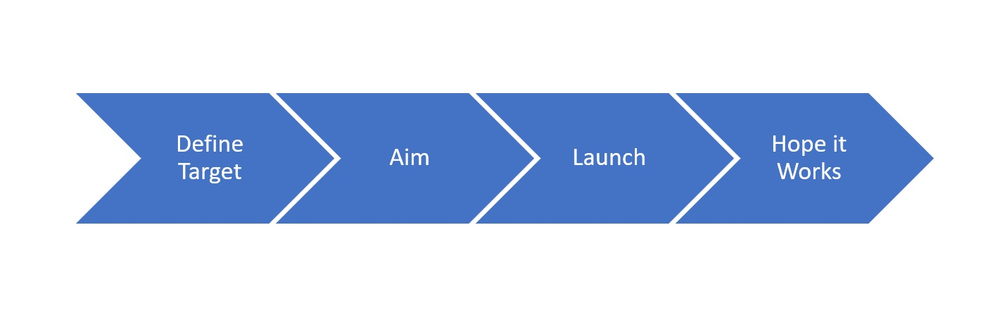

Marriott Relaunch MPL Technique

For our project we needed a management tool that was most employed in construction typical scenarios, as what we planned to do falls closer to that bracket than, as an example, software development.
After a review of the methods above, the decision was to follow a traditional approach supported by a Gantt chart. The reasons the traditional technique seemed more adequate is due to the clear end goal: have a commercially viable property by the set date of 17th of May. This method also pertains to us as most tasks will be outsourced to external contractors due to the specialist nature of the job.

Implementation Plan

Initial consultation

On 28th of January 2021 a meeting took place between the Executive Committee of Marriott Park Lane and the Owners of the property, the latter mentioned party will henceforth remain mentioned under that label due to privacy concerns. It was established that the sum of one million pounds sterling will be made available for the initiation of the following works:
- Remove and replace grout and silicone in all areas of the hotel.
- Deep abrasive work on all marble surfaces and polish.
- Replace all carpets in guest rooms and public areas.
- Replace one of the water tanks in main plant room due to normal wear and tear.
On 1st of February the board appointed me as the project manager due to the nature of my position as Director of Engineering. I was then tasked with creating a Gantt chart highlighting the various stages of the project, alongside with providing a list of contractors and tasks for our own engineering team.

Organizational chart and human resource requirement

As it will be evident from the Gantt chart, the selection was as follows:
- RCL (Robust Contractors Limited) appointed for the silicone and grout process.
- Rednum tasked with marble polishing.
- In-house engineers, two-man team working 8 hours per day to support the jobs.
- Carpet Busters will be the company in charge of changing the carpets.

The employees and how they interact

Ever since the focus of management shifted from tools and machines towards humans and the interactions between them, the search for a perfectly balanced work environment has increased exponentially. This search is centred mainly on people’s character and loosely based on whether those people are highly communicative, expressive, and enjoy attention – extroverts, or, analytical, withdrawn, and restrained – introverts. Ideally, a team will have a healthy mix of both, with more or less of a spectrum depending on the nature of the business they are conducting. As an example, an advertising agency would look at hiring more extroverts, to satisfy the need for creative thinking and idea sharing. Conversely, an accountancy firm, might turn their attention towards a heavier introvert balance as it needs people that can focus for long periods of time and that respect the operating procedures strictly (Schein & Bennis, 1965).
It is worth mentioning that there is no recipe for success when putting together a team, human nature is difficult to predict. A person’s behaviour can change in relation to the situation they are reacting to and exhibit a completely different response to what they are classed as. An interesting and less cluttered approach to workplace management was attempted by the Swedish writer Thomas Erikson who divided people in four colours:
- Red – the fire people: fast, firm, strong, natural-born leaders.
- Yellow – the sun people: energic, happy, positive, the centre of attraction in a group.
- Blue – the water people: precise, analytic, methodical, reserved, the accountant type.
- Green – the tree people: calm, welcoming, patient, the type of people who put other people’s needs first (Erikson, 2019).
The author posits that we all have a little bit of all these colours, but the highest percentage is represented by only two, for instance red and blue. From a psychologist’s perspective, this view is reductionist, ignoring years of contemporary studies, however, what cannot be ignored is that this “wrong” perception is encountered across the world and in ancient civilizations who had no interaction with each other. Another positive aspect is that it looks at people from the perspective of how they would act and react in a certain situation, the label attached to them being a lot more flexible. It also has a natural ease of use to it when it comes to how a manager should create their teams: it needs a lot less psychology and as humans we remember information better when it is associated with imagery (Erikson, 2019).

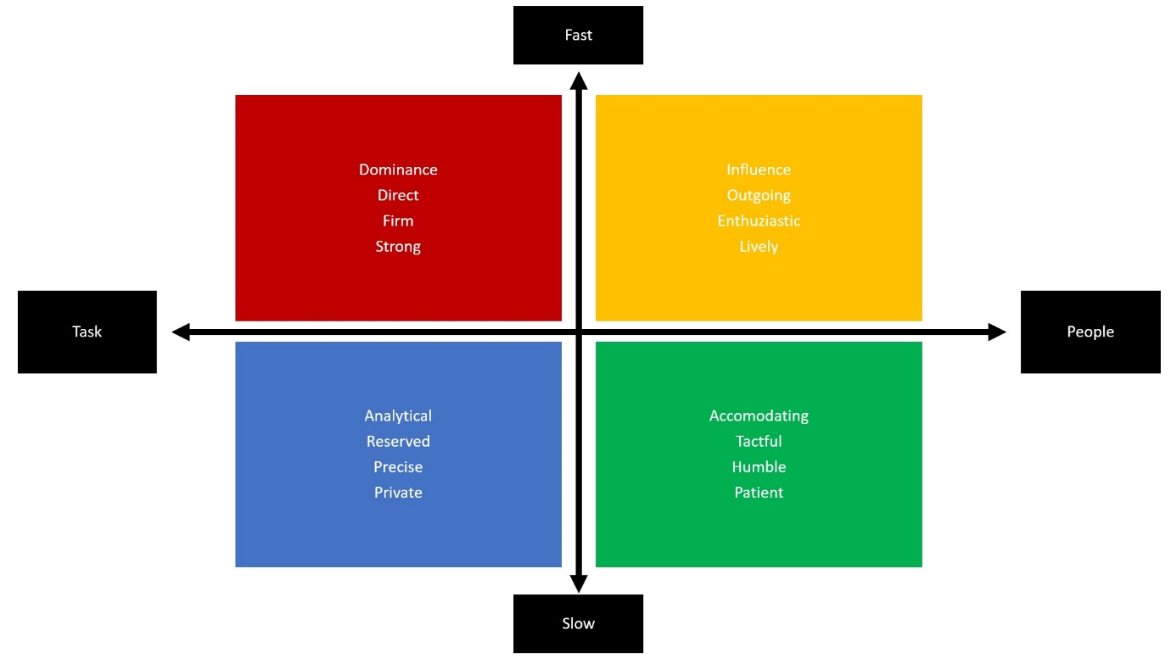
Based on the above, in our project, I decided to allow my engineers to supervise the contractors. Both these employees have red personalities which makes them suitable as leaders and exhibit a strong presence of green in their make-up, factor that will contribute to them keeping things smooth with the contractors. As for the latter, these three companies have a mature and stable composition, they have been around for more than a decade in this format. And for the last seven years they have been the most adequate choice for the contracts awarded by the hotel in their respective areas of expertise. Beyond this, throughout our past interactions, we have never had a conflict or a loss of quality.

Project stakeholders

The success of our project is highly dependent on whether the key people involved are satisfied. The collective term for these people who have a clear interest in having their expectations met or exceeded is stakeholders. When it comes to this category of people, the most important thing a project manager must do is to ensure that he/she clearly identifies all the parties involved and accurately assigns to them the relevant degree of importance. Failing to identify a stakeholder can lead to complete failure of the project as the ripple of repercussions can be overarching (Mabelo, 2020).
Any project has as main stakeholder the sponsor, the person setting everything in motion and the one that has the power to allocate the necessary funds to get it all done. In a classic structure, alongside the project’s main stakeholder, we have the top management, the project team, peers, resource managers, internal customers, external customers, government, contractors, subcontractors, and suppliers (Eskerod & Jepsen, 2013).
In our specific scenario, the project’s main generator is our Director of Operations. Her idea led to the meeting with the hotel owner – a key stakeholder as well – and the executive committee. They all are part of the higher tier of stakeholders and immediately below them we have our guests, employees, contractors, and the government.
Once we have clearly identified the parties involved, we must establish the best way to communicate with them to ensure the project runs along smoothly.
When it comes to people that belong to higher management, their interest is manifested through the power to hold the project manager accountable of the progress, therefore, a clear plan must be drawn out highlighting each step and regular updates sent. Once the plan is detailed, the updates sent must contain the degree to which each task is achieved and whether the project is still within the given time frame.
Our guests will not be a part of the project up until the point they return to the property and communication should only be done from a marketing perspective, using the improvement works as a means of enticing them to choose to stay at this hotel rather than a competitor. Extra care is needed when choosing the new carpets as to not opt for a design that is out of sync with the existing decorations and furniture, thing that has the potential to upset a visitor.
When it comes to employees and the current Covid19 context, this project allows us to give them a glimpse into a near future where the limitations to pay rise, work hours, and hiring, will diminish, and a renewed sense of normality. It is important to acknowledge that this project is in addition to normal operating tasks the engineers must perform, and it is advisable that in the first two weeks of operation, two more members of staff will be recalled from furlough to take over those tasks.
Given the specialized nature of the project, the need for outsourcing the tasks to outside companies arose. The three companies involved in the project, Rednum, RCL, and Carpet Busters, are stakeholders that have worked successfully with us in the past, however, there is a need for oversight when it comes to work quality, costs, and time keeping. At the project manager’s level, the communication with them is done via their respective off-site manager, therefore the interaction on-site teams have with our engineers is crucial. It will be through the two engineers that strict adherence to the outlined schedule is maintained. They are an important piece of this puzzle and statistically, the bulk of time a project manager spends is on interacting with them.
The final stakeholder identified in our project is the government. Under normal circumstances, this stakeholder’s involvement is a matter of routine, where we ensure compliance with the rules and regulations related to refurbishment works. At an internal level, our duty was obtaining the approvals necessary, name the parties working, and provide proof of insurance. When it comes to our employees, they are trained to the highest standards and regular update courses are scheduled every month throughout the year. For our contractors, we demand proof of insurance and training. The part that changed currently is the presence of the SarsCov2 virus. This adds an extra layer of trainings and insurance that will be required, as well as a system of work that never puts employees in the same space if they are not from the same bubble. As it will be relevant from the Gantt chart, the pattern of tasks ensures that there is always a gap between teams and the exclusion of communal areas (Kliem, 2011).

Costs and benefits of the project

The budget allocated for the project is one million pounds sterling. That includes labour and supplies, and the teams will be paid in base of achieving specific milestones throughout the project, specifically, six different payments for contractors and monthly wages for the extra team of engineers. Internally, we will incur a total of £4000 extra costs in a one-off payment, whilst for the contractors we have as follows:
- Rednum: 5 payments of £40000 each, and a final one of £50000
- RCL: 5 payments of £40000 each, and a final one of £50000
- Carpet Busters: 5 payments of £60000 each, and a final one of £100000
The grand total of the costs is £904000 and the remaining £94000 will be kept as a reserve until the project is completed. Providing everything goes according to plan, the reserve amount will be transferred to the development fund and its spending allocated according to a pending executive committee meeting.
It is clear that the current global climate left us confronting an ever-shrinking market when it comes to hospitality, people are both reluctant to travel as well as prohibited to. It is then imperious that we do everything in our power to secure a large market share if we are to see the business thrive in the future. Opting for this project improves our image for the customer, the future traveller is more focused on cleanliness and health, and a new hotel is more appealing. By changing the silicone, the grout, and the carpets, we are changing the hotel on a deep level, thus appearing renewed, as well as providing the sales department with an engaging talking point for a prospective guest.

Gantt chart expanded

Handling the multiple facets of a project is a challenging task, revolving around being able to keep track of multiple activities at the same time. Therefore, in the late 1800s a Polish engineer named Karol Adamiecki came up with a “harmonogram”, a means of putting work tasks into a flow chart. Inspired by this idea, in 1910, Henry Gantt, refined this idea with the purpose of helping manufacturers keep track of the status of their work (Clark, 2019).
This tool has remained in use to this day, becoming a staple tool of any medium to large scale project. By observing it one can grasp the schedule, the milestones, and keep track of who and what is falling behind the predetermined time frame.
For Relaunch MPL we define the milestones as the successful completion of the tasks detailed as follows:
- Main area complete expected on 22/03/2021
- Floors 1-5 complete expected on 24/04/2021
- Offices complete expected on 01/05/2021
By further inspecting the screenshot of our Gantt chart, we can highlight specific correlations between different tasks, for instance completion of miscellaneous steel outlets removals is a prerequisite for the start of grout and silicone replacement. Also, marble polishing cannot take place until the grout is replaced. The most independent team is the one working on the carpets as they are scheduled to start at a longer interval after the other teams have completed their work.
Under the circumstances of Covid19 restrictions and regulations, a Gantt chart also serves as a tool to plan and direct people efficiently and in small groups to and from their workplaces, thus minimizing exposure and contamination hubs. To further enhance compliance and health and safety at work, we will not provide a communal canteen and we will encourage workers to step outside for their lunch meals. As much as possible, Rednum ensured us that they will work on a night shift pattern compared to a day one on RCL to increase space and reduce the number of people present on site.

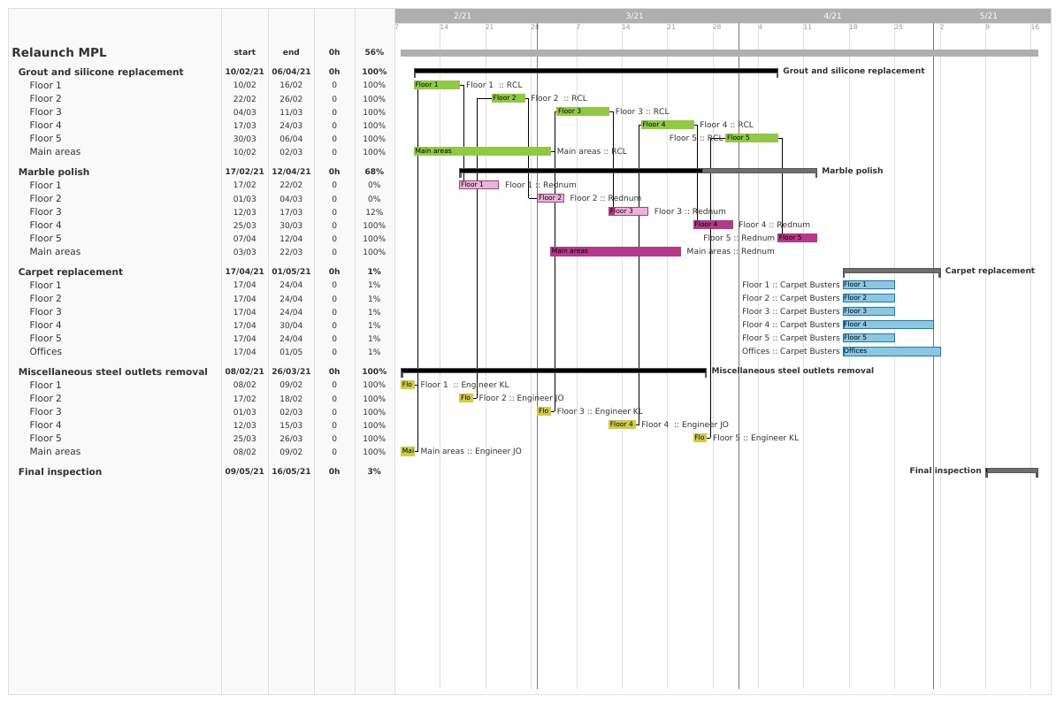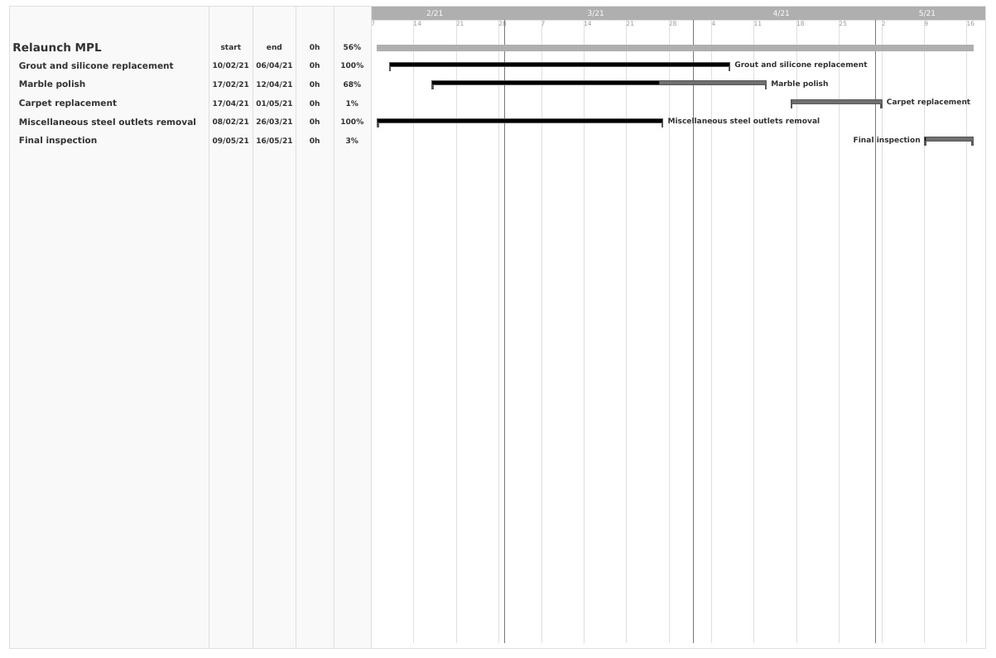

Communication plan

A key factor in keeping all the wheels in motion and spinning in the same direction is communication. To ensure this happens at the highest level and relevant information gets passed on to persons of interest, a communication plan must be established. Each project is different, however, the main areas to consider in a communication plan are identification of audience, setting goals and objectives, preparing the message, choosing frequency and priority of communication, and evaluation (Dow & Taylor, 2010).
For Relaunch MPL our communication plan is as highlighted in the figure below. We focus on our stakeholders with a frequency suitable for them, with a tailored message, and with the aid of an appointed person for the task. The main highlights are that certain stakeholders require less interaction, such as the owner, whereas others will require daily updates, that being the case for our engineers.
One aspect of the plan is the mention of the word contingency in the Executive Committee column. It serves to highlight the people to be called into action if an emergency arose or there were clear indications that the project is failing to meet the deadline. That being said, the presence of this word will modify the frequency from “monthly” to immediately (Pritchard, 2014).

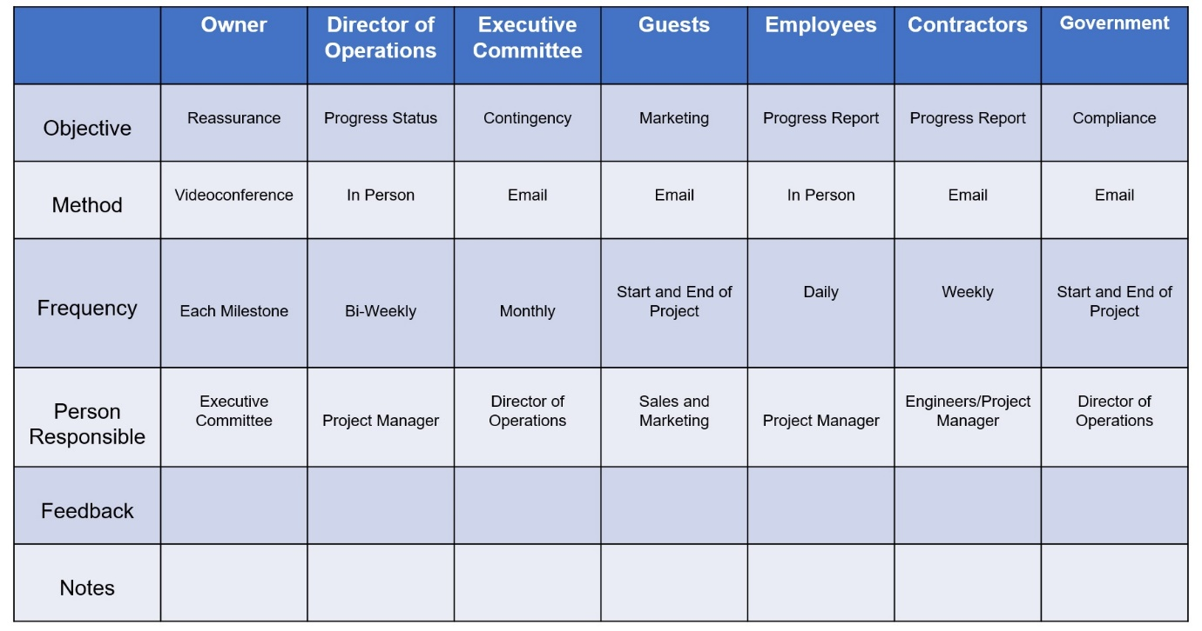

Personal Evaluation

SWOT perspective

In the same way a method of planning a project that is cost-effective and efficient is a SWOT analysis, the same can be said about a person. The acronym stands for strengths, weaknesses, opportunities, and threats (Kerzner, 1982).
When it comes to the first one, I draw strength from my years of experience in the field of engineering and managing people, effective communication skills, strong leadership with a reliable team below me, as well as my innate ability to inspire a shared vision in all the people I work with.
One must be honest and acknowledge their shortcomings too, therefore, my weaknesses stem from the desire for perfection in all the tasks I do which at time can put a lot of pressure on the people on my team. Also, having done this job for over 10 years, there is a clear sign of rigidity when it comes to how things should be done.
In terms of threats, it is clear that failing the project would have drastic repercussions on my employment, be that with this company or in the future. It is worth mentioning that the project and myself rely heavily on contractor’s performance, and although in the past they have a proven track record, the volatility of the current environment may change their future performances. The final thing that is worth considering as a threat is a sudden change in health. Currently, I have no ailments, however, there are no definite solutions for SarsCov2, and that leaves me exposed.
On a more positive note, this project presents a host of opportunities for me. Firstly, the constant engagement with the higher echelon opens a lot of doors for promotion, as well as a successful project may stimulate the owner’s generosity and that may make him look favourably on a bonus.

Self-assessment and development

A manager is a person employed within in a company and as such there are certain norms to which one must perform, thus the requirement for a performance evaluation. To a significant degree the way a manager is assessed is linked to whether they have achieved their goals or met their project deadlines.
On an internal level, the assessment is revolved around reflecting on how difficult completing the project was and whether when faced with obstacles, they navigated them effectively. A self-assessment supports the debrief process, and if similar conclusions are achieved, it opens the road to improvement (Project Management Institute, 2017).

Conclusion

Key findings

The main takeaway topic of this project is the interconnectedness of all stakeholders and how crucial it is to keep everyone informed accurately and relevantly to enable them to perform optimally. Alongside the aforementioned reasons, we have the importance of project management and the creation of specialized team within an organization that can bring large and complex tasks to fruition. It increases the level of budget accountability, promotes taking ownership of one’s action, and provides ease of mind through the presence of a well-defined Gantt chart that can confirm progress.

Recommendations

It is a commonplace practice within Marriott’s hierarchical structures for a manager to create “special tasks” for their employees. Those help expand the employee’s knowledge pool and their confidence, whilst also ensuring that work does not become monotonous. This practice has yielded results in the past and might be one of the main factors in reducing attrition levels for a company, therefore, as an expansion, those “special tasks” could be turned into “special projects”, further enhancing an employee’s abilities. This is a method I employed for my two engineers involved in Relaunch MPL where they were tasked with seeing the contractors as part of their team and figure out how to best manage them. This in turn gave them an insight in the type of mindset a manager should have and how to communicate more effectively.

References

Carstens, D. S., Richardson, G. L. & Smith, R. B., 2016. Project Management Tools and Techniques. Boca Raton: CRC Press.
Clark, W., 2019. The Gantt Chart, a Working Tool of Management. Indianapolis: Alpha Editions.
Dow, W. & Taylor, B., 2010. Project Management Communications Bible. Oxford: Wiley.
Erikson, T., 2019. Surrounded by Idiots. London: Ebury Publishing.
Eskerod, P. & Jepsen, A. L., 2013. Project Stakeholder Management. Farnham: Ashgate Publishing Limited.
Gursoy, D., Bogan, E., Sariisik, M. & Nunkoo, R., 2021. Covid-19 and the Hospitality and Tourism Industry. Cheltenham: Edward Elgar Publishing, Incorporated.
Hinde, D., 2018. Prince2 Study Guide. New Jersey: Wiley.
Hornby, R., 2017. Commercial Project Management. London: Taylor & Francis.
Kerzner, H., 1982. Project Management for Executives. New York: Van Nostrand Reinhold.
Kliem, R. L., 2011. Ethics and Project Management. Milton Park: Taylor & Francis.
Mabelo, P. B., 2020. How to Manage Project Stakeholders. London: Taylor & Francis.
Marriott International , 2021. Marriott.com. [Online]
Available at: https://www.marriott.com/marriott/aboutmarriott.mi
[Accessed 11 04 2021].
Phillips, M., 2019 . The Practitioner's Handbook of Project Performance. London: Taylor & Francis.
Pritchard, C. L., 2014. The Project Management Communications Toolkit. London: Artech House.
Project Management Institute, 2017. Project Manager Competency Development Framework. London: Project Management Institute, Incorporated.
Schein, E. H. & Bennis, W. G., 1965. Personal and Organisational Change Through Group Methods: The Laboratory Approach. New York: John Wiley & Sons.
Schwaber, K., 20004. Agile Project Management with Scrum. London: Pearson Education.
Wysocki, R. K., 2011. Effective Project Management. New Jersey: Wiley.

