Managing Projects in the organization

Project Plan
Onsite Catering DAGI

Table of contents:
1.Executive Summary ……………………………………………………………..3
2.Introduction ……………………………………………………………………….3
3.Case study overview …………………………………………………………….3
4.Project life cycle ………………………………………………………………….4
4.1 Initiation …………………………………………………………………………4
4.1.1 Project scope …………………………………………………………………4
4.1.2 Work Breakdown structure ………………………………………………….5
4.2 Planning …………………………………………………………………………5
4.2.1 Stakeholders analyses ……………………………………………………...5-6
4.2.2 Cost benefit analysis and resources ……………………………………...7-8
4.3 Monitoring and Controlling ………………………………………………….....9
4.4 Execution ………………………………………………………………………....9
4.4.1 Risk assessment …………………………………………………………….10
4.5 Closure ………………………………………………………………………….10
5. Project methodology analyse…………………………………………………...10
Conclusion …………………………………………………………………………...11
References …………………………………………………………………………...11
Appendix ……………………………………………………………………………...12

Executive summary
Project plan for onsite catering “DAGI” provides planning and information of all project teamwork. Following project plan report is trying to solve business objectives such as: reducing movement of the employees from the workplaces during break time, helping employees to develop a healthy life and reduce staff absents. After employees feedback the solution to sort those goals was to create an onsite catering. Catering will provide area for rest and various food option. In the future it will help with improving employee’s lifestyle.
Introduction
To successfully manage in a business project world, a person needs to be conversant with the organization's planning process and the procedures involved in doing the necessary preparatory work. Apart from determining the best ways to reach out to customers, the company needs to understand the importance of social corporate responsibility. The main goal in this project management plan is to create and manage a fictitious internal plan to ease break time movement, reduce staff absenteeism and encourage a healthy lifestyle at the large manufacturing company in Southeast London. Additionally, in the report will accurately describe the project's planning stages here, along with its expected scope and deliverables. Here will also be outlined a risk analysis and stakeholder analysis for the project.
Case study overview.
The project plan centres on a sizable manufacturing company with headquarters in Southeast London. Approximately 1000 people work at the site, performing a variety of jobs such as office personnel or factory workers. The offices and manufacturing facilities are spread over multiple buildings on the large complex. However, there isn't currently any on-site dining available. In addition, there is a lot of traffic in the region since workers walk out occasionally for lunch and take breaks. The project's primary goal is to establish an on-site catering and wellness programme to help large manufacturing companies address lunchtime congestion and promote the health and wellbeing of their workforce. As part of its CSR goals, the organisation must address this by promoting a healthy lifestyle to reduce absenteeism and limiting individual movement around lunchtime. Employees at project and programme offices oversee examining these goals and creating practical strategies to reach them, which will help the company grow and enhance its operations. The project manager is in charge of coming up with a plan to open a business or catering operation inside the office building. This will guarantee that workers stay on the premises, have meals that are well-balanced, and lessen the possibility of traffic and absence.

Project lifecycle
The Project Life cycle serves as a guide for carrying out a project from beginning to end. The type of project and the firm's requirements dictate the exact number of stages and the order in which they occur throughout the cycle. (Reiss, 2015) They should begin and conclude at specific times because they are time-bound and tied to the project. The project lifecycle outlines the fundamental tasks that must be completed, irrespective of the type of labour required. The PLC model's five steps are shown below.
Project initiation - This stage establishes the project's scope and objectives, goals, and stakeholder preferences. It also provides the framework for the project as a whole. A project's beginning involves a number of processes, such as identifying the important stakeholders, defining the project's goals, and starting the preliminary planning phase. (Maylor, 2010) The process for initiating a project also involves obtaining the required resources and obtaining approval to proceed with the project.
Project scope
This project aims to reduce employee’s absenteeism, minimise workers movement during lunch breaks, encourage healthy lifestyles, and prevent traffic in the surrounding region, and provide wholesome food options by planning, implementing, and analysing on-site dining facilities. With the aid of this project, it can be said that the company will comprehend its growth objectives and challenges in three to six months. Consistent monitoring and communication with project stakeholders will guarantee satisfaction with objectives and timely resolution of issues. (Wysocki, 2000) The project's objective is to improve the working environment's health and productivity in order to help the company reach its objectives and improve employee satisfaction. (Field, and Keller, 1998) After the project is finished, it will be evaluated based on a number of success metrics, including reduced employees’ movement and improved employee health indicators. The project team is responsible for making sure the project is managed to yield the best results possible in the end. This is only possible if the organization's leadership makes the effort to gather all pertinent stakeholders, such as vendors, financiers, and industry experts. (Hughes, 2012) Providing the resources for the construction project on schedule is essential. In addition, risk assessment analyse can provide valuable perspectives on potential roadblocks, facilitate the project's seamless advancement, and measure the project's impact on the organization's overall growth.
Work Breakdown Structure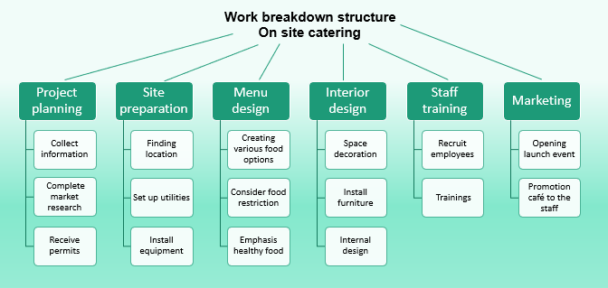
Figure 1
Source (Self)

Project planning - The project team creates and implements a thorough project management plan (PMP) that outlines the tasks, resources, and risk management strategies for the project during the planning phase. Extensive plans are created to direct the project's implementation. (Berkun, 2008) The project's schedule, deliverables, resource allocation, and reach identification are all included. In addition to assigning responsibilities and roles, project planning also includes creating quality standards and communication routes. (Hughes, 2012) Following this stage, the project manager ought to possess an all-encompassing plan for executing and supervising the project.
Stakeholders analyse.
Shareholders – internal stakeholders with the high power and high interest. Their financial interest in the project's success could have an impact on the company's earnings, which is a potential impact. (Maylor, 2010) The project will be improved by profits and overall financial performance, which are the two measures shareholders are expecting. Since they have put a lot of money into the project, they believe that by increasing employee happiness and productivity, they will be rewarded.
Employees – internal stakeholders with low power and high interest. These people are the project's main beneficiaries because it's meant to provide them with convenient and healthful lunch options. Employees expect the project to provide them with healthy lunch options, and onsite lunch options are one of them. They anticipate that getting easier way to meals when working will positively impact both their general well-being and degree of job satisfaction. (Heagney, 2016)
Management team – internal stakeholders with high power and high interest. Their responsibilities include project approval, project financing, and project performance overall. Furthermore, they are curious about the impact the project plan has on employee satisfaction and retention. (Heerkens, 2015) The management anticipates that if the project plan will be permitted, funded, and completed successfully. It is anticipated of managers that they as a team lead will raise employee satisfaction and loyalty, which will assist the company meet its objectives and increase productivity in the cutthroat business world.
Project team members – internal stakeholders with high power and high interest. For the sake of their individual tasks, each member is responsible for the project's planning, execution, and delivery. The project team anticipates specific direction and support from the company's management in order to plan, carry out, and finish the project. They eagerly anticipate receiving recognition for their dedication and completing all of their taxing assignments.
Local community – external stakeholders with low power and interest. The neighbourhood is one of the most significant stakeholders because the canteen will help with the ongoing traffic issues. The residents expect the project will assist to lessen two issues: traffic congestion and the neighbourhood. They anticipate that having food available on-site will improve the mood and reduce traffic issues.
Suppliers – external stakeholders with high power and high interest. This covers the providers' provision of food supplies, kitchenware, and building materials. The vendors anticipate that the initiative would boost demand for their services and create new business avenues. They anticipate prompt payments and wish to have a good working relationship with the business. (Berkun, 2008)
Government – external stakeholders with high power and low interest. The project must adhere to all laws and regulations, according to administrators in charge of safety and rules. They intend to appropriately implement health and safety measures for the benefits for employees and customers.

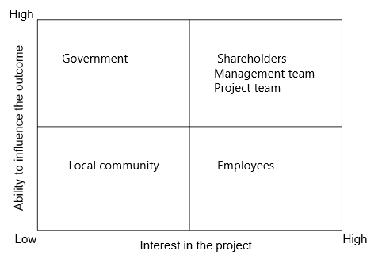
Table 1. Stakeholders.
Source(self)
Cost Benefits analysis
Cost analysis is a mandatory for any business strategy. It assists the company in determining if the project plan is commercially feasible by forecasting the execution costs. The cost of a firm project is determined by considering a number of factors. These consist of many expenses such as labour, supplies, advertising, running costs, and more. The manager can use this data to present a thorough cost breakdown for starting and maintaining the project. (Heerkens, 2015) The precision of the cost estimate determines how well the project manager can steer the business plan. The table below outlines the project's estimated cost.

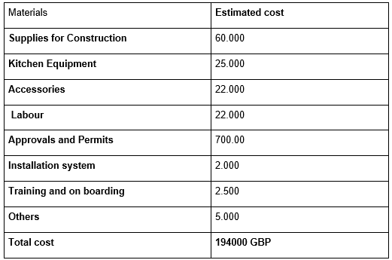
Table:2
Source (self)
Resources
Resources | Material Resources | Human Resources | Financial resources | Technological Resources | Additional resources
Influence | The procurement of goods, including construction supplies and culinary utensils for the recently introduced worker food services, is a major resource requirement for project execution. (Heagney, 2016) This resource is entirely responsible for the purchase and utilization needed to build high-quality facilities and functional amenities. | The most valuable resource in a business is its people, including project teams, skilled labourers, and managers. (Watson, 2002) Their participation and knowledge are essential  and efficient operation of every part of the project, including planning, execution, and supervision. | Financial resources are essential to the project's success since they allow for the construction of the workers' catering facility, the collecting of cash, and the maintenance of the project's financial sustainability. Effective administration will ensure ongoing progress and timely completion. | The manager could enhance collaboration and communication and establish constitutions with the help of technology. (Buttrick, 2009) Technology tools such as project management and construction software can facilitate collaboration and communication, resulting in more accurate and productive projects. (Roberts, 2011) Although their use could enhance productivity and decision-making, they are not required. | Informational and regulatory resources are among the other equally important resources. When utilized properly, they do contribute to a project's increased smoothness and efficiency even though they are not readily apparent.
Importance | High | High | High | Medium | Medium

Project execution - The project team implements the project plan throughout the execution phase and ensures that there are sufficient resources to do the assigned tasks. (Wysocki, 2000) This step includes managing stakeholders, implementing the project scope, and allocating resources. Team members perform as directed and their progress is tracked to guarantee that a project stays on track in terms of budget, schedule, and quality. (Buttrick, 2009)
Risk assessment.
Risk | Importance
Financial risk | High
Construction risk | High
Health and safety | Medium
Operational risk | Low
Reputation risk | Medium
Table 4.

Construction risk – obtaining the required approvals and clearances being difficult, and there are issues with finding skilled staff.
Financial risk - risk of spending too much because of unforeseen expenses and inflation. (Roberts, 2011)
Operational risk - dissatisfaction with the catered food and services at the canteen directly affects employee content.
Health and safety risk - Occupational hazards in the kitchen together with mishaps and injuries associated with building.
Reputation risk - Contempt food safety laws and procedures. When negative publicity and reviews affect a brand, its reputation may suffer. (Reiss, 2015)
Project monitoring and control - The project team will be making sure that everything is still within the established constraints and on schedule at this point. The project team keeps an eye on performance and addresses issues as they arise to ensure that all deliverables are satisfied. (Reiss, 2015)
Project closure - Verifying that all project deliverables have been accomplished to the satisfaction of the project organiser is the aim of this stage of the PLC. The project manager should also let everyone involved in the project know how the project turned out. (Heerkens, 2015) The project resources will be released once all outstanding tasks have been completed, and the finished good or service will be given to the people who matter most. It facilitates the project's transition to the following stage.
Lesson learned - A deep declaration that lists the key lessons gained all member of the project team.
Project methodology analyse.
Agile Manifesto Software main points are client cooperation as opposed to contract drafting,
adapting to change as opposed to sticking to a plan, collaboration and time management are built into the process because the product owner specifies and ranks the tasks that need to be completed in a spring. Along with teams concentrate on delivering a valuable product with significant client input within a given time range. (Wysocki, 2000)

Conclusion
An overview of the construction project plan of an onsite catering service with the zone for rest for the workers was to be provided by this in-depth research, which was built inside the office premises of a significant manufacturing company. In this study, the various steps of project plan are covered. The project's execution and completion, stakeholder resource and risk analysis, and risk-reduction strategies are all included in these phases.

References:
Berkun, S. (2008) Making things happen: mastering project management. California: O’Reilly.
Buttrick, R. (2009) The Project Workout: The Ultimate Handbook of Project and Programme Management. 4th ed. Harlow: Financial Times/Prentice Hall.
Field, M. and Keller, L. (1998) Project Management London: Open University / Thomson Learning
Heagney, J. (2016) Fundamentals of project management. New York: AMACOM. Available at: https://search-ebscohost-com.ezproxy.uwtsd.ac.uk/login.aspx?direct=true&db=nlebk&AN=1135060&site=ehost-live (Accessed: 09 April 2024).
Heerkens, G. R. (2015) Project management (A briefcase book). New York: McGraw-Hill.
Hughes, B. (2012) Project management for IT-related projects (2nd ed.). Swindon: BCS.
Leach, L. (2004) Critical chain project management (2nd ed., Artech House effective project management series). Boston, Mass.; London: Artech House.
Maylor, H. (2010) Project management (4th ed.). Harlow: Financial Times Prentice Hall. https://www-dawsoneracom.ezproxy.uwtsd.ac.uk/abstract/9780273743521 (Accessed 17 April 2024)
Meredith, J. and Mantel, S. (2009) Project Management: A Managerial Approach, Asia: John Wiley & Sons
Roberts, P. (2011) Effective project management. London: Kogan Page. https://www-dawsoneracom.ezproxy.uwtsd.ac.uk/abstract/9780749461584 (Accessed 12 April 2024)
Reiss, G. (2015) Project management demystified London: Routledge.
Watson, M. (2002) Managing Smaller Projects: a practical guide. Hook: Project Manager Today Publications
Wysocki, R. K. et al. (2000) Effective Project Management 2nd ed. New York: Wiley.

Appendix


