  Component One: Student Journal (learning log) 750 words +/- 10%  Contribution to Overall Module Assessment: 25% | Student Name and No: | Constantin Daniel Andronache  2222788
 | Module Title: | Hotel Administration and Front Office Operations
 | Module Code: | BMIH4004
 | Lecturer: | Neil Dyer
Summary of My Learning
The front office department has a crucial role within the organisational structure of a hotel. I have held the position of front desk manager at Premier Inn Teeside, Stockton on Tees. Based on personal observations, it has been observed that the front office department encompasses a range of sub-departments, each with their own distinct functions. Furthermore, individuals within these sub-departments are often assigned several responsibilities. The personnel comprising the front office staff include several roles, such as desk clerks, cashiers, reservations supervisors, and bell staff lift operators, among other positions. Certain occupations are only available in certain hotels, since some front desk workers have many responsibilities due to the smaller size or limited clientele of the hotel. The primary responsibility of the front office is to safeguard the hotel's assets and the well-being of its visitors, by maintaining a secure and safe environment at all times (Namira, 2010). The use of PMS software is prevalent in many front office processes within the hotel sector, since it enables efficient management of operations. The PMS software offers valuable advantages since it offers a comprehensive understanding of the hotel's operations, leading to potential improvements in revenue generation, time management, and overall efficiency. The use of technological breakthroughs has led to the automation of several front office tasks, resulting in increased efficiency and convenience for the personnel (Tesone, 2015). The use of information technology has facilitated expeditious decision-making for managers. Another aspect that was acquired was the skill of effective communication.
Skills required to work in the front office
The individuals employed in the front office engage in frequent interactions with many visitors upon their arrival and departure. It is of utmost importance to establish favourable first impressions, as this contributes to the enhancement of customer satisfaction. Effective communication skills are a necessary need for front office workers (Indeed, 2023). Communication with visitors may be conducted via both verbal and non-verbal means. It is essential for front office employees to engage in effective communication with customers in order to establish a positive relationship with the guests. Proficient communication abilities are essential for front office workers to efficiently manage visitor questions, address any arising difficulties, and provide seamless coordination with other organisational departments. Another essential talent that is necessary for front office personnel is problem-solving (Indeed, 2023). The front office department experiences a high level of activity and encounters many unexpected obstacles. Consequently, it is essential for the front office employees to possess the necessary competencies to promptly address these circumstances by providing effective responses that align with the expectations of the guests. Another important talent is technical expertise (Indeed, 2023). The personnel's technical competency encompasses their ability to effectively use the software and technology resources employed by the hotel, hence facilitating efficient and flawless operations. Additionally, the staff should demonstrate strong organisational skills, meticulous attention to detail, and the capacity to collaborate harmoniously as a team.
Personal Reflections
Throughout my educational journey, I have acquired knowledge on the paramount importance of proficient verbal and nonverbal communication within the context of the hospitality sector. Upon introspection of my encounter as a hotel patron, I had a sense of contentment and gratification when my first interaction included an amiable individual who demonstrated attentive listening skills, so establishing a positive relationship between us. The effectiveness and efficiency of the front office, particularly in the realm of communication, have a notable influence.
Applying the Theoretical Knowledge
The front desk and hotel will succeed only if theoretical knowledge is put to use. Because it facilitates understanding of the front office, theoretical knowledge is crucial. For instance, my newfound communication skills will enable me to interact with hotel visitors in a professional manner. I now know how to interact with visitors in an efficient manner in order to establish a relationship, respond to any issues, and provide them with clear information. My ability to manage difficult situations and quickly come up with good answers has also been enhanced by my theoretical understanding.
Importance of The Topic in Hospitality
The front office is crucial to hospitality. Guest requirements and hotel transactions are actively addressed by the employees (Mondal et al., 2023). If visitors have any issues, they go to the front desk for assistance. The department also generates lodging income. The department is important since it serves all hotel customers (Mondal et al., 2023). It handles check-in, checkout, reservations, departure, pre-arrivals, and guest departure. The section also ensures visitor satisfaction. To succeed, a hotel must guarantee that the front desk delivers excellent service and that guests are constantly happy.

Component Two
Contribution to Overall Module Assessment: 25%
Trip Advisor Review Response 150 words +/-10%
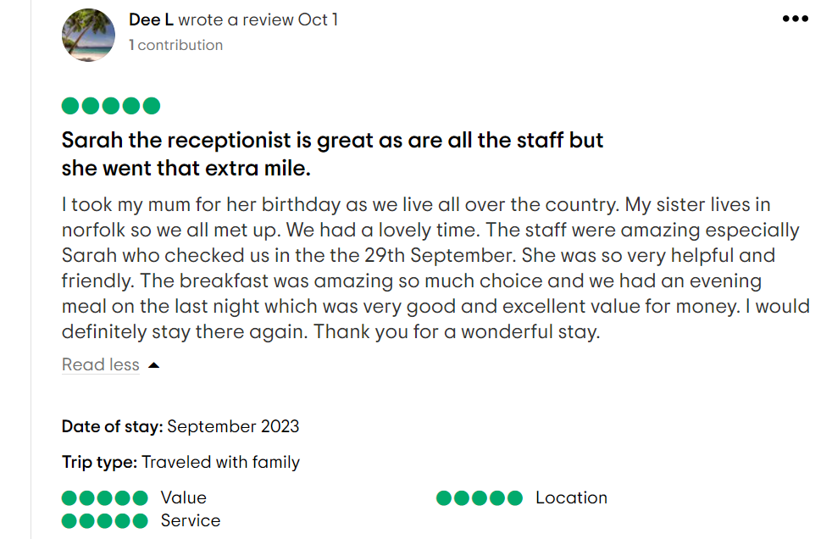
Screen shot of referenced Trip Advisor review used

Dear valued customer,
Greetings, I much appreciate your helpful contribution. We would like to extend our heartfelt appreciation for choosing our hotel as the location for your family event. Our strategy continually places a high priority on customer-centricity. The main goal of our hotel is to provide outstanding accommodations and services to our respected clients. The main objective of our hotel is to provide services that fulfil the requirements of individual travellers involved in business or recreational pursuits, as well as those involved in collective gatherings. Our organisation places a high emphasis on ensuring the provision of high-quality accommodations, as well as food and beverage services. Our organisation acknowledges the need of cultivating a skilled, motivated, and passionate workforce in order to provide a satisfactory return on investment to stakeholders. We would like to extend our appreciation for the time and effort you have devoted to provide valuable comments. Is there any opportunity for improvement in the present circumstances? We expect your attendance in the foreseeable future. We would like to extend our heartfelt thanks and deep appreciation for the valuable time you have devoted to providing us with your rating.

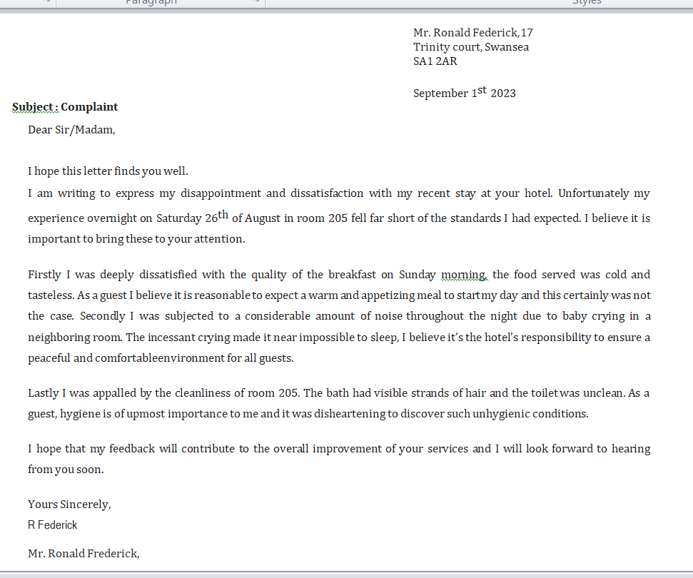

Letter of complaint response 500 words +/- 1-%
Sincere greetings Donald Ronald Federick,
At the Premier Inn Norwich Nelson City Centre, we value all correspondence received. Please accept our sincere apologies for the dissatisfactory service you received. Despite the fact that your accommodation was prepared at the time of check-in, you claim in your letter that you were unable to check in because they were not yet ready. In addition, the accommodation was spotless, there was no disturbance from the neighbors, and the food was delicious. The Premier Inn Norwich Nelson City Centre would like to apologies if our visit to the hotel caused any inconvenience. In response to your complaint, we have retrained our front-desk staff and are working to resolve the issue. As a result, the hotel staff has been instructed that, in the event of incoming guests, it is preferable to retain their luggage and provide certificates for the hotel restaurant as compensation. According to you, the excessive commotion in your room is caused by the area's noisy residents producing noise in their residences. There has been a beginning to what we are doing. Our walls and floors can now be more effectively insulated. In order to reduce disturbance in the home, acoustic windows and draperies were installed, as well as ceiling and wall panels and tiling. Additionally, the doors must be installed so that they close silently. The "floating bedroom" concept was created by Premier Inn. This made it feasible for the hotel to manage both outside commotion and disturbance from the ground floor festivities. Each bedroom in this design is a standalone entity that has no interaction with the others. Quadruple-glazed windows and acoustic linings are added to walls and ceilings to provide superior noise reduction than WHO recommendations. Additionally, we employ new housekeepers to maintain the cleanliness of the restrooms and rooms.They will replace the bed linens and towels, as well as ventilate and restock the room. Completely dust, clean and disinfect high-contact areas in the lavatory. Vacuum the floors and upholstery. Remove waste from the restrooms. Reportedly, you have complained about our dish being tepid and flavorless. Food can also be kept warm using multicores, slow cookers, toaster ovens, and heated warming trays in addition to chafing dishes. In order to enhance the meal's quality, we also confer with the chef. You assert that even after calling the front desk, your accommodation was not updated. After evaluating our records, it appears there was no other room we could have offered you. We still deplore the volume and wish we had done more to make the evening more pleasurable for you. We extend our heartfelt apologies. Considering the negative encounter you have had, we would like to provide to you a voucher worth £100 that may be used for your subsequent visit to the Premier Inn Norwich Nelson City Centre. It is expected that your next visit would surpass our expectations.
We express our gratitude for the effort you have invested in offering insightful remarks, and we extend our sincere appreciation.
Sincerely,
XYZ
Front Desk Manager
Premier Inn Norwich Nelson City Centre

Component Three
The guest cycle encompasses the many phases of engagement that occur between a hotel and its visitors. The Guest Cycle is categorised into four basic phases depending on the sort of activities engaged and the level of contact. The four distinct stages of the process under consideration are as follows: Pre-Arrival, Arrival, Stay, and Departure.
It is essential for front office workers to possess a comprehensive knowledge of guest services and guest accounting operations during all phases of a visitor's stay. The provision of efficient guest service by front office employees is contingent upon their comprehensive comprehension of the operational dynamics inside a hotel. A systematic approach to overseeing front desk operations is the Guest Cycle (Das et al., 2013).
Element 1 – Pre-Arrival
As an integral component of the guest cycle, individuals make a deliberate choice of a hotel ahead to their scheduled arrival. Several elements might impact a visitor's decision-making process while selecting a hotel. These elements are impacted by a multitude of variables, including advertising campaigns, previous experiences, recommendations from acquaintances and colleagues, associations with businesses, geographical proximity, reservations made via travel agents, loyalty programs, reputations, and corporate connections.
The efficacy and efficiency of the reservation procedure have a substantial influence on hotel bookings. One component that has a significant role is the level of communication established between the visitor and the reservation agent. When selecting accommodations, customers consider many factors, including room options, pricing, and available leisure activities.
The reservation centre of an individual or non-corporate company is often known as a sales office. It is important for establishments to preserve a favourable reputation and actively promote sales.
When a reservation is accepted by the hotel reservation agent, it is added to the hotel's software. It is the start of the hotel visitor cycle that this reservation record is created. As part of this reservation, the hotel will be able to provide the visitor with personalised service during their stay based on the specific requests made by the guest.
The information gathered during the reservation process helps the hotel to complete some preregistration tasks, including allocating rooms based on guest preferences, as well as determining the appropriate rate that should be applied to the visitor's account during their stay based on the information collected.
Despite the fact that reservations facilitate anticipatory service, the main function of making a reservation is to ensure that a room is available when the guest arrives at the hotel, which is the main purpose of making a reservation (Su et al., 2019).
Element 2 – Arrival
Visitors are registered and assigned rooms during the first phase of their visit. As soon as the visitor arrives at the hotel, he or she establishes a commercial connection with the hotel. Guests' inquiries about hotel rates and packages are addressed by the front office employees as part of their job duties.
Before beginning the check-in/registration process, front office staff should always make sure they are aware of the status of the reservations of the guests. Front desk personnel can generate additional business from guests who have reservations as well as those without reservations, sometimes known as walk-ins.
Registration cards or registration forms are required at the time of check-in. For the front desk, an information card can be generated and filled out to gather necessary information. In addition to instructions for billing, reservation details, the number of people and children residing on the premises, address information, passports and visas for foreigners, complete personal details, and credit card information, the registration card should include pertinent information. A visitor's signature on a registration card is an essential requirement for obtaining certain legal advantages by both the visitor and the hotel.
Following the confirmation and signature of the payment method and departure date, the registration process is considered complete. Guest service associates and guest service managers accompany guests to their rooms, if they request one, or they may receive a room key with directions to their room (Law et al, 2014).
Element 3 – Duration of stay
The front desk staff represents the hotel during occupancy. Front desk staff handle guest requests and organise hotel operations. Information and supplies are provided to tourists by people.
Answering guests' inquiries and requests promptly and correctly is crucial for the front desk staff. We strive to provide proactive service to our guests in order to exceed their expectations. The hotel will benefit from this by having people return.
Guest and hotel accounts are affected by charges for restaurants, telephones, internet, and travel desks while guests are staying at the hotel. These charges are recorded and reported by the Front Office. A guest's credit limit must be monitored throughout their occupancy, and the front office must verify charges on the guest's account. A front office representative's impression of the hotel matters when guests are staying at the hotel.
Front office staff are responsible for organising visitor requests and serving as the hotel's primary point of contact. Visitors are being provided with information and provisions by the people who are giving them information and provisions.
To ensure guests' needs and inquiries are promptly and accurately addressed, front desk staff need to exercise greater diligence. Providing proactive service and exceeding the expectations of guests are the primary goals of the front desk personnel. Guest loyalty will be increased as a result.
During a guest's stay, ensuring security is a high priority. Among the above concerns are those related to safeguarding financial resources and valuable assets. Organising hotel keys, property surveillance, safe deposit boxes, guests' personal belongings, and dealing with emergency situations require the front desk staff to follow established hotel operational procedures.
During occupation, guests and hotels may incur expenses for services such as restaurants, telephone services, internet access, and travel desk services. In accordance with front office posting processes, these costs are mostly recorded on the guest account. Additionally, it should be noted that in most cases, the guest's invoice is dominated by the cost of lodging.
Aside from reviewing charges recorded on guest accounts and examining them against established credit limits during the occupation phase (Anagnostopoulou et al., 2019), the front office pays additional attention to financial responsibilities during the occupation period.
Element 4 – Departure
During the final phase of the visitor cycle, which is also called departure, the guest services and guest accounting parts are completed.
Having checked out of the hotel, guests are required to quit the room, keep an accurate record of the settlement of the bills, return the keys to the hotel, and then depart from the hotel. In response to a visitor's departure, the front office staff updates room availability and informs the cleaning staff of the situation. A hotel's room status is automatically updated when using property management software.
A guest feedback form is also distributed during this phase to collect feedback from hotel guests (Anagnostopoulou et al., 2019).

References
Anagnostopoulou, S.C., Buhalis, D., Kountouri, I.L., Manousakis, E.G., and Tsekrekos, A.E., (2019) The impact of online reputation on hotel profitability. International Journal of Contemporary Hospitality Management, 32(1), pp.20-39.
Das, B.L. and Baruah, M., (2013) Employee retention: A review of the literature. Journal of Business and Management, 14(2), pp.8-16.Front office department at Sahid Jaya Hotel Solo.
Hayes, D.K., Hayes, J.D. and Hayes, P.A., (2021) Revenue management for the hospitality industry. John Wiley & Sons.
Indeed (2023) Essential Hotel Front Desk Job Skills - indeed, .indeed.com. Available at: https://au.indeed.com/career-advice/career-development/hotel-front-desk- job-skills (Accessed on 16th October 2023).
Johnston, R Clark, G. Shulver, M. (2012) Service Operations Management, Pearson, London
Lai, I.K.W., (2019) Hotel image and reputation on building customer loyalty: An empirical study in Macau. Journal of Hospitality and Tourism Management, 38, pp.111-121.
Law, R., Buhalis, D. and Cobanoglu, C., (2014) Progress on information and communication technologies in hospitality and tourism. International Journal of Contemporary Hospitality Management.
Mondal, B. et al. (2023) Hotel Front Office Department: Importance, functions, duties, Hotel Management Tips. Available at: https://www.hotelmanagementtips.com/hotel-front-office-department/ (Accessed on 25th October 2023).
Namira, D.M., (2010) The essential roles and activities of Nikolskaya, E.Y., Pasko, O.V. and Novolodskaya, G.I., 2019. Development of the staffing system in hotels in the digital economy: Economic and legal aspects. Opción: Revista de Ciencias Humanas y Sociales, 35(20), pp.1059- 1073.
Solomon, M. (2018) The Heart of Hospitality. New York: SelectBooks, Inc.
Su, L., Stepchenkova, S. and Kirilenko, A.P., (2019) Online public response to a service failure incident: Implications for crisis communications. Tourism Management, 73, pp.1-12.
Tesone, D. (2015) Principles of management for the hospitality industry. London: Routledge.
Tewan, J. (2009) Hotel Front Office: Operations and Management, Oxford Higher Education Press.
TripAdvisor (2023) Premier Inn Teeside, Customer Review (Accessed on 20th October 2023).
Vallen, G. & Vallen, J. (2012) Managing Hotel Operations Fallon, M. & Rutherford, D. (2010) Hotel Management and Operations, Wiley, London.

