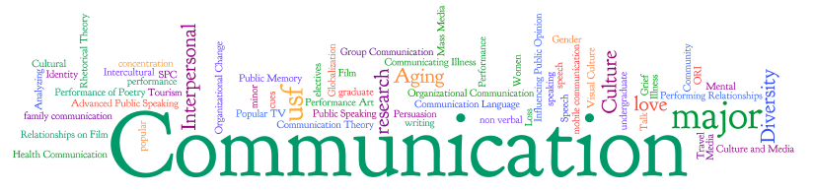

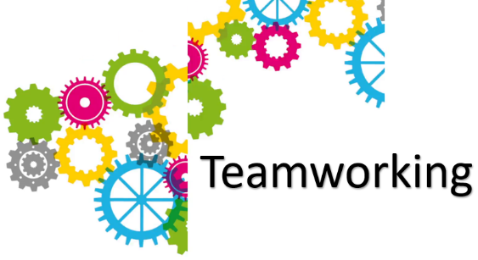



Introduction
A researcher has been investing into Terrance Thomas company by going into depths of how improvement can be made for himself and his employees within the workplace and gather information together and invest in ways of communication theory and recommend to Terrance Thomas for his employees to adjust in the workplace. Terrance Thomas is a business man that opened a grocery store but has had a rapid growth within his company over the last year. When terrace firstly opened the store he had the small amount of just 4 employees. Terrace then realised from the expansion of his store he would now need more staff to remain a good pace company; he has now employed a total of 27 people with a various amount of experience and skills within different age ranges. The majority of the staff floaters throughout the whole categories of job roles and most employees are working part-time with the store hours of 7.00am-10.00pm. Recently a sales assistant is off work due to long term sickness, therefor Terrace has to apply an action plan for a replacement and correct training for his company and staff due to lack of communication within his workplace.


Communication -
What is communication?
- A definition: “Communication is the transactional use of symbols, influenced, guided, and understood in the context of relationships”
Verbal communication –
Verbal communication -Verbal communication is any communication that uses words to share information with others. These words may be both spoken and written. Communication is a two-way process.
Non – Verbal communication –
Nonverbal - Nonverbal communication refers to gestures, facial expressions, tone of voice, eye contact (or lack thereof), body language, posture, and other ways people can communicate without using language

Verbal –

Verbal communication is defiantly a skill that is needed and most importantly within a work place. Communication is broken down into many ranges of categories but verbal is mostly important. The researcher suggests that Terrace Thomas bring his employees into a group and communicate among each other across many subjects, the researcher also thinks the conversations does not have to be involved with work as it may up bring problems and awkwardness between Terraces employees, especially with the ongoing problems with his work place right now. The researcher believes with this activity taking place it will help the employees grow a bond with each other and give confidence as it will help them develop talking professionally and non-professional with also having a comfortable atmosphere around the individuals for the employees.


Nonverbal –
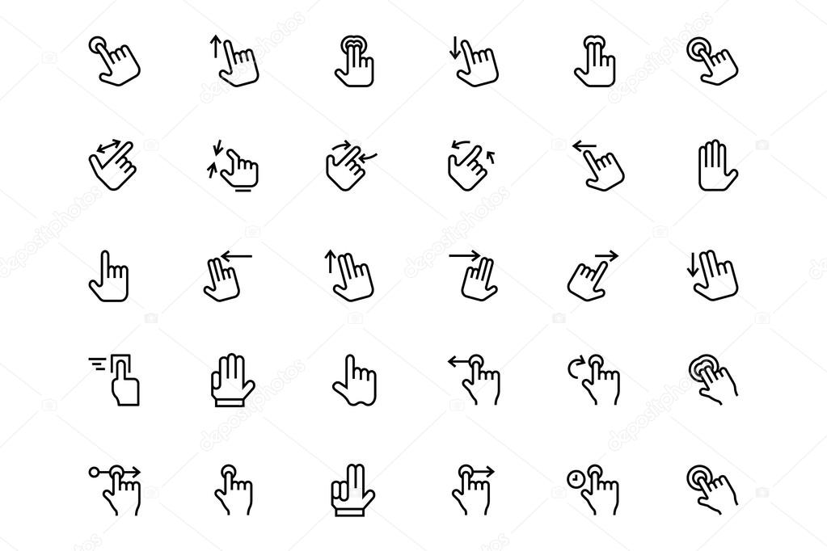
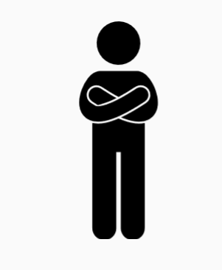
Non – Verbal communication is can also be a major impact in the workplace as it covers many skills and areas. The researcher recommends Terrance gathering all his employees together and focus on different types of emotions. That allows the rest of the employees to guess and evaluate on what emotions are being shown. The researcher believes this will improve customer service skills as the employees are practising showing body language, gestures, eye contact, tone of voice; the researchers aim for Terrance’s employees to develop confident and come across approachable to not only customers but their employees.


Two – way communication
Two-way communication is when one person is the sender and they transmit a message to another person, who is the receiver. When the receiver gets the message, they send back a response.
The importance of two – way communication is that the listening and speaking skills are used in correct terms. The importance of this is if the person speaking to the person listening the speaker expects a correct response and vice versa. This is extremely important in any work place as two – way communication is often used between staff and employees.
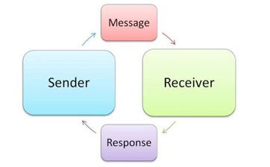

What is the Shannon Weaver Model?
The Communication Cycle model is a linear model of communication that provides a schematic representation of the relation between sender, message, medium/ media and recipient. It was developed by Claude Elwood Shannon and Warren Weaver.
The researcher briefly suggest this model as it is a good example of a 2 way communication, as it shows the correct processes of the message sender and the message receiver. By sending messages you have to gather the correct information before forwarding to the message receiver. If the incorrect information gets across this could develop many problems, so the importance of listening skills have a major impact in the workplace.
The researcher believes that the employees could gain few skills but could improve many other skills such as listening and responding, the employees should then find their best fit into the 2 categories of message sender or message receiver.

The Shannon Weaver Mathematical Model, 1949
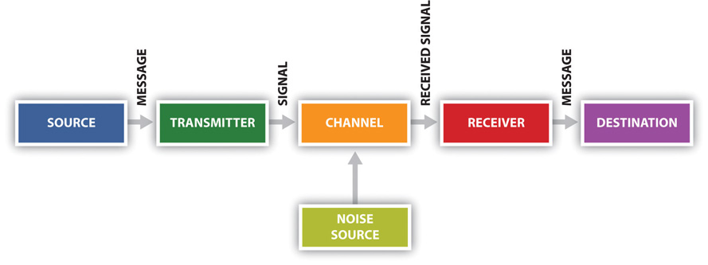

Belbin’s Theory –
Belbin's team roles. An effective way to assess the relative strengths and weaknesses of a team. Helps the team to understand ways in which it could improve performance. ... Belbin describes a team role as "a tendency to behave, contribute and interrelate with others in a particular way."
Belbin’s theory is broken down into 3 categories listed, and then followed by further break downs into more personal roles:
- Thinking oriented roles:
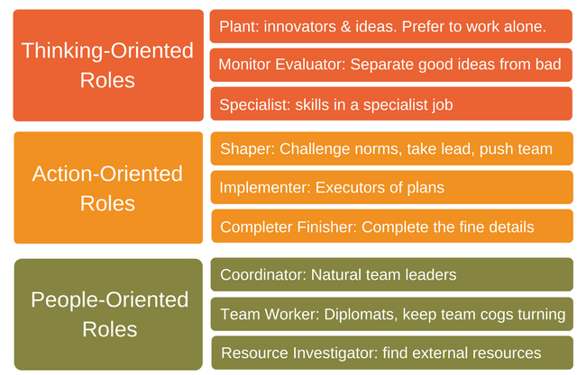
- Plant
- Monitor evaluator
- Specialist
- Action oriented roles:
- Shaper
- Implementer
- Completer Finisher
- People oriented roles:
- Co-ordinator
- Team worker
- Resource Investigator
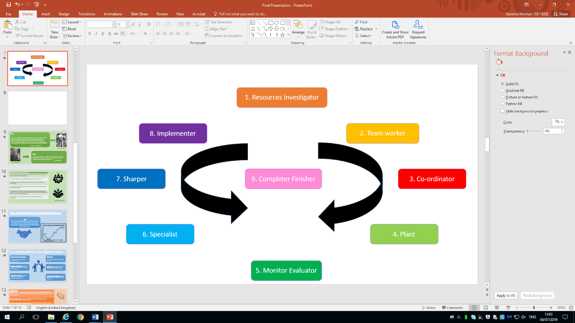
Terrance Thomas employees can use Belbin’s theory as individuals firstly as Belbin breaks down into categories of where people fit into specific roles and help gather together and see their fit within the workplace and thieve with their comfortably. Then the employees should gather together after places themselves into the Belbin roles and work on building up a successful team and keep Terrance Thomas business up – running and successful as well. After these stages of Belbin the employees should then put forward a simple action plan where they and Terrance come to a solution to help improve his business including training for the employees, allocate specific job roles.

Tuckman’s Theory –
Tuckman's theory focuses on the way in which a team tackles a task from the initial formation of the team through to the completion of the project. Tuckman later added a fifth phase; Adjourning and Transforming to cover the finishing of a task.
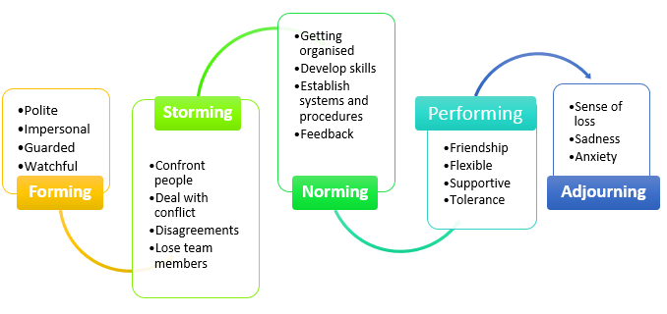

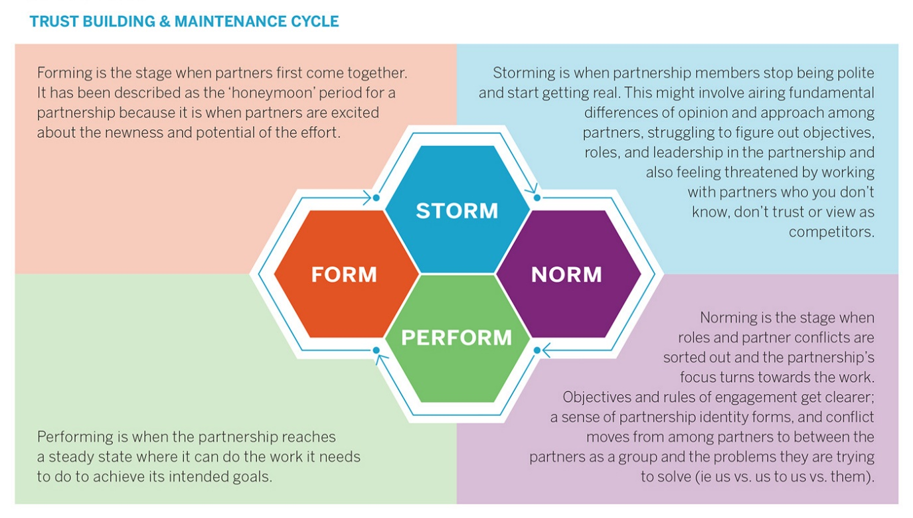
The researcher suggest that Tuckman’s can cover over many factors of skills that can be gained within the workplace for Terrance’s employees. Tuckman’s theory can categorise individuals for the personal fit and develop many skills and shine as individuals which can help the situation of Terrance’s problem. Terrance can use this theory for his employees to encourage them to interact between in groups, which can help them improve on confidence and build up to leadership from using Tuckman’s theory.

The researcher believes that this theory is beneficial and most successful, due to Tuckman’s theory starting from simple stages and building up along the way can pick up and improve skills what are needed within the workplace.

Language Diagram –
Body language (55%) – Body language is a strong way of communicating due to the body being the first appearance visible. Body language is a key skill to have and develop due to showing person/persons an emotion or feeling before even communicating by voice. Body language can make a person come across as confident by them having strong mannerisms or even look approachable.
Tone of voice (38%) – Tone of voice can be extremely effective in a various amount of ways as if you have correct volume and tone within your voice you are easier for people to understand and listen even further respond to what you are speaking. Having correct tone of voice can help the audience/ group/individuals understand due to them finding the speaker confident or knowable as they are coming across correctly with having the skill of tone of voice.
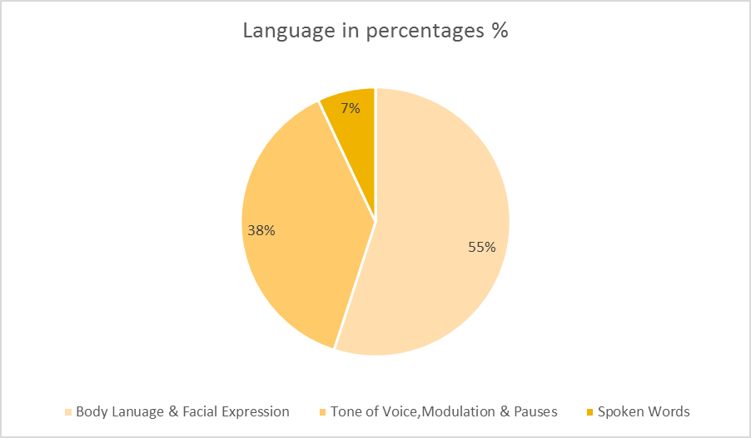
Words (7%) – Even though words is a low percentage it is still majorly important as people still take in that percentage of what you’re saying. If you speak clearly and confidently they can respond correctly with the correct terms. If the person is knowable of what the subject is based on the audience/group/individually automatically can be intrigued by the correct communication by spoken about.

Body language & facial expression – Having these as skills in the workplace are important as it firstly shows your appearance before even physically speaking to one another. Using correct body language can endure others that you are confident and knowledgeable, same principle for facial expressions.
Tone of voice – Having correct volume and speaking clearly can benefit individuals and whom is listening majorly due to the person speaking can sound knowable of what there speaking about and then is also easier to understand for other to.
Spoken words – Even though there is a smaller percentage of words that are spoken, the importance is still high, as this can gain and improve skills within the workplace.
The researcher have recommended this diagram as it shows a strong understanding of communication and language broken down into barriers of communication by percentages. Terrance should use this diagram for his employees as is covers a large aspect of skills.

Action Plan
Action Plan (Weekly) | How to monitor? | Time Frame
New Rota | Each week the rota gets posted, ensure that the hours and correct for the employees and all staff is happy with proceeding the on-going shifts. | Weekly Rota  10 minutes to look over rota.
Weekly staff meetings | These meetings should include all staff including Terrance to answer any questions or if the employees have any suggestions for improvement within the workplace. | Take 1 – 2 hours for meetings.
One to one meetings with employees | The one to one meetings are for personal preference between Terrance and an individual, As there could be a private matter occurring in a personal out of work life or in work matter. | 30 minutes – 1 hour time slots.
Feedback for staff | Having feedback for the employees could help them engage on improvement and reinsure them on the progress in the workplace. And also monitor areas of improvement. This could also get treated as an appraisal. | Weekly  30 minutes – 45 minutes
Training procedures | Having weekly training can avoid problems occurring in the workplace. And succeed Terrance on having a good up running company. | 2 – 3 days a week if possible.

The researcher has put an action in place for Terrance and his employees as it will help improve the training and help build strong skills. This will also help the company as this will action plan is routine and will get improvements and suggestions for the workplace and individuals. All the employees should apply to this action plan to improvement in themselves and the company.

Recommendations -
The researcher suggests that to improve Terrance’s company the training strategies should take place immediately. Terrance should gather his employees together and use team – building exercises to build up bonds and relationships in the workplace. This can also develop many communication skills and also improve and gain skills to. As the researcher mentioned using the Shannon Weaver Model can help the employees due to practising two – way communication which is a vital skill to have. Even though the employees might already have a skills in ranges of communication there is always room for improvement this is where the model helps.
Researcher also recommends using Belbin’s and Tuckman’s theory as is has a several of skill break downs and can put individuals into personal categories for their best fit. As these both theory start of small and gradually build-up this is a professional and appropriate w\y to help Terrance improve his training for the employees and succeed for his company.
Conclusion –
The researcher advice is for Terrance to forward and up take the theories mentioned and see what works best for himself and the employees and improve themselves. Terrance should also monitor his success if the improvement is working. The researcher believes that all the theories Terrance to up take these as it should fit into all individuals to improve the way of work in the workplace. The researcher gave Terrance the action plan for a breakdown of how to improve and monitor his success and also his employees training to avoid problems and on-going matters. The researcher believes that if Terrance and the employees apply to these theories then the company should become more successful rapidly.
References –
- https://www.youtube.com/watch?v=-efhOLVgEvM
- Belbin, R Meredith, 2012 23rd May ,Team roles at work (2nd Edition), Routledge
- https://www.google.com/search?q=what+is+communication&source=lnms&sa=X&ved=0ahUKEwiLpdWPmZvjAhUFx4UKHcYeBWEQ_AUICygA&biw=1920&bih=985&dpr=1

- http://www.businessdictionary.com/definition/verbal-communication.html
- https://www.skillsyouneed.com/ips/nonverbal-communication.html
- https://expertprogrammanagement.com/2017/06/belbin-team-roles/
- https://culcgloria.wordpress.com/2016/04/01/blog-2-challenge-of-managing-diverse-team/
- https://www.livingcities.org/blog/1173-form-storm-norm-perform-how-to-consider-the-stage-of-your-cross-sector-partnership-in-a-new-year
- Duck, S & McMahan, D.T, (2015), p.5
- https://redeapp.com/2016/01/26/are-you-guilty-of-linear-communication/linear/
- https://www.toolshero.com/communication-skills/communication-cycle-shannon-weaver/
- https://mcburgess11.wordpress.com/2013/03/25/statistical-pie-chart/
- https://study.com/academy/lesson/what-is-two-way-communication-definition-systems-examples.html

