Matthew Barnard
1702418
Lab book
Gary Jones

Operational Amplifiers
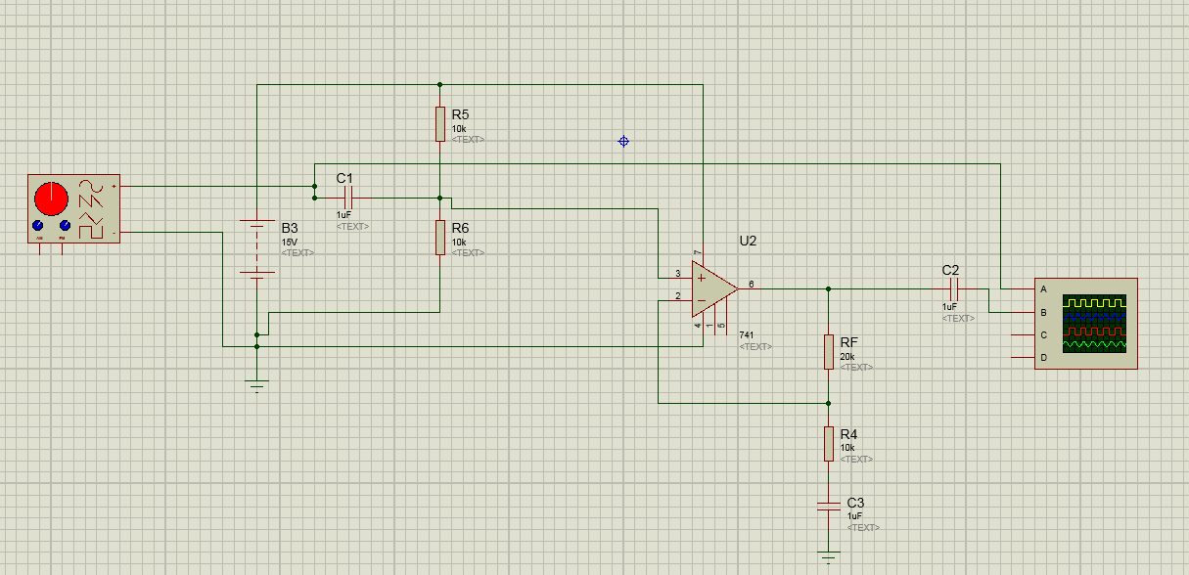
This is the operational amplifier which was built on proteus. It produces a sine wave on an oscilloscope and has a theoretical Gain of 4. The graph below is the theoretical output of this circuit where channel A is the input at C1 and Channel B is the output at C2.
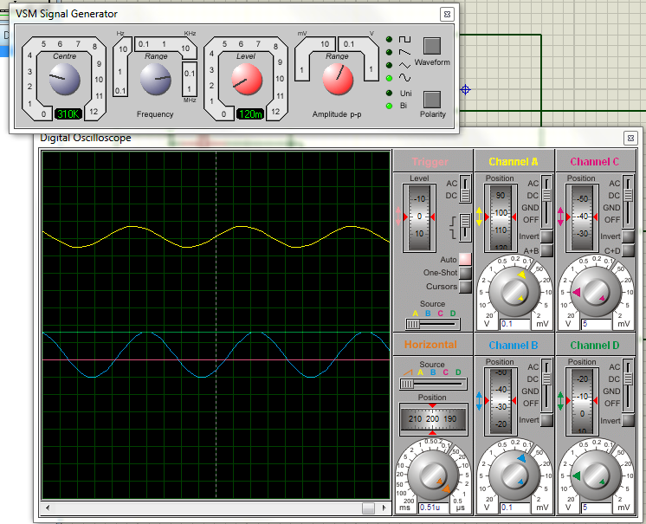
Where the above is the theoretical oscilloscope readings the pictures below is the real life readings of the actual circuit that was built on a bread board. It shows that the output drops below the R.M.S. value after a certain frequency which is 300 KHz which means the GBP is 900 KHz.

GBP = Gain * RMS Frequency
GBP = 3 * 300 KHz
GBP = 900 KHZ
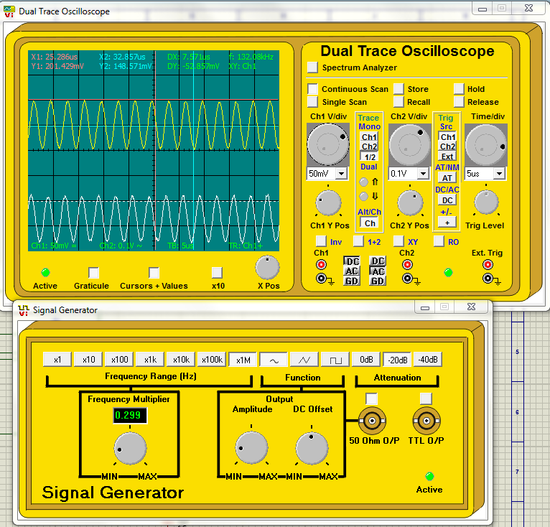

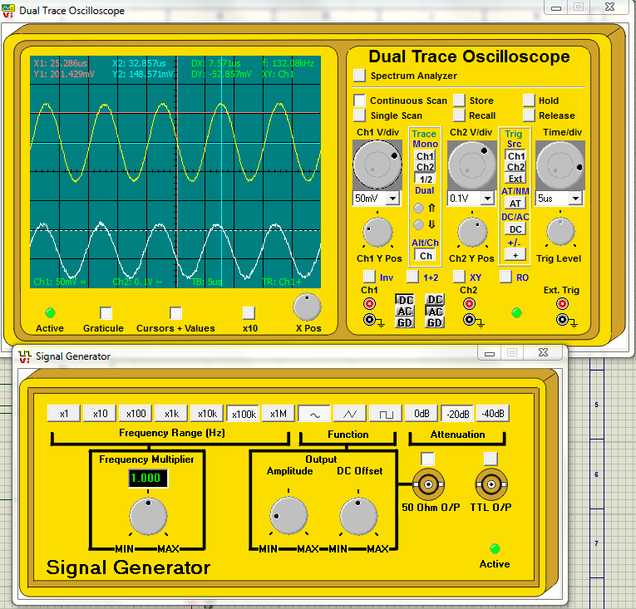
The pictures below are the same graphs but at a different frequency where the voltage is above the R.M.S. value.
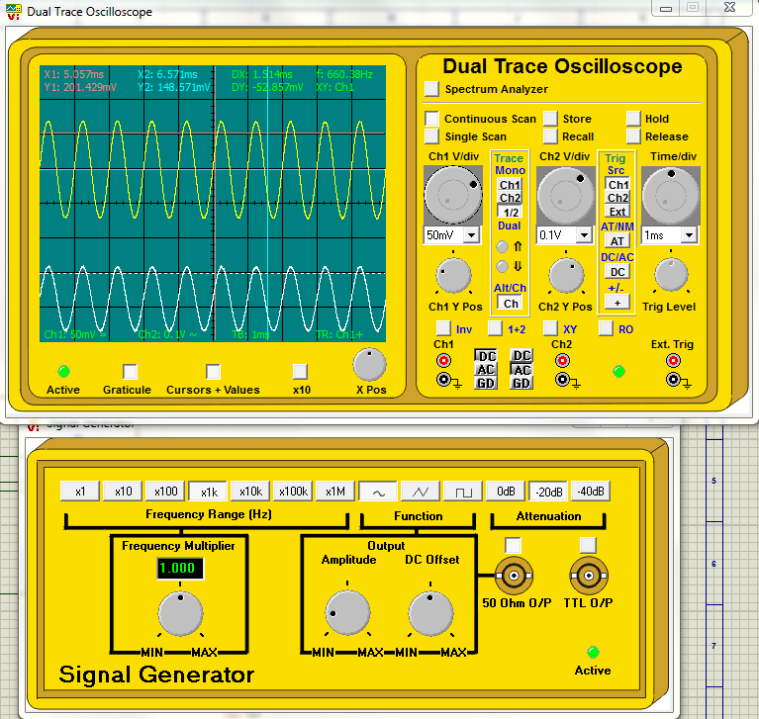

tested to make sure it worked and to get the results to check if they matched the theoretical results. The graph is shown below.
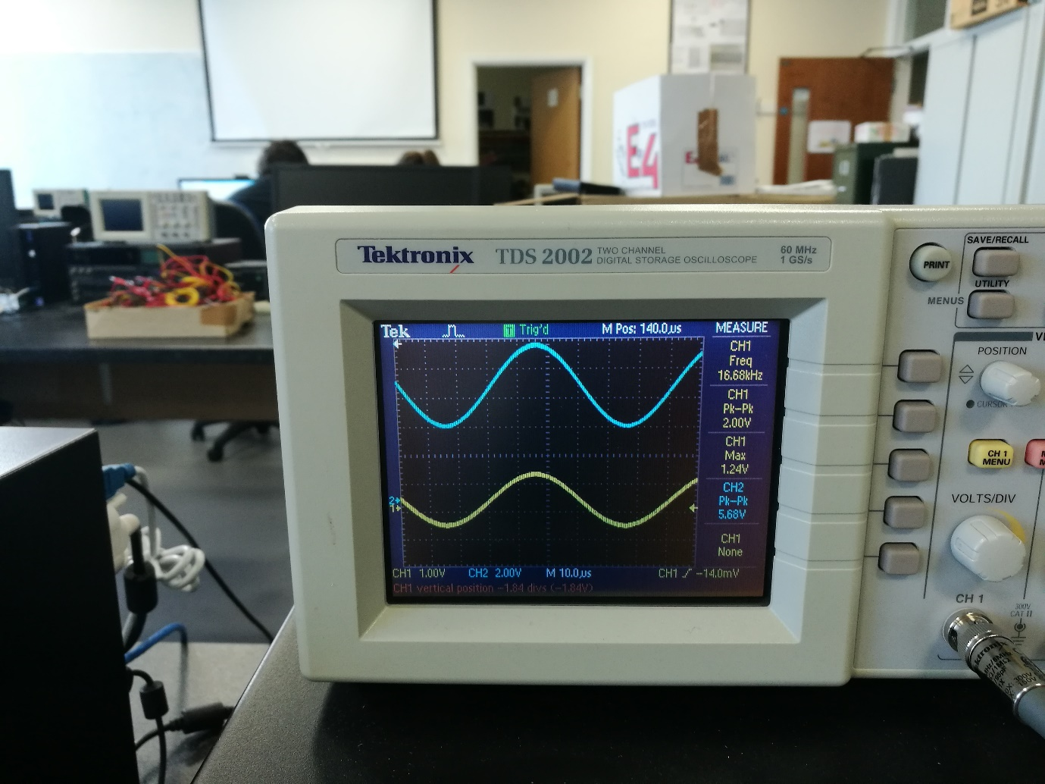

The graph shows that the input voltage is at 2V peak to peak and the output voltage is at 5.68V peak to peak this makes the gain roughly 3.
$$Gain=Output\frac{Voltage}{\begin{aligned}Input voltage \\ \end{aligned}}$$
$$Gain=\frac{5.68}{2}$$
$$Gain=2.84$$
To work out the gain bandwidth product we will be using the same calculation as before:
$$GBP=Gain*RMS Frequency$$
$$GBP=2.84*300kHz$$
$$GBP=852kHz$$
In conclusion the gain bandwidth product has changed slightly between each of the testing circuits where one is 900kHz the other is 852kHz which is not far from the value, the difference comes from the tolerances of the components where on the simulation there is no tolerance on the components it classes as a perfect environment.

