Report Title: Business Issues and the Contexts of Human Resources

Name: Stephen Watts

CIPD Membership Number: 48698902

Date: 11 January 2018

I declare that this assignment is my own work and that any information obtained from books and other sources have been appropriately referenced.

Signed......Stephen Watts......................... Date....10 January 2018.............

Contents
Introduction 3
1.1 Key Forces Shaping the HR Agenda 4
2.1 Different tools for analysing the business environment 7
2.1.1 SWOT Analysis 7
2.1.2 PESTLE Analysis 8
3.1 Factors which impact on an Organisations Business and its HR Function 9
3.1.1. Private Sector 9
3.1.2 Public Sector 9
3.1.3 The Third Sector 9
3.2.1 Factors 10
4.1.1. Strategy Formulation and implementation 11
5.1.1 Business Performance and the Role of HR in Business Planning and change management agenda. 12
5.2.1 Controllable 12
5.2.2 Uncontrollable 13
6.1.1 Sources of data that can be assessed and utilised for planning purposes 13
7 Conclusion 14
References 15

Introduction

This paper is a review of key contemporary business issues and the main external forces affecting different organisations and the impact of HR. It focuses on HR strategy and practices and how they are shaped and developed.

Key Forces Shaping the HR Agenda

The role of HR has changed widely over the last 20 years and we have moved from personnel roles to human resource management or HRM as we now know it. From 2008 onwards the CIPD identified major changes in the structure of HR in large private and public-sector organisations. It revealed that many were adopting variants of Ulrich’s (1997) multi legged model for HR. From this organisation are becoming more specialised and being divided between “shared services”, “business partners”, “centres of excellence”, or “vendor management”.

Shared Services | Provide information and advice to clients
Corporate HR | Responsibility for developing HR and People Strategy and follow Good Practice
Business Partners | Work with business on strategy, design, performance or change
Centres of excellence | Support business partners, develop policy for corporate HR. i.e. Employee Relations
Vendor Management | 3rd party Services, such as Pension
Outsourcing | Subcontract HR work

In small and medium size organisations, HR is likely to continue with more traditional people management activities, based on generalist roles. (Taylor & Woodhams, 2016)
Human Resource Management encapsulates the strategy of the business and formulates the HR strategy to deliver the required goals of the organisation. Focusing more detail on the people and the mechanisms required to enable the workforce to deliver. Training, skills, development and morale.
Two pieces of work were published in 1984, one was a more “soft” approach of HRM developed by Harvard Business School by Beer et al (1985). It starts with analysing the stakeholders and the situational factors. The model provides a map of HR policy choices and outcomes for developing commitment. Within this model strategy is developed in relation to employee needs. See Fig 1 Overleaf

Fig 1 – Harvard Model
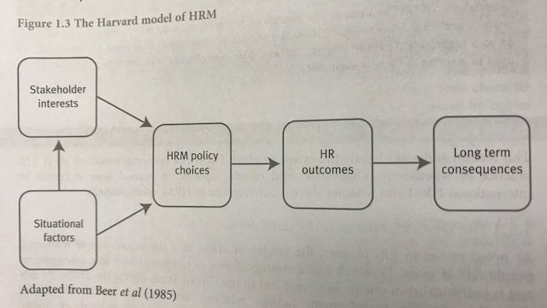

The second piece of work was the “hard” version of HRM promoted by Fombrun et al (1984). This version was known as the Michigan Model, focusing on close strategy between business and HR. This type focused on the level of performance required by employees to deliver organisational goals. Based on a HR cycle it focuses on selection of the person matched to the qualities required supported through a appraisal system to drive performance supported by a training and development to build capability and further improve performance. The reward system is designed to acknowledge different levels of performance and further enhance. The benefit of the model is it is a cycle that continues. See Fig 2 below.
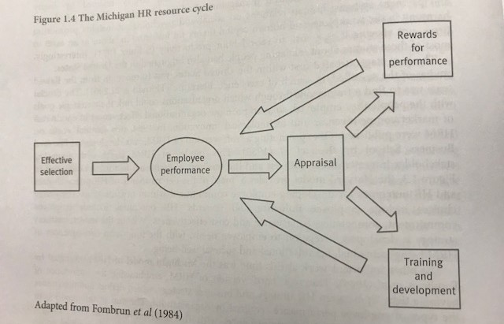
Each of the 3 models discussed are different but all focus on the same end result of improving the organisations performance. HRM has a seat at the table and clearly businesses have identified the importance of this and have reacted.

2.1 Different tools for analysing the business environment

There are a variety of tools to analyse the business environment both internally and externally. In this section I want to explore the different tools available to compare.

2.1.1 SWOT Analysis
A SWOT analysis is a planning tool which seeks to identify the strengths, weaknesses, opportunities and threats involved in a project or business. It's used to help match an organisation's goals, programs and capacities to the social environment in which it operates. (CIPD, 2015)
A SWOT could be used for both internal and external analysis and normally used as part of a team exercise to gather varying views of the same environment. Using a SWOT analysis gives a structured approach, and can be very effective in getting contributions from a range of people.
Table 1 Advantages and Disadvantages of SWOT (CIPD, 2015)
Advantages | Disadvantages
- It is a simple four box framework.  - It facilitates an understanding of the strengths and weaknesses of the organisation.  - It encourages the development of strategic thinking.  - It enables a management team to focus on strengths and build opportunities.  - It can enable an organisation to anticipate future business threats and take action to avoid or minimise their impact.  - It can enable an organisation to spot business opportunities and exploit them fully.  - It is flexible | - Some users over-simplify the amount of data used for decisions – it is easy to use scant data.  - To be effective this process needs to be undertaken on a regular basis.  - The best reviews require different people being involved, each having a different perspective.  - Access to quality internal data sources can be time consuming and politically difficult (especially in more complex organisation – parent company, etc).  - The pace of change makes it increasingly difficult to anticipate developments that may affect an organisation in the future.  - The risk of capturing too much data is that it may make it difficult to see the wood for the trees and lead to ‘paralysis by analysis’.  - The data used in the analysis may be based on assumptions that subsequently prove to be unfounded (good and bad).  - It lacks detailed structure, so key elements may get missed.

2.1.2 PESTLE Analysis

Organisations can analyse the environment they operate in by using a PESTLE. This allows them to predict change before it happens and decide how they will manage it. They then have the ability to be proactive and make plans for the future.
There are six elements to a PESTLE analysis: Political, Economic, Sociological, Technological, Legal, and Environmental. (CIPD, 2017)
Table 2 What is PESTLE and what does each point mean
Political | Political issues – tax policy, trade restrictions etc..
Economic | Growth/decline, minimum wage, interest rates
Sociological | Cultural, health, age distribution, population
Technological | Social media, AI, streaming of goods etc…
Legal | Legislation, import export, taxation
Environment | Sustainable resource, ethical sourcing

Using a PESTLE analysis can also be a useful way of getting opinions and contributions from a variety of people, especially if used in a group dynamic. It’s most effective when used in association with a SWOT analysis.
You may also see other Acronyms including ETPS, STEP, PEST, and STEEPLE (where the extra E stands for Ethical).
Advantages | Disadvantages
- It’s a simple framework.  - It facilitates an understanding of the wider business environment.  - It encourages the development of external and strategic thinking.  - It can enable an organisation to anticipate future business threats and take action to avoid or minimise their impact.  - It can enable an organisation to spot business opportunities and exploit them fully. | - Some users (of a PESTLE analysis) oversimplify the amount of data used for decisions – it’s easy to use a limited selection of data.  - The risk of capturing too much data may lead to ‘paralysis by analysis’.  - The process needs to be undertaken on a regular basis to be effective.  - The pace of change makes it increasingly difficult to anticipate developments that may affect an organisation in the future.  - The data used may be based on assumptions that subsequently prove to be unfounded.

SWOT and PESTLE have many similarities, but PESTLE can help to predict future change where SWOT focuses on past or present, PESTLE also takes into consideration the external environment factors.

3.1 Factors which impact on an Organisations Business and its HR Function

Almost all organisations belong to one of three major economic sectors; Private, Public and voluntary (or third) sector. (Taylor & Woodhams, 2016)

3.1.1. Private Sector
Private sector is made up of businesses which are owned by private individuals or groups. Most are commercial and aim to make profit, but there are also some which are not for profit.
Private sector organisations vary in terms of their HRM. PLC’s would almost always employ teams of HR specialists to carry out their people management work. In recent time we have seen a shift towards more strategic roles proactively supporting business objectives. The admin work is then tended to be given to line managers or even outsourced.
Smaller organisations may employ smaller teams to carry out basic tasks. In these cases the organisation would look to outsourcing.

3.1.2 Public Sector
These are largely funded by taxpayer and subject to a degree of public accountability. The major types of public sector organisations are:
- Central government departments
- Local and regional government organisations
- Public service providers
- QUANGO’s (quasi-autonomous non-governmental organisations)
- Publicly owned organisations
Similarly, to large private sector organisations public sector normally tend to have large HR functions

3.1.3 The Third Sector
This comprises organisations which do not fit into either public or private. They are either:
- Co-operatives
- Campaigning organisations or pressure groups
- Charities
- Controlled by boards of trustees and are subject to the law of the trust
Or
- Are chartered bodies such as universities and professional bodies.
These organisations are run not for profit and not subject to direct government control. HR will vary across the third sector. HR tends to have a secondary role and completes basic administrative task.

3.2.1 Factors

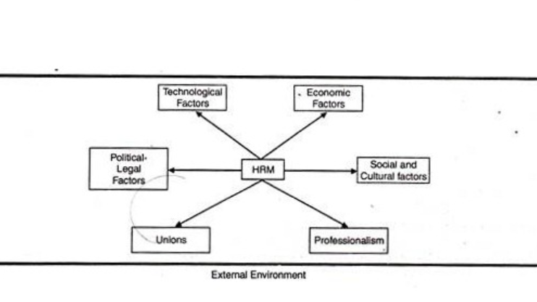
Diagram 1 – External Factors (Friedman, 2013)
Economic Conditions – One of the biggest external influences is the shape of the current economy. Not only does it affect the talent pool, but it might affect your ability to hire anyone at all. One of the biggest ways to prepare against economic conditions is to not only know what’s happening in the world around you, but also create a plan for when there is an economic downturn. All companies can make due in a bad economy if they have a rainy day fund or plan to combat the harsh environment.
Technological Advancements – This is considered an external influence because when new technologies are introduced the HR department can start looking at how to downsize and look for ways to save money. A job that used to take 2-4 people could be cut to one done by a single person. Technology is revolutionizing the way we do business and not just from a consumer standpoint, but from an internal cost-savings way.
According to (Benjamin, 2013) “internal policies and procedures effect HR activity, for example, if the company is committed to promoting from within, HR must ensure employees receive appropriate training and development to be ready for promotion when the time comes. HR should monitor the number of employees eligible for retirement and ensure potential replacements or other staff members are trained to avoid a sudden departure of business knowledge. If the company is unionized, HR must engage in collective bargaining with the union on matters of representation. External influences, political factors and organizational culture all influence the amount of grievances and complaints HR must respond to.”

4.1.1. Strategy Formulation and implementation
It is widely stated that there are three basic approaches to formulating HR strategy outlined by (Taylor & Woodhams, 2016).
Rational/Classic – Undertaken by senior managers to review external and internal environments through using tools (SWOT) and drawing goals, aims and objectives from the data to push the organisation forward.
Emergent/logical incrementalism – formulated by senior managers who can influence the direction of the strategy. Over time environmental changes influence the direction and adapts the strategy to continue the growth. Sometimes viewed as opportunistic trial and error as much as top down strategy. Vision for the direction is built and many people help shape the strategy over time to enable them to get to the required goal.
Symbolic/radical – less organised approach making changes as they move along, adapting as they go and formulating strategy to give credibility to the organisation.
It is also suggested that there are two other approaches, Best Fit and Best Practice (Farnham, 2015)
Best Fit – identifying HR strategies that “fit” their organisation and implementing. What is right for one may not be for another.
Best practice – a central idea that best practice models can bring about improved performance in all organisations regardless of their background. Emphasising a clear link between HR activity and business performance.
The role of HR within strategy is focusing on the people element and tailoring the approach to the organisation or situation. From the different approaches above if it was a classic approach HR would manage the communication element if it is from bottom up the would facilitate and consult. The purpose would be to determine the best strategy and methods to enable progress to be made.
HR professionals play a central role in supporting a workplace culture where the motivation for 'doing the right thing' is because it's the right thing to do. Sometimes, that may mean compromising performance in the short term. Ethical businesses support that, because of the benefits in the long term.
HR professionals are also the main points of contact for all staff within an organisation and have unique access to staff throughout their career – from induction training to exit interviews. They should encourage decision-makers to review the ethical dimensions of business decisions and support ethical practice. (CIPD, 2017)
The important element of HR is its role in ethics is contribution. Contribution to the organisations values and ensuring it is practiced and shared throughout the organisation. HR has a role to play in generating policy and lead, by behaving ethically themselves. The culture of the organisation needs to support this and all colleagues need to be aware of the expectation, delivered through training or a colleague code of conduct. All that is done needs to be within the values of the organisation and done in an ethical format.

5.1.1 Business Performance and the Role of HR in Business Planning and change management agenda.

Performance depends on both efficiency and effectiveness. Efficiency is a measure of economy and the use of resources. It is measured as Outputs versus inputs. Involves avoiding waste, avoiding over-manning, increasing labour productivity, generally doing the right thing. Effectiveness is a measure of how far an organisation achieves its goals. It is about doing the right thing. Both are important but ultimately effectiveness is more important. (Kew & Stredwick, 2010)
Private Sectors use Key performance indicators such as financial results to measure performance. Within my organisation Tesco we measure performance through KPI focusing on 6 key measures, Customers Recommend us, Colleagues Recommend us, Build Trusted Communities, Grow Sales, Control costs, Control Stock. Within these areas we would have underlying measures feeding in to the overall success. The aim overall is to create an environment where colleagues feel valued and happy in the workplace to serve our customers which will naturally ensure a great level of service and customer loyalty and satisfaction.
There are three main processes for managing organisational performance; planning, improving and reviewing.
- Planning the vision and the strategy
- Continuous improvement of the process
- Review measure and evaluate the plan and the process
HR’s contribution to business planning is their method of analysing and sharing of data. HR will share and analyse to forms of data Quantitative which is numbers and Qualitative which is words. To analyse Quantitative data, they will do this through spreadsheets and bespoke statistical software. (Taylor & Woodhams, 2016)
If change management is to be successful, the HR function has a vital part to play. Effective change Management concerns more than just the controllable, it concerns the uncontrollable.

5.2.1 Controllable
HR professionals can contribute in the following way:
- Involvement at the initial stage in the project team
- Advising project leaders in skills available within the organisation-identifying any skills gaps, training needs, new post, new working practise and so on
- Balancing out the narrow/short term goals with broader strategic needs
- assessing the impact of change in one area/department/site on another part of the organisation
- Balancing the interests of different stakeholder groups
- Understanding stakeholder concerns to anticipate problems
- Understanding the appropriate mediums of communication to each group
- Evaluating and reporting on the impact of change initiatives on human resources-this can include absence levels, turnover, number of grievance raised, internal moves, training spend, employee feedback (satisfaction survey scores) and so on

5.2.2 Uncontrollable
The uncontrollable element is the human element. The reaction to change, unique to individuals and unpredictable. The HR function can help deal with the somewhat uncontrollable human element of change and coach and support managers to grow and be able to support in a proactive method. The key to change is communication.

6.1.1 Sources of data that can be assessed and utilised for planning purposes
Examples of internal data for planning purposes would be quantitative data such as staff development, this information would be used for workforce planning and targeting supply and demand for current and future vacancies. Qualitative information would be information gathered by satisfaction surveys from staff and customers. Example within Tesco would be our What Matters to You survey. The information received by the staff surveys again could be used for workforce planning and retention of staff, the information from customer surveys could give further insight into how the organisation compares to its competitors.
According to the (CIPD, 2017) HR analytics enables HR and their major stakeholders to measure and report key workforce concepts, such as performance, well-being, productivity, innovation and alignment. This in turn enables more effective evidence-based decisions by strategic business functions. HR analytics enables HR teams to demonstrate the impact that HR policies and processes have on workforce and organisational performance, and can be used to demonstrate return-on-investment and social-return-on-investment for HR activity. Business managers are increasingly interested in how to use HR concepts more effectively, and so HR analytics is an important way in which HR teams can evaluate and improve people and business performance.
HR analytics can be applied to almost any aspect of HR. Examples such as driving business performance, enhancing morale, improving retention etc….
HR data should also have a connection with the organisations strategy plan so HR can measure the return on investment. HR analyse people data and business data, the impact that the people data has, to the impact of business data, for example high volumes of absence can have an effect of sales falling, high levels of absence means the use of more payroll to cover the man hours lost resulting in a reduction in profit. With this data HR would work on absence policy and investigate the reason for high absence level putting a plan in place to try and combat the level of absence. (CIPD, 2017)
HR would also analyse data around performance, wellbeing, productivity, innovation and alignment, HR will be able to make strategic business decision based on evidence gathered. Analysing data around their policies and procedures would give evidence on how these have an impact on the employee’s performance and the organisations performance. (CIPD, 2017)
External factors such as government information would allow organisations the tools to plan for proposed changes, i.e. Brexit or Minimum wage. Organisations can then put steps in place to combat or release sufficient funding to cover the change. This could be in the form of re-structuring, productivity changes etc….

7 Conclusion

Within this report we have reviewed the different models which help to shape the HR Agenda. Gathered an understanding of the various tools to help analyse the business climate and identify opportunities both internally and externally to advance. It also describes factors which can impact on an organisation, exploring the different types of impact. Performance of organisation is key to success and this has been explored looking also at the traditional and modern indicators but also considering the ethics involved with a successful organisation. HRM is changing constantly and during the last 20 years we have seen massive shifts in contribution and value of HR and business strategy being aligned. The future is very exciting…………

References
Beer, M. et al., 1985. Human Resource Management : a general manager perspective. 1 ed. Glencoe: Free Press.
Benjamin, T., 2013. External and internal factors influencing HR Activities. [Online]
Available at: http://smallbusiness.chron.com/external-internal-environmental-factors-influencing-hr-activities-34745.html
[Accessed 01 01 2018].
CIPD, 2015. Changing HR Operating Models. [Online]
Available at: https://www.cipd.co.uk/knowledge/strategy/hr/operating-models
[Accessed 1 01 18].
CIPD, 2015. SWOT Analysis. [Online]
Available at: https://www.cipd.co.uk/knowledge/strategy/organisational-development/swot-analysis-factsheet
[Accessed 01 01 2018].
CIPD, 2017. Business Ethics and the role of HR. [Online]
Available at: https://www.cipd.co.uk/knowledge/culture/ethics/role-hr-factsheet
[Accessed 01 01 2018].
CIPD, 2017. Change Management. [Online]
Available at: https://www.cipd.co.uk/knowledge/strategy/change/management-factsheet
[Accessed 14 11 2017].
CIPD, 2017. HR Analytics. [Online]
Available at: https://www.cipd.co.uk/knowledge/strategy/analytics/factsheet#7738
[Accessed 01 01 2018].
CIPD, 2017. PESTLE Analysis. [Online]
Available at: https://www.cipd.co.uk/knowledge/strategy/organisational-development/pestle-analysis-factsheet
[Accessed 01 01 2018].
Farnham, D., 2015. Human Resource Management in Context. 4th Edition ed. London: CIPD.
Friedman, E., 2013. 4 External Factors which affect HRM. [Online]
Available at: https://workology.com/4-external-factors-that-affect-human-resource-management/
[Accessed 01 01 2018].
Kew, J. & Stredwick, J., 2010. Human Resource Management in a Business Context. 1 ed. London: CIPD.
Taylor, S; Woodhams , C;, 2016. Studying Human Resource Management. 2nd ed. London: CIPD.

