Nasreen Akhtar
2407148
BMHP5014
Changemakers: Creativity and Value Creation
Component 2: Poster and Written Report

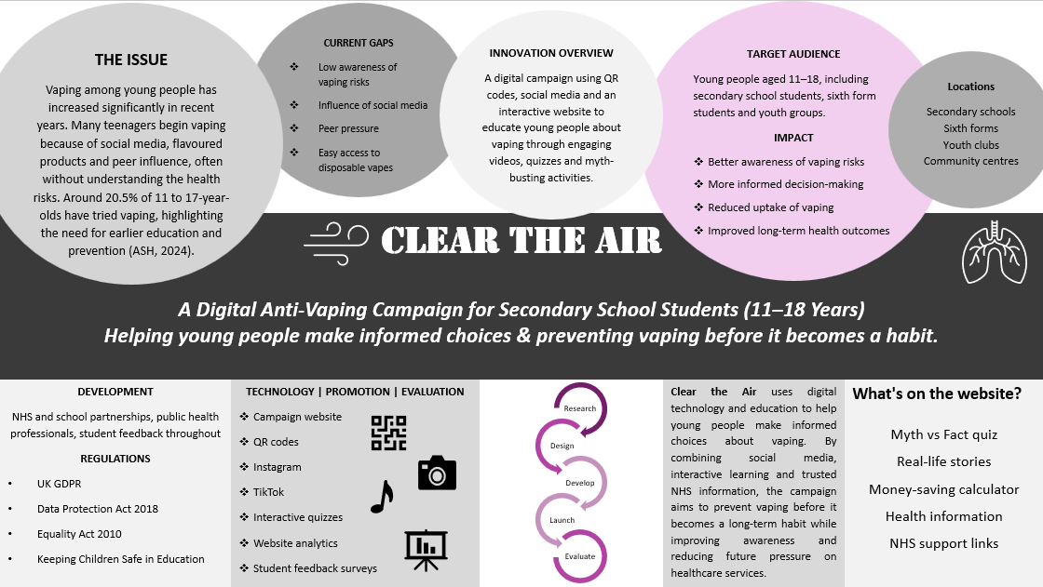

Clear the Air: Helping Young People Make Informed Choices About Vaping
If I asked a group of teenagers whether vaping was harmful, I think I'd get a mixture of answers. Some would know the risks, but many would probably tell me it's harmless because that's what they've seen online or heard from their friends. That is why I've chosen to develop Clear the Air, a digital health campaign designed to reduce vaping among young people aged 11 to 18 by giving them reliable information in a way that feels relevant and engaging.
Vaping has become increasingly common in schools across the UK. Although e-cigarettes were originally introduced as a stop-smoking aid for adults, they have become popular with young people who may never have smoked before. Research from Action on Smoking and Health (2024) found that experimentation with vaping continues to rise among children and young people. This highlights the need for early education before vaping becomes a regular habit.
My campaign is based on a simple idea. Instead of telling young people what they should or should not do, I want to help them understand the facts so they can make informed decisions for themselves. I believe young people are far more likely to engage with information if it is presented in a way that feels interactive rather than like another lesson in school.
The campaign will use posters displayed around secondary schools containing QR codes that take students directly to a dedicated website. Once there, they will be able to explore short videos, interactive quizzes, myth versus fact activities and real-life stories about vaping. There will also be links to trusted NHS information for students who want to learn more or seek support. Alongside the website, social media platforms such as Instagram and TikTok will be used to share short educational videos and campaign messages. These platforms are already part of most teenagers' daily lives, making them an effective way to reach the target audience. The use of digital technology within health promotion is becoming increasingly important because it enables healthcare messages to reach larger audiences quickly and at a relatively low cost.
The campaign will be delivered through partnerships with secondary schools, local NHS services, youth organisations and public health teams. Schools provide direct access to the target audience, while NHS professionals ensure the information shared is accurate and evidence based. Working with youth organisations will also help make the campaign feel more relatable and encourage greater participation. The module has highlighted that successful health campaigns depend on collaboration, credibility and clear communication, and I believe these partnerships will strengthen the campaign and increase its impact (Rice and Atkin, 2009).
The first stage would involve researching the needs of students through questionnaires and discussions with teachers. Once this information has been gathered, the campaign website, social media content and promotional materials would be developed. After testing the resources with a small group of students and making any necessary improvements, the campaign would be launched across participating schools. Student engagement would then be monitored using website analytics, QR code scans and feedback surveys to understand which parts of the campaign were most effective.
As with any public health campaign, there are challenges that need to be considered. A big one is that many teenagers believe vaping is safe because it is often marketed as a healthier alternative to smoking. Social media can also spread misinformation very quickly, making it difficult for accurate health advice to compete. To address this, all information shared through Clear the Air would be based on current NHS guidance and evidence from trusted public health organisations. The content would be reviewed regularly to make sure it remains accurate and up to date.
Another challenge is encouraging young people to engage with the campaign in the first place. Teenagers are exposed to a huge amount of online content every day, so health messages can easily be ignored. For this reason, I would keep the content short, visual and interactive. Rather than relying on long articles, students would be able to complete quick quizzes, watch one-minute videos and test their knowledge through myth versus fact activities. This approach encourages participation while helping students remember key messages.
The campaign would also need to meet important legal and ethical responsibilities. Any information collected through feedback forms or surveys would comply with the UK General Data Protection Regulation and the Data Protection Act 2018. As the campaign is aimed at young people, safeguarding would remain a priority throughout. Information would be written in clear language, links would only direct students to trusted organisations, and schools would be involved throughout the project to provide appropriate support where needed.
I believe this campaign offers good value because it focuses on prevention rather than waiting until health problems develop. If young people are supported to make informed decisions before vaping becomes a habit, there is the potential to reduce nicotine dependence and improve long-term health. Campaigns like these can also reduce future demand on NHS services by encouraging healthier behaviours at an earlier stage. This reflects the wider aim of public health, which is to improve health outcomes before more intensive treatment becomes necessary (Office for Health Improvement and Disparities, 2022).
The campaign is also realistic to deliver. Developing a website and digital resources would require an initial investment but once created they could be updated easily and shared with schools across different regions. Working in partnership with organisations such as the NHS, schools and youth services would also reduce costs by sharing knowledge, expertise and existing resources (NHS England, 2019).
To understand whether the campaign is successful, I would monitor several measures. These would include the number of QR code scans, website visits, quiz completions and engagement on social media. I would also collect anonymous feedback from students and teachers to understand whether the campaign had improved knowledge and confidence around vaping. Reviewing this information would allow changes to be made where necessary so that the campaign continued to meet the needs of young people.
I am asking for your support to help make Clear the Air a reality. By investing in education before addiction develops, we could help young people make informed choices, improve future health and reduce avoidable pressure on NHS services. Even if the campaign prevents a small number of teenagers from taking up vaping, it will have made a meaningful difference to individuals, families and communities.

References
- Action on Smoking and Health (2024) Use of vapes among young people in Great Britain. Available at: https://ash.org.uk/resources/view/use-of-vapes-among-young-people-in-great-britain (Accessed: 8 July 2026).
- Department for Education (2024) Keeping children safe in education 2024. Available at: https://www.gov.uk/government/publications/keeping-children-safe-in-education--2 (Accessed: 8 July 2026).
- HM Government (2018) Data Protection Act 2018. Available at: https://www.legislation.gov.uk/ukpga/2018/12/contents (Accessed: 11 July 2026).
- NHS England (2019) Dementia-friendly Health and Social Care Environments. Available at: https://www.england.nhs.uk/wp-content/uploads/2021/05/HBN_08-02-1.pdf (Accessed: 8 July 2026).
- Office for Health Improvement and Disparities (2022) Nicotine vaping in England: 2022 evidence update. London: Department of Health and Social Care. Available at: https://www.gov.uk/government/publications/nicotine-vaping-in-england-2022-evidence-update (Accessed: 11 July 2026).
- Office for National Statistics (2023) Young people's health and well-being in England. Available at: https://www.ons.gov.uk/ (Accessed: 11 July 2026).
- Rice, R.E. and Atkin, C.K. (2009) Public Communication Campaigns. 4th edn. Thousand Oaks, CA: Sage Publications.
- The UK General Data Protection Regulation (UK GDPR) (2021) Available at: https://www.legislation.gov.uk/eur/2016/679/contents (Accessed: 18 July 2026).
- World Health Organization (2023) Health promotion. Available at: https://www.who.int/health-topics/health-promotion (Accessed: 18 July 2026).
- YoungMinds (2024) Supporting young people's health and wellbeing. Available at: https://www.youngminds.org.uk/ (Accessed: 18 July 2026).

