Applied Leadership and Management in the Workplace
Module Assignment Submission
Student Name: | Katie Stokes
Student Number: | 2237488
Module No: | BMSK4014
Module Title: | Problem Solving and Decision Making
Statement of Confirmation of Authenticity
By the act of making this submission, the student declares that this is the work of the student named above. The work has not, in whole or in part, been knowingly presented elsewhere for assessment, or where assessment has been built on a previous assessment, this has been identified. Where materials have been used from other sources it has been properly acknowledged. If this statement is untrue, the student acknowledges that an assessment offence has been committed.
Attention is drawn to the plagiarism and unfair practice policies of both the University and of ILM.

Table of Contents
Define a complex problem in the workplace including its scope and impact. 3
Introduction 4
Analyse information on identified problem, to help inform the decision making process 5
Propose a range of alternative solutions to the problem 6
Using a decision making technique evaluate a range of solutions to identify the most appropriate option 9
Develop a detailed plan for implementing the solution 11
Communicate the plan to relevant stakeholders 12
Assess appropriate monitoring and review techniques to ensure successful implementation of solutions 13
References 15
Appendix 16

Define a complex problem in the workplace including its scope and impact.
There are many different aspects within the workplace that can cause complex problems, these problems maybe minor within the workplace, but the butterfly affect that could ripple, could be major for an individual or the company. A complex problem, as stated by Gawande A (2009) “Is a problem that has many variables and for which the outcome is uncertain.” meaning that any problem no matter how big or small may have many different avenues that could be followed to try and solve it but even then, it might not be successful. There are different approaches which can be used, when trying to solve a problem, these include brainstorms, mind maps and flow charts. From this you could then create a Fishbone diagram, circling things you can act on. This allows you to create a Grid analysis table, which is non-financial, based on what is most important to you i.e., training/team moral. This highlights the best option for you and your company. You are then able to create a cost/ benefit analysis table which shows you how much it will be to follow the process through, giving you an annual saving/expense based on the option highlighted in the Grid Analysis table. You can then create a Gantt Chart to show how you will plan and arrange your chosen method over a period of weeks or months. These processes allow you to determine the best option to solve your problem.

Introduction

There are many factors within business that create problems that need to be solved. The nature of these problems could be due to lack of knowledge, training, miscommunication, or lack of resources to complete the job that has been given out. There are also external factors which can contribute to problems arising such as politics, the environment, or the way the company is run. All these issues need to be solved for the company to run efficiently and effectively. Problem solving is complex, it requires time, patience, creativity and sometimes collaboration with others, to highlight the problem and break it down into manageable parts to find a solution.
The nature of my problem that will be discussed, analysed, and find a solution for an Employee who is not fulfilling their job role. The scope and impact of this problem starts with team, other members are picking up uncomplete work to ensure it is submitted to the accountant in time. This puts extra pressure on them, it could mean them working longer hours daily which could affect their personal and homelife. If effects management as they need to budget for overtime and staff pay, they will have to help pick up extra work that’s not being completed on top of their own workload. They end up working longer hours, which can have an impact on home and personal life. The accountant will be affected because the books are not handed in on time, meaning she will have to work extra days and maybe longer hours, which will them mean we will be charged more for her services. These are just immediate affects and as stated it could then impact family, friends, businesses if they have out of hour appointments. Therefore, it's important to acknowledge the problem as soon as possible, so you can begin to find a solution.

Analyse information on identified problem, to help inform the decision making process.

When trying to identify the root cause of any problem, you need to look at all the possible reasons which could be causing the problem. There are many different methods which can be used to help identify the problem. Brainstorming is a process that allows to put all your ideas on the map, you can evaluate your ideas at a different time with this process. Its flexible and encourages out of the box ideas. Mind maps offer a bit more structure to finding a solution although it is still flexible. A flow chart offers a sequence of actions to follow to find a solution. It is structured and all answers lead to a solution.
When problem solving you can allow use the force field analysis, “Force field analysis (Lewin 1951) is widely used in change management and can be used to help understand most change processes in organisations.” IFM (2016) as well as this “In force field analysis change, is characterised as a state of imbalance between driving forces (e.g. new personnel, changing markets, new technology) and restraining forces (e.g. individuals' fear of failure, organisational inertia).” IFM (2016). SWOT and PESTOL Analysis “can be very useful for project and business planning. They both help you evaluate the feasibility and potential strengths and weaknesses of a plan.” Indeed (2023). The is also Risk Analysis which can help identity impact of following solutions through. This method “consists of using tools and techniques to determine the likelihood and impact of project risks that have been previously identified.” Project Manager (2023)
All these methods allow you to see the possible causes to the problem. There are other processes, such as the 5 W’s process (appendix 1) also known as the Root Cause analysis that allows you to ask why to every answer given to find the root cause of the problem. There is also the fishbone diagram also known as Cause and Effect diagram and the Ishikawa diagram. As stated by ASQ (2023) “The fishbone diagram identifies many possible causes for an effect or problem. It can be used to structure a brainstorming session. It immediately sorts ideas into useful categories.”

Propose a range of alternative solutions to the problem.
I completed a brainstorm, mind map and Ishikawa diagram for possible ideas to find a solution for my problem. I then completed a Root Cause Analysis that gave me two possible solutions for my problem. These methods are shown below.
Mind Map: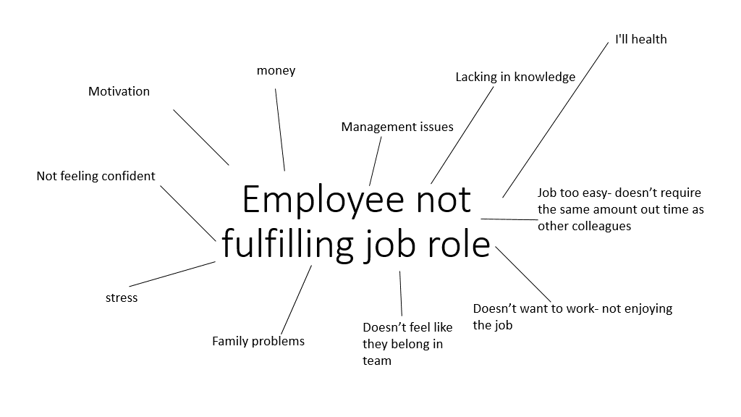
Brainstorm:
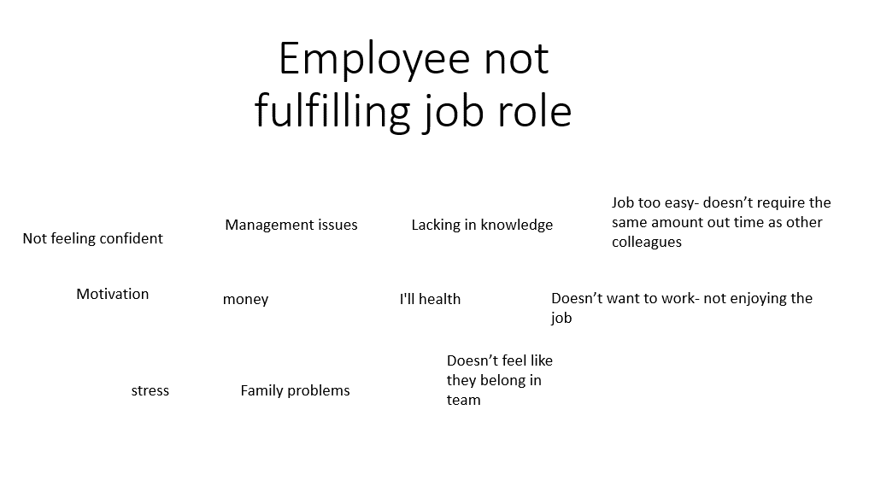

Root Cause Analysis:
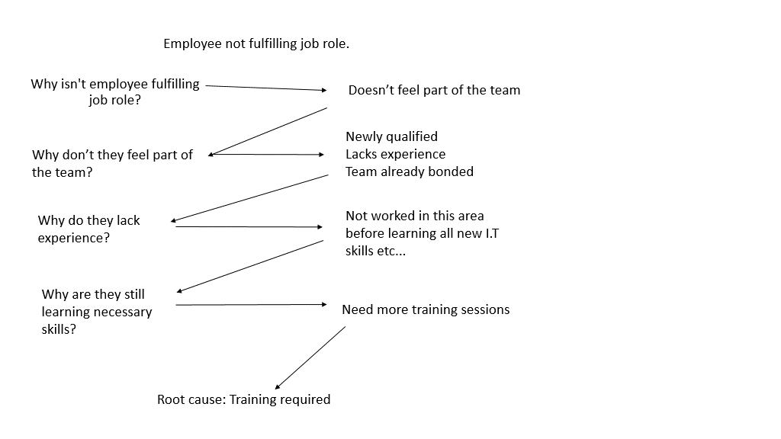
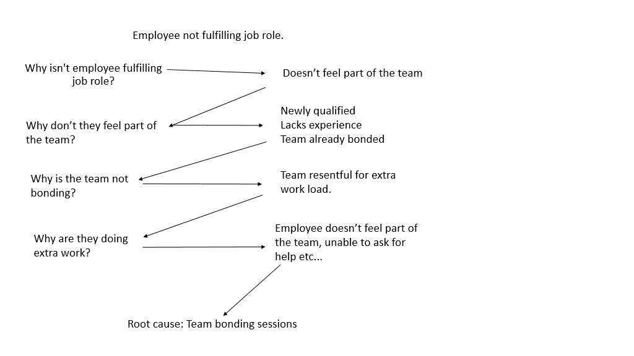

Ishikawa Diagram:
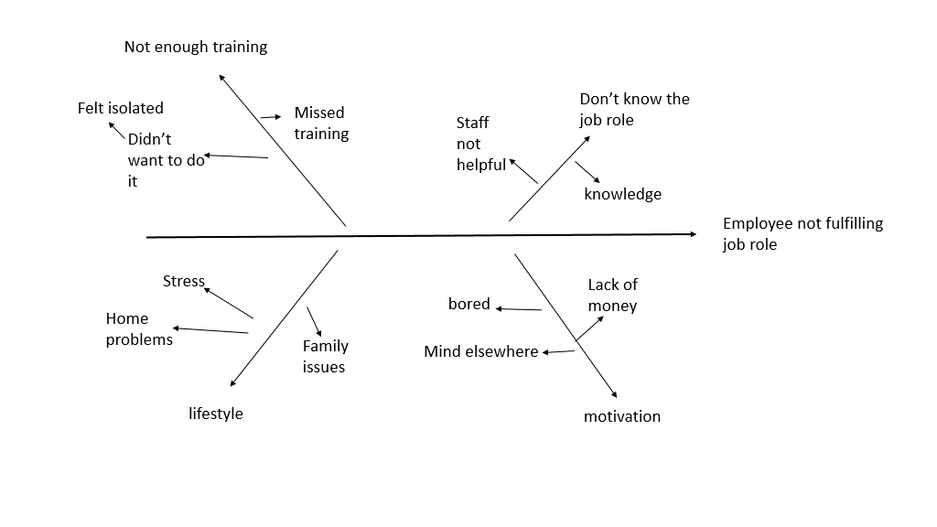

As you can see the root causes analysis has given me two possible solutions to my problem. These are training sessions for the Individual or team building sessions for the whole team. These solutions were backed up with the Ishikawa Diagram which also showed that training and team involvement could play a part to my employee not fulfilling their job role.

Using a decision making technique, evaluate a range of solutions to identify the most appropriate option.

After brainstorming and completing a mind map, I created a grid analysis to evaluate and see the potential benefit my solution could have based on financial benefit.

Grid Analysis:
Factors | Training | Motivation  (Management issues) | Cost / Money | Team moral | Total
Weights | 5 | 4 | 3 | 5
Workload/ job share | 5 25 | 3 12 | 3 9 | 3 15 | 14 61
Training courses | 5 25 | 4 16 | 3 9 | 4 20 | 16 70
Team building | 4 20 | 5 25 | 4 12 | 5 25 | 18 82
Flexi hours | 5 25 | 5 20 | 2 6 | 5 25 | 17 76
Solution: Team Building

As you can see from my grid analysis based on the weight factors that I believe are most important, team building comes out highest. The reasons I have allocated these numbers are due to what I think can improve my employee, so that they begin to fulfil their job role. Training can be provided in house; it just requires team members to reshow the employee how to do certain tasks and how to use different computer operating systems. Team moral is very important because if everyone feels valued, they become more efficient, meaning the work that has been given out is complete on time and to a good standard. Therefore, these two factors I have given a weight of 5. I have given motivation a 4 because similarly if colleagues don’t feel motivated daily, they begin to question if they are a valued part of your team. If you give regular praise, colleagues feel like they belong and know that they are a valued member of the team and without them work wouldn’t be completed. Cost/ Money I have weighted as a 3 because I don’t feel this is the most important thing when ensuring a colleague feels valued and respected and part of your team. If you must spend money for example on extra training, then it is worth it to ensure team members feel like they are a part of your team. This all leads to fulfilling job roles that have been allocated to team members.
Based on the outcome from the Grid analysis I can create a cost/ benefit analysis which will show me how much this solution is going to cost over 5 years and what the annual benefit could be.

Cost Analysis Grid:
Costs: |  |  | Years |  |  | Cost Total
 | 1 | 2 | 3 | 4 | 5
Team building courses | £500 | £500 | £500 | £500 | £500 | £2,500
Net cost of purchases | £500 | £500 | £500 | £500 | £500 | £2,500
Food | £100 | £100 | £100 | £100 | £100 | £500
Travel | £150 | £150 | £150 | £150 | £150 | £750
Hotel | £270 | £270 | £270 | £270 | £270 | £1,350
Total costs | £1,020 | £1,020 | £1,020 | £1,020 | £1,020 | £5,100

Benefit Analysis Grid:
Benefits |  |  | Year |  |  | Total
 | 1 | 2 | 3 | 4 | 5
Staff saving from overtime | £36,000 | £36,000 | £36,000 | £36,000 | £36,000 | £180,000
Total benefits | £36,000 | £36,000 | £36,000 | £36,000 | £36,000 | £180,000

3000 hours of overtime x £12ph= £36,000

Benefits £180,000
= ----------------- 35.29:1
Costs £5,100

For every £1 invested ill have a return of £35.29.

Net annual benefit: £36,000-£1020= £34,980

Annual benefit: £180,000-£5,100
--------------------------- = £34,980
5

As you can see from the cost benefit over the year, I'll be saving £34, 980 from regular overtime. This outweighs the cost of doing regular team building sessions each year, which will cost £1,020. If the employee who isn't fulfilling their job role begins to feel part of the team, is able to ask for help or finds it easier to communicate with colleagues they will start to complete all tasks given to them. This is because they know they are surrounded by a team who are approachable and will help when required.

Develop a detailed plan for implementing the solution.
Over the process of finding a solution for the problem. We have found that team building could be the most successful way to engage my employee to begin fulfilling the job role they employed to do. Now I have a possible solution I need to plan and implement it. To do this, I will create a Gantt Chart. A Gantt chart “is a project management tool assisting in the planning and scheduling of projects of all sizes; they are particularly useful for visualising projects.” Association for Project Management (2022)
The Gantt Chart will show each task that needs to be fulfilled, by when and by whom for the chosen solution to be implemented.
 |  | Month 1
 | Week 1 | Week 2 | Week 3 | Week 4
Research venue
Book venue
Research travel
Book travel
Research hotel
Book hotel
Date

Red = Me Green= All team members

I felt it was important that we all chose a date to go away, to ensure everyone could be in attendance. This would increase team bonding between all staff members as they will all be able to mix at different times during the session. Due to the solution being team building, I felt it was appropriate that I research the venues to ensure maximum team bonding. Thus, increasing motivation by the team member who wasn’t fulfilling their job role.
As you can see over the course of one month everything should be completed to ensure the smooth process of the team bonding session. In week one the date must be confirmed. This needs to be confirmed so that venues can be researched. Once a venue has been decided it can then be confirmed in week 2. In week 2 the venue can be booked and research into travel and hotels can begin. Week 2 the hotel can be booked because you will already have a confirmed number of team members who will be coming to the team building session. Once travel has been research and the most effect way for everyone to get to the team building session has been processed this can then be booked in Week 3. As you can see from the chart some things run parallel to each other whilst other factors need to be done first before moving on to the next stage.

Communicate the plan to relevant stakeholders.
A Stakeholder can be anyone, they have no financial gain over your company, but with one tweet or one conversation they could affect your business dramatically. As stated by Fernando (2023)
“A stakeholder is a party that has an interest in a company and can either affect or be affected by the business. The primary stakeholders in a typical corporation are its investors, employees, customers, and suppliers. However, with the increasing attention on corporate social responsibility, the concept has been extended to include communities, governments, and trade associations.” Therefore, it is important to talk to your team members regularly, inform them of the decisions that have been made and how you are hoping they will impact the team and the business. This will show them, that you have spotted an issue and are taking steps to solve it. This then stops the rippling effect before it begins. If issues were not solved, then you would begin to lose team members, this would then affect their personal and home life. They don’t want to work for a company where they feel over worked and undervalued. This issue will then be spoken about to family, friends or anyone asking about working for your company or becoming your client, it would be spoken about negatively which could cause more future problems. As clients need to rely on our company to complete their accounts on time for the accountant, if they are not completed on time, we could potentially lose a client. If we lose too many then we would have to terminate contracts and the consequences to not spotting and trying to solve the problem, continue escalate.

As you can see in the Influence- Interest matrix it is important to manage, monitor and inform all the necessary people. This will allow me to work through the problem and solve it before it comes a larger issue.

Keep informed.  Customers  Bank  Accountant  Credit Accounts | Manage clearly.  Staff  Myself
Monitor  Suppliers  Local Businesses | Keep satisfied.  Owner of the company
Level of influence ------------------------------------------------->

Assess appropriate monitoring and review techniques to ensure successful implementation of solution.

Throughout this process I have looked at possible solutions to my problem, a team member not fulfilling their job role. Using different methods brainstorming, mind mapping, root cause analysis and the Ishikawa diagram I was able to identify different reasons that could be leading to my employee not fulfilling their job. These solutions were then put into a Grid Analysis to find out what was the most important factors to me and why these factors were important. This allowed me to highlight one approach and then go through the process of implementing it using a Gantt Chart.

The solution to my problem once implemented needs monitoring and reviewed regularly. This is to ensure that the chosen method, in this instance team bonding, is having the desired effect on the team member that needs to begin fulfilling their job role. If this solution is working the team member will start completing all the tasks given to them on time, thus decreasing everyone else's work over and the need for them to work overtime to complete the work. If this solution isn't working, then I could look at increasing team bonding sessions. Instead of yearly team bonding, I could include monthly team bonding sessions via a coffee morning, this is more informal, and the team member could feel more relaxed. If this solution doesn’t work then an informal meeting needs to be held to find the reasons behind them not fulfilling their job role and look for potential solutions together, this could be working 1 to 1 with another team member until they are confident to go on their own. They also need to be reminded that they have made a contractual agreement and therefore, need to fulfil it.
A Communication Plan can be created to ensure that everyone who needs to be informed is done so using an appropriate method to ensure they receive it.
Communication Plan:
What | When | How | Responsible | Audience
Team building | Annual (to start) | Meetings  Emails  Request forms | Me | Owner  Team
Sign off | Annual | Meeting  Letters  Emails | Me | Owner  Finance manager
Email update | weekly | Email | me | Team
Team meetings update | Weekly | Team meeting | me | Team
One 2 one appraisals | Quarterly | Meeting  Follow up email | me | Individual employee

If none of these solutions are working, we can go back to the root cause analyse and grid method to look at another solution that was proposed but didn’t rank high enough to follow, for example offer more training. Every effort needs to be made to ensure that you are giving the colleague every opportunity to improve and that if they don’t comply then different steps will need to be made, because as a business you cannot afford to lose good and clients because they are unable to fulfil their job role.

References

American Society for Quality (2023), Excerpted from The Quality Toolbox, 2nd Edition, ASQ Quality Press.
https://asq.org/quality-resources/fishbone

Association for Project Management (2022) What is a Gantt Chart. Association for project management
https://www.apm.org.uk/resources/find-a-resource/gantt-chart/

Fernando J (2023) What Are Stakeholders: Definition, Types, and Examples Investopedia
https://www.investopedia.com/terms/s/stakeholder.asp

Gawande A (2009) The Checklist Manifesto Metropolitan Books
https://www.shortform.com/app/book/the-checklist-manifesto/chapter-3

IFM (2016) Force Field Analysis University of Cambridge
https://www.ifm.eng.cam.ac.uk/research/dstools/force-field-analysis/

Indeed (2023) A guide to PESTLE and SWOT analysis (with example) Indeed
https://uk.indeed.com/career-advice/career-development/pestle-and-swot-analysis#Pestle%20and%20SWOT%20Analysis

Project Manager (2023) Project Risk Analysis: Tools, Templates & Techniques
ProjectManager.com, INC
https://www.projectmanager.com/training/how-to-analyze-risks-project

The business Analyst (2023) Job Description The Business Analyst
https://thebusinessanalystjobdescription.com/5-whys-technique-basics-examples-and-tips/

Appendix A –
Appendix 1
The business Analyst (2023) Job Description The Business Analyst
https://thebusinessanalystjobdescription.com/5-whys-technique-basics-examples-and-tips/



