BA Leadership and Management

Module: Strategic Management of SME’s
Module Code: BMSW6104
Lecturer: Dr Sampath Liyanage
Student Name: Toni Trevis
Student Number: 2016781

Executive Summary
This report breaks K9 Health’s Business proposal down into various segments and uses various strategies and models to evaluate sustainability and viability in the current market.
A firms Strategy can be defined as “A way to help gain competitive advantage” Barney, J.B. & Hesterly, W.S. (2018). Analysing internal and external operations including barriers, threats, and current market situations to better understand K9 Health’s strengths, weaknesses and how to best penetrate the market effectively with their strategic approach to cost leadership and differentiation ensuring sustainability, innovative proposals and realistic ideology and approaches to business processes and operational standards.

2
Introduction

In this Business proposal K9 HEALTH aim to highlight their business ideas and bring forward ideology regarding K9 health and specialist training for not only dogs but their handlers too. K9 HEALTH are more than a pet store or breeders’ shop K9 health aim to support K9’s health and wellbeing whilst giving handlers the correct training to prevent bad behaviour and help anxious pets. K9 health offer a strength and conditioning pool which is perfect for k9’s with joint and limb issues these pools provide safe, healthy swim sessions to support and help K9s in need. K9 health specialise in nutrition and matching your dog to the best tailored food to prevent allergies and skin issues. K9 Health also offer grooming and wellbeing sessions for dogs and their owners to come along to encourage social interaction and friendly behaviour (NON-AGGRESSIVE DOGS ONLY). K9 Health also aim to offer obedience and show training sessions for both K9’s and their Handlers. This proposal is reaching out in hope of support to get K9 Health up and running. With a breakdown of the business proposal and plan to help achieve long term success within the field. With canine physiotherapy costing is excess of £200 for initial session and consultation and sessions going forward ranging from around 60-80 pounds per time treatment can sometimes be out of budget for canine owners (Anon, n.d.). K9 Health aim to provide cheap affordable monthly plans to cater to every requirement at an affordable more realistic price. Whilst offering tailored expert advice and programmes within the monthly packages.

3
K9 Health – strengthening the paws of your furry friends.

K9 Health have a goal and that is to provide a safe, calm environment which supports and promotes the healthy functions of the k9 body. K9 Health strongly supports k9s suffering from things such as pain, stress, anxiety, social issues, bad behaviour, and much more helping ease handler worries and ensure each dog presented to the service gets the best experience and support tailored to their individual needs. The Mission is facilitating and support initial operations, ensuring dogs and their owners have a reliable facility to support their individual needs. K9 Health understands the need for a cheaper option regarding joint issues and long-term health concerns in pets and the aim is to provide an affordable service that accommodates to various needs and health issues all under one roof. As it stands in the UK (United Kingdom) no other pet service provides such a facility and the pdsa is over run with pets needing joint and skin care K9 Health offer a referral service whereby those most at need of help may attend 1 swim session per month free of charge (providing it is rebooked) over a 12 week period, helping take some of the pressure off services that are already stretched to their limits.

Vision- Facilitate to every K9 health need. Bringing about better health and knowledge for K9s and handlers nationwide.

Mission- build adapted pools and faculties for operational purpose. Networking with competitors to change the K9 world and the ability to obtain treatment when needed.
Objectives- build and facilitate health services for K9s nationwide. With a Tight 1-year schedule to complete faculties and obtain licencing and government backing. Contractors aim to complete pool build and lodges within 6 months with proper planning in place and operations set to commence. K9 Health is set to open by the end of 2024 with aims to promote online via social media platforms in the meantime.

4
SWOT Analysis on K9 Health
Business Strengths | Business Weaknesses
- Unique offers  - Cost effective.  - Supports k9 Health.  - Sole Provider of such facilities | - Financial support  - Lack of backing  - Lack of H. R
Business Opportunities | Threats to the Business
- Progression and growth  - Various upscaling options  - Collaborating with fellow competitors to provide a unique service for k9s nationwide | - Councils/government  - Rivals and competition

Advanced Swot Analysis
Strengths | Importance | rating | Overall score
Unique offers | 0.1 | 1 | 0.1
Cost effective | 0.2 | 2 | 0.4
Support K9 health | 0.5 | 3 | 1.5
Unique faculties | 0.2 | 2 | 0.4
Weaknesses | Importance | rating | Overall score
Financial Support | 0.5 | 3 | 1.5
Backing/Support | 0.3 | 2 | 0.6
Lack of H. R | 0.2 | 1 | 0.2
Opportunities | Importance | rating | Overall score
Expansion/ Growth | 0.5 | 3 | 1.5
Co-opetition | 0.3 | 2 | 0.6
Avenues to venture | 0.2 | 1 | 0.2
Threats | Importance | rating | Overall score
Councils | 0.6 | 3 | 1.8
Competition | 0.4 | 2 | 0.8

5
K9 Health offer a unique service seen nowhere else in the UK. The broad array of options and facilities gives k9 health a strong position. Offering handlers and pet owners everything in one facility! A unique service that boasts great awareness for k9s and their health. The business strengths clearly show their ability to offer such services at a reduced rate whilst keeping the quality standards highly maintained ensuring safe practice. Offering a one-off facility to suit the needs of all. The business does however need financial support and backing to get the plan off the ground. A lack of internal Human resources and funding is preventing the business idea from being a success and weakening the ability to progress and develop the idea, there are numerous opportunities for K9 Health going forward. There is a vast array of options regarding expansion and providing different services from food to harnesses and dog care there are numerous opportunities. Aswell as the chance to work with other organisations and support dogs in need across the country the likes of the pdsa, rspca and private run vet practices coming together to change the lives of k9s in need. K9 health seems to have various avenues that they could venture down. There are also various threats to the business such as existing established competition and the need for financial support. Conducting a SWOT analysis helps K9 Health make better decisions for the business and operations (Prasanna, 2022). Structured planning and a clear business model alongside strategic approaches to market advancements will help K9 Health excel in the current climate (Lindley, 2021).

6
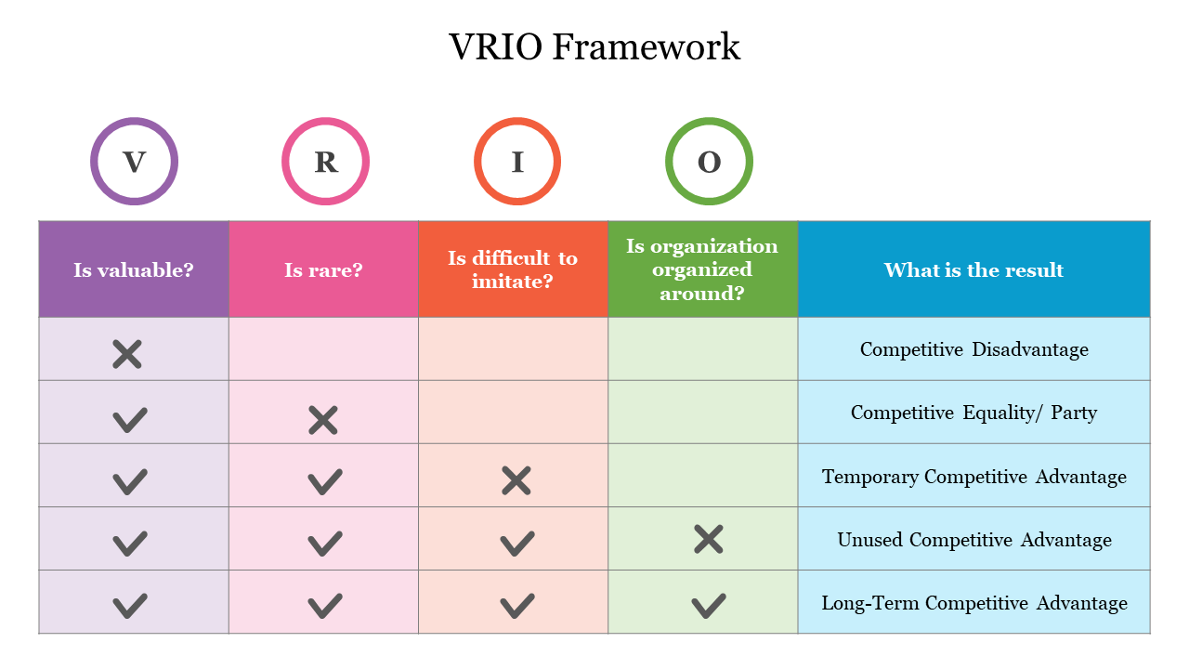
(slideegg, n.d.)
Valuable (HIGH) | Rare (HIGH)
YES  - Unique services  - Helping disadvantaged households fund vital treatment for their pets.  - Training for k9’s and handlers | YES  - No other facility facilitates these kinds of services from one company.  - Collaboration of multiple k9 facilities
Imitability (LOW/Moderate) | Organized (HIGH)
NO  (Unique offerings and tailored services will prevent imitability.)  - design rights  - Unique Tailored offerings  - patents  - non-disclosure agreements  - Scale of operations | YES  - mapping out operations  - project planning  - clear coordination  - overseeing operations  - regular quality checks

Within the UK there is limited accessibility to strengthening pools and health facilities for K9s there is a huge gap in the market and This business proposition aims to fill the gap. Its Unique cost-effective facility will offer everything from agility to muscle and joint support plans making the offerings valuable to customers, K9s and local vets as well as distilling its uniqueness and rarity in the market.
7
Patented products and unique services for VIP members make the company strong in the field and reduces imitability due to branding and unique exclusive services tailored to each dog. Ensuring project planning and mapping out operations is vital in the success of the business proposal ensuring regular safety checks are conducted and operations are overseen and reviewed throughout the build and progression is crucial and within this proposal are various models helping support operations, coordination, and proper planning to support internal and external operations.

Pestel Analysis
Political factors- government policies may restrict backing from councils without the ability to highlight how the company will benefit k9s and not promote bad breeding, instead help unfortunate K9s in pain and those who lack social skills and training. Helping promote a healthier happier environment for K9s and their owners.
Economic factors- inflation and the cost of living within the UK has pushed people into tough times leaving them struggling to afford pet plans and vet bills. If the company succeeds making the ability to access such facilities at a much cheaper rate will benefit those who cannot afford the huge costs of vet bills, training, physio, or treatment.
Social factors- the surrounding/neighbouring community may oppose to the idea of a K9 facility and worry about general disruption, ensuring the business is located correctly and not to close to the neighbouring community is vital in ensuring a happy environment.
Technological factors- Building a webpage and promoting the company will help boost interest and get the company name out there. Marketing and online services will help promote the business however there will need to be facilities to accommodate such operations.
Environmental factors- K9 waste and disposal laws, ensuring safe hygienic work practices is vital in the success of K9 Health and ongoing operations.
Legal factors- laws and permits, laws governing animal welfare and hygiene regulations. Acquiring permits, licences and hygiene certifications will be vital in ensuring total compliance and quality working conditions.

8
Porters 5 forces
Looking at external competitive forces to analyse the company's strengths and weaknesses as new entrants to the market.
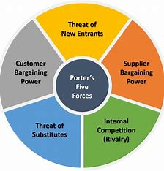

K9 Health aim to disrupt the existing market with its unique offerings and cost-effective tailored services. Making them less imitable and able to retain and maintain operations going forward, Newer Entrant’s will not pose such a threat to K9 Health due to the lack of uniqueness of services. K9 Health has a strong position with their offerings and Threats of substitutes is quite low due to the array of services, unique plans, and tailored sessions all in one place. Collaborating with vet practices and animal welfare operations will reduce rivalry due to their Joint venture (JV) combining Resources with the need for animal health improvements. Customer bargaining power again will be low due to the cost-effective services and K9 Health’s ability to facilitate to all at a reasonable price with the animal and handler's best interests at heart. Due to the ability to source materials and the various options regarding suppliers and offerings reduces supplier bargaining power as K9 Health may choose to source raw materials and products elsewhere. Overall K9 Health seem to be in a stable position going forward with operations and production.

9
Stakeholder Analysis
When conducting a stakeholder analysis on K9 Health it identified that stakeholders of high power and high interest are governing bodies and animal welfare operators/ inspectors these stakeholders have the power to close operations and enforce laws, rules, and legislations. They also have high interest in internal operations and have a duty to ensure K9 Health are promoting quality services and are meeting requirements. High power low interest stakeholders include surrounding communities that may be affected by noise pollution may have little interest in the company however if they are not satisfied with the changes they may complain to local councils for removal of licencing. Stakeholders with low power and a high interest in the business include suppliers and contracted workers these stakeholders have no power over initial operations but have an interest in the company and working together. Stakeholders with low power, low interest include customers who are not involved with operations have little power or interest in anything outside of the quality of services K9 Health provide. Ensuring K9 Health know their target markets appeals is crucial (BBC Bitesize, n.d.)
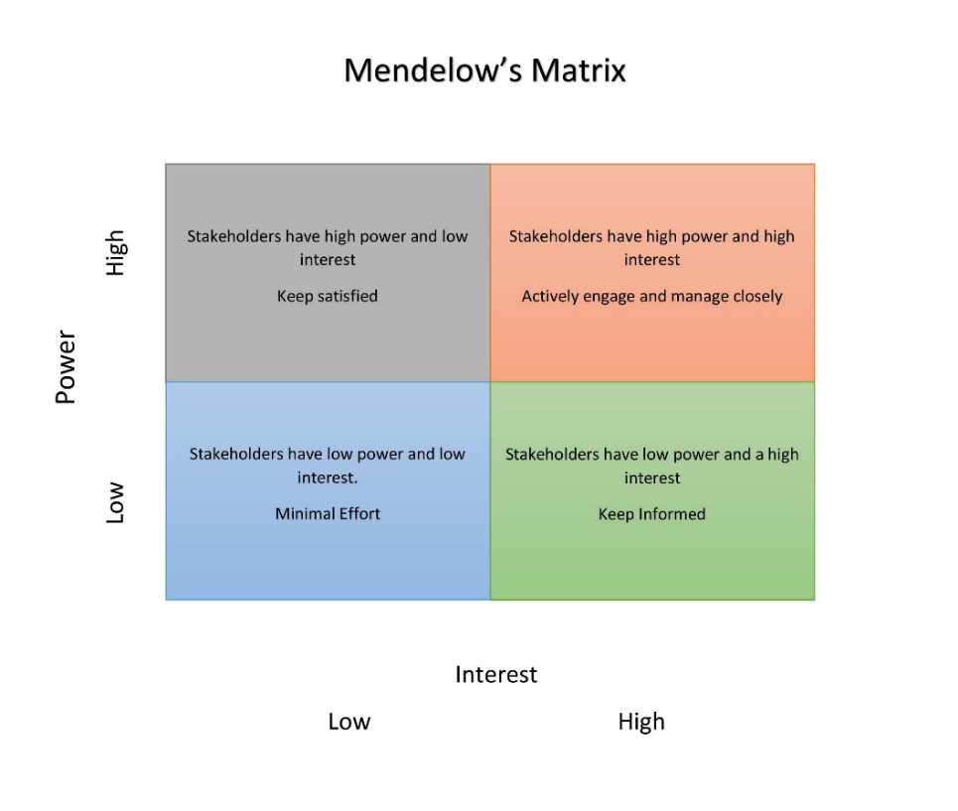
(Professional Academy, 2023)

10
Strategic growth

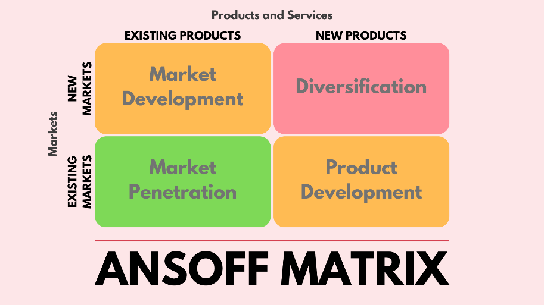
(Pinterest, n.d.)

K9 Health has two Market developing strategies, These strategies are used to retain market advantages (Stirbu, 2023), with aims of Market penetration K9 Health has a new way of offering existing products and services with existing markets via the use of unique, tailor-made sessions, services and health plans that are NOT available readily in the current market to the degree K9 Health intend to operate. Giving help not only to K9s but educating handlers to best help the needs of their clients. Internal operations will cover all aspects of health and nutrition ensuring every client's plan and sessions are tailored to benefit their individual needs. Full support will be available throughout the customer journey with K9 Health ensuring total balance and understanding for each dog as an individual. K9 Health aim to maintain and sustain operations via their unique offerings and cost effective, quality services. Ensuring sustainability and room for financial growth with an estimated 35% yearly profit margin by 2026. If targets are met and K9 Health thrives in the industry there are aims to adapt the business and offer call out options and mobile personal health specialists for elderly clients with pets that need at home treatments, grooming and health services.

11
Porters Generic Strategy
This strategy is used to outline the approach of a company or organization toward its competitors (Opinaldo, 2022). Within the current market K9 Health intend to disrupt the market with its unique offerings. K9 Health will hold a strong position in the market for cost leadership and product differentiation although offering existing products the specialised tailored services and unique offerings make K9 Health Different from its current competitors balancing cost leadership and differentiation is vital in ensuring sustainable competitive advantages over competitors. Looking at the strategic growth options ensuring Cost leadership and differentiation are balanced will help K9 Health excel in the market and help ensure financial growth for further developments and viable, sustainable operations.

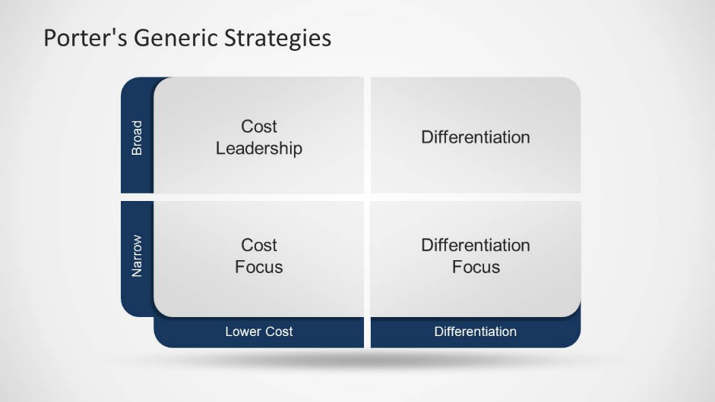
(SlideModel, 2019)
Differentiation focused and cost leadership.
K9 Health as stated intend to work on their cost leadership and ensuring quality services at an affordable rate. Whilst ensuring unique specialised offerings and tailored health plans made specifically for each individuals want and needs. Ensuring regular checks and monitoring will help keep a strong position within the market and enable focused strategies to keep or retain their competitive advantage. Mastering marketing strategies is said to start with analysing the market, customers, and competitors to better offerings (Cambridge Judge Business School, n.d.).

12
SAFe Model

Sustainable | K9 Health offering cost effective services with no compromise on quality whist ensuring a new and unique service to meet the health needs of K9s makes their marketing strategy sustainable, less imitable, and able to retain a strong position in the market ensuring market penetration success.
Acceptability | Strategies going forward will meet the needs of main stakeholders and ensure acceptance, position in the market and ability to obtain and retain customers whilst meeting satisfactory profit margins. Differentiation and cost-effective services are what keep K9 Health alive.
Feasibility | Employing staff to oversee operations and look for new competitive advantages or innovative business strategies may also be a fantastic way to ensure operations remain top class and the company meets the demands of the forever changing workplace environment, laws, and legislations. Innovative ideas going forward will enable the company to sustain operations.

13.1

Implementation and monitoring plan

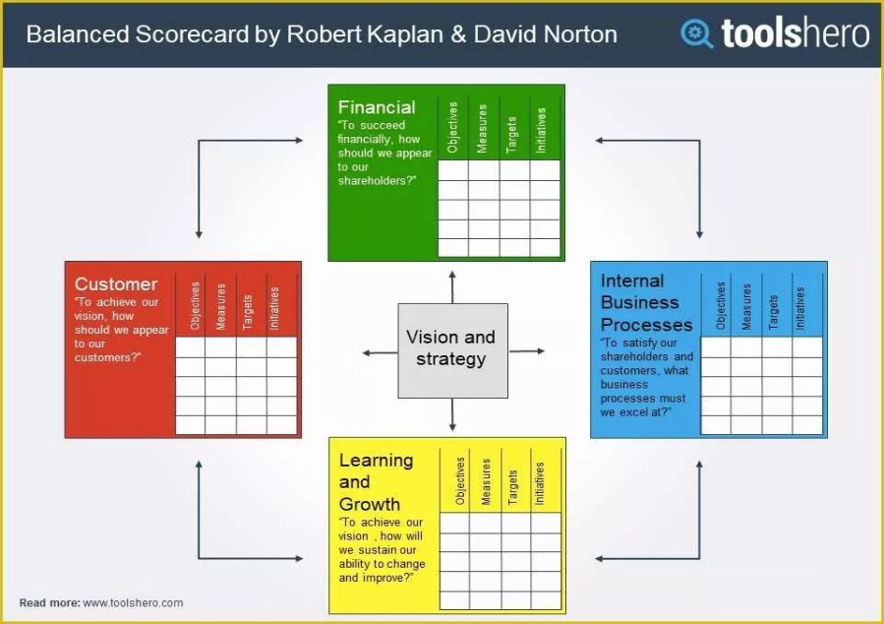
13.2
Customers
K9 Health aim to tend to owners every health need ensuring total satisfaction and readily available support for their K9s. K9 Health aim to target Dog owners who need support in understanding their pet's health issues or requirements. With aims to obtain around 200 new customers every month and retain on average 20% going forward with long term plans.
Growth
K9 Health have plans to progress steadily increasing operations as they develop and expand on site. With various avenues to venture within the K9 Health sector there may be future plans to facilitate an onsite vet practice and additional mobile services. Ensuring sales targets are met is vital in developmental plans going forward for K9 Health and steady increase in customers and operational sales should see K9 Health reach profit margins and enable expansion plans and extra services to be provided.
Internal processes
Total compliance to laws and government/ council legislations is crucial, effective data handling and data protection processes must be in place to ensure total compliance and a satisfactory work practice operating effectively and to a high quality when providing K9 Health service. Feedback and surveys for customers and employees may be a fantastic way to ensure total satisfaction and quality services are provided to all.
Financial plan
K9 Health need to meet sales targets to ensure they meet required yearly profit margins starting at 20% and increasing steadily at a rate of 5% annually to ensure targets are met internal operations will be overseen, inventory monitoring of incoming and outgoing resources will ensure transparent operations and monitored transactions. Initial targets are set at a reasonable rate to ensure sustainability and reasonable offerings and expectations.

14
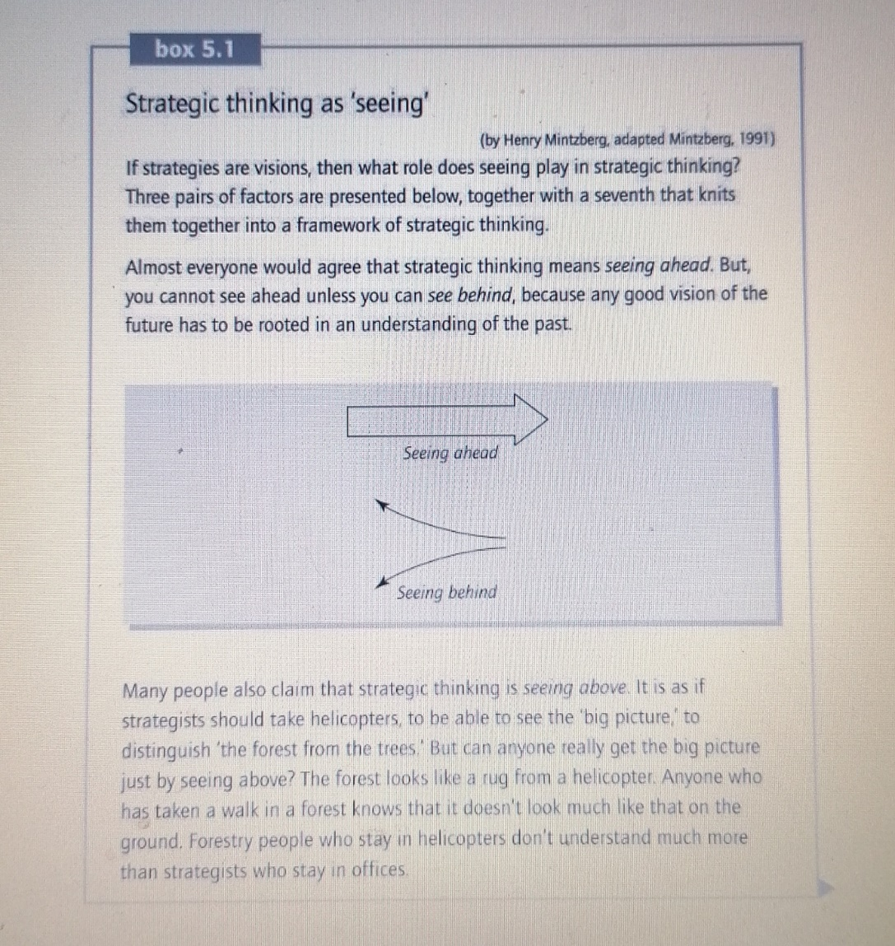
Mintzberg, H. (2009) Strategy safari
Looking at numerous factors such as existing competition, current market conditions, customer wants, needs, and gaps in the market that have been lacking creativity and innovative services, help build a picture for operations going forward strategic approaches to ensure cost leadership and service differentiation help align processes and operations with visions, missions, and company objectives. Knowing what has been and what is currently needed helps produce services sort after by the potential target market, increase chances of success and ensure stability within the current market with their strategic approach and competitive advantage. Strategic thinking skills are vital when mapping out competitive edge and market placement (Bowman, 2019). Strategic approaches are said to “involve forecasts about future conditions and outcomes” Johnson, G. (2019). This Unique Business proposal clearly shows how K9 Health has the ability to support thousands of canines nationwide and reduce pressures on charitable organisations.

.15
Conclusion
K9 Health is a new innovative way to provide Great Health services to K9’s and their Handlers with the intention of relieving financial pressures off the customer and local pet charities. Working alongside existing market leaders to provide a unique tailor-made service only available within K9 Health facilities The business proposal has highlighted key functions, planning and business ideology breaking down the Business proposal to evaluate sustainability, imitability, and viability in the market. K9 Health is a terrific way of offering support to those at need through challenging times helping K9 joint and muscle pains, support behavioural issues and educate handlers ensuring their furry friend gets the best possible service and tailored health and conditioning plan. K9 Health and the plan going forward is an ideal way to penetrate the market and sustain operations whilst ensuring the customer and stakeholder satisfaction is high. With support from the Enterprise Hub K9 Health has the potential to grow into a healthy, sustainable, Innovative business promoting animal welfare like never seen before.

16
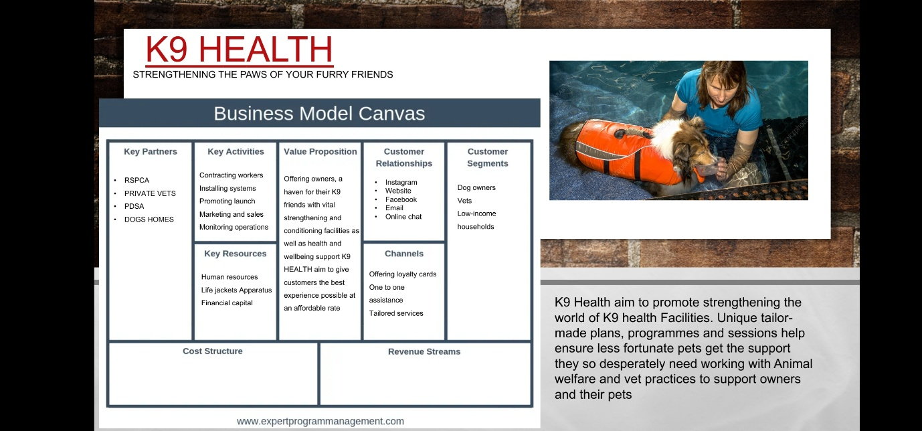
17
Reference list

Anon, (n.d.). Rehabilitation Therapy Pricing – The Canine Fitness Centre. [online] Available at: https://www.thecaninefitnesscentre.co.uk/pricing/.

Barney, J.B. & Hesterly, W.S. (2018) Strategic management and competitive advantage: concepts and cases. Pearson Education.
BBC Bitesize. (n.d.). Benefits of target marketing - Customers - National 5 Business management Revision. [online] Available at: https://www.bbc.co.uk/bitesize/guides/z9w43k7/revision/2.
‌
Bowman, N.A. (2019). How to Demonstrate Your Strategic Thinking Skills. [online] Harvard Business Review. Available at: https://hbr.org/2019/09/how-to-demonstrate-your-strategic-thinking-skills.

Cambridge Judge Business School. (n.d.). Mastering Marketing Strategy for Non-Marketeers - Marketing. [online] Available at: https://www.jbs.cam.ac.uk/executive-education/marketing/mastering-marketing-strategy/?msclkid=d598500e4f991dd75b3e34bd5d2a2322&utm_source=bing&utm_medium=cpc&utm_campaign=MMS%20RSA&utm_term=marketing%20strategy%20plan&utm_content=Mastering%20Marketing%20Strategy%20RSA [Accessed 15 Jul. 2023].
‌
Johnson, G. (2019) Exploring Strategy, Text and Cases, 12th Edition. Harlow, United Kingdom, Pearson Education Limited.

Lindley, S. (2021). How to structure an effective business plan - free template. [online] Smart Insights. Available at: https://www.smartinsights.com/digital-marketing-strategy/digital-strategy-development/business-plan-structure/#:~:text=A%20solid%20business%20plan%20has%3A%201%20Clear%2C%20realistic [Accessed 15 Jul. 2023].
‌
Mintzberg, H. (2009) Strategy safari : the complete guide through the wilds of strategic management. Second edition. Harlow, UK :, FT Prentice Hall

Opinaldo, N. (2022). Porter’s Generic Strategy: Explained with Examples. [online] gitmind.com. Available at: https://gitmind.com/porters-generic-strategy.html.
‌
Prasanna (2022). Advantages And Disadvantages Of SWOT Analysis | Benefits, Limitations, What are the Advantages And Disadvantages Of Swot Analysis? [online] CBSE Library. Available at: https://cbselibrary.com/advantages-and-disadvantages-of-swot-analysis/.
18
Professional Academy (2023). Mendelow’s Matrix - Marketing Theories. [online] www.professionalacademy.com. Available at: https://www.professionalacademy.com/blogs/mendelows-matrix-marketing-theories/.

Pinterest. (n.d.). ANSOFFS MATRIX MODEL | Management skills, Skills development, Development. [online] Available at: https://www.pinterest.co.uk/pin/337558934548597358/ [Accessed 15 Jul. 2023].
‌
slideegg. (n.d.). Effective VRIO Framework PowerPoint Template Designs. [online] Available at: https://www.slideegg.com/vrio-framework-56618.
‌
SlideModel (2019). Porter’s Generic Strategy PowerPoint Template - SlideModel. [online] SlideModel. Available at: https://slidemodel.com/templates/porters-generic-strategy-powerpoint-template/.
‌
Stirbu, C. (2023). What is a market development strategy? [online] LogRocket Blog. Available at: https://blog.logrocket.com/product-management/what-is-a-market-development-strategy/.
‌

19

