MANAGEMENT ECONOMICS
Student name: Diana Tincul
Student ID:2028613
Lecturer name: Taye Osadiya
Module code: LCBB5003
ASSIGNMENT 1
Executive Summary
The paper involves the necessary description in the context of Management Economics. Further, to provide detailed information on the impact of different factors of the economy on the demand of the commodities of Tesco all sorts of the necessary information has been provided. Moreover, Tesco Steam Bags Long Grain White Rice is selected as the most essential product or commodity of Tesco. The purpose behind choosing the commodity is to provide detailed information concerning the effect of different economic factors on the demand margin of the commodity. As per the given description, it is determined that necessary information concerning the price of substitute and complementary products, the income of the customer, their preferences and taste and other demographics and their impact on the demand for rice has also been provided. Moreover, Substitution and income effect is illustrated as their impact on the Price Elasticity of Demand. Further, it is recommended concerning the market position of Tesco that it should employ a price skimming strategy.

Table of Contents
Description of the business and its main product 4
Identification of the demand and market equilibrium for each factor that influences demand 4
Illustration in context to each factor that creates an impact on the price elasticity of demand 11
References 16

Description of the business and its main product
Tesco PLC is identified as a multinational general merchandise retailer and groceries company in Britain. The headquarter of the chosen firm is located in Welwyn Garden City, England (tescoplc.com, 2022). Further, it is identified that the company is known in the business market for its food retail business. On the other hand, it is determined that the firm is a multinational business company and it sells and transits its products outside the union territory. Based on further analysis and observation it is perceived that Tesco is famous for its healthy, affordable and sustainable food items. Its main aim is to improve the living standard of its customers and easier the way of living. Therefore, based on the provided pieces of information it is ordained that the Tesco Steam Bags Long Grain White Rice is selected (tesco.com, 2022). The chosen company is further known in the marketplace due to its general merchandise multinational retailer store.
It is further articulated that the company further proceeds its business activities with the help of multi-format stores and online business platforms. The main reason behind selecting Tesco Plc is to illustrate the detailed information in context to the management of business economics. Another purpose behind choosing the multinational retail company is to evaluate the economic data in the context of international and national organizational business activities. The main reason behind selecting the long-grain white rice is that Tesco is mainly known in the business market for its healthy food products. Moreover, from the selected food product it would further become easier to determine the market equilibrium and demand and the factors that influence the demand for rice products in the market. Further, it is ordained that rice is considered one of the most essential food items. The fluctuation in demand and supply of Rice further creates a fluctuating impact on the cost and sales of the commodity (Silalahi et al. 2019, p. 1).

Identification of the demand and market equilibrium for each factor that influences demand
According to the accumulated information it is determined that the different economic factors create an impact on the demand and supply of commodities. The different factors that mainly affect the demand for commodities are the price of its substitute and complementary goods, the income of the consumer, clients' taste and preferences, their expectations and other demographics.
Price of substitutes: According to the perceived description and information it is obtained that the substitute goods are considered as the goods that can be used in place of other commodities. Further, concerning the provided description it is articulated that the chosen food item is Tesco Steam Bags Long Grain White Rice. As per further observation, it is perceived that there are many other food items that can be used as an alternative to Steam Bags Long Grain White Rice. The substitutes for a chosen food item are quinoa, Riced cauliflower, Shirataki rice and barley. Rice is further considered the most essential and survival food item and steamed bag rice is also known as the staple in the diet routine of many customers.
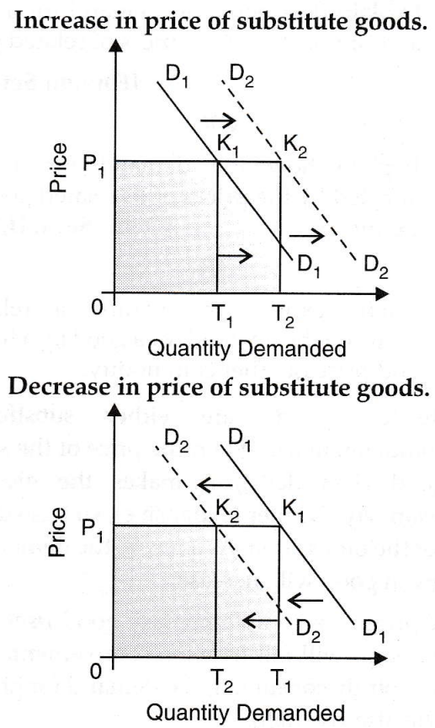
Figure 1: Impact on demand curve due to the fluctuation in the price of a substitute good
(Source: Corporate finance institute. com, 2022)
The price of long-grain white rice is £40 per kg whereas, the price of its substitute item quinoa is £ 3.63 per 100 grams (Healthy supplies. co. UK, 2022). The comparison between the price of both food items further resembles that the price of the substitute commodity is more than that of the original food product. Therefore it can be said that the price of substitute goods is increasing due to the increasing demand for other products (Hatak et al. 2019, p. 32). Due to the increasing price of the substitute food items the demand for other products increases. The reason behind the increasing demand is the positive correlation between the price of a substitute product and the demand for the product (Corporate finance institute. com, 2022).
Price of complements: The commodity that provides value to another commodity is referred to as the complementary good (Bahmani-Oskooee et al. 2020, p. 170). According to the analysis, it is identified that there are several complementary food items of rice such as peas, beans, vegetables, meat and others. The complementary food items further balance the nutrition and taste of dishes. Of all the identified complementary food items Fava beans are considered the most essential complementary food product of rice. Fava beans are further identified as an expensive food product and their price is evaluated to be £ 3.05/kg.
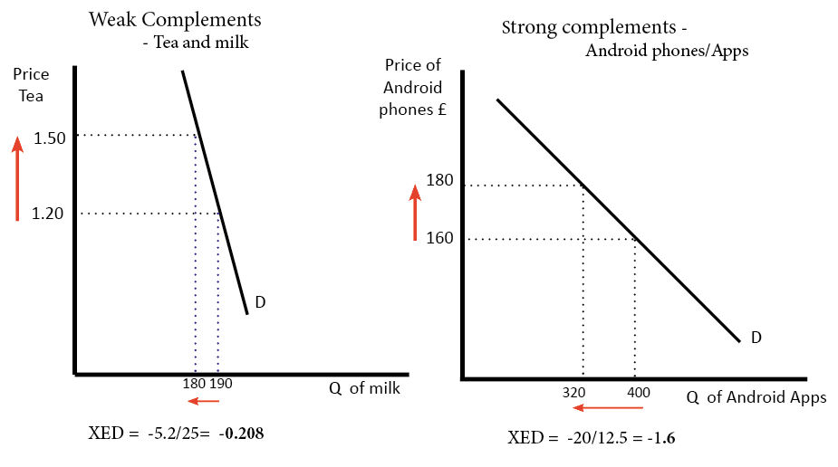
Figure: Cross elasticity of demand and complementary good
(Source: Economics help. org, 2022)
Therefore, based on the analysis and interpretation it can be said that the price of complementary food items of rice is increasing. It is further obtained that the complementary commodity further creates a negative cross-elasticity of demand. Therefore, it can be said that if the price of complementary food items increases the price of other items decreases (Economics help. org, 2022). It is also identified that the price of substitute and complementary goods creates an impact on the demand curve of the commodity.
Consumer Income: The income of the consumer is further determined as the most effective economical factor of the economy. The fluctuation in the range of consumers' income creates a direct impact on the demand and supply of the commodity.
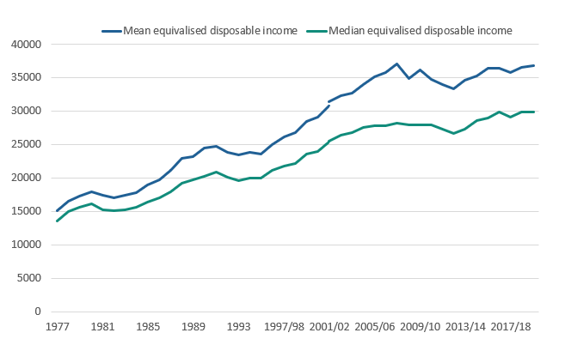
Figure 3: Statistics showing the average household income of the UK consumers
(Source: ONS. Gov. UK, 2022)
The provided statistics state that the income of the consumers of the UK has increased by 10% in the last 10 years (ons.Gov. UK, 2022). Therefore, based on the given description it is determined that the income of the consumers is increasing.
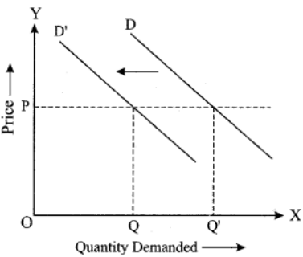
Figure 4: Impact of consumers' income on the demand for the commodity
(Source: Mahaputra and Saputra, 2022)
It is further ordained that the increasing income of the consumer increases the demand for commodities (Mahaputra and Saputra, 2022, p. 36).
Consumer tastes & preferences: According to the present scenario it is identified that the taste and preferences of the consumers are changing due to the increasing health possessiveness and other issues. Moreover, it is ordained that because of the fluctuation in taste and preferences of the consumer the demand margin of the commodity also fluctuates (Allcott et al. 2019, p. 1600). Further, it is advocated that the taste and preferences of the customers further also depend on the essentiality of the products, if the product is very essential then the demand for the commodity increases. On the other hand, if the product is not important to the consumer then the demand for the specific product decreases. The factors that affect the taste and preferences of the customers are dishes, commonly consumed flavours and others. It is further advocated that the taste and preferences of the customers also change as per the changing marketing tactics of the company (Kovač et al. 2019, p. 1).
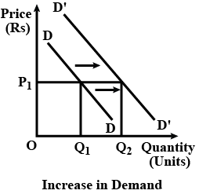
Figure 5: Impact of consumers' tastes and preferences on the demand for the commodity
(Source: Hovhannisyan et al. 2020)
It is further advocated that the change in the preferences and tastes of the consumers further shifts the demand curve towards the right. Based on the provided description, therefore, it can be said that the demand for the commodity increases due to the favourable change in the taste and preferences of the consumer (Hovhannisyan et al. 2020, p. 481).
Consumer expectations of price: Based on the analysis it is determined that the price of rice in the UK is expected to increase by 17.93 USD
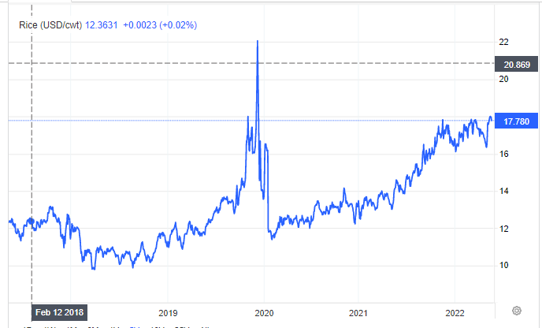
Figure 6: Expectations of a rise in the price of rice in the UK
(Source: trading economics. com, 2022)
According to the given image, it is identified that previously the price of rice in the UK was £ 17.96 whereas; according to the actual status the price of rice is identified to be £17.78. It is further assumed that the price of rice would increase by £24.46 in mere future (trading economics. com, 2022).
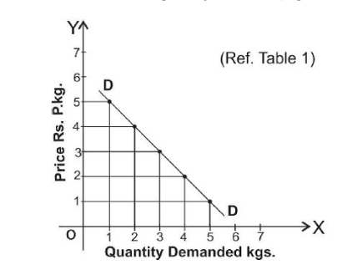
Figure 7: Impact of consumers' price expectations on the demand for the commodity
(Source: Tax mann. com, 2022)
Moreover, based on the provided description and observation it is identified that if the expectations of the consumers in the price of the product in mere future increases then the current demand for the commodity also increases (Tax Mann. com, 2022).
Demographics: According to the accumulated knowledge it is perceived that demographics also create an impact on the demand curve of the commodity. If the population increases the demand for the essential food items also increases. Hence, it can be said that if the buyer increases then the demand for the commodity also increases (Kaur. and Sharma, B., 2020, p. 1).
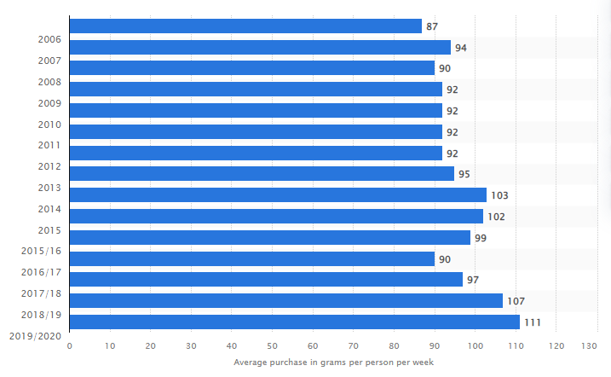
Figure 8: Statistics showing household consumption of rice in the UK
(Source: statista.com, 2022)
Concerning the provided image it is articulated that the purchase range of rice the consumers of the UK has increased to a great extent. The range of purchases in the years 2017 and 18 was identified to be 107 whereas, the purchase scenario of the years 2019 and 2020 reflects that the average purchase margin has increased by 111 (statista.com, 2022).

Illustration in context to each factor that creates an impact on the price elasticity of demand
Based on the provided description it is perceived that the different economic factors further create an impact on the price elasticity of demand. As per the previous description, it is opined that due to the fluctuation in different economic factors the demand for rice also fluctuates to a great extent. Moreover, it is analyzed that some factors of the economy create a positive impact on the demand for another commodity while other creates a negative impact. The factors further also indicate whether the demand is inelastic or elastic.

Substitution effects
As per the acquired information and further observation, it is perceived that the demand of the customers for the product fluctuates as per the importance of the commodity. In other words, it can be said that if the importance or essentialness of the commodity is high then the demand of the consumer for the particular commodity also increases. On the other hand, the demand for the commodity decreases if the commodity is not necessary or essential for the consumers. The substitution effect is further determined as the reduced sales margin of the commodity that can further be allocated to the consumers shifting to cheaper alternatives due to the increasing price of the commodity (Ludbrook, 2019, p. 8).
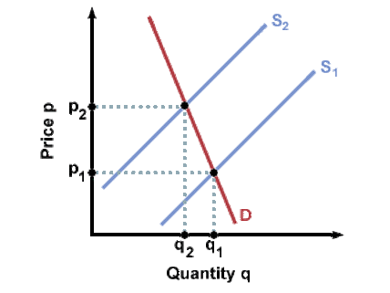
Figure 9: Impact of substitution effect on the demand elasticity
(Source: Teng et al. 2019)
The substitution effect mainly occurs in the market if the income of the consumer does not increases but the price of the necessary commodity increases. The effect of substitution mainly occurs when the customer replaces the cheap commodities with an expensive commodity because of the fluctuation in the price of the commodity. In other words, it can be said that if the financial condition of the consumer stabilises then the substitution effect occurs in the marketplace. The price elasticity of demand is further evaluated by dividing the changing percentage of demand for the commodity by the changing percentage of the price of the commodity (Teng et al. 2019, p. 1188).
Moreover, concerning further analysis, it is determined that if the quotients are high or equal to 1 then it is considered that the demand for the particular commodity is elastic in nature. On the other hand, it is articulated that if the price value of the commodity is less than 1 than it indicates or signifies that the demand for the commodity is inelastic in nature. Concerning the substitution effect, it is advocated that if the substitution effect is high then the demand for the commodity is considered to be highly elastic. On the other hand, if the effect of substitution is less than the demand is said to be inelastic.
In other words, it can be said that the commodities with close substitutes tend to have high elasticity of demand whereas, the commodities with fewer substitutes lead to less elasticity of demand. As per further analysis, it is determined or ordained that the elasticity of demand increases if it is easier for the consumer to switch from one product to the other. Further, the elasticity of demand for rice can further be evaluated by the fluctuation in the sales margin of the commodity. Moreover, it is perceived that if the increased price of the commodity increases the sales margin of the product then the demand for the product is said to be elastic. On another note, it is identified that if the rise in price does not create an impact on the quantity demanded then it indicates inelasticity of demand. As per the provided description in the further content, it is advocated that the demand is more elastic as the price of the rice creates a higher impact on the demand for rice.
Income effect
In the field of microeconomics, the income effect is determined as the after-effect change in the demand for the commodity due to the fluctuating purchasing power of the consumer (Chua et al. 2020, p. 5). The demand for the commodity increases if the income of the consumer increases on the other hand, if the income of the customer decreases the purchasing power of the consumer decreases that further creating a negative impact on the demand elasticity. Therefore, the income effect can be defined as the change in the demand for the commodity due to the change in buyers' income (Corporate finance institute. com, 2021).
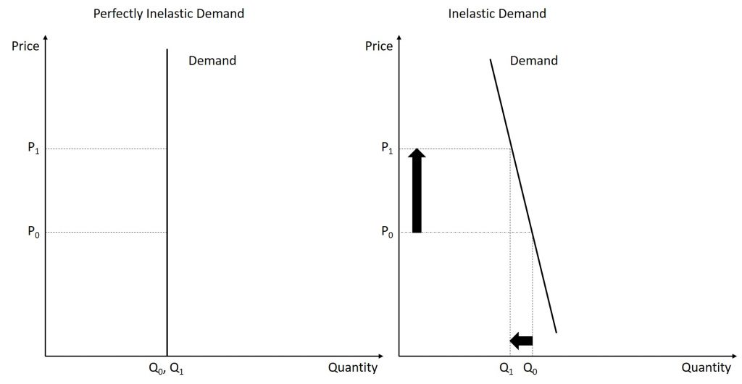
Figure 10: Income effect on the elasticity of demand
(Source: Corporate finance institute. com, 2021)
According to the provided description in the previous content, it is perceived that the income of the consumers has increased due to which the buying ability of rice of the consumers of the UK has also increased. The purchasing ability of the consumers further also indicates a higher income of the consumers. In other words, it can be said that due to the increased income of the consumers their ability to purchase rice has increased to a great extent. Further, it is observed that if the income of the consumer increases the expenditure of the consumer for the necessary goods decreases. This further determines that inferior commodities have a negative income elasticity of demand. In other words, it can be said that if the income of the buyer increases then the demand or their purchasing ability for inferior goods decreases. Based on further analysis it is advocated that higher income indicated higher elasticity of demand (Fredman and Wikström, 2018, p. 52). Moreover, the lower income of the consumer signifies the inelasticity of demand.
Illustration concerning the pricing policy
Based on further analysis and observation it is identified that Tesco emphasizes or implements a cost leadership pricing strategy in its business activities. Concerning the provided description and the given illustration, it is perceived that the company can further implement the price skimming strategy to make its business more profitable in the business market price skimming strategy is further considered as the strategy of setting the high price (Ali and Anwar, 2021, p. 39). It would further oblige the company to enhance the sales margin of the product. The price skimming strategy is further recommended because the income of the consumers of the UK is high and the demand for the commodity is also high. Therefore, by increasing the price of a commodity the sales and revenue margin of the commodity can be easily enhanced.

References
Journals
Ali, B.J. and Anwar, G., 2021. Real Estates Strategies: Analysis of Strategic Management Practices in Real Estate Companies. Ali, BJ, & Anwar, G.(2021). Real Estates Strategies: Analysis of Strategic Management Practices in Real Estate Companies. International Journal of Rural Development, Environment and Health Research, 5(3), pp.35-48.
Allcott, H., Lockwood, B.B. and Taubinsky, D., 2019. Regressive sin taxes, with an application to the optimal soda tax. The Quarterly Journal of Economics, 134(3), pp.1557-1626.
Bahmani-Oskooee, M., Usman, A. and Ullah, S., 2020. Asymmetric J-curve in the commodity trade between Pakistan and United States: evidence from 41 industries. Eurasian Economic Review, 10(2), pp.163-188.
Chua Chen Lu, A., Kueh, J., Sze Wei, Y., Yau, J. and Liwan, A., 2020. Impact of foreign direct investment (FDI) on Housing Affordability Index: Vector autoregressive model. Journal of International Business, Economics and Entrepreneurship (JIBE), 5(2), pp.1-11.
Fredman, P. and Wikström, D., 2018. Income elasticity of demand for tourism at Fulufjället National Park. Tourism Economics, 24(1), pp.51-63.
Hatak, I. and Zhou, H., 2021. Health as human capital in entrepreneurship: individual, extension, and substitution effects on entrepreneurial success. Entrepreneurship Theory and Practice, 45(1), pp.18-42.
Hovhannisyan, V., Kondaridze, M., Bastian, C. and Shanoyan, A., 2020. Empirical evidence of changing food demand and consumer preferences in Russia. Journal of Agricultural and Applied Economics, 52(3), pp.480-501.
Kaur, R. and Sharma, B., 2020. Impulsive buying behavior for essential goods: Covid-19. Journal of Critical Reviews, 7(8), pp.1326-3135.
Kovač, A., Kovačević, D., Bota, J. and Brozović, M., 2019. Consumers’ preferences for visual elements on chocolate packaging. Journal of Graphic Engineering and Design, 10(1), pp.13-18.
Ludbrook, A., 2019. Fiscal measures to promote healthier choices: an economic perspective on price-based interventions. Public health, 169, pp.180-187.
Mahaputra, M.R. and Saputra, F., 2022. Determination of Public Purchasing Power and Brand Image of Cooking Oil Scarcity and Price Increases of Essential Commodities. International Journal of Advanced Multidisciplinary, 1(1), pp.36-46.
Silalahi, N.H., Yudha, R.O., Dwiyanti, E.I., Zulvianita, D., Feranti, S.N. and Yustiana, Y., 2019. Government policy statements related to rice problems in Indonesia. Journal of Biological Science, 3(1), pp.35-41.
Teng, A.M., Jones, A.C., Mizdrak, A., Signal, L., Genç, M. and Wilson, N., 2019. Impact of sugar‐sweetened beverage taxes on purchases and dietary intake: Systematic review and meta‐analysis. Obesity Reviews, 20(9), pp.1187-1204.
website
Corporate finance institute. com , 2021 Income Effect Available at: https://corporatefinanceinstitute.com/resources/economics/income-effect/ [Accessed on: 16th November 2022]
Corporate finance institute. com , 2022 Substitute Products Available at: https://corporatefinanceinstitute.com/resources/economics/substitute-products/ [Accessed on: 16th November 2022]
Economics help.org , 2022 Complementary Goods Available at: https://www.economicshelp.org/blog/glossary/complementary-goods/#:~:text=Complementary%20goods%20will%20have%20a,both%20complementary%20goods%20will%20fall. [Accessed on: 16th November 2022]
Healthy supplies. co. uk , 2022 Online Health Food Store | UK Health Food Specialists Available at: https://www.healthysupplies.co.uk/quinoa.html [Accessed on: 16th November 2022]
ons.gov.uk, 2022 Average household income, UK: financial year 2020 Available at: https://www.ons.gov.uk/peoplepopulationandcommunity/personalandhouseholdfinances/incomeandwealth/bulletins/householddisposableincomeandinequality/financialyear2020 [Accessed on: 16th November 2022]
statista.com, 2022 Weekly household consumption of rice in the United Kingdom (UK) 2006-2020 Available at: https://www.statista.com/statistics/284474/weekly-household-consumption-of-rice-in-the-united-kingdom-uk/ [Accessed on: 16th November 2022]
taxmann.com, 2022 [Opinion] Between the Scheduled Offense and Money Laundering – A Line Drawn in Chalk Available at: https://www.taxmann.com/post/blog/opinion-between-the-scheduled-offense-and-money-laundering-a-line-drawn-in-chalk/ [Accessed on: 16th November 2022]
tesco.com, 2022, Top Rated Products Available at: https://www.tesco.com/groceries/en-GB/buylists/top-rated-products/all-products?preservedReferrer=https://www.google.com/ [Accessed on: 16th November 2022]
tescoplc.com, 2022 PLC | About Available at: https://www.tescoplc.com/about/ [Accessed on: 16th November 2022]
tradingeconomics.com , 2022 Rice Available at: https://tradingeconomics.com/commodity/rice [Accessed on: 16th November 2022]

