

Module Name: International Business Concepts

Module Code: LCMB7034

Strategic Market Analysis for Primark in Brazil

lecturer name: Akshay narayanan, mansoob murshed

student name: hinaben rajshibhai sundavadra
student id: 2521861

Executive summary
This report aims to evaluate potential expansion of Primark into Brazil through the evaluation of its international strategy, market attractiveness as well as appropriate market entry mode. Bartlett and Ghoshal’s strategic typology identifies Primark as pursuing a predominantly global strategy supported by centralised sourcing, cost leadership and standardised operations. A macro-environmental assessment highlights the large consumer market of Brazil which expands middle-income population and favourable retail growth, while recognising challenges including regulatory complexity, taxation and currency volatility. Dunning’s Eclectic (OLI) Paradigm demonstrates that Primark possesses strong ownership, location and internalisation advantages to support expansion. Based on the strategic analysis, a wholly owned subsidiary is recommended to ensure operational control, brand consistency as well as long-term competitive advantage in Brazil.

Table of Contents
Introduction 3
Section 1: Strategic Analysis and Market Entry 4
1.1 Organizational Classification and Global Strategy 4
1.1.1 Strategic Categorisation 4
1.1.2 Global configuration 5
1.2 Macro-Environmental Appraisal and Market Attractiveness 5
1.2.1 Host Country Analysis 5
1.2.2 Market Entry Analysis Using the OLI Framework 11
1.3 Entry Mode Strategy and Strategic Synthesis 15
1.3.1 Historical Pattern Recognition 15
1.3.2 Strategic Fit and Justification 15
1.3.3 Conclusion and Recommendation 16
Section 2: Reflective account 17
2.1 Introduction 17
2.2 Description 17
2.3 Feelings 18
2.4 Evaluation 18
2.5 Analysis 19
2.6 Conclusion 19
2.7 Action plan 19
Conclusion 21
References 22
Bibliography 29
Appendices 30
Appendix 1: Gibbs Reflective Cycle 30

Introduction
This study has an aim to evaluate the international market entry strategy of Primark through an examination of its strategic positioning and expansion potential into Brazil. It applies strategic management frameworks to assess market attractiveness of Brazil and recommend an appropriate entry strategy that is supported by theoretical and practical evidence.

Section 1: Strategic Analysis and Market Entry

1.1 Organizational Classification and Global Strategy

1.1.1 Strategic Categorisation
The strategic typology developed by Bartlett and Ghoshal has an aim to categorise multinational corporations (MNCs) into four international strategies that include international, multidomestic, global as well as transnational (Bartlett and Ghoshal, 1989). According to Bartlett and Ghoshal (1989), such a categorization is based on the balance between global integration (the extent to which activities are standardised across different countries) and local openness (the degree to which firms adapt and make use of new products and operations according to the needs of the local market). Primark has a focus to offer centralised sourcing, highly uniform product categories, constant value-for-money positioning and similar store layouts across more than 480 stores in international markets (Associated British Foods, 2024; Primark, 2026). In addition to that, the selected company has a focus to uninterruptedly strengthen its strategic decisions regarding procurement, merchandising as well as supply chain management synchronised centrally to exploit economies of scale along with maintaining its low-cost business model (ABF, 2025). In addition, while the standardised model of Primark aligns with a global strategy, it may limit responsiveness to local consumer preferences in culturally diverse markets such as Brazil. For example, Zara has adapted its pricing and operations to address the complex tax and logistics environment of Brazil which demonstrates that better localisation works towards improving market competitiveness where standardisation alone is inadequate (BTGPactual, 2019).
Significant international operations of Primark work towards supporting this classification further. Primark sources more than 98% of its products with the help of a globally coordinated supplier network across 22 countries that directly supports standardised merchandise as well as centralised procurement steady with a global strategy (ABF, 2025). The chosen retailer has a tendency to rely on internationally integrated sourcing networks and bulk purchasing to decrease production costs while sustaining steady pricing across markets (Davey, 2024). In addition to that, the firm has worked towards introducing selective local responsiveness that include expanding its Click & Collect service in the UK along with adjusting store formats in certain European markets which indicates a limited degree of adaptation without fundamentally altering its international operating model. Therefore, although some localisation exists, it does not outweigh the company’s strong emphasis on global standardisation. The global strategy of Primark provides a strong foundation to enter Brazil through standardised operations and cost efficiency. Standardised global retail strategies can succeed in emerging markets but long-term performance depends on balancing cost efficiencies with adaptation to local institutional, cultural as well as competitive conditions (Meyer et al., 2023). Moreover, distinct consumer preferences, regulatory complexity and strong local competition in the Brazilian market necessitate a gradual shift towards a transnational strategy (Walger, Longhi-Santos and Dittrich, 2026). However, adapting to Brazilian consumer preferences and market conditions would necessitate a gradual shift towards a transnational strategy that stabilises global integration with local receptiveness.

1.1.2 Global configuration
Significant international operations further support this classification as the extensive store network and centralised sourcing of Primark strengthen cost leadership and value creation but limited local adaptation works towards constraining competitiveness in culturally diverse markets (ABF, 2025). Primark has a focus to sustain an extensive global footprint that operates in 473 stores across 17 countries in the United States and Europe that is supported by an internationally integrated network of sourcing spanning Europe, Africa and Asia (ABF, 2025). Such a geographic configuration works towards enabling the chosen retailer to accomplish significant economies of scale with the help of centralised procurement, efficient logistics as well as high volume of purchasing (Davey, 2024; ABF, 2025). In addition to that, diversified market presence decreases dependence on any single economy along with strengthening revenue resilience (Kashob, Chakor and Al-Ansi, 2025). However, limited presence of Primark outside Europe and North America pressures exposure to high-growth emerging markets like Brazil (ABF, 2025). Therefore, while the current configuration of Primark supports cost leadership through scale economies, its limited geographic diversification underscores the strategic need for expansion into high-growth markets like Brazil to sustain and strengthen long-term competitive advantage.

1.2 Macro-Environmental Appraisal and Market Attractiveness

1.2.1 Host Country Analysis
Political & Legal Factors
The political stability of Brazil is reported to be 43% which indicates moderate risk of social unrest (Trading Economics, 2023). This country achieves 43 out of 100 points and it demonstrates lack of political violence, terror (Trading Economics, 2023) (Figure 1). Therefore, it can be said that Brazil presents relatively low risks of political violence and such a stable framework can offer a favorable environment for retail FDI. Even though periodic political changes can lead to operational uncertainties, the overall external environment supports foreign direct investment.
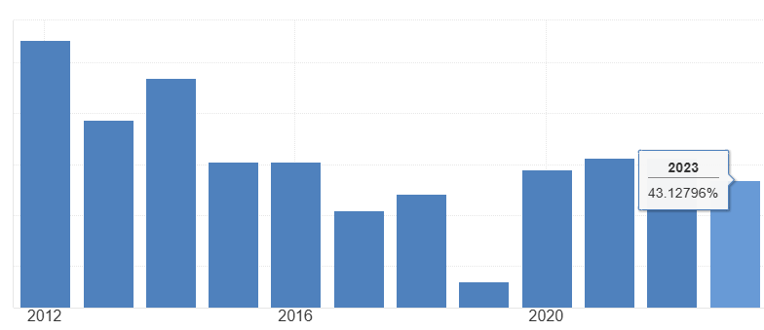
Figure 1: Political stability of Brazil
(Source: Trading Economics, 2023)
The retail fashion industry has to follow certain legal regulations in Brazil to ensure consumer rights, employment practices, and product safety. Under the Consumer Protection Code, businesses have to make sure products are high in quality with transparent pricing and fair commercial practices (UNCTAD, 2026). Compliance with these regulations enhances consumer trust for international retailers. Strong adherence to these regulations can help Primark to establish commitment towards product quality and ethical sourcing.
Brazil provides Intellectual Property (IP) protection for retail fashion companies through some key legal tools. As per the International Intellectual Property Alliance, Brazil ranks within the top 30% among emerging markets for IP enforcement across the retail industry (IIPA, 2025). Under the supervision of National Institute of Industrial Property (INPI), copyrights, trademarks and designs receive legal protection. With the help of such strong IP enforcement, international retail companies like Primark can safeguard its brand identity and product differentiation.
Brazil is a founding member of the MERCOSUR, which provides easy access to regional trade opportunities and building commercial relationships (Mercosur, 2026) (Figure 2). Trade integration supports future regional expansion once retail fashion operations become established in Brazil. However, at the same time this host country has high import duties up to 35% for finished apparel products, thereby increasing the cost of imported goods (ITA, 2023). Based on such trade policies, Primark might be encouraged to build professional relationships with local suppliers and manufacturers. Overall, the current political and legal environment significantly supports foreign retail investment even though taxation complexities with high corporate income tax (34%) and several state level ICMS taxes require Primark to plan carefully (World Bank Group, 2025).
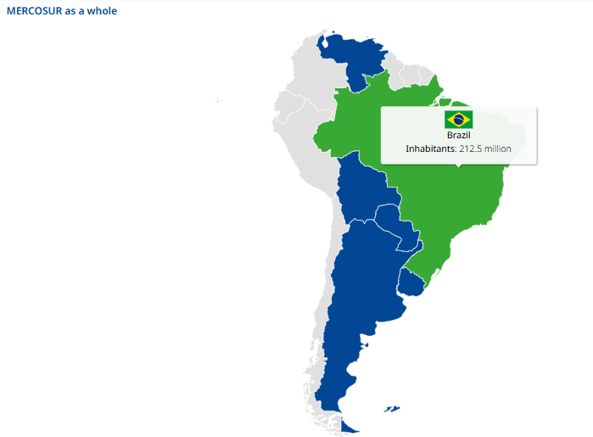
Figure 2: Brazil founding member
(Source: Mercosur, 2026)
Economic Factors
Brazil is the largest economy in Latin America that is considered an attractive destination for building the physical presence of Primark stores. The current population of Brazil is 213.6 million and is the seventh most populous country in the world (Worldometer, 2026) (Figure 3). This presents access to a substantial consumer market for Primark that currently does not have any direct operations in Brazil. According to reports, the retail fashion market in Brazil is valued at $76 billion with an annual growth rate of 6% (Euromonitor, 2026). The annual household income per capita increased from $4,491 in 2024 to $4,862 in 2025 (World Bank Group, 2025). Some of the major metropolitan cities including Sao Paulo, Rio de Janeiro have modern shopping centers that can help retail fashion company Primark to expand operations.
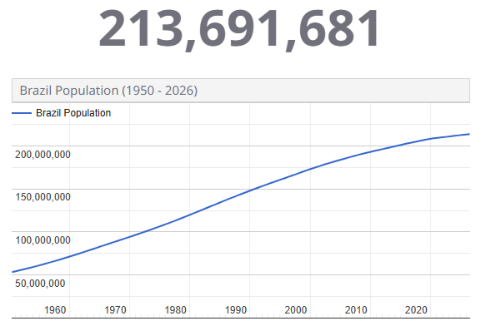
Figure 3: Brazil population growth
(Source: Worldometer, 2026)
The economic growth of Brazil is under stable conditions and exceeds 3% over the past three years (World Bank Group, 2025). Total private consumption reached $1.5 trillion in 2025 that accounts for 63% of the country’s GDP (Worldbank, 2026). According to reports, total household disposable income reached $811.33 billion in 2026 especially among middle income groups (CEIC, 2026). This has encouraged greater spending on apparels, footwear and other lifestyle products. Due to the high inflation rate of 6.5%, the consumers in Brazil are looking for affordable fashion products (Ken Research, 2019). This confirms increased price sensitivity within the Brazilian apparel market and that economic factors can drive demand for low-cost products. However, it aligns well with the value driven business strategy of Primark as noticed by the success in Spain which is also a price sensitive market.
The Brazilian Real depreciated more than 20% against the US dollar in 2024 and it led to an increase in the cost of imported clothing (Reuters, 2025). As per Kohler, Bonizzi and Kaltenbrunner (2023), financial uncertainties challenge the low-cost model followed by businesses especially during currency depreciation periods. Therefore, the company can establish partnerships with local manufacturers in order to reduce dependency on imported inventory. Brazil has around 24,000 textile fashion manufacturing companies which showcases the availability of local apparel manufacturers (ABIT, 2026). Brazil has invested around 76.5 billion BRL for transport, logistics and digital infrastructure (Datamar News, 2026). There are several highway networks with a density of 23 kilometers per 100 square kms, international airports and distribution centers that support efficient movement of products across major consumer marketplaces (Datamar News, 2026). The last mile delivery services and modern logistics networks support faster inventory replenishments and improve future omnichannel retail operations. For instance, Primark has strengthened its omnichannel strategy through Click and Collect in the UK market (Primark, 2025). Altogether, the expanding middle income population creates growth potential for Primark however it requires strategic planning to address income inequality. The gini coefficient of Brazil was approximately 0.52 in 2024, which indicates one of the highest levels of income inequality (World Bank, 2022) (Figure 4). The chosen company can mitigate this issue by opening stores initially in densely populated areas like Sao Paulo and Rio de Janeiro to attract consumers.
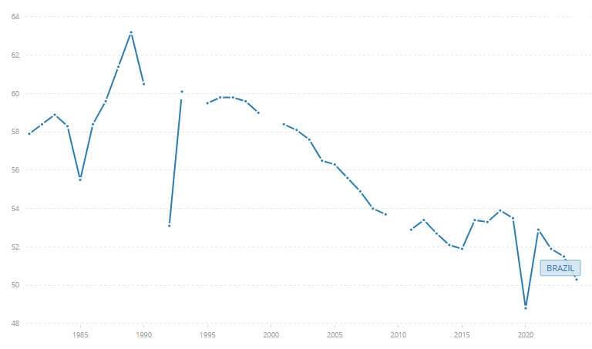
Figure 4: Gini coefficient of Brazil
(Source: World Bank, 2022)
Cultural Factors
Cultural factors are crucial for fashion retail companies like Primark to expand operations in a new target market (Hofstede, 2001). As per Hofstede’s cultural dimensions, Brazil has a high-power distance (69) compared to Ireland (28) (Clearly Cultural, 2024). This indicates that consumers value established brands, however, the low-cost positioning of Primark can appeal to price sensitive consumers instead of those who seek status brands. Whereas on the other hand, Brazil scores lower on individualism (38) than Ireland (70) (Clearly Cultural, 2024). Brazil also showcases a collectivist culture where opinions of family or friends influence purchasing decisions. Over 90% Gen Z Brazilian consumers prioritise appearance and view fashion as a core tool for identity through social media platforms like TikTok, Instagram (Furtado and Fernandes, 2024). This consumer behaviour closely aligns with the digital presence of Primark. On Instagram, the company has around 11.3 million followers that helps reach a wide customer base (Instagram, 2026) (Figure 5). Apart from that, regional differences in consumer preferences, climate and lifestyle require Primark to adapt products accordingly. For instance, the company can offer seasonal collections that reflect local styles in order to gain a competitive advantage over companies like Lojas Renner, Riachuelo and others. Business culture in Brazil places a considerable importance on trust and face to face communication. With the help of transparent communication, the company can establish long term relationships with suppliers and local business partners. For instance, it embraces a collaborative supplier management approach to develop long term collaborations, highly suitable for the Brazilian market. Overall, the cultural characteristics closely align with the value driven retail model of Primark and growing interest in international brands create favorable conditions for successful market entry.

Figure 5: Primark Instagram profile
(Source: Instagram, 2026)
Synthesis
Based on the above analysis, economic factors emerge as the most influential aspect for Primark business success in Brazil. The country has a large consumer market with an expanding middle income population. There is immense demand for affordable fashion that highly complements the cost leadership strategy of Primark. However high-income inequality and inflationary situations significantly increased price sensitivity among consumers. Despite this external environment, Primark can compete against local retailers through its value for money offering. The company can compete effectively with local retailers like Lojas Renner, Riachuelo by offering products at a lower price than these companies. Since the competitors primarily offer high priced collections, Primark can gain a competitive advantage through its low-cost model (Euromonitor, 2026). The company can mitigate the issue of exchange rate volatility through open and transparent partnership with local business manufacturers. For instance, Primark already embraces a diversified global sourcing strategy through collaboration with local or regional suppliers (Primark, 2025). Therefore, adoption of a similar approach in Brazil can reduce dependency on imported apparel and improve supply chain responsiveness. Apart from that, the political and legal factors also significantly contribute towards market attractiveness. Brazil provides a secure environment when it comes to legal guidelines, IP protections. These factors effectively support future regional expansion and continuous foreign investment into Primark business operations. However due to complex taxation systems, the company needs to plan carefully. The cultural factors appear less restrictive when compared to political, legal or economic factors as consumers showcase strong demand for fashion on social media. The combination of a massive price sensitive customer base and stable political-legal protections suggests that Brazil offers several opportunities for Primark expansion which outweighs risks associated with import duties or income inequality situations.

1.2.2 Market Entry Analysis Using the OLI Framework
The eclectic paradigm (OLI) framework serves as a holistic model for evaluating foreign entry markets through analysis of ownership, location and internalisation advantages (Dunning, 1988) (Figure 6). The paradigm enabled this report to determine whether the specific business capabilities of Primark, the nature of the market in Brazil and the governance structure create sustainable competitive advantage and internationalisation success.
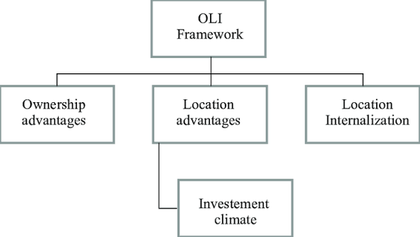
Figure 6: OLI Framework
(Source: Dunning, 1988)
Ownership (O) Advantages: In Dunning’s OLI paradigm, ownership advantages are those firm-specific assets that are valuable, difficult to imitate and can be moved across various international markets for the benefit of multinational companies to reduce the disadvantages of being foreign. In primark, the advantages that can support their venturing into Brazil includes, their ownership advantage of having a brand that has an excellent reputation worldwide as a fashion-led and cheap product. The company is recently recognised as the ‘Global disruptive leader in apparel’ with about 486 outlets in 19 countries, showing that it has the ability of replicating its business model across international markets (ABF, 2026). The second aspect of the advantages of ownership concerns the integrated product development and sourcing skills that Primark offers. The company is able to take full responsibility for the development of the products, as well as for purchasing and ethical sourcing, without outsourcing it via brand licensing or procurement.
There is an appointment report of a dedicated Choif Commercial Officer in 2026 to integrate product, retail, digital and customer functions (ABF, 2026b). Infrastructure material and finance being some of the potent barriers in Brazilian fast-fashion industry, such a vertically integrated business strategy allows fast adjustments of the merchandise range while staying in the position of cost leadership, which cannot be replicated by the local competitors (Bhandari et al., 2022). However, the aforementioned ownership benefits cannot remain untouchable. The mounting competition from digital retailers like Shein and Temu, coupled with the inability of Primark to perform well in certain regions of Europe, show that even brand reputation is not sufficient to ensure success in any international market (Pratley, 2026). Thus, despite the fact that Primark has all necessary ownership assets including brand equity, economies of scale, logistics advantages, and merchandising experience, its successful localisation in Brazil would require adaptation to Brazilian consumer demands and not simply transfer of the European business model.
Location (L) Advantages: The most important location advantage of Brazil is the size of the consumer market, as given the leading position of Brazil as the largest economy and apparel market in Latin America as per the Eclectic Paradigm proposed by Dunning. This opportunity is further evident by international retailers, as H&M decided to develop Brazil as one of its priority markets due to the weakening of the demand in Europe and North America and opened its first flagship store there (Reid and Fondahn, 2025). Thus, Brazil provides good prospects for the volume-based strategy of Primark, since it relies on the high number of customers and quick turnover of inventory. Furthermore, large urban centres like São Paulo and Rio de Janeiro have elaborate retail environments that consist of modern shopping malls and well-established supply chains capable of supporting large-scale retail business (Retière and Darly, 2023). The recent expansion of MercadoLibre in terms of logistics infrastructure to the tune of 57 billion reais and establishment of fourteen new fulfilment centers also point to an advanced supply chain environment in Brazil (Reuters, 2026). As such an infrastructure will be valuable for Primark in lowering logistics cost and effective stock replenishment, Primark might be required to evaluate the cost-benefit of using third-party logistics. Consequently, although the large consumer market and better logistics in Brazil offer an attractive location for the company in terms of their volume strategy, Primark might also need to consider other aspects that may negate those advantages.
However, Brazil also corresponds to challenges such as a difficult regulatory environment, their relatively high labour cost and logistical shortcoming pose serious issues to foreign retailers. It was seen in the case of Shein, when they attempted to establish Brazil as a regional manufacturing hub, as several domestic suppliers withdrew due to production costs, delivery expectations and regulatory compliance reduced commercial viability (Magalhaes and Reid, 2026). Based on the foregoing, Brazil has been found to be highly attractive as a consumer market, whereas it is considerably less competitive as a low-cost manufacturing location. Moreover, formidable domestic competitors like Lojas Renner are well acquainted with consumers, have huge store networks along with strong supplier networks (Laier, 2025). Such brands further pose competition to the Brazilian retail market. In this regard, from the OLI framework perspective, it can be seen that Brazil’s main location advantage in relation to Primark stems from its access to markets rather than cost efficiency. In this respect, the presence of a huge customer base in Brazil, coupled with its improved retailing environment and increasing attractiveness to foreign investors, presents very compelling reasons to enter the market.
Internalisation (I) Advantages: OLI Theory posits that internalisation economies are realised if there are increased benefits from keeping control over the foreign businesses in the hands of firms rather than engaging in external dealings such as franchising and licensing. The need for internalisation is highly critical for Primark since its competitive advantage is based on the consistent execution of its low-cost and high-volume retail model. The international expansion of Primark has largely been based on wholly-owned shops which allow full control of merchandising, pricing, stock control, and ethical sourcing of raw materials and products (Primark Corporate, 2022). Although the recent partnership of the company with Alshaya Group through franchising has occurred in the Middle East, it has taken place only in strategic markets where the help of experienced local partners minimises institutional obstacles (Alshaya Group, 2026). Furthermore, Internal control is more strategic for Primark in Brazil since it allows Primark to keep its unique product development, value pricing, and image from any transaction and monitoring costs that come along with using licensees. The decision of ABF to establish Primark as a standalone business reflects this confidence in their independent international expansion capabilities (Conti, 2026). As such, being entirely controlled by Primark may allow proper implementation and increase the trust of customers. In summary, ownership-based governance in Primark ensures strategic control and consistency in operations.

1.3 Entry Mode Strategy and Strategic Synthesis

1.3.1 Historical Pattern Recognition
Primark has historically adopted a wholly owned subsidiary (WOS) as its dominant market entry mode. This company owns and operates its stores across major markets like UK, Spain, Germany instead of relying on joint ventures or franchising (Primark, 2026). The wholly owned business model of Primark has strategically allowed it to standardise store layouts in almost 16 European markets (Primark, 2026). Direct ownership also enables the organisation to maintain strict quality and ethical standards across international markets. Even though WOS has several benefits, it requires continuous capital investment and exposes a business towards risk during market entry. For example, the WOS entry of Primark in the USA required an initial investment of $500 million which exposed the firm towards currency fluctuation risks (Rozario, 2020). Therefore, before entering into Brazil, Primark has to make sure to assess this risk against control benefits.

1.3.2 Strategic Fit and Justification
In regard to the past internationalisation strategy followed by Primark, the firm has made use of wholly owned subsidiaries (WOS) with selective franchising in the Middle East region due to its affiliation with Alshaya Group (Primark, 2025). This reveals that the company focuses on ownership and control rather than franchising, which is done in regions where institutional distance exists. Lin et al. (2023) argued that the use of WOS becomes justified when companies have firm-specific advantages that need to be protected, while JV helps in reducing market uncertainties due to knowledge of the local partner but results in higher coordination costs. In contrast to this view, Abdul Ghani et al. (2022) explained that franchising provides fast market penetration with reduced capital outlay, whereas weakens control over brand implementation and customer experience. This implies that Primark poses an exception driven by regional institutional complexity rather than a strategic shift in their global expansion model.
Brazil represents an environment that is better suited for Primark to continue with its owner-centric strategy rather than opting for franchising and joint ventures. As per the institutional theory, the modes of entry that have high control will have better performances in the long term if the competition between the firms occurs in terms of standardised operational capabilities and brand consistency even though such a mode of entry demands financial resources (Giachetti and Peprah, 2020). On the other hand, the theory of transaction cost advocates that partnership becomes a desirable option only when the value of market knowledge is much higher than the value of control (Seggie, 2012). Even though Brazil is a complicated regulatory environment, the country has a well-developed retail environment, which reduces the dependency of the venture on local intermediaries for distribution and market intelligence.
As such, the use of wholly owned subsidiaries as opposed to joint ventures and franchising appears to be the right entry strategy for the Brazilian market. While joint ventures will allow fast acquisition of local market knowledge and franchising will mitigate risk of investment, both options will have a detrimental impact on the ability of the company to influence the price, merchandising and customer service, which are the key sources of competitive advantage. Franchising through the experienced Alshaya Group in the Middle East market, where institutional barriers are substantially different compared to Brazil, also indicates that franchising is an exception to the rule.

1.3.3 Conclusion and Recommendation
Conclusion: In summary, this assessment reveals that the global integrated nature of Primark, combined with its ownership advantages and international experience, makes the company a good fit for the favorable market potential in Brazil. Although the regulation and currency risks cannot be ignored, the increasing consumer market and the retail environment in Brazil overshadow the difficulties and make a wholly-owned subsidiary an ideal mode of entry.
Recommendation: It is advisable for Primark to use the wholly owned subsidiary (WOS) form of business in entering the Brazilian market, using the phased approach that sees the opening of flagship stores in big cities like Sao Paulo and Rio de Janeiro before moving further into other cities. This method allows the company to maintain its competitive advantage since it maintains full control over pricing, merchandising, procurement and customer experiences despite the high financial risk involved compared to franchising and joint venture forms of business organization.

Section 2: Reflective account

2.1 Introduction
This reflective account has an aim to evaluate my experience of preparing the strategic analysis and market entry assessment for the proposed expansion of Primark into Brazil with the application of Gibbs' Reflective Cycle. The focus of Gibbs' Reflective Cycle is to describe the overall experience of individuals through different stages that include description, feelings, evaluation, analysis and action plan (Gibbs, 1988; Zafeer, Li and Maqbool, 2023) [Appendix 1]. The purpose of this reflection is to critically examine how I researched, analysed as well as interpreted strategic management concepts while developing Section 1 of the report. The overall reflective process permitted me to assess my strengths, identify areas requiring improvement and understand the role of theoretical frameworks in supporting practical international business decisions. Moreover, with the help of reflecting on each stage of the assessment, I expanded valuable insights into evidence-based strategic analysis, academic research and critical evaluation which strengthen my future academic work as well as professional decision-making.

2.2 Description
Throughout the process of conducting Section 1, I first studied the assessment requirements to understand the expected structure and learning outcomes. I worked hard to conduct extensive research using academic journal articles, company annual reports, government publications as well as industry reports to gather reliable information about Primark and the Brazilian retail market. In addition, I also analysed the international strategy of Primark with a focus on incorporating Bartlett and Ghoshal's strategic typology before investigating its global configuration and market attractiveness with the help of political, economic, legal as well as cultural factors. I also applied and made use of Dunning's Eclectic (OLI) Paradigm to evaluate ownership, location and internalisation advantages that support market entry of Primark into Brazil. Throughout the process, I compared theoretical concepts with real business practices through the incorporation of examples from competitors such as Zara, Shein as well as H&M. After completing the analysis, I studied the content several times with an aim to improve logical flow, strengthen academic arguments along with ensuring that recommendations were supported with recent evidence as well as relevant literature.

2.3 Feelings
At the initial stage of executing the assignment, I felt confident because I had earlier studied international business theories related to business expansion. However, as I proceeded with the study, I realised that the application of theoretical models to a real organisation required much deeper critical thinking than only clearing up different concepts. Moreover, I found it quite complicated and exhausting to identify recent and reliable evidence that directly supported my arguments regarding the retail market of Brazil and the expansion strategy of Primark. At such times, I became uncertain about if my analysis was adequately critical or merely expressive. Moreover, getting feedback that some recommendations lacked clear justification made me realise that academic writing necessitates stronger integration between evidence and theories. Although this worked towards reducing my confidence at initial stages but at the same time it encouraged me to think more critically about every argument I offered. As I refined the report, I became more confident because I understood the role of theoretical frameworks in justifying strategic recommendations rather than simply describing organisational activities.

2.4 Evaluation
One of the robust aspects of my work was to collect information from an extensive variety of credible sources that include company reports, academic journals as well as international organisations. This directly worked towards enabling me to support my strategic analysis with current evidence rather than depend solely on textbook knowledge. The successful application of Bartlett and Ghoshal's framework and the OLI Paradigm also enhanced the structure of my analysis as it proved its excellence by providing logical explanations for Primark's international strategy along with the attractiveness of Brazil as a target market. Furthermore, comparing Primark with competitors such as Zara, H&M as well as Shein supported the overall practical application of my discussion. However, several encounters emerged throughout the process. Initially, some sections focused too heavily on describing theories instead of critically evaluating their relevance to the expansion of Primark. I also identified it as problematic to integrate multiple sources into a coherent argument without the repetition of similar ideas. Feedback highlighted that some recommendations were deficient in sufficient justification and stronger connections between market evidence, organisational capabilities as well as theoretical perspectives. Another challenge was to locate recent country-specific data for Brazil because some statistics varied across different sources. All these experiences demonstrated that effective strategic analysis necessitates not only precise information but also critical synthesis as well as logical interpretation that is supported by evidence.

2.5 Analysis
The lecture on the Bartlett and Ghoshal typology combined with the case analysis of Zara's global operations worked towards helping me to understand that while Primark follows a global strategy, the Brazilian market requires selective local responsiveness. The application of Bartlett and Ghoshal's model and Dunning's OLI Paradigm permitted me to understand that theoretical frameworks must be supported by market-specific evidence rather than applied in a descriptive way. Moreover, I also identified the requirement to balance quantitative data with qualitative interpretation while evaluating foreign market entry decisions. Overall, this experience reinforced my critical thinking, research skills as well as my ability to develop evidence-based strategic recommendations for real-world business circumstances.

2.6 Conclusion
The assessment proved its proficiency in deepening my understanding of the OLI framework discussed in class and the importance of aligning entry modes with host-country risks, as highlighted in the lecture on market entry strategies. The study also increased my confidence in developing well-justified market entry recommendations while recognising the importance of continuously refining my critical thinking, research as well as academic writing skills.

2.7 Action plan
Skills to improve | Action required | Required time
Critical analysis | - To improve my critical analysis, I will critically compare multiple academic sources  - Evaluate contrasting viewpoints | 2-3 months
Academic research | - To improve my academic research ability, I will use Scopus, Web of Science and Google Scholar to identify recent peer-reviewed studies  - Verify data across credible sources | 3-4 months
Table 1: Action plan

Conclusion
In conclusion, the global strategy of Primark together with its ownership benefits as well as the favorable environment in Brazil are key reasons why international business activities will be successful regardless of institutional hurdles. In all, it is best to choose a wholly-owned subsidiary form of entry mode for Primark.

References
Abdul Ghani, M. F. et al. (2022) “A Preliminary Study: Exploring Franchising Growth Factors of Franchisor and Franchisee,” Journal of Open Innovation: Technology, Market, and Complexity, 8(3), p. 138 (Accessed: July 28, 2026).
ABF (2025) Annual report 2025, ABF Corporate. Available at: https://www.abf.co.uk/investors/annual-report-2025 (Accessed: July 29, 2026).
ABF (2026a) ABF announces the outcome of its review of Group structure, ABF Corporate. Available at: https://www.abf.co.uk/media/news/2026/ABF-announces-the-outcome-of-its-review-of-Group-structure (Accessed: July 25, 2026).
ABF (2026b) Appointment of Primark Chief Executive, ABF Corporate. Available at: https://www.abf.co.uk/media/news/2026/appointment-of-primark-chief-executive (Accessed: July 27, 2026).
ABIT (2026) MUCH MORE POWER FOR THE SECTOR AND FOR BRAZIL , Texbrasil. texbrasil.com.br. Available at: https://texbrasil.com.br/en/abit/ (Accessed: July 24, 2026).
Alshaya Group (2026) Primark Opens Its First Store in Dubai in Partnership with Alshaya Group, Alshaya.com. Available at: https://www.alshaya.com/en/english/media-centre/alshaya-news/primark-opens-its-first-store-in-dubai-in-partnership-with-alshaya-group/ (Accessed: July 23, 2026).
Associated British Foods (2024) “annual report 2024,” in. Available at: https://www.abf.co.uk/content/dam/abf/corporate/ar-assets-2024/pdfs/abf-annual-report-2024.pdf.downloadasset.pdf (Accessed: July 29, 2026).
Bhandari, N. et al. (2022) “Barriers to sustainable sourcing in the apparel and fashion luxury industry,” Sustainable Production and Consumption, 31(31), pp. 220–235. doi: https://doi.org/10.1016/j.spc.2022.02.007 (Accessed: July 28, 2026).
BTGPactual (2019) Brazil Retail and Internet. Available at: https://static.poder360.com.br/2019/01/07.01-Brazil-Retail-and-Internet-1.pdf (Accessed: July 27, 2026).
CEIC (2026) Brazil Households Disposable Income, ceicdata. www.ceicdata.com. Available at: https://www.ceicdata.com/en/brazil/household-disposable-income/households-disposable-income (Accessed: July 27, 2026).
Clearly Cultural (2024) Power Distance Index, Clearly Cultural. clearlycultural.com. Available at: https://clearlycultural.com/geert-hofstede-cultural-dimensions/power-distance-index/ (Accessed: July 22, 2026).
Conti, S. (2026) Primark Will Become a Stand-alone Retailer After ABF Demerger in 2027, WWD. Available at: https://wwd.com/business-news/business-features/primark-become-standalone-retailer-separation-abf-2027-1238922852/ (Accessed: July 26, 2026).
Datamar News (2026) Brazil investments in transport and logistics reach highest level in 11 years, Datamar News. datamarnews.com. Available at: https://datamarnews.com/noticias/brazil-investments-in-transport-and-logistics-reach-highest-level-in-11-years/ (Accessed: July 24, 2026).
Davey, J. (2024) “Primark looking to expand click & collect trial,” Reuters, 13 March. Available at: https://www.reuters.com/business/retail-consumer/primark-looking-expand-click-collect-trial-2024-03-13/ (Accessed: July 29, 2026).
Dunning, J.H. (1988) The Eclectic Paradigm of International Production: A Restatement and Some Possible Extensions. Journal of International Business Studies, 19, 1-31. http://dx.doi.org/10.1057/palgrave.jibs.8490372 (Accessed: July 25, 2026)
Euromonitor (2026) Retail in Brazil, Euromonitor. www.euromonitor.com. Available at: https://www.euromonitor.com/retail-in-brazil/report (Accessed: July 22, 2026).
Fraga, G. J. (2022) “Investment climate and foreign direct investment in Latin American countries: firm-level evidence,” Estudios económicos, 39(79), pp. 103–126. doi: 10.52292/j.estudecon.2022.2809 (Accessed: July 29, 2026).
Furtado, B. and Fernandes, P. (2024) Brazilian consumer optimism rebounds in line with economic growth, McKinsey & Company. www.mckinsey.com. Available at: https://www.mckinsey.com/industries/consumer-packaged-goods/our-insights/the-state-of-the-brazilian-consumer (Accessed: July 26, 2026).
Giachetti, C. and Peprah, A. A. (2020) “How Much Control Do Firms Exercise over Their Resources When Entering Emerging markets? The Influence of Institutional Voids on Entry Mode Degree of Control,” BRQ Business Research Quarterly, 25(2), p. 234094442092440. doi: 10.1177/2340944420924402 (Accessed: July 28, 2026).
Hofstede, G. (2001) “ Culture’s consequences – Comparing values, behaviours, institutions and organisations across nations.” (Accessed: July 21, 2026).
IIPA (2025) 2025 SPECIAL 301 REPORT ON COPYRIGHT PROTECTION AND ENFORCEMENT, IIPA. www.iipa.org. Available at: https://www.iipa.org/files/uploads/2025/01/BRAZIL-2025-Copyedited-011625.pdf (Accessed: July 24, 2026).
Instagram (2026) Primark, Instagram. www.instagram.com. Available at: https://www.instagram.com/primark/?hl=en (Accessed: July 20, 2026).
International Trade Administration (2023) Brazil - Market Challenges, www.trade.gov. Available at: https://www.trade.gov/country-commercial-guides/brazil-market-challenges (Accessed: July 29, 2026).
ITA (2023) Brazil - import tariffs, ITA. www.trade.gov. Available at: https://www.trade.gov/country-commercial-guides/brazil-import-tariffs (Accessed: July 24, 2026).
Kashob, H., Chakor, A. and Al-Ansi, A. M. (2025) “Economic diversification and sustainable development: Evaluating progress in SDGs 7, 8 and 11, 12,” Multidisciplinary Reviews, 9(2), p. 2026058. doi: 10.31893/multirev.2026058 (Accessed: July 29, 2026).
Ken Research (2019) Brazil Gen Z Apparel Market, Kenresearch. www.kenresearch.com. Available at: https://www.kenresearch.com/brazil-gen-z-apparel-and-streetwear-market (Accessed: July 21, 2026).
Kohler, K., Bonizzi, B. and Kaltenbrunner, A. (2023) “Global financial uncertainty shocks and external monetary vulnerability: the role of dominance, exposure, and history,” Journal of International Financial Markets, Institutions and Money, 88. doi: 10.1016/j.intfin.2023.101818 (Accessed: July 21, 2026).
Laier, P. A. (2025) “Brazil apparel firm Lojas Renner expects softer sales before 2026 improvement, CFO says,” Reuters, 10 September. Available at: https://www.reuters.com/markets/europe/brazil-apparel-firm-lojas-renner-expects-softer-sales-before-2026-improvement-2025-09-09/ (Accessed: July 28, 2026).
Lin, C.-C. et al. (2023) “The determinants of the use of process control mechanisms in FDI decisions in headquarters–subsidiary relationships,” Humanities and Social Sciences Communications, 10(1), pp. 1–14. doi: 10.1057/s41599-023-01890-w (Accessed: July 28, 2026).
Lojas Renner (2024) Annual Report 2024. www.lojasrennersa.com. Available at: https://www.lojasrennersa.com.br/en/wp-content/uploads/2025/05/250425_LojasRenner_RA24_V3A-compactado.pdf (Accessed: July 26, 2026).
Magalhaes, L. N. and Reid, H. (2026) “Shein tried to turn Brazil into a production hub. Local factories walked away,” Reuters, 4 February. Available at: https://www.reuters.com/business/retail-consumer/shein-tried-turn-brazil-into-production-hub-local-factories-walked-away-2026-02-04/ (Accessed: July 26, 2026).
Mercosur (2026) what is mercosur? – mercosur, Mercosur. www.mercosur.int. Available at: https://www.mercosur.int/en/about-mercosur/what-is-mercosur (Accessed: July 25, 2026).
Pratley, N. (2026) The Primark machine suffers a continental splutter at a bad moment, The Guardian. The Guardian. Available at: https://www.theguardian.com/business/nils-pratley-on-finance/2026/jan/08/the-primark-machine-suffers-a-continental-splutter-at-a-bad-moment (Accessed: July 26, 2026).
Primark (2025) Primark adds 24 more stores to popular Click & Collect service, Primark. corporate.primark.com. Available at: https://corporate.primark.com/en-gb/a/news/corporate-news/primark-adds-24-more-stores-to-popular-click-and-collect-service (Accessed: July 23, 2026).
Primark (2025) Primark announces first stores in Middle East in partnership with Alshaya Group, Primark.com. Available at: https://corporate.primark.com/en-gb/a/news/corporate-news/primark-announces-first-stores-in-middle-east-in-partnership-with-alshaya-group (Accessed: July 25, 2026).
Primark (2026) About us, Primark Corporate. corporate.primark.com. Available at: https://corporate.primark.com/en-gb/a/about-us/who-we-are (Accessed: July 22, 2026).
Primark (2026) Primark Cares (US) | Homepage, corporate.primark.com. Available at: https://corporate.primark.com/en-us (Accessed: July 29, 2026).
Primark Corporate (2022) Primark continues international expansion as it confirms its first store in Romania | Primark Cares (UK), Primark Corporate. Available at: https://corporate.primark.com/en-gb/a/news/corporate-news/primark-continues-international-expansion-as-it-confirms-its-first-store-in-romania (Accessed: July 24, 2026).
Reid, H. and Fondahn, G. R. (2025) “H&amp;M targets Brazil and India as US, European spending slows,” Reuters, 25 September. Available at: https://www.reuters.com/business/retail-consumer/hm-targets-brazil-india-us-european-spending-slows-2025-09-25/ (Accessed: July 23, 2026).
Retière, M. and Darly, S. (2023) “School food policies and the transition of urban food systems in Brazil and France: Insights from São Paulo and Greater Paris region case studies,” Frontiers in sustainable food systems, 7. doi: 10.3389/fsufs.2023.984207 (Accessed: July 28, 2026).
Reuters (2025) Brazil’s finance minister rules out hiking taxes to curb dollar outflow, Reuters. www.reuters.com. Available at: https://www.reuters.com/world/americas/brazils-finance-minister-rules-out-hiking-taxes-curb-dollar-outflow-2025-01-06/ (Accessed: July 25, 2026).
Reuters (2026) “MercadoLibre to invest $11 billion in Brazil this year,” Reuters, 24 March. Available at: https://www.reuters.com/business/finance/mercadolibre-invest-11-billion-brazil-this-year-2026-03-24/ (Accessed: July 27, 2026).
Rozario, K. (2020) primark pushes forward with us openings despite a sales hit of $580 million this fall, Forbes. www.forbes.com. Available at: https://www.forbes.com/sites/kevinrozario/2020/12/04/primark-pushes-forward-with-us-openings-despite-a-sales-hit-of-580-million-this-fall/ (Accessed: July 21, 2026).
Seggie, S. H. (2012) “Transaction Cost Economics in International Marketing: A Review and Suggestions for the Future,” Journal of International Marketing, 20(2), pp. 49–71. doi: 10.1509/jim.11.0119 (Accessed: July 21, 2026).
Trading Economics (2023) Brazil - Political Stability And Absence Of Violence/Terrorism: Percentile Rank, Upper Bound Of 90% Confidence Interval - 2022 Data 2023 Forecast 1996-2020 Historical, Trading Economics. tradingeconomics.com. Available at: https://tradingeconomics.com/brazil/political-stability-and-absence-of-violence-terrorism-percentile-rank-upper-bound-of-90percent-confidence-interval-wb-data.html (Accessed: July 21, 2026).
UNCTAD (2026) Translation of the New Chapter of the Brazilian Consumer Code on Prevention and Treatment of Consumer Over-Indebtedness, UNCTAD. unctad.org. Available at: https://unctad.org/system/files/non-official-document/ccpb_IGECON2022_contrib_Brazil_en.pdf (Accessed: July 22, 2026).
Walger, E. C. de C., Longhi-Santos, T. and Dittrich, J. R. (2026) “Regulation, trust and consumer preferences in Brazil’s honey market: evidence from Paraná state,” British Food Journal, 128(6), pp. 2448–2462. doi: 10.1108/bfj-10-2025-1389 (Accessed: July 29, 2026).
Wang, Z. (2023) “the reasons of primark brand loyalty in the post-epidemic era based on marketing mix theory,” Highlights in Business, Economics and Management, 23, pp. 590–596. Available at: https://www.researchgate.net/publication/377706194_The_Reasons_of_Primark_Brand_Loyalty_in_The_Post-Epidemic_Era_Based_on_Marketing_Mix_Theory (Accessed: July 29, 2026).
World Bank (2022) GINI Index (World Bank estimate) - Brazil, Worldbank. data.worldbank.org. Available at: https://data.worldbank.org/indicator/SI.POV.GINI?locations=BR (Accessed: July 24, 2026).
World Bank Group (2025) Brazil , World Bank Group. www.worldbank.org. Available at: https://www.worldbank.org/ext/en/country/brazil (Accessed: July 26, 2026).
Worldbank (2026) Final consumption expenditure (% of gdp), Worldbank. data.worldbank.org. Available at: https://data.worldbank.org/indicator/NE.CON.TOTL.ZS (Accessed: July 20, 2026).
Worldometer (2025) Brazil Population - Worldometers, Worldometers.info. Available at: https://www.worldometers.info/world-population/brazil-population/ (Accessed: July 29, 2026).
Worldometer (2026) Brazil Population, Worldometers. www.worldometers.info. Available at: https://www.worldometers.info/world-population/brazil-population/ (Accessed: July 21, 2026).
Zafeer, H. M. I., Li, Y. and Maqbool, S. (2023) “An Approach to Progress Learning Outcomes: International Graduate Students’ Engagement in Reflective Practice and Reflective Journal Writing during Pandemic,” Sustainability, 15(3), p. 1898. doi: https://doi.org/10.3390/su15031898 (Accessed: July 21, 2026)
Zhao, J. et al. (2026) “Feeling stuck: (Im)mobility and transnational strategies of Chinese migrants in Belo Horizonte, Brazil,” Geoforum, 175, p. 104758. doi: 10.1016/j.geoforum.2026.104758 (Accessed: July 29, 2026).
Zhu, T. (2022) “international business strategy of fast fashion brands (on the example of Zara),” Journal of Education, Humanities and Social Sciences, 4(4), pp. 221–227. doi: https://doi.org/10.54097/ehss.v4i.2770 (Accessed: July 28, 2026).

Bibliography
Doherty, R. et al. (2023) The growth code: go global if you can beat local, mckinsey. www.mckinsey.com. Available at: https://www.mckinsey.com/capabilities/strategy-and-corporate-finance/our-insights/the-strategy-and-corporate-finance-blog/the-growth-code-go-global-if-you-can-beat-local (Accessed: July 21, 2026).
Forbes (2024a) 20 effective strategies for managing an international business, Forbes. www.forbes.com. Available at: https://www.forbes.com/councils/forbesbusinesscouncil/2024/03/07/20-effective-strategies-for-managing-an-international-business/ (Accessed: July 22, 2026).
Forbes (2024b) How to integrate geopolitics in your business strategy, Forbes. www.forbes.com. Available at: https://www.forbes.com/sites/esade/2024/06/11/how-to-integrate-geopolitics-in-your-business-strategy/ (Accessed: July 26, 2026).
Gibbons, S. (2023) How to compete on an international scale, Forbes. www.forbes.com. Available at: https://www.forbes.com/sites/serenitygibbons/2023/07/29/how-to-compete-on-an-international-scale/ (Accessed: July 24, 2026).
Ordorica, S. (2023) International market entry strategies for businesses, Forbes. www.forbes.com. Available at: https://www.forbes.com/councils/forbesbusinesscouncil/2023/10/19/international-market-entry-strategies-for-businesses/ (Accessed: July 23, 2026).
Yakovlev, S. (2026) Six breakthrough business models reshaping global growth, McKinsey & Company. www.mckinsey.com. Available at: https://www.mckinsey.com/capabilities/strategy-and-corporate-finance/our-insights/six-breakthrough-business-models-reshaping-global-growth (Accessed: July 26, 2026).

Appendices

Appendix 1: Gibbs Reflective Cycle
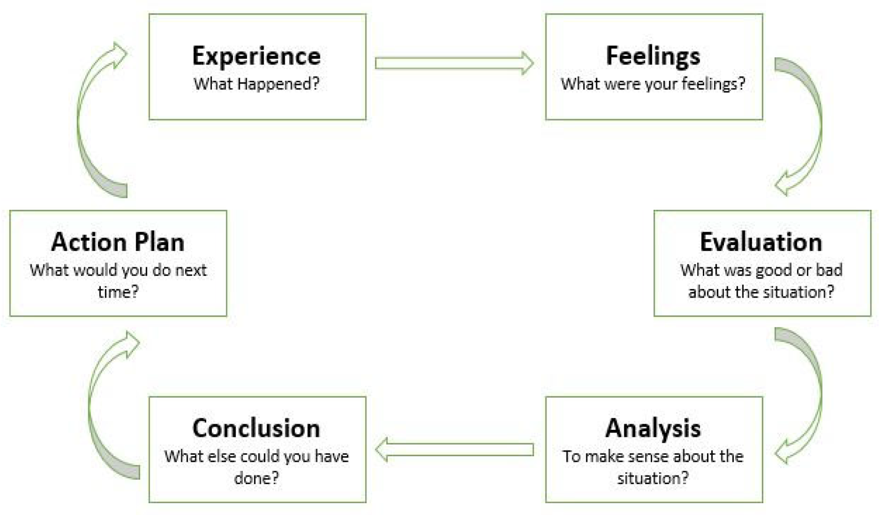
Figure 7: Gibbs Reflective Cycle
(Source: Zafeer, Li and Maqbool, 2023)

