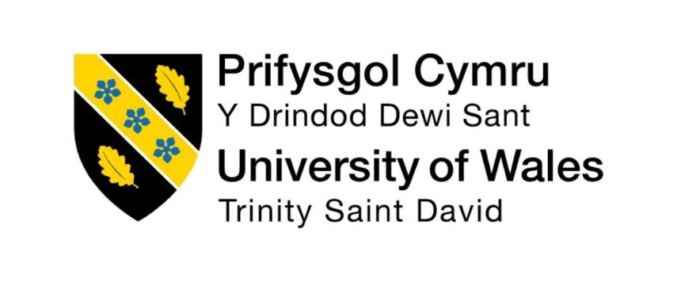

Programme: Master of Business Administration
Module: Human Capital Management
Module code: LCMB7023
Title: Global Workforce Transformation: HRM and IHRM Responses to Technological, Demographic, and Geopolitical Change
Word count: 2582
Lecturer : Ejike Udeogu (Birmingham)
Student Name : Promi Das Gupta
Student ID: 2428537
Submission Date- 16th October 2025
Table of Contents
1. Introduction………………………………………………………………………………3
2. Technological Advancements and Their Implications for HRM and IHRM……………………………………………………………………………………...3-4
3. Demographic and Geopolitical Influences on Labour Markets…………….4-6
4. Addressing Skills Gaps and Talent Shortages through Strategic HRM …………………………………………………………………………………………….6-9
5. Personal Reflection: Capabilities for the Future of Work……………………9-11
6. Conclusion…………………………………………………………………………11-12
7. References…………………………………………………………………………12-14
1.0 Introduction
Technology-related change, demographic shifts and geopolitical challenges are making the international labour market change and evolve at a rapid pace. These forces are altering the manner of organisational approach to people, skills and doing business across borders and therefore require flexible responses among HRM and IHRM. HR practitioners in a globalised economy will be required to integrate digital technology, manage cross-cultural teams, and be intelligent in dealing with skills shortages (CIPD, 2023). The changes in job configurations and employment relationships are influenced by new artificial intelligence (AI), automation and digital platforms (World Economic Forum, 2023). At the same time, the populations of developed economies are ageing, and, in certain regions, there are rising youth labour supply, which is changing the global labour supply (OECD, 2022). Moreover, there is also the problem of geopolitics that has become a hindrance to the movement of workers due to Brexit, disruption of trade, and barriers to immigration (ILO, 2022). The paper shall critically examine how these macro trends have influenced the HRM and IHRM strategies as well as on my own preparation to compete in an evolving international labour market.

2.0 Technological Advancements and Their Implications for HRM and IHRM
One of the main sources of change in the international labour markets is the introduction of new technologies, such as (but not limited to) artificial intelligence (AI), automation and digital platforms. Meanwhile, soft skills will be in demand in a fast evolving workforce - although some World Economic Forum (2023) estimates suggest that by 2025, automation and AI will replace approximately 85 million jobs, nearly 97 million new jobs utilizing advanced digital, analytical and creativity capabilities will be created. These standards also carry a great weight in HRM and IHRM in making companies anxious about how to approach job structures differently, increased levels of digital skills in their staff, and lifelong learning as part of business strategies. AI and automation have increased productivity and at the same time caused an immediate need to have a mass reskilling and upskilling. The lifelong learning, the flexibility of training, and digital preparedness are becoming distinguishing features of HRM (CIPD, 2023).
At the international level, IHRM should respond to technological differences in uptake and e-staff across the regions. Multinational organisations like Unilever and IBM are some examples of multinational organisations that use IAI-enabled talent analytics to anticipate skill gaps, simplify the recruitment process and standardise HR practices in operations throughout the world (Armstrong and Taylor, 2023). Instead, it is a matter of integrating HR and digital platforms and how these tools can be used to enhance a stronger relationship between the companies and their employees. HR Organization DNA On parallel to these developments at the corporate level, technology is transforming the workforce management functions. These systems help monitor the engagement of employees, productivity and international assignment to assist in evidence-based decisions (Stone and Deadrick, 2015).
However, digitisation brings up some dire ethical and regulatory challenges. Algorithms, data privacy, and regulation fears, such as the General Data Protection Regulation (GDPR) by the EU, demand that HR practitioners adopt an open and equitable AI governance (Hendry, 2017). Automation has also caused polarisation of the labour-market, i.e. the high-skilled digital professionals are in demand and the routine low-skilled jobs are in demand (ILO, 2022). The HRM programs must therefore emphasize on inclusion by approving career transition policies and promoting diversity in the technology-driven areas. IHRM is confronted with the task of modifying the strategies of MNEs of varying technological advancement - in specific, in developing nations such as Bangladesh, where the technology that relies on automation is inexpensive and which affects decision-making concerning offshoring and outsourcing (Rahman, 2020).
As to the future, it will be a hybrid of human and technology-driven intelligence that will characterize the next-gen HRM. HR professionals will be important in the skills of digital leadership, virtual teamwork, and hiring that is supported by AI. In order to be effective in the changed landscape, the HR leaders will be required to balance digital savvy with moral astuteness and cross cultural awareness in such a way that technology does not replace the human aspect of work.

3.0 Demographic and Geopolitical Influences on Labour Markets
The long term structural alterations in the world labour markets are both geopolitical and demographic changes. The world has been experiencing two distinct demographic trends, where, on one hand, there is the aging of advanced economies and on the other there is increased youth on the developing world.
By 2030, European labour supply will be more than a quarter of all above the age of 55 (OECD, 2022), and both South Asia and Sub-Saharan Africa are estimated to remain in a rapidly expanding youth workforce. These discrepancies lead to labour supply and demand asymmetries which in turn cause international people mobility across borders, international hiring as well as alter the way workforce plans are formulated. Regarding the Human Resource Management (HRM) point of view, the existence of age-minded populations forces organisations to adopt them and make them undertake age-friendly policies, flexible working styles, and the provision of lifelong learning to the older workers (CIPD, 2022).
Such foreseeable situations in the coming decades would witness the massive migrations of talents (labor force) to the developed world like UK, Canada or even the EU, yet the developing countries like India, Bangladesh and Nigeria would be sending out large numbers of talents. International Human Resource Management (IHRM) would consequently have to deal with such large scale migrations of talents. Such migration, in its turn, results in the need to employ culturally sensitive management, balanced wages rates and active onboarding procedures to retain and engage such global employees.
Similarly, geopolitical events have increased the uncertainty in the labour market. Worldwide supply chains, mobility and labour availability have also been shaken severely even by Brexit, the covid-19 pandemic and the war in Russia-Ukraine. As an example, the number of EU migrant labour in the UK through the hashtag Brexit reduced considerably and this has only increased the shortages in sectors such as healthcare, construction and hospitality (ONS, 2023). Similarly travel cuts downs due to the pandemic, border restrictions have accelerated the application of remote and hybrid-like work force planning, which has broken the HR walls (Deloitte, 2023).

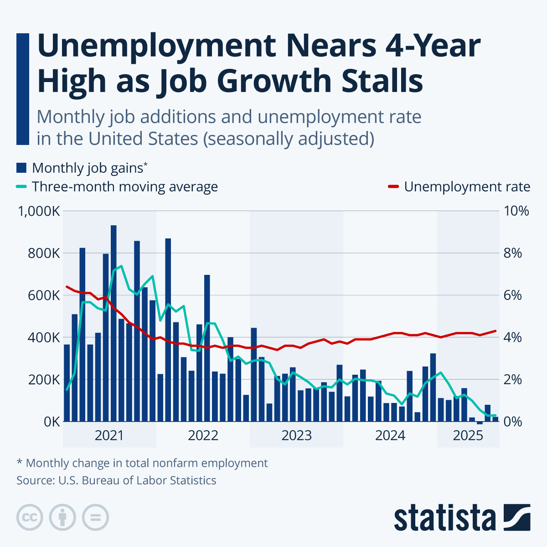
Source: Statista, 2023b

Adherence to different labour laws It has complicated an already tedious task of compliance even more because this time around, compliance to different labour laws, immigration laws and employment ethical standards is also a requirement. IHRM strategies have now included global risk management, agile contract strategies, scenario planning to ensure resilience of business in turbulent geopolitical times.
Moreover, political instability and sanctions across the globe have contributed to inflation of wages and high turnover in the energy, logistics and manufacturing industries (KPMG 2023). Dealing with a diverse workforce is also the key to the modern workplace. IHRM continues to rely on the cultural dimensions model that was developed by Hofstede (2011) in order to handle multi-culture teams, improve communication, and diffuse cultural conflicts. Indicatively, cross-cultural leadership development had begun in HSBC to improve worldwide cooperation in cross-functional teams (HSBC, 2023).
Conclusively, ageing of the population, unemployment of the youth, instability of geopolitics, and conflicts call on HRM practices that are agile and inclusive. The companies must pay attention to global talent mobility, diversity management, and workforce resilience in order to successfully overcome these complicated global challenges.

4.0 Addressing Skills Gaps and Talent Shortages through Strategic HRM
Talent shortage has been persistently an issue of concern to HR practitioners all over the globe that is frustrating owing to a higher degree of mismatch between the skills present and the skills needed by organisations. In the UK, skills gaps are associated with a fraction of job vacancies of up to 36% (UK Commission for Employment and Skills, 2023).

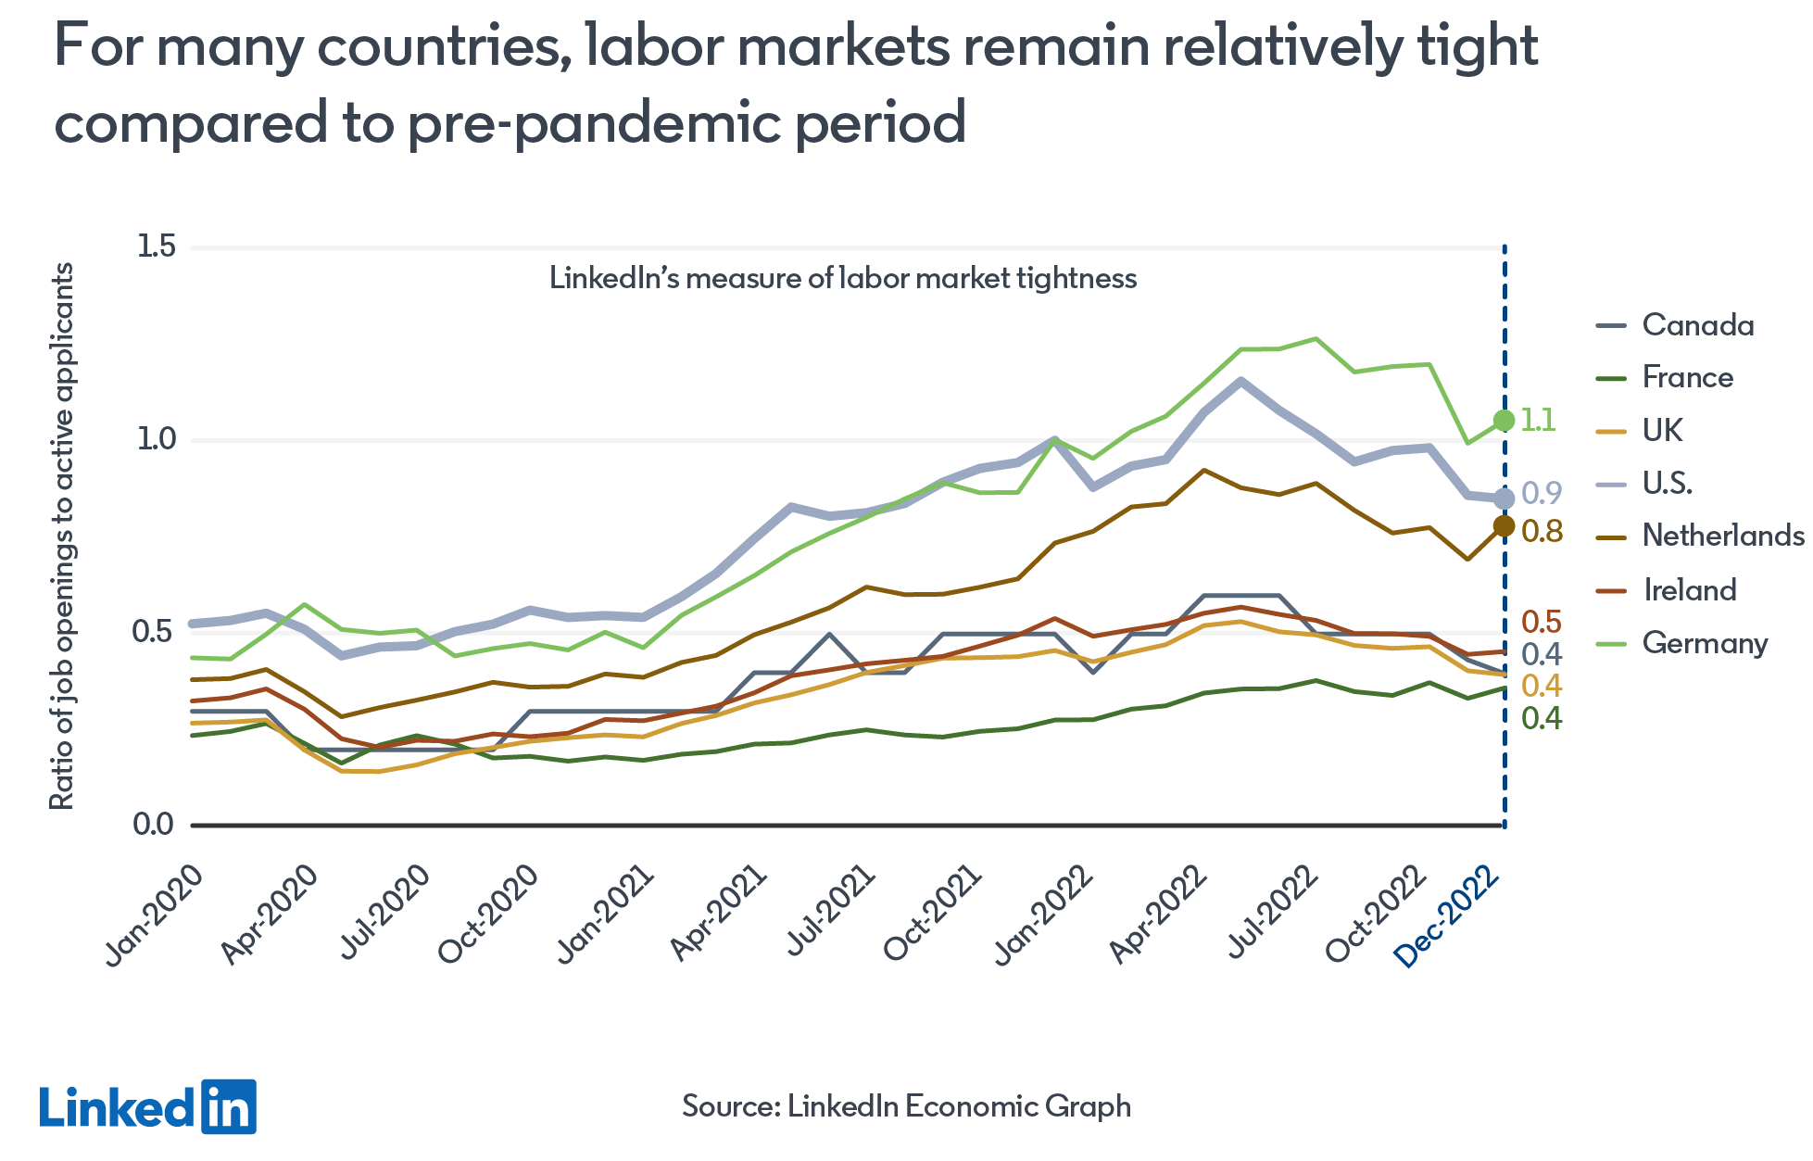
Source: LinkedIn, 2023

Globally, the World Health Organization (2022) predicts that the global workforce of healthcare providers will be short by approximately 10 million employees by 2030 and there will always be acute shortages of digital and hospitality employees also due to the radical global shifts in technology and demographic. Various evidence- based SHRM methods can be used in mitigating these problems. The key principle of this method is an interest in evidence-based workforce planning, applying predictive methods of analytics to predict skill requirements in the future (CIPD, 2023). This allows HR professionals to be more proactive in matching the talent pipelines to the expanding business needs. And Learning and Development (L&D) is a necessity in the upskilling of employees as well. The monopolistic companies such as Amazon and Google have also developed global digital training to train their personnel in fields like AI and analytics, cloud computing (Deloitte, 2023). The above examples are illustrative of the concept of strategic fit in which the HR policies help in enabling long term competitiveness (Armstrong and Taylor, 2023).

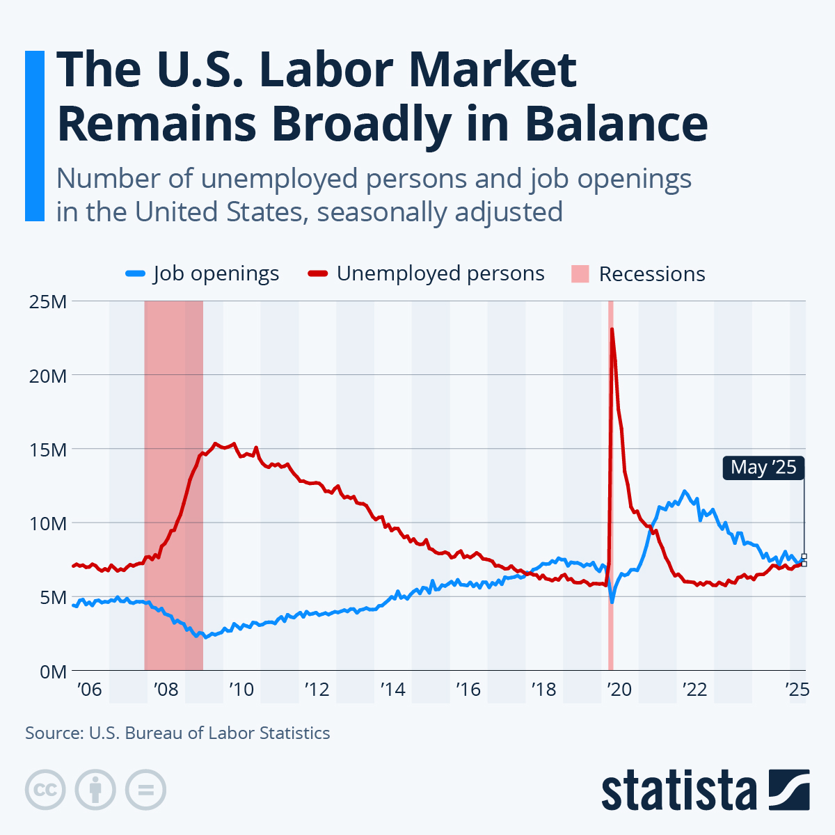
Source: Statista, 2023a

There also should be inter-organizational and inter-academic collaboration. The partnerships, apprenticeships, and internships develop bespoke talent pipeline to satisfy shortages in the various sectors (UKCES, 2023). As an example, the collaboration between the NHS and the universities in the UK to educate foreign nurses demonstrates how partnerships between the public and the private sector can help to tackle the healthcare shortages in sustainable manner. And that role of expansions of talent pools is also extended to diversity and inclusion. In case your company is interested in hiring in a different industry, or is seeking access to new talent, including under-represented populations or foreign labour markets, this may bring new innovations and creativity in the long-term (CIPD 2022). Expatriate transfers and global mobility programmes are programs in IHRM that can be involved in the transfer of skills between countries, to eliminate the existence of disparities in the developed and emerging economies (Tung, 2016).
Technology also enables the recruitment across borders by transforming the manner in which organisations seek talent. The emergence of global freelancing The emergence of global freelancing and online job market places such as Upwork and LinkedIn has provided businesses with the opportunity to recruit remote and specialised skills (World Economic Forum, 2023). Thus, HRM policies should restructure performance management and incentive systems along with engagement in practice working in distributed workplaces.
Finally, there must be good learning culture and management dedication to assist in defaultery of skills. Companies with a culture of lifelong learning and adaptive talent management generate more innovation and retention of staff members than their competitors (McKinsey, 2023). It is therefore appropriate that SHRM entraps flexibility, inclusiveness and lifelong learning as a strategy of countering skills shortage in global HRM.

5.0 Personal Reflection: Capabilities for the Future of Work
Being a graduate student in Bangladesh, studying in the UK, I am aware of the significance of the international job market and professional skills. The reflection also considers my competence in the areas of technology, communication, team work, leadership and self-directed learning skills against the demands of the modern work environments that are becoming more dependent on technology.

Technological Skills
During my academic program, I have also been taught how to utilize the most important digital tools, such as Microsoft Teams, Zoom and many data analysis software packages in my collaborative projects. They have made me more digitally literate, which has also served to work in distance academic environments. However, I need to tell the truth that I am not fully familiar with such modern technology as an artificial intelligence (AI), automation, and HR analytics. As a recognition that digitalisation is becoming an increasingly important concept in HRM, my professional objectives in my life, including digital HRM and people analytics on such platforms as CIPD and Digital Learning Pathways, are to become professionally qualified. This will improve my employment opportunities in addition to developing my technical capability as per the future HR trends in the world.

Communication and Teamwork
Studying in a multicultural setting has significantly enhanced my communication and intercultural cooperation skills. The experience of working together with peers of different cultural and language levels has provided me with some great insights into the importance of active listening, empathy, and communicative adaptation. Nonetheless, when discussing topics in groups, I cannot say things emphatically every time. To eliminate this, I will enroll in professional communication workshops in the university and participatory in group assignments so that I can be more confident and articulate my views. This kind of development will enable my ability to work effectively when working in global teams, both in and out of academia.

Leadership
My postgraduate programme has revealed that I have demonstrated emerging leadership through taking group work, assisting in achieving a consensus, and sharing responsibilities within team members. My leadership style is based on the transformational model of leadership that emphasizes on inspiration, shared vision and empowerment (Bass, 1990). However, I find that my strategic management and conflict resolution areas are the areas that I will value improvement in to adapt better to the high-pressure and multicultural organisations. I would also like to join professional mentoring programs and HR bodies in the UK to ensure that I not only consult with the experienced practitioners, but I also develop my leadership abilities in a global manner.

Self-Directed Learning
The relocation to the UK has rendered me quite a bit more independent, flexible and self-reliant. With the help of Gibbs Reflective Cycle (1988), I am able to examine the way I conduct my things and the things I learn through them and see the areas that I should correct. I can now expect realistic goals and gauge success using a formalised Personal Development Plan (PDP) within the framework of my PGCert in Learning and Teaching. I will further practice this practice of self-assessment in the future, consider the feedback of lecturers and even peers in enhancing my learning strategies and professional preparedness.

International and Global Insensitivity
My exposure to the practices in the UK workplaces has made me more appreciative of ethical, inclusive and sustainable HRM principles. In particular, attention paid to equality, diversity and inclusion (EDI) within organisations in the UK. I consider empathy and cultural sensitivity as the strengths obtained as a result of my obligations at my home country in Bangladesh as essential in working on the global teamwork. I believe that I can apply this knowledge and employ such values in my future work to make HR more fair and ethical.

Concisely, I have a strong foundation on cross-culture communication, cooperation as an element of group work and reflection learning. However, I still have to continue developing my online capabilities and assertive communication along with advanced leadership. All in all, with the help of a lifelong learning process, mentorship and active involvement in professional community of practice, I hope to emerge as a well-rounded HR professional working worldwide with the ability to contribute to the future of work.

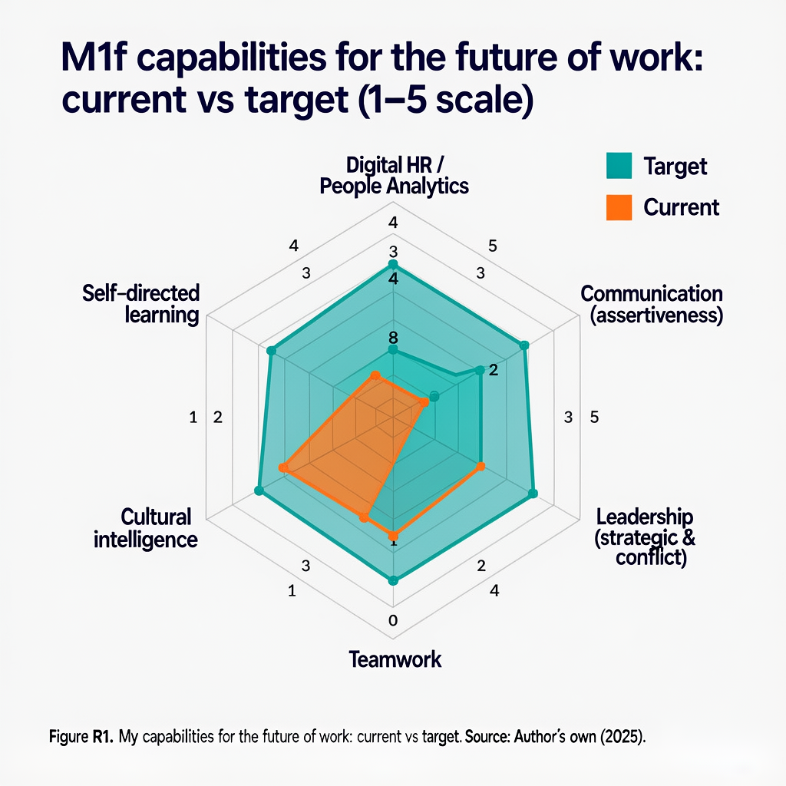

6.0 Conclusion
Technology, demographic changes and geopolitical volatility are reshaping national and international labour markets. These changes require active HRM and IHRM approaches which focus on digital preparedness, global engagement and life-long learning. The HR managers and employees have to juggle automation, empathy, cross-cultural teamwork, and skill shortages across the globe with strategic talent management. To a person especially an international student, it is important to build adaptability, technological literacy, and intercultural competence to be employable in the future. The solution to the enduring transformation in the work environment is to intertwine self-reflective career planning and research-informed HRM practices to ensure the prosperity of both organisations and employees in the present state of endless change.

7.0 References

Armstrong, M. & Taylor, S. (2023) Armstrong’s Handbook of Human Resource Management Practice. 16th ed. London: Kogan Page.
Bass, B.M. (1990) From Transactional to Transformational Leadership: Learning to Share the Vision. Organizational Dynamics, 18(3), pp.19–31.
CIPD (2022) Managing an Ageing Workforce. [online] Available at: https://www.cipd.co.uk/ (Accessed: October 16, 2025)
CIPD (2023) Workforce Planning and the Future of Work. [online] Available at: https://www.cipd.co.uk/ (Accessed: October 16, 2025)
Deloitte (2023) Global Human Capital Trends. [online] Available at: https://www2.deloitte.com/ (Accessed: October 16, 2025)
Gibbs, G. (1988) Learning by Doing: A Guide to Teaching and Learning Methods. Oxford: Oxford Polytechnic.
Hendry, C. (2017) Human Resource Management: A Strategic Approach to Employment. London: Routledge.
Hofstede, G. (2011) Dimensionalizing Cultures: The Hofstede Model in Context. Online Readings in Psychology and Culture, 2(1).
HSBC (2023) Global Leadership and Inclusion Strategy. [online] Available at: https://www.hsbc.com/ (Accessed: October 16, 2025)
ILO (2022) World Employment and Social Outlook 2022. Geneva: International Labour Organization.
KPMG (2023) Global Economic Outlook. [online] Available at: https://home.kpmg/ (Accessed: October 16, 2025)
LinkedIn. (2023). For many countries, labor markets remain relatively tight compared to pre-pandemic period [Graph]. LinkedIn Economic Graph. Available at: https://www.linkedin.com/economic-graph (Accessed: October 16, 2025).
McKinsey (2023) The State of Organizations 2023. [online] Available at: https://www.mckinsey.com/ (Accessed: October 16, 2025)
OECD (2022) Employment Outlook 2022. Paris: OECD Publishing.
ONS (2023) UK Labour Market Overview. [online] Available at: https://www.ons.gov.uk/ (Accessed: October 16, 2025)
Rahman, M. (2020) Automation and the Future of Work in South Asia. Dhaka: UPL.
Statista. (2023a). Number of unemployed persons and job openings in the United States from December 2000 to May 2025 [Graph]. U.S. Bureau of Labor Statistics. Available at: https://www.statista.com/statistics/616654/monthly-job-openings-and-unemployed-persons-in-the-united-states/ (Accessed: October 16, 2025).
Statista. (2023b). Monthly job additions and unemployment rate in the United States from January 2021 to December 2025 [Graph]. U.S. Bureau of Labor Statistics. Available at: https://www.statista.com/statistics/1367750/monthly-job-growth-unemployment-rate-united-states/ (Accessed: October 16, 2025).
Stone, D.L. & Deadrick, D.L. (2015) Challenges and Opportunities Affecting the Future of Human Resource Management. Human Resource Management Review, 25(2), pp.139–145.
Tung, R.L. (2016) New Perspectives on Human Resource Management in a Global Context. Journal of World Business, 51(1), pp.142–152.
UKCES (2023) Employer Skills Survey. [online] Available at: https://www.gov.uk/government/organisations/ukces (Accessed: October 16, 2025)
WEF (2023) The Future of Jobs Report 2023. Geneva: World Economic Forum.
WHO (2022) Global Strategy on Human Resources for Health. Geneva: World Health Organization.
World Bank (2023) Migration and Development Brief. Washington, D.C.: World Bank.

