
Master of Business Administration (MBA)
International Business
LCMB7023: Human Capital Management
Assessment component 1: Individual report
Lecturer Name: Dr Hoang Dang Nguyen

Navigating the Future of Work: Strategic Human Resource Management in an Era of Technological Disruption, Demographic Shifts, and Global Talent Challenges

Student Name: Md. Habibur Rahman
Student ID: 2432474
Word Count: 2695

Table of Contents
1. Introduction 5
2. Discussion/Analysis/Examination 6
2.1 Question 1: Technological Advancements Reshaping Labour Markets 6
Introduction 6
Definitions: Technology and Labour Markets 6
How Technology is Reshaping Labour Markets 7
Strategic Implications for HRM and IHRM 7
Conclusion 8
2.2 Question 2: Demographic and Geopolitical Factors 9
Introduction 9
Major Demographic Shifts 9
Geopolitical Factors 9
Challenges for HR Professionals 11
Conclusion 11
2.3 Question 3: Addressing Skills Gaps and Talent Shortages 12
Introduction 12
Context of Skills Gaps 12
Sector-Specific Analysis 13
Strategic HRM Solutions 14
Conclusion 14
2.4 Question 4: Personal Reflective Report 15
Introduction 15
Application of Gibbs' Reflective Cycle 16
Conclusion 19
Conclusion 20
References 21

List of Figures
Figure 1: The Evolving Landscape of Work in the Fourth Industrial Revolution. 6
Figure 2: Challenges for HR Professionals in a Changing Global Landscape. 9
Figure 3: Strategic HRM Solutions to Bridge Skills Gaps. 11
Figure 4: Gibbs' Reflective model 13
List of Tables:
Table 1: Evaluations of the Good and Bad sides of the experience 14
Table 2: Personal Development Action Plan: Strengths, Growth Areas & Timelines. 15

1. Introduction
The modern labour markets are transforming the strategic objectives of the Human Resource Management (HRM) and International HRM (IHRM). Technology, demographic and geopolitical changes provide a multifaceted situation. The culture of the senior workforce is failing. These dimensions are four vital dimensions that have a serious scrutiny toward this report. Firstly, the future of artificial intelligence and automation is shaking the labour market. Second, the HR professionals are put to the challenge by the demographic and geopolitical pressures. Third, organisations need to fill their long-term skills gaps. Fourth, I use Gibbs' Reflective Cycle to look at how well I can communicate, work with others, lead, use technology, and learn on my own in today's fast-paced, globalised, and tech-driven workplace.

2. Discussion

2.1 Question 1: Technological Advancements Reshaping Labour Markets

Introduction
In this section, the impact of technology on the HRM/IHRM strategic implications and its effect on the reorganisation of the labour market are observed. Analysis clarifies the concepts; the work transformation brought by technology, and finally provides strategic HR implications.

Definitions: Technology and Labour Markets
It is also necessary to define the major terms used before discussing technological disruption. Technology is defined as the process of AIs, automation, robotisation, algorithms, and the digital platform economy changing the work process (Schwab, 2016). This involves the use of hardware and software that perform tasks that have been done by human beings before. Labour markets are the demand and supply of labour (Stone, Cox and Gavin, 2020). The fourth industrial revolution is the backdrop of the convergence of rapidly developing technology and labour markets.
The fourth industrial revolution, which is the radical restructuring of the labour market, is driven by the use of AI, automation, and digital platforms. The AI models execute cognitive tasks, whereas repetitive tasks are automated by robots (Frey and Osborne, 2017). New types of employment have emerged because of digital labour markets (Uber, Fiverr) (ILO, 2022). According to the estimates provided by the World Economic Forum (2020), automation is going to remove 85 million jobs and create 97 million new ones, which will require such levels of workforce migration.

How Technology is Reshaping Labour Markets
The labour market dynamics created through the technological change are contradictory. Whereas pessimistic views focus on the mass displacement of jobs, within the report, Lund et al. (2021) presume that by 2030, 30% of work activities will be automated, explaining why other studies consider complementary relations between humans and intelligent systems. As shown by Autor (2015), automation usually does not replace human potential but instead expands it, posing a need for other workers who will be able to work in conjunction with computers. Nonetheless, this process creates a polarisation of skills: the number of high-skilled analytical jobs increases at the expense of the middle-skill routine jobs, which increases inequality (Acemoglu and Restrepo, 2020). The gig economy is the prime example of this divide, being flexible and, at the same time, depleting employment security and social protections. The percentage of gig workers grew to 14.7% of the workforce in 2021, compared with 5.8% in 2016, which shows that the United Kingdom is experiencing profound structural changes (Trade Union Congress, 2021). This work, produced directly by the platform, presents specific complications with labour regulation, which are reflected in the constant legal controversies regarding the limits of the classification and rights of the workers (Taylor et al., 2017).

Strategic Implications for HRM and IHRM
Technological forces need to reposition HRM/IHRM. For workforce planning, algorithmic prediction of technological displacement is needed (Căvescu and Popescu, 2025). Google uses People Analytics as it attempts to forecast turnover and talent management. Talent acquisition needs to be recreated. AI platforms such as LinkedIn Talent Solutions help to revolutionise the sourcing process using predictive analytics and automated screening (LinkedIn, 2022). However, limitations such as algorithmic bias necessitate ethics (Dastin, 2018). Organisations need upskilling. IBM's Watson Talent offers AI skills gap analysis and AI personalised learning (Goldstein, 2023). International dimensions make IHRM more complex because the penetration of technology varies (93% high-income vs. 27% low-income countries) (Filipenco, 2024). This landscape is pictured in the following figure:
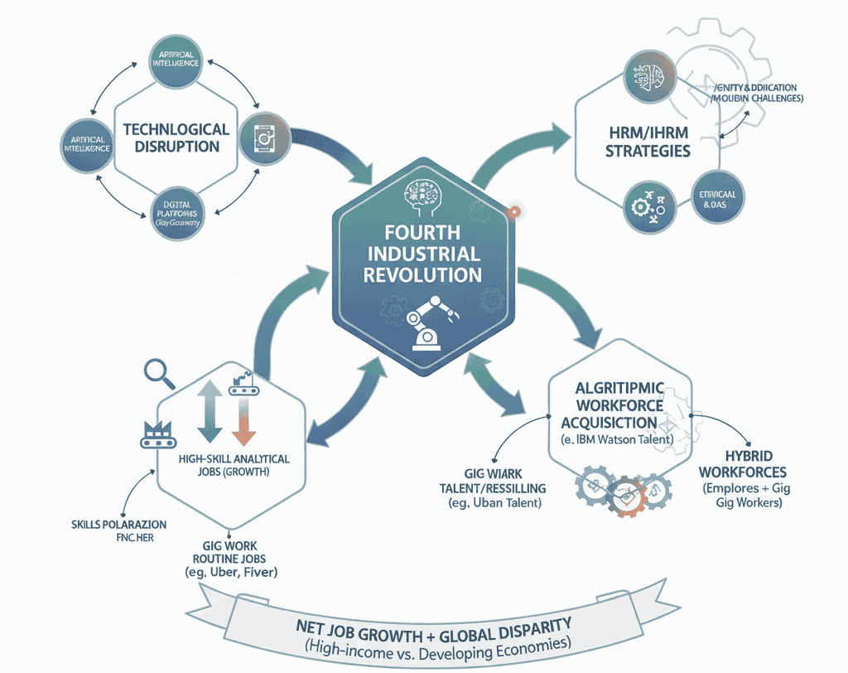
Figure 1: The Evolving Landscape of Work in the Fourth Industrial Revolution.
Hybrid workforces (employees and gig workers) are challenging to manage when it comes to equity, too. This requires creative employment arrangements to make things fair (Katz and Krueger, 2018).

Conclusion
There are technological changes (automation, AI) that are transforming the labour market, which are displacing workers, but they are also generating new opportunities. To successfully navigate through this change, HRM/IHRM will need to be strategic, deal with hybrid workforces, employ analytics, and overcome prejudice, as well as reskill.

2.2 Question 2: Demographic and Geopolitical Factors

Introduction
This part compares demographic and geopolitical impact on labour markets. It also looks at the ensuing dilemmas for HR. Ageing, diversity, migration and geopolitical disruptions are discussed. Such aspects influence the availability of talent.

Major Demographic Shifts
The demographic shifts that are changing labour markets have a fundamental impact and, as yet, uncharted strategic implications. The world's developed economy is greyed out. Workforce trends are changing as well; the 65+ population in OECD countries will increase from 17% (2019) to 26.7% (2050) (World Health Systems Facts 2023). Japan's working population is declining at a rate of 0.44% per year, which is driving the need for pension reform and lengthened working years (Hagan, 2025). On the contrary, developing countries have a youth bulge. More than 600 million new workers of working age are needed outside of work by 2050 (Bodewig et al., 2025), and in sub-Saharan Africa, the working-age population will increase by over 600 million, generating the need for employment. The rate of workforce diversification has increased. Participation of women in the workforce is up to 51.8% globally, but the gender pay gap, with the gap at 17%, persists (Ortiz-Ospina, Tzvetkova and Roser, 2018; Holder, 2025). Migration is an important source of labour supply. International migrants represent 3.7% of the global population and receive more than $690 billion in remittances (Monterroso and Vilan, 2025; United Nations, 2025).

Geopolitical Factors
Geopolitical processes cause huge trouble in the employment market. Brexit, for example, derailed labour inflows, leaving the UK with 125,572 NHS vacancies by 2023 after EU workers stopped coming (Rolewicz, Palmer and Lobont, 2024). Migration policies directly determine the accessibility of talent. U.S. H-1B visa restrictions caused tech talent to immigrate to Canada and Singapore (Kerr and Kerr, 2020). Political instability is also a weakener of labour markets. Conflicts in Syria and Venezuela forced 13 and 7 million people, respectively, leading to humanitarian problems and labour supply alterations in the recipient countries (World Population Review, 2025). The following figure represents the challenges in a changing landscape:
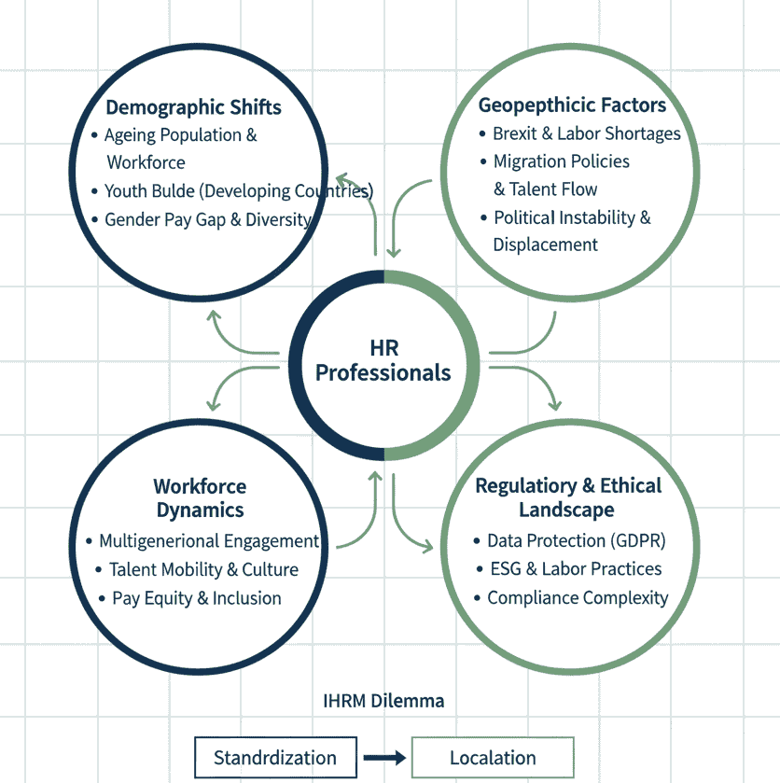
Figure 2: Challenges for HR Professionals in a Changing Global Landscape.
Regulatory systems vary wildly from jurisdiction to jurisdiction, an obstacle to multinational compliance. The European Union's General Data Protection Regulation (GDPR) has very high standards for data regarding employees. Environmental, Social, and Governance (ESG) is also becoming part of employment practices. Most investors are now looking at ESG, resulting in reputational and operational pressure for good labour practices (PwC, 2022; Boxall, Purcell and Wright, 2022).

Challenges for HR Professionals
Complicated demographic and geopolitical forces create complex HR issues. Talent mobility needs value propositions that are localised and cultural intelligence (Tarique and Schuler, 2015). Handling multigenerational workforces that have witnessed diversity necessitates differentiated engagement approaches; multigenerational cultures that are inclusive of age boost productivity by a good margin. Meeting regulatory obligations causes operational costs: there are more than enough different regulatory regimes that multinationals have to cope with (Cooke, Dickmann and Parry, 2022). Pay equity and inclusion are necessary to address because different organisations are 36% more likely to outperform their less diverse peers (Ravio, 2024). There is a need to incorporate agility in workforce planning in terms of geopolitical shocks (Tirmizi, 2025). The IHRM dilemma of standardisation (scale, consistency) vs. localisation (culture, regulation) continues; hence, it requires managers to balance these two contrasting features (Stone, Cox and Gavin, 2020).

Conclusion
Demographics and geopolitics cause a complex talent environment. HR practitioners require adjusting to a specific culture, regulatory adaptability, and a nimble strategy. They have to strike a balance between IHRM standardisation and localisation. The strategies needed are diversity, pay equity, and resilience amid geopolitical uncertainties in order to become successful.

2.3 Question 3: Addressing Skills Gaps and Talent Shortages

Introduction
This part explores the issue of chronic skills gaps and talent shortages in the labour markets of the world and looks at technologies, hospitality, and healthcare. It discusses industry-related issues and analyses strategic HRM solutions such as talent pipeline building, reskilling, and strategic recruiting.

Context of Skills Gaps
Continual skills shortages limit growth. According to the ManpowerGroup's 2025 Talent Shortage report, 76% of employers claim that they are struggling to allocate staff, the highest level in ten years (ManpowerGroup, 2025). Such shortages are structural issues due to technology in the creation of skills misalignment. The complexity of the problem-solving method and constant adaptation require continuing developments and are necessitated by the knowledge economy (Boudreau and Ramstad, 2021).
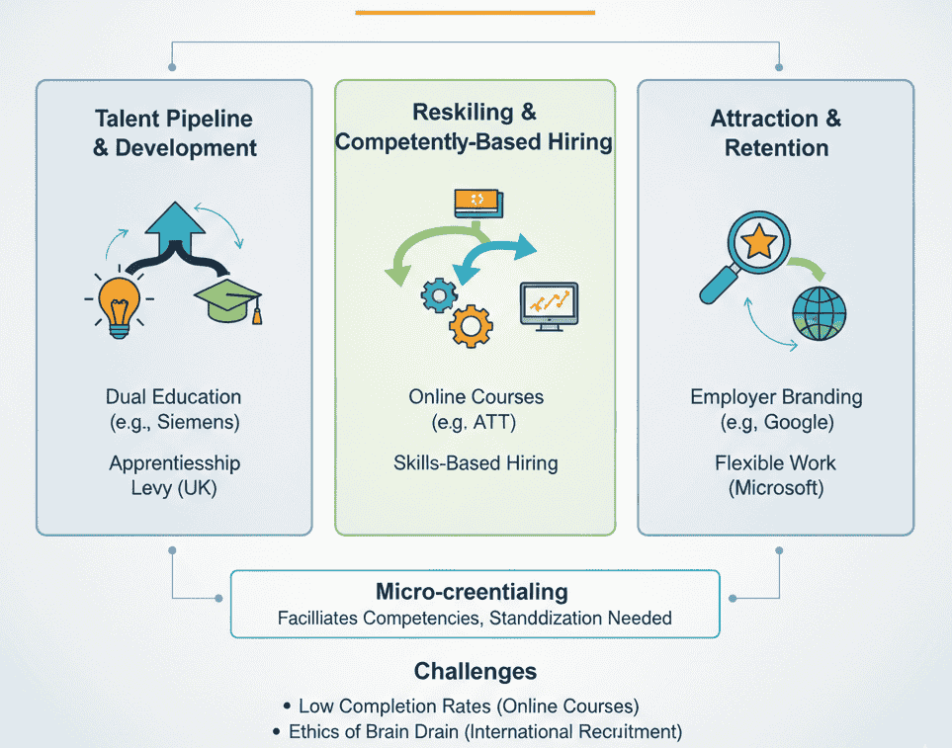
Figure 3: Strategic HRM Solutions to Bridge Skills Gaps.

Sector-Specific Analysis
The technology industry suffers from a severe talent shortage. In cybersecurity, this global gap is more than 3.4 million professionals (ISC2, 2022). Due to these shortages, cloud computing certifications are still costly. Moreover, digital literacy is an issue as well. 44% of Europeans do not possess basic digital skills (Connecting Women In Digital, 2025).
Hospitality has some significant post-pandemic hurdles. The UK had 186,000 job vacancies in 2022, compared to pre-pandemic times, driven by Brexit and Covid-19 (Department for Culture, Media & Sport and Department for Science, Innovation & Technology, 2022). Other alongside service skills are undersupplied, such as emotional intelligence (Baum, 2015).
Healthcare is facing extreme pressures on its workforce. The WHO estimates a global shortage of 11 million healthcare workers by 2030 (World Health Organisation, 2024). Developed nations suffer from a lack of specialised physicians because of burnout. Nursing shortages are vital. There is a total of more than 36,000 nurse vacancies in the UK (Royal College of Nursing). The U.S. anticipates more than 1 million RNs will be retiring by 2030 (Feeney, 2024; Garuba, 2025).

Strategic HRM Solutions
Extreme HRM measures are needed to bridge the skills gaps. Siemens has a dual education system which trains 10,400 people per year (Siemens, 2019). The UK's Apprenticeship Levy was $2.7B in training in 2022 (Camden, 2023). Internal talent management, such as Unilever's Future Leaders Programme, is also a powerful method of developing capabilities and can be proactive.
Reskilling fills in technological deficits. AT&T's industries invested $1 billion in online training programmes for 250,000 employees (Caminiti, 2018), and challenges include low completion rates. Competency-based hiring is an interesting idea that has been followed; IBM has sidelined degree requirements to increase the hiring pool. Micro-credentials are a step in this process, but they are not standardised.
Employer branding is essential. Google's total reward strategy is an example of total reward (Armstrong and Taylor, 2020). Flexible Work: A vast majority, 73%, of workers prefer to have the option of working from any location, and 76% prefer working flexible hours (Microsoft, 2023). International recruitment, like Canada's Express Entry (Immigration, Refugees and Citizenship Canada, 2023), targets shortages but raises brain drain concerns (Clemens, 2015).

Conclusion
The skills gaps require complex HRM solutions: that is, talent pipelines, reskilling, competency-based recruiting, and employer branding. Such issues as low completion of training remain. Nevertheless, those organisations that will invest in developing the workforce and flexible working will be more successful in alleviating such shortages of talent. Effective mitigation requires a long-term investment, dedication, and fresh approaches to talent.

2.4 Question 4: Personal Reflective Report

Introduction
This reflective report evaluates my potential as a future HR professional in the contemporary global labour market. HR consulting experience as a postgraduate in Human Capital Management makes me understand that I need to acquire skills that can fit in either a global or a technology-oriented world. This reflection has utilised Gibbs Reflective Cycle (1988) as a framework in which to evaluate competencies, process reflections and develop a plan of development. The following figure represents this model:
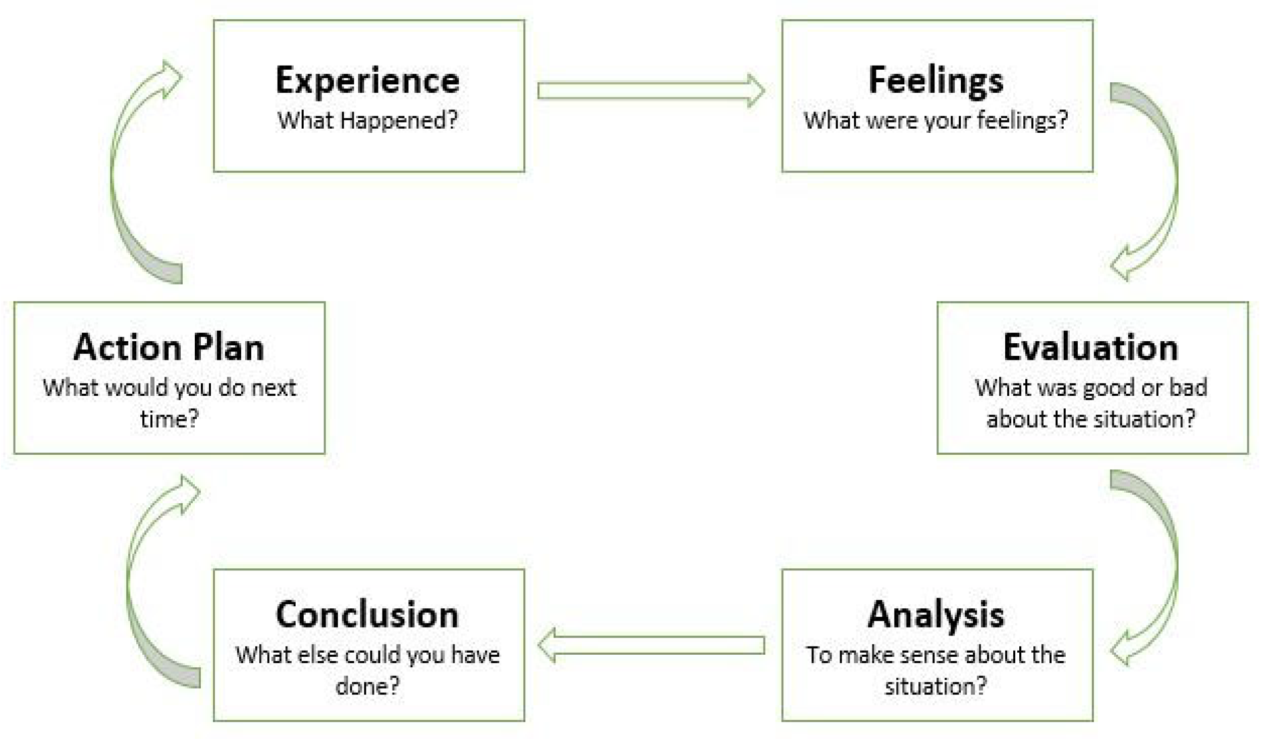
Figure 4: Gibbs' Reflective model
Source: (Jasper, 2013)

Application of Gibbs' Reflective Cycle
Reflective Cycle by Gibbs offers a reflection framework on six stages involving: Description, Feeling, Evaluation, Analysis, Conclusion and Action plan (McLeod, 2025). This model helps to learn more from experiences and helps to develop professionally with the help of developed critical reflection.
Description: What Happened?
During my postgraduate work and the internship in an HR consulting company, I had to deal with recruitment, talent management, and analytics. I headed an HR dashboard implementation (60% reporting time savings) and used AI (35% improvement of hiring efficiency). I organised a five-member project (highest grade) in the HRM strategies, in this case, psychological safety. I have collaborated with employees from fifteen countries, but have no experience working on international assignments, particularly in the Asia-Pacific region.
Feelings: What Was I Thinking and Feeling?
I was sure of my engineering skills (Workday, SAP SuccessFactors), which was supported by the dashboard success. Nonetheless, the cross-cultural circumstances put me in perplexity, highlighting cultural intelligence weaknesses. It irritated me when I had low competence in languages other than English/Spanish, which hindered international HR practices. As the leader of the HRM project, I was satisfied, and at times, I perceived myself as a servant leader who slacked in decision-making.
Evaluation: What Was Good and Bad About the Experience?
Strengths Identified | Weakness Identified
- Technology Skills: HR technology/data analytics; reduced reporting time by 60 per cent; AI recruiting.  - Teamwork: Managing teams, establishing psychological safety.  - Self-Directed Learning: Adaptability (Coursera). | - International Competence: Limited international experience and language skills constrain global effectiveness.  - Leadership Decisiveness: Servant leadership hinders crisis decision-making.  - Advanced Analytics: Lacking Python/R proficiency.
Table 1: Evaluations of the Good and Bad sides of the experience
Analysis: What Sense Can I Make of the Situation?
I have adequate tech skills in the 4IR, but their extent is limited. The demographics and geopolitics need cultural intelligence/international experience. Attendance: my technical skills are good, and softer international/leadership skills are poor. This is a wide gap, and MNEs need HR to strike a balance between standardisation and localisation (Stone, Cox and Gavin, 2020).
Conclusion: What Else Could I Have Done?
I ought to have pursued overseas assignments and focused on learning languages (Mandarin) in the past. I had to have leadership that demanded decisiveness and Python/R certifications as well.
Action Plan: What Will I Do Differently?
Category | Area of Focus | Specific Actions | Timeline
Leveraging Strengths | Technology Leadership | Mentor colleagues on HR tech; volunteer for faculty data research. | Ongoing
Leveraging Strengths | Team Excellence | Actively seek group project leadership roles. | Ongoing
Leveraging Strengths | Continuous Learning | Read industry publications; attend webinars. | Ongoing
Addressing Weaknesses | Advanced Analytics | Complete Python for Data Science course. | Jan-26
Addressing Weaknesses | Advanced Analytics | Execute three HR analytics projects (e.g., predictive modelling). | Jun-26
Addressing Weaknesses | International Competence | Secure an international internship (preferably Asia-Pacific). | Sep-26
Addressing Weaknesses | International Competence | Begin intensive Mandarin; achieve advanced Spanish. | Jan 2026 / Dec 2026
Addressing Weaknesses | International Competence | Obtain cultural intelligence certification. | Mid-2026
Addressing Weaknesses | Leadership Development | Read leadership books; join case competition teams. | Ongoing
Addressing Weaknesses | Leadership Development | Seek mentorship from senior HR professionals; join Toastmasters. | Ongoing
Table 2: Personal Development Action Plan: Strengths, Growth Areas & Timelines.
Monitoring and Evaluation:
I will self-evaluate quarterly on these objectives and keep a reflective journal. My long-term objective can be attained when I am hired as an HR Business Partner by September 2026. I will consider the ability to accomplish this career goal as the key indicator of effective ability development.

Conclusion
This systematic reflection with the help of the Gibbs Cycle was an assessment of my HR skills. Although I have good technical/team-based skills, analysis shows that I have to develop acute international competence, sophisticated analytics, and decision-making traits. The action plan also fills these gaps, making me better prepared to work as a strategic HR professional.

Conclusion
Labour markets are changing because of technology, geopolitics, demographics and skills. This calls for any strategic adjustment of HRM/IHRM policies. AI and automation clearly carry with them opportunities and risks. A strategy needs to balance innovation and have an inclusive workforce. Demographic changes and geopolitical events make talent management and compliance difficult. Persistent skill shortages also call for interventions. These forces need a combination of HRM/IHRM response. HRM needs to stop being an administrative function and transform itself into a strategic partner of the business. It must deal with the unpredictable and stabilise the workforce.

References
Acemoglu, D. and Restrepo, P. (2020). Robots and jobs: Evidence from US Labour Markets. Journal of Political Economy, 128(6), pp.2188–2244.
Armstrong, M. and Taylor, S. (2020). Armstrong’s Handbook of Human Resource Management Practice. 15th ed. London: Kogan Page.
Autor, D.H. (2015). Why Are There Still So Many Jobs? The History and Future of Workplace Automation. Journal of Economic Perspectives, 29(3), pp.3–30.
Baum, T. (2015). Human Resources in tourism: Still Waiting for change? – a 2015 Reprise. Tourism Management, 50, pp.204–212.
Bodewig, C., Holmemo, C., Namara, S. and Chase, R.S. (2025). A Ladder of Opportunity: Unlocking Jobs for Today's African Youth. [online] World Bank Blogs. Available at: https://blogs.worldbank.org/en/africacan/a-ladder-of-opportunity-unlocking-jobs-for-todays-african-youth.
Boudreau, J.W. and Ramstad, P.M. (2021). Beyond HR: the New Science of Human Capital. Harvard Business School Press.
Boxall, P.F., Purcell, J. and Wright, P. (2022). The Oxford Handbook of Human Resource Management. Oxford University Press.
Camden, B. (2023). Apprenticeship Levy Turns into Treasury ‘cash cow’. [online] FE Week. Available at: https://feweek.co.uk/apprenticeship-levy-cash-cow/ [Accessed 28 Oct. 2025].
Caminiti, S. (2018). AT&T's $1 Billion Gambit: Retraining Nearly Half Its Workforce for Jobs of the Future. CNBC. [online] 13 Mar. Available at: https://www.cnbc.com/2018/03/13/atts-1-billion-gambit-retraining-nearly-half-its-workforce.html.
Căvescu, A.M. and Popescu, N. (2025). Predictive Analytics in Human Resources Management: Evaluating AIHR’s Role in Talent Retention. AppliedMath, [online] 5(3), p.99.
Clemens, M.A. (2015). Global Skill Partnerships: A Proposal for Technical Training in a Mobile World. IZA Journal of Labour Policy, 4(1).
Connecting Women In Digital (2025). Europe’s Digital Decade: Mid-Term Insights on the 2021–2030 Transformation Strategy. [online] WiDigital. Available at: https://widigital.eu/europes-digital-decade-mid-term-insights-on-the-2021-2030-transformation-strategy/ [Accessed 28 Oct. 2025].
Cooke, F.L., Dickmann, M. and Parry, E. (2022). Building Sustainable Societies through human-centred Human Resource management: Emerging Issues and Research Opportunities. The International Journal of Human Resource Management, [online] 33(1), pp.1–15.
Dastin, J. (2018). Amazon Scraps Secret AI Recruiting Tool That Showed Bias against Women. Reuters. [online] 11 Oct. Available at: https://www.reuters.com/article/world/insight-amazon-scraps-secret-ai-recruiting-tool-that-showed-bias-against-women-idUSKCN1MK0AG/.
Department for Culture, Media & Sport and Department for Science, Innovation & Technology (2022). Economic Estimates: Employment in the Digital Sector, January 2022 to December 2022. [online] UK Government. Available at: https://www.gov.uk/government/statistics/economic-estimates-employment-in-dcms-sectors-and-digital-sector-january-2022-to-december-2022/economic-estimates-employment-in-the-digital-sector-january-2022-to-december-2022.
Feeney, A. (2024). The U.S. Nursing shortage: a state-by-state Breakdown. [online] NurseJournal. Available at: https://nursejournal.org/articles/the-us-nursing-shortage-state-by-state-breakdown/.
Filipenco, D. (2024). Internet Access and Digital Divide: Global Statistics. [online] DevelopmentAid. Available at: https://www.developmentaid.org/news-stream/post/185774/internet-access-and-digital-divide.
Frey, C.B. & Osborne, M.A. (2017). The Future of Employment: How Susceptible Are Jobs to Computerisation? Technological Forecasting and Social Change, [online] 114(1), pp.254–280.
Garuba, L. (2025). Nurse of 2030: No Job Description Can Contain Them. [online] The Royal College of Nursing. Available at: https://www.rcn.org.uk/news-and-events/Blogs/nurse-of-2030-no-job-description-can-contain-them.
Goldstein, J. (2023). New IBM Study Reveals How AI Is Changing Work and What HR Leaders Should Do about It. [online] IBM. Available at: https://www.ibm.com/think/insights/new-ibm-study-reveals-how-ai-is-changing-work-and-what-hr-leaders-should-do-about-it.
Hagan, R. (2025). Nearly a Million More Deaths than Births in Japan Last Year. BBC. [online] 7 Aug. Available at: https://www.bbc.com/news/articles/c74dnzr4jdvo.
Holder, M. (2025). Gender Pay Gap Statistics: a Comprehensive Analysis. [online] Equal Pay Today. Available at: https://www.equalpaytoday.org/gender-pay-gap-statistics/.
Immigration, Refugees and Citizenship Canada (2023). Express Entry Year-End Report 2022. [online] IRCC. Available at: https://www.canada.ca/content/dam/ircc/documents/pdf/english/corporate/publications-manuals/2022-ee-report-eng.pdf.
ISC2 (2022). Cybersecurity Workforce Study 2022. [online] Available at: https://edge.sitecorecloud.io/internationf173-xmc4e73-prodbc0f-9660/media/Project/ISC2/Main/Media/documents/research/ISC2-Cybersecurity-Workforce-Study-2022.pdf.
Jasper, M. (2013). Beginning Reflective Practice. 2nd ed. Cheltenham: Nelson Thornes.
Katz, L.F. and Krueger, A.B. (2018). The Rise and Nature of Alternative Work Arrangements in the United States, 1995–2015. ILR Review, 72(2), pp.382–416.
Kerr, W.R. and Kerr, S.P. (2020). Immigration Policy Levers for U.S. Innovation and Startups. NBER Working Paper No. w27040.
LinkedIn (2022). 2022 Global Talent Trends: the Reinvention of Company Culture. [online] LinkedIn Corporation. Available at: https://business.linkedin.com/content/dam/me/business/en-us/talent-solutions-lodestone/body/pdf/global_talent_trends_2022.pdf.
Lund, S., Madgavkar, A., Manyika, J., Smit, S., Ellingrud, K., Meaney, M. and Robinson, O. (2021). The Future of Work after COVID-19. [online] McKinsey & Company. Available at: https://www.mckinsey.com/~/media/mckinsey/featured%20insights/future%20of%20organizations/the%20future%20of%20work%20after%20covid%2019/the-future-of-work-after-covid-19-report-vf.pdf.
ManpowerGroup (2025). Talent Shortage Survey 2025. [online] ManpowerGroup. Available at: https://www.manpowergroup.co.uk/b_talent-shortage-survey-2025/.
McLeod, S. (2025). Gibbs Reflective Cycle. [online] Simply Psychology. Available at: https://www.simplypsychology.org/gibbs-reflective-cycle.html.
Microsoft (2023). 2023 Work Trend Index: Annual Report. [online] Microsoft Corporation. Available at: https://assets.ctfassets.net/y8fb0rhks3b3/5eyZc6gDu1bzftdY6w3ZVV/beeb0f2e437044fc99a0408867a263d8/WTI_Annual_2023_Will_AI_Fix_Work_.pdf.
Monterroso, O. and Vilán, D. (2025). Global Remittances Cycle. [online] Federal Reserve. Available at: https://www.federalreserve.gov/econres/notes/feds-notes/global-remittances-cycle-20250227.html.
Ortiz-Ospina, E., Tzvetkova, S. and Roser, M. (2018). Women’s Employment. [online] Our World in Data. Available at: https://ourworldindata.org/female-labor-supply.
PwC (2022). Global Investor Survey 2022. [online] PricewaterhouseCoopers. Available at: https://www.pwc.com/gx/en/global-investor-survey/PwC-Global-Investor-Survey-2022.pdf.
Ravio (2024). Pay equity explained: What It Is and Why It Matters. [online] Ravio. Available at: https://ravio.com/blog/what-is-pay-equity.
Rolewicz, L., Palmer, B. and Lobont, C. (2024). The NHS Workforce in Numbers. [online] The Nuffield Trust. Available at: https://www.nuffieldtrust.org.uk/resource/the-nhs-workforce-in-numbers.
Schwab, K. (2016). The Fourth Industrial Revolution. [online] Geneva: World Economic Forum. Available at: https://law.unimelb.edu.au/__data/assets/pdf_file/0005/3385454/Schwab-The_Fourth_Industrial_Revolution_Klaus_S.pdf.
Siemens (2019). Vocational Training at Siemens. [online] Siemens Press. Available at: https://press.siemens.com/global/en/feature/vocational-training-siemens.
Stone, R.J., Cox, A. and Gavin, M. (2020). Human Resource Management. 10th ed. Wiley.
Tarique, I. and Schuler, R.S. (2010). Global Talent Management: Literature Review, Integrative Framework, and Suggestions for Further Research. Journal of World Business, 45(2), pp.122–133.
Taylor, M., Marsh, G., Nicol, D. and Broadbent, P. (2017). Good work: the Taylor Review of Modern Working Practices. [online] Available at: https://assets.publishing.service.gov.uk/media/5a82dcdce5274a2e87dc35a4/good-work-taylor-review-modern-working-practices-rg.pdf.
Tirmizi, H. (2025). HR in the Age of Geopolitical Shifts: beyond Borders, beyond Boundaries. [online] LinkedIn. Available at: https://www.linkedin.com/pulse/hr-age-geo-political-shifts-beyond-borders-boundaries-hassan-iammf/ [Accessed 28 Oct. 2025].
Trade Union Congress (2021). Gig Economy Workforce in England and Wales Has Almost Tripled in the Last Five Years – New TUC Research. [online] Trades Union Congress (TUC). Available at: https://www.tuc.org.uk/news/gig-economy-workforce-england-and-wales-has-almost-tripled-last-five-years-new-tuc-research.
United Nations (2025). International Migrant Stock 2024: Key Facts and Figures. [online] Department of Economic and Social Affairs. Available at: https://www.un.org/development/desa/pd/sites/www.un.org.development.desa.pd/files/undesa_pd_2025_intlmigstock_2024_key_facts_and_figures_advance-unedited.pdf.
World Economic Forum (2020). The Future of Jobs Report 2020. [online] World Economic Forum. Available at: https://www3.weforum.org/docs/WEF_Future_of_Jobs_2020.pdf.
World Health Organisation (2024). Health Workforce. [online] World Health Organisation. Available at: https://www.who.int/health-topics/health-workforce#tab=tab_1.
World Health Systems Facts (2023). Aging. [online] World Health Systems Facts. Available at: https://healthsystemsfacts.org/aging/.
World Population Review (2025). Refugees by Country 2025. [online] World Population Review. Available at: https://worldpopulationreview.com/country-rankings/refugees-by-country.

Acknowledgement of Not Using Any AI Tools
RESEARCH | For this assessment, you can use Generative AI to support you in research, including searching for a bibliography and using tools to summarise, compare and interrogate materials. | Yes ☐  No ☐✔
STRUCTURE | For this assessment, you can use Generative AI to support you in structuring your submission, including creating a draft argument structure, identifying parts and headings, etc. | Yes ☐  No ☐✔
PROOFREADING | For this assessment, you can use Generative AI to check your text/creation for grammatical and syntactical mistakes, including rephrasing your work within specific standards. | Yes ☐✔  No ☐
WRITING | For this assessment, you can use Generative AI to create text for submission. | Yes ☐  No ☐✔
CREATIVE | For this assessment, you can use Generative AI to create creative materials, such as images. | Yes ☐  No ☐✔
PROGRAMMING | For this assessment, you can use Generative AI to create and check code. | Yes ☐  No ☐✔
NONE | For this assessment, you are not allowed to use any Generative AI support. This includes research support, structural support, writing and proofreading support, as well as creative support. | Yes☐  No ☐

