Assessment Form

Module: Preparing for Professional Policing
Student Name: Hari Cannon
Module Tutor (s): Kelly Andrews
Question | 1  Situation | 2  Task | 3.  Action | 4.  Result |  | Total Mark
1 | 3/5 | 3/5 | 8/15 | 2/5 |  | 15/30
2 | 3/5 | 3/5 | 9/15 | 2/5 |  | 16/30
3 | 3/5 | 3/5 | 9/15 | 2/5 |  | 16/30
 |  |  |  |  |  | Total Mark 47/ 90
Key
No Reference | Minimum | Satisfactory | Exceptional
0 | 0-4 | 5-10 | 11-15

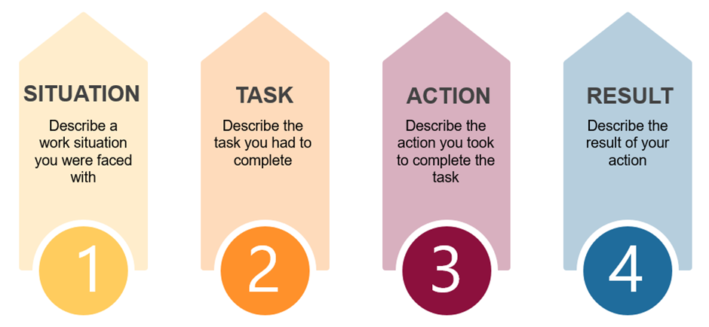

Question | Comments
1 | Q1  Work example: Collaboration being part of a team.  Worked in retail over Christmas which was very busy. I was in a manager role. I was taking ownership in a team with new people, they were coming to me to support.  There were targets set so we needed to work as a team.  Actions: working towards the targets set.  Result. Working as part of a team you can achieve the set targets.  Good use of STAR but needed to be more specific with example, it lacked detail too broad you talked around the subject but needed more detail – what you did and why – how did you collaborate – you said you did it but not how you did it.
2 | Q5  Work example: working in retail working with security because of shoplifters.  Situation: some one was coming through the store trying to steal items, we used key words as a team to communicate this.  Task; needed to talk with colleagues and security.  You have a make a key decision within a short space of time looking at the situation,  Actions: Deciding if you are taking it on yourself or if you are calling security to help.  Result: Finding the best solution for problem solving.  Good use of STAR but needed to be more specific with example, it lacked detail too broad you talked around the subject but needed more detail – what you did and why. Select an example and discuss it in detail.
3 | Q7:  Referred back to the question which was good.  Situation – work example:  When managers come in they need to make a decision about certain things – I might not agree with this decision.  Task: I would need to collaborate with them to hear them but also get them to hear my point of view.  Action: Collaborate with them – this section lacked detail – how would you do this?  Result: You could change their perspective – which could make a positive impact on the store.  Be mindful of using the same words constantly – you mentioned collaborate several times for each question but did not explain how you would do this.  Good use of STAR but would be strengthened with more specific detailed examples.  .

.

.

