Assignment Component 2: Written Report
Module Title: Living with Care: The older Person
Module Code: BMHP6009
Lecturers Names: Joanne Davies / Liz Tilly
Student’s Name: Fatima Al Hassan
Student’s Number: 2129080

Table of Contents
Introduction 3
Case Study: Usayla 4
Support and Intervention that Usayla Needs 8
Conclusion 9
References 10

Introduction
Old age refers to the last stage of the life process of a person that includes the period nearing or exceeding life expectancy (Stearns, 2024). It is the age segment that comprise of the group with oldest people in a society. The minimum years for old age vary from country to country. In the UK people who are above 65 years are categorised to be in their old age. Old age has various challenges. Old people have financial challenges because most of them have reached the retirement age and they cannot secure jobs. They also face psychological and mental health challenges as there are specific diseases that are associated with old age such arthritis and lose of sight. People in old age have social challenges and they may not have people to give them social support (Wenger, 2021). They have specific needs such as social and physiological needs that they lack in their life.
Increasing old age in the UK has become a health and social care challenge in the UK. According to ONS, (2023), there were 11 million people above the age of 65 in the UK in 2021. This was an increase from 9.6 million old age population in the country in 2011. Consider the chart below showing the aging population of the UK.
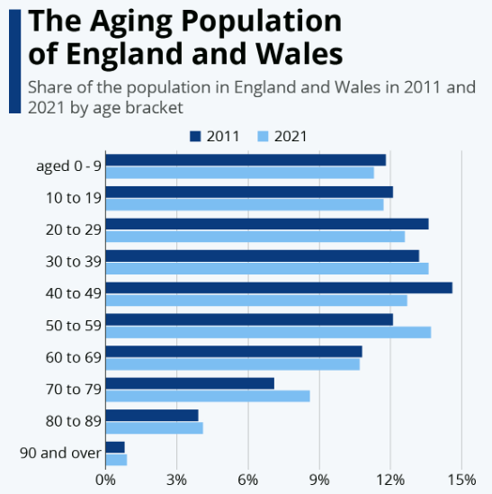
Source: ONS, (2023).
The portion of old people have increased significantly since the 2011. This increasing old population can be attributed to various reasons. Firstly, medical advancements have been made that ensure that health issues that are a threat to old age have been reduced (Tunstall, 2024). Secondly, the old social environment for old people have been improved through social programs such as housing programs. Thirdly, there is free healthcare for old people in the UK and this has reduced the deaths resulting from diseases such as TB (Lithander et al., 2020). Moreover, people in the UK have increased wealth compared to previous years and old people retire having accumulated wealth that they can use to support themselves at old age. Most young people are now employed and they can support their parents when they are old. This report is based on a case of an old woman in the UK. The reports assesses and outlines the social and healthcare needs of the woman. The report considers various legislation and policy that influence the wellbeing of the person in this case. Moreover, the report proposes the possible support interventions that can be offered to the woman.

Case Study: Usayla
This report is based on the case of Usayla who lives independently in a small town in the UK. She is aged 88. Usayla is at risk of health worsening as she has arthritis and she needs medical attention. Living independently forces her to attend various chores including going shopping as well as gardening. This may make her health condition to worsen. Her children are complaining that she is losing her weight which indicates that her health is not good. The social situation of Usayla is not good. She lives along and her children are out of the UK. The child that lives in the UK does not visit frequently that makes Usayla to be lonely in her house. Moreover, her surroundings are not good as she relies onj local bus services to go shopping and visit friends. The service is more costly, as the local council has reduced funding for the bus service. She is reluctant to buy a mobile phone that makes it difficult for the friend to give her lifts and social support.
Usayla’s Health and Social Care Needs
Aging people may require various healthcare services. There are various diseases that are opportunistic of the old age and are highly prevalent among old people. Most age-related health conditions that affect people that are old include arthritis, cancer, stroke, diabetes, chronic kidney disease, osteoporosis, and dementia (Sines et al., 2013). Usayla is free from most diseases that affect old people. However, she has arthritis that makes her to have medical care needs. This disease causes chronic inflammation and joint pain, which restricts the movement of the victim (Cao et al., 2020). Usayla is not an exception and her movement has been significantly affected by this disease. She cannot move to the local shops without having a lift or boarding a bus. This is a challenge as she cannot go shopping easily to buy essential things such as food. The diseases is raising her cost of living as she has to do more trips to the shops because she cannot carry the shopping that she used to carry because of arthritis. Arthritis leads to pain and stiffness of joints and this makes it difficult for a person to complete daily chores such as carrying large luggage (Cao et al., 2020). Usayla is facing the challenge of going shopping as usual.
Usayla is facing personal care need. This has been worsened by her health condition of living with arthritis. She needs to address the issues of personal care chores at her house such as going shopping, washing, and cooking (Hassan et al., 2023). Her arthritis condition makes it difficult for her to visit the shops that are nearby. She also needs some assistance in personal care. As a person living with arthritis, she needs to manage it with pain killers and she needs a person who can go and bring her painkillers (Serhal et al., 2020). She also needs help with her mobility. Her condition of living with arthritis causes restriction in movement. This indicates that she cannot move for long distances and she requires to travel by car or bus to complete daily activities such as going to church or shopping.
Usayla has social needs that need to be addressed. Maslow’s hierarchy of needs theory suggests five levels of human needs that people want to fulfil (Ștefan et al., 2020). This theory arranges needs into various levels with physiological needs being the lowest and self-actualisation needs being the highest level of needs as shown below.
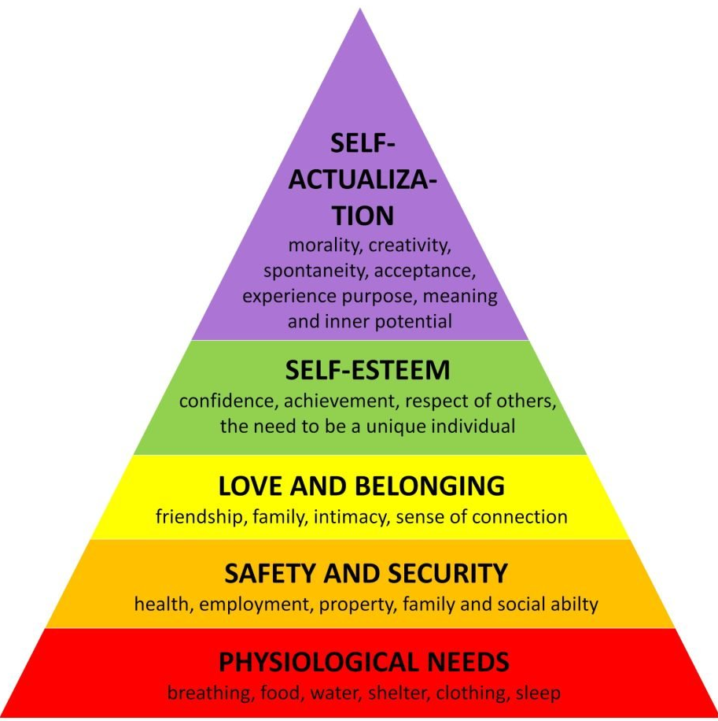
Based on hierarchy of needs theory, Usayla lacks safety and security as well as social needs. Safety and security involves having good health (Ștefan et al., 2020). She lives with arthritis which makes her to lack safety and security needs. She needs assistant and medical care. One social needs, Usayla needs social care due to the loneliness that she has been experiencing. The social needs involve love and belonging to social groups, family, and social connection. Since her family members are not around her, she needs social connection with family and friends. She wants social care from social workers to get along with her daily duties as she cannot support get along with life when she is alone. To maintain social connection. Usayla likes chatting with people who visit a nearby park. It is an emotional challenge for a person to stay without seeing the members of her family for a long time.
Social issues affect many old people. The disengagement theory suggests that as people start aging, they voluntarily disengage themselves from the social world (Zhang & Lin, 2022). However, Usayla has not disengaged herself and she keeps connected to the member of community. She visits the local church where she has friends and she is well connected with the members of the community that visit the nearby park. The disengagement theory suggests that people may lose social ties to those around them as they age. However, she may start disengaging with people around her as she does not want to buy a mobile phone. Most people in the digital era connect through the phone and lack of a mobile phone can be a form of disengagement. The disengagement theory suggests that aging is an ego change that can cause skill and knowledge to change (Khan et al., 2024). As an individual recognises that skills and knowledge are declining they choose to disengage. Usayla has not fully disengaged as she makes video calls. However, her reluctance to buy a mobile shows that she may be ready to disengage from society.
Usayla is still active even if she has arthritis. The activity theory posits that the process of aging is delayed or slowed, and when the elderly are socially activity it enhances the quality of their life (Shephard, 2024). Usayla goes to church and remains socially connected with the members of the church. She also volunteers in litter collection and likes chatting with the members of the public while collecting litter in the local area. This shows she is socially active. Being socially active enhances the quality of her life and improves her general wellbeing (Mulenga & Marbán, 2020). It reduces the chances of having the emotional challenges. At the age of 88, Usayla has lost touch with people who used to be close to her including her family members. This is a threat to her wellbeing as she does not have many friends who can check on her frequently. She has to remain socially active by attending some religious and community events.
There are several needs that aging people have. One of the needs that they need is protection from being discriminated in private and public areas such as in boarding buses or in public gatherings (CPA, 2024). Discrimination threatens the security of the old people. Maslow’s hierarchy of needs theory categorises security and safety needs as some of the needs that people should have. Ageism refers to the discrimination of people based on their age. Some members of society tend to discriminate the elderly. The Equality Act 2010 provides that people should not be discriminated in any way and that everyone has a right to access public services such as boarding vehicles (Bhopal & Pitkin, 2020). Usayla frequently boards a bus to go shopping. This is an indication that she is not discriminated.
However, ageism affects many old people and their views may not be considered in gathering such as religious gatherings. There are other elements that can intersect and lead to further discrimination of Usayla. Usayla is a black person who migrated from Jamaica. She belongs to the minority group and this increases chances of being discriminated. Moreover, she is a woman. The case of Usayla has several factors that lead to intersectionality. Intersectionality occur when there are several factors on one person that can make that person to be discriminated (Abrams et al., 2020). She can be discriminated based on her limited ability due to her old age, gender, race, sexual-orientation, and class. Notably, she worked as a teacher and librarian during her years and this indicates that she belongs to the low class group. Intersectionality in her life can be portrayed by the figure below.
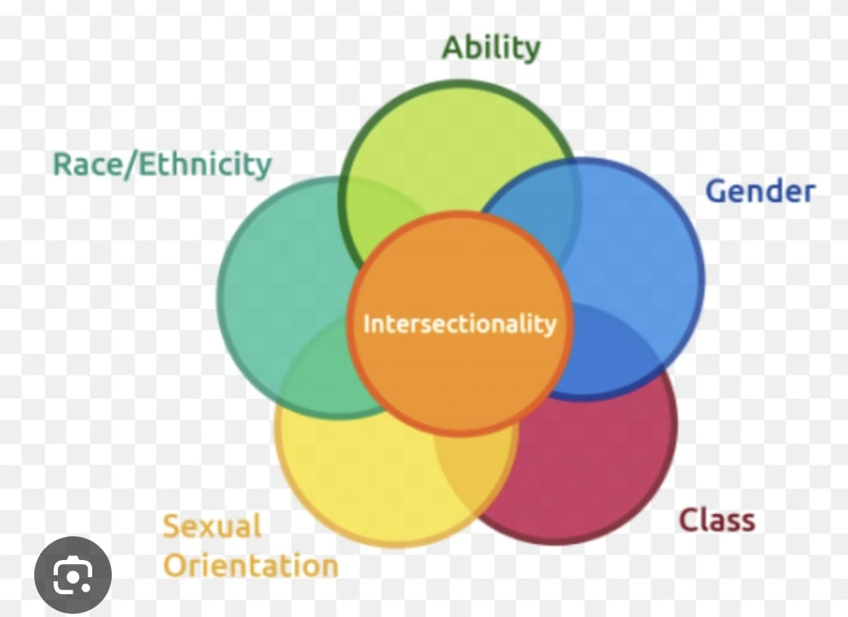
The Equality Act 2010 plays a crucial part in ensuring that people are protected from discrimination based on age, gender, race, or any other form of discrimination. Care givers and the local authority should equality offer services to Usayla without any form of discrimination.
Old people may also face abuse from young people because of their reduced physical activities. They need to be protected from abuse. Usayla needs care from the local authority and protection from abuse. The Care Act 2014 provides protection of the elderly from neglect of abuse (UK Government, 2014). This includes intervention to safeguard emotional and physical wellbeing of old people in the UK. This responsibility has been given to the local authorities and Care Act 2014 a clear legal framework for carers and local authority to protect old people from the risk of neglect and abuse. Care Act 2014 provides that the dignity of old people should be protected by treating them with respect (UK Government, 2014).
The Covid-19 had an impact on the wellbeing of many old people including Usayla. The Covid-19 pandemic required people to have social isolation. The UK government also put lockdown measures that restricted the movement of people including gathering in churches. This affected Usayla because she depends on gatherings such as going to church and visiting the nearby park to chat with people. During the Covid-19 pandemic, people were required to stay indoors. Old people are likely to die from the Covid-19 disease (CPA, 2024). This indicates that she was emotionally affected. Shopper also used online shopping. Usayla does not have a mobile where she can make online orders to shop groceries. The pandemic disconnected her from her friends.

Support and Intervention that Usayla Needs
There are several support and interventions that Usayla needs. Firstly, she needs domiciliary care. Domiciliary care is the most appropriate for of care compared to nursing care because she can perform some of her daily activities. Usayla is living with arthritis and this is not a sickness that would require her to have nursing care. It will be more appropriate for the doctor to visit her at home because she does not require high level of medication (Tański et al., 2021). The doctors will be checking her progress on the management of arthritis.
Secondly, she requires physical therapy for the management of arthritis (Serhal et al., 2020). Exercises are crucial to increase the range of motion and to strengthen the muscles that support motion around the joints. Usayla has reduced range of motion and arthritis is reducing her physical strength to complete the chores at home. This indicates that should be guided on how to do exercises as form of therapy. Thirdly, medical management support should be given to her. As a person with arthritis she needs pain killers such as acetaminophen to relief her joint pain (Serhal et al., 2020). She also requires anti-inflammatory drugs as inflammation is one of the symptoms of arthritis and it should be managed.
Futhermore, she needs social care support in the form of home care services (Aveyard, 2023). These services include dressing, bathing, grooming, and washing. As an aged person, Usayla has reduced abilities to complete these tasks by herself. She should also be helped in completing house hold tasks such as cooking, shopping, and cleaning. However, it is difficult for the government to provide house maids. Her children should employ house helps to assist Usayla in home care services. Finally, she requires social care in the form of mobility aids (Aveyard, 2023). She should be provided with walking sticks and frames to assist her in movement. Moreover, the apartment where should stays should be modified to make it more accessible. The apartment should have non-slip flooring and walk-in showers.
Usayla should be provided with the services of day care centres. The local authority is tasked by the Cares Act 2014 to support the elderly. The local authority should connect Usayla with the day care centre that is locally available. The local day care centre is important because it can assist her with meal and social activities. From the local day care centre, Usayla will be able to get social support activities as she will be able to interact with other old people in the centre. This will enable her to avoid being socially disengaged and ensures that she continues being active. The activity theory posits that the process of aging is delayed or slowed, and when the elderly are socially activity it enhances the quality of their life (Mulenga & Marbán, 2020). Consistent with the activity theory, this intervention will improve her quality of life and promote her wellbeing. Social support is available in many day care centres around the UK.
Usayla should be given nutritional support. She should get dietary advice on the balanced diet that would support her overall wellbeing and joint health (Tański et al., 2021). It is recommended that people with arthritis should eat anti-inflammatory foods that are rich in omega-3 fat acids (Kwiatkowska & Maślińska, 2020). Should needs to get free meals. However, this service is not available currently. In the future, old people who experience difficulties in cooking should get free meals. Usayla should be given psychological support. The reduced mobility may bring stress and mental health challenges if it is are not properly addressed. She should get therapy and counselling on how to deal with the emotional impact of reduced mobility and chronic pain (Verwoerdt, 2022). Psychological support should include relaxation and mindfulness techniques. This services is available for the aged people, through the NHS and in care centres.

Conclusion
Usayla is aged person who has various needs. She needs medication, personal care services, and social support. She lives alone and this may make her disengage socially as she ages further. She remains socially activity but having arthritis may socially disconnect her due to reduced mobility. This report proposes that Usayla should get domiciliary care, physical therapy for the management of arthritis, nutritional support, day care services, mobility aids, and personal care services. The house where she lives should also be modified to make it more accessible for her.

References
Abrams, J. A., Tabaac, A., Jung, S., and Else-Quest, N. M. (2020). Considerations for employing intersectionality in qualitative health research. Social science and medicine, 258, 113138.
Aveyard, H. (2023). Doing a Literature Review in Health and Social Care: A Practical Guide 5e.
Bhopal, K., and Pitkin, C. (2020). ‘Same old story, just a different policy’: race and policy making in higher education in the UK. Race Ethnicity and Education, 23(4), 530-547.
Cao, Y., Fan, D., and Yin, Y. (2020). Pain mechanism in rheumatoid arthritis: from cytokines to central sensitization. Mediators of inflammation, 2020(1), 2076328.
CPA, (2024). Policies on Aging. Available at http://www.cpa.org.uk/cpa/policies_on_ageing.html (Accessed: 05 July 2024).
Hassan, H., Alsherbieny, E., and Fahmy, M. (2023). Daily living activity among elderly women with knee osteoarthritis pain: impact of socio-demographic characteristics. World Journal of Social Sciences and Humanities, 9(1), 24-33.
Khan, A., Adil, A., Niazi, S., Ghayas, S., and Yousaf, A. (2024). Development and Validation of Engagement Aging Scale for Older Adults. Pakistan Journal of Psychological Research, 39(2), 351-369.
Kwiatkowska, B., and Maślińska, M. (2020). The place of omega-3 and omega-6 acids in supplementary treatment of inflammatory joint diseases. Reumatologia/Rheumatology, 58(1), 34-41.
Lithander, F. E., Neumann, S., Tenison, E., Lloyd, K., Welsh, T. J., Rodrigues, J. C., ... and Henderson, E. J. (2020). COVID-19 in older people: a rapid clinical review. Age and ageing, 49(4), 501-515.
Mulenga, E. M., and Marbán, J. M. (2020). Prospective teachers’ online learning mathematics activities in the age of COVID-19: A cluster analysis approach. Eurasia Journal of Mathematics, Science and Technology Education, 16(9), em1872.
ONS, (2023). Profile of the older population living in England and Wales in 2021 and changes since 2011. Available at https://www.ons.gov.uk/peoplepopulationandcommunity/birthsdeathsandmarriages/ageing/articles/profileoftheolderpopulationlivinginenglandandwalesin2021andchangessince2011/2023-04-03 (Accessed: 05 July 2024).
Serhal, L., Lwin, M. N., Holroyd, C., and Edwards, C. J. (2020). Rheumatoid arthritis in the elderly: characteristics and treatment considerations. Autoimmunity reviews, 19(6), 102528.
Shephard, R. (2024). Physical activity and aging. Taylor & Francis.
Sines, D., Aldridge-Bent, S., Fanning, A., Farrelly, P., Potter, K., and Wright, J. (Eds.). (2013). Community and public health nursing. John Wiley & Sons.
Stearns, P. N. (2024). Old age in European society: The case of France. Taylor & Francis.
Ștefan, S. C., Popa, Ș. C., and Albu, C. F. (2020). Implications of Maslow’s hierarchy of needs theory on healthcare employees’ performance. Transylvanian Review of Administrative Sciences, 16(59), 124-143.
Tański, W., Wójciga, J., and Jankowska-Polańska, B. (2021). Association between malnutrition and quality of life in elderly patients with rheumatoid arthritis. Nutrients, 13(4), 1259.
Tunstall, J. (2024). Old and alone: A sociological study of old people. Taylor and Francis.
UK Government. (2014). Care Act 2014. Available at: https://www.legislation.gov.uk/ukpga/2014/23 (Accessed: 05 July 2024).
Verwoerdt, A. (2022). Psychotherapy for the elderly. In Health Care of the Elderly (pp. 118-140). Routledge.
Wenger, G. C. (2021). The supportive network: Coping with old age. Routledge.
Zhang, X., and Lin, H. (2022). Disengagement theory. In Encyclopedia of gerontology and population aging (pp. 1471-1476). Cham: Springer International Publishing.

