

COMPONENT 2: COURSEWORK: ESSAY
THE IMPORTANCE OF CONTROLLING AS A MANAGERIAL FUNCTION: CHALLENGES AND STRATEGIES FOR EFFECTIVE ORGANISATIONAL PERFORMANCE

Tanya Eftimova
2317898

Table of Contents
Introduction 3
Managerial Functions Overview 4
Why Controlling is Essential in Organisations 7
Challenges Associated with Controlling 9
How Managers Can Mitigate Controlling Challenges 11
Conclusion 12
References 13

Introduction
In complex environments, management is significant in assisting organisations to attain goals. Managers organize individuals, resources, and operations in order to sustain efficiency and sustained stability. In contemporary organisations, competitiveness, innovation and sustainable organisational growth are achieved with the aid of effective management. In classical management theory, four important functions are identified and these are planning, organising, leading as well as controlling. The functions are separate and each of them fulfils a specific role, which is combined to achieve success in operations.
The modern business landscape is characterized by the changing technological nature, the international competition, and the increased demands. Managers are therefore required to make sound decisions but adapt fast to the dynamic situations. Control is one of the most prominent managerial functions that are of great importance in the success of organisations.

Managerial Functions Overview
Managerial functions give a systematic approach to the attainment of organisational goals. Henri Fayol came up with four fundamental functions, namely, planning, organising, leading, and controlling (Bacud, 2020). These functions have not gone away as they help in coordination, accountability and performance enhancement. Managers do not perform these functions as individual or sequential tasks, but as functions that should be implemented continuously. Planning is a process which gives the objectives and determines the way the organisational goals will be accomplished (Tavo and Rasmus, 2024). It involves the future condition analysis, resource allocation, and the risks to be expected. Proper planning assists organisations to act ahead of the curve to uncertainty and changes in the market. Indicatively, Amazon applies predictive information analysis to strategize inventory and delivery logistics.
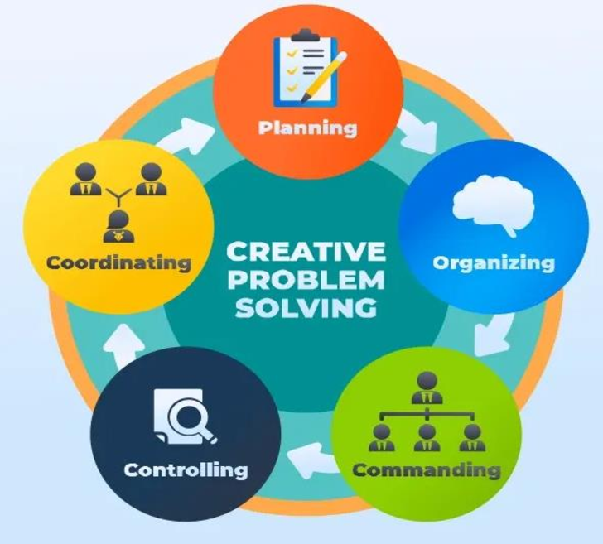
Figure 1: Henri Fayol's Five Functions of Management
(Source: Yuwono and Rachmawati, 2024)
Organising is concerned with the arrangement of organisational resources and the depiction of responsibilities inside the organisation. Managers also create jobs, define reporting and work teams in their attempt to improve efficiency. Another evident aspect is the definite organisational designs which facilitate in avoiding confusion and also the communication between the different departments. Flexible structures are practised by many multinational companies to enhance cooperation across global operations (Jooss et al., 2020). Organisation is a way of ensuring that the plans are backed by the right systems and human resource.
Leading is about influencing employees to accomplish organisational goals through motivation and direction. Good leaders have the ability to convey vision to their staff and provide them with conducive workplaces. The styles of leadership change based on the organisational culture and the situation. Transformational leadership promotes innovation, whereas transactional leadership is performance-oriented and has rewards (Salameh-Ayanian et al., 2025). Good leadership makes the employees stay devoted to organisational objectives and performance benchmarks.
Controlling is the one of checking performance and rectifying performance deviation. Managers quantify performance, benchmark results, and act rightly when the need arises. This role is the one that keeps the organisational processes on track with the strategic objectives and expectations (Khalilov, 2025). Key performance indicators are usually utilised by companies to assess the level of efficiency and productivity. The feedback available through controlling enhances better future planning and decision-making.
The functions of these managers are interdependent and rely on each other in order to be efficient. Planning provides the direction, organisational provides resources and leading employees is the driver. The process of control measures the outcomes and provides progressive enhancement in the organisational operations (Ogor and Fidelia, 2022). Managers are unable to establish whether or not strategies are yielding desired results without control. Thus, controlling is an important bridge between planning and organisational performance.

Why Controlling is Essential in Organisations
Control is also necessary as it will make sure that the organisational activities are in line with the planned objectives. Controlling is a technique employed by managers to assess the performance and to discover the discrepancies between the results and plans (Alshaiti, 2023). This is done to enable organisations to stay on track and accomplish strategic objectives. Organisations can end up losing efficiency and going off track without control, which is unintended.
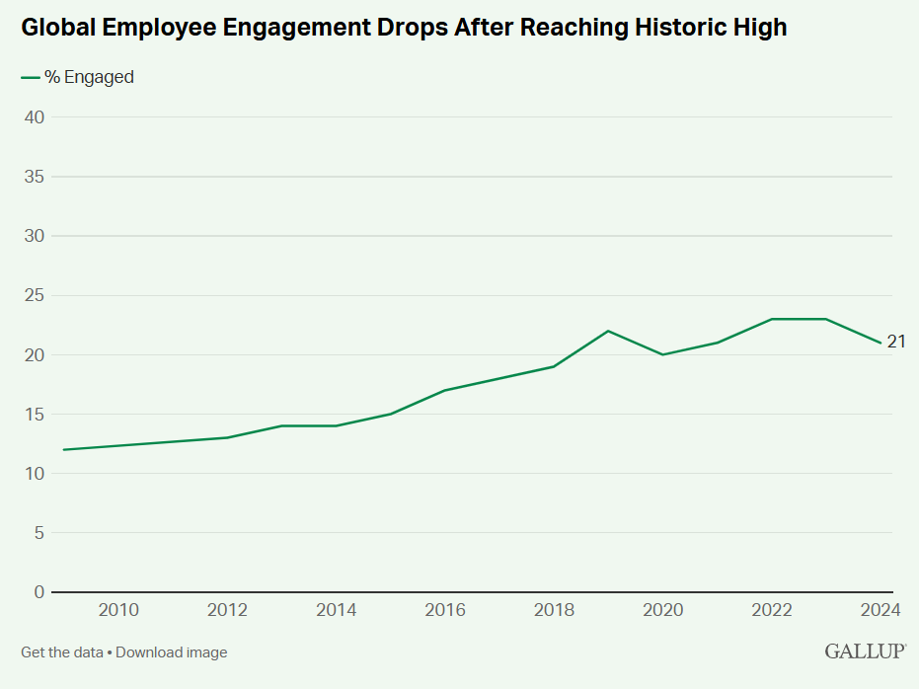
Figure 2: Global percentage of engaged employees over the years
(Source: Gallup, 2025)

The global employee involvement stands at a mere 21%, and hence, a majority of employees are poorly engaged in performance. Approximately 62% of workers are not engaged, and this is an indication that vigorous monitoring of performance is needed (Gallup, 2025). Indicatively, McDonald's has a stringent quality management to ensure the customer experiences are of the same quality around the world. These systems are used to preserve the brand image and stability of operations across sites.
Strategic alignment is also facilitated through controlling in organisations that are working in competitive environments. Without proper execution that aligns desired organisational direction, plans and strategies can never work. Control systems enable managers to monitor progress and take corrective actions on time (Yeboah et al., 2023). An example is the Apple company that enforces high-quality and design standards to defend brand coherence. These controls make sure that products are as expected by customers, and they have a competitive advantage in the global market.
Risk management and problem prevention in organisational processes is another significant thing. Managing assists managers to identify problems promptly before they can turn out to be expensive organisational failure. The occurrence of operational risks is warned at an early stage through performance data and feedback systems. Toyota has enhanced its quality control systems following massive product recall challenges (Yeboah et al., 2023). This example demonstrates that controlling may minimize risks in the future and regain the trust of the stakeholders.
Financial management is also important in organisational sustainability and management of resources that are involved in a responsible way. The managers track costs and profitability with the assistance of budgets, audits, and performance reports (Song et al., 2025). Decent financial management aids in prevention of over spending and making better decisions on how resources should be spent. Gallup estimates put disengagement as a part of the global decline in productivity of 8.9 trillion per year.
Control also helps in improving employee performance as expectations and performance standards are made clear (Rendi et al., 2025). Employees are able to make efforts that are consistent with organisational priorities when they realise quantifiable goals. Performance appraisal systems assist managers in giving feedback and ensuring that there is continual improvement. But in other situations, too much control can be a dampener of creativity and employee motivation. As such, managers should find a balance between control and trust, autonomy, and supportive leadership behaviour. Managers are considered to have a huge impact on performance, with performance being 70% accounted by them (Hashmi et al., 2024). Volkswagen emissions have led to poor control implications, as it has cost it more than 32 billion in fines and litigation costs. Through this learning process, organisations are able to adjust to the changing market conditions. Firms that are driven by data-based control systems tend to be more efficient and innovative. Therefore, the notion of control is not only concerned with monitoring, but also with organisational development.

Challenges Associated with Controlling
Monitoring is important, but managers encounter a number of challenges when implementing. Employee resistance to control systems in the workplace can also be considered as one of the biggest challenges (Awan et al., 2020). The monitoring can be viewed as mistrust or unwarranted interference of the manager in the employees. This image may decrease the motivation, creativity, and the level of employee engagement considerably. Employees who find control to be restrictive will only be target-oriented rather than improvement-oriented.
According to the global data, 17% of workers are actively disengaged, and this makes it more difficult to implement control systems effectively (Gallup, 2025). Intangible outcomes are likely to be generated in creative industries, in research teams and in leadership positions. Without simplifying complex performance results, managers might be unable to fairly gauge their contribution. The existence of excessive dependence on numerical goals can consequently result in erroneous or partial performance evaluation.
The need to control organisational operations has also become more difficult due to globalisation and remote working. Managers will have the tendency of overseeing teams that are situated in various nations and different cultures. The cultural differences shape the attitudes about authority, monitoring and performance evaluation practices (Awan et al., 2020). Telecommuting also makes performance measurement more challenging to managers due to the lack of direct observation. This makes the issue of control systems consistency more difficult today.
Another critical challenge that has made the use of modern control systems problematic to managers is information overload. Digital monitoring technologies allow organisations to generate huge amounts of data on performance. In Great Britain, 964,000 employees were indicated to have stress, depression or anxiety associated with the work conditions (Clyde, 2026). The lost working days due to work-related ill health were 40.1 million, which further added to management control problems.
There are also ethical concerns when organisations apply the control mechanisms based on surveillance too much. The use of surveillance employee software can lead to a decrease in the degree of trust at the workplace significantly and create privacy issues (Glavin et al., 2024). Employees may end up feeling unsafe when it is all watched or measured on a continuous basis. This can have adverse impacts on the organisational culture and sabotage the relationship between the employees and the managers. Accountability / employee wellbeing are therefore the questions that moral issues raise.
The second problem will be control and flexibility in the dynamic business environment. The control systems may be highly inflexible, where it is difficult to be creative and adopt change sluggishly in an organisation. Modern organisations must be lean, experimental, and fast when making decisions to remain competitive (Steegh et al., 2024). Strong control systems scare-away risks and reduce team flexibility. Strict systems of control should not, therefore, exist in managers that suppress organisational learning and development.
Engaged managers in teams have a higher probability of being engaged at work, 59%. When managers are actively supportive of employees, the chance of them reporting positive onboarding increases 2.5 times (Clyde, 2026). In case managers do not revise control mechanisms, they can promote inappropriate behaviours. Employees may concentrate on past goals instead of the present organisational goals. It is thus required but in practice usually very hard to continue to review control systems.

How Managers Can Mitigate Controlling Challenges
Balanced and flexible control approaches can assist managers to minimize the difficulties in controlling. They ought to have both the formal and informal controls as opposed to monitoring alone. This method will allow accountability, as well as trust and motivation of employees in teams (Clyde, 2026). Nondestructive control mechanisms promote performance but do not form the culture of extreme pressure.
Controlling systems may become more acceptable to employees who are involved in the process of setting performance targets. Employees have a sense of ownership and responsibility when they are involved in goal definition. The participative control enhances transparency and better acceptance of performance measuring procedures. Collaborative goal-setting is a common method of Agile project teams to ensure connectivity and responsibility (Steegh et al., 2024). This will enhance the relationship of trust between the manager and the employees when evaluating their performance.
Outcome-based controls should also be directed by managers instead of having constant behavioural monitoring. The ability to measure results enables employees to be flexible in the manner in which they accomplish their work assignments. According to Gallup research, managers are capable of greatly influencing the performance of employees by providing constant feedback and responsibility to the employees (Khalilov, 2025). The level of manager engagement determines the organisational productivity and retention of employees.
The prudent application of technology may assist managers in breaking down the data overload and tracking problems. Analytics tools and digital dashboards enable managers to monitor the key performance indicators effectively (Salameh-Ayanian et al., 2025). Managers should, however, not concentrate on gathering irrelevant information, but they should concentrate on meaningful data.
The leadership style is also important in ensuring that issues of control are mitigated successfully. Transformational leaders foster trust through assisting the workers and promoting free communication habits. Resistance greatly diminishes with time when employees get to know the objective of control (Salameh-Ayanian et al., 2025). Control should be built by the managers as a development mechanism and not as a punishment mechanism. A positive environment for performance monitoring and improvement is developed by supportive leadership.

Conclusion
Management functions are core points in ensuring organisational effectiveness and strategy success. Planning, organising, leading, and controlling collectively work towards facilitating performance in organisations. Control is one of these functions that are necessary in the achievement of goals. It offers feedback, assists accountability, and assists organisations to keep on track in strategy. Controlling is however not free of issues as staff reluctance and measuring issues arise. Modern managers are also challenged by globalisation, ethical issues and overload of data which adds to complexity. Such difficulties underscore the necessity of considerate and moderate control techniques in organisations. The managers should not be too controlling to the extent of diminishing creativity or undermining the trust of employees.

References
Alshaiti, H. (2023). Influences of Internal Control on Enterprise Performance: Does an Information System Make a Difference? Journal of Risk and Financial Management, 16(12), p.518. doi:https://doi.org/10.3390/jrfm16120518.
Awan, S.H., Habib, N., Akhtar, C.S. and Naveed, S. (2020). Effectiveness of Performance Management System for Employee Performance through Engagement. SAGE Open, 10(4), pp.1–15. doi:https://doi.org/10.1177/2158244020969383.
Bacud, S.A.D. (2020). Henri Fayol’s Principles of Management and its effect to organizational leadership and governance. Journal of Critical Reviews, 7(11), pp.162–167. doi:https://doi.org/10.31838/jcr.07.11.25.
Clyde (2026). HSE increase their focus on work-related stress. Clydeco.com. Available at: https://www.clydeco.com/en/insights/2026/01/hse-increase-their-focus-on-work-related-stress-cl [Accessed 23 Feb. 2026].
Gallup (2025). State of the Global Workplace Report. Gallup. Available at: https://www.gallup.com/workplace/349484/state-of-the-global-workplace.aspx [Accessed 23 Feb. 2026].
Glavin, P., Bierman, A. and Schieman, S. (2024). Private Eyes, They See Your Every Move: Workplace Surveillance and Worker Well-Being. Social currents , 11(4), pp.327–345. doi:https://doi.org/10.1177/23294965241228874.
Hashmi, S., Tahir, O., Nasir, Z., Hasnain, H., Ullah Riaz, R.S., Ali Khan, H.M., Ramza, R., Alghzawi, H.M., Mukherjee, J. and Palav, A. (2024). Impact of emotional intelligence on professional performance and stress resilience among healthcare practitioners. Cureus, 6(11). doi:https://doi.org/10.7759/cureus.74113.
Jooss, S., McDonnell, A. and Conroy, K. (2020). Flexible Global Working arrangements: an Integrative Review and Future Research Agenda. Human Resource Management Review, 31(4), p.100780. doi:https://doi.org/10.1016/j.hrmr.2020.100780.
Khalilov, T. (2025). The Role of Leadership and Managerial Skills in Strategic Planning. Journal of Information Systems Engineering and Management, 10(20s), pp.98–104. doi:https://doi.org/10.52783/jisem.v10i20s.3014.
Ogor, M. and Fidelia, I. (2022). Management control attributes and the organizational performance. International research journal of management, IT and social sciences, 9(4), pp.524–537. doi:https://doi.org/10.21744/irjmis.v9n4.2114.
Rendi, C.D.H., Poluru, N.V. and Pappachan, R. (2025). The impact of performance management systems on employee work attitudes: empirical evidence. Cogent Business & Management, 12(1). doi:https://doi.org/10.1080/23311975.2025.2538717.
Salameh-Ayanian, M., Lakkis, P., Jabbour, N. and Makki, M. (2025). Leading Through Uncertainty: How Transformational and Transactional Leadership Shape Employee Satisfaction and Performance in Lebanese NGOs. Administrative Sciences, 15(5), p.172. doi:https://doi.org/10.3390/admsci15050172.
Song, J., Song, J., Browning, T. and Vanhoucke, M. (2025). Project monitoring and control with an empirically grounded budget-release model. European Journal of Operational Research. doi:https://doi.org/10.1016/j.ejor.2025.06.007.
Steegh, R., Van De Voorde, K., Paauwe, J. and Peeters, T. (2024). The agile way of working and team adaptive performance: A goal-setting perspective. Journal of Business Research, 189, pp.115163–115163. doi:https://doi.org/10.1016/j.jbusres.2024.115163.
Tavo, K. and Rasmus, R. (2024). The Role of Planning in Management: Strategies to Achieve Organizational Success. Sharia Oikonomia Law Journal, 2(2), pp.106–115. doi:https://doi.org/10.55849/solj.v2i2.1148.
Yeboah, O.-W., Diaba, B., Mohammed, A. and Boateng, P.A. (2023). Role of Strategic Control Systems in Achieving Strategic Goals. International journal of research and scientific innovation, X(VII), pp.232–241. doi:https://doi.org/10.51244/ijrsi.2023.10728.
Yuwono, M.A. and Rachmawati, D. (2024). Development of Henri Fayol’s Principles of Management on the Implementation of Governance in the Banking Industry in Indonesia: International Journal of Management, Accounting & Economics. International Journal of Management, Accounting & Economics, 11(6), pp.803–824. doi:https://doi.org/10.5281/zenodo.12604609.

