DATA ANALYSIS

Student Name: Diana Stoyanova
Student Number: 2007366
Module: Data Handling and Business Intelligence
Module Code: LCBB5000
Lecturer: Dr Md Nazmul Hasan

Part 1: Excel Analysis

Use of Excel for Pre-processing
Working with a raw dataset could be tedious and possibly result in errors. For instance, the current Superstore sales dataset contains real-world raw data manually entered into Excel. This kind of data is likely to be incomplete, inconsistent, and unstructured, meaning that it cannot be used directly - equally, the data required to be checked for any missing values or duplicates. The process is referred to as pre-processing. According to García, Luengo, and Herrera (2015), the aim of pre-processing is to transform raw data into a structured and helpful format. Once the errors and the inconsistencies have been removed, the data would be considered to be safe for analysis.
The first step under pre-processing involves searching for missing data. García, Luengo, and Herrera (2015) observe that the presence of missing data may result in inaccurate inferences after analysis. In this dataset, there are a total of 8399 values. A quick scan of data indicates that there are no missing values. The ideal way of checking the missing values is using the IF function. This aspect involves setting a condition that would either be returned as TRUE or FALSE.
To determine the missing values, one data set must be compared against another. Based on findings by Schmuller (2013), Excel functions can only return missing values for values that are present in one list and absent in another. In this case, we used the COUNTIF and IF functions. The latter sets a certain criterion or condition that ought to be met, while the former counts the number of cells that meet the criteria. To determine whether there was any missing number, I rearranged the sales dataset and took a number (872.48) as a checklist for missing values. The following formula was used: IF(COUNTIF(D3:D8401, C3), "OK," "Missing"
In this formula, D3:D8401 was the dataset range, while C3 was the checklist value. A screenshot of the results is shown in Figure 1 below. Based on the results, it means that the value is not missing from the list.
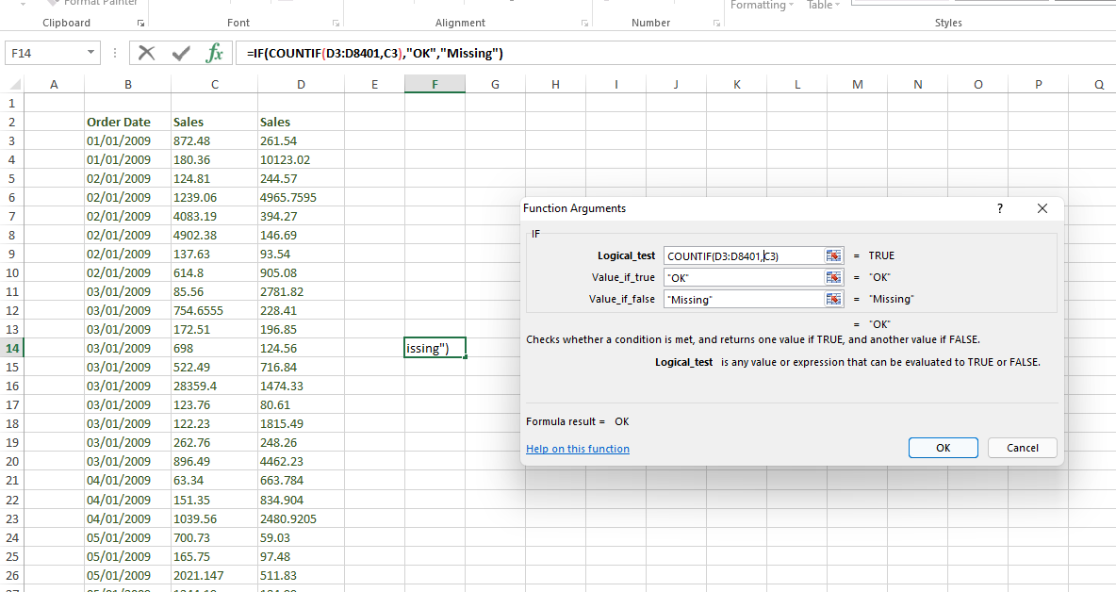
Figure 1: IF Function

Having determined that there are no missing values in the dataset, the next step will be to look for duplicates. The first step was to highlight the data then use the conditional formatting option to highlight the duplicate values, as shown in Figure 2 below.
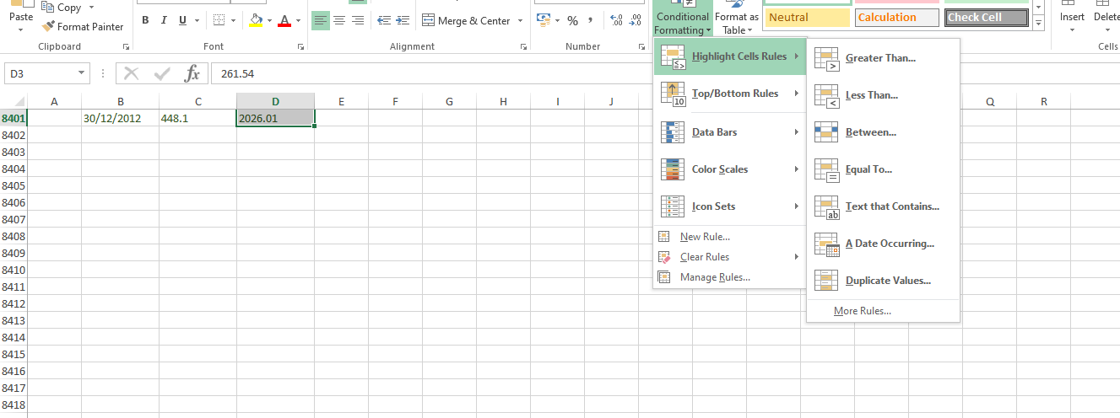
Figure 2: Conditional Formatting

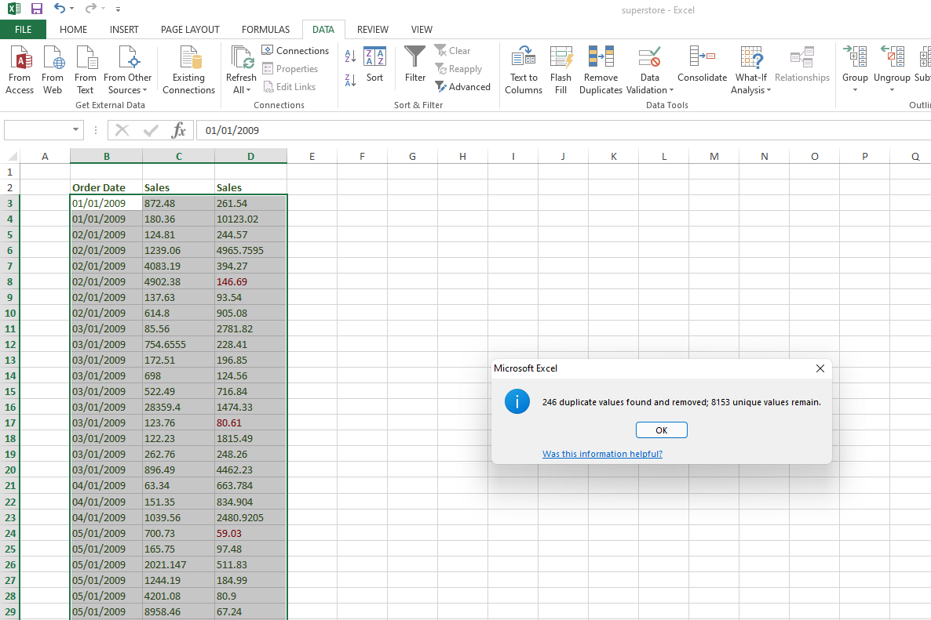
All the duplicates from the dataset were highlighted in red. In total, the sales data had a total of 246 duplicates, as shown in Figure 3 below. The next step here was to decide on whether to remove the duplicates. The process of removing repetitive records provides us with an opportunity to use a more accurate dataset for analysis. After removing the duplicates, the remaining data set had a total of 8153 values. The dataset will be used for analyses in the preceding parts.
Figure 3: Duplicates

The aim of this study is to determine the decline in sales over the years. In the Superstore dataset, the dates are mixed up given that they were only manually and roughly entered into Excel. Therefore, there is a need to ensure that the data is well arranged into dates. This was done using the Sort and Filter option under the Home tab. Here, the data was arranged from the oldest to the newest (1st January 2009 to 31st December 2012).
Use of Excel for Analysing
The next function of Excel is analysing data. The process involves modelling the data with the aim of drawing valid conclusions (Khadka, 2019). The first type of analysis that was conducted on the dataset was descriptive analysis. The analysis was used to summarise the main elements of the dataset. The analysis was conducted after removing duplicates with a count of 8153. As shown in the Excel output below, there was a huge disparity with the values, with the minimum value at 2.24 and the maximum value at 89061.05. This aspect means that the highest sale made over the four-year period was 89,061.05 and the least sale was 2.24. The mean sale over the period was 1819.54, with a standard deviation of 3625.89. Looking at the output, the mode of the dataset is not available because the data used in the analysis had no duplicates.

Column1
Mean | 1819.53622
Standard Error | 40.1564608
Median | 476.04
Mode | #N/A
Standard Deviation | 3625.88604
Sample Variance | 13147049.6
Kurtosis | 59.6802482
Skewness | 5.32905643
Range | 89058.81
Minimum | 2.24
Maximum | 89061.05
Sum | 14834678.8
Count | 8153
Largest(1) | 89061.05
Smallest(1) | 2.24
Confidence Level (95.0%) | 78.7169044
Table 1: Descriptive Analysis

In regards to analysis, we determine whether there has been a decline in sales/profit over the years. To continue with the analysis, we need to convert the data from the daily format to years. On the sales data, the conversion to years was done by calculating the mean sales in the stores in each year. The results are shown in Table 2 below.
Year | Mean Sales
2009 | 1953.89
2010 | 1659.04
2011 | 1705.04
2012 | 1754.33
Table 2: Yearly Mean Sales for Superstore

As shown in Table 2 above, the mean sales for the products were highest in 2012 and lowest in 2010. There was a huge drop in sales between 2009 and 2010 which later improved over the next two years. It is important to note that using cleaned and filtered data did not have any difference in the trend of mean sales over the years. The mean sales for this data are shown in Table 3 below.
Year | Mean Sales
2009 | 1953.87
2010 | 1659.04
2011 | 1703.41
2012 | 1755.76
Table 3: Yearly Mean Sales for Superstore (Without duplicates)

The sales data above does not show a clear decline in sales over the years. I, therefore, sought to determine the decline in the profit dataset. The results are shown in Table 4 below. Using 2009 as the base year, there was a general decrease in profits across the study period.
Year | Mean Profits
2009 | 201.16
2010 | 170.44
2011 | 190.35
2012 | 162.91
Table 4: Yearly Mean Profits for Superstore

In comparing the two datasets, the years 2012 had the highest sales and the lowest profits. It means that the store was making sales without a huge increase in profits. Rieley (2018) links the situation to increasing operating expenses. The profits were highest in 2009, in this year, the company had made huge sales. Over the next years, there was a consistent decrease in sales and profits.

Use of PIVOT Tables
In regards to the sales, products at Superstore were divided into three main categories; office supplies, technology, and furniture. Therefore, while considering a decline in sales, there is a need to examine the trend across the three departments. In this case, data sorting will be conducted using PIVOT Tables. The tool allows analysts to determine the trend from a large dataset. The first step here was to ensure that the dataset containing sales and product categories was organised into years. The second step is to select the range for the PIVOT Tables, as shown in Figure 4 below. The third step is to fill the PIVOT Tables by selecting appropriate rows and columns. In this case, the product category dataset is dragged into the columns section. The aim is to determine the sum of each category over the years.

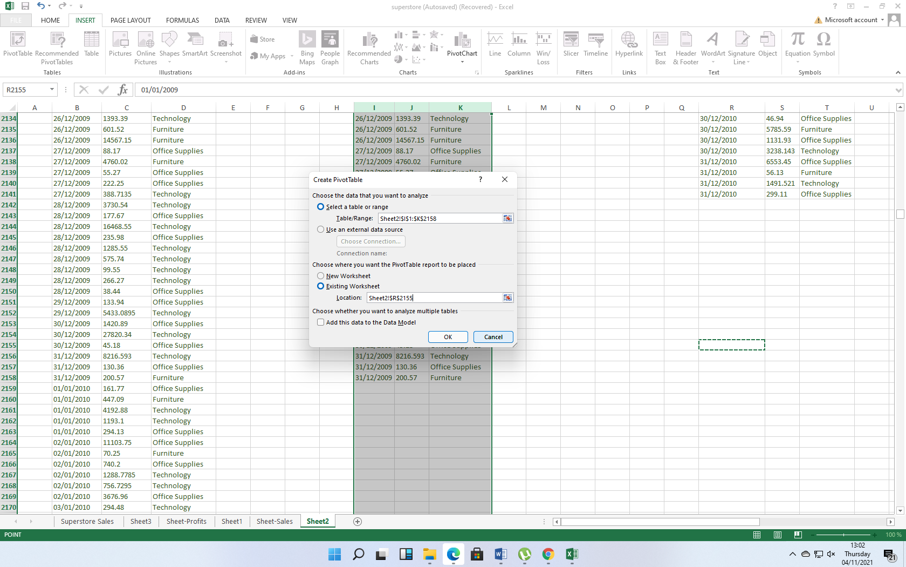
Figure 4: PIVOT Tables

The results of the PIVOT Tables analysis are shown in Excel outputs below.
Row Labels | Sum of Sales
Furniture | 1472671.724
Office Supplies | 1035399.64
Technology | 1701825.482
Grand Total | 4209896.846
Table 5: PIVOT Table 2009
Row Labels | Sum of Sales
Furniture | 1252518.416
Office Supplies | 910359.95
Technology | 1397208.679
Grand Total | 3560087.045
Table 6: PIVOT Table 2010
Row Labels | Sum of Sales
Furniture | 1268656.078
Office Supplies | 796383.79
Technology | 1364905.113
Grand Total | 3429944.981
Table 7: PIVOT Table 2011
Row Labels | Sum of Sales
Furniture | 1184744.324
Office Supplies | 1010618.72
Technology | 1520308.909
Grand Total | 3715671.953
Table 8: PIVOT Table 2012

Use of Excel for Visualisation
According to Schmuller (2013), Excel is one of the best data visualisation tools. It allows analysts to represent their data in the form of charts, graphs, and tables. Representing the data in this format makes it easier to identify the trend and the general flow of information. In this section, representation of data will be done using graphs. Figure 5 below is a graphical representation of mean sales over the years. As shown below, the sales decreased in 2010 and later increased towards 2012.

Figure 5: Graphical Representation of Sales

Figure 6 below is a graphical representation of mean profits over the years. Based on the graph, there was a slight increase in profits in 2011, which later reduced in 2012.

Figure 6: Graphical Representation of Profits

Product Categories
In section, we arrange the sales according to various categories. The aim is to determine whether there is a decline in sales across the categories. The first step is to rearrange the output of the PIVOT Tables so that we have the totals for each product category across the years, as shown in Table 9 below.

Category/Year | 2009 | 2010 | 2011 | 2012
Furniture | 1472671.72 | 1252518.42 | 1268656.08 | 1184744.32
Office Supplies | 1035399.64 | 910359.95 | 796383.79 | 1010618.72
Technology | 1701825.48 | 1397208.68 | 1364905.11 | 1520308.91
Total | 4209896.85 | 3560087.05 | 3429944.98 | 3715671.95
Table 9: Sum of Sales in Product Categories

Figure 7 below shows a visual representation of the sales trend for the three product categories across the years. The trend shows that the sales in each product category decreased in 2010. This is in line with earlier findings which found a decline in total sales over the same period. At this point, the company may have had a poor marketing strategy or has products that do not meet the needs of their customers, resulting in a decline in sales. In the following year, the sales volumes for office supplies decreased significantly by 12.5% while those of furniture and technology only increased by 1.2% and 2.3% respectively. In the following year, all product categories apart from furniture recorded an increase in sales. The analysis indicates that in each year, there was a decline in sales in at least one product category.

Figure 7: Comparing Sales across Product Categories

Table 10 below shows a general change in sales (total product categories) over the four-year period. The change between 2009 and 2010; 2010 and 2011 was -15.5% and -3.7%, respectively showing a decline. According to Rieley (2018), the trend could be linked to changing economic conditions, which resulted in a lower buying power. Equally, it is possible that the firm was not able to keep up with the existing competition, especially in furniture and office supplies. Based on this data, Superstore should therefore relook at its marketing strategy and the overall business model.
Year | % Change in Sales
2009 -2010 | (15.5%)
2010 -2011 | (6.5%)
2011 -2012 | 8.3%
Table 10: Percentage Change in Sales

Part 2: SPSS Analysis

The study analysed the customers’ data collected from the Nutritionist centre “Smile Clinic” to determine whether the customers eat rice in their daily meal from a healthy diet point of view. Figures 8, 9, and 10 below show the descriptive statistics for the study variables.

Gender

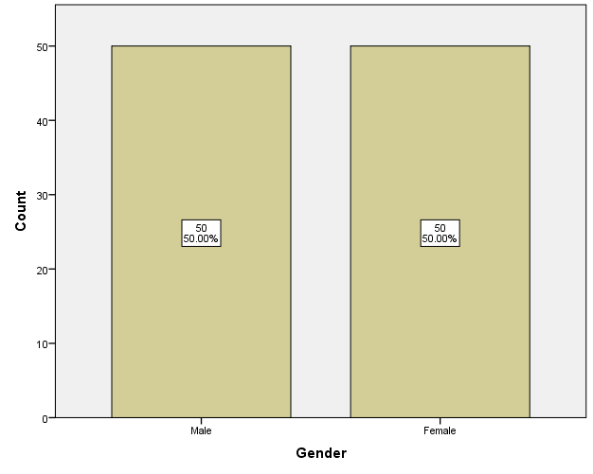
Figure 8. Distribution of Gender

According to Figure 1 above, a total of n=100 respondents participated in the study. Out of which 50 % (n=50) of the customers were males, and n=50 were female customers.

Number of Customers who Eat Rice

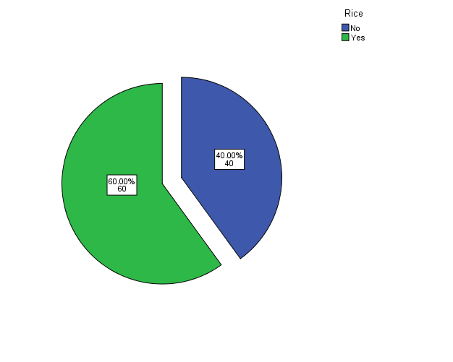
Figure 9: Number of Customers Who Eat Rice

Based on Figure 1 above, the majority (n=60) of the customers eat rice in their daily meal, and only 40% (n=40) of the customers do not eat rice in their daily meal.

Age
Statistics
Age
Mean | 20.35
Median | 19.00
Table 11: Age

Table 11 above shows the descriptive statistics of the respondents’ age. On average, the respondents were aged 20.35 years (~ 20 years) with a median of 19.

Mean and median (For respondents who eat rice)

Group Statistics | Rice | N | Mean | Median
Age | No | 40 | 20.55 | 19.00
Age | Yes | 60 | 20.22 | 19.00
Table 2: Mean and Median

Based on Table 2 above, the mean age and median of the customers who ate rice were 20.22 and 19.00, respectively.

Clustering
Clustering is a crucial method of text mining. Clustering organises textual information into relevant groups/clusters for easy analysis. However, there is a great challenge in grouping these clusters from unstructured data without prior information (Mughal, 2018). A good example of clustering is centroid clustering. In this clustering, we choose the number of clusters we want. In our case, we choose two clusters (1= who eats rice, 0 = who does not eat rice) regarding age. Thus, we have;
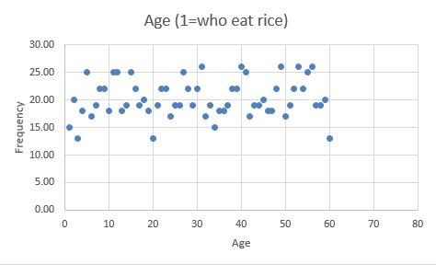
Cluster 1

Cluster 2

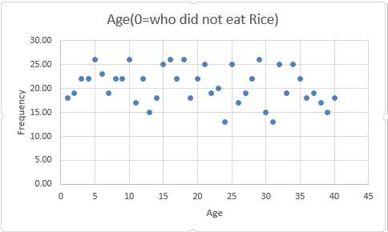

We determine the centroid for each cluster and determine how far each data point is from the centroid. Thus, we have the two clusters determining who eats the rice daily in their meal and who does not.

Text mining method
According to Bharara, Sabitha, and Bansal (2018), text mining is a critical method of analysing and processing unstructured data. There are several methods of text mining, these include;

- Collecting/gathering unlabeled textual data from distinct data sources, like pdf files, web pages, emails, and plain text, to name a few. For instance, such data may entail business performance over the last five months. This data can be obtained from the respondents through mail interviews or from web pages.
- Detect and remove outliers from the data: Statistical techniques are used to determine the existence of anomalies in the data. Such anomalies from the data can be removed to obtain meaningful information from the study results.
- Converting meaningful information unlabeled textual data into structured formats allows the researcher to analyse the data quickly.
- Use of management Information System to analyse the business patterns within the data.
- Storing valuable information into a secure database enhances data analysis and facilitates the organisation's decision–making process.

Advantages and Disadvantages of using SPSS and Excel
SPSS
Advantages of using SPSS
- Quick and Easy to learn: SPSS is majorly used for quantitative data analysis, and therefore it is quick and easy to learn. Its user interface is entirely point-and-click, which makes it easy to learn. Not much coding is required when using SPSS, unlike other statistical packages such as R and STATA. For instance, when entering data, you only need to understand the concept of naming the study variable and assigning numerical values to nominal and ordinal variables; however, no coding technicality is required in this task.
- Handles large amounts of data: Since SPSS is used for quantitative data analysis and is quick and easy to learn, it can handle a large amount of data. Its flexibility in speed and ease allows one to enter a large amount of data. For instance, SPSS can accommodate large volumes of data since there is no command-line feature that restricts the entry points. In addition, it is possible to import data in SPSS from other packages, including Microsoft Excel.
- Great User Interface: SPSS has one of the most friendly user interface that is easy to learn and understand. The user interface also allows the research to import the data into SPSS from other sources. For instance, the researcher can import data from Excel, where the data is organised as a database. This is fairly a simple process, only requiring a few basic steps and some preparations. SPSS is majorly designed for average data analysts /beginners who do not have enough skills and experience to use alternative statistical software packages such as R, STATA, S.A.S., and others.
Disadvantages of using SPSS
- Very Expensive: SPSS is very expensive to purchase for students. Therefore, this can limit the students and also some potential researchers from using this software package due to its high cost in the market. Similarly, students may also incur extra charges from added training to completely understand SPSS and all the available features in the software.
- Limited functionality: SPSS has limited graph features that make it useful to use Excel to get more informative graphs (Opie, 2019). This implies that graph features in SPSS may lack some important features used in formatting the graphs, unlike in Excel. Such restrictions limits the researchers from using SPSS to graph specific variable data.
- Similar to Excel: SPSS may be just as simple as Excel since it does not contain complex functionalities. Therefore, it lacks additional functionalities needed in both quantitative and qualitative data analysis.
Microsoft Excel
Advantages of Using Excel

- Easy to use: Microsoft Excel is very easy to use in collecting and organising data. Besides, one can sort and filter data using the custom sort command. However, the process is quite simple and require basic knowledge of Excel. Only basic coding may be required when analysing data.
- Streamlines calculations: Excel contains a variety of mathematical formulas that are used in various calculations. The great appeal of Excel is that the software/program does all math calculations for the user, unlike other statistical software packages such as SPSS.
- Data organisation: Using Excel, one can organise large amounts of data into refined logical spreadsheets and orderly charts. This allows the researcher to easily analyse and digest the data through visual data representations (Ose, 2016).

Disadvantages of Using Excel
- Calculation errors: Excel has the capability to check for human errors during data entry thus;, wrong entry can skew all the results. This may result in the wrong findings and conclusions of the study.
- Time-consuming: Data is manually entered into Excel, which is tiresome and time-consuming, especially if you have a lot of entries to make. The time to enter the data into Excel manually is extremely inefficient (Morris, Deochand, and Peterson, 2018). The process of data entry in Excel can be boring, thus resulting in costly inattentiveness.

References
Bharara, S., Sabitha, S. and Bansal, A., 2018. Application of learning analytics using clustering data mining for students’ disposition analysis. Education and Information Technologies, 23(2), pp. 957-984.
García, S., Luengo, J. and Herrera, F., 2015. Data preprocessing in data mining (Vol. 72). Cham, Switzerland: Springer International Publishing.
Khadka, B., 2019. Python and Excel tools. UK: Springer.
Morris, C.A., Deochand, N. and Peterson, S.M., 2018. Using Microsoft Excel® to build a customized partial-interval data collection system. Behavior Analysis in Practice, 11(4), pp. 504-516.
Mughal, M.J.H., 2018. Data mining: Web data mining techniques, tools and algorithms: an overview. Information Retrieval, 9(6).
Opie, C., 2019. Using EXCEL/SPSS in your research. UK: SAGE.
Ose, S.O., 2016. Using Excel and Word to structure qualitative data. Journal of Applied Social Science, 10(2), pp. 147-162.
Rieley, M., 2018. Inside the decline of sales occupations. BLS, 9(5), p.28.
Schmuller, J., 2013. Statistical analysis with Excel for dummies. UK: John Wiley and Sons.

