Towards a fully digital Set of Concordances for the Beirdd y Tywysogion: Digital Humanities Assignment 2 (5000 words)
M Youde, May 2025
The Medieval Welsh Poetry of the Princes (Beirdd y Tywysogion) is one of the most important corpora in Welsh literature. It provides a rich insight into representations of the lives, exploits and characters of Medieval Welsh Kingdoms, pre-Edwardian conquest; and it is an invaluable source of both the genre of Medieval Praise Poetry and the form of strict Welsh poetic metre known as Cynghanedd. It is a precious corpus, contained mostly within one manuscript, the Hendregadredd, and the edited and printed edition produced by the Centre for Advanced Welsh and Celtic Studies at the University of Wales remains the primary point of access to the poems. As part of that project, Ann Parry Owen prepared a full set of concordances for the corpus, the Concordans Barddoniaeth Beirdd y Tywysogion (hereafter CBYT), cataloguing thousands of distinct words and terms and presenting them in context, with a sample of the words that come before and after each occurrence of each word. This and her concordances for the earlier body of Welsh poetry (Hengerdd) arguably constitute the definitive word lists for medieval Welsh poetry. They were essential in my BA dissertation, where I tracked occurrences of the ancient Celtic adornment the torque through centuries of evolution as a motif in Welsh literature. Though linear and sequential, they are easy to search, and the keys – provided in separate plain text files - are straightforward to understand. Nonetheless, further digital conversion – either of the concordans itself or its source file - might enable further and more sophisticated analysis as well as studies of co-occurrences/collocations and the building of social networks between terms and concepts used in the poetry.
About Concordances
Concordances are word-lists that show each occurrence of a word in the line, sentence, paragraph or stanza in which it appears, allowing a researcher to gain insight into how it is used and compare it to its other occurrences in a literary corpus. In other words, they offer a view of ‘the company that words keep.’
Concordances have a long history, first being used for scriptural study, with word lists compiled for the Bible and Qur’an. Later, they were used for high-status works like those of Shakespeare. Produced manually, they would require many people working on them, with medieval scriptoria sometimes deploying hundreds of monks to create Biblical concordances, for example.
The computer age has made the production of concordances much more straightforward. Even though for the team working on Barddoniaeth Beirdd y Tywysogion in the 1980s, ‘using computers for research was very new,’ they nonetheless utilised computing to both typeset the volumes for printing (using a program called Vuwriter Scientific) and produce CBYT using the Oxford Concordance Program (OCP), produced by OUCS.’
Ann Parry Owen gives an interesting view into the work of producing the CBYT. She used texts of the corpus in modern Welsh orthography rather than that of the manuscripts; we can infer this allowed for a standardisation that would prevent anomalies resulting from multiple ways of writing the same word, for example. She would prepare both a text file of the poetry and then a command file, which allowed her to set the order of the alphabet (‘very useful for Welsh, a, b, c, ch, d, dd, etc.;’ this would have mitigated for the automatic ordering otherwise provided by programs, as shall be seen later), and the number of characters on each side of the sorted word. It was a very basic program, she notes, but also very powerful, in that the user had control of the outputs, even this early on in the use of such digital tools. In correspondence with Ann Parry Owen, she also helpfully provided the unpublished source file for the CBYT, which proved invaluable for this project.
Now there are many online concordances of literary corpora, especially poetry, as well as substantial secondary literature on their value and numerous guides for how to use them in research and education. There are also various tools – online and offline – and open-source code scripts for creating new concordances from source files. We will briefly review this landscape before proceeding to outline the project goals, methodology and results.
Literature review
Why concordances?
Poser notes that concordances carry more comparative information than an index. While an index is more compact and allows quick and relatively easy referencing to occurrences of a particular word within a text, it cannot provide the contextual reading of each occurrence that a set of concordances can.
Wynne discusses the value of concordancing in modern corpus linguistics, noting a belief that ‘interesting insights into the structure and usage of a language can be obtained by looking at words in real texts and seeing what patterns of lexis, grammar and meaning surround them.’ While a linguistics application will not be considered here, it is nonetheless worth noting. Moreover, it arguably enhances the case to provide a pathway for the data in the CBYT, or its source file, to be available via some tools which enable more sophisticated analysis such as looking at co-occurrences (how often two words are used together in phrases or rhyme, within a defined number range of words) or collocations (‘combinations of words that are frequently found close to each other’). This might provide further insight into linguistic patterns detectable in medieval Welsh poetry.
Looking at the CBYT plain text file, it can be tempting to wish for a more succinct and manageable visual representation of occurrences in the corpus. Indeed, tools such as word clouds can quickly give a very useful view of the language used at a glance, but it is also argued (Oxford University tutorial on concordancing) that tools such as these ‘soon exhaust their usefulness,’ and it is the addition of ‘limited context’ that increases the value of concordances over word clouds, word trees and indices. This same tutorial also highlights how concordances can be used to compare and contrast different poets, for example, in their use of the same word. This is very clearly on display in the CBYT where one might compare for example how terms for weapons or adornments are used by the various poets of the corpus.
Mahlberg et al – in an insightful account of their work building a digital set of concordances for the works of Charles Dickens - remind us how concordances, rather than simply being seen as deeper and more sophisticated tools than word clouds or indices, can actually be used in tandem with them, providing additional insight after word associations have been identified through these other tools (for example, we might see the place name Gwynedd appear prominently in a word cloud derived from an analysis either of the CBYT or its source file, the corpus itself). It is interesting to consider their view that literary concordances are ‘ ‘read ‘vertically’, rather than horizontally, as a text is normally read,’ and this is worth keeping in mind; our understanding and appreciation of the text(s) of interest will change as we read the information contained within them differently.
Indeed, they sound some notes of caution about using concordances, noting that while they can assist with ‘close reading,’ we must not in the process lose sight of the value of ‘distant reading’; that is, ‘where the close texture of literary works is set aside in preference for large-scale trends and… patterns.’ This will become even more notable when we consider automatically generated concordances, where we are able to read the texture of the text even more closely. Additionally, they argue that concordances do not allow for identifying ‘textual colligations (that is, the frequency which the word being considered is also the main theme of the passage/sentence/line).’ It is therefore only knowledge of both language and text that allows one to identify this.
Finally, Lamy et al note that concordances can also be useful tools for educators to ‘generate exercises based on examples drawn from a variety of corpora…Students can work out rules of grammar or usage and lexical features for themselves…thus turning themselves into budding researchers.’ This assumes that the tools for the corpus of interest are both available and usable; and this highlights one challenge to digital humanities: the tools are often necessarily quite simple in presentation and style, favouring – understandably so – content and use for researchers. There is no standard approach for how to create and code concordancing software, and the more sophisticated methods and programmes, with additional features, might make a corpus even less accessible to younger students.
Digital/automatic concordances
Poser highlights the value of digital concordances over printed ones: the length of the set is not a restriction, can be indexed in various ways, and can be changed when needed, unlike printed concordances which are fixed. He also notes that both in printed and digital forms, an index takes up less space but carries less comparative information. This supports the potential value of finding a digital vehicle for the CBYT that makes it more accessible than a plain text document hundreds of pages long.
Young, in her account of using online concordances of Dostoyevsky, makes the worthwhile observation that while digital concordances are useful for analysing word frequency, they can become less useful over time, requiring updating and improving, and it seems that researchers may sometimes take to creating their own new ones for their specific purposes instead (as will be the case in this project, for example). She also provides a useful reminder that embarking on such a project without having specific questions to answer can be unhelpful; even so, the initial results of such an endeavour, even without such guiding questions, can still yield some interesting insights, demonstrating correlations or features of language not otherwise picked up upon, something that will also be shown presently in this project.
The developers of the digital Dickens concordances observe that automatic concordances such as theirs would appear to have an advantage over fixed/printed concordances in that one can set the parameters of the context oneself, altering the amount of context each side of the search term. This arguably requires some knowledge of the text in advance, however, and in some cases having direct quotations of the text in mind.
Perhaps most crucially for the purposes of this project, Wynne notes that there is an important and technical distinction between using concordances, which he argues ‘is essentially a manual task for human analysts’ and the generation of sets of concurrences and collocations by computer programs:
Automatic extraction of wordlists, collocate lists, etc. can lead the analyst to deal only with words abstracted from the texts where they occur, and taken away from the place where meaning is created…reading concordances allows the user to examine what occurs in the corpus, to see how meaning is created in texts, how words co-occur and are combined in meaningful patterns, without any fixed preconceptions about what those units are. It can be a method of approaching the corpus in a theory-neutral way.
This is an interesting cautionary note against the overuse of automatic analysis and a worthwhile reminder that the act of reading through lists of concordances is itself an important exercise in understanding. However, he seems to overlook that these very concordances are also mostly automatically generated by these same programs and can be viewed alongside information such as collocations and concurrences, as shall be shown.
Project Aims
This project will explore ways to convert the information in CBYT (or its source file) from a single plain text file into more interactive and dynamic forms. It shall briefly investigate the possibility of transferring the information into a database; and also run it and the original source file (or representative samples thereof) through several digital tools in order to test their usefulness in handling this data.
This project will be a test only; the concordances alone comprise a huge amount of data, the source file equally so. It is impossible therefore to convert them in full, but these tests should produce some interesting insights and raise suggestions for further work.
As has already been noted in the literature review, this project should be driven by some research questions where possible. Therefore, this project will aim to explore:
- What are the most frequently used terms (either across the corpus, or perhaps more usefully, by individual poets)?
- Are certain terms/words used together with notable frequency?
- More generally, can a set of new and useful concordances be generated from the source file using newer digital tools, and how can these be used with other tools such as collocation analysis?
Methodology
A brief note on the technical challenges is worthwhile here. As Wynne notes, ‘[c]oncordances are [already] essentially a method of data visualisation.’ Therefore, to run CBYT through data analysis tools again likely offers diminishing returns, not to mention anomalies and over-representation in the results. Additionally, the identifying data for each concordance would need to be added to stop-words or coded in a way that avoids it being part of the textural analysis.
Farrington et al note the challenge older literature raises for this sort of work. There are sometimes different variants of texts across several manuscripts and if this material has not been edited into one scholarly edition, then it is difficult to analyse and represent it through tools such as concordances, since there will be duplication and confusion. This is relevant here because the source file does indeed contain multiple variants of some poems from different manuscripts, which would duplicate results. For the purposes of this project we will ignore this when using the whole source file but avoid duplication in smaller samples of it. Additionally, the key for reading the identifying information is not present with the source file (it is available as a separate plain text file with CBYT, but the information is presented differently), so sorting/reading it relies on the knowledge of the researcher. Nonetheless, with some time and editing, these challenges could be overcome and the files used effectively.
The approaches to this project will be as follows:
- Explore several options for databases and test the converting of information from CBYT.
- Import the CBYT file, in whole and in part (creating new plain text files of samples of CBYT, for example by term or poet), into NVIVO and annotate the identifying information with a view to creating codes or classes that would allow for sorting and searching. We will also add identifying information to stop-words and run several types of query to generate new visual representations of the data, including word-clouds and word-trees.
- Upload the entire CBYT file to Voyant and assess whether any useful results can be gleaned.
- Using the source file: create a sub-corpus (of one poet’s work, for example) comprising separate files of individual poems, using the identifying information for file names, and analyse with both NVIVO and Voyant, looking for interesting examples of collocates in particular.
Results
1. Database Options
Several database options were considered. Most online programs used in Digital Humanities projects required coding rather than providing a template (although such templates could probably be found if looked for further). The Merlin Poetry Project, evaluated for the previous assignment, used Django for its word-list databases, for example. It would have required greater familiarisation to use than was possible in the timeline for this project. So too, would Microsoft SQL. Nonetheless, it was worthwhile to read some overviews and tutorials for tools such as these.
A brief test was done using Microsoft Access. Offline, a sample table was created incorporating a small subset of concordances as can be seen below.
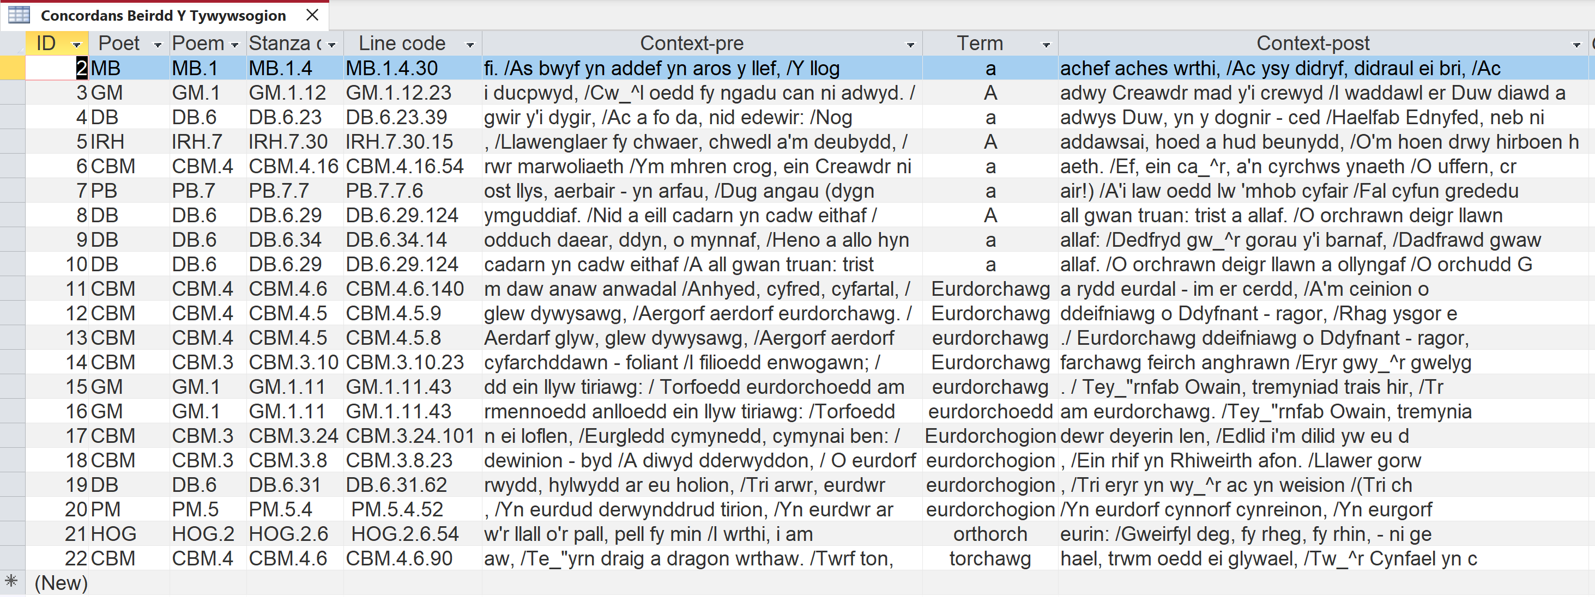
Figure 1: Sample of MS Access database for CBYT
The identifying information was converted in a way that would allow a researcher to sort by stanza or line without this showing results for every stanza and line of every poem and poet.
If such a database were to be built out to contain the entire CBYT data, then it could be hosted online. However, this would be incredibly time consuming; a full database for the CBYT file would require extensive manual copying and pasting, coding, or a program specially written to lift the information and transfer it. In the end, it was better to explore what can be automatically generated.
2. CBYT into NVIVO
Importing the whole CBYT file into NVIVO actually crashed the machine used for this project. This is an important consideration for future Digital Humanities work where large amounts of data are handled. Therefore a sample of the file was instead imported so as to annotate and demonstrate just how complex it would be to code the identifying information, let alone the concordances themselves.
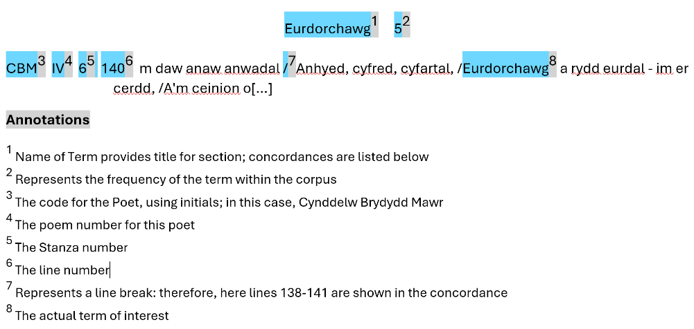
Figure 2: annotated concordance
To go through either the entire CBYT or even the source file and code everything would take far too much time. Nonetheless, there might be some value in taking a word at a time and creating a separate file for each (or clusters of related words; this, however, relies on the discrimination of the researcher) in order to demonstrate some of the value of NVIVO in further analysis, though this does not solve the problem of identifying information forming part of the text to be analysed/adding this to the stop-words list.
As a test we have used terms related to the torque, the neck ring often associated with the ancient Celts and which appears as a literary motif in medieval Welsh literature, often in the epithet eurdorchawg/og/ion (‘gold-torqued warrior/s’).
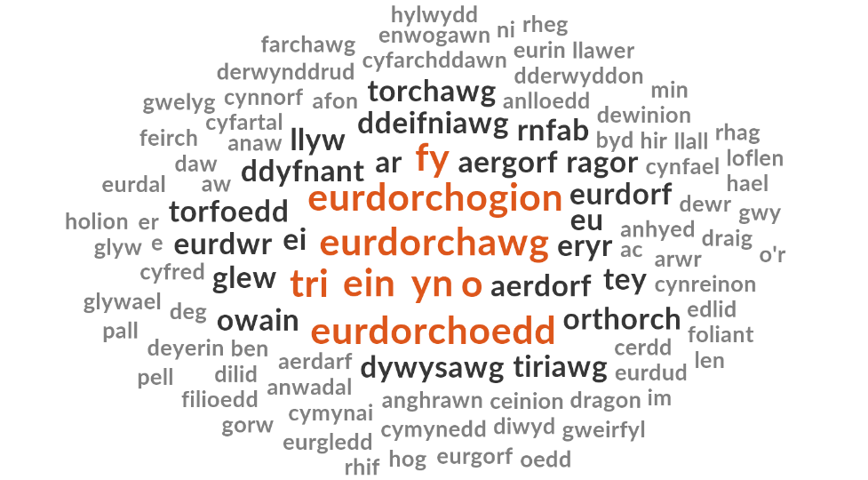
Figure 3: word cloud from NVIVO using sample of variants of the term ‘torch’ (Torque).
At first glance, the word cloud shows some interesting clustering of terms that co-occur with torque-terms. Indeed, this visual analysis of a fairly limited set of concordances gives not only insight into how the terms were connected to others conceptually, but also how they were used in the strict metre of medieval Welsh cynghanedd. Even the prepositions are of value here: terms like fy (my) and ein (our) suggest that the poet and by extension his audience felt personal or familiar connection with the subject. Terms related to the number three appear frequently; this suggests a link between the concept of gold-torque wearers and the prince’s war-band (Teulu), typically represented as three hundred mounted warriors. Other words demonstrate the internal correspondence of Welsh cynghanedd. Ddeifniawg obviously provides internal rhyme in a line containing eurdorchawg, as do eurdorf and torfoedd with eur/dorch terms more broadly (although the word cloud cannot confirm this; we have to look to the original concordances to verify). This is, however, such a small sample that no great conclusions can be drawn on the use of language; but by building up the number of files in the NVIVO project this might become possible.
3. Uploading CBYT file to Voyant
The CBYT file was uploaded to Voyant. The word-cloud below shows the complexity of working with such an approach, giving a sense of the sheer number of stop-words one would have to add to the list before any notable patterns begin to emerge.
Nonetheless, two things stand out once we disregard prepositions and conjunctions. These are not necessarily easily gleaned from a manual reading of the CBYT file.
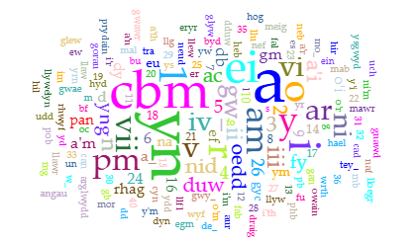
Figure 4: Voyant Word Cloud from full CBYT.
Firstly, the initials cbm appear to be the most frequently occurring term; this is the identifying code for the poet Cynddelw Brydydd Mawr, and this is therefore an excellent visual verification of the fact that he is the most prolific of the Beirdd Y Tywysogion (at least, in the extant sources), with far more attested material than any other.
Secondly, it would appear that the most frequently occurring term within the poetry (again, after the usual stop-words) is Duw (God). This again provides a potential insight into the poetry: even where God was not the subject of the poems, it might have been customary to open poems with a note of praise to God, and to invoke God in praising the qualities and behaviour of princely patrons. This same information, however, could be extracted from using the source file rather than the CBYT; moreover this would avoid the repetition and over-representation that is a problem with using the concordances as a primary source.
Using the Source File.
For the next tests a new, mini-corpus of 12 separate plain text files of the individual poems of Dafydd Benfras (DB) were created allowing some of the research questions suggested earlier to be explored; namely, whether poets use certain terms more than others (and what that might tell us) and what words are used with each other to create certain meanings.
1. Analysis of Dafydd Benfras Corpus with NVIVO
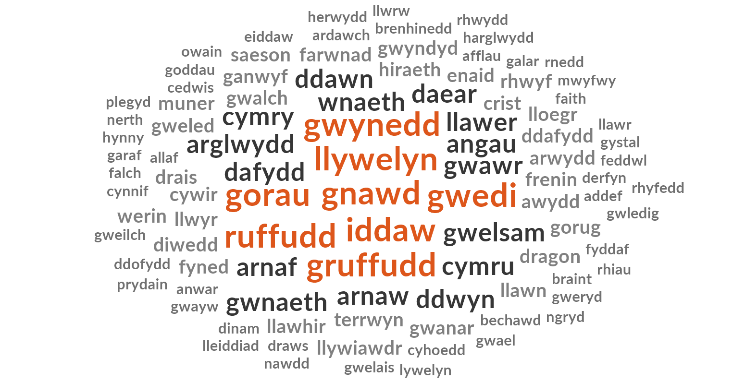
Figure 5: NVIVO Word-cloud for Dafydd Benfras Corpus.
One question that is difficult to explore manually with the CBYT file (though not impossible), but for which NVIVO is invaluable (especially when each poem is a separate file) is the distribution of frequently occurring terms. Here the results show that Gwynedd, one of the most frequent words used (see figure 5.) seems quite distributed across Benfras’ work, appearing only once or twice in each of 7 of the 12 poems/source files, as shown below.
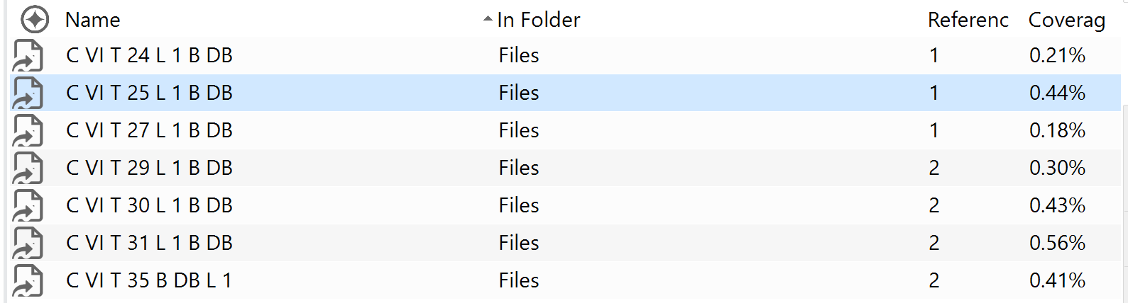
Figure 6: NVIVO Text Search Query results for ‘Gwynedd’
Because no other locations appear to occur prominently, this strongly suggests that Benfras was a poet of the court in Gwynedd. We can also see from figure 5 that the name Llywelyn concurs relatively frequently, which suggests close association with a Prince or Princes of that name. The two most prominent Llywelyns (the Great, and the Last) were both rulers of Gwynedd, and indeed Benfras’ biographic information confirms he wrote in praise and eulogy of both. This demonstrates the value of data analysis in discovering these sorts of insights for those who might not have such historical and biographical knowledge already, for example students.
It is possible to represent a sub-set of concordances slightly differently; through a word-tree. It provides quite an engaging visual representation of concordances for a word (in this case Gwynedd, as shown below), although because it orders each before/after context by a type of frequency (here, placing each time it occurs before/after a punctuation mark higher than where it appears mid-sentence), it is less useful for seeing each complete context.
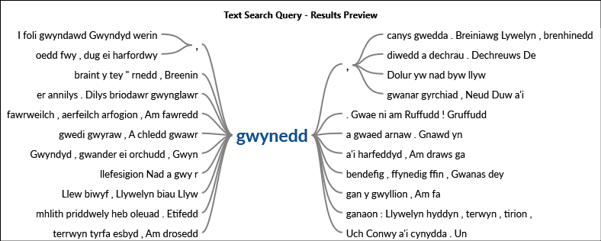
Figure 7: NVIVO word tree for the search query ‘Gwynedd’
This is still of potential use, since in showing how often terms appear in various parts of a line/sentence, insight may be possible into their poetic value, how they are used in rhyme/correspondence and so on.
2. Analysis of Dafydd Benfras Corpus with Voyant (see footnotes for link)
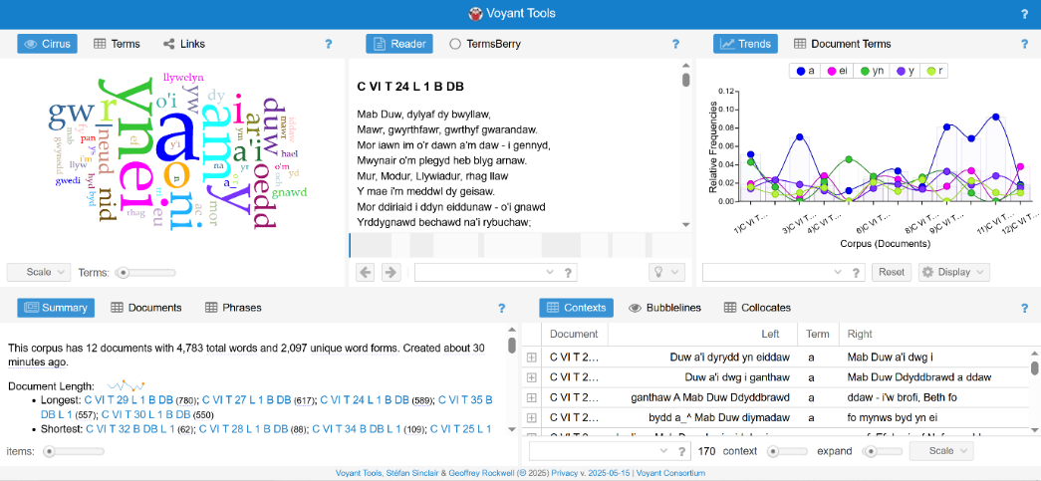
Figure 8: whole project view for Voyant – Dafydd Benfras corpus.
Uploading the Dafydd Benfras corpus to Voyant allows for extensive and interesting analysis. It generates a new set of concordances along with word clouds, summarised analysis, distribution of terms and a viewer panel for the poems. This is crucial because it allows for concordances to be viewed alongside the poems in which they appear in the same plane, for example.
Voyant is far from perfect; it can slow down when processing several commands subsequently (at least with the hardware and public Wi-Fi used when completing this project). It therefore needed to be refreshed after each major test.
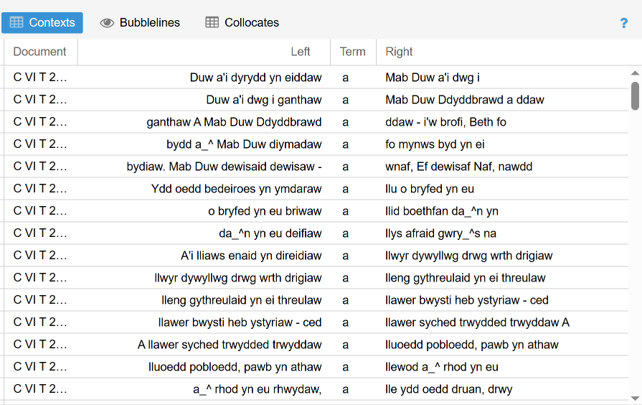
Figure 9: concordances generated by Voyant.
As shown above, the concordances (here called ‘contexts’) are laid out much like in CBYT, although they do not provide the stanzas and lines in which terms appear. This information in CBYT serves to enable a researcher to look up the relevant poem, stanza and line in the printed edition of the Beirdd y Tywysogion; this is less necessary here, because Voyant allows each concordance to be explored further, including by bringing up the poem in which it appears in another panel to view simultaneously with the stanza and line highlighted for further ease. This reduces the need for this information in the concordances themselves. These concordances unfortunately do not show line breaks, identified with forward slashes in CBYT. Perhaps this can be rectified with a command, but this requires further knowledge and practice with the platform.
It is possible to export these concordances into a new offline document.
As with NVIVO, we can analyse the distribution of terms across the corpus. Shown below is the relative frequency distribution of the name Llywelyn. This demonstrates that it is spread fairly evenly across Benfras’ poems, suggesting he is the key Prince of focus across his work.
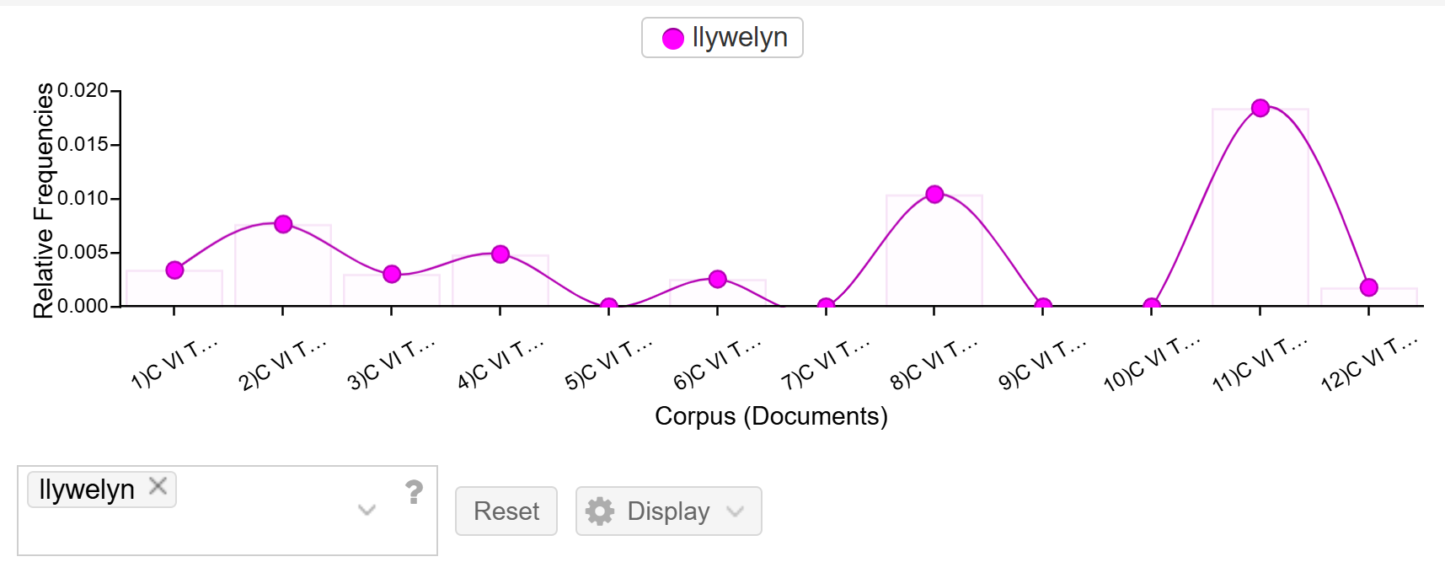
Figure 10: Distribution/relative frequencies graph for the term ‘Llywelyn.’
The spikes in the graph do not correspond to the most occurrences of the term but rather the highest ratio of occurrences in relation to the length of the poem. So where we see the largest spike at Poem 11 above, this corresponds to two occurrences of the term in one of the shorter poems (as can be seen in the Documents Summary – figure 11 – below). This suggests, perhaps, that in this poem Llywelyn is even more prominent, and it surely would have been more impactful when performed orally to hear the name twice in a relatively short period of time.
More significantly, using these particular tools in tandem with concordances allows us to do what cannot easily be done with the concordances alone, as noted earlier by Mahlberg et al; that is, to identify (or at least hypothesise) where certain terms are also the main subject of their text.
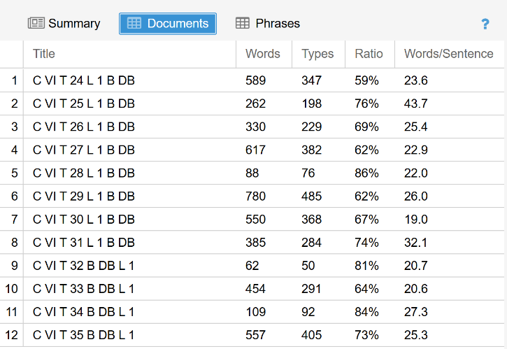
Figure 11: Documents summary.
Overall the documents summary is a little less useful, as it is difficult to know if Voyant recognises the sentence endings in Welsh poetry with a high degree of accuracy. Though punctuation and upper/lower cases have been added or standardised in the editing, it cannot be known for sure if this information is accurate without manually counting a representative sample. However, the number of words per poem is an interesting at-a-glance feature and might be of use to some researchers.
More crucial to our research questions are the ‘collocates.’ Here they can show us at a glance what key words are most frequently used in proximity with each other.
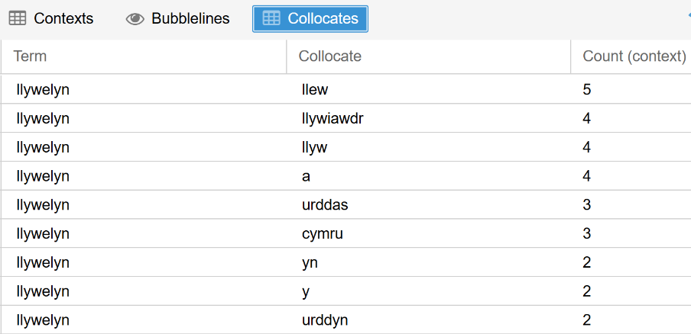
Figure 12: Collocates for the term ‘Llywelyn.’
As we can see above, the personal name Llywelyn most frequently collocates with the term Llew (Lion), suggesting the Llywelyn of focus is indeed Ein Llew Olaf (Llywelyn the last), although Llew could have also been used as a more general epithet for multiple Princes. We can also see a high frequency of collocation with the term llywiawdr (leader/ruler) and llyw (Geiriadur Prifysgol Cymru suggests meanings for this including ‘rudder,’ ‘stern’ [as in, of a ship], and ‘master handle of a plough’). These highlight a focus on the leadership qualities of a ruler in Praise Poetry. These terms also have strong poetic correspondence with the name Llywelyn, both with the ‘ll’ ‘w’ and ‘yw’ sounds; this correspondence between the name and the epithets arguably fuse these qualities to the name (and therefore the person) of Llywelyn, almost making them synonymous, and is a powerful poetic flourish. Additionally, while it did not seem possible to remove stop-words from this view, even these might assist someone looking at metre or cynghanedd more broadly, using the expanded view (as seen below) to see which side of a conjunction key words fall, for example.
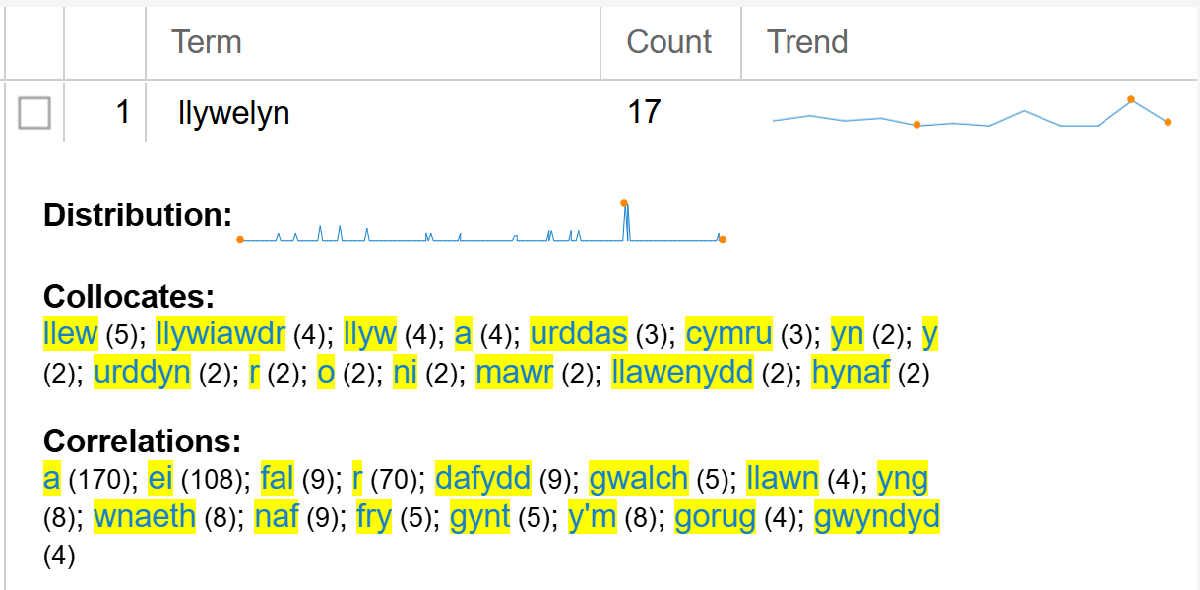
Figure 13: Expanded view for the term ‘Llywelyn.’
Concluding Comments
Ultimately, short of writing a programme to identify and sort the information contained within the CBYT and convert it into a database; or manually populating a database by copying and pasting the information across (and having to establish how to represent the identifying information), further digitisation of the CBYT file itself is difficult and has limited uses. It is important to remember that the CBYT like other concordances is the outcome of a programme that has already analysed its source corpus. Therefore, treating CBYT like a primary source for further analysis was bound to create difficulties and errors, as we have seen. While the aim of faithfully adhering to Ann Parry Owen’s work, working to allow it to be used in new ways, was a reasonable one, the best results have indeed come – at least relating to the interests of this project – through analysing the same source file that she used to create the CBYT in the first place with new tools.
The readability and ordering of CBYT remains of higher quality than these new, automatically generated concordances (which may be mitigated with a more sophisticated knowledge of and approach to coding in order to set the alphabet order, for example), and it is reasonable to agree with Wynne when he argues that reading concordances without bias is more worthwhile; therefore the plain text CBYT remains a definitive resource, despite the navigability of those produced on more dynamic platforms. Additionally, it is frustrating not to be able to produce the same social networks or cluster analyses on NVIVO or Voyant that are possible with material in other languages (they cannot read Welsh). Nonetheless, these tools do demonstrate how it is possible to identify relationships between terms via collocations and word-trees. The collocations in particular provide a potentially genuinely new visual representation of the corpus (or at least the small part of it used in this limited test project). It would be most fruitful to continue to convert the source file into individual poem files, each named in a way that identifies poet and poem (and perhaps information such as manuscript references?) and create a full Voyant project that can be used by anyone.
Bibliography
Primary Sources:
Owen, A.P., Concordans Barddoniaeth Beirdd y Tywysogion / Concordance of the Poets of the Princes Poetry (this version 2001): <https://www.academia.edu/12504625/Concordans_Barddoniaeth_Beirdd_y_Tywysogion_Concordance_of_the_Poets_of_the_Princes_Poetry?sm=b> [Accessed 12/3/25].
Owen, A.P., Source File for Concordans Barddoniaeth Beirdd y Tywysogion, unpublished.
Secondary Literature:
Farrington, M., Thompson, C., and Perrings, L., ‘A Complete Concordance to the Poems of John Donne,’ DigitalDonne: the Online Variorum: <https://donnevariorum.dh.tamu.edu/toolsandresources/poems-concordance/> [Accessed 12/4/25].
Jones, N.A. and Owen, A.P. (eds.), Gwaith Cynddelw Brydydd Mawr II (Cardiff: University of Wales Press, 1995). Online at Wiley Online Library: <https://onlinelibrary.wiley.com/doi/abs/10.1002/9781118396957.wbemlb421?msockid=25db97b42a606589296686d32b1f640c> [Accessed 20/5/25].
Lamy, M.N., Jørgen, H., Mortensen, K. and Davies, G., (introduction), Information and Communications Technology for Languages Teachers Module 2.4: Using concordance programs in the Modern Foreign Languages classroom, ICT4LT Website: <http://www.ict4lt.org/en/en_mod2-4.htm> [accessed 20/4/25].
Mahlberg, M., Stockwell, P., de Joode, J., Smith, C. and O'Donnell, M.B., ‘CLiC Dickens: novel uses of concordances for the integration of corpus stylistics and cognitive poetics,’ in Corpora Vol 11 No. 3 (Edinburgh University Press, 2017) <https://www.euppublishing.com/doi/10.3366/cor.2016.0102> [accessed 12/05/25].
Parry, T., ‘Dafydd Benfras,’ Dictionary of Welsh Biography: <https://biography.wales/article/s-DAFY-BEN-1230> [Accessed 20/5/25].
Poser, B., (formerly of MIT), Indices and Concordances <https://www.billposer.org/Linguistics/Computation/LectureNotes/Concordances.html> [accessed 03/04/25].
Wynne, M., ‘Searching and Concordancing,’ in Merja Kytö & Anke Lüdeling (eds.), Handbook of Corpus Linguistics (Mouton de Gruyter, 2008), pp. 706–737. Pre-published online version: <https://llds.ling-phil.ox.ac.uk/guides/searching/#:~:text=A%20concordance%20is%20a%20listing,with%20the%20words%20surrounding%20it.> [Accessed 07/05/25].
Young, S.J., Making and using concordances, Dr Sarah J. Young website: <https://sarahjyoung.com/site/2010/02/27/making-and-using-concordances/> [accessed 24/4/25].
Online learning/technical guides:
‘Analysing Poems Using Online Tools - Concordancing,’ tutorial at The First World War Poetry Digital Archive, University of Oxford: <https://war.web.ox.ac.uk/concordancing> [accessed 02/05/25].
‘Analysing Poems Using Online Tools – Co-occurrences,’ tutorial at The First World War Poetry Digital Archive, University of Oxford: <https://war.web.ox.ac.uk/co-occurences> [Accessed 03/05/25].
Build an Access database to share on the Web, Microsoft Support: <https://support.microsoft.com/en-us/office/build-an-access-database-to-share-on-the-web-cca08e35-8e51-45ce-9269-8942b0deab26> [Accessed 13/5/25].
Create a database, Microsoft Learn: < https://learn.microsoft.com/en-us/sql/relational-databases/databases/create-a-database?view=sql-server-ver16> [Accessed 30/04/25].
Other:
Academic Self-Publishing – how, why, Podcast with Prof. Ann Parry Owen, Dr Daniel Reed and Dr Adam Chapman, Institute of Historical Research (recorded 23 July 2024): <https://www.history.ac.uk/podcasts/academic-self-publishing-how-why> [Accessed 30/4/25].
Correspondence with Prof. Ann Parry Owen (29/4/25).
Geiriadur Prifysgol Cymru: <https://geiriadur.ac.uk/gpc/gpc.html>

Owen, A.P., Concordans Barddoniaeth Beirdd y Tywysogion / Concordance of the Poets of the Princes Poetry (this version 2001): <https://www.academia.edu/12504625/Concordans_Barddoniaeth_Beirdd_y_Tywysogion_Concordance_of_the_Poets_of_the_Princes_Poetry?sm=b> [Accessed 12/3/25].
Marie-Noëlle Lamy, Hans Jørgen Klarskov Mortensen, and Graham Davies (introduction), Information and Communications Technology for Languages Teachers Module 2.4: Using concordance programs in the Modern Foreign Languages classroom, ICT4LT Website: <http://www.ict4lt.org/en/en_mod2-4.htm> [Accessed 20/4/25].
Michaela Mahlberg, Peter Stockwell, Johan de Joode, Catherine Smith, and Matthew Brook O'Donnell, ‘CLiC Dickens: novel uses of concordances for the integration of corpus stylistics and cognitive poetics,’ in Corpora Vol 11 No. 3 (Edinburgh University Press, 2017) <https://www.euppublishing.com/doi/10.3366/cor.2016.0102> [Accessed 12/05/25].
Correspondence with Prof. Ann Parry Owen (29/4/25).
Correspondence with Prof. Ann Parry Owen (29/4/25).
Bill Poser (formerly of MIT), Indices and Concordances <https://www.billposer.org/Linguistics/Computation/LectureNotes/Concordances.html> [Accessed 03/04/25].
Martin Wynne, ‘Searching and Concordancing,’ in Merja Kytö & Anke Lüdeling (eds.), Handbook of Corpus Linguistics (Mouton de Gruyter, 2008), pp. 706–737. Pre-published online version: <https://llds.ling-phil.ox.ac.uk/guides/searching/#:~:text=A%20concordance%20is%20a%20listing,with%20the%20words%20surrounding%20it.> [Accessed 07/05/25].
University of Oxford, ‘Analysing Poems Using Online Tools – Co-occurrences,’ tutorial at The First World War Poetry Digital Archive <https://war.web.ox.ac.uk/co-occurences> [Accessed 03/05/25].
University of Oxford, ‘Analysing Poems Using Online Tools - Concordancing,’ tutorial at The First World War Poetry Digital Archive <https://war.web.ox.ac.uk/concordancing> [Accessed 02/05/25].
Michaela Mahlberg, Peter Stockwell, Johan de Joode, Catherine Smith, and Matthew Brook O'Donnell, ‘CLiC Dickens: novel uses of concordances for the integration of corpus stylistics and cognitive poetics,’ in Corpora Vol 11 No. 3 (Edinburgh University Press, 2017) <https://www.euppublishing.com/doi/10.3366/cor.2016.0102> [Accessed 12/05/25].
Marie-Noëlle Lamy, Hans Jørgen Klarskov Mortensen, and Graham Davies (introduction), Information and Communications Technology for Languages Teachers Module 2.4: Using concordance programs in the Modern Foreign Languages classroom, ICT4LT Website: <http://www.ict4lt.org/en/en_mod2-4.htm> [Accessed 20/4/25].
Poser, Bill (formerly of MIT), Indices and Concordances <https://www.billposer.org/Linguistics/Computation/LectureNotes/Concordances.html> [Accessed 03/04/25].
Sarah J Young, Making and using concordances, Dr Sarah J. Young website: <https://sarahjyoung.com/site/2010/02/27/making-and-using-concordances/> [Accessed 24/4/25].
Michaela Mahlberg, Peter Stockwell, Johan de Joode, Catherine Smith, and Matthew Brook O'Donnell, ‘CLiC Dickens: novel uses of concordances for the integration of corpus stylistics and cognitive poetics,’ in Corpora Vol 11 No. 3 (Edinburgh University Press, 2017) <https://www.euppublishing.com/doi/10.3366/cor.2016.0102> [Accessed 12/05/25].
Martin Wynne, ‘Searching and Concordancing,’ in Merja Kytö & Anke Lüdeling (eds.), Handbook of Corpus Linguistics (Mouton de Gruyter, 2008), pp. 706–737. Pre-published online version: <https://llds.ling-phil.ox.ac.uk/guides/searching/#:~:text=A%20concordance%20is%20a%20listing,with%20the%20words%20surrounding%20it.> [Accessed 07/05/25].
Martin Wynne, ‘Searching and Concordancing,’ https://llds.ling-phil.ox.ac.uk/guides/searching/#:~:text=A%20concordance%20is%20a%20listing,with%20the%20words%20surrounding%20it.
Mary Farrington, Carly Thompson and Laura Perrings, ‘A Complete Concordance to the Poems of John Donne,’ DigitalDonne: the Online Variorum: <https://donnevariorum.dh.tamu.edu/toolsandresources/poems-concordance/> [Accessed 12/4/25].
Create a database, Microsoft Learn: < https://learn.microsoft.com/en-us/sql/relational-databases/databases/create-a-database?view=sql-server-ver16> [Accessed 30/04/25].
It did not seem necessary to provide the project file for this, since the database approach was ultimately abandoned.
Build an Access database to share on the Web, Microsoft Support: <https://support.microsoft.com/en-us/office/build-an-access-database-to-share-on-the-web-cca08e35-8e51-45ce-9269-8942b0deab26> [Accessed 13/5/25].
Text annotated with NVIVO and exported to word.
Nerys Ann Jones, and Ann Parry Owen, (eds.) Gwaith Cynddelw Brydydd Mawr II (Cardiff: University of Wales Press, 1995). Online at Wiley Online Library: <https://onlinelibrary.wiley.com/doi/abs/10.1002/9781118396957.wbemlb421?msockid=25db97b42a606589296686d32b1f640c> [Accessed 20/5/25].
Thomas Parry, ‘Dafydd Benfras,’ Dictionary of Welsh Biography: <https://biography.wales/article/s-DAFY-BEN-1230> [Accessed 20/5/25].
Project online at: <https://voyant-tools.org/?corpus=1fbee256e1b50dca9508be124c6a660c>
Llyw, Geiriadur Prifysgol Cymru (1987) [Accessed 22/5/25].

