Abstract
Coursework 1: Research and Implementation
DDA School of Applied Computing
March 3rd 2026
NOSS2026 VIRTUALISED NETWORK
Technical Research Report
Terra Strickland
Student ID: 2316328
Contents
Introduction: 2
Section 1: Hypervisors 3
Section 2: IP Addressing 4
Section 3: Routing 6
Section 4: Network Services 7
Conclusion 8
References 9
Task 2: 10
Hypervisor Justification: 10
Technical Documentation: 10
Task 3 19
Technical Reflection 19
Personal Reflection 19

Introduction:
In this study, the fundamental technologies that would be necessary for a virtual network infrastructure setup for NOSS2026, an international corporation with offices in Swansea and London, would be examined. These areas include the selection of a hypervisor, IP addressing, routing, and network services.
The investigation would take into account both the current topology needs as well as those that would be needed in the future for expansion purposes. These areas would be thoroughly examined to identify the technologies necessary for each area, as well as their feasibility for implementation in the context of the SWANSEA.ACCA domain, utilizing existing academic literature for implementation purposes.

Section 1: Hypervisors
The most important difference between Type 1 and Type 2 hypervisors is the way they interact with the hardware layer. A Type 1 hypervisor interacts directly with the server hardware by directly accessing the hardware without the need for an operating system. This allows the hypervisor to access the hardware directly, such as the CPU, memory, and network interface cards. The Type 2 hypervisor has an operating system such as Windows or Linux and must go through the operating system to access the hardware resources. [1]
For the NOSS2026 topology, including its enhanced version with additional servers, a Type 1 hypervisor is preferable for use in a production network. Empirical evidence suggests that Type 1 hypervisors are more secure because they are not susceptible to having their host OS compromised.[2] This is important when running Active Directory for the SWANSEA.ACCA domain. If the host OS is compromised, it would mean that the entire environment has been compromised. In addition, Type 1 hypervisors are more efficient because they have 5% overhead as opposed to 15-20% for Type 2. [1]
The enhanced topology will eventually need to scale up with more domain controllers, VPN services, and certificate authorities. Type 1 hypervisors handle this expansion better because they don't compete with a host OS for resources. [3] They also provide better isolation between the Windows Server 2022 and Debian Server VMs.
However, for this coursework, using a Type 2 hypervisor such as VirtualBox is more practical due to hardware limitations and the learning environment. While not ideal for production, it still demonstrates the required network services and domain functionality.

Section 2: IP Addressing
When data moves from one computer to another on the internet, it gets broken into packets, and each packet includes source and destination IP addresses.[4] Routers read these IP addresses and forward packets between networks until they reach their destination [4]. Switches work at the local network level, using MAC addresses to deliver packets to the right device on the same network [5]. The IP address tells routers which network to send data to, while switches handle delivery within that network.
When data moves from one computer to another on the internet, it gets broken into packets, and each packet includes source and destination IP addresses. Routers read these IP addresses and forward packets between networks until they reach their destination [4]. Switches work at the local network level, using MAC addresses to deliver packets to the right device on the same network [5]. The IP address tells routers which network to send data to, while switches handle delivery within that network.
Figure 1: IPv4 Address Structure
192 | 168 | 10 | 1
Four octects (0-255 each) = 32 bits total
Subnetting divides networks into smaller segments for better organization and security [5]. For the NOSS2026 topology, a /24 network can be split into /26 subnets - one for Swansea (192.168.10.0/26) with 62 hosts and one for London (192.168.10.64/26) with 62 hosts (Figure 2). This prevents broadcast traffic from one office flooding the other and makes the network easier to manage [5].
Figure 2: Subnetting Example
Original Network: 192.168.10.0/24
Total usable addresses: 254 hosts
Swansea Subnet: 192.168.10.0/26
Addresses: 192.168.10.1 – 192.168.10.62 (62 Hosts)
London Subnet: 192.168.10.64/26
Addresses: 192.168.10.65 – 192.168.10.126 (62 Hosts)
Efficient IP addressing is important for scalability and troubleshooting [4]. Proper planning prevents address exhaustion and makes DHCP easier to configure. For example, reserving specific ranges for servers versus workstations helps organise the network logically and reduces conflicts when devices request addresses [5].

Figure 3: IPv6 Address Format
2001:0db8:85a3::8a2e:0370:7334
128-bit address (8groups of 16 bits in hexadecimal

Section 3: Routing
Routing protocols determine how routers learn about networks and decide the best path to forward packets. Static routing requires administrators to manually configure routes on each router, which gives complete control but becomes difficult to manage as networks grow. Dynamic routing protocols like RIP, OSPF, and EIGRP automatically share routing information between routers and adapt when network topology changes [7].
The main difference between static and dynamic routing is maintenance and scalability. Static routes don't change unless manually updated, making them predictable and secure for small, stable networks [8]. Dynamic routing handles changes automatically - if a link fails, routers recalculate paths and traffic flows through alternate routes without manual intervention [7]. However, dynamic protocols use bandwidth and CPU resources to exchange routing updates.
For the NOSS2026 topology connecting Swansea and London offices, the routing approach depends on network complexity. Since the Debian server acts as a DHCP relay, it needs to forward DHCP requests between subnets, which requires routing between the two sites [9]. If the topology remains simple with just two locations and predictable traffic patterns, static routing will work well. It's secure, uses no overhead, and administrators maintain full control [8].
However, if the enhanced topology adds more sites, VPN connections, or redundant links, dynamic routing becomes more practical [7]. Protocols like OSPF would automatically handle failover and load balancing without constant manual updates. The trade-off is between simplicity and automation - static routing for straightforward networks, dynamic routing for complex or growing infrastructures [9].

Section 4: Network Services
VPNs create encrypted tunnels between sites or remote users, ensuring data confidentiality across untrusted networks like the internet. For NOSS2026's Swansea/London topology, a site-to-site VPN would secure office traffic without requiring dedicated leased lines. Best practices include using strong encryption (AES-256), implementing split-tunnelling policies, and regularly updating VPN software to patch vulnerabilities [10].
DHCP automatically assigns IP addresses to devices, reducing manual configuration errors and simplifying network management. Best practices include configuring DHCP scopes with appropriate lease times, reserving static addresses for servers and network devices, and implementing DHCP relay agents for multi-subnet environments like NOSS2026's two-location setup [11]. This prevents broadcast traffic from crossing subnets while still centralizing DHCP management.
Active Directory Domain Services offers centralised authentication and policy management for Windows environments. The SWANSEA.ACCA domain allows administrators to manage user permissions, deploy software, and enforce security policies from one location. Best practices include implementing proper organisational unit structure, using Group Policy Objects for configuration management, and deploying multiple domain controllers for redundancy [12].
Certificate Authorities issue digital certificates that verify identity and enable encrypted communications. In an AD DS environment, Certificate Services supports features like smart card authentication, encrypted email, and SSL/TLS for internal web applications. Best practices include securing the CA server (preferably offline for root CAs), implementing certificate templates for different use cases, and establishing clear certificate lifecycle management including expiration monitoring and revocation procedures [10].

Conclusion
This research has examined the fundamental technologies required for implementing NOSS2026's virtualised network infrastructure. The analysis demonstrates that while Type 1 hypervisors offer superior performance and security for production environments, Type 2 solutions remain the ideal for development and educational purposes. Proper IP addressing schemes, particularly subnetting strategies, are essential for managing multi-site topologies and preventing network congestion.
Routing decisions should balance administrative control against scalability requirements, with static routing suitable for simple topologies and dynamic protocols better suited for complex or growing networks. The integration of VPN, DHCP, Active Directory Domain Services, and Certificate Authorities provides a comprehensive security and management framework for the SWANSEA.ACCA domain environment.
The enhanced topology's future requirements suggest that planning for scalability and security from the outset will reduce administrative overhead and improve network resilience as NOSS2026 expands its infrastructure.

References

[1] | P. S. a. L. C. A. Kumar, “Performance analysis of Type 1 and Type 2 hypervisors in mixed workload environments,” IEEE Trans. Cloud Comput., vol. 15, no. 1, pp. 112-128, january 2024.
[2] | W. Z. a. H. Li, “Security architecture of bare-metal hypervisors in enterprise Active Directory environments,” Cybersecurity Journal, vol. 11, no. 4, pp. 201-218, 2024.
[3] | J. Portnoy, “Virtualization essentials for Windows Server 2022 infrastructure,” Microsoft, 2023.
[4] | J. K. a. K. Ross, Computer Networking: A Top-Down Approach 8th edition, London: Pearson, 2023.
[5] | T. Lammle, CCNA Certification Study Guide: Routing and Switching, 5th edition, Indianapolis, IN: Sybex, 2023.
[6] | S. Hagen, IPv6 Essentials: Integrating IPv6 into Your Network, 3rd edition, Sebastopol, CA: O'Reilly Media, 2024.
[7] | W. Odom, CCNA 200-301 Official Cert Guide: Routing and Switching, Indianapolis, IN: Cisco Press, 2023.
[8] | R. W. a. D. Slice, “Static vs dynamic routing: Performance and security trade-offs in enterprise networks,” Network System Management, vol. 31, no. 2, pp. 45-67, 2024.
[9] | K. W. a. S. Wilkins, “DHCP relay configuration and routing requirements in multi-site environments,” Cisco Networking Academy, vol. 12, no. 3, pp. 89-104, 2023.
[10] | M. D. a. I. Foulds, Network Security Essentials: Applications and Standards, 7th edition, London: Pearson, 2024.
[11] | J. M. a. A. Zacker, “DHCP server configuration and best practices for Windows Server environments,” in Exam Ref 70-741: Networking with Windows Server 2022, Redmond, WA, Microsoft, 2023, pp. 156-189.
[12] | B. S. a. V. Vukovic, Active Directory Domain Services Implementation and Administration, 2nd edition, Birmingham, UK: Packt Publishing, 2024.

Task 2:

Hypervisor Justification:
As seen by the research conducted in Task 1, the most viable and effective option given the academic context was a Type 2 Hypervisor. In a true production environment, a Type 1 Hypervisor such as VMware or Microsoft Hyper-V would be the ideal choice due to superior performance and direct hardware access. However, for the purpose of this assignment, it was more practical to use Oracle VirtualBox to deploy 4 separate VMs on a personal laptop. VirtualBox was chosen over other Type 2 solutions due to its support for multiple guest operating systems, its Internal Network feature enabling isolated network segments, and its ability to support the additional services required in Coursework 2 such as Active Directory and DHCP.

Technical Documentation:
S-DC Microsoft 2022 Server:
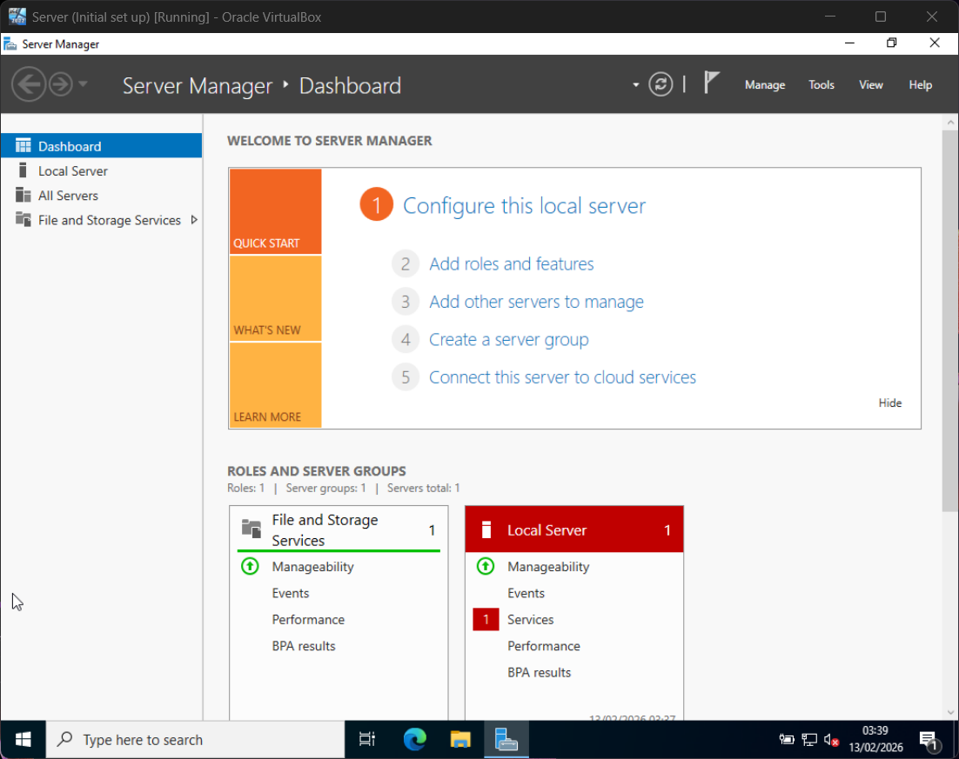
IP Address and Subnet added to LAN-A
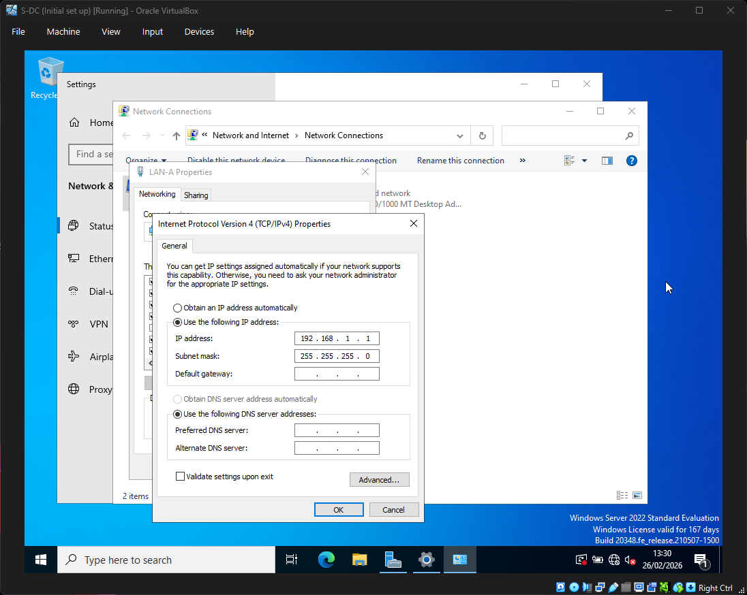

IP Address and Subnet added to WAN-Link
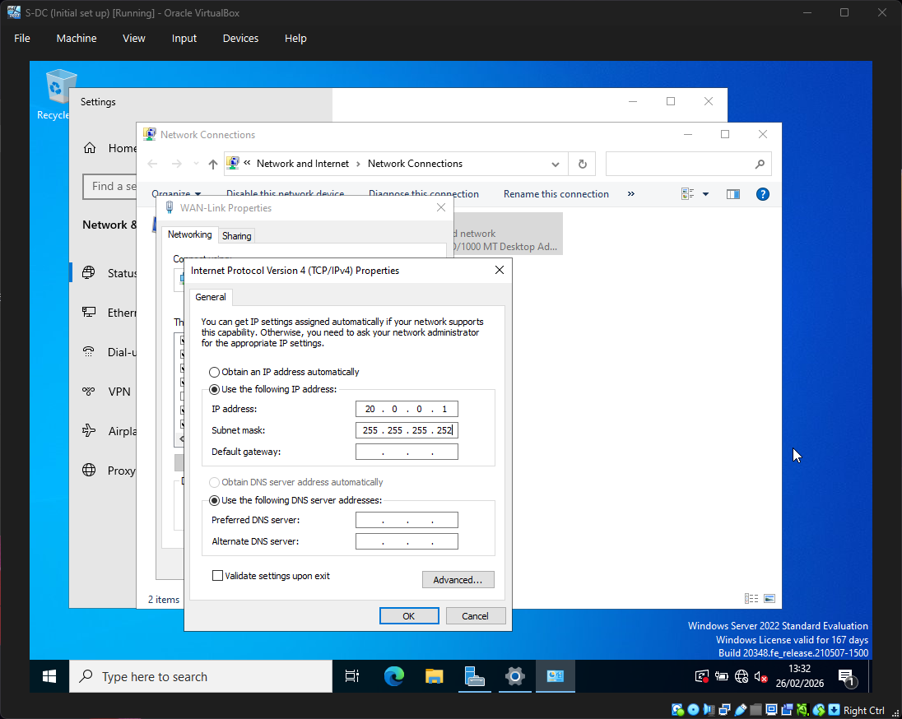
Ipconfig /all
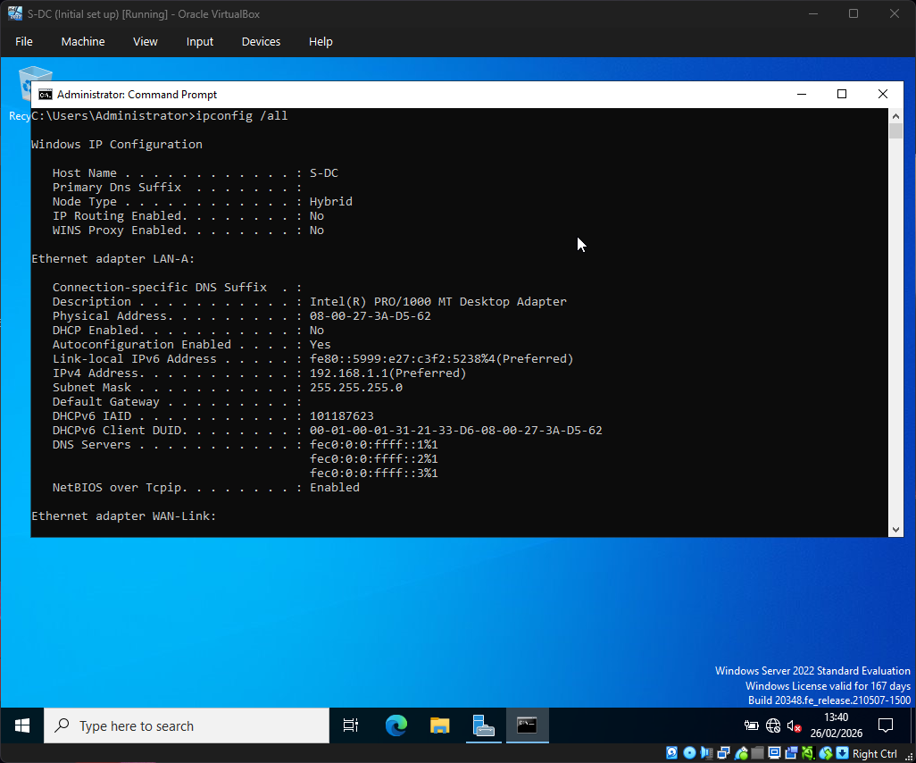
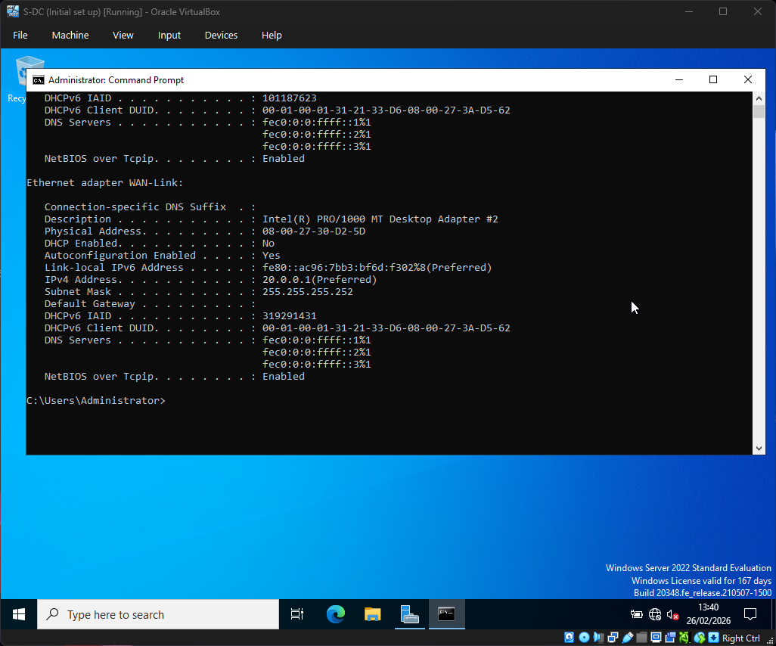

ClientS1:
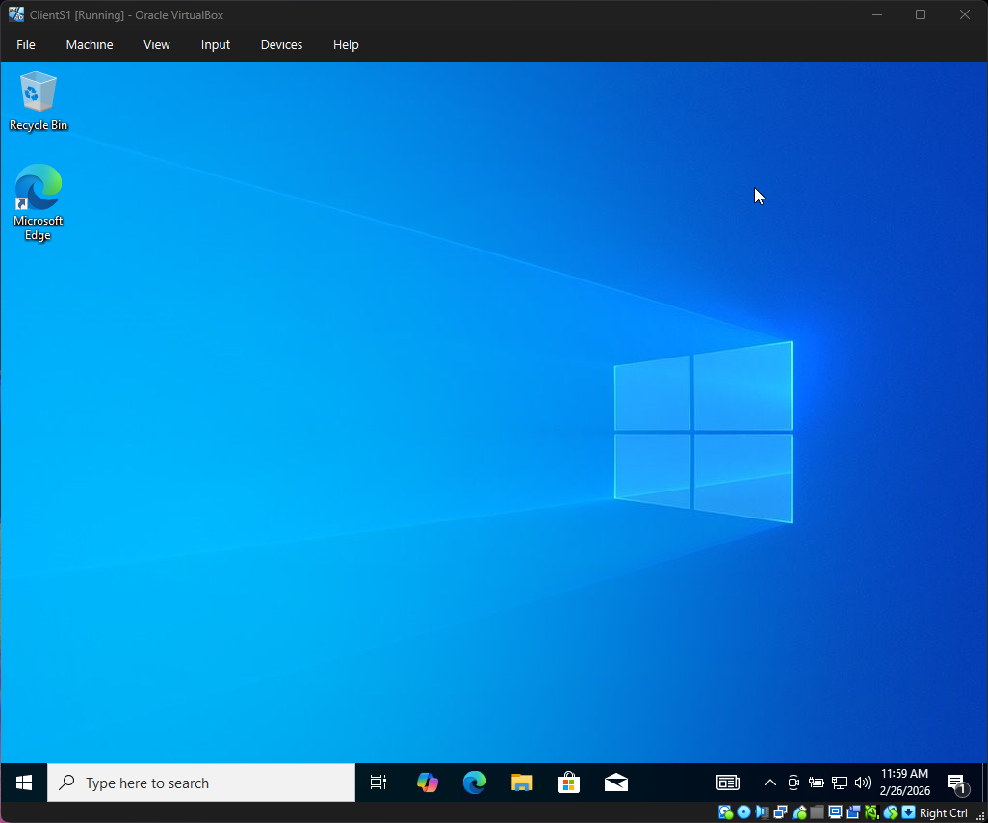

LAN-A Properties:
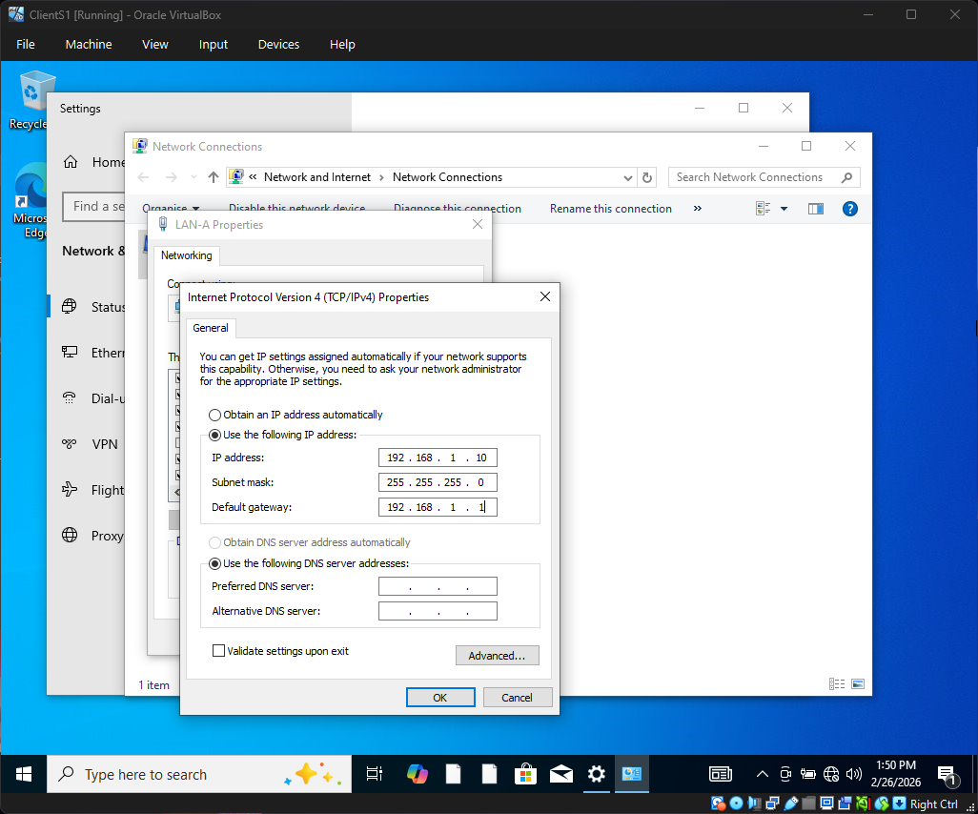
Ipconfig /all:
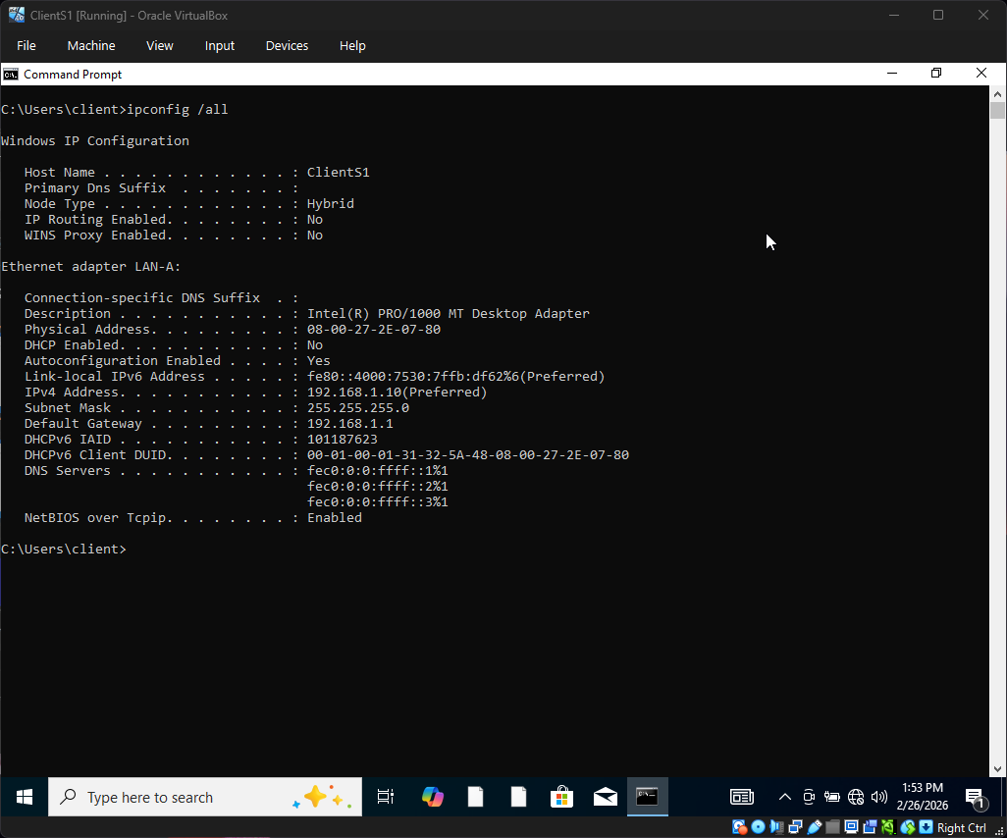

Ping test from ClientS1 S-DC
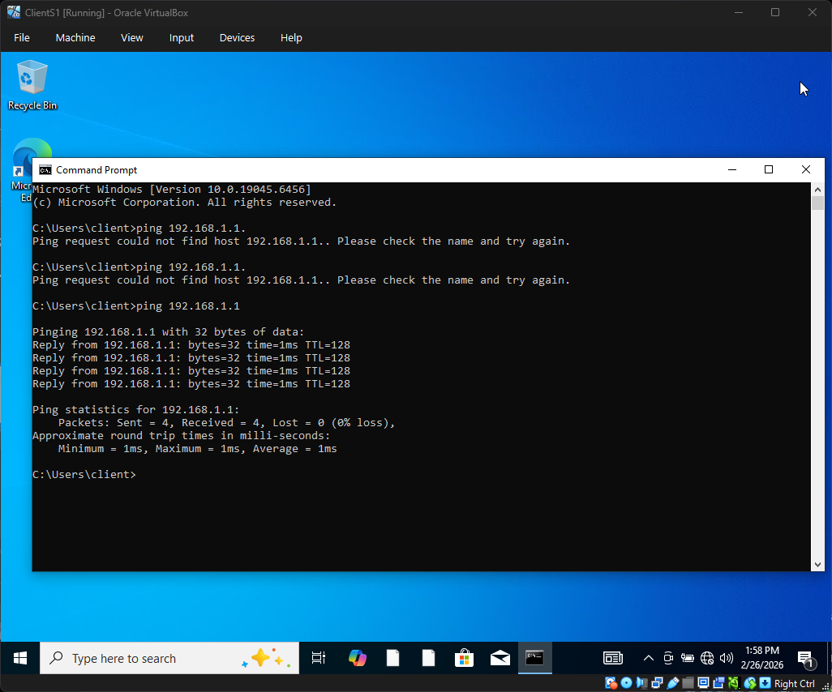

L-CD:
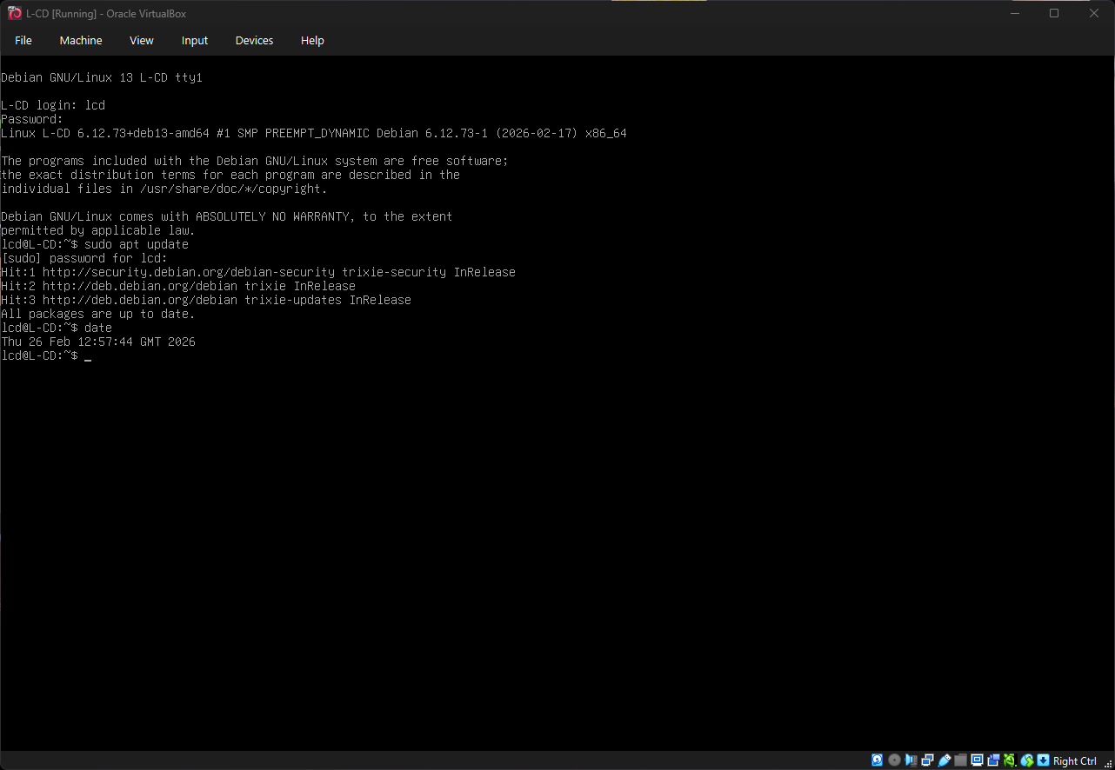

Configuring IP/Subnet
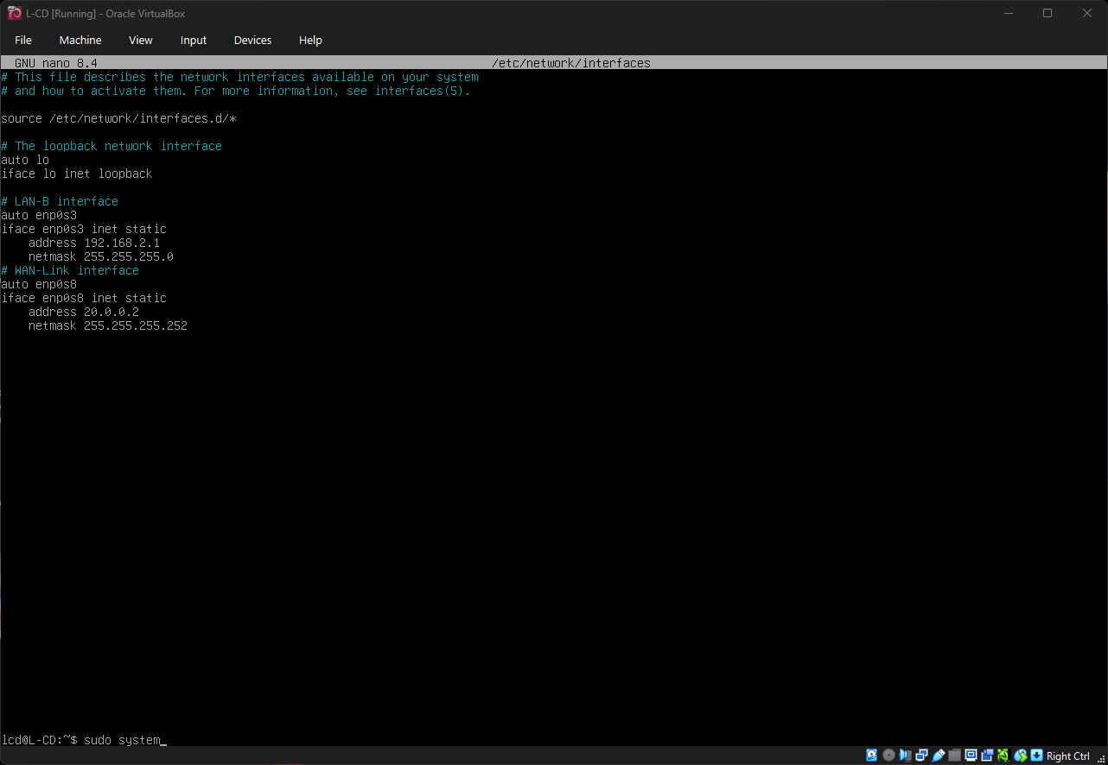
Ip addr show:
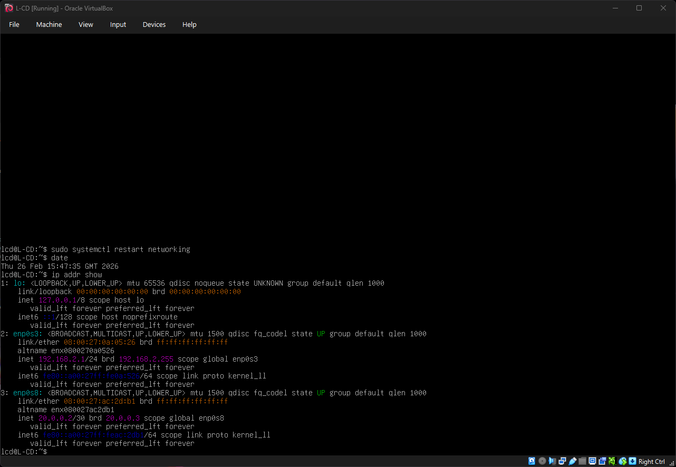
ClientL1:
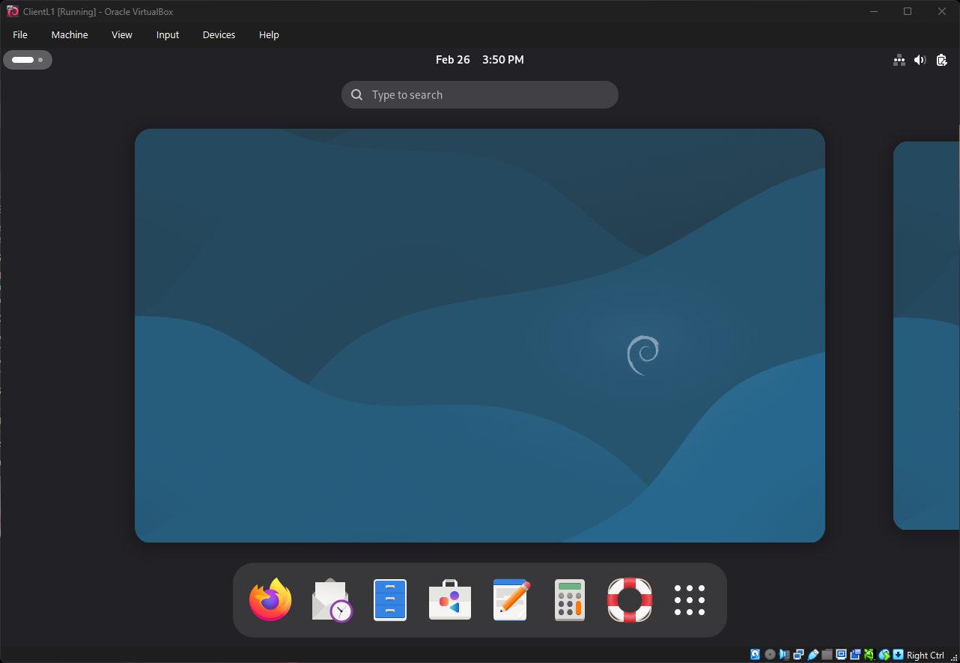
Network configuration:
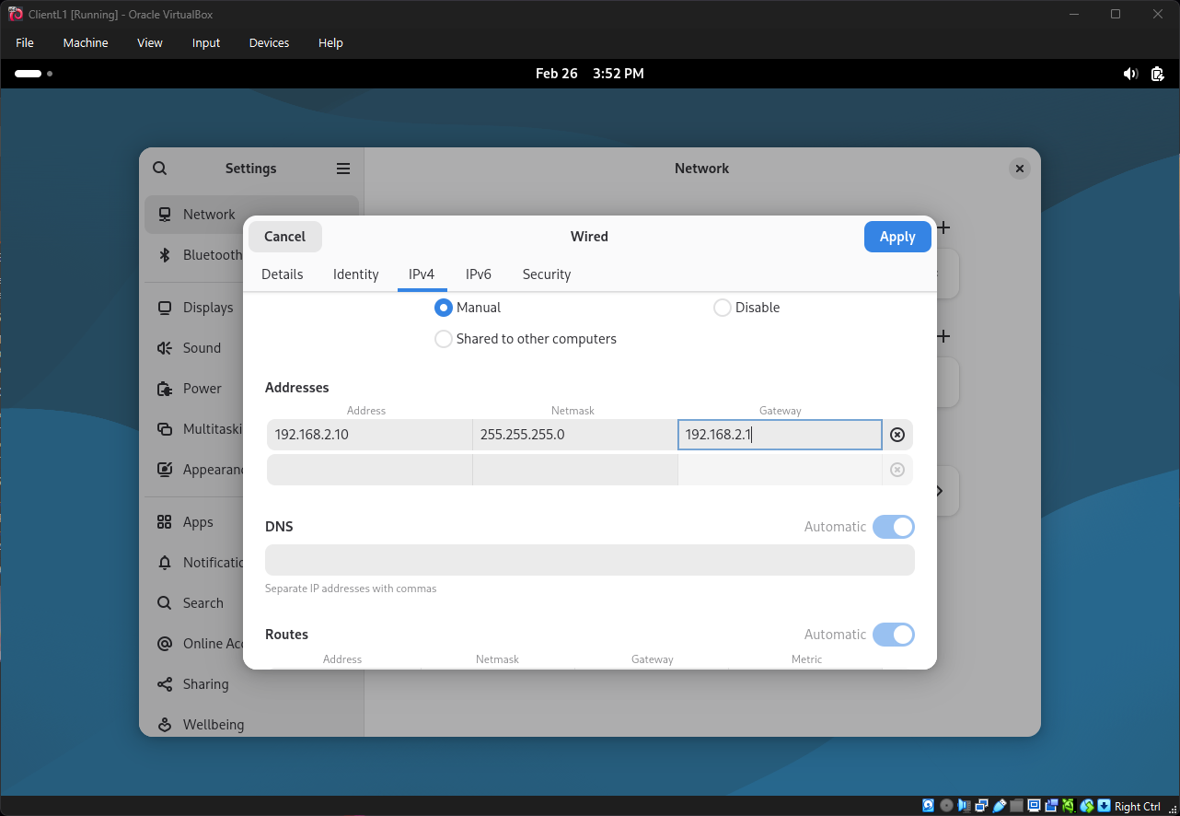
ip addr show:
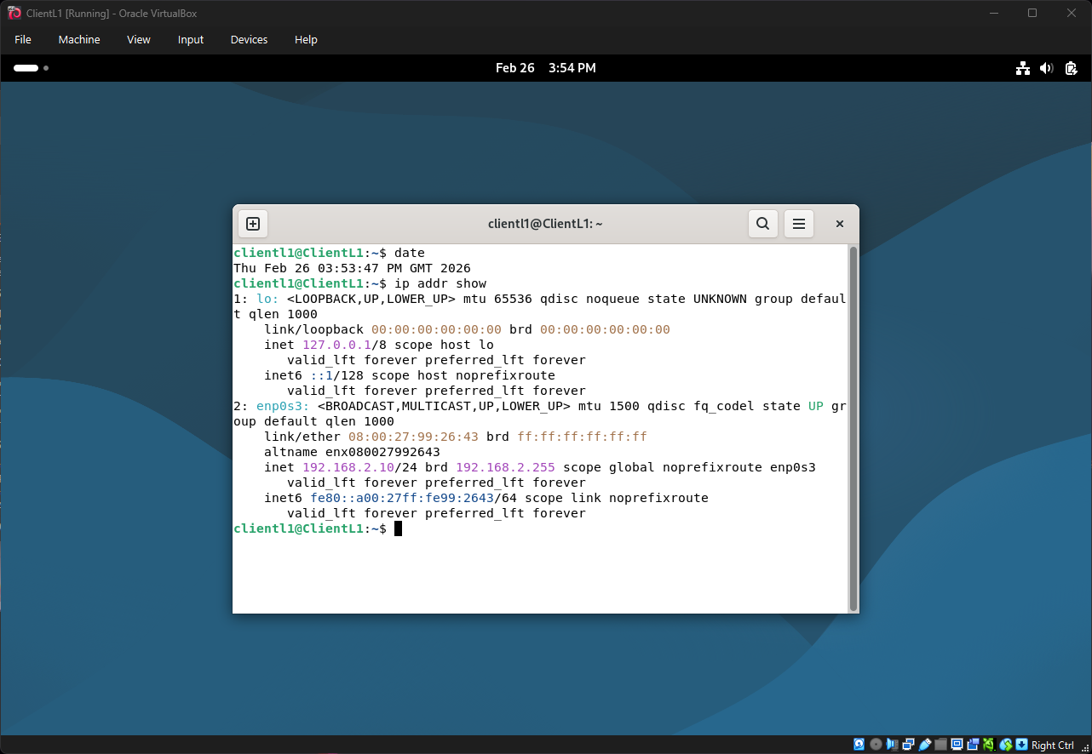
Ping from ClientL1L-CD
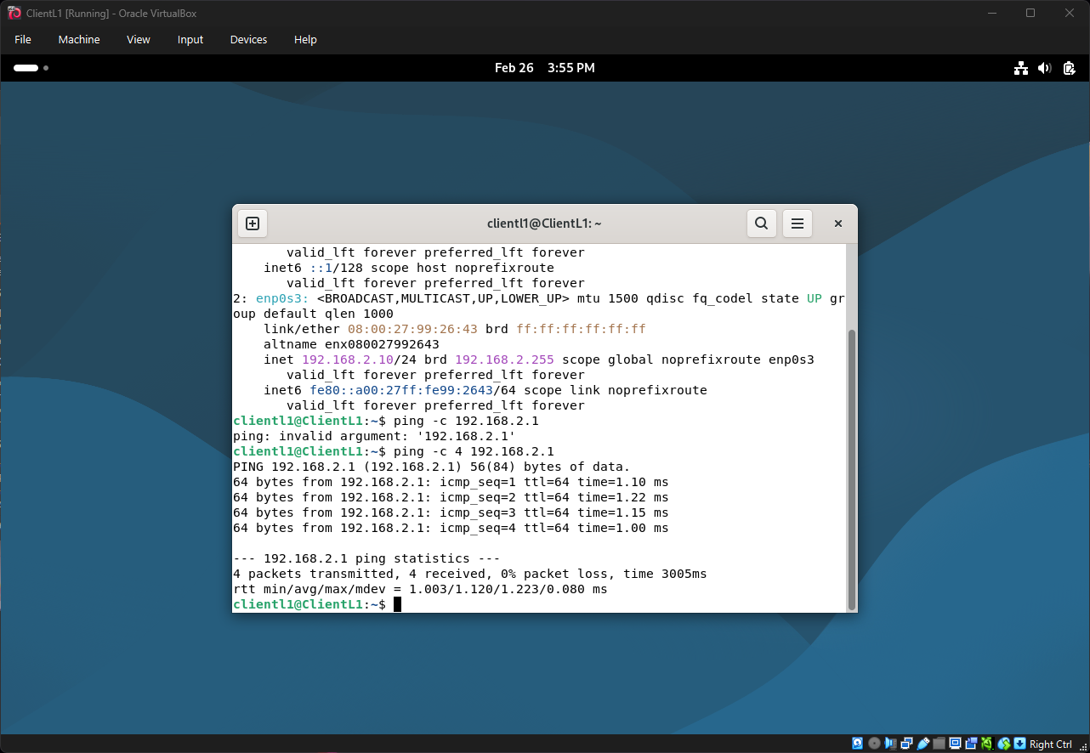
Failed Ping between ClientL1S-DC
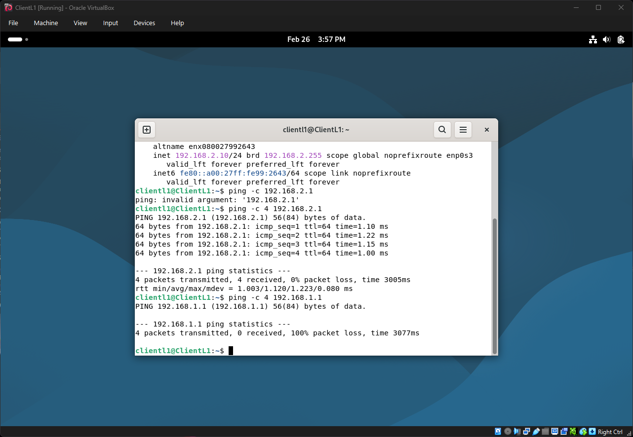

Task 3

Technical Reflection
During deployment several challenges were encountered. The initial Windows Server installation used Server Core rather than Desktop Experience, requiring a reinstall. VirtualBox's unattended installation feature produced COM registration errors, necessitating manual installation instead. On the Debian VMs, an accessibility screen reader (brltty) was inadvertently installed and required removal. A typographical error in the network interfaces configuration file caused initial connectivity issues, which was resolved through careful review and correction.

Personal Reflection
This assignment proved highly challenging, particularly the networking configuration aspects. Multiple VMs required rebuilding due to configuration errors, which was frustrating but ultimately a valuable learning experience. Networking remains a difficult concept to grasp intuitively, however completing the deployment and achieving successful connectivity results was rewarding. The experience gained will hopefully make Coursework 2 a smoother process.

