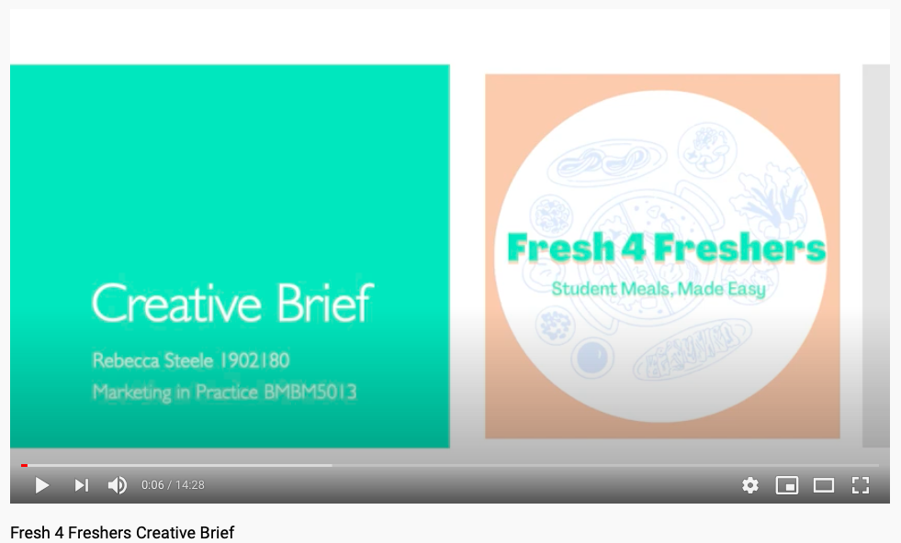

Assessment 1 – creative brief
Marketing in Practice BMBM5013
Rebecca Steele 1902180

Assignment 1: Creative brief for TV advertisement
Please provide the link to your Video Presentation in the box below:

https://youtu.be/pnUeXf_CE5A

Please provide a Reference list of all the sources used to support your Video Presentation in the box below:

Baker, C. (2021). Obesity Statistics. [online] House of Commons Library. Available at: https://commonslibrary.parliament.uk/research-briefings/sn03336/ [Accessed 15 Mar. 2021].
BBC News (2020). “Three quarters of UK does grocery shopping online.” [online] BBC News. Available at: https://www.bbc.co.uk/news/uk-wales-53840920 [Accessed 15 Mar. 2021].
Facilitate Magazine (2017). Global report shows students want healthier foods at UK universities. [online] Available at: https://www.facilitatemagazine.com/news/2017/09/11/global-report-shows-students-want-healthier-foods-uk-universities [Accessed 15 Mar. 2021].
Gousto (2021). Gousto. [online] Available at: https://www.gousto.co.uk/box-prices [Accessed 15 Mar. 2021].
HelloFresh (2021). Order Your Delicious Food Box | Healthy Meals | HelloFresh. [online] Available at: https://www.hellofresh.co.uk/plans?featured=:&mealsize=-&c=WM-WDREW&dis=communication_four&gclid=CjwKCAiAhbeCBhBcEiwAkv2cY-9aVbugBv9YGNJlRLAqSLm2ajrMd_yhI53u7GicFzhALTqdGt5GDBoCxlIQAvD_BwE&link_id=325202769 [Accessed 15 Mar. 2021].
Nus.org.uk (2018). New survey shows trends in student drinking @ NUS. [online] Available at: https://www.nus.org.uk/articles/new-survey-shows-trends-in-student-drinking [Accessed 13 Mar. 2021].
Nutrition.org.uk (2018). Students - British Nutrition Foundation. [online] Available at: https://www.nutrition.org.uk/healthyliving/lifestages/students.html [Accessed 15 Mar. 2021].
Palumbo, D. (2018). Student rents jump as accommodation goes upmarket. [online] BBC News. Available at: https://www.bbc.co.uk/news/business-46459694 [Accessed 15 Mar. 2021].
Simmonds, E. (2021). Which? reveals the cheapest supermarket of the year – Which? News. [online] Which? News. Available at: https://www.which.co.uk/news/2021/01/which-reveals-the-cheapest-supermarket-of-the-year/ [Accessed 15 Mar. 2021].
Study International (2017). 5 facts about British university students’ eating habits - Study International. [online] Available at: https://www.studyinternational.com/news/students-eating-habits/ [Accessed 13 Mar. 2021].
The Independent (2021). The Independent. [online] 12 Mar. Available at: https://www.independent.co.uk/extras/indybest/food-drink/subscription-boxes/best-recipe-boxes-a9409706.html [Accessed 13 Mar. 2021].
unidays.com (2021). HelloFresh 10% Off - UNiDAYS student discount March 2021. [online] Available at: https://www.myunidays.com/GB/en-GB/partners/hellofresh/view [Accessed 15 Mar. 2021].

‌

