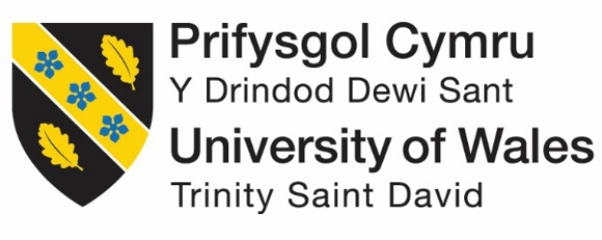

Investigation implementation and evaluation of up-to-date Social Media strategies for SMEs
by
Runa Bibi

Supervisor: Sue Maw
Second Marker: Beverley Holland

Project submitted as part of the requirements for the award of BSc (Hons) Business Information Systems

June 2020

DECLARATION

I, ............................................RUNA AMREEN BIBI………………………………… declare that I am the sole author of this Project; that all references cited have been consulted; that I have conducted all work of which this is a record, and that the finished work lies within the prescribed word limits.
This work has not previously been accepted as part of any other degree submission.


Signed : .............................................

Date : ......15/06/2020........................

FORM OF CONSENT

I ............................................RUNA AMREEN BIBI………………………………… hereby consent that my Project, submitted in candidature for the B.Sc.(Hons) Business Information Systems degree, if successful, may be made available for inter-library loan or photocopying (subject to the law of copyright), and that the title and abstract may be made available to outside organisations.

Signed : .............................................

Date : ........15/06/2020......................

Abstract
This project has set out to create an up-to-date best practice guide of social media marketing for SMEs. This is done through research of traditional and social media marketing, investigating social media strategies used by SMEs today, creating a survey to see how SMEs use social media and analysing SME social media pages. The methods to carry this out are a survey of local SMEs from Swansea and analysis of social media pages of an SME from each different sector that responded. Most SMEs have a social media presence but an unsuccessful social media strategy. Each sector has different types of posts and post times so the sector of an SME is important when choosing a social media strategy. SMEs must keep up-to-date with their social media and see how successful they are using selected metrics. The guide can be shared with SMEs in Swansea to see if it makes their social media strategies successful. Beyond this, SMEs from other localities may use the guide to see how it affects their social media strategy or if they need a different approach.

Table of Contents

1. Introduction 7
2. Research & Review of Literature 9
2.1 History of Marketing 9
2.2 Social Media Marketing 12
2.3 Case Studies of Social Media Marketing 16
3. Research Methodology 22
3.1 Survey Design 24
4. Research Analysis 29
4.1 Survey Results 29
4.2 Social Media Pages Analysis 36
4.3 SME Social Media Marketing Guide 52
5. Evaluation 56
6. Conclusions and Recommendations 58
6.1 Suggestions for further work 58
7. Reflection 59
8. References 60

Table of Figures
Figure 1 - 1930's Converse Ad 9
Figure 2 - 1970's Converse Ad 10
Figure 5 - 4 P's of Marketing 11
Figure 6 - Key Social Media Objectives 15
Figure 7 - Vision Express Twitter 17
Figure 8 - The Brand's Social Media Marketing Activities on its Facebook Brand-Page [55] 18
Figure 9 - The Brand's Social Media Marketing Activities on its Twitter Brand-Page [55] 19
Figure 10 - CareOne Debt Relief Services Webpage 20
Figure 11 - Pie Chart showing No. of SMEs in each sector 29
Figure 12 - Bar Chart showing No. of SMEs with marketing team/employee 30
Figure 13 - Bar Chart showing No. of SMEs with a social media presence 30
Figure 14 - Bar Chart showing Social Media Platforms used by SMEs 31
Figure 15 - Bar Chart showing No. of SMEs partaking in certain Social Media Activities 32
Figure 16 - Pie chart showing No. of times SMEs post to social media a week 32
Figure 17 - Pie Chart showing No. of SMEs who found their social media strategy successful 33
Figure 18 - Pie Chart showing the No. of SMEs that think social media is important for their company 34
Figure 19 - Word Cloud for Question 11 35
Figure 20 - Swansea Mind Facebook Page 36
Figure 21 - Swansea Mind Twitter Page 37
Figure 22 - Swansea Mind Instagram Post 37
Figure 23 - Pie Chart showing Types of Social Media Post made by 'Swansea Mind' on Facebook 39
Figure 24 - Pie Chart showing Types of Social Media Post made by 'Swansea Mind' on Twitter 40
Figure 25 - Vintage Bloom Facebook Page 41
Figure 26 - Vintage Bloom Instagram Page 42
Figure 27 - Pie Chart showing Types of Social Media Post made by 'Vintage Bloom' on Facebook 43
Figure 28 – Pie Chart showing Types of Social Media Post made by 'Vintage Bloom' on Instagram 44
Figure 29 - Langland's Brasserie Facebook Page 45
Figure 30 - Langland's Brasserie Twitter Page 46
Figure 31 - Pie Chart showing Types of Social Media Post made by 'Langland's Brasserie' on Facebook 47
Figure 32 – Pie Chart showing Types of Social Media Post made by 'Langland's Brasserie' on Twitter 48
Figure 33 - Pandora's Box Llanelli Facebook Page 49
Figure 34 – Pie Chart showing Types of Social Media Post made by 'Pandora's Box' on Facebook 50

1. Introduction
“Marketing is a philosophy of business that places the customer at the centre of the universe”
This definition of marketing as stated in Marketing Management and Strategy by Peter Doyle [1] helps to deduce that the key notion of marketing is to focus on the customer and find the best way to communicate with them. While traditional marketing works more on “selling” the business and is more static, modern day marketing allows for feedback and further outreach to a larger variety of customers that would not be possible without social media.
Social media marketing allows for businesses to create and share their own content to achieve their marketing goals [2] without always having to pay distributors to promote their material [3] and with Facebook having 2.41 billion monthly users after the second quarter of 2019 [4] and Twitter averaging 330 million monthly users as of the first quarter of 2019 [5] it has become almost vital for any business or enterprise of any size to utilise social media marketing as a tool and engage their consumer base.
Nevertheless, small and medium sized enterprises (SMEs) could find this difficult as they are likely to have a small or no marketing department and not a lot of time or budget available to commit to social media marketing [6]. Not having a presence online can be seriously detrimental, with the possibility of reaching over 2 billion people through Facebook ads [7], SMEs without an online presence are less likely to be known or heard about due to the barrage of posts people receive online daily, which can push SMEs to the background.
The aim of this project is to produce a best practice guide of social media marketing for small and medium enterprises. In order to achieve this aim I will:
- Research traditional and social media marketing

- Investigate social media strategies used by SMEs today

- Create a survey to see how SMEs use social media

- Analyse SME social media pages

- Write an up-to-date best practice guide on social media strategies for SMEs

The following chapters of this project will include research and review of available literature on traditional marketing and social media marketing including case studies for both bigger companies and SMEs. Research methodology, which will be comprised of a survey and research analysis of its results and implementation of social media strategies will also be included. The results will be evaluated and a best practice guide for social media strategies for small medium enterprises will be produced along with conclusions and recommendations for any further work.

Research & Review of Literature
This section will discuss the history of marketing including some vital marketing concepts, social media marketing and case studies of social media marketing.

2.1 History of Marketing
Throughout time, the definition of marketing has changed as the nature of marketing has reformed. In the 1930’s Converse defined marketing as relating to “getting goods and services from the hands of producers into the hands of ultimate consumers” [8] which puts emphasis on the act of selling the product. By 1967, Kotler said “Marketing is the analysing, organising, planning, and controlling of a firm’s customer-impinging resources, policies, and activities with a view satisfying the needs and wants of chosen customer groups at a profit” [9] which showed a shift in a simple selling to consumer action towards meeting the needs of the customer and not just the manufacturer.
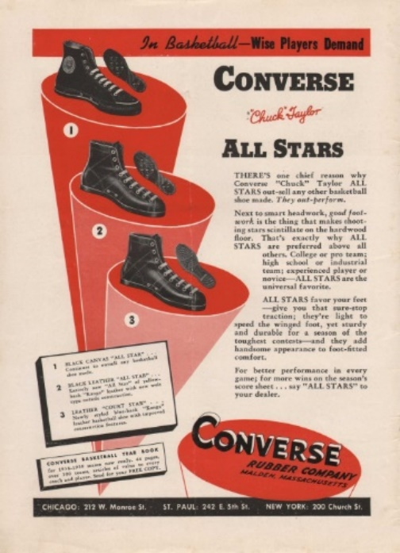
Figure 1 - 1930's Converse Ad [10]
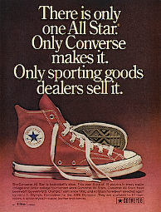
Figure 2 - 1970's Converse Ad [11]
While there is no clear single definition of marketing, The American Marketing Association (AMA) defined marketing in 2017 as “…the activity, set of institutions, and processes for creating, communicating, delivering, and exchanging offerings that have value for customers, clients, partners, and society at large” [12] which was approved by five scholars and is reviewed every three years. This shows that communication with the customer has become important in marketing and the advertisement itself needs to be of value to the customer.
Examples of traditional marketing include television, newspapers, radio and magazines [13]. This way of marketing only allows for a one-way line of communication to the customer and only maintains the audience’s attention for a short period of time [14]. With the increase of competition between companies brought the popularity of making your brand prevalent and meeting your consumer’s needs to the fullest [15] in order to do so. This was what made communication to the customer so important.
One traditional marketing framework is the Marketing Mix which was first brought forth by Neil Borden based on Culliton’s investigation of the mix of components used by marketers and whether certain combinations work better than others [16]. Riaz defined Marketing Mix as marketing tools used by a company to produce the “…desired response in the target market” [17]. It was made popular by McCarthy in 1960 who came up with the 4 P’s as part of the marketing mix [18]. The 4 P’s consist of price, promotion, place and product [19]. The product is said to be the most important element and is presented with advantages to the consumer for a price [20]. The price is quite simply the funds given by the customer to buy the product [21]. The placement of the product includes making it available to the customer at the right time and place and promotion involves sharing product information, imagery and persuasion [22].
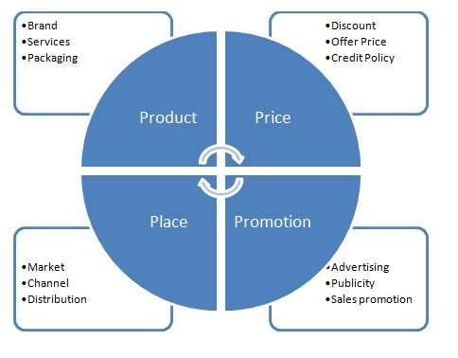
Figure 5 - 4 P's of Marketing [23]
The main reason many marketers accept the Marketing Mix is because of the wide exposure of the idea in introductory manuals on marketing in their college years wherein they accept it as the centre of their structure [24]. David Jobber also emphasises the strength of the 4 P’s is in its practicality and memorability for decisions in marketing and its use in business school for case study analysis [25].
While this form of marketing may have previously been effective, one 30 second advert from Procter and Gamble that would reach 80% of U.S women in 1960 on three television networks, would now have to show on 100 channels to reach the same goal [26]. Another example of a traditional marketing medium that is not as effective is the “door-to-door salesman”. Nowadays, people are less likely to want a sale this way because the product or service is not tailored to them specifically, but is simply a mass produced product that the salesperson wants to get as many sales as possible of [27]. Customers now want to feel treasured and buy the right products for them. They want to make their own decisions based on reliable information shared by a company and have the opportunity for two-way communication to have their thoughts and concerns shared. As the behaviour and needs of customers change, so to the way in which we market should change.

2.2 Social Media Marketing
As marketing progressed, despite widespread acceptance, many marketers argued that the 4 P’s are “obsolete”, and the elements need to be changed or new elements need to be added [28]. The need for a different combination of components may be necessary in other marketing areas, such as service marketing as the original 4 P’s were based on research on the manufacturing sector [29].
Booms and Bitner suggested a 7 P’s framework for the service marketing sector, which included the original 4 P’s and added a further three which are process, people and physical evidence [30]. They recognised that environmental factors i.e. the physical evidence are important in services when “influencing the quality perception” and included the service delivery (process) and the customers and personnel (people) [31]. Compared to the 4 P’s this framework is more detailed and a better standardisation model but it is more complicated and the three new elements are not as easily controlled [32].
This framework may not be relevant for social media marketing, and Gunelius [33] has suggested social media requires its own unique 7 P’s to provide the best results for a business. Her components are perception, predominance, progression, proof, prevalence, prominence and power [33]. Below is a table showing how to achieve each one.
7 P’s | Description
Perception | Meet the expectations of the audience and develop your brand [33]
Predominance | Focus on the target audience and evade actions that put your brand in a negative light [33]
Progression | Always evolve your content and keep it useful [33]
Proof | Quality is more important than quantity – develop trust with your audience [33]
Prevalence | Publish posts frequently to keep your brand memorable [33]
Prominence | Choose the right sites depending on what your target audience use [33]
Power | The power of social media marketing derives from the combined strength of all the P’s together – this is what gets the results [33]

One main theme these components share is the emphasis on the audience and doing what they want in order to reach your goal. This shows that in all marketing there has been a shift to meet the needs of the customer to find success. The big difference between traditional and social media marketing is the fact that it has moved from a one-way to two-way conversation with the customer. There are several micro-theories which look at the forces at work during information sharing online and communication between individuals [34].
One of the micro-theories is Psychological Ownership Theory which Asatryan and Oh [35] used to explain why people want to give word-of-mouth feedback. Compared to traditional word-of-mouth marketing which was simply face to face feedback, word-of-mouth feedback provided by the customer online regarding a company or product can be positive or negative and is available to a plethora of people on the Internet [36]. The upside to this is that people leaving reviews are generally unbiased and more likely to be honest as they have nothing to gain by being falsely positive in their feedback. There is also the possibility for them to be negative based on their own experience, which may differ from the general positive feedback, but could still affect people’s buying decisions with 88% of people trusting online reviews from fellow consumers to the same level as recommendations from family and friends [37].
Psychological ownership is when people feel a connection to the product they own as shown by the language such as “mine”, “my” and “our” used in reviews [35] and by feeling this connection they start to build a relationship with the company and feel loyal to them. Loyal customers are more likely to leave positive reviews and want the company to succeed hence why the opportunity for reviews is so vital. However, the accessibility and spread of information allows for fast sharing of rumours, such as in Russia where a rumour was spread that children got diabetes from Snickers [38]. A negative rumour can lower the credibility of a company and affect their sales [39].
SMEs may find it easier for the customers to feel psychological ownership as they have a smaller client base and are able to build more personal relationships. When a customer feels a connection to a person e.g. the owner rather than the company, they are more likely to feel loyal to the business. Durkin et al. [40] worry that building customer relationships using technology loses the personal touch and Cesaroni and Consoli [41] say that SMEs fear losing “personal contact with key customers” as they usually want to interact face-to-face.
Another micro-theory is Social Exchange Theory which explains how people communicate and form bonds [42] and Pan and Crotts [34] say is important when looking at social media marketing theory to see why people participate in social media. The theory says that people will communicate based on whether they will be reciprocated to by the other person [43]. It also states that people interact to gain acceptance and a reputation and because they are willing to help others, even if they become disadvantaged themselves [43].
These theories are used to show the power of social media being used as word-of-mouth online, which several researchers accept as the clear mechanism of how social media marketing works and emphasise the importance of feedback for success, but there are many different theories and no clear “right” answer.
Hoffman and Fodder take a different approach where they look at social media metrics and say that “alternative measures” are required to find the effectiveness of social media marketing [44]. They propose the 4 C’s in place of the 4 P’s for working with social media which are consumption, creation, control and connections [45]. This needs a change in how marketing metrics are evaluated and collected [45]. The way to do this is by altering the traditional return on investment (ROI) approach wherein you consider why customers use social media and measure their “investments” as they engage with the company’s brand rather than measuring returns based on customer response [46]. Using this method takes into consideration long-term returns from investment in social media [46]. Figure 6 is a table showing a sample of social media objectives with relevant metrics as brought forth by Hoffman and Fodor.
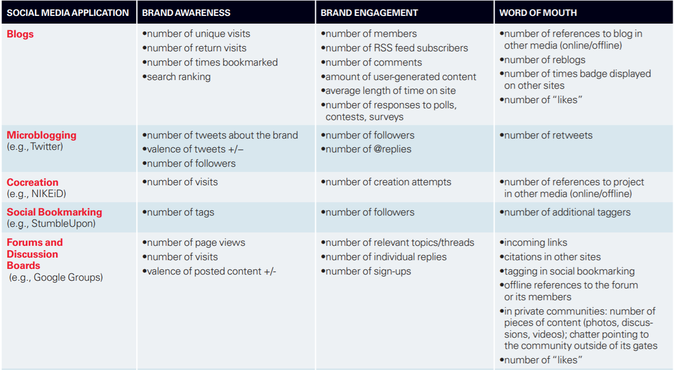
Figure 6 - Key Social Media Objectives [46]
There is a lack of research on how SMEs specifically can use social media metrics to see if their social media marketing strategy is successful. A report from Choi et al. who interviewed a small agency found many reasons for this, such as lack of planning and not enough resources [47]. It was also found that there was no one responsible for keeping track of their strategy and there was no data or information captured about clients as well as a lack of sufficient metrics with which to measure their success [47]. As is usually the case for SMEs, lack of funding, time and planning means they are at a disadvantage in social media marketing and lack of research makes it harder for them to form a plan.
Kim and Ko [48] investigated how companies use social media alongside traditional media to grow customer equity as another theory. Customer equity as defined by Hogan et al. [49] is a mixture of the value of a company’s “potential customer assets” [49] and their “current customer assets” [49]. The customers’ value is not only the profit they bring from each single transaction but the potential profit they can provide over their whole relationship with the company and therefore they are considered to be “intangible assets” with no way to establish an exact value [50]. Kim and Ko established a framework that ascertained vital social media marketing activities and discovered links between numerous variables i.e. value equity, brand equity, relationship equity, perceived activities, purchase intention and customer equity [51]. This provides a technique to improve brand performance through finding significant factors for customer equity produced from social media marketing activities [51].
Ward Roofthooft [52] researched how customer equity (CE) can be of use to SMEs within the service industry in relation to customer acquisition, customer retention, add-on selling, strategic alliances and external economy of sale. Though this is not applied to social media marketing, it is explained what activities are needed to build a “CE company” [52]. It describes when choosing customers, SMEs should look for those which will be profitable throughout their future with the business and to find them they need to collect, manage and mine data [52]. One of the easiest ways to do this is online using social media analytics and see who is engaging with their social media activities.
Other than Roofthooft, there is a lack of research on this theory specifically catered for SMEs and customer equity. This overall lack of social media marketing theory research for SMEs shows there is a need to look at theories for larger companies and see how they can be altered and applied accordingly. Any social media strategy already in place at SMEs also need to be analysed and any commonalities found.

2.3 Case Studies of Social Media Marketing
To fully understand the way social media marketing is utilised, it is important to look at case studies, both in large businesses and within SMEs.
Vision Express
Dave Chaffey [53] spoke to the online marketing manager of Vision Express, Kate Webb regarding her social media marketing strategy that is used across Vision Express groups. Webb said their main goals were to provide service to online customers including customer feedback which is shared to their stores, building relationships with online customers via a “one customer view database” [53] which matches in-store activity to social media activity and building brand awareness [53]. She emphasises you need a platform to monitor your social media which allows you to view what customers are saying across social media, forums and blogs [53].
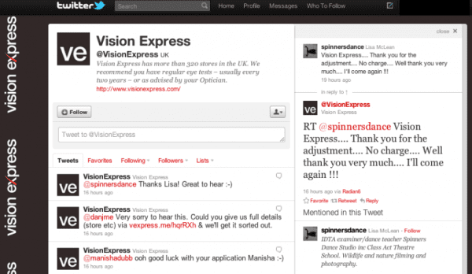
Figure 7 - Vision Express Twitter [53]
To be successful she says social media needs to be “integrated into core business activities” [53]. Management needs to recognise the impact of social media on the customer base and internally within the organisation [53]. Vision Express integrate social media in planning their marketing strategy e.g. whether social media is appropriate for a promotion and which platform is most suitable [53]. Their Customer Care team also respond to customer queries daily [53]. This shows that they made their social media strategy beneficial to them in building customer relationships and not just solely for selling their products and services.
The Bandee
Sarah Cox [54] carried out a study on a small Internet-based accessory business called ‘The Bandee’ based in Florida and interviewed its owner Dede Parise on how social media is used to engage with customers. From the interview, Cox found three themes: information sharing, e-Word of Mouth (e-WOM) and relationship and network building [54]. Parise said her main goal was to communicate with customers, and social media allowed for a more personal relationship – she began with Facebook and then joined Twitter and claimed she has built various relationships that may not have been possible without social media [54]. Parise also used e-WOM by promoting other business’ products in hopes for reciprocation, which shows SMEs could be receiving e-WOM from other SMEs [54]. Parise emphasised that information sharing should not just be about the company’s product because it will feel like a sales job, and so she also talks about the customer’s interests [54].
Overall, this small business owner has shown more advanced marketing than expected e.g. she values long-term relationships with the customers and does not only work on the short-term, she does not post solely about her own products and she keeps track of customer’s activities allowing her to customise the content she publishes [54]. In order to gain a clearer picture of how SMEs use social media, more case studies need to be researched.
Unnamed Italian SME fashion brand
Ananda et al. [55] did another case study that looks at an Italian SME fashion brand that remains unnamed and produce leather accessories and bags for the high-end market. The reason the brand applied a social media marketing strategy is to raise brand awareness and reputation, as well as gain new followers and reach their target market [55]. In contrast to the previous case study, this brand stated that their social media marketing activities are mostly to do with sales and promotion and customer support [55]. Ananda et al. analysed the brand’s Facebook page and found more than half (54%) of their posts are related to promotion and sales with the next biggest ratio being public relations (26%) [55].
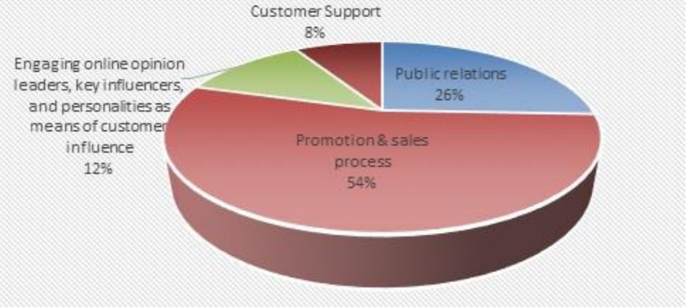
Figure 8 - The Brand's Social Media Marketing Activities on its Facebook Brand-Page [55]
Most of the user engagement is through “liking” the posts with a lack of sharing and commenting [55]. The actions that presented the most likes came from offline store or promotion events content as well as key influencers or personalities posting about the brand [55]. Their Twitter page was also analysed over a year, where 134 tweets were examined [55]. Like their Facebook page, over half of their tweets were on promotion and sales (58%) [55]. Again, public relations were the next highest post type (32%) [55]. The tweets that gained the most retweets were associated with product promotion, similar to Facebook [55].
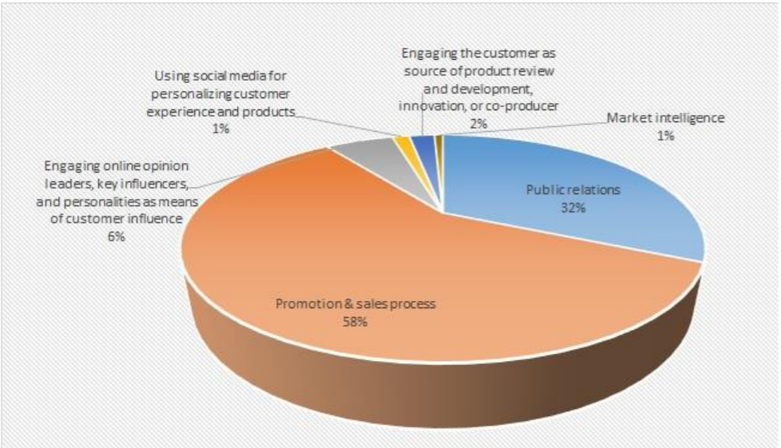
Figure 9 - The Brand's Social Media Marketing Activities on its Twitter Brand-Page [55]
Unlike Vision Express, the brand has admitted that their company managers and big decision makers do not yet see how important social media is, despite having a substantial social media marketing strategy [55]. There are also no “key performance indicators” in place for their social media marketing strategy [55] so there is no real way to measure the success of their strategy. However, their posts are in-line with what they aimed to do with their social media marketing e.g. to hit their target market and raise brand awareness they did product promotion and for customer support they would answer questions from customers and respond to complaints [55]. As this is a luxury brand, it is important that they manage to balance its accessibility and desirability [56]. It is difficult to do so, as stated by Mark Ng, who describes social media as “class-neutral” which goes against the uniqueness and exclusivity of luxury brands [57]. It is clear there is a difficulty trying to appear accessible while being a luxury brand, particularly being an SME.
CareOne Debt Relief Services
CareOne debt relief services had a similar goal to Vision Express in that their social media marketing strategy’s main goal was customer retention [58]. They are also a service rather than a physical product company. They initially started with an “online community” in 2006 for anyone to register and make enquiries on debt consolidation and relief etc. and over 1.4 million individuals signed up [58]. In 2009, a social media team was introduced whose job it was to raise awareness of CareOne via social media platforms and to engage with their customers who were already a part of their online community [58].
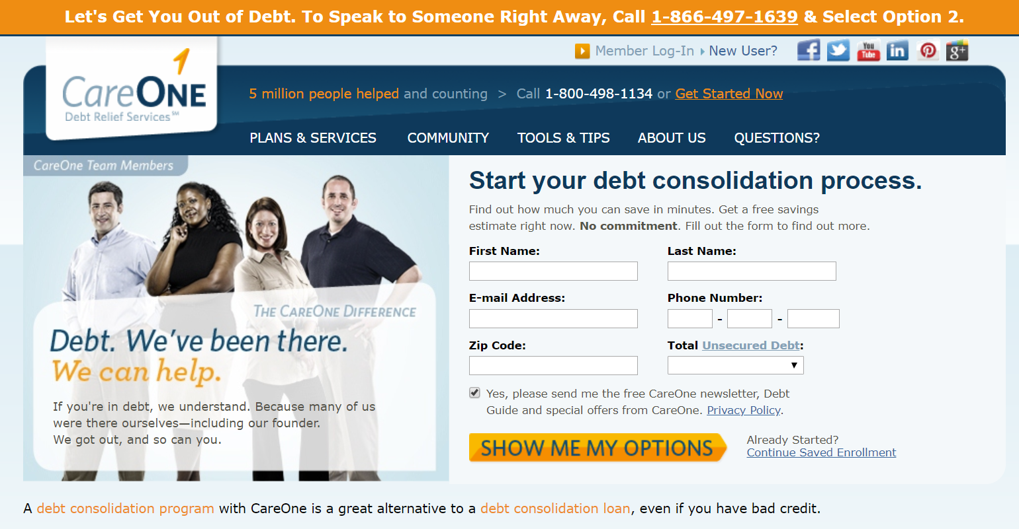
Figure 10 - CareOne Debt Relief Services Webpage [59]
Nichole Kelly, the head of the social media team, realised there was no way to measure their success so she built an “end-to-end measurement solution” to track customers who visited through social media platforms and then follow their journey from when they sign up to their first payment [58]. Kelly could compare this journey between customers who had no contact with social media and a control group of those who did [58]. CareOne discovered the customers who had social media contact coincided with a “longer buying cycle” i.e. 24-28 days than those who did not (30 minutes) and they were also 218% more likely to complete their first payment and 680% more likely to return to an uncompleted sign-up form [58]. The conclusion that Falls comes to is that while social media customers may bring more value in terms of dollars to CareOne, that does not inherently make them more valuable than those who do not, but rather building those relationships with them adds more value [58].
Compared to traditional marketing, these case studies have shown more of an emphasis on building customer relationships through social media. This brings in two-way communication and by allowing the customer to give feedback and ask questions, as well as share content posted by the company, they can feel more connected to the company which builds a loyalty. This makes them more likely to purchase more products and more likely to recommend their product to others through e-WOM. This helps to increase the company’s reliability.
Also, from the case studies, it can be said that lack of research on SMEs can make it difficult for them to decide to adopt a social media marketing strategy and if they do, to choose which goals will fit their company. There is also the issue with lack of budget and personnel to carry it out. However, those that do, share similar characteristics to large companies who have employed a social media marketing strategy. At its core, it is down to each SME to decide what will be beneficial to their future and not just see it as its own separate marketing tool, but to infiltrate it into different aspects of the business. Even within the SME sector, there are considerations to make considering the type of business they are e.g. luxury brands and services rather than products.

Research Methodology
The research methodology chosen for this project is a survey and document analysis. A survey has been chosen because it can provide an insight into how SMEs in the local area are using social media and using their responses, a model can be built for SMEs to use in the future. An advantage of using this method is the ability to reach a large number of people in a short amount of time [60]. With the time constraints of this project, it is important to get responses as soon as possible from as many people as possible. It is also low cost [61] and respondents are also more likely to reply with more comprehensive answers to open ended questions via online surveys than mail surveys [62].
The main disadvantage that researchers have previously discussed is the fact that not everyone is comfortable with using computers and not everyone has access to the Internet [63], although the majority of this research was done many years ago, and now there is at least one I.T individual at a company who could fill in the survey, and people are generally more comfortable with computers. Also, to overcome this disadvantage, the survey will be designed to be simple and user-friendly as though to emulate a paper survey and not intimidate respondents.
A case study is an alternative research methodology that could be chosen for this project. A case study investigates an individual, event or group in its real-life context [64]. While case studies do provide rich qualitative data, one big disadvantage is that data cannot necessarily be generalised for the whole population and there is also the possibility for researcher bias [65].
The research philosophy will be phenomenological because it explores the actual experience of a phenomenon [66] i.e. social media marketing in SMEs today. An advantage of using this research philosophy are the unique opinions that can be retrieved by people who experience this certain phenomena or event, providing a thorough understanding of it [67]. A further advantage is the rich data which is given from the direct experience of individuals [68].
A disadvantage to this philosophy is that analysis of the gathered data and interpreting the results can be difficult [69]. This can be handled using evaluation criteria and the analysis of social media pages to back-up the answers of the survey. Another disadvantage from critics is the method is subjective and there is no objective measures of representativeness or reliability for the researcher [70]. The survey will be done on SMEs in the local area so the results be representative of the local area and gathering the results can show if there is a consistency and reliability that can be applied to generalise them.
The research approach chosen for this project is inductive which combines numerous premises, all thought to be true or found true the majority of the time, to attain a precise conclusion [71]. This approach has been chosen because it allows qualitative data to be gathered and a new conclusion can be found from current social media marketing by SMEs to create a guide for future use. An advantage of this approach is it gives a starting point so your expectations can be narrowed down to an informed conclusion [72].
A disadvantage is that there is only the option for a probable conclusion [73] because there is always more evidence that needs to be gathered and anything unobserved may invalidate the hypotheses made [74]. While this may always be true for inductive research, the results that are gathered can be seen as “probably true” [74] as the evidence gathered on SMEs will be pertinent and complete [74].
Data collection will be cross-sectional i.e. taking place from one single point of time [75]. This was chosen for the project due to the limited timescale. An advantage to this is that it is inexpensive, quick and simple to carry out [76]. For this project, the timescale and budget need to be considered, which makes the factors listed important. Another advantage is that it allows for different variables and to see how they correlate with the “variable of interest” [77]. This means the different sectors of SMEs can be explored and how each sector works differently with social media marketing. A further advantage is that this type of study can provide a catalyst for further research [77]. For a topic with as little research as social media marketing for SMEs, this could be a good starting point for others to follow.
A disadvantage to this type of data collection is that because it takes places in a single point of time, it may not be fully representative [78]. While this cannot necessarily be avoided, we can take the data as representative of local SMEs in the current time, which can be applied in the future. Another disadvantage is there is a possibility for a non-response bias, if respondents of the survey differ from ones who choose not to take part [79]. This could result in a lack of representativeness of the population [79]. The survey will be given out to a variety of SMEs so as fair of a response as possible can be gathered.
Mixed methods research will be used for this project as both qualitative and quantitative data will be gathered with the survey and analysis of social media pages [80]. A big advantage to this type of research is how it compares qualitative and quantitative data so you can see if there are any contradictions [81] i.e. between survey responses on social media posts and actual posts on social media. It also provides more in-depth research so data interpretation is more meaningful [82]. A disadvantage is how time consuming this type of research can be [83]. With a proper plan and good schedule this can be solved.

3.1 Survey Design
The objectives for my survey are to discover:
- How the size of local SMEs affects their social media presence
- The social media platforms that are most popular for SMEs
- The primary activities that are done on social media by SMEs
- How often SMEs post on social media per week
- Whether SMEs believe their social media strategy is successful and important
The target group is local SMEs in the Swansea area. The questions are:
- How many employees work at your company?
□ □ □ □ □
1-50 51-100 101-150 151-200 201-250
This will be asked to find out the size of the company to see how it affects the social media marketing team and presence.
- What sector is your company in?

□ □ □ □
Retail Charity Food Other
Please specify other

This question will be asked to see whether the sector of the SME affects the frequency and type of posts they make.
- Do you currently have a marketing team/employee?
□ □ □
Yes No Don’t know

This will be asked to find the correlation between size of the company and if they have a marketing department.
- Do you have a social media presence?
□ □ □
Yes No Don’t know

This will be asked to find out how many SMEs use social media.
- If yes, what platforms are you currently using?

□ □ □ □ □ □
Facebook Twitter Instagram Snapchat YouTube Other

Please specify other

This question is to see which social media platforms are most popular for SMEs. From the literature review it appears as though Facebook and Twitter are most prevalent.
- If no, why not?

This is to get qualitative data and see the reasons why some SMEs may not have a social media presence.
- What activities do you use social media for?

□ □ □ □
Sales Customer support Public relations Other

Please specify other

This question is to find out what social media is primarily used for by SMEs. This is like the case study previously discussed on the unnamed Italian fashion brand. It will show how many SMEs use social media to actively engage with users or use it to passively sell and promote the business/products.
- How often do you post on social media?

□ □ □
0-2 times a week 3-5 times a week 6-8 times a week
□
9+ times a week
This question will be asked to see the frequency of posts to social media by SMEs per week. This will show how active they are on social media because while they may have a presence, if they do not post frequently, they will be buried under the plethora of other businesses out there.
- Do you think your social media strategy is successful?

□ □ □
Yes No Don’t know

This is to gather the opinion of SMEs on how they view their social media strategy and what they see as successful.
- Do you think social media is important for your company?

□ □ □
Yes No Don’t know

This will gather SMEs opinion on social media marketing and whether they see it as important.
- Please explain why you believe social media is important or not

This is to further elaborate on their opinion on social media for their company and will help to discover if they believe it is needed for their company.
The survey is valid because the questions cover all necessary aspects and measure what is needed. It will also be piloted to test its validity. The survey is reliable because it will be measured against social media pages. The survey is generalisable to the extent of SMEs in Swansea and possibly Wales. The survey was piloted with the supervisor of this project, who answered the questions using information from a local charity. One question was added onto the survey after this pilot.
- Please provide any social media links for your company (optional)

This question was added as an optional extra as participants may want to remain anonymous. However, if they choose to answer, it will provide valuable comparison for their survey answers with their social media pages.
The results will be analysed by comparing size of the company with their presence on social media and whether they have a marketing employee or team. The sector will also be compared to presence on social media. The amount of times they post per week can also be compared to whether they have a marketing team or employee.

Research Analysis

4.1 Survey Results
The survey received 18 respondents from a variety of small/medium businesses in Swansea from different sectors. This will help to get an idea of the differences within SMEs themselves, and how they compare to big businesses.
The first question which asked how many employees worked at the SMEs came back with 100% of respondents saying they had 1-50 employees working at their company which classifies them as small businesses according to the OECD [84]. Question 2 found that of the SMEs that responded, the sector that was most popular was ‘Other’ which entailed a variety of sectors such as florists and hairdressers. This was different from what was originally thought would be the most popular e.g. retail and charity.

Figure 11 - Pie Chart showing No. of SMEs in each sector
Question 3 was dependent on whether respondents answered with ‘Other’ in Question 2. The responses were Hairdressers, Florists, Computer repairs, Independent Bookstore and Health and Beauty. Question 4 addressed whether the SMEs had a marketing team/employee, and only one respondent replied with yes which was what was expected as explained in the literature review, SMEs lack the time or budget for social media marketing and usually do not have any sort of marketing team.

Figure 12 - Bar Chart showing No. of SMEs with marketing team/employee
Small businesses like the respondents normally have an employee with other responsibilities do any marketing activities which also limits the time and effort put into it. Despite having these factors against them, as shown in the case studies such as ‘The Bandee’ [54], SMEs still tend to have a social media presence. This is shown in the responses from Question 5 which asked SMEs whether they are on any social media. The results, as displayed in Figure 13, show a complete opposite to Question 4, which means SMEs still know the value of having a presence online, although how they use social media will affect how beneficial it is for their business.
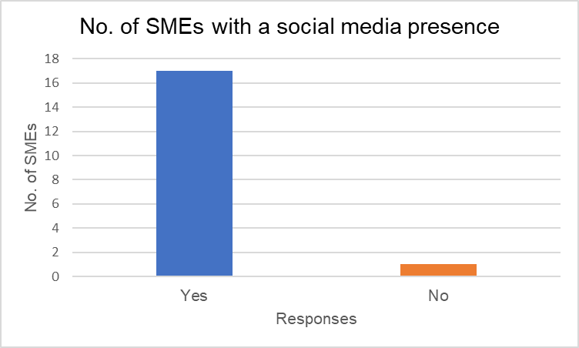
Figure 13 - Bar Chart showing No. of SMEs with a social media presence
Figure 14 shows the results of Question 6 which asked which social media platforms the SMEs were using, with 94% of SMEs using Facebook and 38% using Twitter and Instagram. Newer and alternative social media like Snapchat and YouTube are not used by any SMEs. This was expected from previous case studies where SMEs used Facebook and Twitter at most as a marketing platform.

Figure 14 - Bar Chart showing Social Media Platforms used by SMEs
The next question asked what activities each SME uses social media for. Figure 15 shows that the most popular social media activity done by SMEs is Sales, followed closely by PR and then Customer Support. This was also the expected result, as shown by the previous case study of an unnamed Italian fashion brand, which had sales and promotion as its highest percentage of posts, followed by PR.

Figure 15 - Bar Chart showing No. of SMEs partaking in certain Social Media Activities
The next question looked at how many times SMEs posted to social media a week. Figure 16 shows that 42% of SMEs posted on social media 0-2 times a week, followed by 32% posting 3-5 times. This was expected because SMEs do not tend to have a clear social media marketing plan and may not know what the right amount of posts are for a week. However, the next most popular response was 9+ times a week which was unexpected. This could be because they are posting multiple times in one day which will be looked at in the social media page analysis.

Figure 16 - Pie chart showing No. of times SMEs post to social media a week
Question 9 asked SMEs whether they found their social media strategy successful. Figure 17 shows that 67% of SMEs did not find their social media strategy successful. This was expected because SMEs usually do not have a social media strategy or do not have a method of knowing how successful their social media strategy is.

Figure 17 - Pie Chart showing No. of SMEs who found their social media strategy successful

The last close ended question asked if the SMEs thought social media was important for their company. Figure 18 shows 89% of SMEs that responded believed social media was important for their company. This was expected because most SMEs know social media is important, and know the reasons for it, but they may not know how to make it useful for them.

Figure 18 - Pie Chart showing the No. of SMEs that think social media is important for their company
The following question asked SMEs to explain why they believe social media is important or not. All but one of the respondents shared the same opinion that social media is important.
It might be useful but there’s a lot of competition out there
Brings in more customers
It’s important as people spend more time browsing online
We work in a charity that aims to improve mental health, therefore having a social media presence is important for us to be able to encourage more of a discussion about mental health issues, and promote what services are available to those in need.
I believe that social media can help boost sales for our company and spread the word about us.
We can spread the word of our shop and post about our items which people can show interest in and enquire about.
We think it is important as through social media we are able to easily promote our store and share our portfolio of hairstyles to gain more customers.
It is important because we keep our customers updated about us and encourage sales from new customers by giving contact information in posts.
Social media can help, however most of our customers come from word-of-mouth and our reputation in the community as we are a ladies only beauty salon which appeals to many women.
We think it's important because we can share the type of orders we do for customers with pictures and information and we can reach more people.
We are a charity that support children and young people with additional learning needs so social media is important for sharing what we provide for these young people and encouraging more people to volunteer.
It is important because we are able to gain interest in our store and promote deals to attract customers. The ability for people to share our posts also helps the word get out there about our store much quicker than what used to be possible.
We mostly use social media for sporadic updates and remind people of the services we provide but social media is important to keep us relevant and in the minds of potential customers.
Social media is important because it helps us keep connected with our customers and share our latest updates.
Social media helps us to get new customers as people can share and engage with our posts. This helps us to reach more people than would be possible without it, especially for a small local business such as ourselves.
As we are an independent bookstore and fairly unknown, it is important to have a presence on social media in order to tell people about our store, what we are selling and what events we are taking part in.
It is important because most businesses now have social media so we do not want to be left behind and we wish to try and get more people into our store.
We think social media is important for letting customers know what we do as a business and update them on any changes to our restaurant.

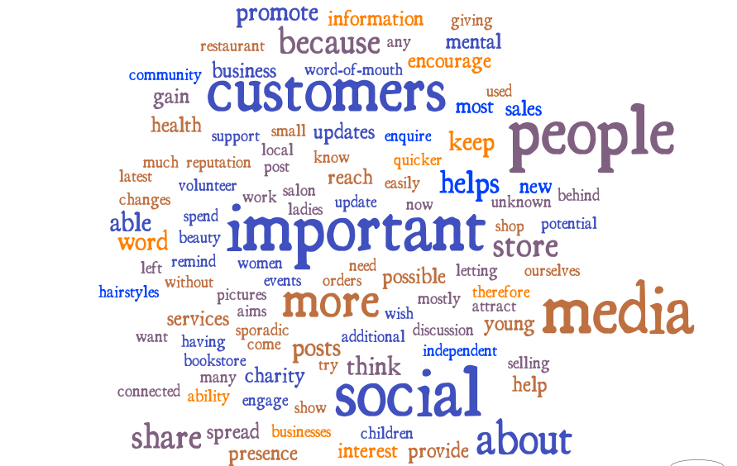
Figure 19 - Word Cloud for Question 11
This word cloud shows that the word “customers” was frequently used which shows a theme of SMEs believing social media is important to reach out to customers and gain new customers. However, this goes against the previous question regarding social media activities where the least popular activity was customer support.
The final question asked for SMEs social media links if they were comfortable with sharing them. 14 responses were received of a possible 17, so a selection of these pages i.e. one from each sector, can be analysed against their responses on how many times they post in a week and what activities they do on social media.

4.2 Social Media Pages Analysis
Swansea Mind
The first SME which provided links to their social media pages was the local Swansea charity ‘Swansea Mind’. They have a Facebook, Twitter and Instagram page. The first aspect explored was how many times they posted to social media in a week over the course of a month. From the 27th April – 31st May, they posted on Facebook a total of 32 times, which is an average of 6 (6.4) posts a week. They posted on Twitter 38 times in this same duration, which is an average of 8 (7.6) posts a week. Their Instagram had no posts in this duration, so instead 30th March – 3rd May was looked at, during which they only posted 12 times with an average of 2 (2.4) posts a week. Overall, this gave an average of 6 (5.5) posts a week across social media which matched their response of posting 6-8 times a week in Question 8.
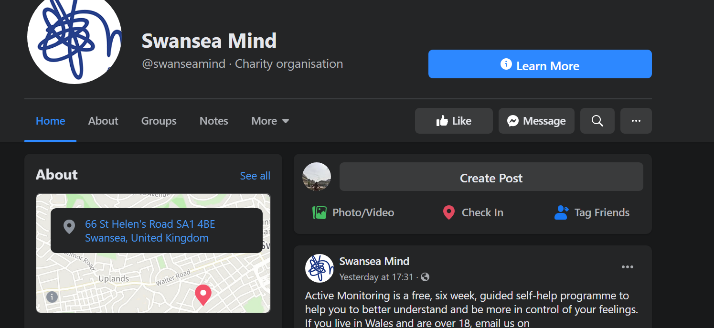
Figure 20 - Swansea Mind Facebook Page [85]
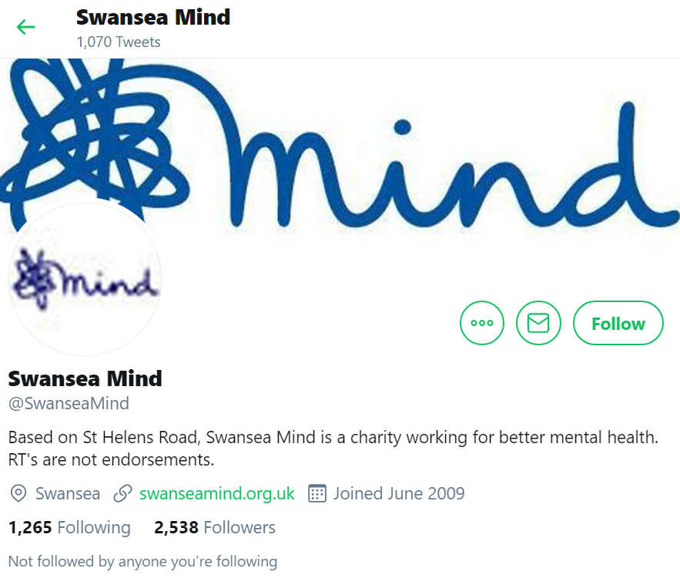
Figure 21 - Swansea Mind Twitter Page [86]
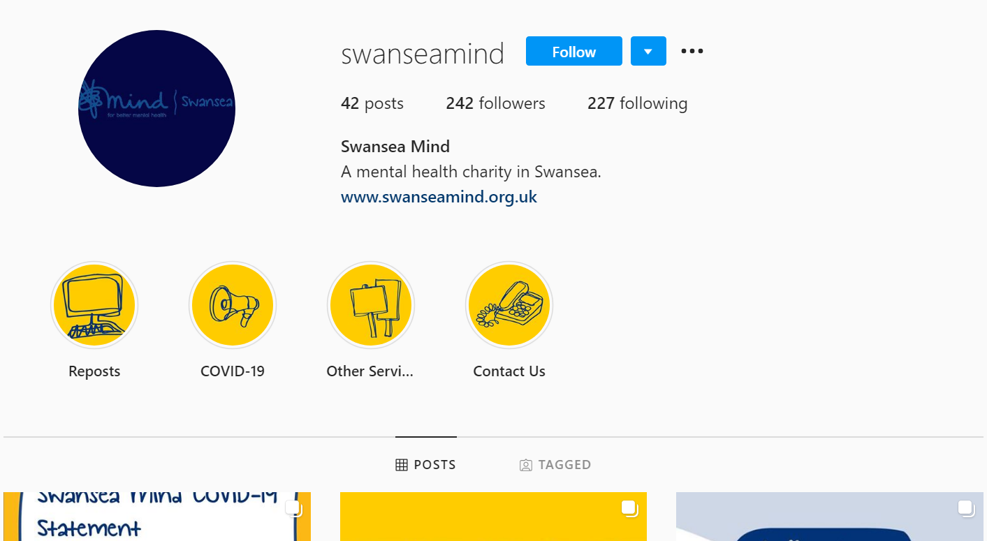
Figure 22 - Swansea Mind Instagram Post [87]
Next the number of likes, shares and comments over the same period on their Facebook posts was looked at.
 | 27th April – 3rd May | 4th May – 10th May | 11th May – 17th May | 18th May – 24th May | 25th May – 31st May
Likes | 10 | 15 | 19 | 56 | 18
Shares | 19 | 4 | 5 | 40 | 2
Comments | 1 | 0 | 0 | 0 | 2

On average, they received 23 (23.6) likes, 14 shares and 2 (1.5) comments per week. At a rate of an average 6 posts a week, that equates to 4 (3.8) likes, 2 (2.3) shares and 0 (0.3) comments per post. This rate of interaction is okay compared to the posts, however, not all posts will receive interaction from the viewer.
Their Twitter page was checked for retweets and likes, also over these dates.
 | 27th April – 3rd May | 4th May – 10th May | 11th May – 17th May | 18th May – 24th May | 25th May – 31st May
Retweets | 8 | 5 | 17 | 18 | 0
Likes | 9 | 6 | 20 | 32 | 1

On average, they received 14 (13.8) retweets and 9 (9.2) likes per week. With an average of 8 tweets a week, that is 2 retweets (1.75) and 1 (1.125) like per tweet. Their response to Question 9 where they say their social media strategy is unsuccessful, can be shown with their lack of interaction from people.
Their Instagram page had the least amount of activity, by both them and their viewers. Their likes per week are shown below:
 | 30th March – 5th April | 6th April – 12th April | 13th April – 19th April | 20th April – 26th April | 27th April – 3rd May
Likes | 11 | 3 | 13 | 3 | 1

This gave an average of 6 likes per week, which is 3 likes per post at 2 posts a week. This may be because they are a charity, and not likely to be followed on Instagram for information, which could be why their Facebook page has the most traction. This can be compared with an SME such as a florist, which has more use for an Instagram page, but may not post as much on Twitter or Facebook.
Like the case study of the unnamed Italian brand in the literature review, the types of posts made on Facebook were analysed. Figure 23 shows that 53% of the 32 posts made over the period 27th April – 31st May, were associated with Public Relations and the other 47% was associated with Customer Support. This was expected from their response to what activities they do on social media. Customer support took the form of promoting the charity’s supporters with their projects and PR involved promoting what the charity does and raising awareness of mental health. This is similar to Twitter, as shown in Figure 24, except customer support has a bigger percentage of 55% and public relations is 45%. This may be because a lot of customer support tweets are posted more than once which can be common for Twitter to keep tweets visible on people’s timeline. Their Instagram posts were 100% PR related e.g. posts about mental health and services they were providing.
Swansea Mind’s response to why they think social media is important correlates with what has been shown in their social media pages: “We work in a charity that aims to improve mental health, therefore having a social media presence is important for us to be able to encourage more of a discussion about mental health issues, and promote what services are available to those in need.”

Figure 23 - Pie Chart showing Types of Social Media Post made by 'Swansea Mind' on Facebook

Figure 24 - Pie Chart showing Types of Social Media Post made by 'Swansea Mind' on Twitter

Vintage Bloom
The next SME’s social media pages which will be analysed are those of ‘Vintage Bloom’, a small florist from Swansea. They gave links to their Facebook and Instagram pages. Like with Swansea Mind, the amount of posts over the period 27th April – 31st May were analysed. During this time, they posted on Facebook 88 times, which is 18 (17.6) average posts per week. Their Instagram was also analysed during this time, wherein they posted 34 times which averaged 7 (6.8) posts a week. This equated to 12 (12.2) average posts overall on all social media. This matches what they responded for Question 8, where they answered that they post 9+ times a week.
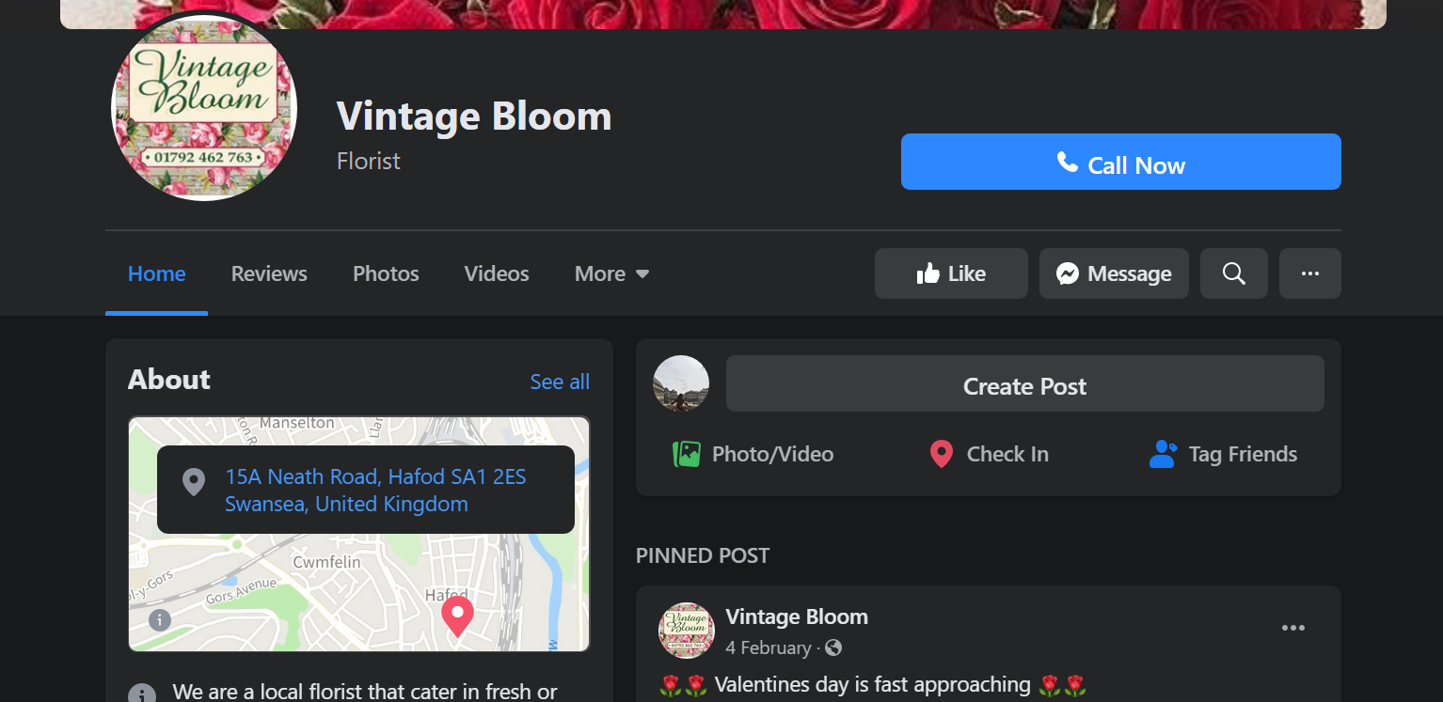
Figure 25 - Vintage Bloom Facebook Page [88]
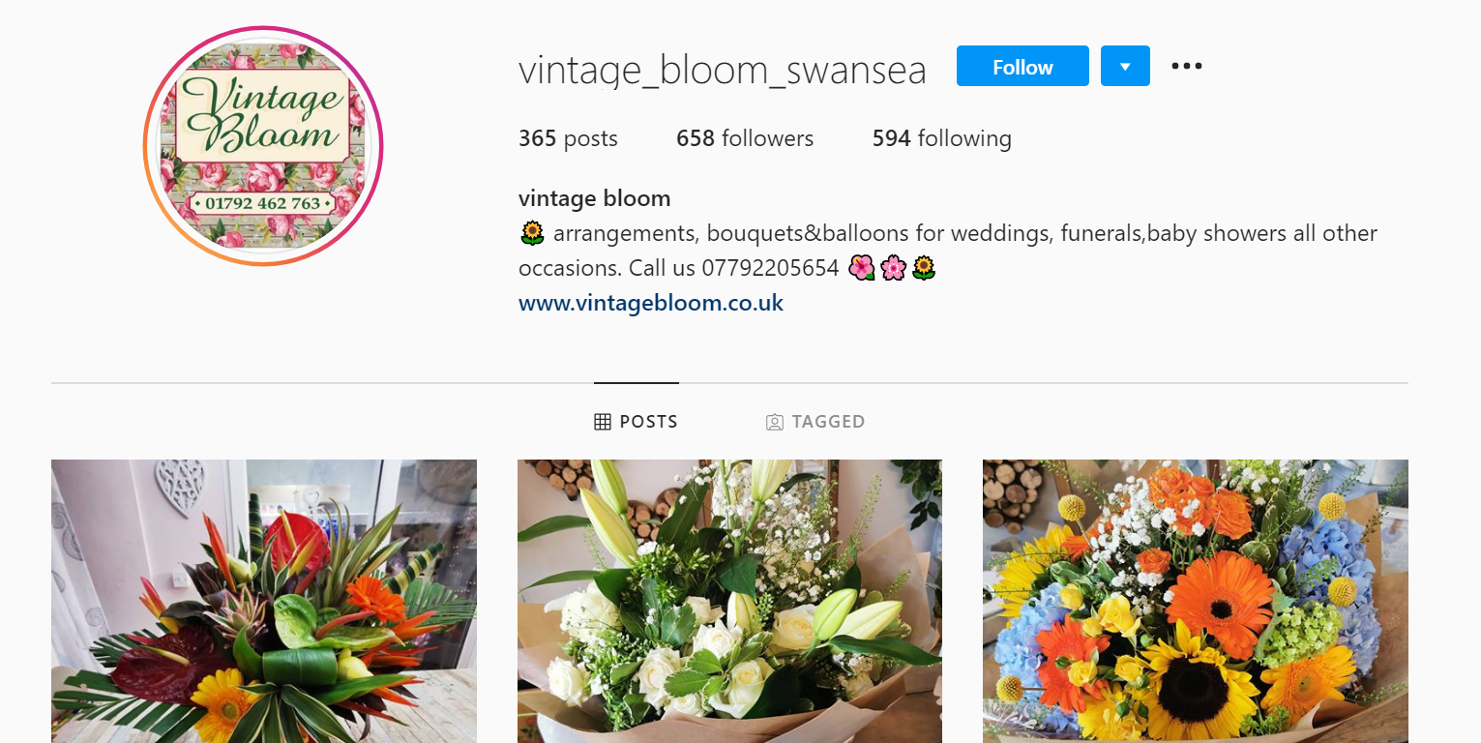
Figure 26 - Vintage Bloom Instagram Page [89]
The likes, comments and shares on the Facebook page were also analysed.
 | 27th April – 3rd May | 4th May – 10th May | 11th May – 17th May | 18th May – 24th May | 25th May – 31st May
Likes | 610 | 641 | 924 | 661 | 887
Shares | 34 | 28 | 45 | 43 | 27
Comments | 79 | 48 | 70 | 38 | 68

The average number of likes per week came to 744 (744.6). The number of shares was 35 (35.4) and the number of comments was 61 (60.6). This meant the average number of likes per post was 41, the average number of shares per post was 2 and the average number of comments per post was 3. This is a decent interaction rate, as many of the posts were pictures which normally get just likes as part of the user interaction.
Their Instagram page was also analysed for likes per post.
 | 27th April – 3rd May | 4th May – 10th May | 11th May – 17th May | 18th May – 24th May | 25th May – 31st May
Likes | 166 | 0 | 222 | 180 | 127
Comments | 5 | 0 | 5 | 3 | 1

On average, they got 174 (173.75) likes per week and 4 (3.5) comments per week. This averages to 25 likes per post and 1 comment per post. This may be because their main social media marketing campaign is on Facebook and their Instagram is used to simply share photos of their flowers, and gain interest in them. As expected, most of the posts made on Facebook by this SME was sales.

Figure 27 - Pie Chart showing Types of Social Media Post made by 'Vintage Bloom' on Facebook
They did this quite simply by posting pictures of the flowers/bouquets they had available, and people could then comment or message them regarding an order for those products. They did a similar thing on Instagram, where they posted pictures of flower/bouquets, however a lot of these were orders that were ready-made which comes into the PR aspect of their posts.

Figure 28 – Pie Chart showing Types of Social Media Post made by 'Vintage Bloom' on Instagram
65% of posts were part of PR and 35% were sales which also matches what they put down as what activities they use social media for. They shared that the reason they thought social media was important was because it helps them reach new customers than would be possible without a social media presence, which can be shown through the comments on their Facebook page praising their arrangements and enquiring on how much they cost. Their official statement was:
“Social media helps us to get new customers as people can share and engage with our posts. This helps us to reach more people than would be possible without it, especially for a small local business such as ourselves.”
In contrast to Swansea Mind, the goal is to get new customers, whereas Swansea Mind wish to spread awareness of mental health and what they can provide. Although, a similarity in their goals is to share what services they offer, while the services themselves may differ.

Langland’s Brasserie
The third SME whose social media pages were analysed was Langland’s Brasserie, a small brasserie in Mumbles. They also had a Facebook and Twitter page. From first perusal of their pages, it is clear they were more active before COVID-19 guidelines came into place, as they would have been closed. So, instead of analysing from 27th April – 31st May, the dates 27th January to 1st March were analysed for both Twitter and Facebook. On Facebook during this time, they posted 22 times, with an average of 4 (4.4) posts a week. Their Twitter had 15 tweets, with an average of 3 tweets per week. This equated to 4 (3.7) posts on average overall which matched their answer to Question 8 on how many times they post a week, where they answered 3-5 times.
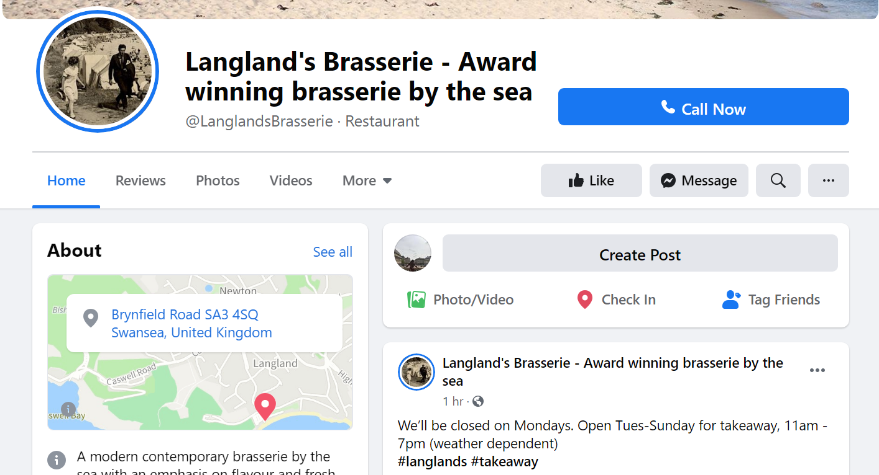
Figure 29 - Langland's Brasserie Facebook Page [90]
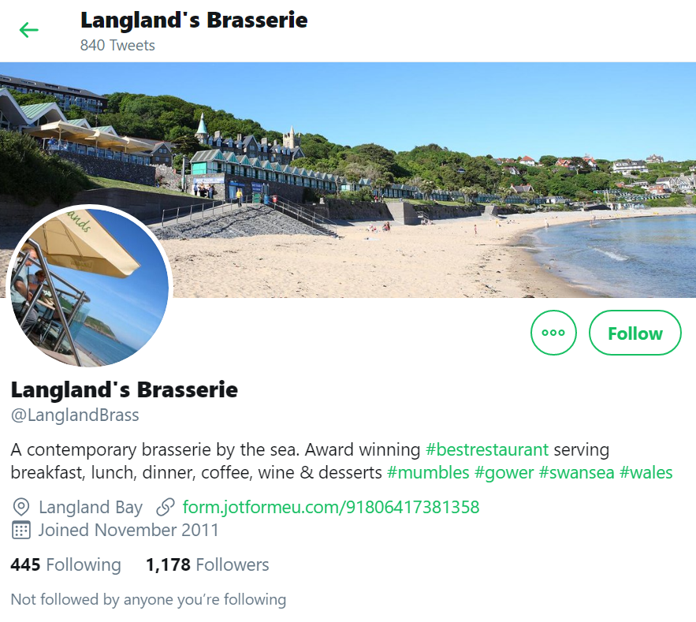
Figure 30 - Langland's Brasserie Twitter Page [91]
The likes, comments and shares on these Facebook posts were also analysed.
 | 27th Jan – 2nd Feb | 3rd Feb – 9th Feb | 10th Feb – 16th Feb | 17th Feb – 23rd Feb | 24th Feb – 1st March
Likes | 17 | 95 | 107 | 189 | 61
Shares | 1 | 3 | 5 | 7 | 3
Comments | 1 | 3 | 3 | 10 | 5

On average they received 94 (93.8) likes, 4 (3.8) shares and 4 (4.4) comments per week. With 4 posts a week on average, this meant they got 24 (23.5) likes, 1 share and 1 comment per post. Based on how often they are posting, this is an okay interaction rate. Their Twitter has a similar response rate.
 | 27th Jan – 2nd Feb | 3rd Feb – 9th Feb | 10th Feb – 16th Feb | 17th Feb – 23rd Feb | 24th Feb – 1st March
Likes | 7 | 6 | 4 | 4 | 13
Retweets | 2 | 2 | 0 | 1 | 3

They received an average of 7 (6.8) likes and 2 (1.6) retweets per week. With 3 tweets a week, that is 2 likes and 1 retweet per tweet on average. Most SMEs in the food sector are not active on social media as shown by the only SME in the survey respondent that did not have a social media presence being from the food sector. They also may feel there is not much to share, especially if they are already well known in the area. Also, if they have a website which covers their bookings and menu, like Langland’s Brasserie, then they may only feel like they need social media because it has become a necessity for modern businesses.
The types of social media post made on Facebook and Twitter were also analysed. Figure 31 shows 78% of posts on Facebook were relating to PR and 22% were relating to customer support. This was expected from their answer to Question 7 where they responded that they use social media for PR and customer relations. By being in the food sector, the best thing they can do with their social media is promote their business and try and bring more customers to their restaurant.

Figure 31 - Pie Chart showing Types of Social Media Post made by 'Langland's Brasserie' on Facebook
Their Twitter showed a similar weighting of post types, with 73% being related to public relations and 27% being related to customer support.

Figure 32 – Pie Chart showing Types of Social Media Post made by 'Langland's Brasserie' on Twitter
Their statement on why they believe social media is important is as follows:
“Social media is important because it helps us keep connected with our customers and share our latest updates.”
Their posts show that they are working towards connecting with their customers and keeping them updated on what is happening. Like Vintage Bloom and Swansea Mind, PR is a big part of their social media strategy. It seems that a common theme with all SMEs is the need to promote their business and share to the public what they provide.

Pandora’s Box
The last SME’s social media pages which will be analysed are the small independent store ‘Pandora’s Box’. They only have a Facebook page which was analysed over 27th April – 31st May. This may be because Facebook is better known for marketing for businesses [92], and as their time is spread thin already, there may not be the option for multiple social media platforms.
They posted 8 times with an average of 3 (2.67) posts a week. This matched their answer to Question 8 on how many times they post in a week, where they answered 3-5 times. Although, on two of those weeks they had no posts at all.
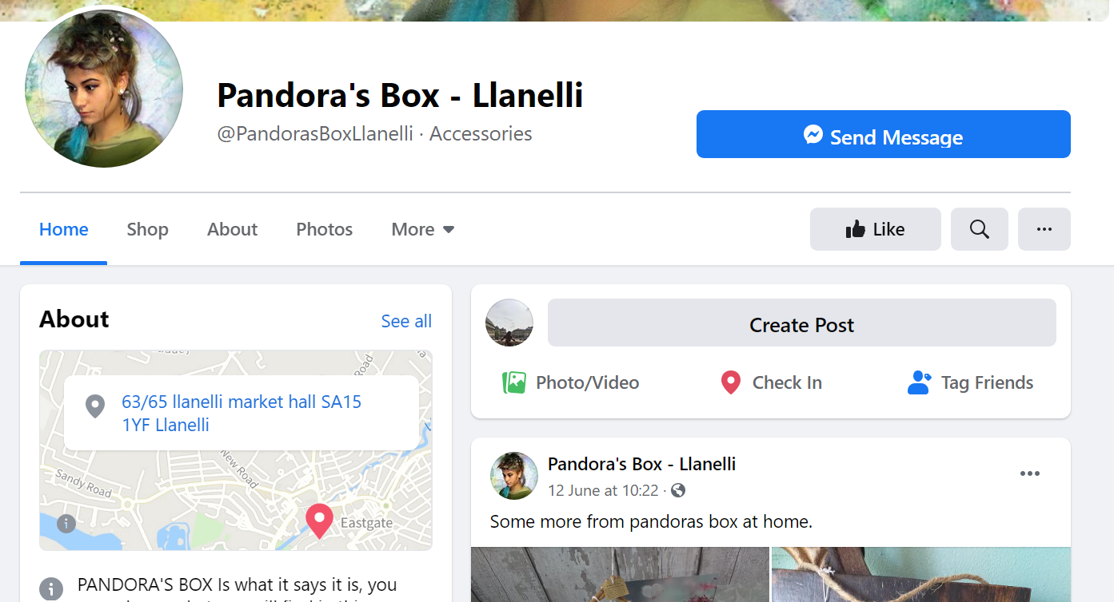
Figure 33 - Pandora's Box Llanelli Facebook Page [93]
Their Facebook page was also analysed for likes, shares and comments over this time.
 | 27th April – 3rd May | 4th May – 10th May | 11th May – 17th May | 18th May – 24th May | 25th May – 31st May
Likes | 48 | 0 | 43 | 0 | 56
Shares | 1 | 0 | 0 | 0 | 3
Comments | 5 | 0 | 5 | 0 | 14

They received 49 likes on average per week, 2 shares on average per week and 8 comments on average per week. With 3 posts a week, that is 16 likes, 1 share and 3 comments per post on average per week. The posts are mainly sales posts, which not many people are responding to.

Figure 34 - Types of Social Media Post made by 'Pandora's Box' on Facebook
Of all the posts analysed, 62% were based on sales, 25% on customer support and 13% on PR. This was expected as they are in the retail sector, and social media is an easy way to share their products. However, as seen in previous case studies, if you make your social media page all about sales, you can lose the interest of customers because they can feel they are being bombarded by products. Pandora’s Box believed social media was important because of the following reasons:
“We can spread the word of our shop and post about our items which people can show interest in and enquire about.”
They make it clear that a main priority for them is to share products to boost sales from people who visit their page. Similar to Vintage Bloom, a large proportion of their posts were about sales. This could be because they both have physical items which they are selling which are easier to post sales posts on, rather than Langland’s Brasserie that are not sell physical things online but are sharing what they provide instore.
From the information gathered by the survey and analysing social media pages, a social media marketing guide can be proposed with steps SMEs can take to help them boost visits and interactions to their social media pages.

4.3 SME Social Media Marketing Guide
Before SMEs consider a social media marketing strategy, they need to understand that social media marketing (SMM) is a whole new form of marketing and to not approach it the same way as traditional marketing. SMM needs to be seen as a two-way communication between you and the audience; the more interaction, the better. This interaction can take place in different forms e.g. comments and shares. Traditional marketing can still be used, but when utilised in a way that works best for your company, social media marketing can be a very powerful tool.
The following are the steps SMEs can take for a successful social media marketing strategy:
1. Consider what sector they are in and how social media marketing can help to reach their goals
When choosing what method to take for their social media marketing, first they need to look at what sector they are in and how social media can help them reach their goals as a company. Below are some typical SMM goals SMEs from the following sectors may have for their company:
Charity:
- Spread awareness of the cause they are fighting/helping with
- Provide information on services they offer
- Manage interested volunteers
Retail:
- Raise more awareness of their company
- Boost sales of their products/services
- Provide deals to bring in more customers
- Keep connected with their customers
Food:
- Keep customers updated on their business
- Share deals on their products
- Share information on what they offer
Other (e.g. Beauty Salons)
- Build brand awareness
- Communicate with customers and get feedback
- Bring in new customers
2. Choose their target audience and what social media platforms to join
Once they have considered their sector and decided on goals for their SMM strategy, the next step is to decide on their target audience and which social media platforms to join to reach this target audience. Here are some useful tips on reaching your target audience on certain social media platforms:
- Facebook has the option for paid targeted ads where you can specify the location, age, gender, interests etc. that you want your audience to have [94].
- Twitter has ad campaigns where you can set up an ad group, choose your payment bid, select your audience and pick an optimisation technique e.g. maximum outreach or maintain engagement with maximum outreach [95].
- Instagram provides promoted posts where you can track the number of people seeing and interacting with your post, as well as targeted ads based on location, demographics and interests [96].
3. Decide what kind of posts to post and choose an appropriate upload schedule
For SMEs to get maximum engagement with posts, they should have key knowledge on when the best times to post are and what type of posts they should be. If they are in the retail sector or one of their primary goals is to sell, they should avoid posting too many product/sales posts, in order to not alienate their audience and create a disconnect.
According to Hootsuite, the best time to post on Facebook for B2C (Business to Consumer) brands, is 4pm GMT (12pm EST) on either Monday, Tuesday or Wednesday [97]. For Twitter, this is 4pm or 5pm GMT (12pm or 1pm EST), from Monday to Wednesday [97]. The best time to post for Instagram is 4pm – 5pm GMT (12pm – 1pm EST) on Monday to Friday [97]. SMEs should use a social media management platform such as Buffer [98], which can schedule their posts for the days and times they choose. Facebook Analytics also tells you when your audience will most likely be online, so you can post these times [99].
As the key thing for all SMEs in SMM is engaging with the customer, posts providing customer support should be present in their social media pages. Any queries made by the customer should be replied to as promptly as possible and any messages sent to the company should also be replied to as soon as possible. Automated messages should be used as little as possible so the customer can feel a connection to the company. As an SME, it is important to try and keep those strong relationships with your customers, even as you continue to grow.
Another type of post SMEs can add to their pages is a problem/query for a direct response from the audience [100] to show that they are part of the company and being included in decisions. This also strengthens the relationship with the customer. They can also do live video streams on Facebook and Instagram, where they can directly respond to customer questions while promoting a new product for example.
4. Lay out social media metrics to see whether their social media marketing is successful
When SMEs have a clear plan for their social media posts, they should use social media metrics to see how successful/unsuccessful they are. This can help with deciding what to change/keep in their social media strategy. While many SMEs use social media marketing, they fail to take this step and so, according to the survey results, this has led to 67% of SMEs believing their social media marketing strategy is unsuccessful.
Facebook has an Insights page [101] and Twitter has an analytics page [102] which can do this process for you. However, for a more thorough inspection, SMEs can use a social media analytics tool such as Sprout Social [103]. This easily creates reports with whichever information you need, whether it is from one social network or multiple [104].
Some important metrics they can measure are:
- Growth rate of their audience [105]
- Brand awareness e.g. mentions and shares [105]
- Likes per post relative to number of followers [105]
- “Share of voice” i.e. the number of times they are mentioned compared to their competitors [106]
- Reach of individual posts and campaigns [107]
- Frequency of visitors [108].
It is important that these metrics are checked on a schedule e.g. once a month to know what is working on each social media platform an SME may have. Using these metrics, an SME can see what their audience is interacting with and what is not as successful. This can help them update their social media strategy whenever it is needed. Following these steps can ensure as much as possible that an SME has a good chance of having a successful social media strategy.
5. Build strong relationships with your audience
No matter what an SME’s goals may be, it is vital that they use social media marketing to build relationships with their audience. SMEs tend to have a small loyal following on account of their face-to-face interactions and maintaining personal relationships with them is often the reason for their success. While the social media success metrics can measure what is working for an SME, the crucial aspect they need to remember is that the true success is in satisfied customers.
The following are some steps SMEs can take to build and maintain their strong relationships using social media:
- Keep messaging/DMs open for enquiries and respond promptly
- Reply to comments on posts, even if they are just a compliment
- Show your appreciation for your audience e.g. deals on products, praising work they have done for your charity
- Share information on your company and do not just barrage them with sales/promotion

Evaluation
From all the data collected, it can be seen that social media marketing for SMEs is its own entity that requires its own guidelines that they can follow. It is important to consider the sector of an SME when deciding what goals and activities they need for their company’s social media strategy. SMEs tend to not have a marketing team or budget, so they should make use of automated tools for post schedule and success metrics.
The data gathered in the survey was like previous case studies from the literature review. This was shown through the type of posts for the unnamed Italian fashion brand matching the type of posts made by Pandora’s Box (both in the retail sector). However, CareOne and The Bandee had more of an emphasis on relationship building much like Swansea Mind who would share achievements from their supporters and praise them for the work they do.
The objectives of this project were met which helped reach the aim of the project of writing a best practice up-to-date best practice guide of social media marketing for SMEs.
Overall, the answers reached came out to be what was expected. The size of a business does affect its marketing strategy because of the lack of a marketing team/employee, budget and time in an SME. This is also what can lead to lack of posting on social media frequently. Other measures can be put in place e.g. an automatic posting schedule to help SMEs manage their time with social media marketing better. While SMEs may have a social media presence, most do not believe they have a successful social media strategy. This goes back to lack of time for social media marketing and lack of research on social media marketing for SMEs. Existing success metrics can be used by SMEs to test how successful their social media strategy is.
If this project was to be done again, more SME social media pages could be analysed, so pages between the same sectors can be compared. Social media pages of bigger companies could also be analysed to compare against SMEs. The guide that was created could also have been shared with the survey respondents and tested. This could be followed up with interviews with the respondents to see whether it results in a successful social media strategy for the SME. The metrics that the social media platforms offer can be measured against goal success metrics for SMES. The survey results could be shown as a correlation e.g. size of business vs marketing team/employee and size of business vs number of posts a week. This can better show how different factors affect an SMEs social media strategy. There are also policies that can be put in place by the Welsh Government to help train SMEs in social media marketing, so they are given a fair chance in a big field.

Conclusions and Recommendations
In conclusion, like traditional marketing, social media marketing is a continually evolving field which requires more research for SMEs. Traditional marketing evolved from newspaper to radio to television and social media marketing is still a growing concept with new social media platforms being introduced all the time. Every SME has a different strategy with a variety of post times and post types a week across sectors which could be because there are no set guidelines for SMEs for social media marketing. A key aspect of social media marketing is building relationships with your audience. Most SMEs find their social media strategy unsuccessful, which could be helped with an up-to-date best practice guide as provided by this project. SMEs need to keep track of their social media marketing strategy and its success using metrics like the ones mentioned in the guide or they may fall behind amongst the bigger companies and SMEs who have successful social media strategies.

6.1 Suggestions for further work
With the guide that has been produced, SMEs that are currently struggling with their social media strategy, can be chosen for a case study and have this guide tested with them. This can be done over a year to see the effect the guide has over a longer period of time. It can be checked in increments e.g. monthly or every 3 months. The project can be extended beyond Swansea to see how other SMEs in different localities may be using social media marketing and whether this guide can be useful beyond the original scope of the project.

7. Reflection
Throughout the course of this project, the importance of critical thinking was made clearer to me. The ability to look at a piece of research and form a judgement based on all the facts, including from other researchers, will be incredibly useful when I face a problem in the workplace and help me see all aspects of the issue and work to solve it. Initially, the work I did had very little critical thinking, such as choosing an appropriate research methodology, and through the help of my mentor I was able to look at my work and bring it more depth by seeing the problems as well as the advantages.
I underestimated the time required to complete such a big project and personal circumstances took away more of that time. This has taught me for the future that any time is precious for an undertaking of this size, and time management is crucial, so working to goals more closely will be greatly useful in the future. The pandemic also meant that SMEs were closed, although the response rate from the survey was still acceptable, which showed me that the companies are working hard to maintain a relationship with customers. They were also posting more on social media and keeping people updated on whether they were open and/or still providing their service. This made me realise how important it is for a company to continue to keep their line of communication open with their customers, especially at such uncertain times. When I look for a job, one of the key questions I will ask any future employer is how they handled the COVID-19 as a business with their employees and customers.

8. References

[1] | P. Doyle and P. Stern, Marketing Management and Strategy, Harlow: Pearson Education Limited, 2006.
[2] | WordStream, “Social Media Marketing for Businesses,” [Online]. Available: https://www.wordstream.com/social-media-marketing. [Accessed 10 November 2019].
[3] | D. Zarrella, The Social Media Marketing Book, Canada: O'Reilly Media Inc., 2010.
[4] | Statista, “Number of monthly active Facebook users worldwide as of 2nd quarter 2019,” July 2019. [Online]. Available: https://www.statista.com/statistics/264810/number-of-monthly-active-facebook-users-worldwide/. [Accessed 10 November 2019].
[5] | Statista, “Number of monthly active Twitter users worldwide from 1st quarter 2010 to 1st quarter 2019,” April 2019. [Online]. Available: https://www.statista.com/statistics/282087/number-of-monthly-active-twitter-users/. [Accessed 10 November 2019].
[6] | Bonhill Group plc., “Top social media tips for small businesses,” 11 September 2018. [Online]. Available: https://smallbusiness.co.uk/top-social-media-tips-small-businesses-2540617/. [Accessed 10 November 2019].
[7] | K. Smith, “53 Incredible Facebook Statistics and Facts,” BrandWatch, 1 June 2019. [Online]. Available: https://www.brandwatch.com/blog/facebook-statistics/. [Accessed 10 November 2019].
[8] | G. J. Brunswick, “A Chronology Of The Definition of Marketing,” Journal of Business & Economics Research, vol. 12, no. 2, pp. 105-114, 2014.
[9] | P. Kotler, Marketing management : analysis, planning, and control, Englewood Cliffs: Prentice-Hall, 1967.
[10] | Blakplague, “Converse the Decades - Check Your Laces,” 26 April 2015. [Online]. Available: https://blakplague.wordpress.com/tag/1930s/. [Accessed 13 November 2019].
[11] | 70s Born, “Converse Chuck Taylor All-Stars,” 3 December 2014. [Online]. Available: http://www.70sborn.com/converse-chuck-taylor-all-stars/. [Accessed 13 November 2019].
[12] | American Marketing Association, “Definitions of Marketing,” 2017. [Online]. Available: https://www.ama.org/the-definition-of-marketing-what-is-marketing/. [Accessed 13 November 2019].
[13] | S. Bhayani and N. Vachhani, “Internet Marketing vs Traditional Marketing: A Comparative Analysis,” FIIB Business Review, vol. 3, no. 3, pp. 53-63, 2014.
[14] | Y. V. Kuberappa and K. H. Arun, “Comparative assessment of digital and traditional marketing approaches,” BEMS Reports, vol. 2, no. 2, pp. 71-74, 2016.
[15] | Y. Durmaz and I. H. Efendioglu, “Travel from Traditional Marketing to Digital Marketing,” Global Journal of Management and Business Research: E Marketing, vol. 16, no. 2, pp. 35-39, 2016.
[16] | M. J. Baker, Marketing Strategy and Management, London: Palgrave, 2014.
[17] | M. Išoraitė, “Marketing Mix Theoretical Aspects,” International Journal of Research -GRANTHAALAYAH, vol. 4, no. 6, pp. 25-37, 2016.
[18] | J. Yudelson, “Adapting McCarthy’s Four P’s,” Journal of Marketing Education, vol. 21, no. 1, pp. 60-67, 1999.
[19] | K. Sudian Al Badi, “The Dimensions of Marketing Mix,” Management and Organizational Studies, vol. 2, no. 1, pp. 136-142, 2015.
[20] | H. T. Thabit and M. B. Raewf, “The Evaluation of Marketing Mix Elements: A Case Study,” International Journal of Social Sciences & Educational Studies, vol. 4, no. 4, pp. 100-109, 2018.
[21] | MaRS, “The marketing mix in marketing strategy: Product, price, place and promotion,” [Online]. Available: https://learn.marsdd.com/article/the-marketing-mix-in-marketing-strategy-product-price-place-and-promotion/. [Accessed 13 November 2019].
[22] | R. Kapoor, J. Paul and B. Halder, Service Marketing: Concepts & Practices, New Delhi: Tata McGraw Hill Education Private Ltd, 2011.
[23] | MBA Skool, “4 Ps of Marketing (Product Mix),” [Online]. Available: https://www.mbaskool.com/business-concepts/marketing-and-strategy-terms/6778-4-ps-of-marketing.html. [Accessed 14 November 2019].
[24] | E. Constantinides, “The Marketing Mix Revisited:,” Journal of Marketing Management , vol. 22, pp. 407-438, 2006.
[25] | M. Sreenivasulu, Trends in Retail Marketing in India, Hamburg: Anchor Academic Publishing, 2017.
[26] | P. Kotler and K. L. Keller, Marketing Management, Harlow: Pearson, 2009.
[27] | C. Bucholtz, “Death of a Door-to-door Salesman,” Vonage, [Online]. Available: https://www.vonage.com/business/perspectives/death-door-door-salesman/. [Accessed 13 November 2019].
[28] | G. Dominici, “From Marketing Mix to E-Marketing Mix: a Literature,” International Journal of Business and Management, vol. 4, no. 9, pp. 17-24, 2009.
[29] | M. Rafiq and P. Ahmed, “Using the 7Ps as a generic marketing mix: An exploratory survey of UK and European marketing industries,” Marketing Intelligence & Planning , vol. 13, no. 9, pp. 4-15, 1995.
[30] | M. N. Akroush, “The 7Ps Classification of the Services Marketing Mix Revisited: An Empirical Assessment of their Generalisability, Applicability and Effect on Performance - Evidence from Jordan’s Services Organisations,” Jordan Journal of Business Administration, vol. 7, no. 1, pp. 116-147, 2011.
[31] | C. L. Goi, “A Review of Marketing Mix: 4Ps or More?,” International Journal of Marketing Studies, vol. 1, no. 1, pp. 3-15, 2009.
[32] | B. M. Eneizan, K. A. Wahab and Z. M. Sharif, “PRIOR RESEARCH ON GREEN MARKETING AND GREEN MARKETING STRATEGY: CRITICAL ANALYSIS,” Singaporean Journal of Business economics, and management studies, vol. 5, no. 4, pp. 1-19, 2016.
[33] | S. Gunelius, “7 P's Of Social Media Marketing That Drive Results,” Forbes, 3 September 2013. [Online]. Available: https://www.forbes.com/sites/work-in-progress/2013/09/03/7-ps-of-social-media-marketing-that-drive-results/. [Accessed 14 November 2019].
[34] | B. Pan and J. C. Crotts, “Theoretical models of social media with marketing implications.,” in Social Media in Travel, Tourism and Hospitality: Theory, Practice and Cases, Ashgate Publishing, Ltd., 2012, pp. 73-85.
[35] | V. S. Asatryan and H. Oh, “PSYCHOLOGICAL OWNERSHIP THEORY: AN EXPLORATORY APPLICATION IN THE RESTAURANT INDUSTRY,” Journal of Hospitality & Tourism Research, vol. 32, no. 3, pp. 363-386, 2008.
[36] | T. Hennig-Thurau, K. P. Gwinner, G. Walsh and D. D. Gremler, “Electronic word-of-mouth via consumer-opinion platforms: What motivates consumers to articulate themselves on the Internet?,” Journal of Interactive Marketing, vol. 18, no. 1, pp. 38-52, 2004.
[37] | M. Warren, “Word of Mouth Marketing in 2019: How to Create a Strategy for Social Media Buzz & Skyrocket Referral Sales,” BigCommerce, [Online]. Available: https://www.bigcommerce.co.uk/blog/word-of-mouth-marketing/#what-is-word-of-mouth-marketing. [Accessed 13 November 2019].
[38] | E. N. Berkowitz, R. A. Kerin and W. Rudelius, “Consumer behaviour,” in Marketing, New York, McGraw-Hill, 2000, pp. 149-172.
[39] | S. Z. Gildin, “Understanding the power of word-of-mouth,” Revista de Administração Mackenzie, vol. 1, no. 1, pp. 91-106, 2003.
[40] | M. Durkin, P. McGowan and N. McKeown, “Exploring social media adoption in small to medium-sized enterprises in Ireland,” Journal of Small Business and Enterprise Development, vol. 20, no. 4, pp. 716-734, 2013.
[41] | F. M. Cesaroni and D. Consoli, “Are Small Businesses Really Able to Take Advantage of Social Media?,” The Electronic Journal of Knowledge Management, vol. 13, no. 4, pp. 257-268, 2015.
[42] | G. C. Homans, “Social Behavior as Exchange,” American Journal of Sociology, vol. 63, no. 6, pp. 597-606, 1958.
[43] | R. M. Emerson, “Social Exchange Theory,” Annual Review of Sociology, vol. 2, pp. 335-362, 1976.
[44] | P. S. Richardson, P. Choong and M. Parker, “Social Media Marketing Strategy: Theory and Research Propositions,” Journal of Marketing Development and Competitiveness , vol. 10, no. 2, pp. 24-34, 2016.
[45] | A. Hausman, “Can You Measure the ROI of Your Social Media Marketing?,” Hausman & Associates, 24 September 2010. [Online]. Available: https://www.hausmanmarketingletter.com/measuring-roi-in-social-media/. [Accessed 14 November 2019].
[46] | D. Hoffman and M. Fodor, “Can You Measure the ROI of Your Social Media Marketing?,” MIT Sloan Management Review, vol. 52, no. 1, pp. 41-49, 2010.
[47] | S. G.-E. Choi, P. Bolan, K. Hutchinson and R. Mitchell, “Social Media Implementation by SMEs: Overcoming the Challenges of Measurement,” in British Academy of Management, Belfast, 2014.
[48] | A. J. Kim and E. Ko, “Do social media marketing activities enhance customer equity? An empirical study of luxury fashion brand,” Journal of Business Research, vol. 65, no. 10, pp. 1480-1486, 2012.
[49] | J. Hogan, K. Lemon and R. Rust, “Customer Equity Management: Charting New Directions for the Future of Marketing,” Journal of Service Research, vol. 5, pp. 4-12, 2002.
[50] | V. Kumar and G. Morris, “Measuring and Maximizing Customer Equity: a critical analysis,” Journal of the Academy of Marketing Science, vol. 35, pp. 157-171, 2007.
[51] | E. Labib, E. Nasruddin and N. Kader Ali, “The Impacts of Social Media on SME’s Customer Equity: A Conceptual Model,” International Business Management, vol. 12, no. 1, pp. 32-45, 2018.
[52] | W. Roofthooft, “Customer equity: a creative tool for SMEs in the service industry,” Service Business, vol. 4, no. 1, pp. 37-48, 2009.
[53] | D. Chaffey, “How Vision Express developed their social media marketing strategy,” 1 February 2012. [Online]. Available: https://www.smartinsights.com/social-media-marketing/social-media-strategy/vision-express-social-media-case-study/. [Accessed 14 November 2019].
[54] | S. Cox, “Social Media Marketing in a Small Business: A Case Study,” Purdue e-pubs, Indiana, 2012.
[55] | A. S. Ananda, Á. Hernández-García and L. Lamberti, “Social Media Marketing Strategy – A Case Study of an Italian SME Fashion Brand,” 2015.
[56] | M. Phan, R. Thomas and K. Heine, “Social Media and Luxury Brand Management: The Case of Burberry,” Journal of Global Fashion Marketing, vol. 2, no. 4, pp. 213-222, 2011.
[57] | M. Ng, “Social media and luxury fashion brands in China: The case of Coach.,” Journal of Global Fashion Marketing, vol. 5, no. 3, pp. 256-265, 2014.
[58] | J. Falls, “Case Study: Social Media Customers Are More Valuable Customers,” Social Media Explorer, 8 February 2011. [Online]. Available: https://socialmediaexplorer.com/social-media-marketing/social-media-customer-value/. [Accessed 15 November 2019].
[59] | 3C Incorporated, “CareOne Debt Relief Services,” [Online]. Available: https://www.careonecredit.com/. [Accessed 15 November 2019].
[60] | K. B. Wright, “Researching Internet-Based Populations: Advantages and Disadvantages of Online Survey Research, Online Questionnaire Authoring Software Packages, and Web Survey Services,” Journal of Computer-Mediated Communication, vol. 10, no. 3, 2005.
[61] | E. Heiervang and R. Goodman, “Advantages and limitations of web-based surveys:,” Social Psychiatry and Psychiatric Epidemiology, vol. 46, pp. 69-76, 2009.
[62] | N. M. Healey, S. Baron and J. Ilieva, “Online surveys in marketing research,” International Journal of Market Research, vol. 44, no. 3, pp. 1-14, 2002.
[63] | J. Blair, R. F. Czaja and E. A. Blair, Designing Surveys: A Guide to Decisions and Procedures, California: SAGE Publications, 2014.
[64] | PressAcademia, “Definition of Case Study,” 9 July 2018. [Online]. Available: https://www.pressacademia.org/definition-of-case-study/. [Accessed 13 November 2020].
[65] | Psud43, “Advantages and Disadvantages of Case Studies,” 19 February 2012. [Online]. Available: https://psud43.wordpress.com/2012/02/19/advantages-and-disadvantages-of-case-studies/. [Accessed 14 November 2019].
[66] | B. E. Neubauer, C. T. Witkop and L. Varpio, “How phenomenology can help us learn from the experiences of others,” Perspectives on Medical Education, vol. 8, pp. 90-97, 2019.
[67] | ConnectUsFund, “8 Advantages and Disadvantages of Phenomenological Research,” 1 November 2017. [Online]. Available: https://connectusfund.org/8-advantages-and-disadvantages-of-phenomenological-research. [Accessed 14 November 2019].
[68] | S. Rahman, “The Advantages and Disadvantages of Using Qualitative and Quantitative Approaches and Methods in Language “Testing and Assessment” Research: A Literature Review,” Journal of Education and Learning, vol. 6, pp. 102-112, 2016.
[69] | Research Methodology, “Phenomenology,” [Online]. Available: https://research-methodology.net/research-philosophy/phenomenology/. [Accessed 14 November 2019].
[70] | T. Leach, “Phenomonology,” 2014. [Online]. Available: http://www.learningmiddlesbrough.co.uk/wp-content/uploads/2018/02/Phenomenology.pdf. [Accessed 14 November 2019].
[71] | B. Sauce and L. D. Matzel, “Inductive Reasoning,” in Encyclopedia of Animal Cognition and Behavior, Springer International Publishing, 2017, pp. 1-8.
[72] | Indeed, “Inductive Reasoning: Definition and How to Use It,” 7 May 2019. [Online]. Available: https://www.indeed.com/career-advice/career-development/inductive-reasoning. [Accessed 14 November 2019].
[73] | Quizlet, “Strengths and weaknesses of deductive and inductive arguments,” [Online]. Available: https://quizlet.com/276516149/strengths-and-weaknesses-of-deductive-and-inductive-arguments-flash-cards/. [Accessed 15 November 2019].
[74] | Butte College, “Deductive, Inductive and Abductive Reasoning,” [Online]. Available: http://www.butte.edu/departments/cas/tipsheets/thinking/reasoning.html. [Accessed 15 November 2019].
[75] | P. J. Lavrakas, “Cross-Sectional Data,” in Encyclopedia of Survey Research Methods, Thousand Oaks, SAGE Publications, Inc., 2008, pp. 170-172.
[76] | Public Health Action Support Team (PHAST) , “Design, applications, strengths and weaknesses of cross-sectional, analytical studies (including cohort, case-control and nested case-control studies), and intervention studies (including randomised controlled trials),” [Online]. Available: https://www.healthknowledge.org.uk/public-health-textbook/research-methods/1a-epidemiology/cs-as-is. [Accessed 15 November 2019].
[77] | K. Cherry, “How Does the Cross-Sectional Research Method Work?,” Very Well Mind, 10 October 2019. [Online]. Available: https://www.verywellmind.com/what-is-a-cross-sectional-study-2794978. [Accessed 15 November 2019].
[78] | Study.com, “Cross-Sectional Study: Definition, Advantages, Disadvantages & Example,” [Online]. Available: https://study.com/academy/lesson/cross-sectional-study-definition-advantages-disadvantages-example.html. [Accessed 16 November 2019].
[79] | P. Sedgwik, “Cross sectional studies: advantages and disadvantages,” BMJ, vol. 348, pp. 1-2, 2014.
[80] | J. M. Azorín and R. Cameron, “The Application of Mixed Methods in Organisational Research: A Literature Review,” The Electronic Journal of Business Research Methods, vol. 8, no. 2, pp. 95-105, 2010.
[81] | J. Wisdom and J. W. Creswell, “Mixed Methods: Integrating Quantitative and Qualitative Data Collection and Analysis While Studying Patient-Centered Medical Home Models,” March 2013. [Online]. Available: https://pcmh.ahrq.gov/sites/default/files/attachments/MixedMethods_032513comp.pdf. [Accessed 15 November 2019].
[82] | A. S. Hughes, “Mixed Methods Research,” Association for Psychological Science, 2016. [Online]. Available: https://www.psychologicalscience.org/observer/mixed-methods-research. [Accessed 16 November 2019].
[83] | S. Tariq and W. Jenny, “Using mixed methods in health research,” JRSM Short Reports, vol. 4, no. 6, pp. 1-8, 2013.
[84] | OECD, “Enterprises by business size,” [Online]. Available: https://data.oecd.org/entrepreneur/enterprises-by-business-size.htm#:~:text=In%20small%20and%20medium%2Dsized,(50%20to%20249%20employees).. [Accessed 4 May 2020].
[85] | Facebook, “Swansea Mind,” [Online]. Available: https://www.facebook.com/swanseamind/. [Accessed 1 June 2020].
[86] | Twitter, “Swansea Mind,” [Online]. Available: https://twitter.com/swanseamind?lang=en. [Accessed 1 June 2020].
[87] | Instagram, “Swansea Mind,” [Online]. Available: https://www.instagram.com/swanseamind/. [Accessed 1 June 2020].
[88] | Facebook, “Vintage Bloom,” [Online]. Available: https://www.facebook.com/Vintage-Bloom-637544393013557/. [Accessed 1 June 2020].
[89] | Instagram, “Vintage Bloom,” [Online]. Available: https://www.instagram.com/vintage_bloom_swansea/. [Accessed 1 June 2020].
[90] | Facebook, “Langland's Brasserie - Award winning brasserie by the sea,” [Online]. Available: https://www.facebook.com/LanglandsBrasserie.
[91] | Twitter, “Langland's Brasserie,” [Online]. Available: https://twitter.com/LanglandBrass. [Accessed 1 June 2020].
[92] | S. Driver, “Facebook for Business: Everything You Need to Know,” Business News Daily, 30 May 2019. [Online]. Available: https://www.businessnewsdaily.com/7761-facebook-business-guide.html. [Accessed 4 May 2020].
[93] | Facebook, “Pandora's Box - Llanelli,” [Online]. Available: https://www.facebook.com/PandorasBoxLlanelli/?ref=page_internal.
[94] | Facebook for Business, “Help your ads find the people who will love your business.,” [Online]. Available: https://www.facebook.com/business/ads/ad-targeting. [Accessed 2 June 2020].
[95] | Twitter, “Create a reach campaign,” [Online]. Available: https://business.twitter.com/en/help/campaign-setup/create-a-reach-campaign.html. [Accessed 2 June 2020].
[96] | Instagram for Business, “Build Your Business on Instagram.,” [Online]. Available: https://business.instagram.com/advertising/. [Accessed 2 June 2020].
[97] | Hootsuite, “The Best Time to Post on Facebook, Instagram, Twitter, and LinkedIn,” 15 July 2019. [Online]. Available: https://blog.hootsuite.com/best-time-to-post-on-facebook-twitter-instagram. [Accessed 2 June 2020].
[98] | Buffer, “Simpler social media tools for authentic engagement,” [Online]. Available: https://buffer.com/. [Accessed 2 June 2020].
[99] | J. Bramble, “13 Facebook Engagement Tactics for Your Business Page,” Social Media Examiner, 26 November 2018. [Online]. Available: https://www.socialmediaexaminer.com/13-facebook-engagement-tactics-business-page/. [Accessed 2 June 2020].
[100] | K. Garst, “17 Killer Facebook Post Ideas For Small Business Owners,” 29 May 2018. [Online]. Available: https://kimgarst.com/17-killer-facebook-post-ideas-for-small-business-owners/. [Accessed 2 June 2020].
[101] | Facebook for Business, “Facebook IQ: Digital research and insights,” [Online]. Available: https://www.facebook.com/business/insights/tools/audience-insights. [Accessed 2 June 2020].
[102] | Twitter, “Analytics,” [Online]. Available: https://analytics.twitter.com/about. [Accessed 2 June 2020].
[103] | J. Chen, “The most important social media metrics to track,” [Online]. Available: https://sproutsocial.com/insights/social-media-metrics/. [Accessed 2 June 2020].
[104] | B. Barnhart, “10 of the best social media analytics tools for marketers,” [Online]. Available: https://sproutsocial.com/insights/social-media-analytics-tools/. [Accessed 2 June 2020].
[105] | E. Shleyner, “19 Social Media Metrics That Really Matter—And How to Track Them,” Hootsuite, 8 November 2019. [Online]. Available: https://blog.hootsuite.com/social-media-metrics/. [Accessed 2 June 2020].
[106] | J. Baer, “6 Critically Undervalued Social Media Success Metrics,” Convince & Convert, [Online]. Available: https://www.convinceandconvert.com/social-media-measurement/6-critically-undervalued-social-media-success-metrics/. [Accessed 2 June 2020].
[107] | M. Whitney, “The Top 8 Social Media Metrics for Advertisers,” Wordstream, [Online]. Available: https://www.wordstream.com/blog/ws/2018/12/05/social-media-metrics. [Accessed 2 June 2020].
[108] | L. Chitwood, “5 social media metrics that your business should be tracking,” The Next Web, 29 October 2013. [Online]. Available: https://thenextweb.com/socialmedia/2013/10/29/5-social-media-metrics-business-tracking/. [Accessed 2 June 2020].

