REFLECTIVE RAPORT

UNIVERSITY OF WALES TRINITY SAINT DAVID

MODUL CODE: BMSW5101

STUDENT NAME: ADRIAN POP
STUDENT NUMBER: 2109183

LECTURER NAME: ZAHRA MOHAMMADNAZARI

Contents
1.0 Gibbs Reflect Cycle 3
2.0 Using the Gibbs Reflective Cycle model to reflect about learning the Developing Workplace Critical Thinking module 3
3.0 References 5

1.0 Gibbs Reflect Cycle
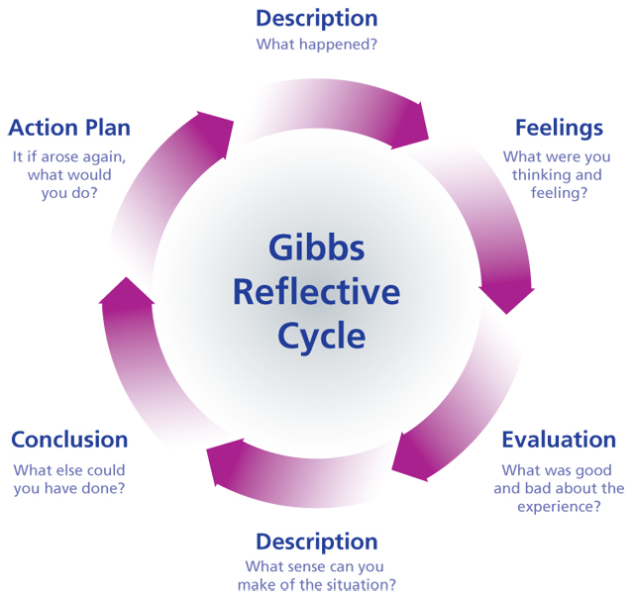

2.0 Using the Gibbs Reflective Cycle model to reflect about learning the Developing Workplace Critical Thinking module

During the first module Developing Workplace Critical Thinking on study year 22-23 I learn about Critical Thinking, Theories of Management, Inductive and Deductive Reasoning, Human Resource Management, McGregor's x and y Theory and Taylor Theories, Belief, Value and Attitude Scientific Management. Whit all this learn during the class sessions was involved whit a lot of group work and study case work
In my imagination, everything was different at the start of the module. I felt like I was in the wrong place when it came to critical thinking and management theory. I used to believe that management was based on what managers thought employees of a company should do and put into practise, but after learning more about different Management theories, such as Taylor's theory, I realised that these practises are still in use today.
Things that are bad I cannot say that I met during the module, the only bad thing was that I was thinking incorrectly, but after studying the module, I met only good things that helped me understand and fill some gaps that I did not understand correctly, and this module made me really understand critical thinking and management and helped me achieve my goals.
After studying this module, I can definitely state that, despite the fact that Taylor's theory is employed by managers, I will not put it into reality in the workplace since each individual employee needs the opportunity to prove that he can, and everyone gets paid for what he does not for what he does. I will never use critical thinking to solve problems; instead, I will use critical thinking to better my own cognitive process. Critical thinking is a thinking paradigm that demands me to be more reflective, to pay attention when making decisions that shape my views and behaviours.
If I had previously understood critical thinking, I would have been more curious, more open-minded to other parties, more analytical and persistent about the truth, confident in the critical thinking itself, and mature, but that is why I chose to study further in order to improve these qualities that this module made me truly understand.
Before I truly understood the need of critical thinking and many management theories, I may have overlooked contact with co-workers and used Taylor's theory as if I were mad to do so, and my critical thinking did not exist, but after that module, it did. My critical thinking has been greatly improved, and I will be lot more cautious, sceptical, and analytical before making a judgement. I will communicate more and consider what others around me believe when implementing critical thinking because everyone around us has value, and in the future if I become a manager or even at work, I will allow each colleague to express his or her point of view so that we can analyse it together, and if the idea is good, we will put it into practise and be rewarded accordingly.

3.0 References

- Gibbs' Reflective Cycle accessed on 26/11/2022 ,available at Gibbs' Reflective Cycle | The University of Edinburgh
- Gibbs’ Reflective Cycle Photo accessed on 27/11/2022 available at KE312: Module Reflection (cazzafah.blogspot.com)

