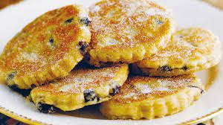
CARD PAYMENTS ONLY
V – suitable for vegetarians
GF- Gluten Free
Hotel Trinity Takeaway Special menu
(10am-7pm monday – Saturday)
Starters
Archwaethwyr

Garlic butter Mussels on Laverbread Bara Lawr (Welsh Seaweed Puree) ∼ 8.5

Crispy Calamari Mor-lawes ∼ 7

GF Garlic King Prawns Corgimychiad ∼ 7
Seafood and Traditional Welsh Cuisine!!

Mains
Prif Ddewislen

GF Faggots Ffagots (Juicy pork herby meatballs served with creamy mash, peas, and onion gravy) ∼ 13.5

Crispy Fresh Haddock with Homemade Chips and Locally Sourced Peas Pysgod a sglodion ∼ 12

Dessert
Pwdin

V Welsh Pancakes (Crempog) with delicious real dairy ice-cream ∼ 9.5
V Welsh Cakes Picau ar y Mae ∼ 6.0
V, GF Gelato and Sorbets Hufen ia (Ask in store for more flavours) ∼
1x scoop 1.5, 3x scoops 3.0

Drinks V
Bottled Wine Gwin potel
Gwin Gwyn (aromatic white wine) - 18
Casillero del Diablo Red Wine – 14

Real Welsh Beer
Tomos Watkin – 6
Brecon Brewing – 6

Soft Drinks
Orange juice - 2
Coca-Cola – 1.2
Lemonade – 1
Water 0.8

Please ask for allergy information and notify us of any allergies or intolerances when ordering.




Delivered to your door by:

Set Menu for 2– Collection Only! (2pm-6pm)
Dewislen Gosod

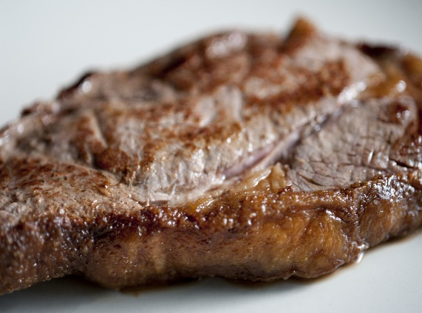
Starter
This Photo by Unknown Author is licensed under CC BY
Garlic butter Mussels on Laverbread - Bara Lawr
(Welsh Seaweed Puree)

Main
GF ‘Welsh Pork and Shells’ (Pan seared pork marinated in garlic and ginger with shellfish, doused in our house special white wine on a homemade chip-bed)
Best served with Gwin Gwyn house wine
or
GF Celtic Ribeye (Stec) With Lobster Tail and Calamari with House Salad (+£8)
Delicious with a glass of Casillero del Diablo

Dessert
V Crempog

32.00
Available to pre-order!!

