

MSc Public Health and Social Care in Practice

Module : Social Epidemiology and Public Health Development

Module Code : LCHS7000

Title : Component 2 Analytical Report

Student Name : Nirav J. Mistry

Student ID Number : 2436886

Lecturer Name : Dr. Jolly Nwankwo

Submission Date- 19th December 2025 (2pm)

Table of Contents
Task 1: Addressing Inequality in Gender and Health Among British Young Adults 3
1.0 Introduction 3
2.0 Contextual background and underlying factors 3
2.1 Higher rates of Mental Health Issues 3
2.2 Low Rates of Access to Healthcare and Social Services 4
2.3 Mortality rates among the younger group 5
2.4 Social Isolation and Loneliness 7
2.5 Poverty and Housing Issues 7
3.0 National Response to Reduce Health Inequalities 8
4.0 Organisations that Support Chosen Group 8
5.0 Conclusion 9
Task 2: Epidemiological Analysis of Parkinson's disease Among Older Adults (40-65 age) in the London Borough of Redbridge 10
1.0 Introduction 10
1.1 Overview 10
1.2 Definition and Consequences 10
1.3 Incidence and Prevalence 10
2. Main body 10
2.1 Public Health Measures 10
2.2 Risk Factors associated to the Disease 11
2.3 Epidemiological Studies and a Health Needs Assessment 12
2.4 Public Health Approaches and Strategies 12
2.5 Impact Assessment 13
2.6 Strengths and Weaknesses of the Epidemiological Approach 13
2.7 Conclusion 13
References 14

Task 1: Addressing Inequality in Gender and Health Among British Young Adults

1.0 Introduction
One of the major concerns associated with the healthcare system of the UK is the gender and health inequalities among the young adults. The target age group belongs to the age between 18 and 30 years. The young men and women receive different kinds of healthcare services, and this is highly influenced by gender expectations. There are various factors which are related to the gender-based health inequalities such as socio-economic factors, mental health problems and health policies to reduce the inequalities. This study will discuss these factors in order to address the issue of gender and health inequality among British Young Adults.

2.0 Contextual background and underlying factors

2.1 Higher rates of Mental Health Issues
The recent trends suggest that the higher rates of mental health issues and prevalence of suicide is more among the males than the females among the younger population in the UK. It is recorded that 17.4% males have committed suicide in 2023 while the rate for female is at 5.7%. One of the reasons is that the young women report their mental health conditions more than the men. As per the data of the NHS survey, about 36.1% of women reported mental health illness compared to 16.3% men. It is also observed that one in four people in the younger adult population in the UK suffer from mental health illness (McCloud et al., 2023). The gender norms regarding masculinity are one of the most significant reasons for which the men do not report about their mental health conditions. Moreover, the healthcare organisations give more priority to the women in this regard as they consider them sensitive. This kind of inequality in the attention to the male patients leads to the increase in the number of suicide rates.
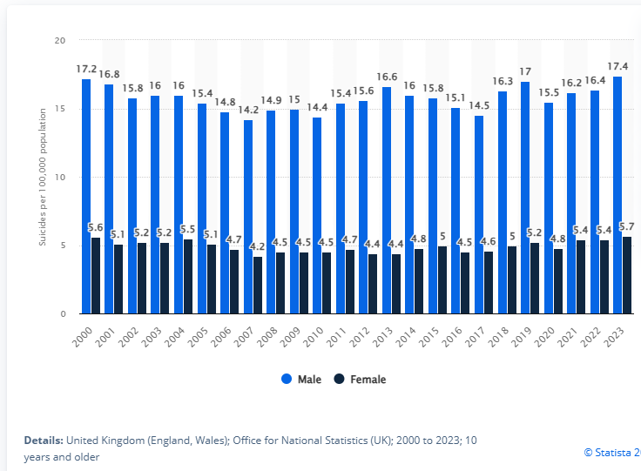
Figure 1: Rate of Suicide among Young Men and Women in the UK
(Source: Statista, 2023)

2.2 Low Rates of Access to Healthcare and Social Services
The waiting lists for the mental health services for young adults in the hospitals of the UK remains quite long, up to 18 weeks. The lack of funding and resources leads to long waiting lists (Punton et al., 2022). This factor directly impacts the physical and psychological social being of the patients. In cases of emergency, the patients are reported to the crisis teams of the UK’s National Health Service. It is observed that in June 2024, more than 45% of the British Young adult were urgently reported to the crisis teams.
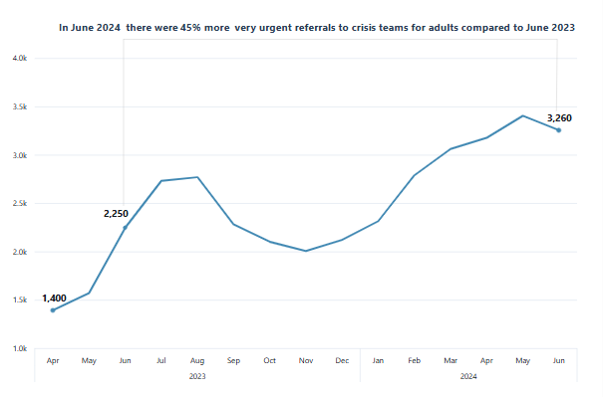
Figure 2: Trend of urgent referrals to crisis teams for young adults
(Source: Care Quality Commission, 2025)

2.3 Mortality rates among the younger group
One of the main causes of the higher mortality rates among the young group in the UK is suicide. Over the years, the rate of suicide has increased in different parts of the country, especially in the Northern Ireland. However, the mortality rate is less in the younger population as compared to the older adults. The total number of suicide deaths is much higher for males than the females.

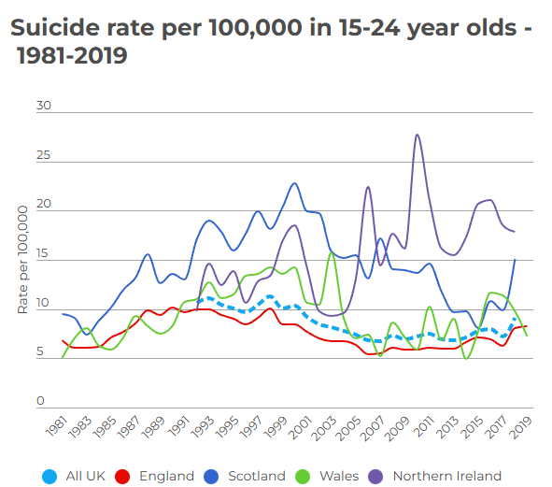
Figure 3: Suicide rate among the young British adults
(Source: RCPCH, 2023)

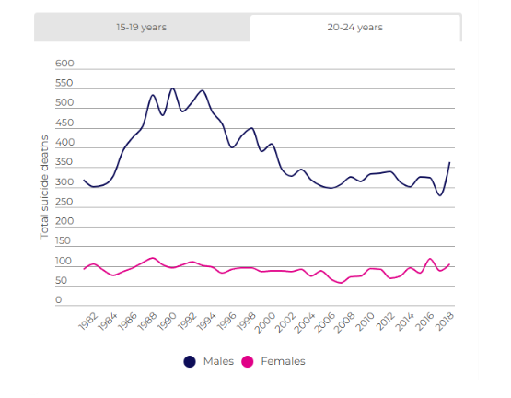
Figure 4: Variation in Sucide rate among British young adults by gender
(Source: RCPCH, 2023)

2.4 Social Isolation and Loneliness
The young people in the UK often suffer from loneliness and social isolation due to lack of friends and support from family. It is observed that 29.5% of young people with probable mental disorder have reported of always feeling lonely. However, the percentage stands at 5.2% for the young people without a mental disorder. Moreover, it must be noted that people who stay in the remote areas suffer more from loneliness than the people in the urban areas. Thus, the health organisations must reach out to the people in the remote areas.
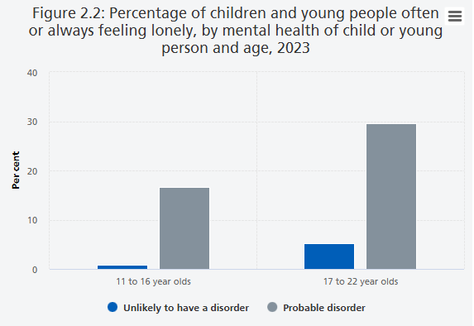
Figure 5: Percentage of young people feeling lonely in the UK
(Source: NHS UK, 2023)

2.5 Poverty and Housing Issues
The poverty and housing security related issues and financial pressure are the reasons for which the younger people do not take medical help. The young adults in the UK give more priority to their lifestyle and expenses related to food and shelter. Moreover, the young and homeless people do not receive adequate medical attention which needs to be taken care of by the national health organisations.

3.0 National Response to Reduce Health Inequalities
The government of the UK makes efforts to reduce the gender-based health inequalities among the young adults through health policies. The national health organisation which looks after the healthcare services in the UK is the NHS UK which is a publicly funded healthcare. The YLL rates in England have increased over the years and the rate is higher in females than in males. A cross-government effort known as NHIS has been adopted in order to reduce the health inequalities. The data of the public health are collected and interventions such health policies and awareness programmes are made to improve the living standards of the young men and women in the United Kingdom.
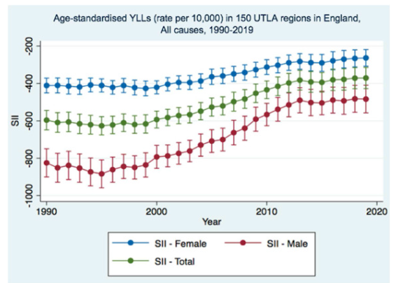
Figure 6: Rate of YLLs in the UK
(Source: Vodden et al., 2023)

4.0 Organisations that Support Chosen Group
The organisations which support the British young adults so that the gender-based health inequalities get reduced include NHS UK, Mind (UK Mental Health Charity) and Young Minds. The other organisations which provide support include the Prince’s Trust and Shelter. All these organisations ensure that the medical conditions of the British young adults belonging to the age group of 18 to 30 years gets reported and receive medical interventions. These organisations do not consider any kind of gender discrimination and treat each patient equally. The support for the macro-economic responses is the highest among the younger population in the UK. The initiatives taken by these organisations include awareness campaigns and reformation of health policies.

5.0 Conclusion
The gender and health inequalities among the British young adults aged 18 to 30 is one of the significant concerns of the UK healthcare system. This study highlights several underlying factors such as mental health issues, higher suicide rates among the young men and limited access to the healthcare services and issues related to poverty and social isolation. The traditional gender norms and financial and socio-economic pressures influence the gender-based health inequalities. The organisations such as NHS, Mind, and YoungMinds take initiatives to reduce the gender inequalities among the young population in the United Kingdom.

Task 2: Epidemiological Analysis of Parkinson's disease Among Older Adults (40-65 age) in the London Borough of Redbridge

1.0 Introduction

1.1 Overview
Parkinson’s Disease is one of the most prevalent neurodegenerative disorders that affects the older adults particularly in the age group of 40 to 65 years in the London Borough of Redbridge. The major symptoms of these diseases include tremor, rigidity, non-motor responses and postural instability (Parkinson’s UK, 2025). This study thus focuses on the epidemiological analysis of Parkinson's disease among the older adults (40 - 65 age) in the London Borough of Redbridge.

1.2 Definition and Consequences
The definition of Parkinson's disease is that it is a chronic and progressive neurodegenerative disorder which is caused due to the loss of dopamine producing hormones (Parkinson’s UK, 2025). The consequences of Parkinson's disease are multifaceted which includes loss of muscular coordination along with memory loss.

1.3 Incidence and Prevalence
In the United Kingdom, more than 1,66,000 people are diagnosed with Parkinson’s disease. As per the reports of the World Health Organisation, more than 10 million people are affected by this disease worldwide (WHO, 2023). However, men are at higher risks of developing the disease as compared to female older adults.

2. Main body

2.1 Public Health Measures
Parkinson’s disease (PD) is one of the emerging health problems for the elderly population in London. This disease can be really concerning as the population is ageing and the life expectancy and awareness of diagnosis is also increasing. The PD is not only a chronic neurological condition, but a long-term condition with great implications on the health care system (Bloem et al. 2020). Moreover, it also involves social care, and quality of life from a public health perspective. The main emphasis of the UK on PD is based on early diagnosis, integrated care pathway, and long-term disease management. As of 2025, approximately 166,000 people have been diagnosed with Parkinson’s disease in the UK, with the average age of patients being 77 and the typical age at diagnosis around 69 (Parkinson’s UK. 2025).
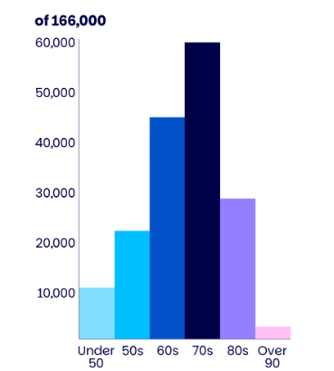
Figure 7: Parkinson’s Age diagnosis in the UK
(Source: Parkinson’s UK. 2025)
National Health Service (NHS) initiatives in the UK such as community neurology services, memory and movement disorder clinics aim to reduce diagnosis delays and enhance community care for the older adults. Moreover, the NHS has a Long-Term Plan on individual care and early intervention which supports the PD patients in London.

2.2 Risk Factors associated to the Disease
The most significant risk factor of Parkinson disease is age with the majority of the patients being diagnosed above the age of 60. With the older population in London, the pressure of PD will continue to rise. Research indicates that men have higher chances of getting afflicted with Parkinson’s disease as compared to women. Genetic factors also contribute to the cause but at a very low percentage. Moreover, environmental and lifestyle factors are also a major cause. The issue of the environmental risk factor is applicable in metropolitan areas such as in London Borough of Redbridge. Recent studies by Bryson et al. 2024 have highlighted the risk of developing Parkinson disease to long term exposure to air pollutants such as fine particulate matter (PM2.5). The older adults who lived in London for a long time may also be concerned about the issue of traffic related pollution. The UK's approach relies heavily on General Practices (GPs), as approximately 98% of the UK population is registered with a GP, and more than 90% of NHS contacts occur in general practice (Okunoye et al. 2022). Population studies also find that PD has been linked to occupational exposure to pesticides and industrial chemicals.

2.3 Epidemiological Studies and a Health Needs Assessment
Epidemiological research offers good information in terms of parkinsonism disease and assists in health planning to the general population. According to recent UK-based investigations, it might appear that the prevalence of Parkinson’s disease was relatively constant across the years considering the age factor. For example, past estimates suggested an estimated prevalence of 447 cases in Redbridge compared with lower counts in some other boroughs (Parkinson’s UK. 2025). Nevertheless, the general population with PD is on the rise due to the fact that individuals are living and surviving longer with the disorder. National data suggest that approximately one in sixteen people diagnosed with PD in the UK were under 50, and over one in three were under 67 at diagnosis, indicating that the 40–65 group are part of the at-risk population. These results underscore the prevalence as well as incidence and disease duration in evaluating the health needs. Risk modifiers have also been reported to be cardiometabolic conditions like hypertension and type 2 diabetes in various UK populations. East London primary care study revealed that the conditions were linked to subsequent PD diagnosis (UK Biobank. 2025).

2.4 Public Health Approaches and Strategies
Examining the incidence and the progression of Parkinson’s diseases in Redbridge depends on wider data points which are routine healthcare data, specialist referrals, and research. GP record and hospital based national studies suggest that the prevalence of Parkinson across London boroughs was quite heterogeneous. 447 cases were estimated in Redbridge in the past with lower figures in case of other boroughs. Although such numbers represent larger age groups and older data. They contribute to the possibility of showing the relative disease occurrence in the area. Research within the country also points to gaps in the diagnosis. Research shows that over 20,000 individuals in the UK have undiagnosed Parkinson’s (Parkinson’s UK. 2025).

2.5 Impact Assessment
Parkinson disease has great short- and long-term implications on individuals, families and health services. Short-term effects on motor and non-motor symptoms, work capacity, daily functioning, and mental well-being can be anticipated in the 40-65 age group. As time elapses, the gradual disability highlights healthcare and social services. Moreover, the overall economic impact is rising because of the lost productivity and the use of more services. These effects are compounded within Redbridge by specialists, and social determinants.

2.6 Strengths and Weaknesses of the Epidemiological Approach
The epidemiological methodology in this report relies on big data primary care databases and national prevalence surveys, which offer wide coverage and can be compared between locations. It is possible to incorporate routine health data with population health planning to achieve evidence-based interventions. Nevertheless, they have limitations such as there is a possibility of being affected by the practice of recording GP diagnoses, and they may not capture early or unusual presentations. The local PD surveillance systems of Redbridge do not exist and the available data lacks full coverage of the undiagnosed diseases.

2.7 Conclusion
Parkinson’s disease among adults aged 40–65 in the London Borough of Redbridge represents a growing public health concern. Early- and mid-onset cases indicate the significance of early-stage diagnosis, comprehensive care, and specific interventions in the population. Epidemiological data suggest that age, sex, comorbidity, and environmental exposures are risk factors of the disease. Moreover, social determinants and access to health services affect the outcome and health disparities. Redbridge has developed the basis of managing Parkinson disease through the public health measures of GP education, referral pathways, and community-based rehabilitation. The interdisciplinary care, multidisciplinary care, community support, caregiver education, and methods of dealing with digital and social inequalities should be the components of a comprehensive health intervention programme. The measurement of such programmes based on the outcomes of patients, service utilisation, and equity indicators will enable continuous improvement. In addition, this will also make sure that the interventions used are sustainable, effective, and responding to locals. In addition, the burden of Parkinson’s diseases among this population needs to be minimised with the help of systematic and locally specific approaches.

References
Bloem, B.R., Henderson, E.J., Dorsey, E.R., Okun, M.S., Okubadejo, N., Chan, P., Andrejack, J., Darweesh, S.K. and Munneke, M., 2020. Integrated and patient-centred management of Parkinson's disease: a network model for reshaping chronic neurological care. The Lancet Neurology, 19(7), pp.623-634.https://doi.org/10.1016/
Bryson, S., 2024. New study supports causal link between air pollutant, Parkinson’s. [online] Parkinson’s News Today. Available at: https://parkinsonsnewstoday.com/news/new-evidence-uk-supports-causal-link-air-pollutant-parkinsons/ [Accessed 16 Dec. 2025].
Care Quality Commission., 2025. Mental Health - Care Quality Commission. https://www.cqc.org.uk/publications/major-report/state-care/2023-2024/access/mh?utm_.
McCloud, T., Kamenov, S., Callender, C., Lewis, G. and Lewis, G., 2023. The association between higher education attendance and common mental health problems among young people in England: evidence from two population-based cohorts. The Lancet Public Health, 8(10), pp.e811-e819. https://www.thelancet.com/journals/lanpub/issue/vol8no10/PIIS2468-2667(23)X0010-3
NHS UK., 2023. NHS Digital Mental Health of Children and Young People in England, 2023 - Wave 4 follow up to the 2017 survey. https://digital.nhs.uk/data-and-information/publications/statistical/mental-health-of-children-and-young-people-in-england/2023-wave-4-follow-up/part-2-sleep-loneliness-activities-and-health-behaviours?utm_.
Okunoye, O., Marston, L., Walters, K. and Schrag, A., 2022. Change in the incidence of Parkinson’s disease in a large UK primary care database. npj Parkinson's Disease, 8(1), p.23.https://doi.org/10.1038/s41531-022-00284-0
Parkinson’s UK., 2025. What is Parkinson’s? https://www.parkinsons.org.uk/information/about-parkinsons/what-is-parkinsons?
Parkinson’s UK., 2025. Parkinson’s statistics. [online] Available at: https://www.parkinsons.org.uk/information/about-parkinsons/statistics.
Punton, G., Dodd, A.L. and McNeill, A., 2022. ‘You’re on the waiting list’: An interpretive phenomenological analysis of young adults’ experiences of waiting lists within mental health services in the UK. Plos one, 17(3), p.e0265542. https://doi.org/10.1371/journal.pone.0265542
RCPCH., 2023. Suicide – RCPCH – State of Child health. https://stateofchildhealth.rcpch.ac.uk/evidence/mental-health/suicide/?utm.
Smith, K.E., Macintyre, A.K., Weakley, S., Hill, S.E., Escobar, O. and Fergie, G., 2021. Public understandings of potential policy responses to health inequalities: Evidence from a UK national survey and citizens’ juries in three UK cities. Social Science & Medicine, 291, p.114458. https://doi.org/10.1016/j.socscimed.2021.114458
Statista., 2023. Mental health issues in the UK. https://www.statista.com/statistics/282203/suicide-rate-in-the-united-kingdom-uk-since-2000-by-gender/ [Accessed on 17 December 2025].
UK Biobank., 2025. Risk factors and Parkinson’s disease presentations in primary care in a diverse UK population. [online] Available at: https://www.ukbiobank.ac.uk/publications/risk-factors-and-parkinsons-disease-presentations-in-primary-care-in-a-diverse-uk-population/\ [Accessed 16 Dec. 2025].
Vodden, A., Holdroyd, I., Bentley, C., Marshall, L., Barr, B., Massou, E. and Ford, J., 2023. Evaluation of the national governmental efforts between 1997 and 2010 in reducing health inequalities in England. Public Health, 218, pp.128-135. https://doi.org/10.1016/j.puhe.2023.02.021
WHO., 2023. Parkinson disease. https://www.who.int/news-room/fact-sheets/detail/parkinson-disease?utm.

