Effective Team Work and Communication

Tutor: Dr Alfred Mensah

Student Name: Mohammed Ashraful Mowla
Student ID: 1922118

Table of Contents
Introduction 3
Communication models 4
Communication skills 6
Poor communication in the workplace 8
Suggestions for improvement 10
Conclusion 12
Reference 13

Introduction
Both teamwork and communication are crucial for the success of a team. If there is a lack of consistency in the communication among the team members, the team will not be successful in performing the tasks. This paper demonstrates an understanding of some communication models including linear model, Shannon-Weaver model and Berlo’s Model. It also includes the required communication skills like positive body language, active listening, group work, personal exposition, use of IT, problem-solving skills etc. referring to a case study on a team of students. It also involves a demonstration of poor communication in the workplace using examples from the workplace. Finally, the paper provided some suggestions for the improvement of the team with poor communication in the workplace.

Communication models
Communication models mean the journey of data and information along with the method of data exchange between the sender and the receiver (Han et al., 2012). Understanding of some models of communication during this course is demonstrated below –
Linear model
Hence, the recipient does not receive an incentive clause as part of the change process. The receiver receives the notice anonymously and is stated or executed as desired under the direction of the dispatcher.
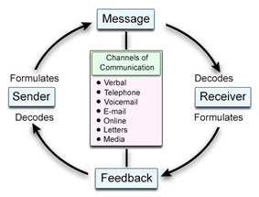
Figure: Linear model of communication
Source: Amiri et al., (2015)
Shannon-Weaver Model
Here, the message begins with a record, and then it is transmitted through an encoder, and then sent close to the collector through a signal. Instead of reaching the recipient of the message, it is necessary to go through any questionable constraints’ resources, that is, noise. In addition, the future recipient will have access to their own excursions.

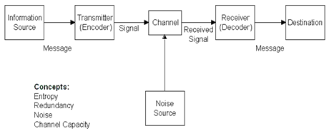
Figure: Shannon-Weaver model of communication
Source: Boholm, (2013)
Berlo’s Model
Here, each encoder and decoder have 5 factors that affect and resolve the stability of the communication. Therefore, Berlo makes this message very elaborate. The beneficiary of the message-channel understands that the sender and the message are very important for communication, as there is no oraldeal without the saver.
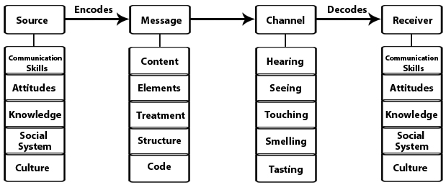
Figure: Berlo’s model of communication
Source: Dwyer, (2012)

Communication skills
In completing the required tasks of this running course, a group of students is developing high-quality output, as well as a high level of collaboration. Their reporting always has positive feedback about other members of the team, and there was no demand or obligation from one team member to another for the semester. Team gatherings were always favourable, and at no point was the team awkwardness. The team has always focused on the study and how to improve the improvementprocedure by studying the expectations of the teachers and classmates. Investigation of the data collected from this group’s members showed that they had some communication skills necessary for their successful operation. These are as follows –
Positive body language
This includes the non-verbal message, facial jargon, harmony and so on (Kuhnke, 2012). In the workplace, the mentioned team communicated through positive body language which helped them to be successful.
Active listening
Listening to the interlocutor actively is another important communication skill. It may not be the most effective of the sentences people speak, but they also show the application of calmness, soft-mind, excitement, etc. The members of the mentioned team actively listen to each other in the workplace.
Group work
In the place of work, group work skills are also important for communication that can be formal or informal. This skill helpsthe mentioned team members to do any kind of critical work in a short time.
Personal exposition
This skill includes providing relevant indicators for the situation and for other options (Clark and Mayer, 2012). Those who do not change themselves and do not feel confident will not be able to communicate effectively or fully utilise their abilities and skills depending on how they expose themselves.
Use of IT
It refers to the use of the devicesused by a member of the mentioned team. Surrounding devices can determine how optimal technology works, and context can be used more flexibly by the IT users than the people who do not use mobile, Smartphoneor other devices.
Problem-solvingskills
Working in a team needs the skill to solve any problem that aids the members of the mentioned teamto face important problems (Malekoff, 2015). Decisions aremade by themconsidering the social environments that helpconnections flourish when difficulties arise.

Poor communication in the workplace
One more team of students was involved in this course which experienced difficult team issues, resulting in indigestion and forced separation. In the first assessment session, group members were assigned a grade, as some group members did not contribute. At this meeting, an agreement was reached to replace the signs, suggestions were made to improve the situation, and opposition from group members intensified. This can be clearly seen from the weekly secret reporting. The teacher held several meetings with the team leader and members to help solve the problem, but to nothing availed. There was a disagreement in one of the team meetings, in which some members of the group verbally resented the other, and there was no reconciliation from that moment on. After this, the group members realised that they could no longer work together, so even though they felt a heavy burden, they unanimously agreed to divide and form two separate teams. Abreakdown of the answers given by the successful team mentioned earlier showed that this group is well versed in the qualities required for successful work. Comparing the answers of this group with the key characteristics required for a successful team, it became clear that this group did not meet somenorms, such as –
Loyalty to team achievements and common goals
One member of the team was motivated to get higher quality output, but the others managed to get just one pass, which meant they were happy to spend less effort. The mismatched pair of expectations caused a lot of difficulties to the moods of the team members at the beginning of the semester.
Interdependence
In this team, two team members were competitive in developinga synergistic group environment. They focused on personal responsibilities and did not want to help the needy. If others are not involved, the person should be evaluated instead of trying to support others. This led to a lack of team unity and cooperation, a sense of self-liberation and, as a result, the team split.

Personal skills
The team paid little attention to each other and could not support others in hardsituations. The team members were incomprehensible and were surprised that their comments angered other members of the team. They do not see that their comments and methods used to solve the team's problems make others feel better.
An open and positive reaction
The opinions of team members revealed that peers are not indifferent to their situation and problems and are unwilling to discuss problems, as they only attract criticism and negative feedback. As a result, group members did not communicate freely or discuss issues that could potentially harm the group.
Relevant group creation
This team was formed randomly were three original members of the group quickly discussed in class and decided to form a team, and a week later another member of the team arrived, so the team agreed to accept him into their group, as they were required four people. Requirements and skills were not cautiouslymeasured.

Suggestions for improvement
If the team with poor communication follows the suggestions mentioned below, it can be improved –
Pursuing an open-door policy
The open-door policy builds confidence and provides a situation where members can ask questions, speak and come up with ideas when wished (Brookfield, 2015). This is avital part of building trust in the team. The inconvenience of management sends a note to lower-level workers that they are not so important. It is very important to keep the door open for them.
Being open to criticism
This means to be constructive to get the most out of the response which is alsosignificantto make it clear to all parties (Seligman, 2012). A simple "repair” in response to the output does not benefit anyone. For auseful response, the response must be obvious and comprehensive. If it is made public, then there are bonus points that they can learn from others. The team members should not forget to get feedback and they all need positive criticism.
Being specific about the assignment
If the members do not know what tasks they will be responsible for, then they will not be able to do any work effectively (Chemers, 2014). The team leader needs to ensure that the entire team knows the scope of the task and that each member of the team is specific about what is expected from them. Along with bringing the team repeatedly to make suregrowth, leaders should ask questions and resolve any issues which are another great way to monitor everything and ensure that all group members take their responsibilities in the task.
Making fun things to hang out
Team building activities have been utilised to perk upcontact between team associates (Katzenbach and Smith, 2015). But instead of role-playing games or some other activity that no one really likes, the team should arrange a playful environment or have a post-workout dinner party within a period.
Setting a goal for the coffee break
In the fortitude of teamwork, a coffee break set for all workerspermitseverybody to cooperate informally while at work. Coffee is a daily fuel, so the team should try to make it enjoyable and productive simultaneously. Studies show that talking in the time of drinking coffee, whether about the work or not, inspire good communication and exchange of thoughts between colleagues.
Emphasising strengths, and making good use of them
The team leader should remember that everyone wants to be behaved inanequal manner (Marczewski, 2013). Some prefer written communication, and some benefit the most from phone calls, video chats, or in-personconversations. This not only allows the team members to understand that everyone is different and builds a good relationship; it also sends a note to the team members that the leader should value them as individuals. This type of relationship will work best for the mentioned team as a self-esteem group member strives to move forward for the team.

Conclusion
The paper showed the applications of some models of communication in the group activities. It also showed the skills required for the success of a team that is important for the communication among the members of the team. Using applicable case studies, it is shown that, the communication skills lead the team toward success while lack of these skills can lead to poor communication within the team and failure in the output consequently. If the unsuccessful team follows the provided suggestions, they can improve communication within the team and increase their possibility of success.

Reference
- Amiri, A., Koosha, M., Azhdari, A. and Wang, G., 2015. Phase I monitoring of generalised linear model-based regression profiles. Journal of Statistical Computation and Simulation, 85(14), pp.2839-2859.
- Boholm, A. ed., 2013. New perspectives on risk communication: uncertainty in a complex society. Routledge.
- Brookfield, S.D., 2015. The skillful teacher: On technique, trust, and responsiveness in the classroom. John Wiley & Sons.
- Chemers, M., 2014. An integrative theory of leadership. Psychology Press.
- Clark, R.C. and Mayer, R.E., 2012. Scenario-based e-learning: Evidence-based guidelines for online workforce learning. John Wiley & Sons.
- Dwyer, J., 2012. Communication for Business and the Professions: Strategie s and Skills. Pearson Higher Education AU.
- Han, Z., Niyato, D., Saad, W., Başar, T. and Hjørungnes, A., 2012. Game theory in wireless and communication networks: theory, models, and applications. Cambridge university press.
- Katzenbach, J.R. and Smith, D.K., 2015. The wisdom of teams: Creating the high-performance organisation. Harvard Business Review Press.
- Kuhnke, E., 2012. Body language for dummies. John Wiley & Sons.
- Malekoff, A., 2015. Group work with adolescents: Principles and practice. Guilford Publications.
- Marczewski, A., 2013. Gamification: a simple introduction. Andrzej Marczewski.
- Seligman, M.E., 2012. Flourish: A visionary new understanding of happiness and well-being. Simon and Schuster.

