

A critical analysis of what influences and encourages consumers to purchase electric vehicles in the UK.

By: Rhys Matthews
1811161
BMBM5001

Abstract
The aim of this dissertation was to analyse what influences and encourages consumers to purchase electric vehicles (EV’s) in the United Kingdom. This study looks at the advantages and disadvantages of ownership whilst looking at the different incentives and encouragements of purchasing.
The researcher conducted a significant review of existing literature which gave a better understanding of perceptions held by existing owners as well as what discourages others from switching over to electric. The findings discovered from the literature review were used to create survey questions
A questionnaire was created and distributed online through email and Facebook to appropriate candidates to which there was a total of 114. Two interviews were scheduled however, due to the covid-19 pandemic these were no longer possible within the timeframe. The finding from the primary research in chapter four support much of the themes from literature in chapter two. These being that battery range and the charging infrastructure is one of the largest concerns and discourages consumers to go electric. Another theme found that the technology and environmental benefits are among the top encouragements to purchase an EV.

Contents

Chapter 1 5
  - Background 6
1.2 Rationale 6
1.3 Aims and objectives 7

Chapter 2 7
2.1 Introduction 7
2.2 Popularity of EV’s in the UK 8
2.3 Popular concerns 8
2.4 Charging 9
2.5 Price 9
2.6 Pollution from EV’s 10
2.7 Government Grant 12
2.8 Tax benefits 13

Chapter 3 13
3.1 Introduction 13
3.2 Questionnaire pilot 14
3.3 Analysis 14
3.4 Sample 14
3.5 Reliability and validity 15
3.6 Limitations 15
3.7 Ethical considerations 16

Chapter 4 16
4.1 Introduction 16
4.2 Demographics 17
4.3 Discussion 23

Chapter 5 23
5.1 Introduction 23
5.2 Achievement of objectives 23
5.3 Main findings 23
5.4 Further research 24
5.5 Conclusion 24
5.6 Self-reflection 25

Bibliography 26
Appendix 30
Copy of questionnaire 30
Copy of answers 34
Question 9 34
Question 11 37

Chapter 1 - Introduction
The purpose of this assignment is to undertake a review of available literature concerning incentives and influences that motivate consumers in the United Kingdom (UK) to purchase electric vehicles. Following feedback from my proposal I have decided to alter the objectives to narrow down my research. I will review the perceptions held by vehicle owners to understand what encouraged them to purchase their chosen vehicle through both primary and secondary research. My main source of primary research will be through conducting questionnaires as well as interviewing electric car owners and electric car dealerships, using findings from my secondary research to assemble my questions. The majority of my secondary research will be undertaken online using google scholar to find existing articles, government and official websites, other appropriate websites, relevant books and newspaper articles. The review of literature from this chapter will be used to design questions for my primary research questionnaire which will be used to gather data for this assignment. Due to the ongoing pandemic my primary research will be limited, resulting in my questionnaire having to be circulated mostly online and face to face interviews will now have to take place over the phone. The rationale for this topic is in relation to electric vehicles appearing to become increasingly popular and I want to discover what is influencing British motorists to make the change from traditional petrol and diesel cars to electric.
Electric powered vehicles are the only mainstream alternative at the moment with other options such as hydrogen and biofuel being years behind in the development process (RAC, 2018). There are a large number of studies on both the advantages and disadvantages of electric vehicle ownership with a high percentage of data being American. However, since the focus of this research is on British consumers, these will not be reviewed in too much detail and will only be referred to as appropriate.

1.1 Background
When consumers make purchase decisions, they face so many alternatives due to the endless access to information, connections to reviews and various studies (Chiang, 2014). This dissertation will compare findings and analyse research to understand what influences and encourages consumers in the UK to purchase electric vehicles.
Electric vehicles have been widely covered by researchers and scientists who have investigated the environmental implications, battery efficiency and how the country's infrastructure must adapt to accommodate a large population of these cars. The information that is not as easily accessible however, is that of how electric vehicles are causing a greater damage to our environment than we are led to believe. A report by the European Environment Agency highlights that CO2 emissions from electric car production are 59% higher than the level in production of traditional vehicles (RAC, 2020). The researcher wishes to explore whether this information as well as other aspects including price, charging availability and others that affect consumers purchasing decision regarding vehicles.

1.2 Rationale
By having a strong interest in cars and technology, an exploration into the research of these subjects has opened avenues to the prominent topics. From analysing the area of study, there appears to be an absence of research related to what encourages consumers to purchase electric vehicles.
Internal combustion engines powered the first cars back in 1885. These relied on petrol or gasoline to fuel the engine, which would send power to the wheels for the vehicle to move (Daimler, No Date). Although this principle has been tweaked over the years, fossil fuel is still the main form of energy used to power most of the cars on our roads. Electric vehicles are seen as one of the biggest advancements in the modern-day automotive industry (Smith, 2019). As well as understanding what influences consumers to purchase these vehicles, the researcher hopes to further understand the advantages and disadvantages of EV’s.

1.3 Aims and Objectives
The aim of this dissertation is to critically evaluate what influences and encourages consumers to purchase electric vehicles in the UK. The objectives are:
- To critically analyse literature on the public’s perception of electric vehicles and understand the advantages and disadvantages of ownership.
- To conduct a questionnaire and analyse the collected data to understand the reasonings behind the purchase of the respondent’s vehicle as well as obtaining their thoughts on EV’s.

Chapter 2 - Literature Review

2.1 Introduction
The intent of this chapter is to carry out a review of existing literature concerning the topics that encourage and discourage consumers to purchase electric vehicles. This literature review aims to achieve the first research objective of this dissertation:
To critically analyse literature on the public’s perception of electric vehicles and understand the advantages and disadvantages of ownership.
To meet the objective, this chapter will utilise sources such as government publications, newspaper articles, academic journals as well as other secondary research. This research will be considered when designing the primary research with the questions being based off appropriate findings.

2.2 Popularity of electric vehicles in the UK
Figures from the Society of Motor Manufacturers and Traders (SMMT, 2020) show that as of March 2020, plug-in hybrid electric cars formulate around 7.3% of new UK car registrations with pure electric models accounting for 4.6% of that figure. The first three months of 2020 have been very positive with regards to plug in hybrid electric vehicles. In comparison to the same time as last year this figure has increase by 120%. Fully electric vehicle registrations are up 205% from the same time frame with just over 18,000 vehicles being sold (SMMT, 2020). From these official figures we can see that the number of both hybrid electric and fully electric vehicle registrations are increasing year after year in the UK (Lilly, 2020).
No official study has been conducted to accurately establish the reasons why more British consumers are purchasing electric vehicles,, however a global survey (Deloitte, 2018). found that the top reasons people are considering purchasing electric vehicles are because of lower operating cost, lower emission/ environmental responsibility and tax incentives.

2.3 Popular concerns
According to Statista (2018), 26% of consumers state that their greatest concern regarding electric powered vehicles is the driving range available due to battery lifespan. The average electric car has just a 181-mile range before requiring another battery charge (Newmotion, 2016). A study by Deloitte (2018) showed that the driving range was highlighted as the main barrier for purchase in many other countries such as Germany, Belgium and China. This further proves that driving range due to battery span potentially may be the biggest reason that consumers are apprehensive about switching over. According to Vantage Leasing (2019) the second most voted concern was the price of these vehicles, with 24% of respondents stating that the price of purchasing and running an electric vehicle is too high. The cost of buying an electric vehicle compared to a petrol/diesel vehicle is approximately 18% higher according to the study by Vantage Leasing (2019). However in a study by Hodges (2018), electric cars are predicted to cost the around the same as its counterparts by 2025 if the price of producing the lithium ion batteries used to power the EV’s continue to fall at the same rate as it has for the past few years. The third largest concern is the lack of electric vehicle charging infrastructure around the country according to 22% of respondents (Statista, 2018). However, as of 2019 the UK has more electric vehicle charging stations than fuel stations (Tyrell, 2019). This shows that action is being taken to resolve this issue and further improve access to charging stations. As this survey was conducted in 2018, I will implement this same inquiry into my questionnaire to understand if the same concerns are still as relevant today or if new concerns have arisen.

2.4 Charging
One of the biggest concerns over the past few years that people have regarding electric and hybrid vehicles is the access to charging. With the range of an electric vehicle being substantially less than traditional vehicles, having an expansive charging infrastructure is vital to further boost the mass adoption of EV’s (Department of Transport, 2019). Since 2015 the number of public charging devices has grown by 312%, with a total of 31,566 connectors available at 11,327 different locations across the UK (Zap-map, 2020). With online communities such as zap-map, locating these chargers are becoming easily accessible with services like route planners, charging guides and online community support.

2.5 Price
As with conventional vehicles, one of the most important factors consumers consider when purchasing electric vehicles is the price (Dow, 2019). Only new vehicles will be considered as the price of second-hand cars vary depending on the history of the vehicle and the condition. According to Statista (2019), the most popular hybrid electric vehicle in the UK is the Mitsubishi outlander, which has a starting price of £35,500 (Mitsubishi Motors, 2020). The same vehicle but with a petrol engine starts at £29,500 which is £6,000 cheaper (Mitsubishi Motors, 2020). Due to the fact that the government grant for hybrid vehicles was abolished in 2018, there is a significant price difference between the two models. According to a study conducted by Motor1 (2019) in 2019, 91% of new vehicles were bought on finance with the most popular options being for 3 to 4 years. Using the Halifax car finance calculator, the monthly payments for the hybrid version of the Mitsubishi outlander is £738 over the course of 4 years and the cost for the petrol version is £602 over the same period (Halifax, 2020). Considering the savings of being able to charge at home the cost is not substantially more expensive, but it is easy to understand why consumers would choose the petrol option. The same Statista study found that the most popular fully electric car is the Nissan Leaf, which starts at £26,850 (Nissan, 2019). Using the government grant would decrease the price to £23,350 which is only £2,900 more expensive than a new ford focus, the most similar car to the Nissan leaf but with a petrol engine (Ford, 2020). Even though the purchase price of an electric vehicle is slightly higher than a conventional vehicle, better technology and improvements in energy density will continue to drive these prices lower (Walker, 2019). Experts suspect EV’s to reach cost-parity with conventional cars within the next five to ten years (Walker, 2019).

2.6 Pollution from electric vehicles
Electric cars are advertised as an eco-friendly mode of transport with minimum environmental impact (Sinn, 2019) however, this topic is controversial due to the fact that some studies show they can be just as polluting as petrol powered vehicles (ICCT, 2018). Driving an electric vehicle in itself may not cause any pollution however, the way the electricity is generated, causes the most damage. According to Energuide (2020), 60% of the world’s electricity is generated by fossil fuels meaning that in some cases an electric car can produce as much co2 per kilometre as a petrol or diesel vehicle.
The UK generates the majority of its energy from coal-powered plants, which has several downsides for the environment. The government plan to close all coal power plants by 2025 however, instead of focusing on environmentally friendly ways to create energy such as wind and solar, the government is keen to replace them with fracking or nuclear energy – neither of which are green alternatives (Downes, 2020). This means that the majority of electric cars around the UK will have a negative environmental impact unless electricity is generated another way (Downes, 2020). From a consumer’s point of view, to be able to charge their car at home causing as little environmental impact as possible, they would have to utilise solar power or a windmill to generate the energy which would be stored in a battery ready to be used. However, that comes at great expense and not every household would have the necessary facilities or financial means (The Green Age, 2020). The International Council on Clean Transportation (2018) concluded that a third of the lifetime co2 emissions from an electric car comes from the energy required to produce the vehicle. This is due to the manufacturing of the lithium ion batteries which are an essential part of an electric car. It seems that consumers are only made aware of the positive impacts of EV’s and not how much of an environmental burden goes into the production process (Browne, 2020).
Controversially, at the start of 2020, the car manufacturer Tesla received permission from the German court to cut down and clear 91 hectares of forest land, this equates to the size of 170 football fields (Browne, 2020). The rationale for the destruction of the forest was to enable Tesla to build a purpose-built establishment purely to focus on the construction of electric vehicles (Browne, 2020). This has faced a backlash from Tesla supporters as well as environmentalists but after receiving this negative attention the company has vowed to replant three times the number of trees they remove (Bloomberg, 2020). Although this was a controversial decision, it could be argued that the positives will outweigh the negatives in the future.

2.7 Government Grant
Since 2011 the UK government has issued grants for the purchase of new electric and hybrid electric vehicles that meet a certain criterion (Vaughan, 2011). The vehicle must be able to drive a minimum of 70 miles off a single charge in order to be eligible with grants of £5,000 off the purchase price with the aim of encouraging consumers to purchase these over standard petrol/ diesel cars (BuyaCar, 2019).
In March 2020 the grant had to be lowered to £3,000 after a surge in orders exhausted funds much sooner than expected (Allen, 2019). This also meant that the grant for hybrid electric cars was axed completely resulting in the cost to purchase a new hybrid car had increased. The new budget also removed the grant for any electric cars over £50,000 which affects popular models such as the Tesla model S and the model X (BuyaCar, 2019). Since the grant was set up back in 2011 it has contributed in the sale of over 200,000 new electric vehicles (Hull, 2020). The grant reduction for each vehicle has meant that the budget has been extended for a further three years to 2023, which by then there will be a number of cheaper electric vehicles that more of the population will be able to afford. Alongside this, the UK government has also set the target of banning the sale of all petrol and diesel cars by 2040 as well as increasing congestion costs to drive these vehicles in cities such as London, giving more of an incentive for people to go electric (EDF, 2020). This shows that the UK government are fully behind the adoption of electric vehicles and are encouraging consumers to purchase them with a number of incentives.

2.8 Tax benefits
A survey by Centrica found that between 2021 and 2023 British companies are expected to invest £12 billion to switch their fossil fuel vehicles over to electric (Ambrose, 2020). According to the department of transport (2019) 8.8% of cars on the road are registered to a company or business, with a third of those stating that the governments looming ban on petrol on diesel cars has influenced them to make the switch to electric. Another incentive for businesses is the multiple tax benefits which include exemptions from fuel duty, vehicle excise duty, company car tax, van benefit charge and fuel benefit charge. Also, electric vehicles have enhanced capital allowances benefits with a 100% allowance in the first year meaning that businesses can claim the entire cost of an electric car or van against taxable profits in the first year of purchase (NIBusinessInfo, 2020). Although this dissertation does not look at electric cars for businesses use, a study by Fully charged (2019) found that 88% of people who switched to electric vehicles would never go back to petrol or diesel meaning that if an increased number of workers use EV’s then they would be more likely to consider obtaining one for personal use.

Chapter 3 - Methodology

3.1 Introduction
Chapter 2 achieved the first objective of this study and has outlined the most popular advantages and concerns people have when considering electric vehicles. This chapter seeks to achieve the second objective:
To conduct a questionnaire and analyse the collected data to understand the reasonings behind the purchase of the respondent’s vehicle as well as obtaining their thoughts on ev’s.
In order to meet this objective, the most suitable methodology has been identified to conduct primary research.

3.2 Questionnaire Pilot
A pilot study was conducted to ensure that the questionnaire was clear, appropriate and included correct options to answer each question. To test for clarity, the pilot study was sent to a sample of 15 people to certify that the online survey was applicable for the intended participants.

3.3 Analysis
To analyse the quantitative data gathered from the online questionnaire, the software Microsoft Excel will be used. This will allow for an in-depth breakdown of the results by using the statistics and text analytics program to identify patterns that can be converted into visuals such as charts to better understand (Foley, 2018). The open-ended questions will be reviewed using a thematic approach to discover any trends or common themes. Closed-ended questions provide the researcher with quantitative data and open-ended questions provide qualitative information. Seliger and Shohamy (1989) are of the assumption that closed ended questions are more efficient due to their ease of analysis however, Gillham (2000) argues that open ended questions lead to a better level of discovery.

3.4 Sample
A purposive sample for this research was selected, which comprised of people that owned or had access to a vehicle. According to DePaulo (2011), obtaining a large sample size broadens the range of data which forms a better picture for analysis. Due to time constrains and the ongoing covid-19 pandemic the sample size needed to be feasible, therefore a target of eighty was chosen which is more than adequate. One hundred and fifty-eight questionnaires were distributed online, of which a total of a hundred and fourteen were completed.

3.5 Reliability and validity
Validity applies to both the method and design of the research and is an indication of how honest the research is (Dudovski, 2018). To determine validity researchers generally ask a series of relative questions and often look for the answers in the research of others (Golafshani, 2003). Collis and Hussey (2014) indicate that using more than one method of questions increases validity, thus the reason for open and closed questions within the online questionnaire.
Reliability is the extent to which results are consistent over time and presents an accurate illustration of the total population under study (Muhammad et al, 2008). If the results of the research can be reproduced under a similar methodology the research instrument is considered to be reliable (Joppe, 2000). The reliability of primary data has been selected to ensure that the data collected will be valid, reliable and of a credible source to meet the aim and objective.

3.6 Limitations
There were a number of limitations within this dissertation such as the ongoing covid-19 pandemic which has affected how primary research can be gathered. To minimise the effect of this limitation, the questionnaires were distributed online as well as face to face interviews being conducted over the phone.
Secondly, another limitation is that the intended participants may not wish to partake in the questionnaire or interview however, to reduce this inhibition a larger number of questionnaires than required were circulated.
Thirdly, a major limitation is the amount of time required to access and gather essential resources to collect both primary and secondary research. To overcome this a detailed plan was set out to ensure efficient time management as well as a schedule for the distribution and collection of questionnaires.

3.7 Ethical considerations
For conducting research, ethics is a crucial element that refers to the appropriateness of behaviour in relation to the rights who those who are the subject or are affected by the research (Saunders et al, 2007). According to Cooper and Schindler (2006), ethical research requires personal integrity from the researcher. The online questionnaire provided anonymity and confidentiality which meets the ethics protocol.

Chapter 4 Data Analysis

4.1 Introduction
This chapter uses primary research conducted through questionnaires and interviews to further contribute towards fulfilling the aim of this dissertation which is to understand what influences and encourages consumers in the UK to purchase electric vehicles.
The purpose of this chapter is to analyse the collected data and present the findings to achieve the objective of reviewing the perceptions held by vehicle owners to understand what encouraged them to purchase their chosen vehicle. The questionnaires were distributed to one hundred and fifty-eight vehicle owners with one hundred and fourteen responses which is a return rate of 72%.

4.2 Demographics
This question was imposed to understand if gender was a factor that affects who purchase EV’s. Due to social changes, research involving gender is becoming more complex which meant that an option for other and prefer not to say were implemented (Wronski, 2017). The results of this questionnaire showed that 65 (57%) of the respondents were male, 46 (4.4%) were female, 2 (1.8%) preferred not to disclose and 1 (0.9%) stated other.

A crosstabulation analysis was conducted to see what gender had purchased more electric and hybrid electric vehicles and to further understand the reasoning behind purchase. The results found that out of the hundred and fourteen respondents, 31 males drive electric vehicles, 10 females drive electric vehicles, one male drives hybrid and no females drive hybrid. This shows that the majority of EV drivers are male, and as agreed by Sierraclub (2018), numbers show that ev’s are purchased predominately by males, but more women are starting to make the switch over which correlates with these results. From the questionnaire results we can see that 48% of males and 22% of females drive an EV.
A crosstabulation of gender and question 8, which asked if the respondent felt that EV’s are the future for personal transport shows that 97% of male respondents agree that it is the future for personal transport as well as 89% of females.

The second question asked for the respondents to select their age bracket. 20 participants were between the ages of 18-24 which counted for 17.6%, 8 (7%) were aged 25-30, 18 (15.8%) aged 31-40, 18 (15.8%) aged 41-50, 33 (28.9%) aged 51-60 and 17 (14.9%) were over the age of 61. This question was posed to better understand what different age groups think of electric vehicles which can be found out by cross tabulating (Aprameya, 2016).

The analysis shows that 100% of respondents from the age group 18-24 agreed that electric vehicles are the future for personal transport. Out of the 8 questionnaires returned from 25-30-year olds, 7 stated that they feel electric cars are the future however, one felt that that they were not sure, and that other means of powering vehicles may be a better solution. 31-40 was the age group with the highest number of responses that stated electric vehicles are not the future for personal transport with 2 people specifying that the charging infrastructure is not efficient and another 4 respondents stating that they were not sure and needed more information before making an informed decision. The remaining 66% from that age group confirmed that they think EV’s are the way forward however, costs need to be reduced and more charging points need to be available which agrees similar studies conducted by Funke et al (2019). From the age group 41-50, 16 respondents agreed with the statements however there was one response that stated otherwise and another that required more information before making a decision. 97% of returned questionnaires from the ages 51-60 also agreed that ev’s are the future for personal transport with the other 3% stating that other solutions may be available in the near future.
The fourth question asked the respondent for their salary bracket. When analysed with their vehicle choice it will show whether people with a higher salary are more likely to own an EV compared to those with a lower level of income. Out of the respondents that stated they earned less than £10,000 one drove an electric vehicle however, the other 90% from this salary bracket drive internal combustion powered cars. The £10,001-£20,000 salary bracket had 9 respondents that drive EV with a further 11 that drive petrol and 6 that drive diesel. It was unexpected to see such a high number of electric vehicles in this bracket however, the price of second hand EV’s are affordable as well as attractive finance options. Respondents that selected £20,001-£30,000 drive 10 EV’s, 1 hybrid electric car, 7 petrol and 7 diesel. From the research conducted in the literature review it’s apparent that price is a big concern for consumers however, this primary research shows that even the lower level of salaries are able to participate in the EV market. The £30,001-£40,000 bracket had 3 EV drivers, 5 petrol and 10 diesel. Respondents earning between £40,001-£50,000 have 4 EV’s, and 8 internal combustion vehicles whilst the bracket of £50,001-£60,000 had 6 EV’s, 3 petrol and a single diesel. From the two respondents in the £60,001-£70,000 bracket, one had an electric vehicle and the other drives a diesel and in the £70,001-£100,000 category 5 people drive EV’s and a single person drives a diesel. The final salary bracket of £100,000 or more had a 100% rate of respondents driving an EV.
The fifth question asks for the respondent’s marital status and if they have children. Out of the 41 respondents that drive an EV, 20 (48.8%) are married and have children, 10 (24.4%) are married without children, 2 are single with children, 7 are single without children, 1 is widowed and 1 prefers not to say. It is clear from this crosstabulation analysis that consumers who are married and have children are more likely to own or purchase an EV.

From these results it is clear that the higher earning respondents’ favour EV’s however, every salary bracket included at least a single EV which shows that there are affordable options available.

The software NVivo was used to create a word cloud for the results of question 8; If you don’t own an electric vehicle, what factors discouraged you to purchase one. The word cloud identified price as being the most important factor with further comments suggesting that charging availability, infrastructure and preference are also responsible.

Question 10 asked the respondent where they see the most advertising regarding electric vehicles. A large majority of vehicle journalists state that over the past 5 years they have been disappointed in the number of television adverts produced to promote electric vehicles (Inside EV’s, 2019). Evannex (2019) believes that the majority of EV television adverts are designed to turn consumers away from the idea, with many depicting the vehicles as cars for the future not for the present (Inside EV’s, 2019). Levy (2019) argues that manufacturers avoid promoting their EV range due to the fact that they are not yet profitable, meaning that they lose money on every EV sold. It was not until the 2020 Superbowl that consumers and journalists started to see a shift as three large automotive companies: GM, Porsche and Audi ran flashy commercials for their EV range (Plumer and Popovich, 2020).
The questionnaire results show that television is where most respondents see advertising with 51.3% and 43.4% state that they see more advertising on the internet. These two platforms account for 94.7% of responses to this question which shows where the manufacturers are focusing their adverts. The remaining results showed that a single respondent sees the most advertising on Facebook, one from personal communication, one from various newspapers and another respondent stating that they don’t notice any advertisement for EV’s.
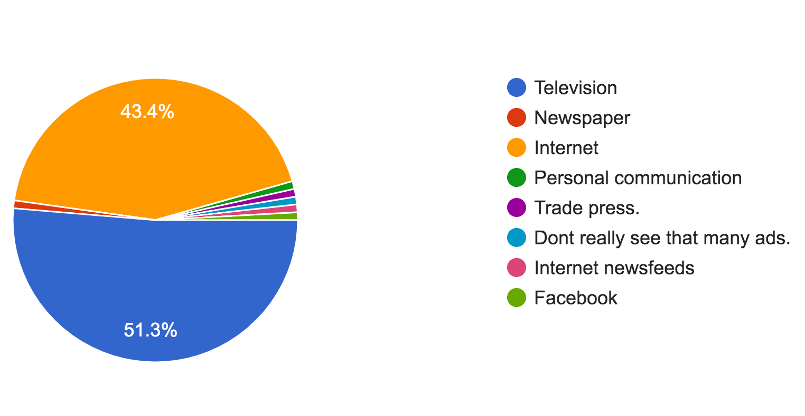

4.3 Discussion
The findings from the questionnaire show that while price is one of the main reasons people refrain from purchasing an EV, some drivers from lower salary brackets are still making the switch to electric. A number of people stated that they required more information with regards to some questions which shows that better understanding is needed and may be the reason people still think prices are too high. As EV’s have been out for a few years, second hand electric cars are increasing in numbers which are much cheaper than brand new models, making them much more affordable.

Chapter 5 – Conclusion

5.1 Introduction
This chapter seeks to state the conclusions reached from both the primary and secondary research as well as the limitations this study has faced. The conclusions will be based on the research conducted within this study as well as the findings from the data collected through the questionnaires.

5.2 The achievement of objectives
- To critically analyse literature on the public’s perception of electric vehicles and understand the advantages and disadvantages of ownership.
A literature review was conducted in the second chapter that analysed previous academic research as well as other sources.
- To conduct a questionnaire and analyse the collected data to understand the reasonings behind the purchase of the respondent’s vehicle as well as obtaining their thoughts on EV’s.
The identification of adequate methodology was done in chapter three. Analysis of the questionnaire findings was concluded in chapter four.

5.3 Main findings
The main findings support much of the literature in chapter two as well as analysis from chapter four. Firstly, a large amount of existing literature and studies state that the price of EV’s are too high, however the primary research finds that even respondents in the lower salary brackets were able to own and drive EV’s. The analysis finds that at least 10% of respondents from each salary bracket, including those earning less that £10,000 drive an EV as their personal vehicle.
The implications that have been discovered from this study is that the overall charging infrastructure in the UK is one of the largest reasons that divert consumers from purchasing an EV. This was found to be a big concern with the questionnaire respondents as 65% stated that it largely affects their vehicle choice.

5.4 Further research
The data collected was substantial and unfortunately could not have been analysed thoroughly within the timeframe however, this study has the potential to be revisited especially when opportunities to speak to car dealerships and consumers are restored after covid-19 lockdown. Further research could also explore how car manufacturers are influencing the purchase of their EV’s. By having to meet certain emission targets and other factors most EV’s on the market are losing money for the manufacturer and is believed to be why advertisement for these vehicles have been minimal.

5.5 Conclusion
The aim of this study which was to critically evaluate what influences and encourages consumers to purchase electric vehicles in the UK has been achieved as well as each objective. The study has also provided the researcher with greater knowledge on the explored areas as well as a better understanding on how to conduct and analyse research.
This research has identified the main features and concerns that encourages and discourages consumers in the UK to purchase EV’s. This has been carried out through each chapter within this dissertation. Firstly, chapter one identified the rationale for the study, which explored how electric is the only mainstream alternative for replacing internal combustion engines as well as setting aims and objectives. Chapter two consisted of a literature review on the relevant topics which identified gaps in research allowing for further exploration. Primary research questions were also influenced from the findings in the literature review. The third chapter identified the appropriate methodology which allowed for the collection of primary data and found that an online questionnaire was an applicable method. Chapter four analysed the data gathered from the questionnaires and presented the findings in charts and graphs.
The conclusion to this study is that the cost of ownership, charging infrastructure and the available battery range are the top three reasons that discourage consumers in the UK to purchase EV’s. The technology and environmental reasons were found to be the main encouragement behind the purchase of these vehicles with television and the internet being the most noticed form of advertising.

5.6 Self-reflection
At times, this dissertation has been somewhat difficult due to a number of factors, much of which as a result of the covid-19 pandemic. The researcher has developed knowledge in learning and using software such as Microsoft Excel and NVivo which has taught the independent process of self-learning.
On completion of this research, a broader judgement of EV’s was achieved as well as understanding the thought process that goes behind deciding on vehicle purchases.

Bibliography / References
Allen, J. (2019). GOVERNMENT PLANS TO SCRAP THE £3,500 PLUG-IN CAR GRANT SUBSIDY FOR ELECTRIC CARS. Available: https://www.driving.co.uk/news/government-plans-scrap-35000-plug-car-grant-subsidy-electric-cars/. Last accessed 7th May 2020.

Ambrose, J. (2020). UK companies to invest £12bn in switch to electric vehicles. Available: https://www.theguardian.com/uk-news/2020/mar/08/companies-to-invest-12-billion-pounds-in-electric-vehicles. Last accessed 2nd May 2020.

Aprameya, A. (2016). Cross Tabulation: How It Works and Why You Should Use It. Available: https://humansofdata.atlan.com/2016/01/cross-tabulation-how-why/. Last accessed 11th May 2020.

Bashir, Muhammad & Muhammad Tanveer, Afzal & Azeem, Muhammad. (2008). Reliability and Validity of Qualitative and Operational Research Paradigm. Pakistan Journal of Statistics and Operation Research; Vol 4. No. 1

Browne, R. (2020). Tesla gets green light from German court to chop down trees for its new Gigafactory. Available: https://www.cnbc.com/2020/02/21/tesla-gets-german-court-approval-to-chop-down-trees-for-gigafactory-4.html. Last accessed 28th April 2020.

BuyaCar. (2019). Government electric car grant: the complete guide. Available: https://www.buyacar.co.uk/cars/economical-cars/low-emission-cars/536/government-electric-car-grant-the-complete-guide. Last accessed 23rd April 2020.

Chiang, W. (2013). Strategic pricing with reference effects in a competitive supply chain. Available: https://www.sciencedirect.com/science/article/abs/pii/S0305048313000704. Last accessed 14th May 2020.

Collis, Jill & Hussey, Roger. (2014). Business research: A practical guide for undergraduate and postgraduate students.

Cooper, D.R., Schindler, P.S. (2006) Business Research Methods McGraw Research Methods, McGraw‐Hill

Deloitte . (2018). 2018 Deloitte Global Automotive Consumer Study. Available: https://www2.deloitte.com/content/dam/Deloitte/de/Documents/consumer-business/2018_GACS_Data%20Deck_Germany.pdf. Last accessed 23rd April 2020.

Department for Transport. (2019). Electric vehicle charging device statistics October 2019. Available: https://assets.publishing.service.gov.uk/government/uploads/system/uploads/attachment_data/file/850417/electric-vehicle-charging-device-statistics-october-2019.pdf. Last accessed 5th May 2020.

Dow, J. (2019). Survey says consumers avoid electric cars due to three myths: range, price, charging. Available: https://electrek.co/2019/08/20/survey-consumers-avoid-evs-myths-range-price-charging/. Last accessed 22nd May 2020.

Downes, H. (2020). Environmental footprint of electric cars. Available: https://www.thegreenage.co.uk/tech/environmental-footprint-electric-cars/. Last accessed 27th April 2020.

Dudovski, J (2018). Writing a Dissertation. Research-methodoloy.net.
Edf energy. (2020). Electric cars and the environment. Available: https://www.edfenergy.com/for-home/energywise/electric-cars-and-environment. Last accessed 25th April 2020.

Energuide. (2020). Are electric vehicles really environmentally friendly?. Available: https://www.energuide.be/en/questions-answers/are-electric-vehicles-really-environmentally-friendly/197/. Last accessed 25th April 2020.

Foley, B. (2018). What is SPSS and How Does it Benefit Survey Data Analysis?. Available: https://www.surveygizmo.com/resources/blog/what-is-spss/. Last accessed 8th May 2020.

Ford. (2020). ALL-NEW FORD FOCUS - CUSTOMER PRICE LIST. Available: https://www.ford.co.uk/content/dam/guxeu/uk/documents/price-list/cars/PL-All_New_Focus.pdf. Last accessed 23rd May 2020.

Fossdyke, J. (2019). 91 percent of new car buyers paid on finance over last 12 months. Available: https://uk.motor1.com/news/353737/91-percent-cars-financed-year/. Last accessed 23rd May 2020.

Fossdyke, J. (2019). A massive 88 percent said they would not return to internal combustion-powered cars.. Available: https://uk.motor1.com/news/299997/ev-drivers-wont-return-petrol/. Last accessed 5th May 2020.

Funke, S. Sprei, F. Gnann, T. Plotz, P. (2019). How much charging infrastructure do electric vehicles need?. Available: https://www.sciencedirect.com/science/article/pii/S136192091930896X. Last accessed 12th May 2020.

Gillham, B (2000). Case Study Research Methods. London: Bloomsbury publishing. 5.
Golafshani, N. (2003). Understanding reliability and validity in qualitative research. The Qualitative Report, 8(4), 597-606. from http://www.nova.edu/ssss/QR/QR8-4/golafshani.pdf. Last accessed 9th May 2020.

Halifax. (2020). Car finance calculator. Available: https://www.halifax.co.uk/car-finance/calculator/. Last accessed 22nd May 2020.

Hodges, J. (2018). Electric Cars May Be Cheaper Than Gas Guzzlers in Seven Years. Available: https://www.bloomberg.com/news/articles/2018-03-22/electric-cars-may-be-cheaper-than-gas-guzzlers-in-seven-years. Last accessed 22nd April 2020.

Hull, R. (2020). Budget slashes grant to buy an electric car by £500 to just £3,000. Available: https://www.thisismoney.co.uk/money/cars/article-8101557/Budget-slashes-grant-buy-electric-cars-3-000.html. Last accessed 24th April 2020.

Inside EV's. (2019). The Time Has Finally Come: Electric Car Ads Are On TV. Available: https://insideevs.com/news/355929/electric-vehicle-commercials/. Last accessed 24th May 2020.

International council on clean transportation. (2018). Effects of battery manufacturing on electric vehicle life-cycle greenhouse gas emissions. Available: https://theicct.org/sites/default/files/publications/EV-life-cycle-GHG_ICCT-Briefing_09022018_vF.pdf. Last accessed 27th April 2020.

Joppe, M. (2000). The Research Process. Retrieved February 25, 1998, from http://www.ryerson.ca/~mjoppe/rp.htm
Levy, G. (2019). Why Few TV Commercials Promote Electric Cars. Available: https://www.caranddriver.com/features/a28069918/tv-commercials-electric-cars-opinion/. Last accessed 24th May 2020.

Lilly, C. (2020). Electric car market statistics. Available: https://www.nextgreencar.com/electric-cars/statistics/. Last accessed 21st April 2020.

Lunetta, M. (2018). Women Are Accelerating the Switch to Electric Cars. Available: https://www.sierraclub.org/compass/2018/03/women-are-accelerating-switch-electric-cars. Last accessed 10th May 2020.

Mitsubishi Motors. (2020). Mitsubishi Outlander PHEV. Available: https://www.mitsubishi-motors.co.uk/cars/outlander-phev. Last accessed 22nd May 2020.

Newmotion. (2016). The Electric Range of an EV. Available: https://newmotion.com/en_GB/the-electric-range-of-an-ev/. Last accessed 22nd April 2020.

NI Business Info. (2020). Electric vehicles for business. Available: https://www.nibusinessinfo.co.uk/content/electric-vehicles-incentives-business. Last accessed 4th May 2020.

Nissan. (2019). NISSAN LEAF. THE TECH ADVANCED, 100% ELECTRIC CAR.. Available: https://www.nissan.co.uk/vehicles/new-vehicles/leaf.html. Last accessed 22nd May 2020.

Plumer, B and Popovich, N. (2020). Super Bowl Ads Hyped Electric Cars. But Will Anyone Buy Them?. Available: https://www.nytimes.com/interactive/2020/02/02/climate/super-bowl-ads-electric-car-hummer.html. Last accessed 25th May 2020.

RAC. (2018). Top nine alternative fuels for cars. Available: https://www.rac.co.uk/drive/advice/emissions/alternative-fuels/. Last accessed 5th May 2020.

RAC. (2020). Are electric cars really better for the environment?. Available: https://www.rac.co.uk/drive/advice/emissions/are-electric-cars-actually-worse-for-the-environment/. Last accessed 16th May 2020.

Saunders, M., Lewis, P., Thornhill, A. (2007) Research Methods for Business Students, 4th edition, Prentice Hall

Seliger, H and Shohamy, E. (1989). Second Language Research Methods.. Available: https://academic.oup.com/applij/article-abstract/13/3/324/235721?redirectedFrom=PDF. Last accessed 8th May 2020.

Sinn, H. (2019). Are electric vehicles really so climate friendly?. Available: https://www.theguardian.com/environment/2019/nov/25/are-electric-vehicles-really-so-climate-friendly. Last accessed 22nd May 2020.

Smith, A. (2019). Electric Car Innovation: How Electric Vehicles Are Changing the World. Available: https://www.plugandplaytechcenter.com/resources/electric-car-innovation-how-electric-vehicles-are-changing-world/. Last accessed 17th May 2020.

SMMT. (2020). Electric Vehicle and Alternatively Fuelled Vehicle Registrations. Available: https://www.smmt.co.uk/vehicle-data/evs-and-afvs-registrations/. Last accessed 21st April 2020.

Statista . (2020). Consumer concerns regarding battery-powered electric vehicles in the UK 2018. Available: https://www.statista.com/statistics/915211/consumer-concerns-regarding-battery-powered-electric-vehicles-uk/. Last accessed 21st April 2020.

tatista. (2019). Leading passenger electric vehicle models in the UK 2019.Available: https://www.statista.com/statistics/965626/uk-leading-passenger-electric-vehicle-models/. Last accessed 22nd May 2020.

Tyrell, M. (2019). UK now has more electric car charging points than fuel stations. Available: https://www.pesmedia.com/electric-vehicles-charging-points-uk/. Last accessed 22nd April 2020.

Vantage-Leasing. (2019). What You Should Know About Electric Vehicles. Available: https://vantage-leasing.com/blog/what-you-should-know-about-electric-vehicles. Last accessed 22nd April 2020.

Vaughan, A. (2011). UK government launches £5,000 electric car grant scheme. Available: https://www.theguardian.com/environment/2011/jan/01/electric-car-grant-uk. Last accessed 7th May 2020.

Walker, A. (2019). Concerns persist over charging infrastructure and price of electric vehicles. Available: http://www.infrastructure-intelligence.com/article/sep-2019/concerns-persist-over-charging-infrastructure-and-price-electric-vehicles. Last accessed 24th May 2020.

Wronski, L. (2017). Why (and how!) to ask survey questions on sexual orientation and gender identity. Available: https://www.surveymonkey.com/curiosity/ask-survey-questions-sexual-orientation-gender-identity/. Last accessed 9th May 2020.

Zap-map. (2020). Charging point statistics 2020. Available: https://www.zap-map.com/statistics/. Last accessed 6th May 2020.

Appendix

Copy of questionnaire
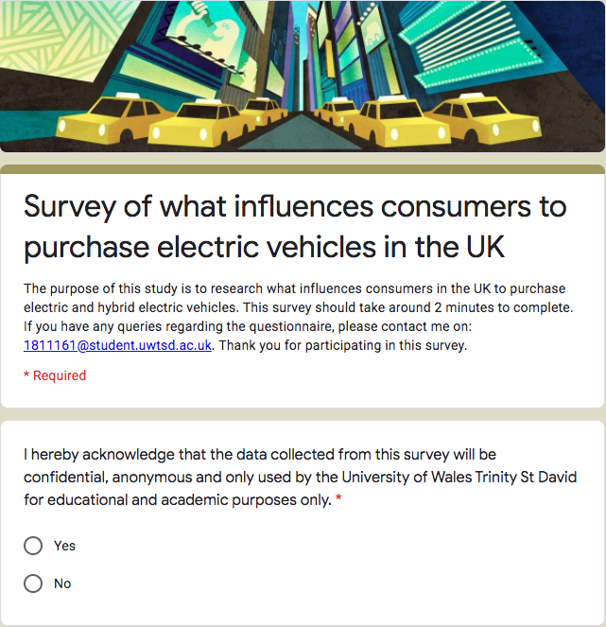

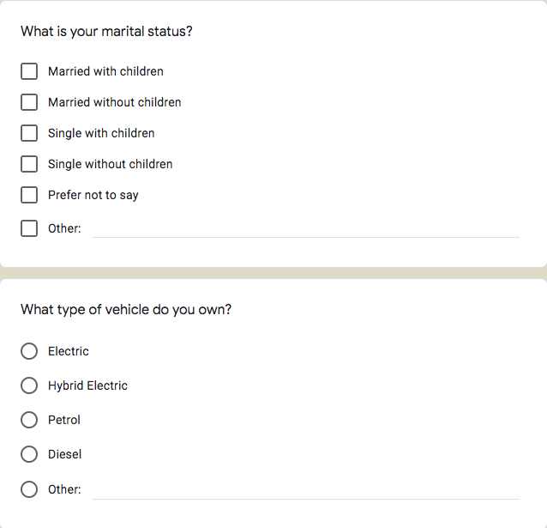

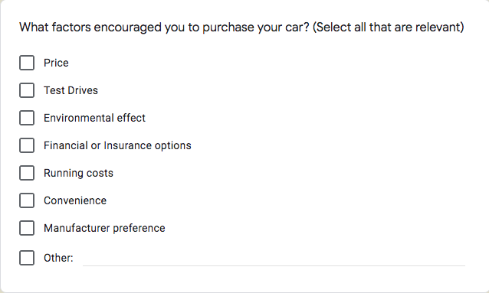

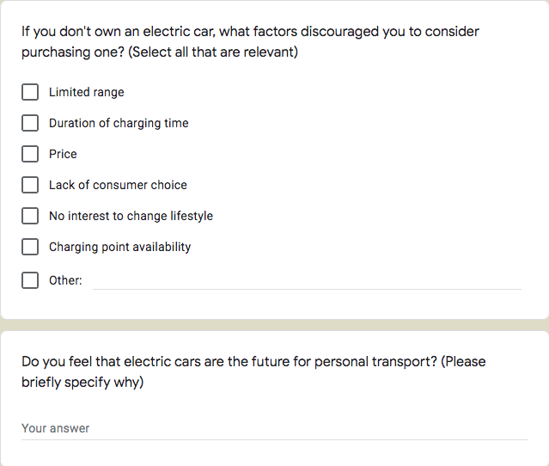
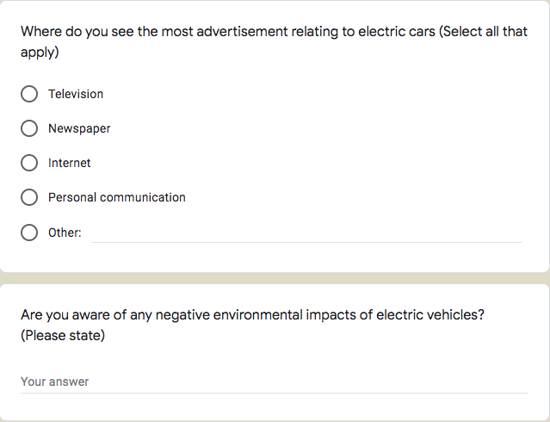

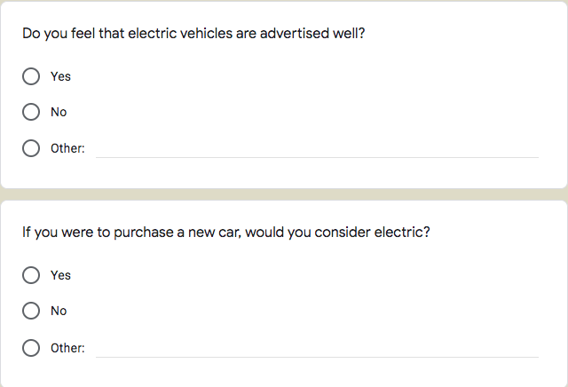

Copy of answers

Question 9: Do you feel that electric cars are the future for personal transport?
Yes
Yes
Yes for environmental factors
Yes I do , they environmentally friendly and they cheaper in the long run
Yes for environmental reasons
Definitely the way to go for the future more environmentally friendly
Yes, eventually when the infrastructure is there to support it
More environmentally friendly
Yes. Cheap fuel and can be very low emission depending on how electricity is generated.
Yes, provided enough charging points available
Yes. No fuel pollution in towns and cities, great to drive. Just great to own
Yes they have the potential to be so, however there needs to be a significant investment in charging infrastructure and capital cost of vehicle cost needs to reduce.
Yes as to ensure that climate change is kesscaffected
Yes, better for environment
Yes diminishing oil reserves and environmental benefits
I would need to know more about how they run ect.
Possibly but I think more research is needed
Yes, when batteries last linger and shorter charge times
No. Far too much to go wrong. Simple diesel engines are better in my opinion.
Yes I believe they are part of the change in life needed to be more sustainable
Yes. No question. Better cars, notwithstanding oil crisis / CO2 / Air Quality
Yes for environmental reasons.
Get us away from burning oil.
The best option we have right now for a cleaner mode of transport.
less emotions
yes, 100%
Yes better for environment
Yes, because of environmental concerns, government incentives and ever-reducing costs.
Yes - cheaper running costs, signify reduced environmental impact, low maintenance, convenient to charge at home.
Yes but only for local/short distances as the charging network is not good and the car range for basic motorway driving is poor
Yes but lower the prices
Yes - they are clean and lovely to drive. I would never go back to petrol again.
Clean, green and cheap to run.
Yes environmental friendly
Yes. Greener
No I think there would be better options eventually like solar or water powered.
Lower lifetime cost, lower lifetime pollution
Yes it keeps air cleaner in urban environments and reduces noise pollution
Yes, good financially in the long term.Better for the environment.
Yes, better for the environment
Yes. Due to environmental issues and the fact that once people actually drive one, they'll find it much superior.
Yes - simply better to drive as well as being cleaner and more sustainable
Yes, economical and environmental benefits
Not sure at the moment, I can see that marketing is pushing them but not sure if they are the future.
Much cheaper to run, and everything presently is going off deals; bargains and saving money
Yes. More appropriate for those making shorter journeys
Yes - cheaper to own and run, clear through-life environmental benefit, more fun!
No
Yes due to being environmentally friendly
Yes, they are clean, easy to operate and help reduce our carbon footprint.
Yes and the over-riding reason is environmental.
Yes less fuel emissions
Yes, quiet sustainable travel, reduction in harmful emissions though not justt cars; electric bikes / morbikes, scooters as well for short distance travel
Yes, when more charging points become more available and the cars run for a longer period before having to recharge.
Yes, battery or hydrogen is the question.
Yes because of sustainability
Much better air quality, huge huge savings in running costs, most people don’t do huge long journeys on a regular basis that warrant a 300mile range.
Yes, but they need to have longer lasting and faster charging batteries, and there needs to be more charging points and a greater range of consumer choice of brands and vehicle types
Amazing to drive and environmentally friendly. I could never go back to driving a fossil fuelled car ever again. My Tesla Model 3 has far exceeded my expectations and I absolutely love it! I’ve done 15,000 miles in it so far and had no problems whatsoever and can travel a real world 280 miles between charges. It only costs £4 in electricity to do 280 miles compared to £45 to do the same mileage in my old polluting petrol car.
Once price is reduced and range is a real world range of 300 miles
Yes, once charging infrastructure developed.
Yes, when made cost effective they will no doubt over take the current market
Yes as they are better for the environment
Yes because we are near the end of using fossil fuels
Clean and cheap
Electricity will not run out. Oil will
Climate change is getting significant attention now and the cost of petrol is huge. UK fuel duty is currently 57.95 pence per litre for petrol and diesel. Vehicle fuels with a lower emissions impact are taxed at lower duty rates; these include liquefied petroleum gas (LPG), compressed natural gas (CNG) and electricity. Other than fuel duty, the forecourt price of a litre of fuel also includes the product cost (around 30p per litre), Value Added Tax (in the region of 20-25p per litre depending on price) and the retailers margin (often only 5p per litre or less).
Yes once charge times are lower and charge points are plentiful.
Yes because they do not release any harmful emissions
Yes better for the environment
For environmental protection
fossil fuels unsustainable
Yes, specs are improving along with the charging infrastructure
Yes, apart from the environment, running costs and fun to drive.
Yes, harmful effect of burning fossil fuels, electric cars able to charge from renewable energy sources.
Yes for sustainability
Yes, because they are more eco friendly and we need to move away from fossil fuel
Yes. Simple infrastructure, renewable sources
Yes as they're more environmentally friendly
Yes. They are so much cheaper to run.
I do, as someone who cares for the well-being on the environment I believe over time electric cars will become much more influential as we move to a more eco friendly environment
Yes. As the new generation of children look for ways to help our planets environment, electric cars are a simple but effective way to reduce emissions globally.
Future ban on hybrids, diesel and petrol cars makes it inevitable
Yes, because it’s better for the environment
Yes
Demand is likely to increase but big improvements need to be made to range, affordability and charging stations
Yes, running costs for people and emmisions for the government.
Yes but not limited to electric.
They’re part of the future, not THE future. Public transport is going to play an equally as important role. Zero tailpipe emissions and an ever de-carbonising grid will make EVs the greenest choice. Technological advances, bigger companies e.g. VW Group making EVs will also drive down the price.
Not really sure. Never driven one, but things have got to change due to the environmental impact
yes. quiet, cheap to run (i have solar panels), loads of gizmos and extras, and they give me a tremendous, and not to be underestimated, feeling of smugness. priceless!
Yes, economical and eco friendly (my finance agreement costs me less a month than my petrol used to!)
Yes. Clean air. No fossil fuels. Not everyone can use walk, bike or public transport.
Yes. Cheap running costs, no emissions and range is increasing all of the time
Yes in the future they will be, but there needs to be more charging points especially South West Wales and cost of cars need to be lower to encourage people to buy electric cars
They could be in a few years but cost and lack of charging points at this time don't make it an option
Yes because they’re environmentally better and as a Geologist that knows a lot about the petrol industry it is not sustainable for our future as it will run out. Therefore alternative ways of powering our cars must be met.
Yes, for next 20 years anyway!
I don’t have an opinion
Yes, they have no emissions and are far more efficient

Question 11: Are you aware of any negative environmental impacts of electric vehicles?
No
No
Manufacturing carbon footprint
no
Do not know that much about them to comment
Still run on electricity which will require more power stations
Yes, manufacturing, energy consumption
Source of materials for batteries.
Lithium and Cobolt mining. Can be addressed but is it really worse than oil ex traction and transportation. Batteries are lasting longer than anticipated and recycling is on the cards so end of life problems are being reduced too
Battery life and how they will be disposed of.
Tyres shed more rubber because of heavier weight
The production process
No, but have never really taken interest, but would be willing to find out more about them.
Use of lithium battery
I've read the manufacturing of elements of the batteries are causing huge environmental issues.
Battery production however it’s quickly offset
All manufacturing has an inherent environmental impact and so does running any electrical item or mode of transport. EV’s are not exempt. They are comparatively cleaner over their lifetime by a huge margin under any fair test.
What is going to happen to all the batteries?
Battery materials especially cobalt
If the grid is dirty, EVs are of limited impact. Luckily the grid is cleaning up rapidly.
Aware of rumours, but also that overall impacts are much worse for ICE cars.
Yes - manufacturing footprint is still large, though quickly paid back in a short time
Lesser than other
No - my car is largely powered by solar panels on my roof and I think the batteries are repurposed for storage at the end of their long lives.
Not compared to regular cars.
It still creates pollution to gather the electric initially unless it would be completely sustainable like wind.
Battery reuse needs to be sorted - reuse as house battery
Mining for lithium
Compared to conventionally fuelled vehicles, there ARE no negative impacts.
Some rare earth metals used in battery production have significant environmental cost in their extraction. However this is a sunk cost - these materials will not continue to cause harm unlike burning fossil fuels, and can be recycled infinitely.
No. There are no new ones compared to ICE vehicles and far less pollution.
Battery manufacture though less impact than fuel processing
Yes, the source of where the electric is generated
Manufacturing of batteries can’t be good for environment as using natural resources, also how electricity is generated, good if from wind turbine etc bad if from nuclear power plant
Only the issue that the production of the electricity to charge the car may have its own environmental impact ( e.g. if the electricity is not generated by 'green' means
A lot of the negativity you hear is blatant lies by the media and big oil corporations. Thank goodness I saw through all the lies and negativity and decided to go electric. It’s genuinely the best decision I’ve ever made in the 30yrs I’ve been driving and having owned over 50 cars of all different makes and models. The Tesla blows every single one away by a massive margin and literally no comparison whatsoever. I got back in to my partners 1 yr old BMW the other day to pop to the shops and get diesel. I used to think it was lovely to drive, but now it feels awful, unrefined, clunky and noisy, and it’s like driving an old banger in comparison to the Tesla! It really shocked me how bad it was compared with clean electric power.
UK still using Coal to generate Electricity but understand this is finishing.
Battery development and recycling
Yes
Expensive to make
Lithium battery
The battery is lithium ion and this is mined in Africa, Chile, Tibet so at the end of the day whilst it is more environmentally friendly, there are still issues. especially regarding recycling.
Maybe concerned about battery life and recyclability.
Not yet
Lack of charging facilities and distances you can travel
Battery recycling
Mining of cobalt for batteries
Unsure about disposal of batteries, how long batteries last for
Legacy fossil fuel generation.
None
None that I know of really.
The batteries emit toxic fumes
Not really
Infrastructure
Electricity needed to power vehicles will increase which create greenhouse gases
Initial production impacts
Battery manufacture and recycling
Whole life emissions of EVs (production etc.) can be worse than combustion cars in locations where the grid is carbon heavy. Not so much in the U.K.
I've read about the building of the batteries and the impact on the environment
lies about children dying down mines to supply elements for the batteries. It overlooks that internal combustion engines and their support network, as well as other industries, are greater evils. Hanging around facebook groups and reading past discussions would prove to be a great educator on electric vehicles and provide you with lots of great counter arguments against the neanderthals that love petrol and diesel pollution.
Other than colbolt no
Production of batteries
No. Myths about battery mining have been discredited
Insufficient supplies of electricity to take over from petrol and diesel engines
Expensive to start up. The electric pump installation in the house is very expensive. These pumps are very limited in Wales therefore long trips may be difficult to do.
The mining of the lithium

