Workplace Culture and its impact on Organisational Efficiency
Name: Nkechi Jefia
Lecturer: Dr. Janet Green
ID Number: 1714551

Table of Contents
Introduction 3
Starbucks background 3
What is culture? 5
The Work Culture at Starbucks 5
Management style - Starbucks leadership style 6
Relationship-based criteria 7
Management theory of Starbucks 8
SWOT analysis of Starbucks 9
PESTLE analysis of Starbucks 10
Political 10
Economic 11
Social 12
Technological 12
Environmental 13
Legal 13
Ethical and standards of the Starbucks culture 14
Impact of ethical standards on employees’ beliefs and values 16
Communication theory 18
Shannon weaver model of communication 19
Conclusion 20
References 21

Introduction
In the present times, the employees are highly influenced and attracted to the companies that follow ethical leadership practices in their business as it provides a broader exposure to new learning and job satisfaction (Fontaine, 2019). The culture of a workplace plays a vital role in designing the work culture of business, especially the internal environment. It is observed that the work culture at Starbucks is quite influencing and powerful corporate cultural type in the domain of international businesses. This report aims to present a comprehensive analysis of the organisational culture of Starbucks and its impact on employee performances. The ethical consideration of Starbucks business model and the influence of their policies over the beliefs and values on the employees will also be encoded in the following report. As well as, Taking into consideration the communication model theory with starbucks and how the organisation implements this into there work environment.

Starbucks background

Figure 1 Starbucks coffee
Source:Johnson (2017).
In the domain of international coffee market, Starbucks that is situated in Seattle Washington in the United States is considered as the topmost revenue generating organisation due to its peculiar work culture and leadership approaches (Johnson, 2017). The first store was opened in 1971 in Seattle, Washington. Starbucks is one of the biggest organisations of the coffee industry across the globe. Beginning from a small business that used to sell a magical coffee, the company has turned into the biggest international roaster in America in the mid-1980s. It has also extended its business to Latin America, North America, Europe, and Middle East.. A collective of roughly around 35 million clients visits Starbucks coffee shops consistently on an annual basis. Starbucks is synonymous with shopping and eating. They sell huge espresso bean coffees with new, luxuriously made Italian hot brews, a great variety of prepared products and desserts that goes well with coffee, mostly from association to retail.
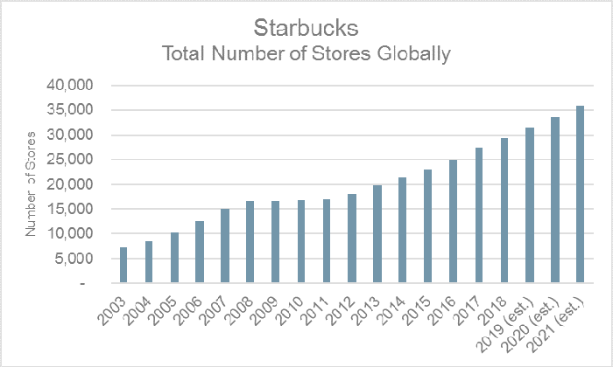
Figure 2Starbucks Growth
Source: Hutt (2019)
Developing markets in Brazil, India, China, South Africa and Mexico with operating structures keep on offering extraordinary probabilities to open new stores and serve more people. Starbucks has quite recently made critical walks in the Chinese market; however, there is still a lot of space for improvement in these ventures. Starbucks should expand it’s scope in developing markets locally. Starbucks needs to improve its purchasing system by becoming more relevant to the needs of their customers. The control groups are suggested to put extra focus on the peculiar needs of every customer so that customer satisfaction could be retained without any further delay. The company should work with employees to ensure they receive a good working enviorment in order to demonstrate great skills that can be brought forth to the company, this will allow employees to satisfy the needs of the customers.

What is culture?
Culture can be definied as shared patterbs of behaviour and interactions and understanding that is learnt through socialization. For example, knowledge from particular groups of people, languages, religion. While, organisational culture is the code of conducts through which the management and the staff work together. This particular type of culture is recognised as one determinant of how people behave within organisations – it is also known that management should influence to improve organisational performance (Sinclair, 1993, p.63-73). It is observed that the employee performance and the behaviour of the workforce is a reflection of the work culture of that organisation.

The work culture at Starbucks
The work culture at Starbucks is reported as one of the most influencing and strongest organisational cultures in the domain of international businesses. The fundamental principle behind the company is to understand the needs of their customers and clients so that the required or demanded service could be provided efficiently. In Starbucks, clients and customers are considered as the partners of the business due to which they are given with immense considerations. The organisational culture at Starbucks emphasises moreover establishing the features of diversity, inclusion and the sense of belongingness among customers and the company.
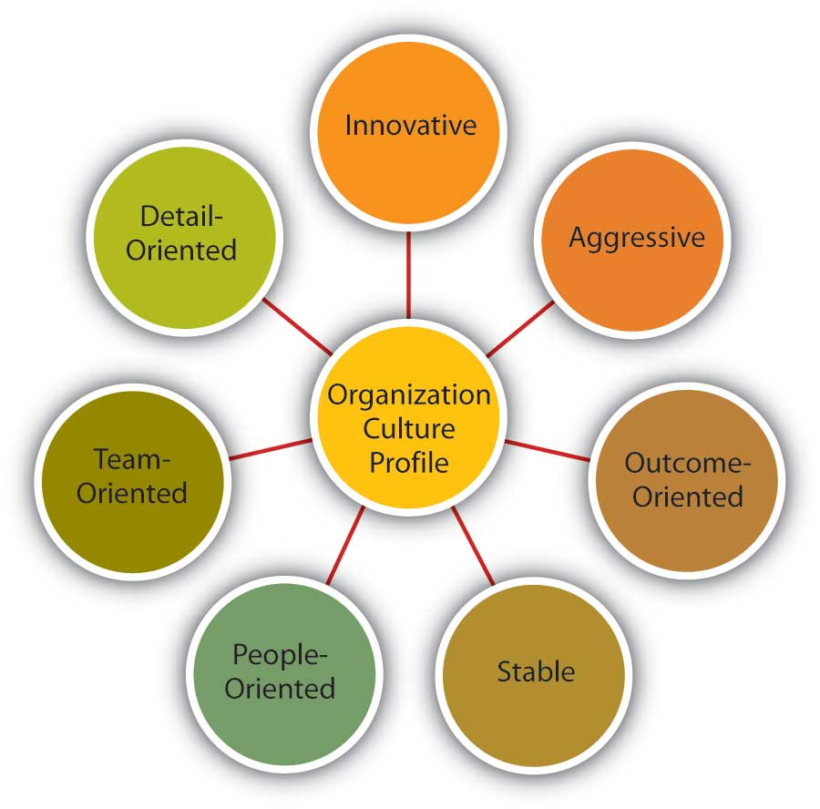
Figure 3Work culture at Starbucks
Source: Hutt (2019)
As mentioned before, they focus on making their customers as the most important part of their business structure and always pay extra attention to them. Among all the coffee houses in the national as well as international coffee industry, Starbucks has been proved as the most promising and unique business platform with the strongest and unique organisational culture. The situation of the work culture of the company is reflected from the productivity and strategy of its human resource management, marketing criteria, branding techniques and the customer service provisions.
Among all the policies of Starbucks, the main features that present the culture of the organisation which impacts the business the most are discussed below:

Management style - Starbucks leadership style
The management style that is apporiate to improve efficiency in starbucks is servant leadership style. The servant leadership is all about facilitating the staff with great knowledge and mentoring them, so that more leaders can be produced. The motive of servant leadership is to create leaders not followers. The theory of servant leadership is observed to be a different phenomenon of leading people. Starbucks puts its great interest in keeping their employees above all as they believe a satisfied employee can give them satisfied customers.
Due to this mindset, the company seems to have a highly valued work culture where the employee is treated with respect and care and also their personal, as well as professional growth is considered as the concern of the management.

Relationship-based criteria
In the work culture of Starbucks, the management puts its keen efforts in maintaining a friendly and warm relationship among every individual in their workforce regardless of their designation, race, and other social or cultural differences (Garthwaite, 2017). With regards to the organisation culture of Starbucks, the organisation includes workers in the dynamic procedures and meetings, which gives a feeling of inspiration among workers. In Starbucks, each worker is permitted to give his or her feedback and recommendation to the companys top management, enhancing the sense of belongingness and developing the relationship-based coordination (Garthwaite, 2017).

In the context of customer satisfaction and employee performance, the feature of relationship-based corporate leading results in great profits because when employees are treated with great respect and compassion, they pass it on the customers fluently. Through this, the customers are made to feel connected with the company, resulting in increased customer loyalty (Hutt, 2019). Starbucks culture has consistently been considered as outstanding amongst other international projects due to their highly valued strategies and policies, which results in high employee satisfaction and increased business profit. The HRM recruits’ people who fit the organisational culture of Starbucks and understand the codes of their working styles as well. Starbucks culture provides its employees with a highly adaptive working environment which encourages the organisation to improve the productivity of its workers (Hutt, 2019).

Management theory of Starbucks

In all the leading companies that operate on international level, it is hard to distinguish one that does not follow the leadership approaches in operating its managerial conducts and policymaking People nowadays are highly influenced and attracted to the companies that follow ethical leadership strategies in running their business because it provides the employees with a better and wider exposure to get more knowledge of the business. Leadership management styles that are implemented in an organisation play a vital role in designing the work culture of the business, especially the internal environment. Starbucks follows the servant leadership strategies in dealing with their business operations which has been facilitating their work culture with numerous beneficial outcomes since its initiation (Fontaine, 2019).

Meanwhile, in meeting the needs of their employees the management is emphasising over the implementation of Maslow’s theory of needs so that every employee could feel satisfied with his or her job role. The Maslow’s theory of needs identifies the basic needs of individuals in an organisation through a hierarchal representations in accordance with the ranking of the needs. For instance; physiological, safety, love and belonging, esteem, and self-actualization. These needs are needed in order to satify employees within the workplace (McLeod, 2020). The presented image will demonstrate the Maslow’s theory though illustrative description of the needs and their ranking.
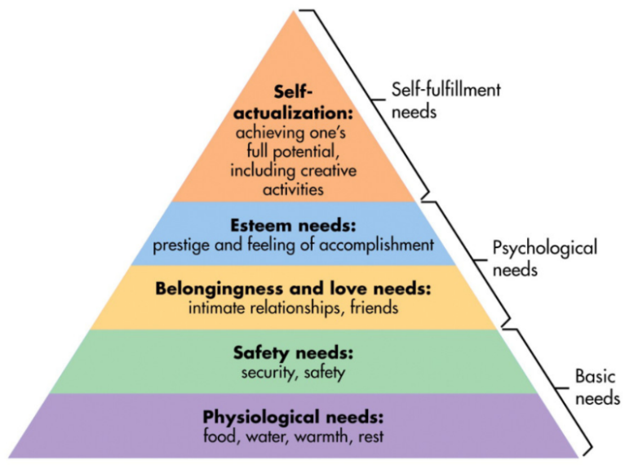
Figure 6 Maslow’s theory of needs (McLeod, 2020).

SWOT analysis of Starbucks
SWOT Analysis
Strength: | - Their coffee is on high demand in western counties  - They provide premium quality of services and products to their customers  - The company enjoys brand image and brand recognition  - The supply chain is highly productive
Weakness: | - Their pricing is highest among all the coffee shops and only elite class can affords their coffee on regular basis and refuse to make products affordable for all types of customers.  - Starbucks products are imtable, this means smaller companies can copy and develop the same products as starbucks.
Opportunity: | - Moderate pricing strategy and Product line can also be improved with little efforts of the top management  - Starbucks can increase its revenue through expansion in developing different markerts in different countries. For example, covering the Asian market and drawing attention from a US market.
Threat: | - Starbucks are exposed to Strong competition in the coffee industry because there are several other companies including Mc café and Costa coffee, who are sell very good coffee at much lesser pricing.  - Being a part of the global business network the company gets impacted easily by slight tension in the international politics.  - The limited choice options in the products sometimes discourage customers buying from starbucks.

PESTLE analysis of Starbucks
Starbucks is considered the leading coffee seller in the global coffee industry with more than around 22,000 cafes and stores all across the world. Their gigantic organisational structure has been influencing the internal and external environmental factors since long. To evaluate the factors that impact environmental aspects of the Starbucks work culture, the environment scanning tool PESTLE is used so that a categorical analysis could be developed. As Starbucks has been observed to have high prestige in the coffee industry, it is further encoded that among all the competitors, they are doing the best with highest business revenue generated yearly (Lakshminarayanan, 2017). The PESTLE analysis of Starbucks presents the influence of the external environments on the business performance, work culture and employee satisfaction of the organisation.
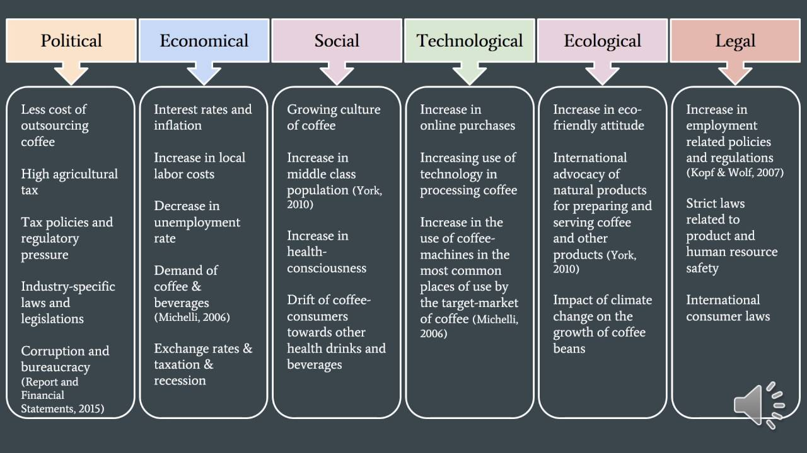
Figure 8: PESTLE analysis of Starbucks
Source: Kragt (2018)

Political
In the domain of political factors that impacts business performance and the work culture at Starbucks, it is observed that international politics, international relations, regional integration seem to have a great impact on the overall business structure. This has given starbucks the opportunity to expand globally. Governments are the world are seeking to improve there infrastructures to accomdate opportunity for businesses like starbucks, which will allow them to access a bigger market and overseas suppliers (Smithson, 2017).
For instance, in the context of Starbucks, it is observed that being an American company from its origin, the company is dedicatedly focussed to develop friendly relations with Asian country like China as the CEO believes that they can increase their business revenue to is highest scales if they get to take hold at the china’s food industry, particularly the coffee industry (Lombardo, 2019).

Economic
The connection among economic growth and the political stance of a company seems to be an unavoidable subject of the matter because environmental factors must be discussed and their impacts over the performance and culture of any given company. Companies like Starbucks and other international projects are reported to be highly influenced with the economic stance of the global market as they operate as per the situation and status of the international coffee industry (Smithson, 2017). The economic growth or the economic stance of the international market is observed to be constantly changing, thus, the companies keep facing economic pressure. However, the high economic growth of most developing countries and declining unemployment rates will create a perfect opportunity for starbucks to gain more capital from various markets across the world and also, exist internationally (Smithson, 2017). But, the cost labor in developing countries threatens strabucks because it increase the company’s spending on ingrediants as opposed to when the financial climate of the developing countries was different.

Social
Over the profitability of any given business, the impact of socio-cultural factors cannot be ignored. Customers are attracted to the brand and services as per the fulfilment of their social and cultural need. For instance, in the case of Starbucks, the founder of the company has emphatically emphasised over establishing the stores all around the globe but keeping the European countries as his basic targets. The reason behind such conduct was to provide coffee to the people who drink this beverage as their basic or primary hot beverage. Unlike Asian culture, where teas of different kinds are more preferred than coffee. The reason behind such preferences of different nations is reported as the degree of the temperature of the nations, and cold nations are more prone to select coffee as their first choice as the beverage is warm in nature while nations across equator are more inclined towards selecting tea.

Technological
In the modern era of the latest technology, every individual seems to have developed a unique relationship with the technological devices, which is impacting the lifestyle and preferences to the core (Smithson, 2017) . For instance, every organisation is moving towards getting their business synchronised with technology innovations because it results in great revenue generation in the nearest future and fastens the business growth. Starbucks has the ability to align themselves as a business because of the rising mobile purchases, by improving it’s mobile apps and link its services to gain more revenue through more mobile purchases (Smithson, 2017). For example, Starbucks has launched their peculiar mobile apps so that their customers can contact them and place orders to dispatch through technology and also, link with other apps like Deliveroo or ubereats. This has increased the public support and customer loyalty of the Starbucks business and has impacted the business performance, work culture and employee performance as well.

Environmental
All around the world, it is observed that the most that governments and people are supporting and accepting businesses that are eco-friendly. The world is taking the environment very seriousl and the international business domain has set up certain programs which includes; sustainability and recycling. Starbucks has also presented a highly skilled and tactfully developed a business plan to accomplish the Green Business platform. Starbucks has invested a huge amount from its business revenue to develop an eco-friendly business platform by ensuring responsible sourcing policies and ensuring that the products that starbucks offers are in recyclable packaging, this will ensure minimal enivromental impact on starbucks end (Smithson, 2017).

Legal
A business should be based on the policies in compliance with legal structures of the international and national business law in order to get its stance clear in the market domain. But in the international business world to keep up the legal formalities maintained and accomplished becomes one of the most challenging factors of the environment that a company must face. For example, incorporating the taxation rates and policies or anything that is related to labour laws of employee rights, the international companies must face a challenges when it comes to dealing with such. Starbucks must see legal policies as an opportunity to satisfy product safety regulations and any regulations on ingrediants from GMOs (Genetically modified organisms) (Smithson, 2017). It is clear that Starbucks is keen to focus on the legal compliance of the international market, as they are highly dedicated to developing an ethically accepted business platform for its stakeholders, employees, and customers.

Ethical and standards of the Starbucks culture
Starbucks is one of the biggest café organisations on the planet with numerous stores everywhere throughout the world. The organisation sells prepared espresso, espresso beans, snacks, and brews of different styles, hot and cold beverages and many more. Starbucks has differentiated its business in different fields. For example, marketing booklets, and audio-visual content for effective and fast advertisement. Numerous items in this organisation are regular and explicit relying upon the territory of the store. The organisation is extending quickly because of the utilisation of ethically justified policies, effective marketing procedures, and developing healthy and highly engaged bonds with their customers and clients (Jehow, 2018).
Starbucks is highly dedicated to develop business strategies founded over their ethical considerations. They put the ethics and moral values above all the shows great progress in developing a highly effective ethically justified business platform in the domain of international business foundation. Starbucks works directly and fairly with farmers to guarantee there is full stockpile of value espresso in the market (Johnson, 2017). They keep a check on the ethical status of the growing of coffee beans (Johnson, 2017). The organisation has placed into thought different estimates that guarantee the government assistance of farmers, clients and representatives are put made to be in focus throughout the entire process. Their ethical foundations included the implementation of non-discriminative policy, to avoid inequality from their structure.

The company prefers that all the business conducted should be planned in line with eco-friendly approaches, since they strictly apply transparency in their business conducts. Payment of the espresso cost and the nature of espresso meant they focused on buying from local coffee farmers so that they can be helped with their business too. Putting resources into better future for espresso ranchers through the arrangement of advances they emphasis on purchasing certified coffee beans only (Kragt, 2018). Assisting with preserving the environment through appropriate removal of waste and, the usage of environmental features is another consideration of Starbucks and eco-friendly resources of energy are used in Starbucks.

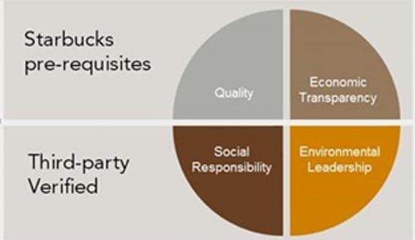
Figure 9: Starbucks ethical considerations
Source: Kragt (2018)
The organisation has built up financial, social, conditions and quality rules that are considered as the establishment of ethical norms. The foremost ethical issue faced by starbucks was observed when it decided to expand the business across the world. As the company was dedicated to open as many stores as they could, they ended up establishing several stores that the business of small coffee shops faced a great decline in its revenue because of them (Kragt, 2018).
Starbucks success is a result of highly skilled leadership approaches and ethically developed business strategies which satisfies company, clients, customers and its employees to the core. They have provided the coffee industry with a great example of working under ethical norms and legal compliances, promoting fair business practices (Peiritsch, 2019). Their goal is to convey the interesting experience to both the important features of its business, the employees and customers.
The company is extremely dedicated in serving and delivering the best quality coffee with customised tastes as per the request to their clients. They are highly focused on leaving an impression over their clients or customers, so that customer loyalty can be gained through hard work and smart strategies. It is the objective of Starbucks to have espresso developed under great principles. The exchanging of such significant item ought to be done in a moral way to meet the needs of longing clients and accomplish the objective of benefits.

Impact of ethical standards on employees’ beliefs and values
Fairtrade policies and ethical consideration in getting pure best quality coffee beans have become the most promising strategies of the Starbucks business that is adding up quality in the company's prestige continuously (McKibben, 2017). These policies are seemed to be as a binding force among the customers and the suppliers that keeps up the business of starbucks reaching to the heights of success. The organisation does not permit the individuals who are underneath the age of eighteen years to work in the espresso fields. Any type of work that is considered as constrained is tended to in the correct way.
Workers in Starbucks are viewed as equivalent and each specialist is dealt with in the similar manner without getting any kind of favour from the administration. This core value has been useful in running the issues of the organisation. This has prompted the work of representatives in a diversified working department (Murphy, 2016). Social obligation is another territory of centre that guides Starbucks while continuing with its commitments. It includes measures that are concerned about acceptable working conditions, reasonableness and safe environment, positive work culture, and so on. The privileges of employees in Starbucks should be secured in order to provide their employees a better quality of life and a batter stance in the society. Starbucks guarantees that its employees get the best compensation from the work they perform and this maintains a strategic distance from abuse of labourers (Murphy, 2016).
The issues related to child labour and constrained work is tended to, in order to guarantee safe conditions for the workplace and the individual. As per the report presented by (Sartori, 2018), Starbucks revealed in 2013 that it "kept on fulfilling and put resources into our full-and low maintenance accomplices by helping them to acknowledge more than $230 million in esteem from value grants, and by holding industry-driving medicinal services benefits paying little mind to changes to the U.S. healthcare laws." That's about $1 million for every representative, in spite of the fact that, as generous as Starbucks officials are with remuneration, (Montgomery, 2019) it is further observed that front line labourers aren't getting six-figure value awards (Murphy, 2016).
It was also observed that Starbucks disclosed a restored "College Achievement Plan." Starbucks is joining forces with Arizona State University to permit representatives who work over 20 hours per week to get a chance in proceeding for a four-year college education with help from the organisation (Peiritsch, 2019). Employees are given the option of more than 40 courses of study and certificate programs, and those conceded under junior or senior class standing will have the option to get full educational cost repayment. While there are a few shortages and grindings with the framework, Starbucks' general way to deal with specialist remuneration is remarkable on the grounds that it shows a genuine enthusiasm for the government assistance.

Communication theory
Communication is a very important aspect in both business and relationships to ensure the best results inside and outside of the work environment. Effective communication allows individuals to share ideas and thoughts in effective ways. Communication is a very vital skill within the workplace because you need it to succeed.
In the organisational culture of Starbucks, the role and stance of effective communication can never be ignored. When it is about analysing the stance of communication among employees and the managers and the leaders, starbucks shows a great uniformity in the area of guidance. Every employee in the company is treated with equality, and no one gets neglected (Fontaine, 2019). The company shows high prestige in compassionate mentoring, which leads to great understanding among employees and the management. Effective communication is the key to high employee satisfaction in Starbucks, which leads to great alternative results. Starbucks’ corporate social obligation , additionally requires its representatives to guarantee that no one's worth, profound quality and morals are being hurt because of any business activity. Likewise, Starbucks’ corporate social obligation rehearses advance reusing of waste and water so as to secure the environment.
Aside from this, Starbucks’ corporate social duty requires the top administration of the organisation to take care of the satisfaction of necessities and wants of its workers. Every individual in the Starbucks staff is determined to provide the best quality of service to their clients and to make a remarkable impression of the company in the global market. This happens because the leaders of the company and all the mangers are highly concerned about maintaining an effective platform for enriching communication among managers and staff so that every individual employee could understand the motives of the company and strategies to achieve them as well (Fontaine, 2019).

Shannon weaver model of communication


(Source: Businesstopia, 2018)
Shannon weaver model of communication looks at how communication messages is sent from person to person. Employers and employees may face problems while communicating which effects the organisation and it’s employess. However, once a effective strategy of communication is established to achieve the best performance within the organisation, the matter will be resolved. To improve an organisations communication, for instance, starbucks – the model notes that proper communication is imperative. Verbal communication between managers and employees are needed to be successful within the organisation. In order to improve the internal communication structure of the organisation the management is suggested to incorporate some new strategies of spreading word within the organisation so that every employee could get to know the motives and tactics of achieving the motives of the organisation, for instance:
- Every employee should be provided with their portals where they can access to daily updates of the company.
- Discussions should be conducted on and off so that employees can stay guided and heard.
- The management should conduct seminars and meeting occasionally where the top managers themselves come and discuss the company strategies and performance evaluation.

Conclusion
The organisational culture at Starbucks emphasises over establishing the features of diversity, inclusion and the sense of belongingness among customers and the company. This report presented a detailed analysis of the work culture of Starbucks and its impact on employee performances. The ethical consideration of Starbucks business model and the influence of their policies over the beliefs and values of the employees was also a main focus of the above-encoded business report. As it is observed that the work culture at Starbucks is quite influencing and powerful corporate cultural type in the domain of international businesses.
Starbucks puts the ethics and moral values above all the shows great progress in developing a highly effective ethically justified business platform in the domain of international business foundation. They are highly dedicated to understanding the needs of their customers and clients in order to provide them with high quality of service as per their demands. In the structure of Starbucks, clients and customers are counted as business stakeholders and are given with immense considerations. The report concluded that in order to satisfy potential customer the company is advised to emphasis on managing a profound culture for the employees so that a required and fulfilling service could be served to the customers which will enhance the number of customers directly and it will lead to a profound.
Reference
businesstopia (2018). Shannon and Weaver Model Of Communication - Businesstopia. [online] Businesstopia. Available at: https://www.businesstopia.net/communication/shannon-and-weaver-model-communication [Accessed 2 May 2019].
Fontaine, M., 2019. Corporate social responsibility and sustainability: the new bottom line?.International Journal of Business and Social Science, 4(4).
Garthwaite, C., Busse, M., Brown, J. and Merkley, G., 2017. Starbucks: A story of growth. Kellogg School of Management Cases, pp.1-20.
Hutt, R.W., 2019. Reputation on the line: the Starbucks cases. Journal of Business Strategy, 37(1), pp.19-26.
Jehow, F.A., Gikandi, J. and Mwencha, P., 2018. Effect Of Training And Leadership Skills On Employee Performance In Devolved Governments In Kenya: A Case Of Wajir County. European Journal of Business and Strategic Management, 3(4), pp.87-104.
Johnson, S.K., 2017. What 11 CEOs Have Learned About Championing Diversity. Harvard Business Review.
Kragt, D. and Guenter, H., 2018. Why and when leadership training predicts effectiveness: The role of leader identity and leadership experience. Leadership & Organization Development Journal, 39(3), pp.406-418.
McKibben, W.B., Umstead, L.K. and Borders, L.D., 2017. Identifying dynamics of counseling leadership: A content analysis study. Journal of Counseling& Development, 95(2), pp.192-202.
Mcleod, S. (2020). Maslow’s Hierarchy of Needs. [online] Simply Psychology. Available at: https://www.simplypsychology.org/maslow.html.
Montgomery, N.V. and Cowen, A.P., 2019. How leader gender influences external audience response to organisational failures. Journal of personality and social psychology.
Murphy, S.E. and Johnson, S.K., 2016. Leadership and leader developmental self‐efficacy: Their role in enhancing leader development efforts. New directions for student leadership, 2016(149), pp.73-84.
Peiritsch, A.R., 2019. Starbucks' Racial-Bias Crisis: Toward a Rhetoric of Renewal. Journal of Media Ethics, 34(4), pp.215-227.
Sartori, R., Costantini, A., Ceschi, A. and Tommasi, F., 2018. How do you manage change in organisations? Training, development, innovation, and their relationships. Frontiers in psychology, 9, p.313.
Sinclair, A. Approaches to organisational culture and ethics. J Bus Ethics 12, 63–73 (1993). https://doi.org/10.1007/BF01845788
Smithson, N. (2017). Starbucks Coffee PESTEL/PESTLE Analysis & Recommendations - Panmore Institute. [online] Panmore Institute. Available at: http://panmore.com/starbucks-coffee-pestel-pestle-analysis-recommendations.

‌

